**Restoring the database**

1. In SQL Server, right click on the database
2. Go to tasks, then restore, then database

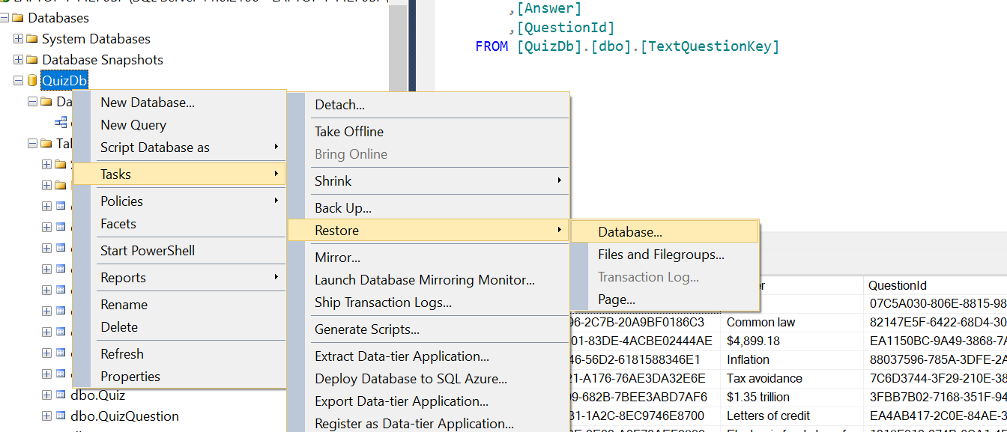

1. Click device
2. Click the button on the right
3. Add the backup file

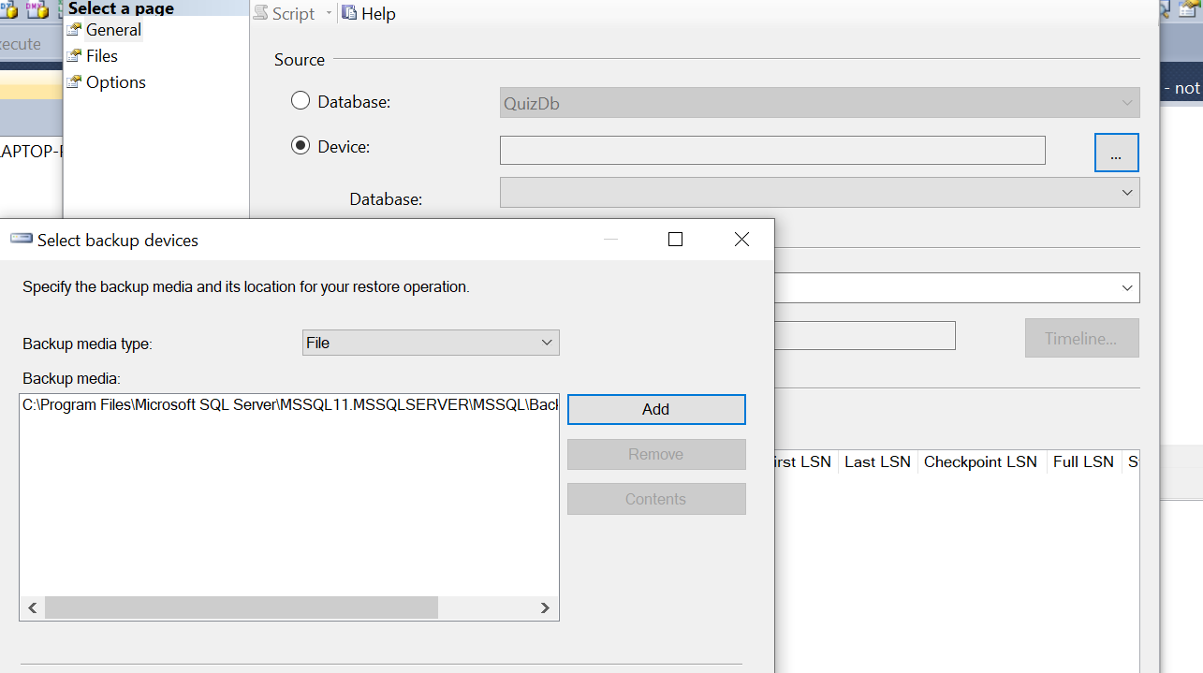

**Launching the program**

1. In the flash drive, open the “FblaQuizzer” folder
2. Open the “FblaQuizzerProgram” folder
3. Open the “FblaQuizzerWpf” folder
4. Open the “bin” folder
5. Open the “Debug” folder
6. Click on the “FblaQuizzerWpf.exe” file

**How to use the program**

* Taking a quiz
  + Click the “Take Quiz” button to create and take a quiz
  + Question types:
    - Multiple choice: Select your answer. Only one answer may be selected at a time, and you may not unselect an answer without selecting another answer.
    - Text question: Type your answer into the textbox. Questions with numerical answers have a format which is outlined in the question. Answers are not case sensitive and also ignore spaces.
    - True or false question: Same as multiple choice
    - Matching question: Drag the options on the right side of the screen next to the appropriate prompts on the left side of the screen. If you believe the prompts and options are already matched correctly, simply go to the next question.
  + Navigate between questions using the previous and next buttons.
  + Click the finish button on the last question once you are satisfied with your answers
  + You may not resume a quiz once you have closed it
* Reviewing a quiz
  + Once you finish a quiz, the results page will display. You can also navigate to the results page of any quiz by clicking on “View Quizzes” on the home page and double-clicking on the quiz of interest.
  + Your score will appear at the top of the results page.
  + For each question, the original question, whether you got the question correct, your answer, and the key answer will be displayed.
  + Click “Print” to save a printable report for the quiz.
  + Click “Close” to return to the home screen.