# Debugging

Debugging for the project was done with the NetBeans IDE debugger tool.

While developing the application, each functional section of code was debugged to determine the causes of errors.

A first prototype was assembled as a console-only app to test logic easily. On completion of the prototype, a testing phase began. I tested the project against the requirements and used the debugger to locate and solve logic errors.

A second prototype was assembled with a Java Swing GUI. Another testing phase began at this stage, and the debugger tool was used in the same way to resolve logic errors during testing.

To determine the cause and location of logic errors, I used ‘breakpoints’ and ‘watches’ to check that the code was behaving as intended at each line. When an error occurred, I placed breakpoints through relevant areas and checked that variables were as expected at each point.

For example, using this process I determined that my hashing method was giving a different hash for a string read from a text file vs the same string typed in. With this information was able to see that there was an issue with my file reading method.

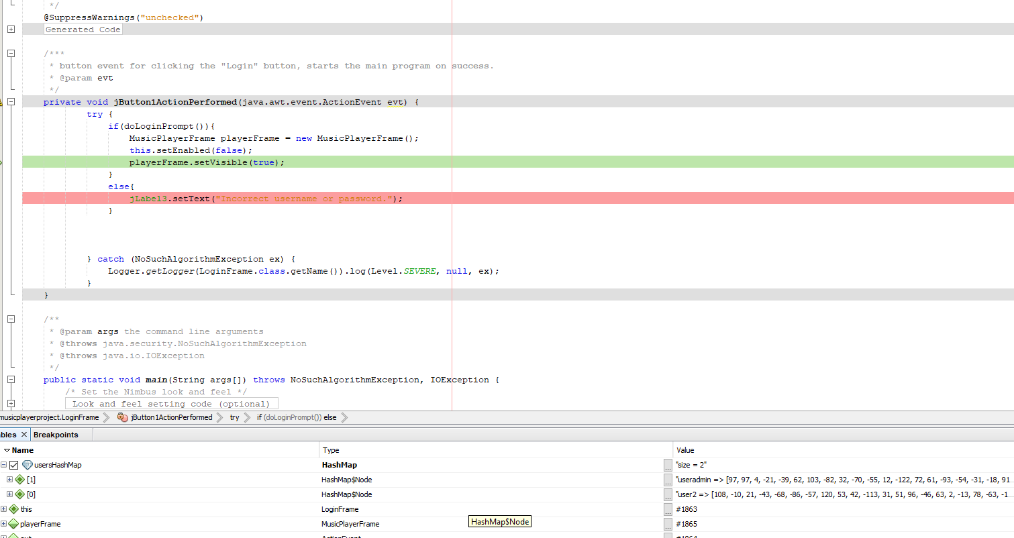

Debugging and checking the contents of the HashMap with the NetBeans Debugger tool.