# Testing

## Login Page

|  |  |  |  |
| --- | --- | --- | --- |
| Test case | Expected Result | Actual Result | Screenshot |
| Login with correct credentials. | Proceed to next frame. | As Expected. | 1, 2 |
| Login with incorrect credentials | Do not proceed. | As Expected. | 3, 4 |

## Music Player Page

|  |  |  |  |
| --- | --- | --- | --- |
| Test case | Expected Result | Actual Result | Screenshot |
| Add song | Song added | As Expected. | 5, 6 |
| Play song | Song plays | As Expected. | Can’t screenshot, but the song did play. |
| Stop song | Song stops | As Expected. | Can’t screenshot, but the song did stop. |
| Search song | Correct song appears | As Expected. | 7, 8 |
| Press help button | Help PDF appears | As Expected. | 9 |
|  |  |  |  |

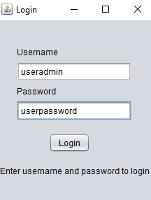

Screenshot

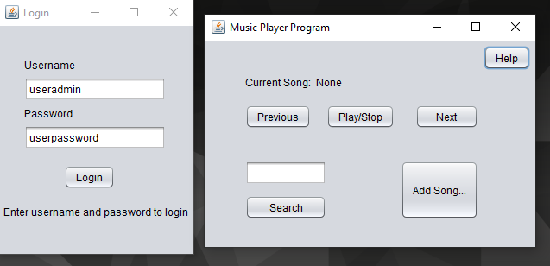

Screenshot

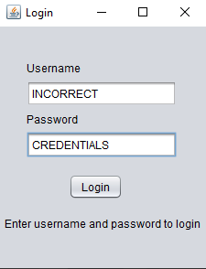

Screenshot

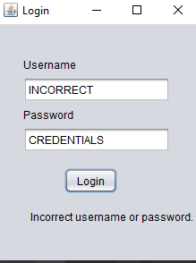

Screenshot

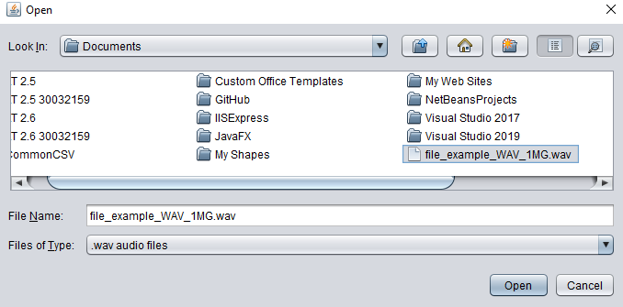

Screenshot

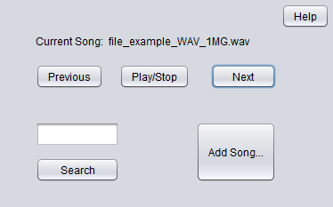

Screenshot

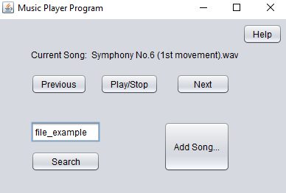

Screenshot

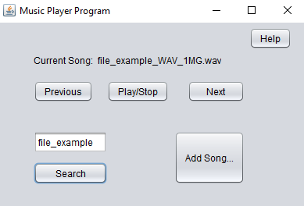

Screenshot

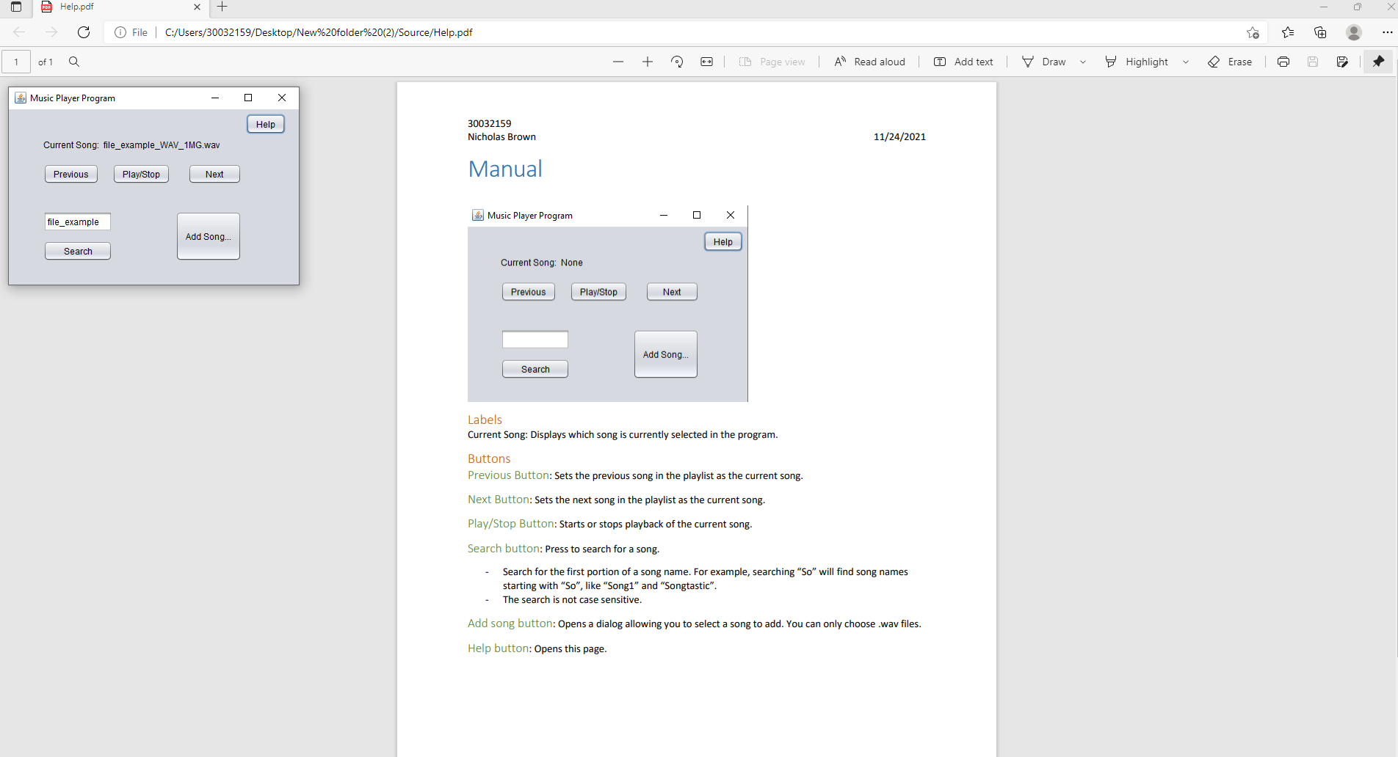

Screenshot