# Cyrus

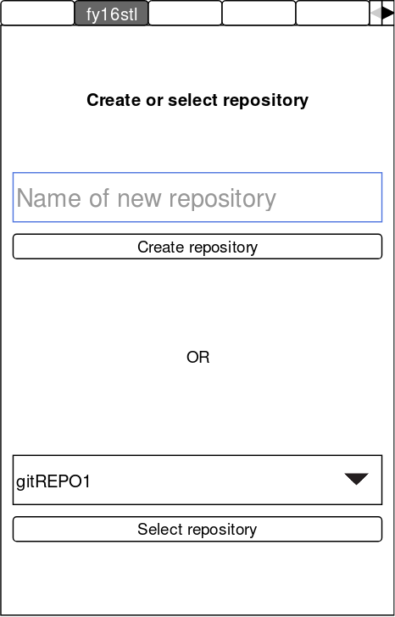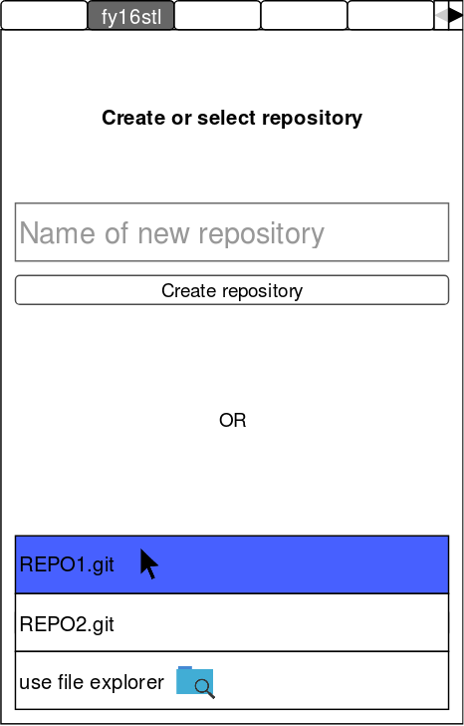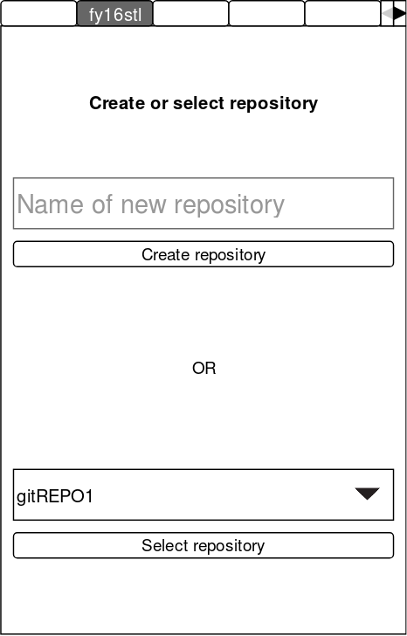Sketch prototype

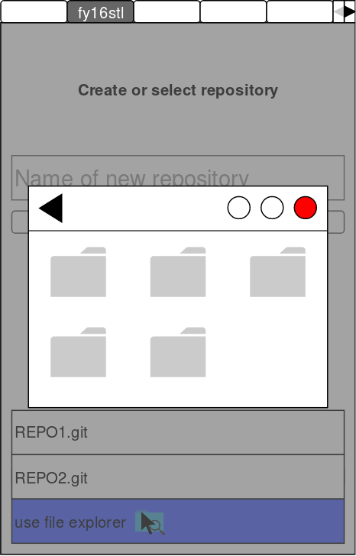

*Figure 1*

*Figure 2*

*Figure 3*

*Figure 4*

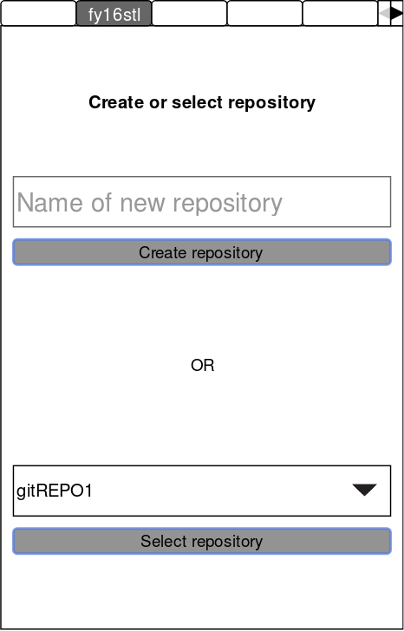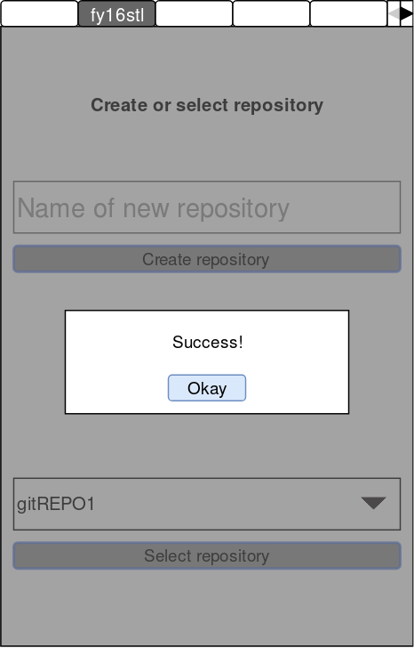

*Figure 5*

*Figure 6*

Reasoning behind design

Introduction

This tab is used for creating or selecting a repository within the directory. We wanted to make the UI user friendly and visually pleasing, to achieve this, we used colours that users are familiar with in other applications (white, black, blue, grey) throughout the whole UI, the result is consistency. I have designed the layout such that it will make the best use of the space available, where everything is spaced out appropriately and will be readable even when the window is resized.

Layout

From *Figure* 1, we can see that the top of the page is a description of what the tab does, the user should read this first so I made the description bold. As the tab has 2 functions that the user can choose between, I have split the page into 2 sections, top section is for creating a new repository and bottom section is for selecting an existing repository. The user is reminded of the functions by the ‘OR’ label in the middle of the page.

Create/Select repository

For the ‘create repository’ section, a *LineEdit* class will be used where the user can input to name their new repository. The input field contains opaque place-holder text to tell the user what they should be entering into the field. The ‘select repository’ section contains a *ComboBox* class, the user can click on the arrow to view a drop down list of all the repositories they can choose, *Figure 3* shows a rough idea how this will look. At the bottom of the list is the option to find the repository using the file explorer, clicking on this option opens the file explorer where the user can find the desired repository, *Figure 4* shows this.

Feedback

Feedback is one of the most important aspects of any UI design, without feedback users would dislike the application very quickly. Here, everything the user does it communicated back to them to assure that everything is working properly. In *Figure 2*, when the user presses on the input field, the edges of the field turns into a light blue colour and a cursor appears in the field to tell the user that the click was successful and that they can start typing. In *Figure 3*, when the user is selecting a repository, the choice the cursor is hovering on will turn blue to tell the user what they would select if they clicked. When the buttons are pressed, their outlines will change blue and the button will turn into a grey colour to signalise its been clicked on, how this looks can be seen on *Figure 5*. If a git repository is created successfully or a repository gets selected, a window appears telling the user that everything worked as intended, *Figure 6* shows this.