sc17mtab
No commits
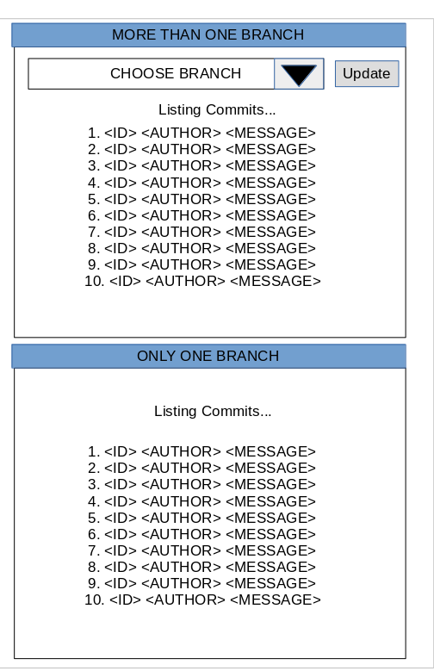
This page will show if the git repository has no commits, it outputs a message to the user to inform them of the current situation.
One branch
If there is only one branch then the system will just output a list of up to ten commits on the page. It will not display the combo box or the update button as this could confuse the user.
More than one branch
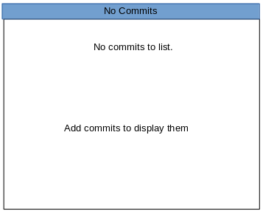
If system detects that the git repository has more than one branch it will populate a combo box with the branch names and an update button so the user can refresh the page to show the commits for their chosen branch. A combo box was chosen as a text input would have a high chance of user error and radio buttons would be cluttered if there was a large number of branches.

