# sc17r2jb

Sketch prototype

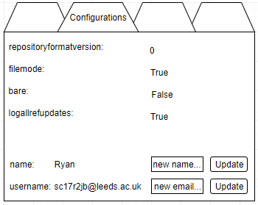

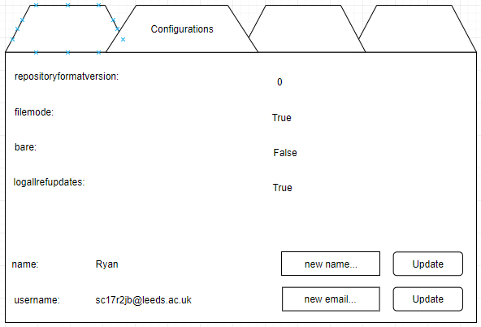

Reasoning behind design

Consistency

Consistency is achieved by using the tabs for all the different sections. As well as this, little to no colour is used. All the buttons and widgets in general are very minimalistic, with a focus on displaying information to the user without cluttering the screen. The window will be structured in a way that it remains easy and readable regardless of how big or small the window is stretched to (within reason). Specifically, the same relative space between objects in the window will be kept.

Visibility

The functionality for “configurations” itself is extremely easy to find, as the users know already, thanks to the consistency of using tabs, that they need to just look for the title in the tabs themselves.

Once on this tab, all the information relevant is displayed in plain text. No borders or boxes around the information. This means that they won’t confuse information with inputs. The few parts in this tab which will be interacted with stand out as they have box shapes or are buttons. The input boxes for new emails and names even have placeholder text in them to demonstrate where they can put text, and what the text should be. The buttons are right next to their respective input boxes to update the fields, meaning it won’t be confusing as to which one they will press.

Feedback

Successful and failed attempts can be tied to the button presses, meaning that when the input is changed, a pop-up can notify the user.