# sc17mtab

Sketch prototypes

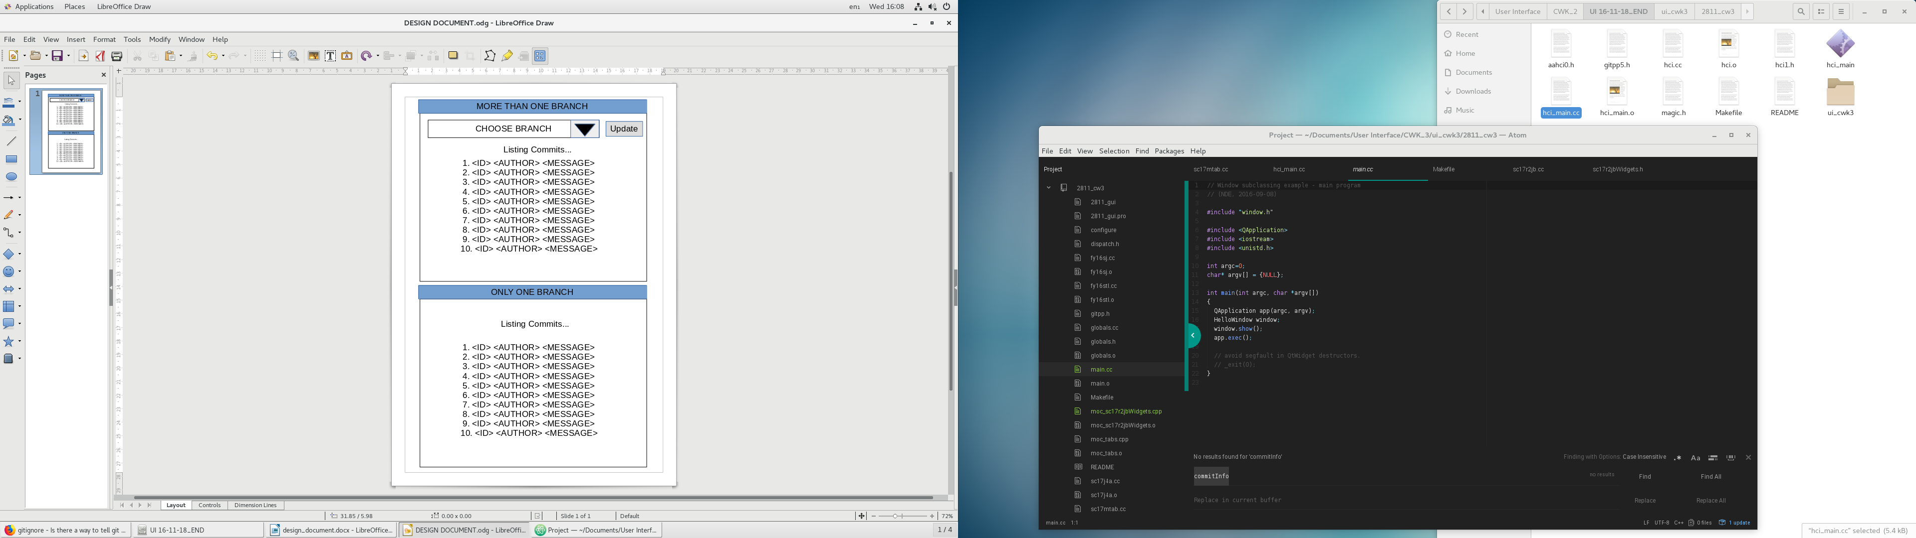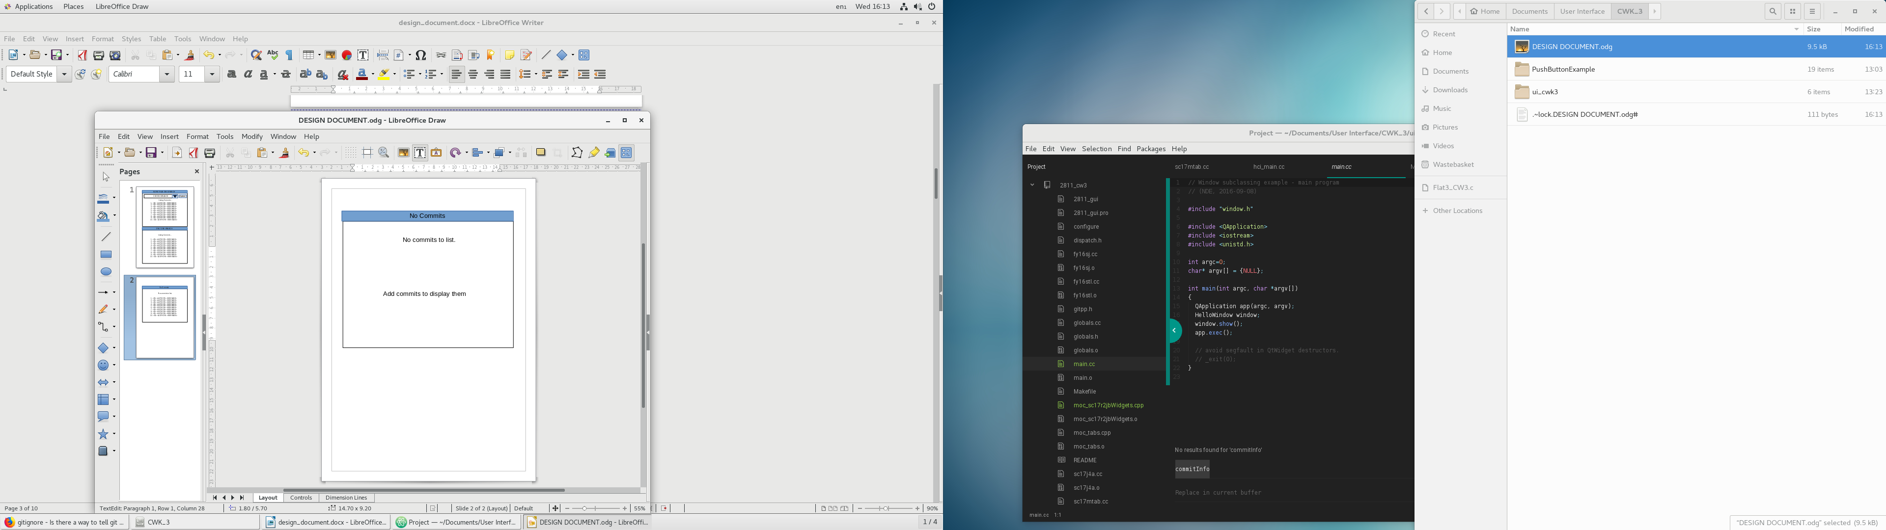The system