**Game Report**

**Description:**

This mini game is developed as a shooter based response game. You are tasked with shooting a bird at different objects with different points based on size and other features. The bird has a speed bar for the user to determine the speed of their bird, and a semicircular shooting area where the user can choose in which direction the bird will be flying. The main goal of the game is to knock as many objects as you can with the given 3 birds.

Level 1 consists of a easier level with bigger shooting birds, more points on objects and no moving objects.

Level 2 consists of a harder level with smaller shooting birds, less points on objects and a final boss that moves and taunts you giving you a lot of points.

The game tests your hand eye perception and coordination while providing a nice calm game to play around with and get the highest score.

**Class Diagram:**

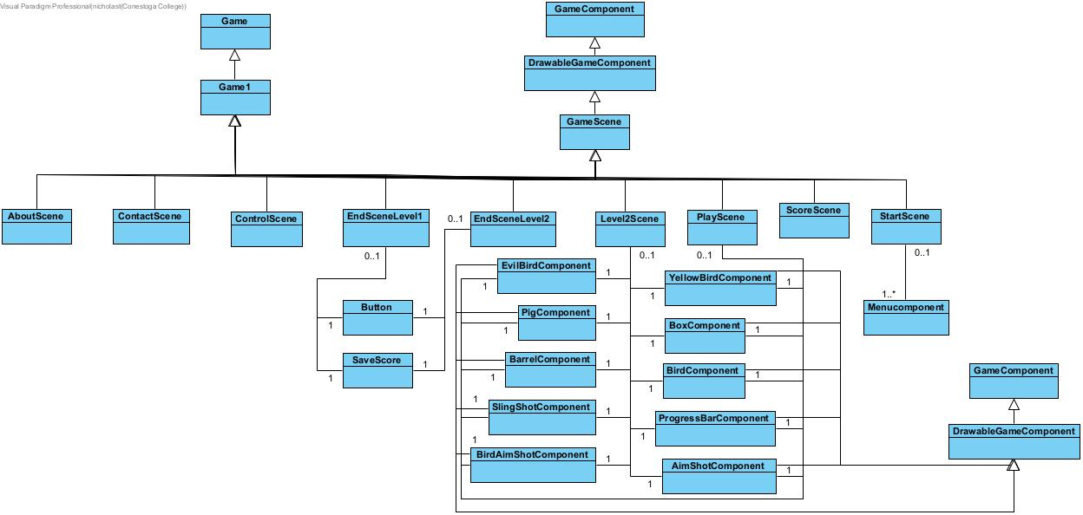

**References**

[**https://icon-icons.com/**](https://icon-icons.com/)

<https://gamedev.stackexchange.com/questions/47750/how-to-fill-a-rectangle-with-tilable-texture-in-xna>

<https://cloudconvert.com/mp3-to-wav>

<http://soundfxcenter.com/sound-effects/angry-birds/0>

<https://www.free-stock-music.com/fscm-productions-epic-battle.html>

<https://www.flaticon.com/>

<https://angrybirds.fandom.com/wiki/Angry_Birds_Wiki>