**Análise da Tabela de Hashing de Cuco**

**Docente:** João Dias

**Discente:** Diogo Fonseca nº79858

**Análise de qualidade das funções de hashing**

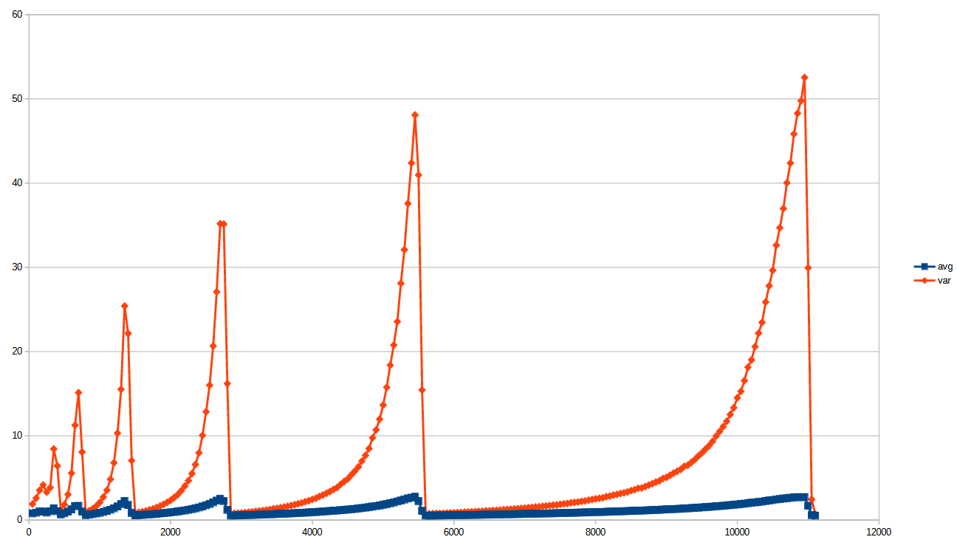

Gráfico I. Média e Variância do número de colisões por tamanho da tabela de hash

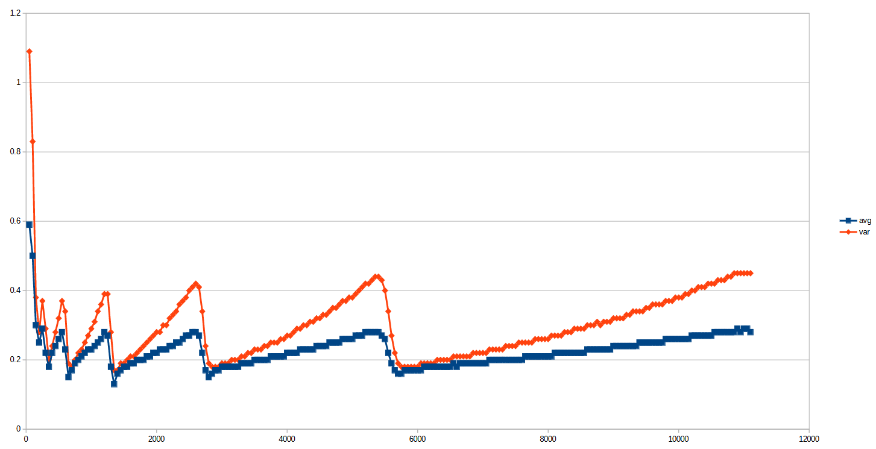

Gráfico II. Média e Variância do número de colisões por tamanho da tabela de hash com esquecimento

Blah blah blah. Ddddddddd dddddd dddddddddddddd dddddddddddddd ddddddddddd dddd.

(mencionar que os dados estão no final).

(mencionar o numero de testes e como eles são feitos, como os dados foram obtidos).

|  |  |  |
| --- | --- | --- |
| n | Tempo Médio de Execução (ns) | Razão |
| 250 | 416 | 0.0 |
| 500 | 230 | 0.6 |
| 1000 | 177 | 0.8 |
| 2000 | 605 | 3.4 |
| 4000 | 1053 | 1.7 |
| 8000 | 875 | 0.8 |
| 16000 | 1349 | 1.5 |
| 32000 | 2531 | 1.9 |
| 64000 | 2591 | 1.0 |
| 128000 | 3483 | 1.3 |
| 256000 | 2302 | 0.7 |
| 512000 | 3110 | 1.4 |
| 1024000 | 3223 | 1.0 |
| 2048000 | 3297 | 1.0 |
| 4096000 | 3223 | 1.0 |

Tabela 3. Testes de razão dobrada da função put() do CuckooHash (redimensionamento a 50%)

|  |  |  |
| --- | --- | --- |
| n | Tempo Médio de Execução (ns) | Razão |
| 250 | 71 | 0 |
| 500 | 39 | 0.5 |
| 1000 | 44 | 1.1 |
| 2000 | 42 | 1.0 |
| 4000 | 79 | 1.9 |
| 8000 | 86 | 1.1 |
| 16000 | 87 | 1.0 |
| 32000 | 95 | 1.1 |
| 64000 | 124 | 1.3 |
| 128000 | 162 | 1.3 |
| 256000 | 232 | 1.4 |
| 512000 | 301 | 1.3 |
| 1024000 | 359 | 1.2 |
| 2048000 | 362 | 1.0 |
| 4096000 | 377 | 1.0 |

Tabela 4. Testes de razão dobrada da função get() do CuckooHash (redimensionamento a 50%)

|  |  |  |
| --- | --- | --- |
| n | Tempo Médio de Execução (ns) | Razão |
| 250 | 576 | 0.0 |
| 500 | 265 | 0.5 |
| 1000 | 258 | 1.0 |
| 2000 | 545 | 2.1 |
| 4000 | 901 | 1.7 |
| 8000 | 1336 | 1.5 |
| 16000 | 2194 | 1.6 |
| 32000 | 2553 | 1.2 |
| 64000 | 2911 | 1.1 |
| 128000 | 2963 | 1.0 |
| 256000 | 2992 | 1.0 |
| 512000 | 3019 | 1.0 |
| 1024000 | 3180 | 1.1 |
| 2048000 | 3339 | 1.1 |
| 4096000 | 4104 | 1.2 |

Tabela 5. Testes de razão dobrada da função put() de Linear Probing Hash (redimensionamento a 50%)

|  |  |  |
| --- | --- | --- |
| n | Tempo Médio de Execução (ns) | Razão |
| 250 | 84 | 0.0 |
| 500 | 47 | 0.6 |
| 1000 | 60 | 1.3 |
| 2000 | 50 | 0.8 |
| 4000 | 68 | 1.4 |
| 8000 | 67 | 1.0 |
| 16000 | 75 | 1.1 |
| 32000 | 73 | 1.0 |
| 64000 | 91 | 1.2 |
| 128000 | 107 | 1.2 |
| 256000 | 202 | 1.9 |
| 512000 | 393 | 1.9 |
| 1024000 | 337 | 0.9 |
| 2048000 | 344 | 1.0 |
| 4096000 | 370 | 1.1 |

Tabela 6. Testes de razão dobrada da função get() de Linear Probing Hash (redimensionamento a 50%)

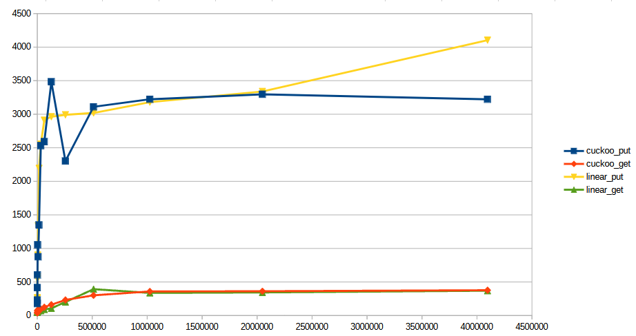

Gráfico III-VI. Testes de razão dobrada das funções get() e put() da Linear Probing Hash e da Cuckoo Hash (redimensionamento a 50%)

|  |  |  |
| --- | --- | --- |
| n | Tempo Médio de Execução (ns) | Razão |
| 250 | 416 | 0.0 |
| 500 | 230 | 0.6 |
| 1000 | 177 | 0.8 |
| 2000 | 605 | 3.4 |
| 4000 | 1053 | 1.7 |
| 8000 | 875 | 0.8 |
| 16000 | 1349 | 1.5 |
| 32000 | 2531 | 1.9 |
| 64000 | 2591 | 1.0 |
| 128000 | 3483 | 1.3 |
| 256000 | 2302 | 0.7 |
| 512000 | 3110 | 1.4 |
| 1024000 | 3223 | 1.0 |
| 2048000 | 3297 | 1.0 |
| 4096000 | 3223 | 1.0 |

Tabela 7. Testes de razão dobrada da função put() do CuckooHash (redimensionamento a 75%)

|  |  |  |
| --- | --- | --- |
| n | Tempo Médio de Execução (ns) | Razão |
| 250 | 71 | 0 |
| 500 | 39 | 0.5 |
| 1000 | 44 | 1.1 |
| 2000 | 42 | 1.0 |
| 4000 | 79 | 1.9 |
| 8000 | 86 | 1.1 |
| 16000 | 87 | 1.0 |
| 32000 | 95 | 1.1 |
| 64000 | 124 | 1.3 |
| 128000 | 162 | 1.3 |
| 256000 | 232 | 1.4 |
| 512000 | 301 | 1.3 |
| 1024000 | 359 | 1.2 |
| 2048000 | 362 | 1.0 |
| 4096000 | 377 | 1.0 |

Tabela 8. Testes de razão dobrada da função get() do CuckooHash (redimensionamento a 75%)

|  |  |  |
| --- | --- | --- |
| n | Tempo Médio de Execução (ns) | Razão |
| 250 | 576 | 0.0 |
| 500 | 265 | 0.5 |
| 1000 | 258 | 1.0 |
| 2000 | 545 | 2.1 |
| 4000 | 901 | 1.7 |
| 8000 | 1336 | 1.5 |
| 16000 | 2194 | 1.6 |
| 32000 | 2553 | 1.2 |
| 64000 | 2911 | 1.1 |
| 128000 | 2963 | 1.0 |
| 256000 | 2992 | 1.0 |
| 512000 | 3019 | 1.0 |
| 1024000 | 3180 | 1.1 |
| 2048000 | 3339 | 1.1 |
| 4096000 | 4104 | 1.2 |

Tabela 9. Testes de razão dobrada da função put() de Linear Probing Hash (redimensionamento a 75%)

|  |  |  |
| --- | --- | --- |
| n | Tempo Médio de Execução (ns) | Razão |
| 250 | 84 | 0.0 |
| 500 | 47 | 0.6 |
| 1000 | 60 | 1.3 |
| 2000 | 50 | 0.8 |
| 4000 | 68 | 1.4 |
| 8000 | 67 | 1.0 |
| 16000 | 75 | 1.1 |
| 32000 | 73 | 1.0 |
| 64000 | 91 | 1.2 |
| 128000 | 107 | 1.2 |
| 256000 | 202 | 1.9 |
| 512000 | 393 | 1.9 |
| 1024000 | 337 | 0.9 |
| 2048000 | 344 | 1.0 |
| 4096000 | 370 | 1.1 |

Tabela 10. Testes de razão dobrada da função get() de Linear Probing Hash (redimensionamento a 75%)

|  |  |  |
| --- | --- | --- |
| n | Média de colisões | Variância de colisões |
| 50 | 0.79 | 1.9 |
| 100 | 0.87 | 2.6 |
| 150 | 1.01 | 3.54 |
| 200 | 1 | 4.17 |
| 250 | 0.89 | 3.31 |
| 300 | 1.05 | 3.86 |
| 350 | 1.39 | 8.43 |
| 400 | 1.05 | 6.44 |
| 450 | 0.66 | 1.2 |
| 500 | 0.8 | 1.84 |
| 550 | 0.99 | 3.03 |
| 600 | 1.26 | 5.56 |
| 650 | 1.66 | 11.26 |
| 700 | 1.68 | 15.13 |
| 750 | 1 | 8.07 |
| 800 | 0.58 | 0.91 |
| 850 | 0.64 | 1.1 |
| 900 | 0.7 | 1.34 |
| 950 | 0.78 | 1.67 |
| 1000 | 0.86 | 2.11 |
| 1050 | 0.96 | 2.73 |
| 1100 | 1.08 | 3.55 |
| 1150 | 1.22 | 4.85 |
| 1200 | 1.39 | 6.8 |
| 1250 | 1.61 | 10.31 |
| 1300 | 1.89 | 15.52 |
| 1350 | 2.25 | 25.41 |
| 1400 | 1.78 | 22.15 |
| 1450 | 0.83 | 7.06 |
| 1500 | 0.55 | 0.82 |
| 1550 | 0.58 | 0.91 |
| 1600 | 0.61 | 0.99 |
| 1650 | 0.64 | 1.09 |
| 1700 | 0.67 | 1.21 |
| 1750 | 0.7 | 1.33 |
| 1800 | 0.74 | 1.49 |
| 1850 | 0.78 | 1.66 |
| 1900 | 0.82 | 1.86 |
| 1950 | 0.86 | 2.1 |
| 2000 | 0.91 | 2.35 |
| 2050 | 0.96 | 2.67 |
| 2100 | 1.01 | 3.03 |
| 2150 | 1.07 | 3.48 |
| 2200 | 1.14 | 4.04 |
| 2250 | 1.21 | 4.67 |
| 2300 | 1.29 | 5.51 |
| 2350 | 1.38 | 6.59 |
| 2400 | 1.49 | 7.97 |
| 2450 | 1.61 | 10.05 |
| 2500 | 1.75 | 12.86 |
| 2550 | 1.9 | 16 |
| 2600 | 2.09 | 20.66 |
| 2650 | 2.3 | 27.08 |
| 2700 | 2.51 | 35.18 |
| 2750 | 2.25 | 35.14 |
| 2800 | 1.2 | 16.2 |
| 2850 | 0.53 | 0.75 |
| 2900 | 0.54 | 0.79 |
| 2950 | 0.55 | 0.82 |
| 3000 | 0.56 | 0.85 |
| 3050 | 0.58 | 0.89 |
| 3100 | 0.59 | 0.94 |
| 3150 | 0.61 | 0.98 |
| 3200 | 0.62 | 1.03 |
| 3250 | 0.64 | 1.08 |
| 3300 | 0.65 | 1.13 |
| 3350 | 0.67 | 1.19 |
| 3400 | 0.68 | 1.25 |
| 3450 | 0.7 | 1.34 |
| 3500 | 0.72 | 1.38 |
| 3550 | 0.74 | 1.47 |
| 3600 | 0.75 | 1.55 |
| 3650 | 0.77 | 1.63 |
| 3700 | 0.79 | 1.72 |
| 3750 | 0.81 | 1.83 |
| 3800 | 0.84 | 1.93 |
| 3850 | 0.85 | 2.03 |
| 3900 | 0.88 | 2.18 |
| 3950 | 0.9 | 2.3 |
| 4000 | 0.93 | 2.45 |
| 4050 | 0.95 | 2.59 |
| 4100 | 0.98 | 2.8 |
| 4150 | 1.01 | 2.97 |
| 4200 | 1.04 | 3.18 |
| 4250 | 1.07 | 3.39 |
| 4300 | 1.1 | 3.64 |
| 4350 | 1.13 | 3.86 |
| 4400 | 1.17 | 4.24 |
| 4450 | 1.2 | 4.58 |
| 4500 | 1.24 | 4.88 |
| 4550 | 1.28 | 5.35 |
| 4600 | 1.32 | 5.81 |
| 4650 | 1.37 | 6.32 |
| 4700 | 1.42 | 6.99 |
| 4750 | 1.47 | 7.67 |
| 4800 | 1.53 | 8.48 |
| 4850 | 1.6 | 9.76 |
| 4900 | 1.66 | 10.71 |
| 4950 | 1.72 | 11.97 |
| 5000 | 1.81 | 13.65 |
| 5050 | 1.89 | 15.76 |
| 5100 | 1.99 | 18.38 |
| 5150 | 2.08 | 20.77 |
| 5200 | 2.2 | 23.56 |
| 5250 | 2.31 | 28.1 |
| 5300 | 2.43 | 32.09 |
| 5350 | 2.56 | 37.58 |
| 5400 | 2.65 | 42.39 |
| 5450 | 2.76 | 48.08 |
| 5500 | 2.24 | 40.96 |
| 5550 | 1.08 | 15.44 |
| 5600 | 0.52 | 0.73 |
| 5650 | 0.53 | 0.75 |
| 5700 | 0.53 | 0.77 |
| 5750 | 0.54 | 0.78 |
| 5800 | 0.54 | 0.8 |
| 5850 | 0.55 | 0.81 |
| 5900 | 0.56 | 0.83 |
| 5950 | 0.56 | 0.86 |
| 6000 | 0.57 | 0.87 |
| 6050 | 0.58 | 0.9 |
| 6100 | 0.58 | 0.91 |
| 6150 | 0.59 | 0.94 |
| 6200 | 0.6 | 0.96 |
| 6250 | 0.61 | 0.98 |
| 6300 | 0.61 | 1.01 |
| 6350 | 0.62 | 1.03 |
| 6400 | 0.63 | 1.05 |
| 6450 | 0.64 | 1.09 |
| 6500 | 0.64 | 1.1 |
| 6550 | 0.65 | 1.14 |
| 6600 | 0.66 | 1.16 |
| 6650 | 0.67 | 1.19 |
| 6700 | 0.68 | 1.23 |
| 6750 | 0.68 | 1.26 |
| 6800 | 0.69 | 1.28 |
| 6850 | 0.7 | 1.32 |
| 6900 | 0.71 | 1.35 |
| 6950 | 0.72 | 1.39 |
| 7000 | 0.73 | 1.42 |
| 7050 | 0.73 | 1.47 |
| 7100 | 0.74 | 1.5 |
| 7150 | 0.76 | 1.55 |
| 7200 | 0.76 | 1.58 |
| 7250 | 0.78 | 1.63 |
| 7300 | 0.78 | 1.67 |
| 7350 | 0.79 | 1.72 |
| 7400 | 0.8 | 1.77 |
| 7450 | 0.81 | 1.79 |
| 7500 | 0.82 | 1.87 |
| 7550 | 0.83 | 1.92 |
| 7600 | 0.84 | 1.97 |
| 7650 | 0.86 | 2.04 |
| 7700 | 0.86 | 2.1 |
| 7750 | 0.88 | 2.14 |
| 7800 | 0.89 | 2.22 |
| 7850 | 0.9 | 2.27 |
| 7900 | 0.91 | 2.36 |
| 7950 | 0.93 | 2.44 |
| 8000 | 0.94 | 2.52 |
| 8050 | 0.95 | 2.59 |
| 8100 | 0.96 | 2.64 |
| 8150 | 0.98 | 2.77 |
| 8200 | 0.99 | 2.84 |
| 8250 | 1.01 | 2.96 |
| 8300 | 1.02 | 3.04 |
| 8350 | 1.03 | 3.15 |
| 8400 | 1.05 | 3.24 |
| 8450 | 1.06 | 3.34 |
| 8500 | 1.08 | 3.49 |
| 8550 | 1.1 | 3.61 |
| 8600 | 1.11 | 3.77 |
| 8650 | 1.12 | 3.8 |
| 8700 | 1.14 | 3.97 |
| 8750 | 1.16 | 4.15 |
| 8800 | 1.18 | 4.32 |
| 8850 | 1.2 | 4.5 |
| 8900 | 1.21 | 4.66 |
| 8950 | 1.24 | 4.93 |
| 9000 | 1.26 | 5.06 |
| 9050 | 1.28 | 5.31 |
| 9100 | 1.3 | 5.57 |
| 9150 | 1.32 | 5.79 |
| 9200 | 1.34 | 6.01 |
| 9250 | 1.37 | 6.37 |
| 9300 | 1.39 | 6.51 |
| 9350 | 1.42 | 6.84 |
| 9400 | 1.44 | 7.18 |
| 9450 | 1.47 | 7.61 |
| 9500 | 1.5 | 7.96 |
| 9550 | 1.53 | 8.41 |
| 9600 | 1.56 | 8.81 |
| 9650 | 1.59 | 9.33 |
| 9700 | 1.63 | 9.96 |
| 9750 | 1.66 | 10.51 |
| 9800 | 1.69 | 11.09 |
| 9850 | 1.73 | 11.72 |
| 9900 | 1.77 | 12.53 |
| 9950 | 1.81 | 13.33 |
| 10000 | 1.85 | 14.51 |
| 10050 | 1.9 | 15.28 |
| 10100 | 1.94 | 16.55 |
| 10150 | 2 | 18.14 |
| 10200 | 2.05 | 19.01 |
| 10250 | 2.09 | 20.58 |
| 10300 | 2.14 | 22.18 |
| 10350 | 2.19 | 23.47 |
| 10400 | 2.26 | 25.88 |
| 10450 | 2.32 | 27.8 |
| 10500 | 2.37 | 29.64 |
| 10550 | 2.45 | 32.62 |
| 10600 | 2.49 | 34.69 |
| 10650 | 2.55 | 36.98 |
| 10700 | 2.59 | 40.03 |
| 10750 | 2.64 | 42.38 |
| 10800 | 2.69 | 45.83 |
| 10850 | 2.72 | 48.29 |
| 10900 | 2.71 | 49.78 |
| 10950 | 2.72 | 52.54 |
| 11000 | 1.68 | 29.95 |
| 11050 | 0.58 | 2.45 |
| 11100 | 0.52 | 0.72 |

Tabela 1. Dados estatísticos para n

|  |  |  |
| --- | --- | --- |
| n | Média de colisões | Variância de colisões |
| 50 | 0.59 | 1.09 |
| 100 | 0.5 | 0.83 |
| 150 | 0.3 | 0.38 |
| 200 | 0.25 | 0.28 |
| 250 | 0.29 | 0.37 |
| 300 | 0.22 | 0.29 |
| 350 | 0.18 | 0.2 |
| 400 | 0.22 | 0.24 |
| 450 | 0.24 | 0.28 |
| 500 | 0.26 | 0.32 |
| 550 | 0.28 | 0.37 |
| 600 | 0.23 | 0.34 |
| 650 | 0.15 | 0.19 |
| 700 | 0.17 | 0.18 |
| 750 | 0.19 | 0.2 |
| 800 | 0.2 | 0.22 |
| 850 | 0.21 | 0.23 |
| 900 | 0.22 | 0.25 |
| 950 | 0.23 | 0.27 |
| 1000 | 0.23 | 0.29 |
| 1050 | 0.24 | 0.31 |
| 1100 | 0.25 | 0.34 |
| 1150 | 0.26 | 0.36 |
| 1200 | 0.28 | 0.39 |
| 1250 | 0.27 | 0.39 |
| 1300 | 0.18 | 0.28 |
| 1350 | 0.13 | 0.17 |
| 1400 | 0.16 | 0.17 |
| 1450 | 0.17 | 0.19 |
| 1500 | 0.18 | 0.19 |
| 1550 | 0.18 | 0.2 |
| 1600 | 0.19 | 0.21 |
| 1650 | 0.19 | 0.21 |
| 1700 | 0.2 | 0.22 |
| 1750 | 0.2 | 0.23 |
| 1800 | 0.2 | 0.24 |
| 1850 | 0.21 | 0.25 |
| 1900 | 0.21 | 0.26 |
| 1950 | 0.22 | 0.27 |
| 2000 | 0.22 | 0.28 |
| 2050 | 0.23 | 0.28 |
| 2100 | 0.23 | 0.3 |
| 2150 | 0.23 | 0.3 |
| 2200 | 0.24 | 0.32 |
| 2250 | 0.24 | 0.33 |
| 2300 | 0.25 | 0.34 |
| 2350 | 0.25 | 0.36 |
| 2400 | 0.26 | 0.37 |
| 2450 | 0.27 | 0.38 |
| 2500 | 0.27 | 0.4 |
| 2550 | 0.28 | 0.41 |
| 2600 | 0.28 | 0.42 |
| 2650 | 0.27 | 0.41 |
| 2700 | 0.22 | 0.34 |
| 2750 | 0.17 | 0.24 |
| 2800 | 0.15 | 0.19 |
| 2850 | 0.16 | 0.18 |
| 2900 | 0.17 | 0.18 |
| 2950 | 0.17 | 0.18 |
| 3000 | 0.18 | 0.19 |
| 3050 | 0.18 | 0.19 |
| 3100 | 0.18 | 0.19 |
| 3150 | 0.18 | 0.2 |
| 3200 | 0.18 | 0.2 |
| 3250 | 0.18 | 0.2 |
| 3300 | 0.19 | 0.21 |
| 3350 | 0.19 | 0.21 |
| 3400 | 0.19 | 0.22 |
| 3450 | 0.19 | 0.22 |
| 3500 | 0.2 | 0.23 |
| 3550 | 0.2 | 0.23 |
| 3600 | 0.2 | 0.23 |
| 3650 | 0.2 | 0.24 |
| 3700 | 0.2 | 0.24 |
| 3750 | 0.21 | 0.25 |
| 3800 | 0.21 | 0.25 |
| 3850 | 0.21 | 0.25 |
| 3900 | 0.21 | 0.26 |
| 3950 | 0.21 | 0.26 |
| 4000 | 0.22 | 0.27 |
| 4050 | 0.22 | 0.27 |
| 4100 | 0.22 | 0.28 |
| 4150 | 0.22 | 0.29 |
| 4200 | 0.23 | 0.29 |
| 4250 | 0.23 | 0.3 |
| 4300 | 0.23 | 0.3 |
| 4350 | 0.23 | 0.31 |
| 4400 | 0.23 | 0.31 |
| 4450 | 0.24 | 0.32 |
| 4500 | 0.24 | 0.32 |
| 4550 | 0.24 | 0.33 |
| 4600 | 0.24 | 0.33 |
| 4650 | 0.25 | 0.34 |
| 4700 | 0.25 | 0.35 |
| 4750 | 0.25 | 0.35 |
| 4800 | 0.25 | 0.36 |
| 4850 | 0.26 | 0.37 |
| 4900 | 0.26 | 0.37 |
| 4950 | 0.26 | 0.38 |
| 5000 | 0.26 | 0.38 |
| 5050 | 0.27 | 0.39 |
| 5100 | 0.27 | 0.4 |
| 5150 | 0.27 | 0.41 |
| 5200 | 0.28 | 0.42 |
| 5250 | 0.28 | 0.42 |
| 5300 | 0.28 | 0.43 |
| 5350 | 0.28 | 0.44 |
| 5400 | 0.28 | 0.44 |
| 5450 | 0.27 | 0.43 |
| 5500 | 0.26 | 0.4 |
| 5550 | 0.22 | 0.34 |
| 5600 | 0.19 | 0.27 |
| 5650 | 0.17 | 0.22 |
| 5700 | 0.16 | 0.19 |
| 5750 | 0.16 | 0.18 |
| 5800 | 0.17 | 0.18 |
| 5850 | 0.17 | 0.18 |
| 5900 | 0.17 | 0.18 |
| 5950 | 0.17 | 0.18 |
| 6000 | 0.17 | 0.18 |
| 6050 | 0.17 | 0.19 |
| 6100 | 0.18 | 0.19 |
| 6150 | 0.18 | 0.19 |
| 6200 | 0.18 | 0.19 |
| 6250 | 0.18 | 0.19 |
| 6300 | 0.18 | 0.2 |
| 6350 | 0.18 | 0.2 |
| 6400 | 0.18 | 0.2 |
| 6450 | 0.18 | 0.2 |
| 6500 | 0.18 | 0.2 |
| 6550 | 0.19 | 0.21 |
| 6600 | 0.18 | 0.21 |
| 6650 | 0.19 | 0.21 |
| 6700 | 0.19 | 0.21 |
| 6750 | 0.19 | 0.21 |
| 6800 | 0.19 | 0.21 |
| 6850 | 0.19 | 0.22 |
| 6900 | 0.19 | 0.22 |
| 6950 | 0.19 | 0.22 |
| 7000 | 0.19 | 0.22 |
| 7050 | 0.19 | 0.22 |
| 7100 | 0.2 | 0.23 |
| 7150 | 0.2 | 0.23 |
| 7200 | 0.2 | 0.23 |
| 7250 | 0.2 | 0.23 |
| 7300 | 0.2 | 0.23 |
| 7350 | 0.2 | 0.24 |
| 7400 | 0.2 | 0.24 |
| 7450 | 0.2 | 0.24 |
| 7500 | 0.2 | 0.24 |
| 7550 | 0.2 | 0.25 |
| 7600 | 0.2 | 0.25 |
| 7650 | 0.21 | 0.25 |
| 7700 | 0.21 | 0.25 |
| 7750 | 0.21 | 0.25 |
| 7800 | 0.21 | 0.26 |
| 7850 | 0.21 | 0.26 |
| 7900 | 0.21 | 0.26 |
| 7950 | 0.21 | 0.26 |
| 8000 | 0.21 | 0.26 |
| 8050 | 0.21 | 0.27 |
| 8100 | 0.22 | 0.27 |
| 8150 | 0.22 | 0.27 |
| 8200 | 0.22 | 0.27 |
| 8250 | 0.22 | 0.28 |
| 8300 | 0.22 | 0.28 |
| 8350 | 0.22 | 0.28 |
| 8400 | 0.22 | 0.29 |
| 8450 | 0.22 | 0.29 |
| 8500 | 0.22 | 0.29 |
| 8550 | 0.22 | 0.29 |
| 8600 | 0.23 | 0.3 |
| 8650 | 0.23 | 0.3 |
| 8700 | 0.23 | 0.3 |
| 8750 | 0.23 | 0.31 |
| 8800 | 0.23 | 0.3 |
| 8850 | 0.23 | 0.31 |
| 8900 | 0.23 | 0.31 |
| 8950 | 0.23 | 0.31 |
| 9000 | 0.24 | 0.32 |
| 9050 | 0.24 | 0.32 |
| 9100 | 0.24 | 0.32 |
| 9150 | 0.24 | 0.32 |
| 9200 | 0.24 | 0.33 |
| 9250 | 0.24 | 0.33 |
| 9300 | 0.24 | 0.34 |
| 9350 | 0.24 | 0.34 |
| 9400 | 0.25 | 0.34 |
| 9450 | 0.25 | 0.34 |
| 9500 | 0.25 | 0.35 |
| 9550 | 0.25 | 0.35 |
| 9600 | 0.25 | 0.36 |
| 9650 | 0.25 | 0.36 |
| 9700 | 0.25 | 0.36 |
| 9750 | 0.25 | 0.36 |
| 9800 | 0.26 | 0.37 |
| 9850 | 0.26 | 0.37 |
| 9900 | 0.26 | 0.37 |
| 9950 | 0.26 | 0.38 |
| 10000 | 0.26 | 0.38 |
| 10050 | 0.26 | 0.38 |
| 10100 | 0.26 | 0.39 |
| 10150 | 0.26 | 0.39 |
| 10200 | 0.27 | 0.4 |
| 10250 | 0.27 | 0.4 |
| 10300 | 0.27 | 0.41 |
| 10350 | 0.27 | 0.41 |
| 10400 | 0.27 | 0.41 |
| 10450 | 0.27 | 0.42 |
| 10500 | 0.27 | 0.42 |
| 10550 | 0.28 | 0.42 |
| 10600 | 0.28 | 0.43 |
| 10650 | 0.28 | 0.43 |
| 10700 | 0.28 | 0.43 |
| 10750 | 0.28 | 0.44 |
| 10800 | 0.28 | 0.44 |
| 10850 | 0.28 | 0.45 |
| 10900 | 0.29 | 0.45 |
| 10950 | 0.28 | 0.45 |
| 11000 | 0.29 | 0.45 |
| 11050 | 0.29 | 0.45 |
| 11100 | 0.28 | 0.45 |

Tabela 2. Dados estatísticos para n com esquecimento