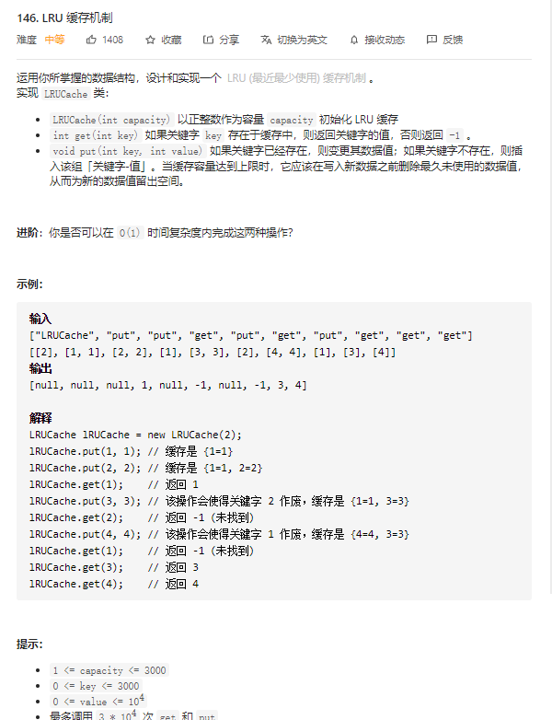

package main

type LinkNode struct {
key, val int
pre, next *LinkNode
}

type LRUCache struct {
m map[int]*LinkNode
cap int
head, tail *LinkNode
}

func Constructor(capacity int) LRUCache {
head := &LinkNode{0, 0, nil, nil}
tail := &LinkNode{0, 0, nil, nil}
head.next = tail
tail.pre = head
return LRUCache{make(map[int]*LinkNode), capacity, head, tail}
}

func (this *LRUCache) Get(key int) int {
cache := this.m
if v, exist := cache[key]; exist {
this.MoveToHead(v)
return v.val
} else {
return -1
}
}

func (this *LRUCache) RemoveNode(node *LinkNode) {
node.pre.next = node.next
node.next.pre = node.pre
}

func (this *LRUCache) AddNode(node *LinkNode) {
head := this.head
node.next = head.next
head.next.pre = node
node.pre = head
head.next = node
}

func (this *LRUCache) MoveToHead(node *LinkNode) {
this.RemoveNode(node)
this.AddNode(node)
}

func (this *LRUCache) Put(key int, value int) {
tail := this.tail
cache := this.m
if v, exist := cache[key]; exist {
v.val = value
this.MoveToHead(v)
} else {
v := &LinkNode{key, value, nil, nil}
if len(cache) == this.cap {
delete(cache, tail.pre.key)
this.RemoveNode(tail.pre)
}
this.AddNode(v)
cache[key] = v
}
}

206.反转链表
//思路：用一个 prev 节点保存向前指针，temp 保存向后的临时指针
package main
func reverseList(head *ListNode) *ListNode {
var prev *ListNode
for head != nil {
// 保存当前head.Next节点，防止重新赋值后被覆盖
// 一轮之后状态：nil<-1 2->3->4
// prev head
temp := head.Next
head.Next = prev
// pre 移动
prev = head
// head 移动
head = temp
}
return prev
}

//写法二,递归
func reverseList2(head *ListNode) *ListNode {
if head ==nil{
return head
}
if head.Next == nil{
return head
}
last:=reverseList(head.Next)
head.Next.Next = head
head.Next = nil
return last
}

21. 合并两个有序链表

//思路1
func mergeTwoLists(l1 *ListNode, l2 *ListNode) *ListNode {
node := &ListNode{}
result := node
for (l1!=nil) && (l2 !=nil){
if (l1.Val > l2.Val){
node.Next = l2
l2 = l2.Next
}else{
node.Next = l1
l1 = l1.Next
}
node = node.Next
}
if l1!=nil{
node.Next = l1
}
if l2!=nil{
node.Next = l2
}
return result.Next
}
//思路2 递归
func mergeTwoLists(l1 *ListNode, l2 *ListNode) *ListNode {
if l1 == nil {
return l2
}
if l2 == nil {
return l1
}
// 定义一个结果节点
var res *ListNode
// 当l1节点的值大于l2节点的值，那么res指向l2的节点，从l2开始遍历，反之从l1开始
if l1.Val >= l2.Val {
res = l2
res.Next = mergeTwoLists(l1, l2.Next)
} else {
res = l1
res.Next = mergeTwoLists(l1.Next, l2)
}
return res
}

