Preparation:

1. Create openstack user, use passw0rd as password:

sudo adduser openstack

2. Add user openstack to sudo group:

sudo usermod -aG sudo openstack

3. Configure user openstack to be able run sudo command without being asked for password:

echo "openstack ALL=(ALL) NOPASSWD:ALL" | sudo tee /etc/sudoers.d/openstack

4. Configure sshd service to accept connection with password authentication:

sudo vi /etc/ssh/sshd_config

Search PasswordAuthentication variable and set its value to yes:

PasswordAuthentication yes

Restart sshd service:

sudo systemctl restart sshd

5. Disable cloud-init:

sudo touch /etc/cloud/cloud-init.disabled

Reference:

https://gist.github.com/zoilomora/f862f76335f5f53644a1b8e55fe98320

6. Modify /etc/hosts file:

sudo vi /etc/hosts

Add following lines:

10.5.20.11 mgmt-control01
10.5.20.12 mgmt-control02
10.5.20.13 mgmt-control03
10.5.20.14 mgmt-compute01
10.5.20.15 mgmt-compute02
10.5.20.16 mgmt-compute03

10.5.21.11 public-control01
10.5.21.12 public-control02
10.5.21.13 public-control03
10.5.21.14 public-compute01
10.5.21.15 public-compute02
10.5.21.16 public-compute03

10.5.22.11 control01
10.5.22.12 control02
10.5.22.13 control03
10.5.22.14 compute01
10.5.22.15 compute02
10.5.22.16 compute03

10.5.23.11 ceph-control01
10.5.23.12 ceph-control02
10.5.23.13 ceph-control03
10.5.23.14 ceph-compute01
10.5.23.15 ceph-compute02
10.5.23.16 ceph-compute03

7. Update system:

sudo apt update && sudo apt upgrade -y

8. Disable auto-update:

sudo vi /etc/apt/apt.conf.d/20auto-upgrades

Change the content FROM:

APT::Periodic::Update-Package-Lists "1";
APT::Periodic::Unattended-Upgrade "1";

TO:

APT::Periodic::Update-Package-Lists "0";
APT::Periodic::Download-Upgradeable-Packages "0";
APT::Periodic::AutocleanInterval "0";
APT::Periodic::Unattended-Upgrade "1";

Reference:

https://linuxconfig.org/disable-automatic-updates-on-ubuntu-20-04-focal-fossa-linux

9. Reboot

sudo reboot

10. Complete step 1-9 for sXr01svr1, sXr01svr2, sXr01svr3, dan sXr01svr4 - where X is site number

11. Login with openstack user

Reconfigure network:

sudo cp /etc/netplan/50-cloud-init.yaml /etc/netplan/50-cloud-init.yaml.backup-20221124
sudo vi /etc/netplan/50-cloud-init.yaml

Sesuaikan:

12. Do PING test

ping -c 3 mgmt-control01
ping -c 3 mgmt-control02
ping -c 3 mgmt-control03
ping -c 3 mgmt-compute01
ping -c 3 mgmt-compute02
ping -c 3 mgmt-compute03

ping -c 3 public-control01
ping -c 3 public-control02
ping -c 3 public-control03
ping -c 3 public-compute01
ping -c 3 public-compute02
ping -c 3 public-compute03

ping -c 3 control01
ping -c 3 control02
ping -c 3 control03
ping -c 3 compute01
ping -c 3 compute02
ping -c 3 compute03

ping -c 3 ceph-control01
ping -c 3 ceph-control02
ping -c 3 ceph-control03
ping -c 3 ceph-compute01
ping -c 3 ceph-compute02
ping -c 3 ceph-compute03

Continue to next step if all PING test return reply, otherwise check network configuration

Install ssmtp

We'll use this for docker container status monitoring

sudo apt update

sudo apt install ssmtp -y

sudo vi /etc/ssmtp/ssmtp.conf

root=pansolusi@gmail.com
mailhub=smtp.gmail.com:587
FromLineOverride=YES
AuthUser=pansolusi@gmail.com
AuthPass=wgjxbpkiowuwngvg
UseSTARTTLS=YES
UseTLS=YES

echo "Greetings from server $(hostname)" | ssmtp dhariady@pansolusi.com

13. Generate ssh keys:

ssh-keygen -t rsa -b 4096

13. Copy public key to other servers

# for site-1:

ssh-copy-id -i /home/openstack/.ssh/id_rsa.pub openstack@gict-01
ssh-copy-id -i /home/openstack/.ssh/id_rsa.pub openstack@gict-02
ssh-copy-id -i /home/openstack/.ssh/id_rsa.pub openstack@gict-03
ssh-copy-id -i /home/openstack/.ssh/id_rsa.pub openstack@gict-04
ssh-copy-id -i /home/openstack/.ssh/id_rsa.pub openstack@gict-05
ssh-copy-id -i /home/openstack/.ssh/id_rsa.pub openstack@gict-06

# for site-2:

ssh-copy-id -i /home/openstack/.ssh/id_rsa.pub openstack@s2r01svr1
ssh-copy-id -i /home/openstack/.ssh/id_rsa.pub openstack@s2r01svr2
ssh-copy-id -i /home/openstack/.ssh/id_rsa.pub openstack@s2r01svr3
ssh-copy-id -i /home/openstack/.ssh/id_rsa.pub openstack@s2r01svr4

# for site-3:

ssh-copy-id -i /home/openstack/.ssh/id_rsa.pub openstack@s3r01svr1
ssh-copy-id -i /home/openstack/.ssh/id_rsa.pub openstack@s3r01svr2
ssh-copy-id -i /home/openstack/.ssh/id_rsa.pub openstack@s3r01svr3
ssh-copy-id -i /home/openstack/.ssh/id_rsa.pub openstack@s3r01svr4

14. Test ssh connection

The test command will return hostname of target server promptly WITHOUT asking for password

15. Complete step 11-14 for sXr01svr1, sXr01svr2, sXr01svr3, dan sXr01svr4 - where X is site number

Install Mellanox OFED driver!

CEPH Installation

1. Install chrony on all nodes

sudo apt install chrony -y

sudo vi /etc/chrony/chrony.conf

pool 10.0.0.21 iburst

sudo systemctl restart chronyd

chronyc sources -v

chronyc sourcestats -v

chronyc tracking

2. Install docker on all nodes

Add repository:
sudo apt install apt-transport-https ca-certificates curl software-properties-common
curl -fsSL https://download.docker.com/linux/ubuntu/gpg | sudo apt-key add -
sudo add-apt-repository "deb [arch=amd64] https://download.docker.com/linux/ubuntu focal stable"

Check repository:
apt-cache policy docker-ce

Install docker
sudo apt install docker-ce -y

Check docker:
sudo systemctl status docker

Add openstack as docker user:
sudo usermod -aG docker ${USER}

Logout, login, check:
groups

Alternative: Podman

Add repository:

echo "deb https://download.opensuse.org/repositories/devel:/kubic:/libcontainers:/stable/xUbuntu_20.04/ /" | sudo tee /etc/apt/sources.list.d/devel:kubic:libcontainers:stable.list

Add gpg key:

curl -L "https://download.opensuse.org/repositories/devel:/kubic:/libcontainers:/stable/xUbuntu_20.04/Release.key" | sudo apt-key add -

Install podman:

sudo apt update

sudo apt install podman

Check version:

podman -v

3. Permit root login

On all ceph related nodes

Edit /etc/ssh/sshdd_config:
sudo vi /etc/ssh/sshd_config

Add:
# 10.5.20.11 is the address of ceph admin node (control-1)
Match Address 10.5.20.11
PermitRootLogin yes

Restart sshd service:
sudo systemctl reload sshd

4. Install cephadm on control-1 node

Login to control-1 node

Create directory:
mkdir -p /home/openstack/projects/ceph

Enter directory and download cephadm:
cd /home/openstack/projects/ceph
curl --silent --remote-name --location https://github.com/ceph/ceph/raw/quincy/src/cephadm/cephadm

Make cephadm executable:
chmod +x cephadm

Configure repository to pacific:
sudo ./cephadm add-repo --release quincy

Install required packages:
sudo ./cephadm install ceph-common

5. Bootstrap first monitor daemon

On control-1 node (network 10.5.22.0/24), set cluster network in 10.5.23.0/24
sudo ./cephadm bootstrap --mon-ip 10.5.22.11 --cluster-network 10.5.23.0/24 --skip-monitoring-stack

Take notes on:
URL: https://control01:8443/
User: admin
Password: 62klp6kd9y

Also:
You can access the Ceph CLI as following in case of multi-cluster or non-default config:

sudo ./cephadm shell --fsid abda9d30-b19c-11ed-8380-390ca81a4f31 -c /etc/ceph/ceph.conf -k /etc/ceph/ceph.client.admin.keyring

Enable telemetry:
sudo ceph telemetry on --license sharing-1-0
sudo ceph telemetry enable channel perf

Check:
sudo ceph orch host ls

Will list control01 as the only host for now

6. Copy ceph public key to control02 and control03

Get content of /etc/ceph/ceph.pub
cat /etc/ceph/ceph.pub

Copy it

Login to control02

Open /root/.ssh/authorized_keys:
sudo vi /root/.ssh/authorized_keys

Go to end of file and paste copied content of /etc/ceph/ceph.pub

Repeat for control03

7. Open you browser and enter following URL: https://10.5.22.11:8443/, use user and password given on step 5 above

8. Change password for user admin, take note for new passwordf

9. Click on Expand Cluster when asked

10. Add more host control02 and control03. Click Add button, enter hostname and network address. Add mon, mgr, and osd as label. Click Add Host button when done.

11. Click Next button to continue

12. Select Cost/Capacity-optimized for OSD then click Next

13. Click Next for Create Services

14. Click Expand Cluster

15. Customize mon and mgr service: Click on Cluster-Services

mon:
Select mon then click Edit button

Modify like following:
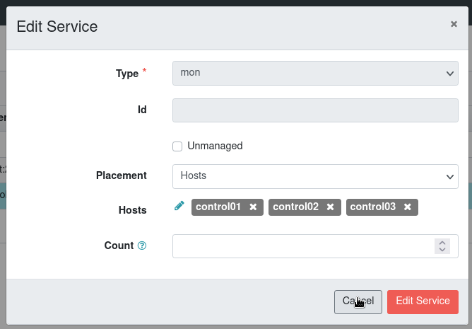

Click Edit Service button

mgr:
Select mgr then click Edit button

Modify like following:
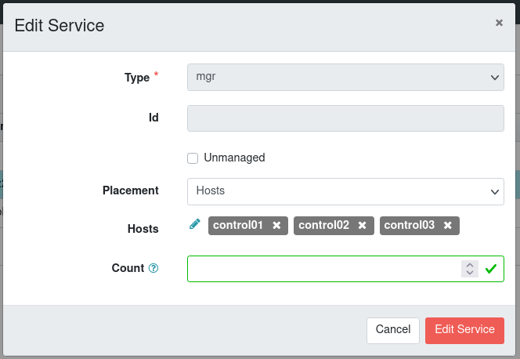

Click Edit Service button

16. Add OSDs: Click on Cluster-OSDs

Click Create button

Select Cost/Capacity-optimized for OSD

Click Create OSDs button

Wait until all OSDs are up

17. Configure monitoring service: Click on Cluster-Services

Prometheus: Click Create button

Configure like following::
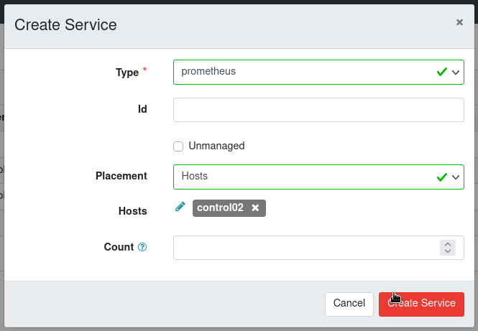

Click Create Service button

You may need to reload the page

AlertManager: Click create button

Configure like following:
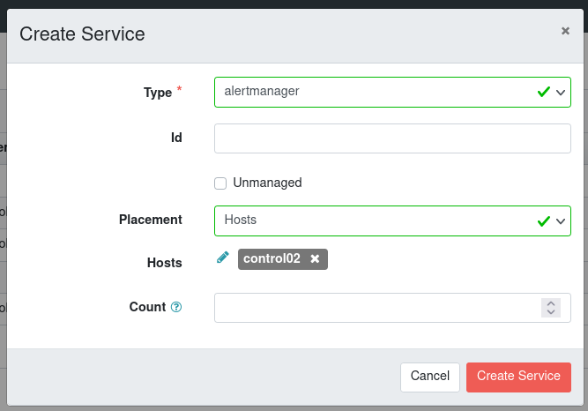

Click Create Service button

NodeExporter: Click Create button

Configure like following:
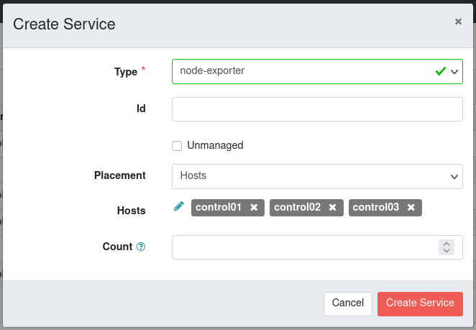

Open CLI on control01

sudo ceph dashboard set-prometheus-api-ssl-verify False

sudo ceph dashboard set-alertmanager-api-ssl-verify False

18. Create pools

Click Pools

Pools to be created are:
volumes, images, vms, backups

Pool volumes:
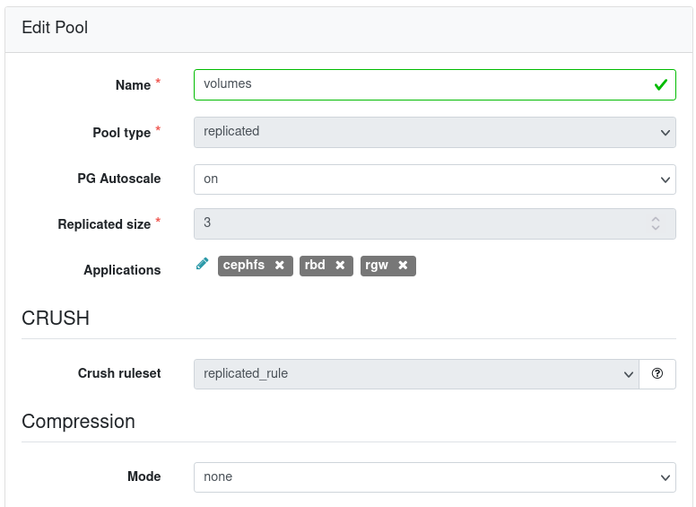

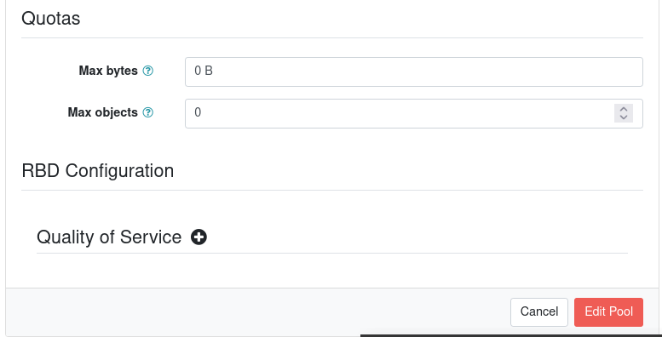

Click Edit Pool button when done

Also create pool images, vms, and backups with same configuration

19. Checks

sudo ceph status
sudo ceph osd tree
sudo ceph osd df

10. Create and initialize pools

sudo ceph osd pool create volumes
sudo ceph osd pool create images
sudo ceph osd pool create vms
sudo ceph osd pool create backups

sudo rbd pool init volumes
sudo rbd pool init images
sudo rbd pool init vms
sudo rbd pool init backups

Note:
For PG calculation check:
https://old.ceph.com/pgcalc/

11. Configure client authorization

sudo ceph auth get-or-create client.glance \
mon 'profile rbd' \
osd 'profile rbd pool=images' \
mgr 'profile rbd pool=images' \
-o /etc/ceph/ceph.client.glance.keyring

sudo ceph auth get-or-create client.cinder \
mon 'profile rbd' \
osd 'profile rbd pool=volumes, profile rbd pool=vms, profile rbd-read-only pool=images' \
mgr 'profile rbd pool=volumes, profile rbd pool=vms' \
-o /etc/ceph/ceph.client.cinder.keyring

sudo ceph auth get-or-create client.nova \
mon 'profile rbd' \
osd 'profile rbd pool=vms, profile rbd pool=images' \
-o /etc/ceph/ceph.client.nova.keyring

sudo ceph auth get-or-create client.cinder-backup \
mon 'profile rbd' \
osd 'profile rbd pool=backups' \
-o /etc/ceph/ceph.client.cinder-backup.keyring

Modify ceph.conf:
sudo cp /etc/ceph/ceph.conf /etc/ceph/ceph.conf.kolla
sudo vi /etc/ceph/ceph.conf.kolla

Edit to match the following:
[global]
public network = 10.5.22.0/24
cluster network = 10.5.23.0/24
fsid = 79992746-ac25-11ed-90ef-d9f05cf81c13
mon_host = [v2:10.5.22.11:3300/0,v1:10.5.22.11:6789/0] [v2:10.5.22.12:3300/0,v1:10.5.22.12:6789/0] [v2:10.5.22.13:3300/0,v1:10.5.22.13:6789/0]
mon initial members = control01,control02,control03
osd pool default crush rule = -1

[osd]
osd memory target = 94363084390

For manual customization:

Check directory:
/var/lib/ceph/<fsid>

Reset ceph warning:

To display a list of messages:

sudo ceph crash ls

If you want to read the message:

sudo ceph crash info <id>

then:

sudo ceph crash archive <id>

or:

sudo ceph crash archive-all

INSTALL OPENSTACK

1. Update repository and install required softwares

sudo apt update
sudo apt install python3-dev libffi-dev gcc libssl-dev -y
sudo apt install python3-venv -y

2. Create virtual environment

python3 -m venv ~/venv/openstack

3. Activate virtual environment - REQUIRED TO DO THIS EACH TIME YOU WANT TO MAKE CHANGES OR ACCESS OPENSTACK

source ~/venv/openstack/bin/activate

4. Install and update required softwares

pip install -U pip
pip install wheel
pip install 'ansible>=4,<6'

# for xena:
pip install 'ansible<5.0'

5. Install kolla-ansible for openstack yoga

pip install git+https://opendev.org/openstack/kolla-ansible@stable/yoga

# for xena:
pip install git+https://opendev.org/openstack/kolla-ansible@stable/xena

6. Configure kolla-ansible

sudo mkdir -p /etc/kolla
sudo chown $USER:$USER /etc/kolla
cp -r ~/venv/openstack/share/kolla-ansible/etc_examples/kolla/* /etc/kolla
mkdir -p ~/projects/openstack
cp ~/venv/openstack/share/kolla-ansible/ansible/inventory/* \
~/projects/openstack

7. Install dependencies for kolla-ansible

# for yoga only!
kolla-ansible install-deps

8. Configure ansible

sudo vi /etc/ansible/ansible.cfg

Add or modify following lines

[defaults]
host_key_checking=False
pipelining=True
forks=100

9. Configure openstack nodes

cd ~/projects/openstack
vi ./multinode

Add or modify following lines

[control]
control-1
control-2
control-3

[network]
control-1
control-2
control-3

[compute]
compute-1
compute-2
compute-3

[monitoring]
control-1

[storage]
control-1
control-2
control-3

10. Check accessibility to all nodes

ansible -i multinode all -m ping

Check previous step if there are any failures

11. Generate password for openstack modules

kolla-genpwd

12. Configure openstack installation

vi /etc/kolla/globals.yml

Add or modify following lines

# kolla options

config_strategy: "COPY_ALWAYS"
kolla_base_distro: "ubuntu"
kolla_install_type: "source"
openstack_release: "yoga"

# Custom docker registry settings:
docker_registry: "docker.io"
docker_registry_username: "dhariady"
# docker_registry_password is set in the passwords.yml file.
docker_namespace: "kolla"

# neutron

network_interface: "eth0"
neutron_external_interface: "bond0"
neutron_plugin_agent: "ovn"

# openstack options

enable_openstack_core: "yes"
enable_hacluster: "yes"
enable_cinder: "yes"
enable_cinder_backup: "yes"
enable_fluentd: "no"
# enable_grafana: "yes" # ceph also install this!
enable_masakari: "yes"
enable_neutron_provider_networks: "yes"
enable_prometheus: "yes"

# ceph

ceph_glance_keyring: "ceph.client.glance.keyring"
ceph_cinder_keyring: "ceph.client.cinder.keyring"
ceph_cinder_backup_keyring: "ceph.client.cinder-backup.keyring"

# glance

glance_backend_ceph: "yes"

# cinder

cinder_backend_ceph: "yes"

# nova

nova_backend_ceph: "yes"
nova_compute_virt_type: "kvm"
nova_console: "novnc"

# neutron

neutron_ovn_distributed_fip: "yes"
neutron_ovn_dhcp_agent: "yes"

#enable_prometheus_openstack_exporter: "yes" # follow enable_prometheus

libvirt_enable_sasl: "no"

#openstack_cacert: "/etc/ssl/certs/ca-certificates.crt"

# to enable network trunking:
enable_neutron_trunk: "yes"
# ref:
# https://docs.openstack.org/kolla-ansible/yoga/reference/networking/neutron-extensions.html

# to enable zun:
enable_zun: "yes"
enable_kuryr: "yes"
enable_etcd: "yes"
docker_configure_for_zun: "yes"
containerd_configure_for_zun: "yes"
# ref:
# https://docs.openstack.org/kolla-ansible/yoga/reference/compute/zun-guide.html

# for site-1

kolla_internal_vip_address: "10.5.20.254"
kolla_external_vip_address: "10.5.21.254"
keepalived_virtual_router_id: "20"
openstack_region_name: "RegionOne"

# for site-2

kolla_internal_vip_address: "10.5.30.254"
kolla_external_vip_address: "10.5.31.254"
keepalived_virtual_router_id: "30"
openstack_region_name: "RegionTwo"

# for site-3

kolla_internal_vip_address: "10.5.40.254"
kolla_external_vip_address: "10.5.41.254"
keepalived_virtual_router_id: "40"
openstack_region_name: "RegionThree"

mkdir -p /etc/kolla/config/neutron

vi /etc/kolla/config/neutron/ml2_conf.ini

[ml2_type_vlan]
network_vlan_ranges="physnet1:500:1000"

[ml2_type_flat]
flat_networks="physnet1"

[ml2]
path_mtu=9000

Configure nova scheduler maximum attempst

mkdir -p /etc/kolla/config/nova

vi /etc/kolla/config/nova/nova-scheduler.conf

[DEFAULT]
scheduler_max_attempts=100

Configure CPU and RAM allocation (overcommit)

Change <myhost> with compute node hostname

mkdir -p /etc/kolla/config/nova/<myhost>/

vi /etc/kolla/config/nova/<myhost>/nova.conf

[DEFAULT]
cpu_allocation_ratio = 6.0
ram_allocation_ratio = 1.5

#kolla-ansible -i multinode certificates

Configure ceph for openstack

Create required directory

mkdir /etc/kolla/config/nova
mkdir /etc/kolla/config/glance
mkdir -p /etc/kolla/config/cinder/cinder-volume
mkdir /etc/kolla/config/cinder/cinder-backup

Copy ceph configuration and keyring

cp etc/ceph/ceph.conf.kolla /etc/kolla/config/cinder/ceph.conf
cp etc/ceph/ceph.conf.kolla /etc/kolla/config/nova/ceph.conf
cp etc/ceph/ceph.conf.kolla /etc/kolla/config/glance/ceph.conf
cp etc/ceph/ceph.client.glance.keyring /etc/kolla/config/glance/
cp etc/ceph/ceph.client.nova.keyring /etc/kolla/config/nova/
cp etc/ceph/ceph.client.cinder.keyring /etc/kolla/config/nova/
cp etc/ceph/ceph.client.cinder.keyring /etc/kolla/config/cinder/cinder-volume/
cp etc/ceph/ceph.client.cinder.keyring /etc/kolla/config/cinder/cinder-backup/
cp etc/ceph/ceph.client.cinder-backup.keyring /etc/kolla/config/cinder/cinder-backup/

Bootstrap servers

kolla-ansible -i ./multinode bootstrap-servers

Precheck

kolla-ansible -i ./multinode prechecks

Deploy

kolla-ansible -i ./multinode deploy

Post deploy

kolla-ansible ./multinode post-deploy

Install openstack client

pip install python-openstackclient -c https://releases.openstack.org/constraints/upper/yoga

Enable bash-completion

openstack complete | sudo tee /etc/bash_completion.d/osc.bash_completion > /dev/null

openstack flavor create --id 1000 --ram 512 --disk 1 --vcpu 1 --public m1.tiny
openstack flavor create --id 2000 --ram 2048 --disk 20 --vcpu 1 --public m1.small
openstack flavor create --id 3000 --ram 4096 --disk 40 --vcpu 2 --public m1.medium
openstack flavor create --id 4000 --ram 8192 --disk 80 --vcpu 4 --public m1.large
openstack flavor create --id 5000 --ram 16384 --disk 160 --vcpu 8 --public m1.xlarge

Check openstack installation

source /etc/kolla/admin

RECONFIGURE CEPH-ANSIBLE

Reference:
https://github.com/ceph/ceph-ansible/issues/5333
https://github.com/ceph/ceph-ansible/issues/5159

Purge dashboard:

ansible-playbook ./infrastructure-playbooks/purge-dashboard.yml

Reconfigure:

ansible-playbook ./site.yml -e container_package_name=docker-ce -e container_service_name=podman

In case OSDs still exist

Check:

lsblk

Get LV path:

sudo lvdisplay

Remove LV:

sudo lvremove <lv_path>

