**de_Plateau**

Crazy experiments at the Black Mesa research facility have long been rumored. A recent security leak has confirmed the rumors. A band of terrorist soldiers plan to assault the facility and destroy it in order to prevent future experiments. A counter terrorist force has been assembled from the research facility’s security team. They plan to defend the facility and defuse any bomb that gets planted.

The terrorists have landed at the southern helipad with two targets in mind, the visitor check-in center and research chamber 37-A. The CT’s will have to defend and prevent the Ts from pushing through the courtyard which grants access to the visitor check-in center and the loading dock which grants access to the research chamber.

* **Medium sized map**
* **Mix of short, med, and long distance fighting**
* **30% exterior, 70% interior**

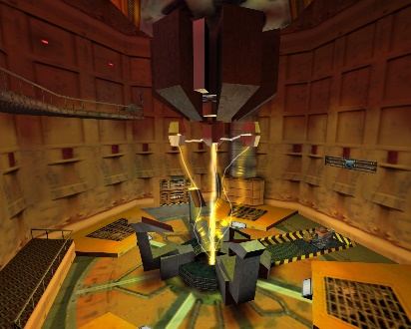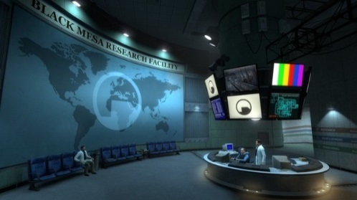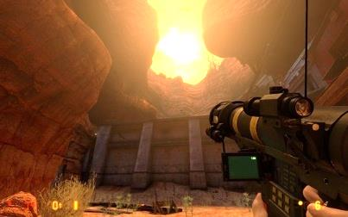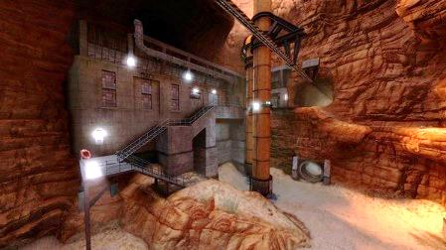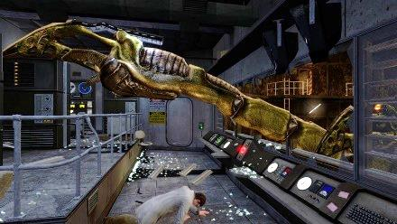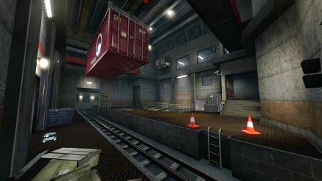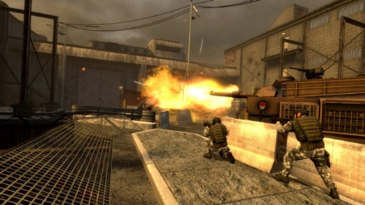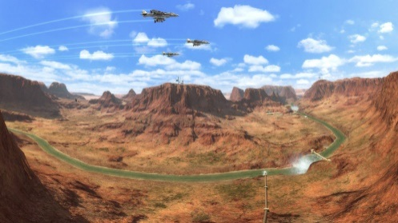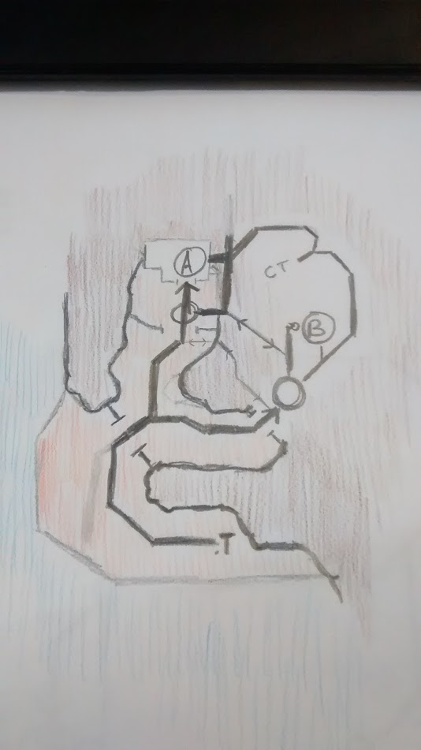<http://cdn.akamai.steamstatic.com/steam/apps/36>

Bombsite B – research chamber

CT spawn  
security room

Bombsite A – security check in

observatory

Chokepoint B – loading dock

T spawn  
helipad vista outlook

3D skybox model / Vista