T-slot structural framing is a [framing system](https://en.wikipedia.org/wiki/Framing_(construction)) consisting of lengths of square or rectangular [extruded](https://en.wikipedia.org/wiki/Extrusion) aluminium, typically [6105-T5 aluminium alloy](https://en.wikipedia.org/wiki/6105_aluminium_alloy), with a T-slot down the centre line of one or more sides. It is also known as 80/20 framing, after the company 80/20, Inc., one of the prominent T-slot framing brands, the name of which is based on the [80/20 or "Pareto" principle](https://en.wikipedia.org/wiki/80/20_principle). While there is no published standard defining this framing system, manufacturers have settled into two categories of product comprising several series each that is generally inter-compatible across manufacturers.

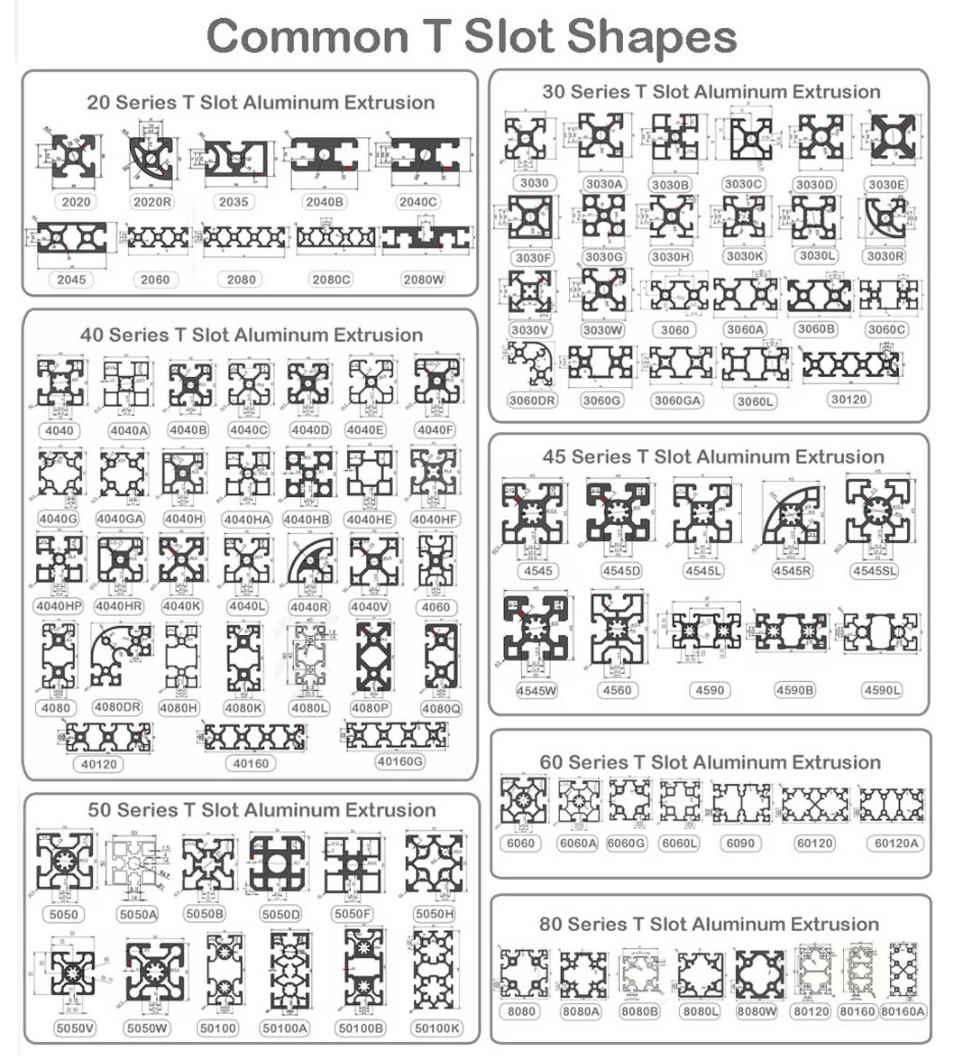

Accessories :

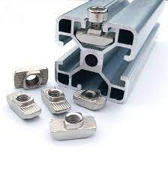

T-Slot Nuts

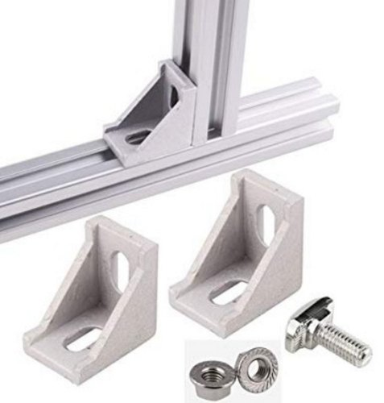

900 Angle bracket

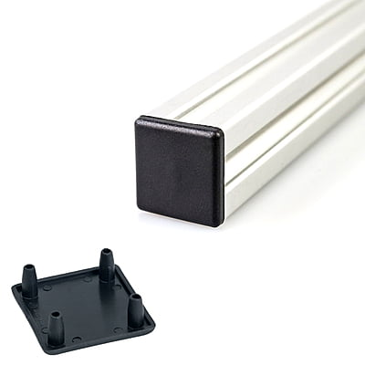

End Cap

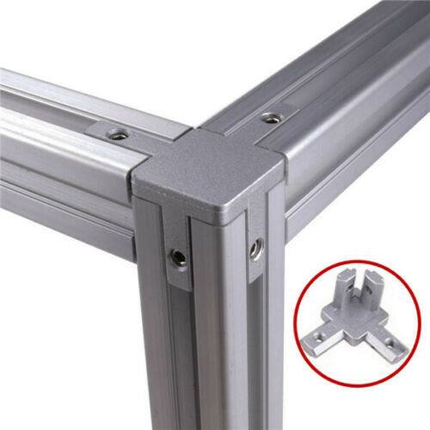

Inner Corner Bracket Connector

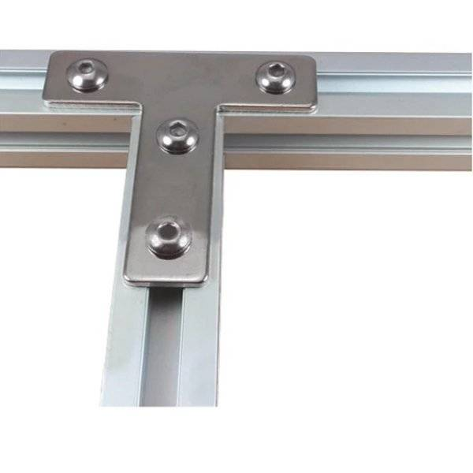

T-Type Connector