Source : <https://www.moonskyedu.com/furniture/水喉潔具/03來水喉.htm>

Grey PVC water pipe (Pressure Pipe)

Grey pipe with thick wall thickness can withstand exceptional water pressure, and the price is more expensive then the white pipe in a justifiable way.

Grey PVC pipe will become soft when heated, and it can be bent according to different layout. Since it is not resistant to sunlight and become brittle when exposed to sunlight for a long time.

PRESSURE CLASS

A range of pressure “classes” is available in each size. These classes are based on the pipe’s recommended maximum working pressure in bar. For example, a class PNT 14 pipe has a recommended maximum working pressure of 14 bar, or 14 meters head at a temperature of 300C.

A special glue is required to connect PVC pipe, which is usually available at the hardware store. Blue top brush type are slow-drying whilst red top brush type are quick-drying (rarely used). The surface to be connected must be clean and dry. When using, apply the glue evenly to the two parts to be connected and join them immediately. It takes 15 mins to touch dry, two hours to attend certain mechanical strength and can be used with running water in 24 hours.

 The connection skills are as follows: Clean the glue throat, if necessary, use emery cloth to remove stains. When applying glue, apply the accessories first, because it is applied to the inner wall, you can lower it after painting, and it will not stick to sand. Shake the glue before opening the cover. Evenly, brush the brush in circular motions in the fittings, until the end of the fittings is applied, put down the fittings and then coat the tube body. Put the water tube into the fitting, turn it lightly for half a turn, press it all the way, and let it go after a short time (15 seconds), if it pops out, you must press it in again.

Dimensions are gauged by inner diameters.

Note : Gauge ½” will be used for the entrie project unless stay otherwise.

|  |  |  |  |  |
| --- | --- | --- | --- | --- |
| Gaure(inch) | Outer(mm) | Inner(mm) | Thickness(mm) | Total Length(m) |
| ½” | 22 | 16 | 2.7 | 4 |
| ¾” | 26 | 20 | 2.7 | 4 |
| 1” | 34 | 27 | 3.1 | 4 |
| 1-1/4” | 42 | 35 | 3.1 | 4 |
| 1-1/2” | 48 | 40 | 3.6 | 4 |
| 2” | 60 | 50 | 4.1 | 4 |
| 2-1/2” | 76 | 65 | 4.1 | 4 |
| 3” | 89 | 80 | 5.1 | 4 |
| 4” | 114 | 100 | 6.6 | 4 |
| 5” | 140 | 125 | 6.7 | 6 |
| 6” | 165 | 150 | 8.5 | 6 |
| 8” | 216 | 200 | 10.5 | 6 |

Pipe fittings / accessories

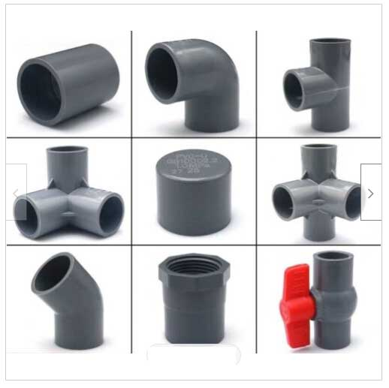

In our project we only need Equal Tee (T-joint/三叉), Equal Elbow (900 joint/90度曲) and end cap(喉冚), however, Equal socket(梳杰) and 450 joint (45度曲) may also be used depending on frame design.

Exercise :

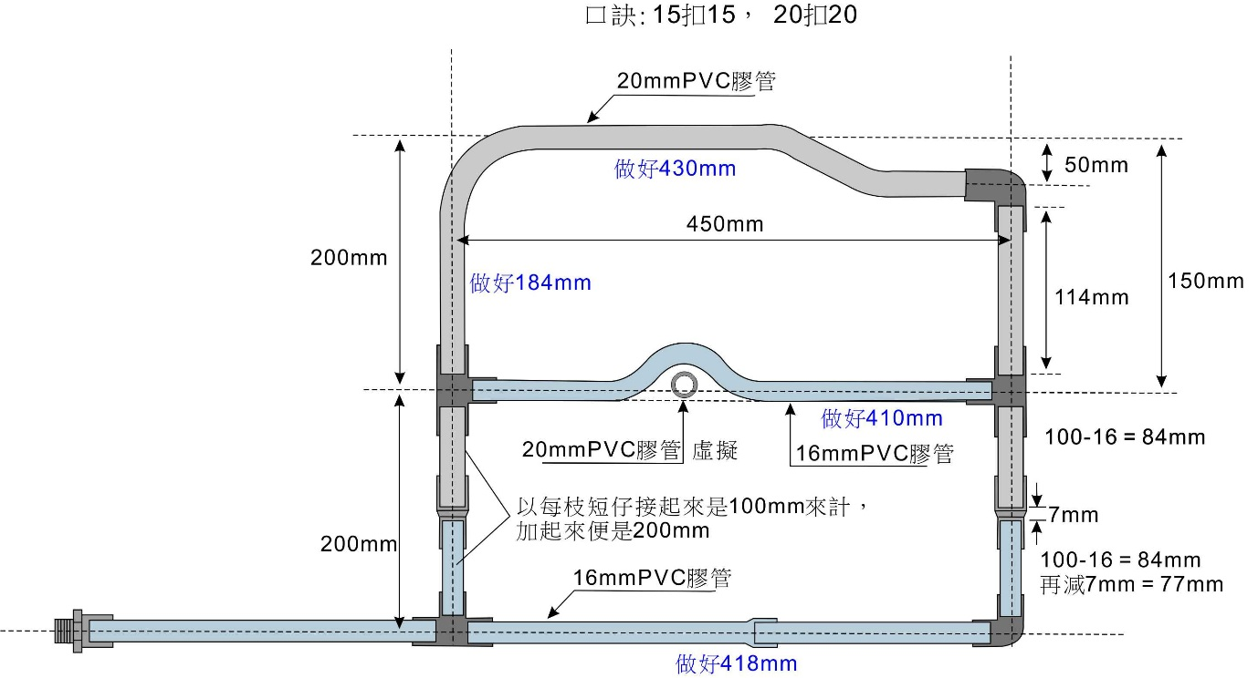

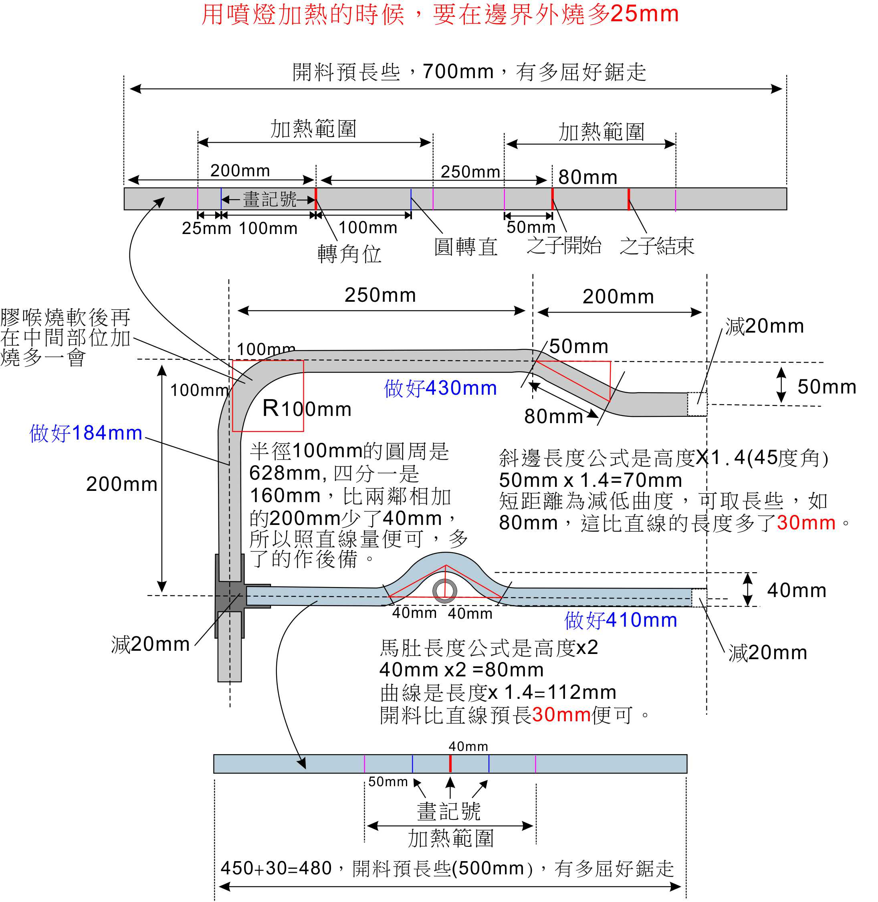

Pipe leak testing by hand pressure leak tester:

