**THUA THIEN HUE CENTER OF INFORMATION TECHNOLOGY**

**HUE-APTECH COMPUTER EDUCATION CENTER**

Logo_huecit

## aptech_ww_lon

**PROJECT**

**COURSE CPISM – ACCP i10**

**Project name:**

**Alluring Decors Website**

**Faculty:** VoThanh Son **Group** : Unknown

**Class** : CP201605L **Members** :1. Le Hai Nam

2. Nguyen Thai Bao



**Hue, [4/2017]**

**CERTIFICATE**

This is to certify that

Group:

Members:

Mr: Le Hai Nam

Mr: Nguyen Thai Bao

Has successfully designed, developed Airline Reservation System

Submitted by: VoThanh Son

Date: ………………………

Signed by: …………………

## Table of contents

[**1. DEFINITION OF THE PROBLEM 4**](#_Toc447548555)

[**2. CUSTOMER REQUIREMENT SPECIFICATION 10**](#_Toc447548556)

[**3. PROJECT PLAN 13**](#_Toc447548557)

[**4. USECASE DIAGRAM 15**](#_Toc447548558)

[**5. FLOWCHART DIAGRAM 16**](#_Toc447548559)

[**6. DATA FLOW DIAGRAM 19**](#_Toc447548560)

[**7. ENTITY RELATIONSHIP DIAGRAM 21**](#_Toc447548561)

[**8. TABLE DESGIN 22**](#_Toc447548562)

[**9. PROGRAMDESIGN 29**](#_Toc447548563)

[**10. GUI DESIGN 35**](#_Toc447548564)

[**11. TASK SHEETS 45**](#_Toc447548565)

[**12. FINAL CHECKLIST 47**](#_Toc447548566)

**A**[**PPENDIX – Install guide 48**](#_Toc447548567)

[**COMMENTS OF FACULTY 53**](#_Toc447548568)

## DEFINITION OF THE PROBLEM

* 1. **Problem**

“Alluring Decors” is one of the upcoming Interior and Exterior Designers in the territory. They had been in to this profession since 5 years down the line. They deal with the Interior and Exterior Decoration of the houses, offices, shops, malls, etc. based on the contract that they had received from their clients.

Alluring Decors, in general advertise about their work through the news papers, TV advertisements, hoardings, banners, and through the internet (some other advertising websites) for which they should have to incur certain amount for advertising. Also for advertising they cannot go up to a full extent, i.e., there is a limitation in advertising either due to costing or due to the limitations of advertisement.

* 1. **Solutions**

The Alluring Decors website is the solution, in which client can advertise with a full span, with images, bussiness management, etc. Also they introduce new tasks and they can advertise the accomplished tasks.

Some of the features are:

* Module: Guest Module, Administrator Module, Client Module
* Administrator The module in which there will be full rights for the user accessing the site
* Guest The module that is generally available for all the users, where one can only view the details or register with the site or login into the site or leave a feedback.
* Client The module that is available for the users who register with the site. In this module one must be able to view the details, apply for the services offered, and check the status of the applications sent

As the whole project is based on the logical perspective of an ideal broadcast and bussiness website, the physical implementation has no fixed rules, thus implementing the concept little difficult.

* 1. **Function**

The Alluring Decors website is supposed to be able to help client advertise with a full span, data manipulation, service request, payment:

1. Pages: Home Page, About Us, Register and Login, Projects, Services Offered,Domain List, Contact Us, Feedback, FAQ’s , Payment.
2. Guest registration / log in.
3. Administrator can manipulate data, check service request, payment, etc
4. Client can making service request, check account and request status
5. Advertising.
   * 1. **Guest registration / log in:**

|  |  |
| --- | --- |
| **Description** | Provides suitable form for guests and registered users to log in or sign up for the system |
| **Input** | Customer profile (including Name, address, email, phone number, … or login account info if registered |
| **Process** | Inserts new record to User and Account database or signs user in if he has already registered |
| **Output** | New user logged in to the system |

* + 1. **Pages:**

|  |  |
| --- | --- |
| **Description** | Provides suitable view for guests, clients, administrator to manipulate a website |
| **Input** | URL of web pages |
| **Process** | User clicked on suitable link on web page, controller will process and show suitable page |
| **Output** | The suitable page |

* + 1. **Administrator** **manipulation**

|  |  |
| --- | --- |
| **Description** | Allow administrator to modify data in database: Store description, Services offered, Services request, Users, Project, Domains List, Contact Us, Feedback, FAQ’s, Bill Detail, Payment detail |
| **Input** | Values depend on function |
| **Process** | Get value from view, validation, passed value to controller and process |
| **Output** | Result of the process |

* + 1. **Client manipulation**

|  |  |
| --- | --- |
| **Description** | Allow client to create service request, check their account, request status. |
| **Input** | Service request ID, account information |
| **Process** | Get value from cart, controller process service request ID, insert into service request table, Show suitable view for account information and request status |
| **Output** | Result of the process |

* + 1. **Advertising**

|  |  |
| --- | --- |
| **Description** | Administrator can advertise with a full span: Store’s description, services offered, project, about us |
| **Input** | Content of description, services offered , project and about us |
| **Process** | Get suitable data from view, in controller depend on what process, it will insert, update, delete in database |
| **Output** | Advertise content |

1. **CUSTOMER REQUIREMENT SPECIFICATION**

They want us to implement the following functionalities in the site that we develop, i.e., the site that we develop should include the following functionalities.

1. **The site should have the following modules**
   1. Guest Module (The module that is generally available for all the users, where one can only view the details or register with the site or login into the site or leave a feedback).
   2. Administrator Module (The module in which there will be full rights for the user accessing the site).
   3. Client Module (The module that is available for the users who register with the site. In this module one must be able to view the details, apply for the services offered, and check the status of the applications sent, etc.)
2. **The Guest Module, Which is the general module of the website, should include the following functionalities.**
   * 1. For this module, the website must include the following links or menus.
        1. Home Page
3. On this page at the sides of the page the following are to be displayed
   * The brief description about the company
   * The brief descriptions about the services
   * The brief description about the on-going projects
4. At the centre of the page, the detailed explanation stating why one must prefer their (Alluring Decors) services. (Give your own description in this section. Ensure that the description looks attractive and very impressive.)
   * + 1. About Us

It should include the general description or introduction about “Alluring Decors” and the various services that they offer to their clients.

* + - 1. Register or Login

In this section the user must be able to either register with the site (if new user), else the user can login into his/her account. From here itself the administrator must also be able to login into the application.

* + - 1. Projects

In this section there will be three sections say three links. They are as follows. For each section you can display the image of the latest project, accompanied with the link.

1. On-Going Projects

In this section list of all the project that are currently on-going are to be displayed along with the images of each, and a link “more details” accompanied with it, so as to view the detailed descriptions for that project.

1. Up-Coming Projects

In this section list of all the project that are going to be taking place in the near future (i.e., the project for which the contract for the project is received, but then the project is not yet started) are to be displayed along with the images of each, and a link “more details” accompanied with it, so as to view the detailed descriptions for that project.

1. Accomplished Projects

In this section list of all the project that have been completed are to be displayed along with the images of each, and a link “more details” accompanied with it, so as to view the detailed descriptions for that project.

* + - 1. Services Offered

In this section the various domains in which the “Alluring Decors” provide services to their clients are to be displayed. The various domains include:

1. Decorating the House which will include the following Services
   * Decorating and Furnishing with Furniture And Glass
   * Kitchen Design
   * Flooring Layout
   * Lightning Effects
   * Window Coverings
   * Colour Schemes
   * Curtain Designing
   * Architectural design
   * Planting
   * Seating Alignment in the Living Rooms, etc.
2. Decorating the Offices which will include the following Services.
   * Decorating and Furnishing with Furniture and Glass, etc.
   * Flooring Layout
   * Lightning Effects
   * Window Coverings
   * Colour Schemes
   * Curtain Designing
   * Architectural design
   * Planting
   * Seating Alignment, etc.
3. Decoration of the “Community Halls” or “Function Halls” or “Banquet Halls” for Parties or get-togethers or Office meetings or seminars, etc. which will include the following Services.
   * Decorating and Furnishing with Furniture and Glass, etc.
   * Window Coverings
   * Lightning Effects
   * Curtain Designing
   * Architectural design
   * Planting
   * Seating Alignment, etc.
4. Decoration of the Restaurants will include the following Services.
   * Decorating and Furnishing with Furniture And Glass
   * Kitchen Design
   * Flooring Layout
   * Window Coverings
   * Lightning Effects
   * Colour Schemes
   * Curtain Designing
   * Architectural design
   * Planting
   * Seating Alignment, etc.

***Note:***

* + - *The customer can opt for more than one domain for service.*
    - *For the services you can also include the additional ones if you feel that it will enhance the look and feel of the project.*
      1. Contact Us

In this section the contact details like address, phone number, etc. of the company are to be provided, as per the details entered by the admin.

* + - 1. Feedback

In this section the user of the application must be able to give feedbacks about the site or ask the queries if any?

* + - 1. FAQ’s

In this section the user must be able to view the FAQ’s as created by the admin.

1. **In the Administrator Module the following functionalities are to be implemented.**
   * 1. In this module, (i.e., after administer logs into the application) the website must include the following links or menus.
        1. Home Page
     2. On this page at the sides of the page the following are to be displayed
        + The brief description about the company
        + The brief descriptions about the services
        + The brief description about the on-going projects
     3. At the centre of the page, the detailed explanation stating why one must prefer their (Alluring Decors) services. (Give your own description in this section. Ensure that the description looks attractive and very impressive.)
     4. Also the administrator must be able to insert and edit the detailed explanation as per the ii) point in this section.
        1. About Us

It should include the general description or introduction about “Alluring Decors” and the various services that they offer to their clients.

These details must be maintained (edited) by the admin.

* + - 1. Users

In this section the admin must be able to view the list of the users of the application. And from here itself he should be able to maintain (delete) them

* + - 1. Projects

In this section the admin must be able to maintain (insert, update and delete) the projects in three categories (i.e., the three sections - On-Going Projects, Upcoming Projects, and Accomplished Projects). For each project, the image is to be included and the detailed descriptions are to be provided for each.

1. On-Going Projects

The projects that are currently on-going will come under this category.

1. Up-Coming Projects

The projects that are going to be taking place in the near future (i.e., the project for which the contract for the project is received, but then the project is not yet started) will come under this category.

1. Accomplished Projects

The projects that had been completed come under this category.

* + - 1. Domains List

In this the Admin must be able to maintain (insert, update and delete) the various domains that they deal in. In general they are in to the following domains.

1. Decorating the House which will include the following
2. Decorating the Offices which will include the following.
3. Decoration of the “Community Halls” or “Function Halls” or “Banquet Halls” for Parties or get-togethers or Office meetings or seminars, etc. which will include the following.
4. Decoration of the Restaurants will include the following.

***Note:***

* + - *The administrator must also be able to insert new ones.*
      1. Services Offered

In this section the admin must be able to maintain (insert, update and delete) the various services based on the domains (say categories) that the “Alluring Decors” provide to its clients.

The various services include:

* + - 1. Decorating and Furnishing with Furniture And Glass, etc.
      2. Kitchen Design
      3. Flooring Layout
      4. Lightning Effects
      5. Window Coverings
      6. Colour Schemes
      7. Curtain Designing
      8. Architectural design
      9. Planting
      10. Seating Alignment, etc.

***Note:***

* + - *The administrator must also be able to insert new ones.*
    - *And for each Service provide certain models as the samples like for the living room decoration the models can be with bamboos, or with steel, leather models, etc. For lightning effects, the models can be with small bulbs, or with chandeliers, etc.*
      1. Contact Us

In this section the contact details like address, phone number, etc. of the company are to be maintained (insert, update, delete) by the administrator.

***Note:*** *You can provide the address of your own.*

* + - 1. Feedback

In this section the admin must be able to view the details of the feedback or the queries that the user of the application posted.

* + - 1. FAQ’s

In this section the admin must be able to maintain (insert, update, delete) the details of the FAQ’s with the questions and the answers. It should include the following Questions.

1. How to register with the site?
2. How to login into the application?
3. I am not a registered user? Will I be able to apply for the service?

Ans: No, only the registered users will be able to apply for the service.

1. How to apply for the Service?
2. What are the charges of the service?
3. I reside at a location ‘X’, will I be provided with the service?

Ans: First you must apply for the service mentioning the service and the domain interested in, and the address at which you want the service to be provided. Then we will get back to you whether we will provide the service at that location or not.

(OR)

You can provide an answer stating that the service will be provided at so and so locations only.

1. Will I be provided in any other services apart from the services and domains displayed? And if yes, what will be the charges?

Ans: Well it will be dependant on the type of the service and the domain you requested. We will revert back to you once the service request is received by us. The charges will be based on the service and the domain you preferred. This will be communicated well in advance before accepting and going ahead with the service.

1. How will I know that whether you will provide the service or not? If yes, then when will the service provided?

Ans: Once the service request is received, we will get back to you like whether we provide the service or not, and if we provide service we will inform when the service will be started.

1. How long will it take to complete the service?

Ans: Well this will be dependant on the service and domain preferred. Also it will be dependant on the work or building or complex, etc. for which the services are preferred for.

1. How will I know about the total charges for the service preferred?

Ans: At the time of booking for a service itself, you can find the charges for the service provided.

1. On what factors will the charges for the service depend upon?

Ans: The charges will be dependant on the type of the domain, and type of the service, area on which the services are preferred.

***Note:***

*Also you can include the models for the services ordered, in order to make the website look more attractive. Like for the living room decoration the models can be with bamboos, or with steel, leather models, etc. For lightning effects, the models can be with small bulbs, or with chandeliers, etc.*

Note: For Questions, for which the answers are not provided, you must provide the answers as per the project designed by you.

* + - 1. Service Requests:

In this section the administrator must be able to view the list of the service requests and maintain (insert, update, delete) them. Also the admin must be able to create the new service requests too. As well the admin must be able to set the status of the service request with one of the below mentioned status as per the point ‘(XI)’.

* + - 1. The various types of the status for the service requests are to be maintained (insert, update, delete).
    1. Request Received (Default one, as soon as the request is received, this status will be set to the request)
    2. Rejected (if the service cannot be provided, then this option is to be selected as the status for that particular request)
    3. Accepted (if the service can be provided, the same is communicated to the client, and the service is yet to began, as the payment is not received)
    4. Payment Received (if the payment is received for the accepted request the status of the request will be set to this)
    5. Service began (once the service begins this is to be set as the status for the service. The services for which this status is set comes under the )
    6. Service Completed

***Note:*** *No matter which ever is the status, there should be a remark section provided through which the administrator must be able to enter the remarks if any.*

* + - 1. Bill Details

The admin must be able to maintain (insert, update, delete and search) the bills based on the service requests received, and the area of the place for which the service is requested for.

* + - 1. Payment Details

The payment details pertaining to the bill generated is to be maintained. And for this the total billed amount, date paid, due amount, balance amount, total paid amount, are to be maintained. And only after the total payment is received for the service request, after it is accepted, the service will be started at that place.

***Note:***

*The payments will be accepted in the form of cash alone. And the payment is to be done at the office of the “Alluring Decors”*

1. **In the Client Module the following functionalities are to be implemented.**
   * 1. In this module, i.e., after the user logs into the application, the website must include the following links or menus.
        1. Home Page
   1. On this page at the sides of the page the following are to be displayed
      * The brief description about the company
      * The brief descriptions about the services
      * The brief description about the on-going projects
   2. At the centre of the page, the detailed explanation stating why one must prefer their (Alluring Decors) services. (Give your own description in this section. Ensure that the description looks attractive and very impressive.)
      * 1. About Us

It should include the general description or introduction about “Alluring Decors” and the various services that they offer to their clients.

* + - 1. Projects

In this section there will be three sections say three links. They are as follows. For each section you can display the image of the latest project, accompanied with the link.

1. On-Going Projects

In this section list of all the project that are currently on-going are to be displayed along with the images of each, and a link “more details” accompanied with it, so as to view the detailed descriptions for that project.

1. Up-Coming Projects

In this section list of all the project that are going to be taking place in the near future (i.e., the project for which the contract for the project is received, but then the project is not yet started) are to be displayed along with the images of each, and a link “more details” accompanied with it, so as to view the detailed descriptions for that project.

1. Accomplished Projects

In this section list of all the project that have been completed are to be displayed along with the images of each, and a link “more details” accompanied with it, so as to view the detailed descriptions for that project.

* + - 1. Services Offered

In this section the various domains in which the “Alluring Decors” provide services to their clients are to be displayed. The various domains include:

1. Decorating the House which will include the following Services
   * + Decorating and Furnishing with Furniture And Glass
     + Kitchen Design
     + Flooring Layout
     + Lightning Effects
     + Window Coverings
     + Colour Schemes
     + Curtain Designing
     + Architectural design
     + Planting
     + Seating Alignment in the Living Rooms, etc.
2. Decorating the Offices which will include the following Services.
   * + - Decorating and Furnishing with Furniture and Glass, etc.
       - Flooring Layout
       - Lightning Effects
       - Window Coverings
       - Colour Schemes
       - Curtain Designing
       - Architectural design
       - Planting
       - Seating Alignment, etc.
3. Decoration of the “Community Halls” or “Function Halls” or “Banquet Halls” for Parties or get-togethers or Office meetings or seminars, etc. which will include the following Services.
   * + Decorating and Furnishing with Furniture and Glass, etc.
     + Window Coverings
     + Lightning Effects
     + Curtain Designing
     + Architectural design
     + Planting
     + Seating Alignment, etc.
4. Decoration of the Restaurants will include the following Services.
   * + - Decorating and Furnishing with Furniture And Glass
       - Kitchen Design
       - Flooring Layout
       - Window Coverings
       - Lightning Effects
       - Colour Schemes
       - Curtain Designing
       - Architectural design
       - Planting
       - Seating Alignment, etc.

***Note:***

* + - *The customer can opt for more than one domain for service.*
    - *On the detailed descriptions page of the service and domain preferred, there should be an option (probably a button “Request for Service now” or “Add to Cart” (this option will be helpful) for requesting that particular service, so that it will be an ease for*
      1. Request Service / Manage Service Requests

In this section one must be able to perform the following actions

* + 1. One should be able to request for a service by selecting the appropriate domain and the service, and provide the details like the location at which the service is requested, etc.
    2. And one should be able to view the list of the requests that are placed till date, and should be able to view the details of each, along with the status of the request.
    3. Also at the time of viewing the request details, one should be able to update or cancel the request that is once made provided, that the service is not completed.
       1. Contact Us

In this section the contact details like address, phone number, etc. of the company are to be provided, as per the details entered by the admin.

* + - 1. Feedback

In this section the user of the application must be able to give feedbacks about the site or ask the queries if any?

* + - 1. FAQ’s

In this section the user must be able to view the FAQ’s as created by the admin.

## PROJECT PLAN

* 1. **Project details**
* **Name of the project:** The AlluringDecors Website
* **Date of Project Plan**
  + Start day: **15-Apr-2017**
  + Finish day: **19-May-2017**
* **Project Vision/ Objectives**(Define the project vision/objective as stated by the client)
  + Store advertising
  + Service Request, feed back, payment
  1. **Quality plan**
* **Review activities** (review meeting participants, frequency)

|  |  |  |  |
| --- | --- | --- | --- |
| **NUM** | **Time process** | **Work** | **The implementation** |
| 1 | 15/04/2017🡪 25/04/2017 | Problem definition, CRS, Project plan | Team |
| 2 | 26/04/2017🡪 30/04/2017 | DesignDFD database Design Form | Team |
| 3 | 01/05/2017🡪15/05/2017 | Coding | Team |
| 4 | 16/05/2017🡪19/05/2017 | Check some existing problem. | Team |

* **Testing activities**
  + Testing activities have processed after modify, update**.**
  + Thanks comment for the teacher, our friends.
* **Backup and recovery strategies**
  + After each test stage, documents have updated in devices: USD, laptop, PC in the center to avoid data loss by the objective circumstances.

## USECASE DIAGRAM

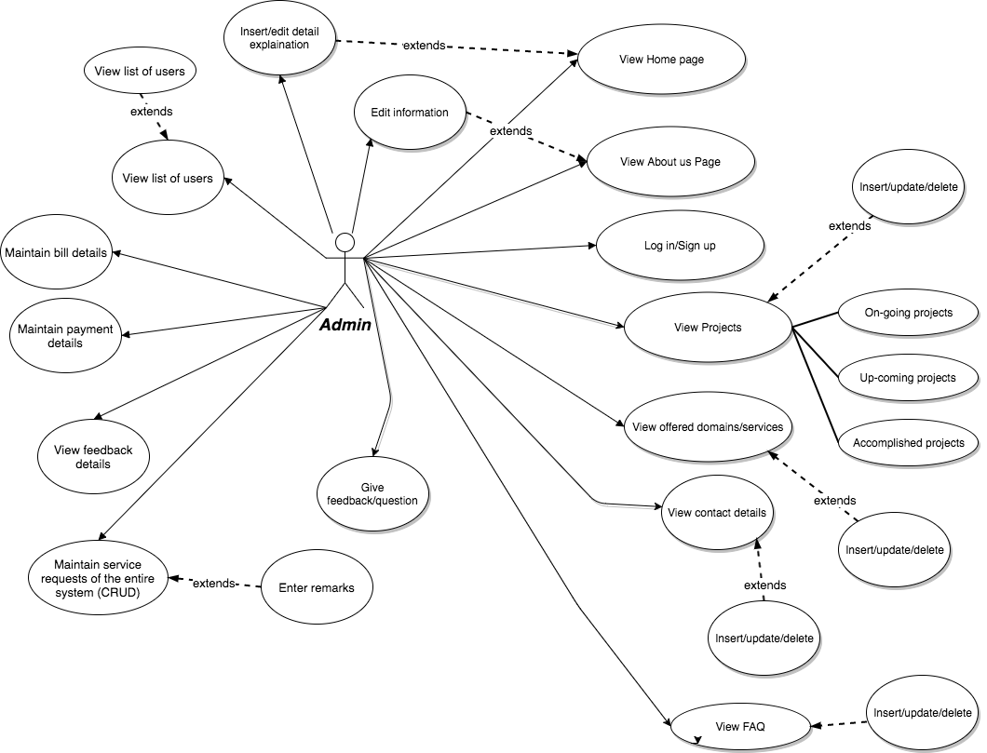

*Admin usecase*

*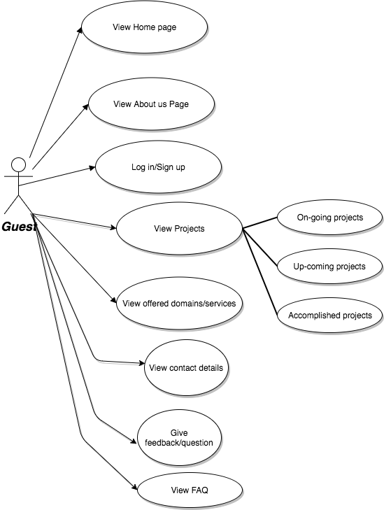*

*Guest usecase*

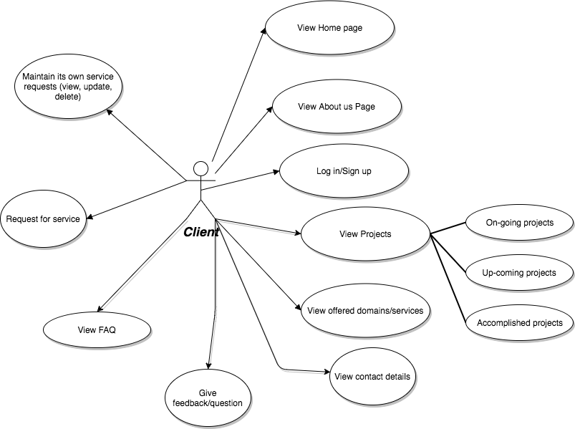

*Client usecase*

## FLOWCHART DIAGRAM

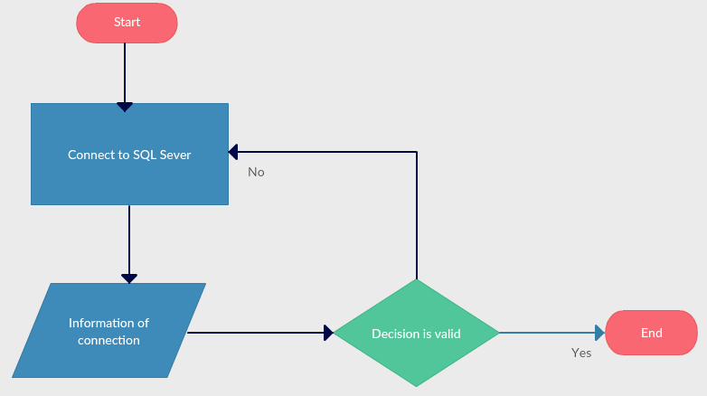

Flowchart diagram 1: Connecting to SQL server

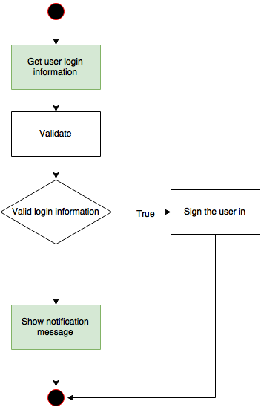

Flowchart diagram 2: Login

## DATA FLOW DIAGRAM

DFD Lever 0: Context diagram

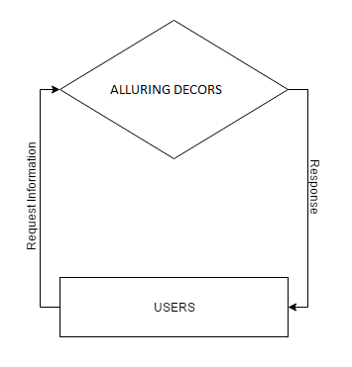

DFD Level 1-1: Configuration SQL Server

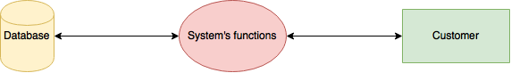

DFD Level 2.1: Sign in and sign up

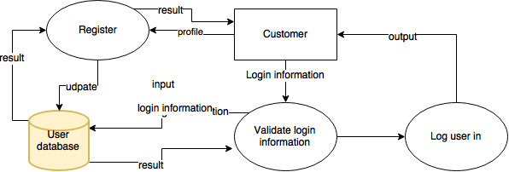

## ENTITY RELATIONSHIP DIAGRAM

## https://gyazo.com/8bf4c3c73b4995a28016e826512e0605.png

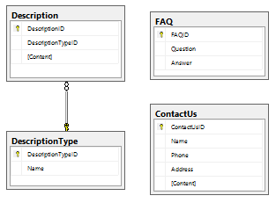

## TABLE DESIGN

|  |  |  |  |  |  |  |  |  |  |  |  |  |  |  |
| --- | --- | --- | --- | --- | --- | --- | --- | --- | --- | --- | --- | --- | --- | --- |
| **Table:User** | | | | | | | | | | | | | | |
| **Field name** | | | **Data Type** | | | **Null** | | | | **Key** | | | **Description** | |
| UserID | | | Int | | | Not | | | | PK | | | Store the ID of User | |
| FirstName | | | nvarchar(50) | | | Yes | | | |  | | | Store the first name of User | |
| LastName | | | nvarchar(50) | | | Not | | | |  | | | Store the last name of User | |
| Email | | | nvarchar(50) | | |  | | | |  | | | Store the email of User | |
| Phone | | | nvarchar(50) | | |  | | | |  | | | Store the phone of User | |
| Address | | | nvarchar(50) | | |  | | | |  | | | Store the address of User | |
| **Table: Account** | | | | | | | | | | | | | | |
| **Field name** | | | **Data Type** | | | **Null** | | | **Key** | | | **Description** | | |
| UserID | | | Int | | | Yes | | | FK | | | Store the ID of User | | |
| Username | | | nvarchar(50) | | | Yes | | |  | | | Store the username name of User | | |
| Password | | | nvarchar(50) | | |  | | |  | | | Store the password of User | | |
| RoleID | | | Int | | |  | | | FK | | | Store the RoleID of User | | |
| **Table: Role** | | | | | | | | | | | | | |
| **Field name** | **Data Type** | | | **Null** | | | **Key** | | | | **Description** | | |
| RoleID | Int | | | Not | | | PK | | | | Store the ID of Role | | |
| Name | nvarchar(50) | | | Not | | |  | | | | Store the Name | | |
| **Table: Service Request** | | | | | | | | | | | | | |
| **Field name** | | **Data Type** | | | **Null** | | | **Key** | | | | **Description** | |
| ServicesRequestID | | Int | | | Not | | | PK | | | | Store the Services Request’s ID | |
| ServicesOfferedID | | Int | | | Not | | | FK | | | | Store the Services Offered’s ID | |
| UserID | | Int | | | Not | | | FK | | | | Store the User’s ID | |
| ServicesRequestStatusID | | Int | | | Not | | | FK | | | | Store the Services Request’s ID | |
| Remark | | nvarchar(250) | | | Not | | |  | | | | Store the remark value (Notes) | |

|  |  |  |  |  |  |  |  |
| --- | --- | --- | --- | --- | --- | --- | --- |
| **Table: ServicesRequestStatus** | | | | | | | |
| **Field name** | **Data Type** | | **Null** | | **Key** | | **Description** |
| ServicesRequestStatusID | int | | Yes | | FK | | Store ServicesRequestStatus’s ID |
| Name | nvarchar(50) | | Not | |  | | Store the name of Services RequestStatus |
| **Table: ServicesOffered** | | | | | | | |
| **Field name** | **Data Type** | | **Null** | | **Key** | | **Description** |
| ServicesOfferedID | Int | | Not | | FK | | Store the Services Offered’s ID |
| Name | nvarchar(50) | | Not | | FK | | Store the Name |
| Content | nvarchar(250) | | Yes | |  | | Store the Content |
| **Table: Bill** | | | | | | | | |
| **Field name** | **Data Type** | **Null** | | **Key** | | **Description** | | |
| BillID | Int | Not | | PK | | Store the Bill’s ID | | |
| ServicesRequestID | Int | Not | | FK | | Store the Services Request’s ID | | |
| DomainID | Int | Yes | | FK | | Store the Domain’s ID | | |

|  |  |  |  |  |  |
| --- | --- | --- | --- | --- | --- |
| **Table: PaymentDetail** | | | | | |
| **Field name** | **Data Type** | **Null** | **Key** | **Description** | |
| PaymentDetaiID | Int | Not | PK | Store the Payment DetaiI’s ID | |
| BillID | Int | Not | FK | Store the Bill’s ID | |
| Date | DateTime | Not |  | Store the Date created | |
| TotalBillAmount | Float | Not |  | Store the Total Bill Amount | |
| DueAmount | Float |  |  | Store the Due Amount | |
| BalanceAmount | Float |  |  | Store the Balance Amount | |
| TotalPaidAmount | Float |  |  | Store the Total Paid Amount | |
| isMaintained | bit |  |  | Store the Is Maintened or not | |
| **Table:Domain** | | | | | |
| **Field name** | **Data Type** | **Null** | **Key** | | **Description** |
| DomainID | Int | Not | PK | | Store the Domain’s ID |
| Name | nvarchar(50) | Not |  | | Store the Domain’s name |

|  |  |  |  |  |
| --- | --- | --- | --- | --- |
| **Table: Description** | | | | |
| **Field name** | **Data Type** | **Null** | **Key** | **Description** |
| DescriptionID | Int | Not | FK | Store the Description’s ID |
| DescriptionTypeID | Int | Not | FK | Store the Description Type’s ID |
| Content | nvarchar(250) | Not |  | Store the content |
| **Table: DescriptionType** | | | | |
| **Field name** | **Data Type** | **Null** | **Key** | **Description** |
| DescriptionTypeID | Int | Not | PK | Store the Description Type’s ID |
| Name | nvarchar(50) | Not |  | Store the Description Type’s name |
| **Table: FAQ** | | | | |
| **Field name** | **Data Type** | **Null** | **Key** | **Description** |
| FAQID | Int | Not | PK | Store the FAQ’s ID |
| Question | nvarchar(50) | Not |  | Store the question |
| Answer | nvarchar(50) | Not |  | Store the answer |

|  |  |  |  |  |
| --- | --- | --- | --- | --- |
| **Table: ContactUs** | | | | |
| **Field name** | **Data Type** | **Null** | **Key** | **Description** |
| ContactUsID | Int | Not | PK | Store the Contact Us’s ID |
| Name | nvarchar(50) | Not |  | Store the guest’s name |
| Phone | nvarchar(50) | Not |  | Store the guest’s phone |
| Address | nvarchar(50) | Not |  | Store the guest’s addess |
| Content | nvarchar(250) |  |  | Store the feedback content |
| **Table: Feedback** | | | | |
| **Field name** | **Data Type** | **Null** | **Key** | **Description** |
| FeedBackID | Int | Not | PK | Store the Feedback’s ID |
| Question | nvarchar(50) | Not |  | Store the question |
| Answer | nvarchar(50) | Not |  | Store the answer |
| UserID | Int | Not |  | Store the User’s ID |

## PROGRAMDESIGN

## GUI DESIGN

## TASK SHEETS

|  |  |  |  |  |  |  |  |
| --- | --- | --- | --- | --- | --- | --- | --- |
| **Project Ref. No.:** | | **Project**  **title** | **Activity Plan Prepared by :** | **Date of Preparation of Activity Plan :** | | | |
| **Sr.**  **No.** | **Task** | **Actual Start Date** | **Actual Days** | **Team Member Names** | **Status** |
| 1 | Problem Definition | The AlluringDecors Website |  |  |  | Team |  |
| 2 | Customer Requirements Specification |  |  |  | Team |  |
| 3 | Architecture  &Design of the Project |  |  |  | Team |  |
| 4 | Data Flow  Diagram |  |  |  | Bao |  |
| 5 | Entity Relationship (ER) Diagram |  |  |  | Nam |  |
| 6 | Database Design/Structure |  |  |  | Nam |  |
| 7 | Design  Snapshot |  |  |  | Bao |  |
| 8 | Design form |  |  |  |  | Bao |  |
| 9 | Build package Data, object, utilities |  |  |  | Nam |  |
| 10 | Build package gui |  |  |  | Team |  |
| 11 | Write help document, guide setup system document |  |  |  | Team |  |
| 12 | Testing |  |  |  | Team |  |

## FINAL CHECKLIST

|  |  |
| --- | --- |
| **Aspect tested** | **Result** (yes/no) |
| Is the problem define correctly deduced from the project abstract | NO |
| All relevant documents have been done | NO |
| Are all program codes working? | NO |
| Are the codes working as per specifications? | NO |

|  |  |
| --- | --- |
| **Testing Parameter** | **Result** (yes/no) |
| Fields in forms should be not null | NO |
| All numeric fields have a default value of 0 | NO |

## 

## APPENDIX – Install guide

The default account is “***admin***” and password is “***123456***”, this one has the role as “***administrator***”, and another role “**user**” has an account with username “**user**” and password “**123456**”.

## COMMENTS OF FACULTY