Single-Stage Single-Phase Semi-Z-Source Inverter with Robust Synchronisation and PR Control for Grid-Connected PV Energy Systems


ASI-ONOB USANG ASI
200992209

Submitted in accordance with the requirements for the degree of Doctor of Philosophy

Under the supervision of
Dr Benjamin Chong
Dr Li Zhang

The University of Leeds
School of Electronic and Electrical Engineering

September, 2026

Declaration of Academic Integrity

The candidate confirms that the work submitted is his/her own, except where work which has formed part of jointly-authored publications has been included. The contribution of the candidate and the other authors to this work has been explicitly indicated in the report. The candidate confirms that appropriate credit has been given within the report where reference has been made to the work of others.
The contribution of the candidate to this work has been indicated in the jointly-authored publication below.

- A. U. Asi, B. Chong, L. Zhang and J. Nkanu, "A Single-Stage Z-source Inverter for Transformerless Grid Connection with a Proportional-Resonant Controller for DC Current Elimination," 2020 IEEE 11th International Symposium on Power Electronics for Distributed Generation Systems (PEDG), Dubrovnik, Croatia, 2020, pp. 560-565, doi: 10.1109/PEDG48541.2020.9244418.
The work presented in the publication above were carried out by the candidate who is the lead author. The supervisors, Dr B. Chong and Dr L. Zhang provided reviews and comments on the manuscript. The publication has been reproduced in some aspect of Chapter 6.
This copy has been supplied on the understanding that no quotation from the report may be published without proper acknowledgement. The candidate, however, confirms his/her consent to the University of Leeds copying and distributing all or part of this work in any forms and using third parties, who might be outside the University, to monitor breaches of regulations, to verify whether this work contains plagiarised material, and for quality assurance purposes.
The candidate confirms that the details of any mitigating circumstances have been submitted to the Student Support Office at the School of Electronic and Electrical Engineering, at the University of Leeds.

Asi-Onob Usang Asi
26/09/2026

Acknowledgements

I would like to express my sincere appreciation to my supervisor, Dr. Benjamin Chong, for his inspiring encouragement, insightful guidance, and dedicated supervision throughout my PhD programme. This thesis would not have been possible without his unwavering support. I am also deeply grateful to my co-supervisor, Dr. Li Zhang, for her invaluable academic expertise and thoughtful advice.
I would like to acknowledge my colleagues from the School of Electronic and Electrical Engineering – Ogaga, Nabila, Han, Agnes, Mohammed, Ifeoma, Emmanuel, John and Opeyemi who made my studies worthwhile and provided the platform to intellectual discussions and friendship. Many thanks to Joanne from the Faculty Graduate School – Engineering & Physical Sciences for her continuous support, counsel and guidance.
My heartfelt appreciation goes to my entire family and close friends, whose constant support and love has been tremendous throughout this research work. To my parents, Prof. Usang Usang Bassey and Dr. (Mrs) Usang Usang Bassey, for sponsoring my PhD programme, and for their continuous encouragement and prayers. To my amazing and lovely husband, Christopher Mbah for his unwavering support, love, care, patience, understanding and being my source of strength throughout this research work. To my children Zuriel and Zoey, for their love and smiles that always soothe my heart. To my wonderful siblings, Victoria, Asibong, Etore-Asi, Juliana, Damian and Kenneth who have always been there for me through thick and thin. To my nephew, Ephriam and his nieces Emmanuella and Ellena for their affection. To my in-laws, Mr & Mrs Ernest Mbah, Tony, Amara, Gozie and Chibuikem for their continuous support and love. To my dear friends, Ebere, Alamu, Miriam, Dr Glory, Joy Oludiran, Abiodun, Bunmi, Onyi, Temitope, Jennie Oroma, and Cleo for their support and prayers all the way through.
I am thankful to my former line manager, Tom, and to Chris, my current manager at SSE Plc, for their support, understanding and kindness during the graduate programme and in helping me transition smoothly into a permanent role.
Lastly, all thanks to my very present and abiding helper, God Almighty, who made this day possible. To Him be all glory, honour, power, adoration, now and forever more.

Abstract

This thesis addresses the control and synchronisation of single-stage semi-Z-source inverters for single-phase grid-connected photovoltaic (PV) applications. The rapid growth of PV generation has intensified the need for power-conversion stages that integrate into the grid safely and with high power quality, yet single-phase grid-connected inverters must reject DC current injection, remain synchronised under distorted grid conditions, and comply with grid codes such as Engineering Recommendation G99 and BS EN 50160. The semi-Z-source topology provides single-stage buck-boost conversion without a separate DC-DC stage, but its grid-connected operation depends on the synchronisation and closed-loop control strategies applied to it.
Two control and synchronisation contributions are developed. The first is a novel αβ-CDSC-SOGI-PLL synchronisation technique that embeds a cascaded delayed-signal-cancellation operator within a SOGI-PLL. Validated in both simulation and on hardware, it reduces the second-harmonic content of the phase estimate by a factor of between 7 and 24 relative to the SOGI-PLL, with the accompanying increase in settling time quantified so that the improvement can be applied as an informed design trade-off. The second is a gain-scheduled proportional-resonant DC-injection compensator, together with an analytical procedure for designing it from a loop-gain specification that replaces the ad hoc gain selection of earlier single-stage designs. Applied to the inverter, it holds the injected DC current to 0.099% of the fundamental at the nominal operating point, within the applicable grid-code limit, and the accompanying analysis further establishes, as a transferable criterion, that a fixed gain is sufficient across the realistic operating envelope, so the cost and complexity of scheduling can be avoided. Both contributions build on a verified small-signal state-space model of the Z-source DC-DC stage developed as part of this work.
The closed-loop, PV-fed inverter meets the G99 and BS EN 50160 voltage, frequency and DC-injection requirements over the tested envelope, and maintains DC-bus regulation and synchronisation through voltage-sag, phase-jump, frequency-change and harmonic disturbances. A loss and efficiency analysis identifies the output-filter damping resistance as the dominant loss and distinguishes the as-built peak efficiency of about 74% from a loss-excluded bound of about 86%, together with the filter redesign that would realise it. The scope is stated explicitly: the synchronisation technique is demonstrated on hardware whereas the inverter is evaluated in simulation, and reduction of the residual second-harmonic current distortion is identified as the principal avenue for further work. Overall, the thesis delivers a hardware-validated synchronisation technique and an analytically-designed, grid-code-compliant DC-injection control scheme for the single-stage semi-Z-source inverter, supported by the modelling and analysis that establish their performance.

Table of Contents
Declaration of Academic Integrity ii
Acknowledgements iii
Abstract iv
Table of Contents vi
List of Tables xi
List of figures xiii
List of Abbreviations xix
Chapter 1 Introduction 1
1.1 Background 1
1.2 Challenges in Grid-Connected Inverter Systems 3
1.2.1 Synchronisation with the Grid 3
1.2.2 Power Quality Issues 4
1.2.3 DC Current Elimination 5
1.2.4 Constant DC Bus Voltage 5
1.3 Overview and Advancements in Z-Source Converters 7
1.4 Single-phase Grid Voltage Synchronisation Techniques 9
1.5 Aims, Objectives and Structure of the Thesis 10
Chapter 2 A Comprehensive Review of Impedance Source (Z-Source) Converters and Their Topological Variations 14
2.1 Introduction 14
2.2 Z-Source Converter Configurations 15
2.2.1 Z-Source DC-DC Converter 15
2.2.2 Z-Source DC-AC Inverter 19
2.2.3 Z-Source AC-DC Converter 23
2.2.4 Z-Source AC-AC Converter 26
2.3 Summary of Impedance-Source Network Topologies for different power conversions 30
2.4 Conclusion 32
Chapter 3 Modelling, Control and Optimal Design of Z-source DC-DC Converter 34
3.1 Introduction 34
3.2 Circuit topology for the Z-source DC-DC converter 35
3.3 Circuit Analysis of the Z-Source DC-DC Converter 38
3.3.1 Operating principles in Continuous Conduction Mode 38
3.4 Mathematical model of the Z-source DC-DC converter 40
3.4.1 Generalised state space average model 41
3.4.2 Derivation of transfer function by small-signal ac perturbations 44
3.4.3 Transfer function of the Z-source DC-DC converter 46
3.5 Verification of small-signal ac perturbation and Z-source DC-DC converter models 48
3.5.1 Comparison and Validation 49
3.5.2 Range of validity of the small-signal model 51
3.6 Dynamic study and selection of DC-DC Z-Source network parameters 54
3.6.1 Variation of C1 (with C2, L1, and L2 constant) 57
3.6.2 Variation of C2 (with C1, L1, and L2 constant) 58
3.6.3 Variation of L1 (with C1, C2, and L2 constant) 58
3.6.4 Variation of L2 (with C1, C2, and L1 constant) 59
3.7 Pole-zero analysis 61
3.7.1 Pole-zero structure at the operating point 62
3.7.2 Frequency response 63
3.7.3 Effect of component variation on the pole-zero map 65
3.7.4 Recommended passive component values 68
3.8 Conclusion 68
Chapter 4 Review of Single-Phase Grid Synchronisation 70
4.1 Introduction 70
4.2 Categorisation of Grid Synchronisation methods for single-phase systems 71
4.3 Phase locked loop (PLL) synchronisation techniques 73
4.3.1 T/4 Transport Delay PLL 75
4.3.2 Inverse Park Transformation (IPT) PLL 77
4.3.3 Second Order Generalised Integrator (SOGI) PLL 78
4.4 Simulation results 80
4.4.1 Voltage sag 84
4.4.2 Phase angle jump 86
4.4.3 Frequency change 87
4.4.4 Presence of odd harmonics 90
4.4.5 Quantitative summary and findings 93
4.5 Summary 95
Chapter 5 A new and highly efficient adaptive phase-locked loop technique for single-phase systems under abnormal grid conditions 97
5.1 Introduction 97
5.2 Cascaded Delay Signal Cancellation 99
5.2.1 Representation of Harmonic Signals 100
5.2.2 $αβ$-frame Delay signal cancellation ($αβ$DSC) 100
5.2.3 Cumulative delay and the frequency-step trade-off 103
5.3 Cascaded delay signal cancellation (CDSC) PLL 104
5.4 The proposed $αβ$-CDSC-SOGI-PLL Synchronisation technique 107
5.5 Simulation results 109
5.6 Experimental setup for hardware validation 118
5.6.1 Bench arrangement and signal path 120
5.6.2 Firmware architecture and disturbance mechanism 123
5.6.3 Data acquisition and analysis pipeline 125
5.7 Metric definitions 125
5.8 Results 126
5.8.1 E0 Steady-state baseline 126
5.8.2 E1 Voltage sag 128
5.8.3 E2 Phase angle jump 130
5.8.4 E3 Frequency change 132
5.9 Consolidated comparison and discussion 135
5.9.1 CDSC-SOGI-PLL against SOGI-PLL across scenarios 135
5.9.2 Agreement between the bench and the simulation 135
5.10 Conclusion 136
Chapter 6 Closed-Loop Control of a Single-Stage Semi-Z-Source Inverter with Gain-Scheduled DC-Injection Compensation for Grid-Connected Photovoltaic Applications 139
6.1 Introduction 139
6.2 The Semi Z-Source Inverter based on Z-Source DC-DC converter topology 141
6.3 Closed-loop Control System for the semi-Z-source Inverter 143
6.3.1 Pulse Width Modulation 144
6.3.2 Sinusoidal Pulse Width Modulation 145
6.3.3 SPWM of Semi-Z-Source Inverter 148
6.4 Semi-Z-Source Inverter Control 149
6.5 DC Voltage Controller 151
6.6 Current Controller 152
6.7 Converter Filter 155
6.8 Photovoltaic Array Model 156
6.8.1 Single-diode equation 156
6.8.2 Array configuration and parameters 156
6.9 Gain-Scheduled Proportional-Resonant DC-Injection Compensator 160
6.9.1 Schedule design 161
6.9.2 Implementation: Gain-schedule script and lookup table 164
6.10 UK Grid Compliance 165
6.10.1 Assessment of the design against the requirements 166
6.11 Loss Model and Converter Efficiency 168
6.11.1 Loss mechanisms 168
6.11.2 Efficiency calculation 168
6.11.3 Dominant loss mechanism 169
6.12 Extended Simulation Results (UK 230 V grid, PV-driven, gain-scheduled) 170
6.12.1 Nominal steady-state operation 173
6.12.2 Baseline PR versus no-PR comparison 174
6.12.3 Fixed-gain versus scheduled-gain comparison 176
6.12.4 Load-step disturbance rejection 178
6.12.5 Voltage sag ride-through 179
6.12.6 Frequency variation 181
6.12.7 Power-factor capability ($Iq$ sweep) 182
6.12.8 Efficiency versus output power 184
6.12.9 Efficiency limitation and proposed LCL filter 185
6.13 Topology Comparison and Prospective Applications 187
6.13.1 Quantitative component comparison 187
6.13.2 Prospective applications 188
6.14 Conclusion 189
Chapter 7 Conclusion and Recommendations for Future Work 191
7.1 Summary of Key Findings and Contributions 191
7.2 Limitations 193
7.3 Recommendations for Future Work 193
7.4 Concluding Remarks 195
List of References 196

List of Tables

Table 2. 1 Comparative Analysis of Z-Source Converter Configurations 31
Table 3. 1 Model parameters for Z-source DC-DC converter and small-signal models 50
Table 3. 2 Summary of duty ratio step changes 53
Table 3.3 Dominant-mode metrics for the component sweeps at D0 = 0.2 (settling time and overshoot are linear-model values) 56
Table 4.1 Consolidated benchmark metrics for the four disturbance scenarios across the three PLL topologies. N/A indicates metrics that are not meaningful for the scenario. 93
Table 4.3 Response of the synchronisation schemes to various abnormal grid conditions 95
Table 5.1 Selection of stationary αβ-frame CDSC parameters to eliminate different harmonics [119] 106
Table 5.2 Consolidated benchmark metrics across all four scenarios and all four PLL topologies. 116
Table 5.3 Peripheral configuration for both boards. 122
Table 5.4 Mapping of scenario_id to disturbance channel on Board A. 124
Table 5.5 Baseline (E0) metrics. Mean ± standard deviation over three repetitions. 128
Table 5.6 E1 voltage sag metrics. Mean ± standard deviation over three repetitions. 130
Table 5.7 E2 phase jump metrics. Mean ± standard deviation over three repetitions 131
Table 5.8 E3 frequency change metrics. Mean ± standard deviation over three repetitions. 133
Table 5.9 E4 harmonic distortion metrics. Mean ± standard deviation over three repetitions. 134
Table 5.10 Consolidated CDSC-SOGI-PLL against SOGI-PLL second-harmonic peak comparison across the five bench scenarios. 135
Table 6.2 Single-diode PV array model parameters, tuned to reproduce the target maximum power point. 157
Table 6.3 Plant characteristics across the operating envelope, computed from the verified Chapter 3 small-signal state-space model at three representative operating points (D₀ = 0.15, 0.20 nominal, 0.30). 164
Table 6.4 Gain-schedule lookup table generated by Ch6_PR_GainSchedule.m. $KpMk$ is computed from equation (6.27) with $Kp,\text{nominal}=0.0016$ at $Mnominal=0.6505$ 164
Table 6.5 Assessment of the converter against UK grid-connection requirements. Continuous power-quality metrics are quantified against the applicable limits; dynamic requirements are demonstrated in simulation; protection trip settings are verified by hardware type-test. 167
Table 6.6 Simulation parameters (including device parasitics) 173
Table 6.7 PR versus no-PR comparison 174
Table 6.8 Steady-state grid-current DC injection and THD under fixed-gain and scheduled-gain PR control at three operating points ($VDC=500$, $540$, $450\text{ V}$; corresponding $M=0.65$, $0.60$, $0.72$). DC injection is given both as an absolute current and as a percentage of the fundamental peak. Differences between the two configurations are below $0.05\%$ of fundamental at every point, confirming no measurable benefit from scheduling. 177
Table 6.9 Power-factor capability sweep at $VDC$ = 500 V. 182
Table 6.10 Converter efficiency curve at $VDC$ = 500 V across irradiance G = 200 to 1000 W/m². Peak efficiency of 74.04% occurs at G = 800 W/m². 184
Table 6.11 LCL filter design for the 230 V, 40 kHz converter, replacing the series-damped L-filter of the present study. 186
Table 6.12 Component comparison of the semi-Z-source against alternative grid-tied PV topologies. The semi-Z-source achieves the lowest switch count while retaining single-stage operation. 187

List of figures

Figure 1. 1 Block diagram of grid-connected PV system 2
Figure 1. 2 Control requirements of the grid-connected PV system 7
Figure 1. 3 Grid synchronisation for control of a grid-connected power converter 10
Figure 2. 1 Z-Source DC-DC Converter [6] 15
Figure 2. 2 Z-source DC-AC Inverter [12] 19
Figure 2. 3 Z-source AC-DC Converter [6] 23
Figure 2. 4 Z-source AC-AC Converter [14] 27
Figure 3. 1 Z-source DC-DC Converter 36
Figure 3. 2 (a) and (b) Two Z-source DC-DC converter topology 37
Figure 3. 3 DC operating modes for the Z-source DC-DC converter circuit 39
Figure 3. 4 Z-source DC-DC converter model 49
Figure 3.5 Output voltage for the validity-boundary step sequence (about $D0$= 0.2). D steps from 0.2 to [0.21, 0.30, 0.40] at t = [0.05, 0.10, 0.15] respectively. 51
Figure 3.6 Zoomed-in step responses at the three verification steps 52
Figure 3.7 Linearisation error vs perturbation magnitude, with validity regions and step-study markers 54
Figure 3.8 Step response for varying C1 57
Figure 3.9 Step response for varying C2 58
Figure 3.10 Step response for varying L1 59
Figure 3.11 Step response for varying L2 60
Figure 3.12 Component-value sensitivity of dominant-mode metrics (settling time and damping vs L and C) 61
Figure 3.13 Pole-zero map of $Gvds$ at $D0$ = 0.20, with inset showing the near-axis poles and the right-half-plane zero pair 63
Figure 3.14 Bode plot of $Gvds$ at $D0= 0.20$, with the 200 Hz bandwidth bound marked 64
Figure 3.15 Pole-zero map, C2 varied 65
Figure 3.16 Pole-zero map, C1 varied 66
Figure 3.17 Pole-zero map, L1 varied 66
Figure 3.18 Pole-zero map, L2 varied 67
Figure 4.1 Hierarchical classification of single-phase grid synchronisation methods 72
Figure 4. 2 Basic structure of a phase-locked loop synchronisation 73
Figure 4. 3 Block diagram of an elementary phase-locked loop 74
Figure 4. 4 Structure of the QSG based transport delay PLL. 76
Figure 4. 5 Inverse Park Transform PLL 77
Figure 4. 6 Structure of the SOGI PLL 78
Figure 4. 7 Simulink model of the T/4 Transport Delay PLL 81
Figure 4. 8 Simulink model of the Inverse Park Transformation (IPT) PLL 81
Figure 4. 9 Simulink model of the Second Order Generalised Integrator (SOGI) PLL 81
Figure 4.10 Phase-error response of T/4, IPT and SOGI PLLs to a 25% voltage sag applied at t = 0.5s, computed against an ideal 50Hz ramp reference: (a) Full simulation. (b) Zoom on transition (0.45 to 0.75s). 84
Figure 4.11 Phase-error response of T/4, IPT and SOGI PLLs to a +10° phase angle jump applied at t = 0.5s, computed against an ideal 50Hz ramp with the expected +10° step subtracted post-disturbance to show residual tracking error around zero: (a) Full simulation. (b) Zoom on transition (0.45 to 0.75s). 86
Figure 4.12 Estimated frequency response of T/4, IPT and SOGI PLLs to a 49 to 51Hz frequency step at t = 0.5s. (a) Full simulation. (b) Zoom on transition (0.45 to 0.7s). (c) Steady-state window (1.5 to 2.0s) with tight y-axis showing IPT and SOGI clearly; T/4’s wider ripple is clipped at this scale and visible in (a). 88
Figure 4.13 Steady-state phase-error and frequency response of T/4, IPT and SOGI PLLs under BS EN 50160 harmonic loading, shown over the 1.5 to 2.0s window. (a) Phase error. (b) Estimated frequency. Reference: ideal 50Hz ramp. 90
Figure 4.14 Verification of the harmonic injection at the simulation input. (a) Time-domain waveform of $Vgrid$ over four cycles within the steady-state window. (b) FFT magnitude spectrum over the 1.0 to 2.0s observation window, with each harmonic peak annotated by its measured amplitude and its percentage of the fundamental. 92
Figure 5.1 Cancellation of 2nd harmonic of the voltage signal by the $DSC4$ operator 101
Figure 5.2 Block diagram of the continuous αβ-frame CDSC+SOGI PLL system. 108
Figure 5.3 Simulink model of the $αβCDSC2,4, 8,16$-SOGI-PLL 109
Figure 5.4 Phase-error response of T/4, IPT, SOGI and αβ-CDSC-SOGI PLLs to a 25% voltage sag applied at t = 0.5s, computed against the ideal 50Hz ramp reference. (a) Full simulation. (b) Zoom on transition (0.45 to 0.75s). 110
Figure 5.5 Phase-error response of T/4, IPT, SOGI and αβ-CDSC-SOGI PLLs to a +10° phase angle jump applied at t = 0.5s, computed against an ideal 50Hz ramp with the expected +10° step subtracted post-disturbance to show residual tracking error. (a) Full simulation. (b) Zoom on transition (0.45 to 0.75s). 111
Figure 5.6 Estimated frequency response of T/4, IPT, SOGI and αβ-CDSC-SOGI PLLs to a 49 to 51Hz frequency step at t = 0.5s. (a) Full simulation. (b) Zoom on transition (0.45 to 0.7s). (c) Steady-state window (1.5 to 2.0s) with tight y-axis showing IPT, SOGI and CDSC-SOGI traces; the T/4 ripple is clipped at this scale and its full extent is visible in (a). 112
Figure 5.7 Steady-state phase-error and frequency response of T/4, IPT, SOGI and αβ-CDSC-SOGI PLLs under sustained BS EN 50160 harmonic loading (1.5 to 2.0s window). (a) Phase error against the ideal 50Hz ramp reference. (b) Estimated frequency. 113
Figure 5.8 FFT verification of the αβ-CDSC cascade’s harmonic-rejection behaviour, computed from the simulation log under sustained BS EN 50160 harmonic loading. Both figures use a logarithmic decibel scale with the input fundamental’s amplitude (309 V) as the 0 dB reference. (a) the input spectrum with the five BS EN 50160 harmonics at their specified amplitudes (b) shows the cascade output spectrum 117
Figure 5.9 Block diagram of the two-board bench. Board A generates the grid emulation signal, coupled through an RC network to Board B ADC-A. Board B runs the PLL under test and exports its phase estimate on DAC-C and over the SCI. 121
Figure 5.10 Photograph of the physical bench. 122
Figure 5.11 Board B PLL model with the $αβ$CDSC subsystem in the middle. The subsystem is present in the CDSC-SOGI-PLL variant only. 123
Figure 5.12 Board A Grid Emulator model 124
Figure 5.13 Oscilloscope captures for the E0 baseline. Ch1 (top trace) shows the Board A grid emulation output. Ch2 (bottom trace) shows the Board B PLL reconstruction from DAC-C. (a) CDSC-SOGI-PLL (b) SOGI-PLL. Both variants track the 50 Hz reference stably in the time domain; the second-harmonic content that distinguishes them is characterised spectrally in Figure 5.14. 127
Figure 5.14 Fast Fourier transform magnitude of the raw frequency estimate over the settled window, computed by Ch5_analyse_logs. The second-harmonic peak at 99.4 Hz in the SOGI-PLL exceeds the corresponding peak in the CDSC-SOGI-PLL by a factor of approximately 16. 127
Figure 5.15 Oscilloscope response to the 25% voltage sag. Ch1 (top trace) shows the Board A grid emulation output with the amplitude step. Ch2 (bottom trace) shows the Board B PLL reconstruction. (a) CDSC-SOGI-PLL. (b) SOGI-PLL. 129
Figure 5.16 Fast Fourier transform magnitude of the raw frequency estimate over the settled window. The second-harmonic peak at 99.4 Hz in the SOGI-PLL exceeds the corresponding peak in the CDSC-SOGI-PLL by a factor of approximately 17. 129
Figure 5.17 Oscilloscope response to a 10 degree phase jump in the grid emulation output. (a) CDSC-SOGI-PLL. (b) SOGI-PLL. 130
Figure 5.18 Fast Fourier transform magnitude of the raw frequency estimate over the settled window. The second-harmonic peak at 99.4 Hz in the SOGI-PLL exceeds the corresponding peak in the CDSC-SOGI-PLL by a factor of approximately 16. 131
Figure 5.19 Oscilloscope response to the 49 to 51 Hz frequency step. Ch1 (top trace) shows the grid emulation transitioning to 51 Hz. Ch2 (bottom trace) shows the Board B PLL reconstruction. (a) CDSC-SOGI-PLL. (b) SOGI-PLL. 132
Figure 5.20 Fast Fourier transform magnitude of the raw frequency estimate over the settled window. The second-harmonic peak at 99.3 Hz in the SOGI-PLL exceeds the corresponding peak in the CDSC-SOGI-PLL by a factor of approximately 23. 132
5.8.5 E4 Harmonic distortion 133
Figure 5.21 Oscilloscope response to BS EN 50160 harmonic injection. Ch1 (top trace) shows the harmonically-distorted grid emulation output. Ch2 (bottom trace) shows the reconstructed PLL sinusoid. (a) CDSC-SOGI-PLL. (b) SOGI-PLL. 133
Figure 5.22 Fast Fourier transform magnitude of the raw frequency estimate over the settled window. The second-harmonic peak at 99.3 Hz in the SOGI-PLL exceeds the corresponding peak in the CDSC-SOGI-PLL by a factor of approximately 7. 134
Figure 6.1 Z-source DC-DC converter [1] 141
Figure 6.2 Voltage gain curve [1] 142
Figure 6.3 (a) The semi-Z-source inverter (b) H-bridge inverter configuration, highlighting the differences in grounding and switching structures. 143
Figure 6.4 Bipolar SPWM generator 146
Figure 6.5 Unipolar SPWM generator 147
Figure 6.6 The switching pulses of S1 and S2, the modified duty cycle and triangular carrier waveform for the SPWM of semi-z-source inverter 149
Figure 6.7 Schematic diagram of the semi-Z-source inverter and associated control for a grid-connected photovoltaic (PV) system 151
Figure 6.8 Block diagram of the DC voltage control for the semi-Z-source inverter. 152
Figure 6.9 Voltage relationship across a grid-connected inverter 154
Figure 6.10 shows the array's I-V and P-V characteristics at G = 200, 400, 600, 800 and 1000 W/m² (T = 25 °C), together with the maximum-power-point locus across the irradiance range. 159
Figure 6.11: Control-to-output plant frequency response $Gvd(s)$ at three operating points spanning the MPPT range ($D₀$= 0.15, 0.20, 0.30), computed from the verified Chapter 3 small-signal state-space model. Top: magnitude; bottom: phase. 163
Figure 6.12 Overall Simulink model of the single-phase, 230 Vrms grid-connected PV system using the semi-Z-source inverter. 172
Figure 6.13 DC current injection across the operating envelope, with and without the gain-scheduled PR compensator. Each operating point ($VDC=450, 500, 540\text{ V}$) shows a pair of bars, PR disabled (open-loop) and PR enabled (closed-loop), against the applicable DC-injection limit. 175
Figure 6.14 Grid-current harmonic content at $VDC=500\text{ V}$, PR disabled versus PR enabled, as a percentage of fundamental amplitude (the $50\text{ Hz}$ fundamental is excluded). The DC component falls from 0.685% to 0.099% with the compensator active. The residual distortion is dominated by the 100 Hz second-harmonic inherent to single-stage single-phase operation, whose elimination is outside the present scope and identified as further work. 176
Figure 6.15 Grid-current waveforms $Igridt$under fixed-gain (left column) and scheduled-gain (right column) PR control at $VDC=500\text{ V}$(top), $540\text{ V}$(middle), and $450\text{ V}$(bottom). Each panel reports the measured DC injection and THD. The fixed and scheduled waveforms and their metrics are near-identical at every operating point, the visual confirmation that gain scheduling produces no measurable change in DC injection for this converter. 178
Figure 6.16 Load-step disturbance rejection at $VDC$ = 500 V. (a) DC bus voltage during the 48 percent load step at t = 1.0 s, with peak undershoot 1.998% and recovery within the ±2 percent band. (b) Grid active power stepping from 2199 W to 1135 W. (c) Grid current waveform. 179
Figure 6.17 Voltage sag ride-through at $VDC$ = 500 V with a 70% sag for 200 ms. (a) Grid voltage (instantaneous and RMS value). (b) DC bus voltage with ±2% band; peak excursion 3.76%. (c) Grid current. (d) PLL angle estimate $θ$, continuous through the sag. 180
Figure 6.18 Grid frequency step at $VDC$ = 500 V (50 to 51 Hz at t = 1.0 s). (a) PLL frequency estimate settling within 100 ms to within 0.1 Hz, with +17 mHz steady-state error. (b) DC bus voltage within 0.9%of reference. (c) Grid current. (d) PLL angle estimate. 181
Figure 6.19 Power-factor capability sweep at $VDC$ = 500 V. (a) $Iq*$ reference stepped through [0, +5, -5, 0] A. (b) Active power held essentially constant, demonstrating decoupling. (c) Reactive power swinging symmetrically by ±814 var. (d) Grid current waveform. 183
Figure 6.20 Converter efficiency versus output power at $VDC=500\text{ V}$. (a) Irradiance command. (b) PV input power and grid output power, the vertical gap being converter loss. (c) Efficiency $η=Pgrid/PPV$ versus $Pgrid$, each point labelled by irradiance. 185

List of Abbreviations

AC | Alternating current
ADC | Analogue-to-digital converter
ADS | Adaptive down sampling
BPWM | Bipolar pulse width modulation
BS EN 50160 | Voltage characteristics of public distribution networks (standard)
CCM | Continuous conduction mode
CCS | Constant current source
CDSC | Cascaded delay signal cancellation
CHB | Cascaded h-bridge
CSI | Current source inverter
DAC | Digital-to-analogue converter
DC | Direct current
DFT | Discrete Fourier transform
DPC | Direct power control
DSC | Delayed signal cancellation
EMC | Electromagnetic compatibility
EMI | Electromagnetic interference
ESR | Equivalent series resistance
EV | Electric vehicle
FC | Flying capacitor
FFT | Fast Fourier transform
FIR | Finite impulse response
FPG | Frequency-phase generator
G99 | Engineering Recommendation G99 (UK grid-connection standard)
GaN | Gallium nitride
GSSA | Generalised state space averaging
HVDC | High voltage direct current
IGBT | Insulated gate bipolar transistor
IPT | Inverse park transform
IPT-PLL | Inverse park transformation phase-locked loop
ISR | Interrupt service routine
IZSI | Improved z source inverter
kHz | Kilohertz
kW | Kilowatt
LCL | LCL (inductor-capacitor-inductor) filter
LF | Loop filter
LHP | Left hand plane
L-ZSI | L-z-source inverter
MATLAB | Matrix Laboratory (numerical computing software)
MBC | Maximum boost control
MCBC | Maximum constant boost control
MOSFET | Metal oxide semiconductor field effect transistor
MPC | Model predictive control
MPP | Maximum power point
MPPT | Maximum power point tracking
NPC | Neutral-point clamped
PCC | Point of common coupling
PD | Phase detector
PF | Power factor
PFC | Power factor correction
PI | Proportional plus integral
PLECS | Piecewise Linear Electrical Circuit Simulation
PLL | Phase-locked loop
PR | Proportional resonant
PSPWM | Phase shifted pulse width modulation
PV | Photovoltaic
PWM | Pulse width modulation
QSG | Quadrature signal generation
qZSI | Quasi-z-source inverter
RDFT | Recursive discrete Fourier transform
RMS | Root mean square
SBC | Simple boost control
SCR | Space-charge region
SHE | Selective harmonic elimination
SiC | Silicon carbide
SL-ZSI | Switched inductor z-source inverter
SMC | Sliding mode control
SOGI | Second-order generalised integrator
SOGI-PLL | Second-order generalised integrator phase-locked loop
SOGI-QSG | Second-order generalised integrator - quadrature signal generation
SPWM | Sinusoidal pulse width modulation
ST | Shoot-through
STC | Standard test conditions
SVM | Space vector modulation
T/4 delay | Quarter-cycle delay
THD | Total harmonic distortion
Trans-ZSI | Trans-z-source inverter
TWh | Terawatt hours
TZSI | Trans z-source inverter
VCO | Voltage-controlled oscillator
VFD | Variable frequency drives
VOC | Voltage oriented control
VSI | Voltage source inverter
VSR | Voltage source rectifier
WBG | Wide bandgap
Z | Impedance
ZCD | Zero-crossing detection
ZCS | Zero current switching
ZSC | Impedance source converters
ZSI | Z-source inverter
ZVS | Zero voltage switching
αβ-CDSC | αβ-cascaded delay signal cancellation
αβ-CDSC-SOGI-PLL | αβ-cascaded delay signal cancellation second-order generalised integrator phase-locked loop

Chapter 1
Introduction

1.1 Background
The imperative to decarbonise electricity supply, together with growing concerns over energy security and the rapidly falling costs of renewable generation, has accelerated the global shift towards renewable energy sources [2]. Among these, solar photovoltaic (PV) systems have emerged as a pivotal technology in the global renewable energy portfolio due to their modularity, scalability, and the abundance of solar energy. PV systems convert sunlight directly into electricity through the photovoltaic effect, using semiconductor materials such as silicon. The deployment of solar PV systems ranges from small residential installations to large utility-scale solar farms [3]. This growth has since accelerated sharply: global solar PV generation surpassed 2,000 Terawatt hours (TWh) in 2024, having risen by approximately 30% (of the order of 480 TWh) in that year alone, the largest annual increase of any generation source and the fastest solar growth rate since 2017. Solar PV supplied close to 7% of global electricity in 2024, up from around 5% in 2023, while cumulative installed PV capacity reached approximately 2.2 TW. Solar PV generation has continued to roughly double every three years, and this rapid expansion is projected to continue through to 2030 [4].
Despite the many advantages, integrating PV systems with the existing power grid poses significant technical challenges. The intermittent and variable nature of solar power is a primary concern, as it leads to fluctuations in the generated power. These fluctuations can cause voltage sags, swells, and frequency deviations, potentially destabilising the grid. Furthermore, the variability of solar irradiance, impacts the energy output of PV systems. The variability can be due to weather conditions, time of day, and geographical location. This variability complicates the prediction and management of power generation, requiring sophisticated forecasting and balancing techniques to maintain grid stability [2], [5].
Integrating these renewable energy sources into power grids has also intensified the demand for efficient and reliable power converters, particularly inverters. These grid-connected inverter systems are essential for transforming and synchronising variable energy inputs into consistent, grid-compatible alternating current (AC) power. However, this integration is not without challenges. Traditional inverter systems face significant hurdles, including power quality issues, synchronisation difficulties, and inefficiencies in handling dynamic grid conditions, which underscore the need for more advanced solutions.
In grid-connected PV generation systems, the direct current (DC) power produced by the PV generator is fed into the AC grid for its subsequent transmission, distribution and consumption through the use of DC-AC converters (simply called inverters). Fig. 1.1 shows a basic structure of the grid-connected PV generation system which comprises of a PV module, a DC-DC converter and an inverter. In general, the DC output of the PV module has very low voltage and a DC-DC converter is used to amplify the voltage output to reach suitable levels for grid connection. The DC-AC converter (inverter) is then used to transform the DC output to AC power which is then fed into the grid [6]-[8].

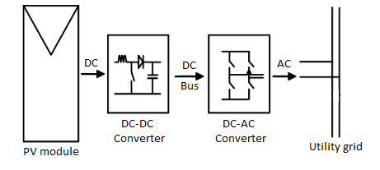
Figure 1. 1 Block diagram of grid-connected PV system

However, these converters encounter several obstacles due to grid fluctuations, load changes, and the inherent intermittent nature of renewable energy. Voltage sags, frequency variations, and harmonic distortions are some of the factors that adversely impact the performance of these inverters, posing risks to both the grid’s stability and the inverter’s lifespan. Overcoming these challenges necessitates innovative converter designs and control strategies that ensure smooth integration and compliance with stringent grid regulations.
This chapter provides a thorough overview of the technical issues associated with grid-connected inverter systems and presents the advancements in impedance source (Z-source) converters as a promising solution. It also outlines the structure of this thesis, presenting each chapter's content and the unique contributions made towards addressing these challenges.

1.2 Challenges in Grid-Connected Inverter Systems
The primary issues facing grid-connected inverter systems for PV application include voltage and frequency fluctuations, harmonic distortions, and synchronisation difficulties.
PV systems must comply with grid codes and standards, which dictate the requirements for voltage, frequency, harmonics, and power factor. These requirements are critical to ensure that PV systems do not adversely affect the grid's operation. Compliance often necessitates advanced control and protection mechanisms, further increasing the complexity of grid-connected PV systems [9], [10].
Power electronics are the backbone of modern solar PV systems, facilitating the conversion, control, and conditioning of electrical power. In grid-connected PV systems, inverters are crucial components that convert the DC output from PV pane ls into AC suitable for grid injection. Traditional inverter technologies, such as voltage source inverters (VSIs) and current source inverters (CSIs), have been widely used, but they come with inherent limitations that restrict their performance and reliability [10], [11].
VSIs and CSIs have limitations in handling the wide voltage ranges typically produced by PV systems. VSIs are prone to shoot-through faults, where both switches in a phase leg conduct simultaneously, causing short circuits. This can lead to significant damage if not properly managed. CSIs, on the other hand, require large inductors, making them bulky and less efficient. Their reliance on specific input and output configurations leaves them vulnerable to faults and inefficiencies under varying grid conditions. When exposed to grid disturbances, traditional inverters risk operational instability and potential damage to sensitive electronic components [11]-[13].

1.2.1 Synchronisation with the Grid
The AC power supplied by the inverter to the grid must be controlled so that its voltage and current output has low harmonic distortions and is in phase (i.e. synchronised) with the grid voltage. Synchronisation is essential for maintaining stable and efficient power flow between inverters and the grid. The grid is however dynamic in nature and is affected by harmonics and disturbances resulting from non-linear loads, load variations, grid faults and other sources. Hence, the magnitude, frequency and phase of the grid voltage may not necessarily be constant values. An unsynchronised operation of the inverter and the grid would introduce grid instabilities (including harmonics, electromagnetic interference, noise, imbalance and power losses) as well as raise several safety concerns [14]-[17]. Various grid regulations for distributed generation systems provide strict measures for the governance of grid-connected systems within specified limits of operation to guarantee an efficient, safe and stable integration of such systems and the utility grid. As a result, the design of grid-connected inverters must also incorporate a method for achieving continuous grid synchronisation. Traditional inverters often require complex synchronisation techniques, yet they may still fall short under rapidly changing grid conditions.

1.2.2 Power Quality Issues
Power quality is a major concern in grid-connected inverter systems, as low-quality power can lead to inefficiencies, losses, and potential damage to the grid. Harmonic distortions caused by non-linear loads, along with rapid fluctuations in voltage and frequency, exacerbate power quality issues. A major requirement for grid-connected inverters is that the inverter must function at unity power factor so as to suppress voltage fluctuations in the grid due to the output power from the PV system. A unity power factor also ensures that only active power is fed to the grid in order to avoid power losses and eliminate the injection of harmonics into the grid [14]. It is possible to maintain a unity power factor by suppressing the reactive component of inverter current using a simple control circuit. This current-control scheme is extensively used in inverters to achieve unity power factor [14]-[16].
Inverter systems must operate within strict limits to mitigate these distortions and prevent adverse effects on connected equipment. However, conventional inverters struggle to manage these conditions, especially under abnormal grid events, which often lead to reduced efficiency and increased operational costs.

1.2.3 DC Current Elimination
In grid-connected inverters, galvanic isolation plays a critical role in enhancing safety, stabilising the system, and improving performance. When this isolation is absent, ground loops can form, creating undesirable currents that bring noise, interference, and potential equipment damage. By maintaining consistent ground potentials between the DC and AC sides, isolation effectively prevents these issues. It also minimises the risk of high-frequency noise and interference transmission between the grid and the inverter, helping to meet electromagnetic compatibility (EMC) standards and ensuring power quality for grid delivery. Transformers are commonly used to achieve galvanic isolation in grid-tied inverters, yet they come with their own downsides, such as energy losses, larger size, higher cost, and increased complexity [9], [10], [14].
In contrast, transformer-less inverters have become a popular alternative, especially for low-voltage applications, as they offer advantages like being more cost-effective, smaller, lighter, and boosting efficiency by as much as 4% compared to transformer-based inverters [18]. However, transformer-less inverters bring their own set of challenges without galvanic isolation, notably in dealing with common-mode leakage currents and DC current injection, both of which can significantly impact grid stability.
To mitigate these issues, various innovative topologies have been developed, specifically designed to reduce or eliminate common-mode leakage currents and DC current injection into the AC grid. These solutions are crucial for addressing safety, reliability, and electromagnetic interference (EMI) considerations [19]-[25]. Among these topologies, Z-source inverters have attracted increasing attention [1], [23], [26]. The semi-Z-source inverter introduced in this thesis incorporates dual grounding, effectively removing the need for transformers. Yet, it requires precise control mechanisms to prevent DC current injection into the AC network, thereby ensuring system reliability and efficiency while reducing costs.

1.2.4 Constant DC Bus Voltage
In grid-connected PV systems, keeping the DC bus voltage at the output of the PV array constant is crucial for stable and efficient operation, meeting both performance and compliance standards. A constant DC bus voltage is key for the maximum power point tracking (MPPT) algorithm, enabling it to adjust the operating point of the PV array to capture the maximum available power despite variations in solar irradiance and temperature. This setup ensures the inverter can consistently feed the highest possible power output into the grid, enhancing the system’s overall energy efficiency [27].
Moreover, a stable DC bus voltage aligns with the operating range of grid-tied inverters, which are typically designed to function optimally within a specific voltage range. Voltage fluctuations outside this range not only reduce inverter efficiency but can also shorten its lifespan. Inverters are calibrated for certain voltage levels to prevent excessive electrical stress on internal components, such as capacitors, inductors, and semiconductor switches, which contributes to greater durability. Maintaining the DC bus voltage within the intended range, therefore, supports component longevity, reducing risks of over-voltage issues that may accelerate aging or lead to equipment failure [28], [29].
Additionally, constant DC bus voltage is essential for producing a reliable AC output, which is critical for grid compliance. Utilities have strict standards for power quality, including requirements for voltage stability, frequency synchronisation, and harmonic distortion. With a stable DC bus voltage, the inverter can deliver an AC output that meets these standards, facilitating smooth grid integration and minimising the risk of disconnection or penalties related to power quality. Uncontrolled DC voltage fluctuations, on the other hand, could lead to inconsistent AC output, introducing harmonic distortion, flicker, and other power quality concerns that may impact grid stability [27], [30].
Without stable DC voltage, more complex control adjustments would be required to handle the PV system’s operations, especially in managing the charging profile of any connected battery, which could decrease overall system efficiency. Consistent DC voltage also enhances the reliability of the PV system by reducing the need for intricate control mechanisms, leading to greater operational stability and minimising the risk of system interruptions or oscillations [31].
Thus, maintaining a constant DC bus voltage is vital for optimising both the performance and durability of grid-connected PV systems. It facilitates efficient power extraction, stable DC-AC conversion, and high-quality power injection into the grid, ensuring that the system provides renewable energy reliably and in accordance with grid standards. This consistency supports both operational efficiency and compliance, reinforcing the system’s role in delivering dependable energy to the grid.
In summary, the grid-connected inverter is required to have the following control schemes:
- Grid synchronisation scheme to enable continuous synchronous operation of the inverter output and the grid voltage.
- Current control scheme to maintain unity power factor by suppressing the reactive AC current output of the inverter.
- Voltage control scheme to enable optimum power flow to the grid from the inverter while maintaining a constant DC bus voltage.
- DC current elimination scheme to prevent the flow of DC current from the PV system into the AC grid.

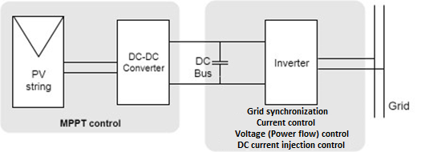
Figure 1. 2 Control requirements of the grid-connected PV system

1.3 Overview and Advancements in Z-Source Converters
Direct-current to direct-current converters (DC-DC) are crucial in solar PV systems for efficiently boosting the variable DC output from solar panels to a stable voltage suitable for energy storage or grid connection. Traditional DC-DC converter topologies such as the buck, boost and buck-boost have been used in solar PV applications. These converters are typically coupled with a suitable inverter to then convert the DC output to AC.
Traditional voltage-source inverters (VSIs) and current-source inverters (CSIs), despite their widespread use, come with inherent limitations that impact their performance. For VSIs, one of the main issues is that the output voltage is restricted by the available DC source. This means that in applications where the DC input is limited or where an extra boost is needed for higher performance, a separate DC-DC boost converter becomes essential. Another critical factor with VSIs is the need for a “dead time” between switching devices on the same phase leg to prevent shoot-through faults caused by electromagnetic interference (EMI). Unfortunately, this dead time can introduce unwanted waveform distortions, affecting the output quality [32].
CSIs, on the other hand, have their own distinct set of challenges. Unlike VSIs, CSIs are constrained in that they cannot produce output voltages lower than the DC input level. Furthermore, they need a specific “overlap time” to avoid open-circuit conditions in the switching devices, either all upper or all lower, which could otherwise lead to operational faults. These challenges illustrate why inverters, despite their versatility, must be carefully managed to mitigate these design-related limitations and deliver reliable performance. [32]
The Z-source inverter (ZSI) can overcome the above problems. Z-source converters (ZSCs) have emerged as a promising alternative to traditional inverters, offering greater flexibility and reliability under varying conditions [12], [32]. The Z-source inverter (ZSI) was first introduced by [12] as a new type of power conversion topology for AC-DC, DC-AC, AC-AC, and DC-DC conversions. This topology featured a unique impedance network of inductors and capacitors between the source and inverter bridge.
Unlike traditional voltage-source and current-source inverters, the ZSI could operate in both voltage buck and boost modes, eliminating the need for additional DC-DC converters in systems where voltage boosting was necessary. They advantageously utilise the shoot-through states of the inverter bridge (when both switches in a leg are on simultaneously, which was previously avoided due to the risk of short circuits). to boost voltage in the VSIs (or open-circuit in the CSIs to buck voltage). They increase efficiency and reduce cost by providing the buck-boost functionality with a single stage power conversion and increase the immunity of the inverters to the EMI noise [33].
From the original concept [12], the Z-source family has since expanded into numerous derivatives, including the quasi-Z-source (QZSI) [34], trans-Z-source (Trans-ZSI) [32] and switched-inductor (SL-ZSI) [35] inverters, among others, each trading component count, voltage-gain capability and device stress differently. These topologies, and the trade-offs between them, are reviewed in detail in Chapter 2.
Despite these impressive advancements, Z-source converters (ZSCs) for PV applications still face a few persistent challenges:
- As power levels rise, thermal management becomes crucial. Overheating risks must be controlled to ensure the long-term reliability of ZSCs, making robust cooling and thermal management strategies essential for both performance and lifespan [36]-[38].
- Advanced ZSC designs and control strategies often add complexity and cost. This added complexity may not always be justified, particularly when affordability is a primary concern. Striking the right balance between added features and cost-effectiveness is critical [33], [39].
- Scaling ZSCs for larger or more diverse systems presents additional challenges. Effective adaptation and scalability to meet various system requirements are essential for broadening ZSC applications across different PV setups [40].
Future research is anticipated to focus on developing simpler, more affordable solutions that don’t sacrifice efficiency or reliability. Incorporating advanced materials and semiconductor technologies could further enhance ZSC performance, potentially addressing current limitations and widening their applicability in PV systems.
This thesis applies advanced yet straightforward synchronisation and control strategies to the single-stage semi-Z-source inverter for single-phase grid-connected PV applications. The topology itself provides single-stage buck-boost conversion; the contributions of this work lie in the synchronisation technique and the closed-loop DC-injection control developed for it, whose design, operating principles and performance are examined in detail.

1.4 Single-phase Grid Voltage Synchronisation Techniques
Building on the synchronisation requirement set out in Section 1.2.1, precise tracking of the grid voltage is what enables maximum power to be delivered at unity power factor and with low harmonic distortion. This section introduces how such synchronisation is achieved in single-phase systems; the principal techniques and their comparative performance are reviewed in detail in Chapter 4.
Grid synchronisation is one of the key issues for PV generation system connected to the grid through power converters. It is an adaptive process whereby the control algorithm of the power converter connected to the grid generates a clean reference signal which must be in unison with the fundamental component of the grid voltage. To guarantee the correct generation of this reference signal as well as meet the grid code requirements with respect to the fundamental components of the grid voltage, a fast and precise detection of the amplitude, phase angle and frequency of the grid voltage is required by the grid-connected converters. The feedback of the phase angle and amplitude obtained from the synchronisation algorithm can be used by the control unit of the converter to cope with DC variables when controlling AC voltages or currents delivered to the grid by the converter [14], [15], [41].
During abnormal grid conditions (such as harmonic distortions, voltage sags/swells and frequency variations), the grid-side converters are exposed to severe problems such as high AC current, excessive DC link voltage and loss of synchronisation of grid voltage [14]. Hence, the requirement of the PV system based on new issued grid codes is to have the capability to track the phase angle, frequency and amplitude of the grid-voltage variations as well as reject harmonic distortions [14], [15], [41]. Figure 1.2 shows how grid-connected power converters can be synchronised with the grid.

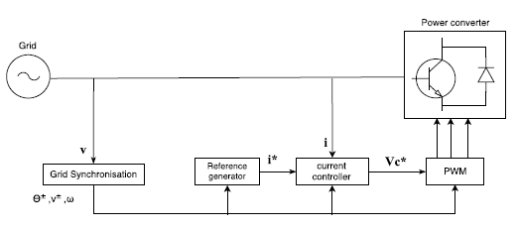
Figure 1. 3 Grid synchronisation for control of a grid-connected power converter

1.5 Aims, Objectives and Structure of the Thesis
The aim of this research is to develop, analyse and experimentally validate the control and synchronisation strategies required for a single-stage semi-Z-source inverter to operate as a standards-compliant single-phase grid-connected photovoltaic interface. The emphasis is on eliminating DC current injection, achieving robust grid synchronisation under distorted grid conditions, and characterising the closed-loop power-quality and efficiency performance of the inverter against UK grid-connection requirements.
To achieve this aim, the following research objectives are defined:
- O1. To review the impedance-source (Z-source) converter family and single-phase grid-synchronisation techniques, in order to identify the control and synchronisation gaps relevant to single-phase grid-connected PV (Chapters 2 and 4).
- O2. To develop and verify a small-signal state-space model of the Z-source DC-DC converter, including its parasitic elements, providing the dynamic plant description on which the inverter control design depends (Chapter 3).
- O3. To develop a single-phase grid-synchronisation technique that offers improved steady-state harmonic rejection over the best-performing classical PLL, and to validate it in both simulation and hardware (Chapter 5).
- O4. To design a closed-loop control scheme for the single-stage semi-Z-source inverter that eliminates DC current injection, employing a gain-scheduled proportional-resonant compensator derived by an analytical procedure, and to determine whether gain scheduling is warranted for this converter (Chapter 6).
- O5. To assess the grid-connected inverter against the UK single-phase grid-code and power-quality requirements of Engineering Recommendation G99 and BS EN 50160, and to characterise its losses and efficiency, identifying the dominant loss mechanism (Chapter 6).
- O6. To evaluate the closed-loop, PV-fed inverter under representative disturbance scenarios, namely voltage sag, phase jump, frequency change and sustained harmonic loading, in order to establish its operational resilience (Chapter 6).
In meeting these objectives, the thesis makes the following principal contributions:
- C1. A comparative review of Z-source converter topologies and a quantitative, five-metric benchmark of single-phase PLLs that identifies the residual steady-state harmonic ripple of the SOGI-PLL as the limitation to be addressed (Chapters 2 and 4).
- C2. A small-signal state-space model of the Z-source DC-DC converter, incorporating parasitic resistances and verified against circuit simulation, which forms the plant basis for the inverter control design (Chapter 3).
- C3. A novel αβ-CDSC-SOGI-PLL synchronisation technique that reduces the steady-state second-harmonic content of the phase estimate by a factor of between 7 and 24 relative to the SOGI-PLL, validated both in simulation and on a two-board hardware bench by a controlled-variant methodology that attributes the improvement to the cascade alone (Chapter 5).
- C4. A gain-scheduled proportional-resonant DC-injection compensator for the single-stage semi-Z-source inverter, together with an analytical procedure for designing it from a loop-gain specification that replaces the ad hoc gain selection of earlier single-stage designs. The compensator holds DC injection to 0.099% of the fundamental at the nominal operating point, within the applicable grid-code limit, and the accompanying analysis provides a transferable criterion showing that a fixed gain is sufficient across the realistic operating envelope, so the cost and complexity of scheduling can be avoided (Chapter 6).
- C5. Confirmation that the closed-loop inverter meets the Engineering Recommendation G99 and BS EN 50160 voltage, frequency and DC-injection requirements over the tested envelope, together with a loss-breakdown and efficiency characterisation that distinguishes the as-built peak efficiency of about 74% from a loss-excluded bound of about 86% and identifies the output-filter damping resistance as the dominant, removable loss (Chapter 6).
- C6. A disturbance-rejection evaluation of the closed-loop, PV-fed inverter across voltage-sag, phase-jump, frequency-change and harmonic scenarios, establishing its operational resilience under representative UK low-voltage grid conditions (Chapter 6).
The semi-Z-source topology itself was introduced in the author's earlier work [42]; the novel contributions of this thesis are the synchronisation technique of contribution C3 and the gain-scheduled DC-injection compensator and its design method of contribution C4, together with the compliance, loss and resilience analyses that establish the behaviour of the closed-loop system.
The remainder of the thesis is organised as follows:
- Chapter 2 reviews the impedance-source converter family across DC-DC, DC-AC, AC-DC and AC-AC configurations, establishing the operating principles and relative merits of the topologies.
- Chapter 3 develops and verifies the small-signal state-space model of the Z-source DC-DC converter, providing the dynamic plant description used in the later control design.
- Chapter 4 reviews single-phase grid-synchronisation techniques and benchmarks the principal classical PLLs, identifying the SOGI-PLL as the best classical option and quantifying its residual harmonic ripple.
- Chapter 5 presents the novel αβ-CDSC-SOGI-PLL, deriving its harmonic-cancellation mechanism, validating it in both simulation and hardware, and characterising the associated delay-for-rejection trade-off.
- Chapter 6 presents the closed-loop control of the single-stage semi-Z-source inverter, including the gain-scheduled DC-injection compensator and its analytical design, the PV-array integration, the assessment against G99 and BS EN 50160, the loss and efficiency analysis, and the disturbance-rejection simulation studies.
- Chapter 7 draws together the conclusions of the thesis and sets out recommendations for future work.
In summary, this thesis advances the control and synchronisation of single-stage semi-Z-source inverters for single-phase grid-connected PV, contributing a hardware-validated synchronisation technique and a gain-scheduled DC-injection control scheme, together with the modelling, compliance and performance analyses needed to establish them.

Scope and delimitations. The scope of this work is bounded as follows. The study addresses single-phase, low-voltage (residential-scale) grid connection; three-phase and higher-power operation are not considered. The synchronisation technique is validated in both simulation and hardware, whereas the closed-loop inverter is evaluated in simulation, so a hardware demonstration of the full inverter is not undertaken. Efficiency is characterised and its dominant loss identified, but the LCL filter that would remove that loss is designed rather than demonstrated. Reduction of the current total harmonic distortion, which is dominated by the low-frequency component intrinsic to single-phase power transfer, lies outside the objectives of this work. These boundaries are revisited in the limitations of Section 7.2.

Chapter 2
A Comprehensive Review of Impedance Source (Z-Source) Converters and Their Topological Variations

2.1 Introduction
Impedance source (Z-source) converters have introduced a groundbreaking approach in power electronics, combining both buck and boost voltage functions within a single-stage conversion. This design reduces the need for additional components, potentially lowering costs, reducing physical space, and improving efficiency by minimising the number of conversion stages. At the heart of this functionality is an impedance network, a two-port arrangement of inductors and capacitors that allows Z-source converters to sustain high efficiency and adapt to a wide range of applications, including renewable energy systems and electric drives [43], [44].
Traditional voltage-source converters (VSCs) are susceptible to shoot-through (ST) faults, which occur when the upper and lower switches of the same phase leg conduct simultaneously, creating a short circuit across the DC-link. This condition can produce excessive fault current, resulting in significant electrical and thermal stress on the switching devices and potentially causing converter failure. In contrast, the Z-source converter, overcomes this limitation by incorporating an impedance network between the voltage source and inverter bridge. This impedance network enables the converter to safely tolerate intentional ST states and utilise them for voltage boosting, thereby providing single-stage buck-boost operation with improved reliability and enhanced voltage conversion capability [43], [44].
The Z-source concept is highly versatile, supporting a wide range of power conversion applications: from direct current to direct current (DC-DC) and alternating current to direct current (AC-DC), to alternating current to alternating current (AC-AC) and direct current to alternating current (DC-AC). It can be applied in both voltage-fed and current-fed configurations, spanning two-level and multilevel structures. In recent years, various studies have introduced multiple Z-source converter topologies, sparking interest in fields like renewable energy integration, electric vehicle propulsion, energy storage systems, and industrial motor control [43]-[45]. This chapter will delve into Z-source converter configurations for DC-DC, AC-DC, AC-AC, and DC-AC single-phase power conversions, exploring each topology, its control strategies, challenges, and recent advancements that continue to improve upon the foundation design.

2.2 Z-Source Converter Configurations

2.2.1 Z-Source DC-DC Converter

2.2.1.1 Topology
The Z-source DC-DC converter features an impedance network comprising two inductors (L₁ and L₂) and two capacitors (C₁ and C₂) arranged in an "X" formation between the input source and the load. This configuration enables the converter to increase (boost) or decrease (buck) the input voltage as required. A typical topology is shown in Figure 2.1, illustrating the impedance network between the input source and the switching devices (typically Metal oxide semiconductor field effect transistor (MOSFET) or Insulated gate bipolar transistor (IGBT)) that drive the load. The converter's operation is managed by controlling the switches with PWM signals that regulate the ST duty ratio [44], [46], [47].
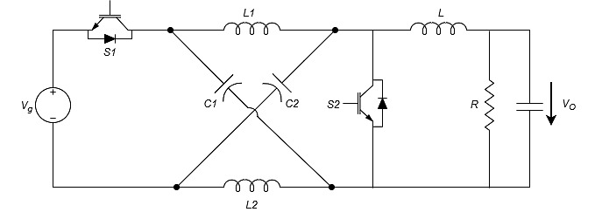
Figure 2. 1 Z-Source DC-DC Converter [6]

One major benefit of this topology is its flexibility in handling wide input-voltage ranges, which makes it well-suited to renewable energy systems such as photovoltaic (PV) arrays [47]-[48]. The impedance network's inductors and capacitors support safe operation during ST states, which elevate the voltage output without risking damage to the converter, distinguishing it from traditional converters [44], [46]-[48].

2.2.1.2 Operation
The Z-source DC-DC converter is distinctive in its ability to perform both boost and buck operations within a single conversion stage [47], [49]. The core of this functionality lies in the ST state, during which switches within a phase leg that would normally be prohibited from conducting simultaneously are intentionally turned on. Unlike traditional converters where such a condition would result in device failure, the Z-source converter exploits the energy stored in its impedance network's inductors and capacitors to achieve voltage boosting during ST states [47], [49], [50].
When the switches are off, energy stored in the inductors is transferred to the load, performing the buck operation. The duration of the ST state versus the non-ST state, determined by the PWM duty cycle, controls whether the converter boosts or bucks the voltage [49], [50]. The voltage gain can be calculated as:
$$G= \frac{V_{out}}{V_{in}}= \frac{1}{1-2D_{ST}} 2.1$$
where D_{ST}​ is the shoot-through duty cycle. [6]
The single-stage buck-boost characteristic represents a significant advantage over conventional DC-DC converters, which often require separate boost and buck stages. This feature makes the Z-source converter popular in renewable energy applications, such as PV systems, where fluctuating input voltages must be regulated and often stepped up to a higher dc-link voltage [47], [50]. Furthermore, the ST state enables higher voltage gains than those achievable with traditional boost converters at practical duty cycle levels [47], [49].

2.2.1.3 Control Strategies
Control strategies for Z-source DC-DC converters have evolved to improve voltage regulation and reduce energy losses. Traditional control techniques for Z-source converters now effectively manage the unique traits of this topology, particularly in regulating ST states for maximum voltage boost. Pulse Width Modulation (PWM) remains one of the most widely adopted control techniques, where the shoot-through duty cycle is adjusted to regulate the output voltage and maintain the desired operating conditions of the impedance network. In a Z-source converter, PWM alternates between normal and ST modes, supporting voltage boosting while keeping energy balanced within the impedance network. This straightforward control approach offers flexibility in buck and boost operations, fitting applications like battery charging and renewable energy systems [48]-[51].

2.2.1.4 Advancements in Design and Control for Z-Source DC-DC Converters
Significant advancements in Z-source converters have been made over the years to overcome limitations found in basic topologies. These improvements include new designs, enhanced control strategies, and integration with advanced technology.
- Topology Design Advancements
Switched-Inductor and Switched-Capacitor Z-Source Converters: To address the need for large passive components in basic Z-source converters, switched-inductor and switched-capacitor topologies were developed. These configurations incorporate additional inductors and capacitors to boost voltage gain while minimising the size of passive components [48], [52]. By toggling between multiple inductors or capacitors, these topologies achieve high voltage gains without requiring large components, easing space and cost challenges in compact applications [48], [53].

- Control Advancements
Sliding Mode Control (SMC): Traditional control strategies, like PWM, may struggle with non-linearities and input disturbances in basic Z-source converters. SM) offers a robust alternative by maintaining stability under load changes and input fluctuations. SMC employs a switching surface to guide the converter’s behaviour, and the controller ensures the system “slides” along this surface to stabilise output, minimising current ripple and enhancing voltage regulation [54], [55].
Model Predictive Control (MPC): Implementing MPC in Z-source converters enhances dynamic performance by forecasting future states and adjusting controls in real-time. This control approach minimises steady-state error and improves transient response, allowing the system to adapt quickly to input or load changes and ultimately improving efficiency [50], [56].

2.2.1.5 Advantages and Limitations
Each Z-source converter topology has distinct advantages, such as one-stage buck and boost capability, ST tolerance, high voltage gain, and greater efficiency. However, these strengths are balanced by certain drawbacks, including the requirement for larger passive components, more complex control methods, and potential switching losses. Recognising these trade-offs is crucial for selecting the right Z-source configuration for a specific application, whether in renewable energy, electric vehicles, or industrial drives.
Advantages
- Single-Stage Buck and Boost: Z-source converters perform both buck and boost functions in one stage, streamlining system design by removing the need for multiple stages [48], [49].
- Shoot-Through Tolerance: Unlike standard DC-DC converters, Z-source converters can tolerate ST states, enhancing reliability by preventing damage during short-circuit events [48], [49].
- Higher Voltage Gain: Due to the impedance network, Z-source converters achieve higher voltage gains than conventional converters that may require additional stages [48], [49].
- Improved Efficiency: Combining buck and boost in a single stage reduces the component count and minimises energy loss, especially beneficial in renewable energy systems and electric vehicles [48], [53].

Limitations
- Larger Passive Components: The impedance network requires larger inductors and capacitors than those in traditional converters, which increases the size and weight of the device – a constraint in space-limited settings [48], [49].
- Control Complexity: Stable voltage regulation during load or input changes can be challenging; managing both normal and ST states adds to control complexity [50], [51].
- Voltage Stress: During ST states, high voltage stress on passive components may impact reliability if not correctly sized or if components degrade over time [49], [53].

2.2.1.6 Applications
Z-source DC-DC converters are used in battery management systems, renewable energy converters (especially PV systems), and electric vehicles, where voltage regulation is essential for optimal performance and system longevity [48], [50], [53].

2.2.2 Z-Source DC-AC Inverter

2.2.2.1 Topology
The Z-source DC-AC inverter (ZSI) is probably the most widely studied topology in the Z-source family. It incorporates a similar impedance network (two inductors and two capacitors) but is designed to convert DC input to AC output [12], [44]. It is typically used in electric vehicles [57] or renewable energy systems like solar PV inverters [58]. The impedance network is placed between the DC input and an inverter bridge, which is responsible for generating the AC output as shown in Figure 2.2.
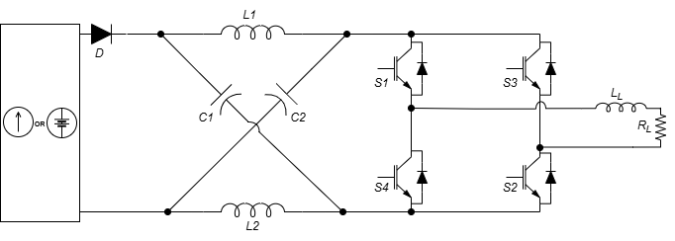
Figure 2. 2 Z-source DC-AC Inverter [12]

The ZSI is designed to overcome the limitations of traditional VSIs by allowing both voltage buck and boost operations within a single stage. This is achieved through a ST state, where both switches in an inverter leg are turned on simultaneously. Unlike traditional inverters, which would short-circuit under such conditions, the ZSI can safely operate, boosting the input voltage to the desired level [43], [44].

2.2.2.2 Operation
The ZSI operates differently from traditional VSIs or CSIs due to the incorporation of the ST state. In a conventional VSI, the simultaneous turning on of two switches in the same leg (a ST condition) would cause a short circuit and potentially damage the system. However, in a ZSI, the impedance network allows for safe operation in this condition.
The inverter can operate in three different states [12]:
- Active state: During this state, the switches in the inverter bridge operate normally, converting DC to AC by following the sinusoidal modulation of the PWM control.
- Zero state: In this state, all the switches are turned off, and no current flows through the load.
- Shoot-through state: This is the critical state for voltage boosting. During this state, both switches in a leg are turned on simultaneously, causing a short circuit that boosts the input voltage through the impedance network before it is applied to the inverter bridge. When ZSI is in the ST state for an interval $T_{0}$ over a switching period $T$, the ST duty cycle DST is the ratio ${T_{0}}/T$.
The voltage gain in a ZSI is determined by both the modulation index ($M$) and the ST duty cycle ($D_{ST}$):
$$G= \frac{V_{out}}{V_{in}}= \frac{1}{1-2D_{ST}} x M 2.2$$
M is the modulation index, which is defined as $M= {V_{REF}}/{V_{CAR}}$.
In case of simple boost control, amplitude of two straight line is equal to peak of reference waveform, so modulation index $M$ and ST ratio, $D_{ST}= {T_{0}}/T=1-M$
So that,
$$G = \frac{V_{out}}{V_{in}}= \frac{1-D_{ST}}{1-2D_{ST}}= \frac{M}{2M-1} 2.3$$

The ZSI topology design allows for simultaneous voltage boosting and DC-AC inversion [59]. The ST state allows the inverter to boost the DC input voltage to a higher level before converting it to AC, improving efficiency and reducing the need for a separate boost converter. This makes ZSIs particularly well-suited for renewable energy systems and applications where the input voltage may fluctuate [6], [60].

2.2.2.3 Control Strategies
Z-source inverters (ZSI) use Sinusoidal Pulse Width Modulation (SPWM) and Space Vector Modulation (SVM) as primary control methods for managing output voltage and current.
- Sinusoidal Pulse Width Modulation (SPWM): SPWM is widely utilised in traditional inverters and has been adapted for ZSIs. This approach compares a sinusoidal reference signal with a high-frequency triangular carrier to generate the gating signals for the switches. With ZSIs, however, the shoot-through (ST) state adds complexity to the control scheme. To address this, variations like shoot-through SPWM were developed, enabling voltage boosts while preserving high-quality AC output [7], [61].
- Space Vector Modulation (SVM): SVM is valued for optimising inverter control by minimising switching losses and improving voltage utilisation. In SVM, the reference voltage vector is created from available inverter switching states. The ZSI's shoot-through state adds complexity, but space vector shoot-through control allows for effective use of the Z-source impedance network while enhancing voltage gain and reducing harmonic distortion. SVM is especially beneficial for high-power applications, like electric vehicle drives and renewable energy systems, where efficiency is essential [61], [62]..

2.2.2.4 Advancements in Design and Control for Z-Source DC-AC Inverters
Recent advancements in Z-source inverter (ZSI) design and control aim to enhance performance, efficiency, and adaptability to various applications.
- Quasi-Z-source Inverter (qZSI): One major innovation in ZSI topology, the qZSI, lowers component stress and ensures continuous input current, which is particularly beneficial for PV systems that need stable input current due to the fluctuating nature of solar energy. The qZSI uses a modified impedance network configuration, improving performance and allowing for a more compact design, especially useful for grid-tied PV systems [6], [60].
- Trans-Z-Source Inverter (TZSI): The TZSI incorporates a transformer into the impedance network, offering galvanic isolation and enhanced voltage boosting. This topology fits well in high-power applications, such as motor drives and renewable energy systems, where high voltage gain and input-output isolation are essential. The transformer in the TZSI also reduces voltage stress on components, improving reliability for industrial use [32], [59], [60].
- Switched-Inductor Z-Source Inverter (SL-ZSI): Designed to boost voltage more effectively, the SL-ZSI integrates additional inductors into the impedance network. This topology achieves high voltage gains without a significant increase in size, making it ideal for high-voltage applications like EV motor drives and large-scale renewable energy systems, where efficient voltage boosts are needed [6], [34], [44], [63].
- Improved Z-source Inverter (IZSI): The IZSI addresses the challenge of high inrush current during ZSI startup. In traditional ZSIs, the initial zero voltage across capacitors can lead to high inrush currents, quickly charging capacitors and causing resonance between capacitors and inductors. This can result in voltage and current surges. The IZSI mitigates this by altering the positions and connections of the inverter bridge and input diode, reducing capacitor voltage stress and inrush current at startup, without needing extra components [6], [64] .

2.2.2.5 Advantages and Limitations
Advantages
- Boosting and Inversion in a Single Stage: ZSIs can both boost voltage and perform DC-AC inversion in a single stage, eliminating the need for a separate boost converter, which reduces system complexity and component count [12], [43], [44].
- High Reliability: Z-source inverters tolerate shoot-through states, enhancing reliability compared to traditional voltage-source inverters (VSIs) and current-source inverters (CSIs), which are more vulnerable in such situations. This resilience makes ZSIs well-suited for environments where input conditions fluctuate, such as PV systems [34], [43], [44].
- Improved Voltage Gain: The impedance network in ZSIs allows for higher voltage gains than conventional inverters, making them ideal for applications requiring a significant boost from a lower input voltage to a higher AC output [43], [44], [63].
- Reduced Switching Stress: The shoot-through state, combined with advanced control methods like SVM, can help alleviate stress on switches, lowering switching losses and enhancing efficiency [32], [43], [44].

Limitations
- Component Sizing: ZSIs require properly sized inductors and capacitors to manage the ST state and voltage boost. This can increase the converter's size and cost, particularly in high-power settings [12], [43], [44].
- Complex Control: Implementing the ST state without causing instability demands sophisticated control strategies, such as SPWM and SVM, which adds to the control system’s complexity. The modulation strategy must balance voltage boosting with AC output generation [43], [44], [65].
- Limited Applicability in Low Power: Due to the added components and complexity, ZSIs are less suitable for low-power applications, where traditional inverters may offer sufficient performance. In such cases, the higher costs and complexity of ZSIs might not justify their benefits [43], [44], [66].

2.2.2.6 Applications
ZSIs are commonly used in grid-tied renewable energy systems, where both voltage regulation and inversion are needed. Applications include photovoltaic systems, wind energy conversion systems, and electric vehicle motor drives [34], [57], [58].

2.2.3 Z-Source AC-DC Converter

2.2.3.1 Topology
Traditional voltage source rectifier (VSR) lacks buck/boost capability, so a dc‐dc converter is generally cascaded to buck to boost their output to the required voltage [43], [46]. The Z-source AC-DC converter integrates an impedance network with a rectifier bridge to convert AC input to DC output, allowing for voltage boost and efficient conversion in a single stage [63]. The impedance network is placed between the rectifier and the load as shown in Figure 2.3, enabling the converter to boost the output voltage as needed. This topology is commonly used in DC microgrids or as a front-end rectifier in industrial applications where stable DC output is required from an AC source.

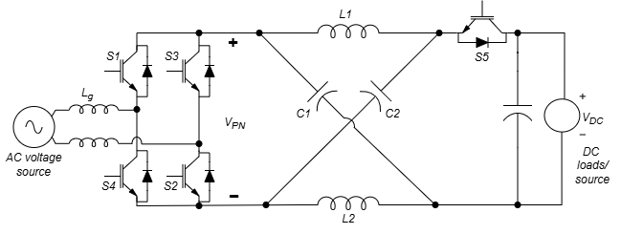
Figure 2. 3 Z-source AC-DC Converter [6]

2.2.3.2 Operation
The operation of a Z-source AC-DC converter resembles that of a Z-source DC-DC converter, with the addition of a rectification stage [44], [46]. Here, the input AC voltage is first converted to a pulsating DC signal through a bridge rectifier. The Z-source impedance network then interacts with the rectifier to either boost or reduce the voltage, depending on the desired output level [6].
In grid-connected applications, active power factor correction (PFC) is often employed to ensure the converter draws current in sync with the input voltage, minimising harmonic distortion and improving efficiency [60], [61]. By controlling the shoot-through (ST) state of the switches in the rectifier, the converter can enhance the DC output voltage while maintaining a high power factor [46].
The boost factor or Gain (G) for an AC-DC Z-source converter mirrors that of a DC-DC Z-source converter:
$$G= \frac{V_{out}}{V_{in}}= \frac{1}{1-2D_{ST}} 2.4$$
where $D_{ST}$​ is the ST duty cycle [6]. This setup enables the Z-source AC-DC converter to both boost voltage and reduce harmonics, making it especially suitable for applications in industrial drives and renewable energy sources like wind and solar farms [7].

2.2.3.3 Control Strategies
Advanced control techniques such as Power Factor Correction (PFC) and Dual-Loop Control (DLC) are commonly used to optimise efficiency and improve response in Z-source AC-DC converters. Maintaining a high power factor is especially crucial in grid-tied systems to ensure stable operation and reduce harmonics [65], [66].
- Power Factor Correction (PFC): In Z-source AC-DC converters connected to the grid, PFC is essential for efficient energy conversion and harmonic reduction. Active PFC uses feedback loops to adjust the duty cycle of the switches, helping maintain a power factor close to unity. This technique enables Z-source AC-DC converters to achieve both voltage boost and harmonic correction in one stage, which is particularly valuable in renewable energy systems where grid compliance requires high power factor performance [67], [68].
- Dual-Loop Control (DLC): This strategy combines voltage and current feedback loops to regulate the performance of Z-source AC-DC converters. The outer voltage loop stabilises output voltage, while the inner current loop controls input current, enhancing dynamic response and reducing voltage ripple. This dual-loop setup improves efficiency, especially under varying load conditions, and is frequently used in industrial AC-DC systems and front-end rectifiers for DC microgrids [59], [66].

2.2.3.4 Advancements in Design and Control for Z-Source AC-DC Converters
Advancements in Z-source AC-DC converter design focus on achieving greater voltage conversion ratios, improving efficiency, and ensuring high performance in demanding applications.
- Extended-Boost Z-Source Converter: Developed to provide a higher voltage conversion ratio, the extended-boost Z-source converter enhances the traditional design by adding extra passive components in the impedance network. This addition allows for significant voltage boosting, which is beneficial in high-voltage direct current (HVDC) systems where efficiency, high voltage gains, and stable output are essential for reliable operation [63].
- Active Rectifier Integration: Integrating active rectifiers into the Z-source AC-DC topology reduces switching losses and supports high power factor correction. Active rectifiers enhance efficiency and allow the converter to reach near-unity power factors in grid-tied applications, making this approach ideal for industrial drives and renewable energy systems requiring stable AC-DC conversion [67].

2.2.3.5 Advantages and Limitations
Advantages
- Single-Stage AC to DC Conversion: The Z-source AC-DC converter combines both rectification and voltage boosting in a single stage, simplifying the converter’s structure and eliminating the need for multiple converters.
- Power Factor Correction (PFC): With integrated active PFC, Z-source AC-DC converters can maintain high power factors, essential in grid-tied applications for boosting system efficiency and reducing harmonic distortion [6].
- Voltage Boost Capability: Like other Z-source topologies, the AC-DC version can increase input voltage, ideal for cases where the input AC voltage needs boosting to achieve a stable DC output.
- Reduced Harmonic Distortion: The impedance network helps smooth out current and voltage ripples, lowering harmonic distortion in the output and improving power quality for the load [6].

Limitations
- Large Passive Components: The inductors and capacitors needed for the impedance network can increase the physical size and cost of the converter, which can be a limitation for compact applications, like portable power systems [6].
- Control Complexity with PFC: Managing power factor correction alongside voltage boost control adds complexity. The control system must ensure that current drawn from the AC supply remains in phase with the voltage while handling voltage boosting [67].
- Switching Losses: While the Z-source design can reduce voltage stress on some components, rectifier switches may still experience significant switching losses, especially at high power levels or switching frequencies [67].
These control and design advancements make Z-source AC-DC converters highly adaptable for applications that demand both efficient voltage boosting and harmonic reduction, aligning well with industrial and renewable energy requirements.

2.2.3.6 Applications
These converters are widely used in DC microgrids, industrial motor drives, and renewable energy systems, where efficient AC-DC conversion is necessary [6], [12].

2.2.4 Z-Source AC-AC Converter

2.2.4.1 Topology
The Z-source AC-AC converter stands out in the Z-source family because it provides direct AC-to-AC conversion, eliminating the need for an intermediate DC link. This unique capability makes the converter more compact and cost-effective, making it ideal for applications such as Variable Frequency Drives (VFDs) and solid-state transformers, where efficient, direct AC conversion is essential [66]. Besides transforming voltage and frequency, Z-source AC-AC converters can condition, isolate, and filter incoming power, while also regulating voltage [69], [70].
In the Z-source AC-AC setup, the impedance network is positioned between the AC input and the inverter/rectifier stages, as shown in Figure 2.4, enabling it to boost or reduce voltage as required. Typically, two sets of switches are employed: one for rectification and the other for inversion, with Pulse Width Modulation (PWM) techniques controlling these switches to adjust output voltage and frequency [66].
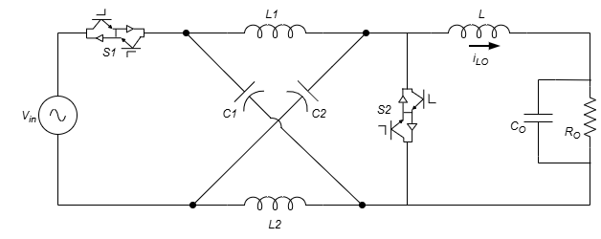
Figure 2. 4 Z-source AC-AC Converter [14]

2.2.4.2 Operation
The Z-source AC-AC converter operates by first rectifying the input AC voltage, then applying the adjusted (boosted or bucked) voltage to an inverter to recreate an AC output with the desired voltage and frequency. A defining feature here is the impedance network’s role in allowing voltage boosts through the shoot-through (ST) states, even while both input and output are in the AC domain.
In this process, the shoot-through state stores energy within the inductors in the impedance network, which is then released to increase the output voltage once the switches return to normal operation [66], [69], [71]. By carefully managing the duty cycle during the shoot-through phase, the converter can control both the output voltage and frequency. The resulting boost factor and frequency are expressed as follows:
$$G= \frac{V_{out}}{V_{in}}= \frac{1-D_{ST}}{1-2D_{ST}} 2.5$$
$$f_{out}=f_{in}× \frac{1}{1-2D_{ST}} 2.6$$
This single-stage voltage and frequency control, without an intermediate DC link, is especially beneficial for VFDs, which need precise control over motor speed and torque. Fewer conversion stages also mean improved efficiency and reduced costs, which are advantageous in industrial applications [69].

2.2.4.3 Control Strategies
To efficiently manage voltage and frequency conversion, Phase-Shifted Pulse Width Modulation (PSPWM) and Resonant Control are employed, enhancing efficiency and lowering harmonic distortion [66].
- Phase-Shifted Pulse Width Modulation (PSPWM): PSPWM is specifically adapted for Z-source AC-AC converters to handle both voltage and frequency adjustments. By phase-shifting the gating signals across switches, PSPWM reduces the total harmonic distortion (THD) in the output waveform, improving efficiency. Integrating the shoot-through state into PSPWM further enables voltage boosting without needing an intermediate DC link, simplifying the system and boosting efficiency in applications like VFDs and power conditioners [71], [72].
- Resonant Control: Resonant control is often used in Z-source AC-AC converters, particularly for reactive power compensation and minimising switching losses. This method leverages the natural resonant frequencies of the impedance network to achieve Zero Voltage Switching (ZVS) or Zero Current Switching (ZCS). By minimising electromagnetic interference (EMI) and switching losses, resonant control makes the converter highly efficient in high-frequency operations. This is valuable for applications requiring precise frequency control and reactive power management, such as in industrial power systems [71],[72].

2.2.4.4 Advancements in Topology Design and Control for Z-Source AC-AC Converters
- Matrix Z-Source Converter: By combining matrix converter technology with the Z-source impedance network, the matrix Z-source converter enables direct AC-to-AC conversion without an intermediate DC link. This innovation reduces the need for switching devices and passive components, resulting in greater efficiency and a smaller system footprint. The matrix Z-source converter is ideal for applications like industrial motor drives and power conditioners, where compact design and high efficiency are key [71].
- Direct Power Control (DPC): DPC is a control approach that allows real-time regulation of active and reactive power in Z-source AC-AC converters. This method is particularly useful in power conditioning applications, where precise control over power flow and reactive power is essential for system stability and efficiency [72].

2.2.4.5 Advantages and limitations
Advantages
- Direct AC-to-AC Conversion: The Z-source AC-AC converter eliminates the need for an intermediate DC stage, providing direct AC-to-AC conversion. This reduction in system complexity translates to higher efficiency and fewer conversion stages.
- Simultaneous Voltage and Frequency Control: The Z-source impedance network facilitates both voltage boosting and frequency conversion, making the Z-source AC-AC converter highly effective for applications like VFDs and power conditioning, where precise control is essential.
- High Efficiency: Direct AC conversion without an intermediate DC stage minimises energy losses, making the Z-source AC-AC converter more efficient than traditional back-to-back AC-DC-AC converters.
- Harmonic Reduction: The impedance network functions as a filter, reducing total harmonic distortion (THD) and enhancing the quality of output power, which is particularly beneficial in industrial environments requiring clean power for sensitive equipment [69].

Limitations
- Complexity in Control: Managing both voltage and frequency while incorporating the shoot-through state adds complexity to the control system. Advanced modulation techniques, such as PSPWM or SVM, are often necessary, increasing both design and computational demands [72].
- Component Size and Cost: As with other Z-source configurations, the impedance network requires sizable inductors and capacitors, which can increase the converter's size and cost. This may be a limitation in applications where space is restricted [69].
- Switching Losses: Although direct AC conversion reduces some energy losses, high-frequency switching can still lead to significant losses, especially in high-power industrial applications [69].

2.2.4.6 Applications
These converters are primarily applied in VFDs, power conditioners, and solid-state transformers, where direct AC-AC conversion is necessary for voltage and frequency control [69].

2.3 Summary of Impedance-Source Network Topologies for different power conversions
Table 2.1 summarises the four Z-source converter topologies discussed in section 2.2, bringing together their operating principles, governing equations, component counts, advantages, limitations and applications. This table provides the basis for the selection made in Chapter 3 and 6, where the semi-Z-source inverter is developed from the Z-source DC-DC converter, owing to its lower component count among the four configurations.

Table 2. 1 Comparative Analysis of Z-Source Converter Configurations
Topology / Aspect | Z-Source DC-DC Converter | Z-Source DC-AC Inverter | Z-Source AC-DC Converter | Z-Source AC-AC Converter
Operation | DC to DC conversion with single-stage buck and boost capabilities | DC to AC conversion with simultaneous voltage boosting and inversion | AC to DC conversion with voltage boost and rectification in one stage | Direct AC-to-AC conversion with simultaneous voltage and frequency transformation
Key Equation | $G= \frac{V_{out}}{V_{in}}= \frac{1}{1-2D_{ST}}$ | $G= \frac{V_{out}}{V_{in}}= \frac{M}{1-2D_{ST}}$ | $G= \frac{V_{out}}{V_{in}}= \frac{1}{1-2D_{ST}}$ | $G= \frac{V_{out}}{V_{in}}= \frac{1-D_{ST}}{1-2D_{ST}}$  $f_{out}=f_{in}× \frac{1}{1-2D_{ST}}$
Number of Components | 2 inductors, 2 capacitors, 2 switches | 2 inductors, 2 capacitors, H-bridge (4 switches) | 2 inductors, 2 capacitors, rectifier, 2 switches | 2 inductors, 2 capacitors, 4 switches (H-bridge), rectifier
Control Strategy | PWM, Sliding Mode Control (SMC), Model Predictive Control (MPC) | Sinusoidal Pulse Width Modulation (SPWM), Space Vector Modulation (SVM) | Power Factor Correction (PFC), Dual-Loop Control | Phase-Shifted PWM (PSPWM), Direct Power Control (DPC)
Modulation Technique | PWM with variable duty cycle | SPWM, SVM with shoot-through control | PWM, active PFC for improved power quality | PSPWM, SVM for harmonic control and efficiency
Key Advantages | Single-stage buck and boost, fewer components required | Single-stage boost and inversion, higher voltage gain | Single-stage AC-DC conversion with voltage boost and PFC | Direct AC conversion, no intermediate DC stage required
Drawbacks | Large passive components, control complexity | Control complexity in shoot-through and voltage regulation | High voltage stress on components, switching losses in rectifier | Complex control, high component count in switching network
Applications | Solar energy systems, electric vehicle chargers, battery storage | Photovoltaic inverters, uninterruptible power supplies (UPS) | Front-end converters for DC microgrids, industrial drives | Variable frequency drives (VFDs), power conditioners, solid-state transformers

2.4 Conclusion
Z-source converters have demonstrated their versatility and efficiency in a wide range of applications, from renewable energy systems to industrial drives. Their ability to perform both voltage buck and boost operations in a single stage significantly simplifies converter design by eliminating the need for complex multi-stage systems, positioning Z-source converters as a compelling solution for future power electronics applications. These converters offer distinct features and capabilities that effectively address many challenges associated with traditional converter topologies.
A detailed analysis of various Z-source topologies reveals that advancements are primarily driven by several key objectives: (1) increasing voltage boost capability; (2) minimising the number and size of active and passive components; (3) reducing voltage stress on both active and passive devices; (4) enhancing input voltage (dc-link) utilisation; (5) improving the electromagnetic compatibility (EMC) of the system; and (6) increasing system reliability [73]. These objectives create situations where each topology is optimised for specific applications, and no single design can be universally applied.
The original Z-source network has evolved into several variants, including the quasi-Z-source and trans-Z-source networks, as well as numerous other configurations tailored for DC-DC, DC-AC, AC-DC, and AC-AC power conversion, available in both two-level and multilevel topologies, with voltage- or current-fed inputs. Continued advancements in control strategies, topology design, and the integration of wide bandgap semiconductors are expected to drive the adoption of Z-source converters in the years ahead.

Chapter 3
Modelling, Control and Optimal Design of Z-source DC-DC Converter

3.1 Introduction
A family of Z-source DC-DC converters was introduced in [26], featuring an impedance network that reduces the number of active switches and passive components (such as inductors and capacitors) compared to other topologies. This design enables a significant voltage boost, making the circuit more reliable and cost-effective. It is particularly well-suited for DC drives and renewable energy applications. However, no detailed mathematical modelling or analysis has been conducted to fully understand the behaviour of these converters in both transient and steady states.
The objective of this chapter is to develop a general model that accurately captures the nonlinear characteristics of the Z-source DC-DC converter introduced in [26]. Small-signal analysis, based on the state-space averaging method, will be used to derive the output voltage response when a small perturbation is applied to the duty cycle. Both the mathematical model and the Z-source DC-DC converter circuit will be simulated and verified in MATLAB Simulink. By applying three excitation magnitudes (step changes) that span the small-signal validity range to the duty cycle in both models, the transient and steady-state performances will be observed. This approach ensures that the mathematical representation aligns with the actual circuit design. The resulting information will be used to derive the transfer function, which is critical for optimising the selection of the Z-source network parameters.
This chapter explains the linearisation procedure and the bounds of its validity. The parasitic elements of the converter (inductor winding resistance, switch on-resistance, capacitor equivalent series resistance) are also considered and included in the state-space matrices.
The main contributions of this chapter are as follows. First, it derives a complete small-signal averaged state-space model of the Z-source DC-DC converter from first principles, together with the control-to-output and input-to-output transfer functions. Second, the model includes the dominant parasitic elements, the inductor winding resistance, the switch on-resistance, and the capacitor equivalent series resistance, rather than adopting a lossless idealisation. Third, the linearised model is validated against a full switching simulation and its region of validity is quantified, establishing explicit bounds on the duty-ratio perturbation for which the linear model is accurate. Fourth, the dependence of the converter dynamics on the Z-network component values is characterised. Fifth, the pole-zero and frequency-domain analysis characterises the linearised plant, identifying the two resonant modes, the non-minimum-phase behaviour, and the bandwidth and damping constraints that inform the controller design of Chapter 6.
The chapter is organised as follows. Section 3.2 establishes the circuit topology and operating conventions of the Z-source DC-DC converter and declares the operating-mode assumptions. Section 3.3 presents the switching equations for each of the two conducting states and combines them into a duty-ratio-averaged set of nonlinear differential equations. Section 3.4 linearises these equations about a chosen operating point and assembles the resulting small-signal state-space mathematical model. Section 3.5 verifies the linearised model against the Simscape simulation through three step-response studies that span the small-signal, moderate-signal, and large-signal perturbation and establishes the quantitative bounds of model validity. Section 3.6 examines the sensitivity of the converter to component-value variation within the manufacturing tolerance band. Section 3.7 characterises the linearised plant in the frequency domain through pole-zero analysis and Bode-diagram analysis. Section 3.8 summarises the findings and identifies the design constraints that the linearised plant imposes on the closed-loop controller of Chapter 6.

3.2 Circuit topology for the Z-source DC-DC converter
Various Z‐source DC-DC converters have been proposed in the literature using the same impedance networks as the ZSI. When realised as a DC-DC converter, the introduced Z‐source impedance network must similarly be short‐circuited for a certain defined duty ratio per switching period, known as the ST duty cycle.
The basic configuration shown in Figure 3.1 is one possibility out of many. This topology was proposed in [26] and is preferred to traditional DC‐DC converter topologies as it can achieve very high voltage boosting. This Z-source DC-DC converter has both buck and boost characteristics, with the distinguishing property that the input source and the output load share a common ground reference. This single-ground feature is the practical reason for choosing the semi-Z-source over the classical Z-source in grid-connected photovoltaic applications: it simplifies the wiring of the input array and the grid-tie output stage to a common chassis reference, removing the need for galvanic isolation transformers at this stage [26]. The converter’s duty cycles varies between 0 and 1. This feature, along with changing the polarity of the load voltage by just controlling the duty cycles of the switches, makes the converters very simple and more economical for many applications, e.g. DC drives and other renewable energy systems.
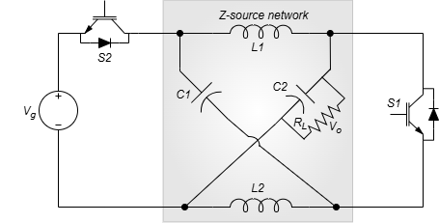
Figure 3. 1 Z-source DC-DC Converter

Fig.3.1 shows the basic structure of Z-source DC-DC converter with a z-source network (consisting of two inductors and two capacitors), two switches and an input voltage source, eliminating the need for a front-end diode [26].
The position of voltage source and the capacitors position can be exchanged resulting in two groups of circuits.

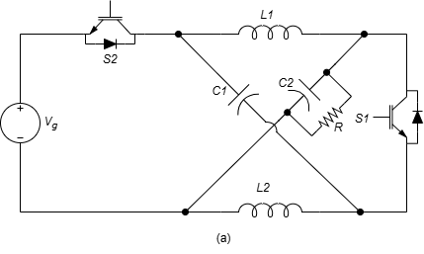
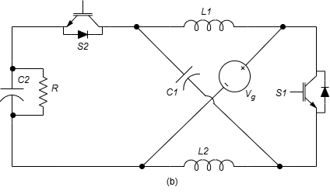
Figure 3. 2 (a) and (b) Two Z-source DC-DC converter topology

When duty cycle changes from (0~0.5), the topology shown in Fig 3.2 (a) have the boost characteristics and positive voltage output. When duty cycle changes from (0.5~1) they have buck-boost characteristics and negative voltage output.
When duty cycle changes from (0~0.5), the topology shown in Fig 3.2 (b) have the buck characteristics and positive output. When duty cycle changes from (0.5~1), they have buck boost characteristics and negative voltage output [1], [6], [26].
Further topologies can be formed by switching the Load to either capacitor and also changing the position of voltage source and the capacitors position.
The Z-source network enables the converter to operate in a unique "shoot-through" mode, where both switches in a leg are turned on simultaneously. In traditional converters, this condition would result in a short circuit. However, in a Z-source converter, the ST mode facilitates energy storage in the inductors and allows the capacitors to charge when both switches are closed. During the non-ST mode, the capacitors discharge, and the energy stored in the inductors is released, thereby boosting the output voltage.
However, the concept of the ST duty cycle to control the output voltage is ruled out completely when simple control of the duty cycle of the switches is applied, as in the case of Bipolar Pulse Width Modulation (Bipolar PWM) switching [6], [26].

3.3 Circuit Analysis of the Z-Source DC-DC Converter
The analysis throughout this chapter assumes continuous conduction mode (CCM) operation. In CCM, both inductor currents remain strictly positive throughout the switching cycle, the diodes conduct continuously during their respective intervals, and the two switching states cleanly alternate between $S_{1}$-conducting and $S_{2}$-conducting with no overlapping or freewheeling third state. Continuous conduction holds when each inductor's current ripple stays below its average current, so the current never falls to zero within a switching period. A large enough inductance, a high enough switching frequency, or a large enough average (load) current each keep the ripple below the average, and with $f_{sw}= 20 kHz$ and the parameters of Table 3.1 the condition is met across the operating range. The averaging procedure used to construct the small-signal model rests on this assumption: it assumes that the converter spends exactly two distinct, mutually exclusive intervals in each switching period, with no third (discontinuous) state in which both inductors are simultaneously freewheeling at zero current. These conventions are adopted to keep the resulting state-space matrices in a form that produces non-negative DC bus voltage at the operating point and to match the sign conventions used in the reference works on this topology [1], [12], [26].
At light load the converter can leave CCM, either through one inductor current reaching zero or, following [1] and [74], through both switches conducting simultaneously when an antiparallel diode forward biases. Neither case is analysed here. The converter is designed in CCM across the residential PV MPPT range, and the Chapter 6 controller enforces a duty-ratio floor that holds the steady-state operating point inside CCM.

3.3.1 Operating principles in Continuous Conduction Mode
The topology shown in Fig. 3.2(b) will be used to demonstrate the DC operating modes of the Z-source DC-DC converter in CCM.
In mode 1: $S_{1}$ is turned on, while $S_{2}$ is turned off
In mode 2: $S_{2}$ is turned on, while $S_{1}$is turned off
Fig. 3.3 (a) and 3.3 (b) shows modes 1 and 2, respectively. $D$ is the duty cycle of S1. The direction of the inductor current is different for the two operating modes
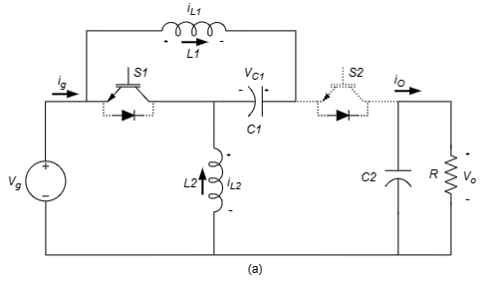
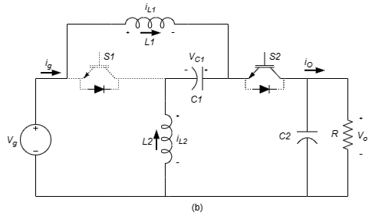
Figure 3. 3 DC operating modes for the Z-source DC-DC converter circuit

For the steady-state CCM analysis that follows, devices are treated as ideal and capacitors and inductors are assumed large enough to maintain voltage and current over a switching period; parasitic elements are reintroduced in the dynamic model of section 3.4. $V_{C1}$ is the voltage across the capacitor $C_{1}$, $i_{L1}$ and $i_{L2}$ is the current through $L_{1}$ and $L_{2}$ respectively and Vo is the voltage across $C_{2}$. The average inductor voltage on $L_{1}$ over one switching period should be zero in steady state, thus we have,
$$-V_{C1}∙D+\left(V_{g}-V_{C2}\right)∙\left(1-D\right)=0 \left(3.1\right)$$
The average inductor voltage on $L_{2}$ over one switching period should be zero in steady state, thus we have,
$$-V_{g}∙D+\left(V_{C1}-V_{C2}\right)∙\left(1-D\right)=0 \left(3.2\right)$$
From (3.1) and (3.2)
$${ V}_{g}=V_{C1} \left(3.3\right)$$
${ V}_{o}=\frac{V_{g}∙\left(1-2∙D\right)}{1-D} \left(3.4\right)$
From equation (3.4), one can deduce the following:
- for $D<0.5, Vo>0$
- for $D>0.5, Vo<0$
- For $D<0.66$, the output voltage is stepped down.
- For $D>0.66$ the output voltage is stepped up.
Therefore,
- when $D<0.5$, the converter has the positive output buck characteristic,
- when $D>0.5$, it has the negative output buck boost characteristic (output voltage polarity inversion)

3.4 Mathematical model of the Z-source DC-DC converter
The non-linear characteristics of electronic circuits like Z-source DC-DC switching converters make it challenging to derive transfer functions directly, especially when dealing with large signal variations. This non-linear behaviour results from components such as switching devices, diodes, inductors, and capacitors, which react differently depending on their operating conditions, particularly when subjected to significant voltage or current changes. Consequently, traditional linear equations don’t capture these circuits accurately under varying input or load conditions [1].
The dynamic model includes three parasitic elements. The inductor winding resistance $r_{L}$ and the MOSFET on-resistance $R_{on}$ combine into an averaged branch resistance $r_{L_eff}=r_{L}+D.R_{on}$ on the inductor diagonals of the state matrix. The capacitor equivalent series resistance (ESR) $r_{C}$ appears as a small correction to the output equation, since $r_{C}$ is much smaller than the load resistance [8].
To simplify the analysis, the circuit has to linearised around a specific operating point, which makes it easier to evaluate behaviour under small AC signal variations. This linearisation process generally involves three main steps:
- Identify a Steady-State Operating Point: The first step is to solve the circuit’s DC equations to find the steady-state voltages and currents at critical nodes and components under a constant input. This operating point becomes the reference around which we analyse the circuit’s behaviour. The mathematical model introduced in this chapter uses this steady-state (DC) operating point as its foundation.
- Small-Signal Approximation: Next, we linearise the non-linear system around the steady-state operating point. In this context, we apply the Generalised State Space Averaging (GSSA) modelling technique, as detailed in section 3.4.1.
- Derivation of the Transfer Function from Small-Signal AC Perturbations: Finally, a small AC signal perturbation is introduced to the input voltage, inductor current, and capacitor voltage to explore the dynamic response of the circuit. This transfer function characterises each parameter as a combination of its steady-state (DC) values and small AC variations, with further discussion provided in section 3.4.2.

3.4.1 Generalised state space average model
The system’s state variables, $i_{L1}\left(t\right)$,$i_{L2}\left(t\right)$, $v_{C1}\left(t\right)$, $v_{C2}\left(t\right)$, at a point time $\left(t\right)$. The converter alternates between two switching states.
With the source voltage $V_{g}$ setting the steady-state operating point of section 3.3.1, the switched dynamics about that operating point, including the $I^{2}R$-loss due to the non-ideal component term $r_{L_eff}$ on each inductor branch, are as follows.
When the switch S1 is ON:
The voltage across inductor $L_{1}$ ​ is equal to the negative of the voltage across capacitor $C_{1}$, opposed by the $IR$ drop across the averaged inductor-branch resistance $r_{L_eff}$.
$$v_{L1}={-v}_{C1}- r_{L_{eff}}.i_{L1}$$
$$⇒L_{1}\frac{di_{L1}}{dt}={-v}_{C1} - r_{L_{eff}}.i_{L1} \left(3.5\right)$$
- The voltage across inductor $L_{2}$ ​ is equal to the negative of the input voltage $V_{g}$, again opposed by $r_{L_eff}$​:
$$v_{L2}={-V}_{g}-r_{L,eff} i_{L2}$$
$$⇒L_{2}\frac{di_{L2}}{dt}={-V}_{g}-r_{L,eff} i_{L2} \left(3.6\right)$$
- The current through capacitor $C_{1}$ is equal to the current through inductor $L_{1}$​:
$$i_{C1}=i_{L1}$$
$$⇒C_{1}\frac{{dv}_{C1}}{dt}=i_{L1} \left(3.7\right)$$
- The current through capacitor $C_{2}$​ is given by the voltage across​ divided by the load resistance $R$:
$$i_{C2}=-\frac{v_{C2}}{R}$$
$$⇒C_{2}\frac{{dv}_{C2}}{dt}=-\frac{v_{C2}}{R} \left(3.8\right)$$
The differential equations when S1 is ON can be written in the state space form as
$$K\dot{x}=A_{1}∙x+B_{1}∙u \left(3.9\right)$$
where K is a constant matrix, $A_{1}$ is the state matrix, $x$ is the state variables vector, $B_{1}$ is the input vector, and $u$ is the input. Thus

$$\left[\begin{matrix}L_{1} & 0 & 0 & 0 \\ 0 & L_{2} & 0 & 0 \\ 0 & 0 & C_{1} & 0 \\ 0 & 0 & 0 & C_{2}\end{matrix}\right]\frac{d}{dt}\left[\begin{matrix}i_{L1} \\ i_{L2} \\ v_{C1} \\ v_{C2}\end{matrix}\right]=\left[\begin{matrix}-r_{L,eff} & 0 & -1 & 0 \\ 0 & -r_{L,eff} & 0 & 0 \\ 1 & 0 & 0 & 0 \\ 0 & 0 & 0 & -\frac{1}{R}\end{matrix}\right].\left[\begin{matrix}i_{L1} \\ i_{L2} \\ v_{C1} \\ v_{C2}\end{matrix}\right]+\left[\begin{matrix}0 \\ -1 \\ 0 \\ 0\end{matrix}\right]V_{g}\left(3.10\right)$$
When the switch S2 is ON:
The differential equations for the system’s state variables are derived as follows:
- The voltage across inductor $L_{1}$ ​ is the difference between the input voltage $V_{g}$​ and the voltage across capacitor $C_{2}$​, opposed by the $IR$ drop across the averaged inductor-branch resistance $r_{L_eff}$.
$$v_{L1}=V_{g}-v_{C2}-r_{L,eff} i_{L1}$$
$$⇒L_{1}\frac{di_{L1}}{dt}=V_{g}-v_{C2} -r_{L,eff} i_{L1} \left(3.11\right)$$
- The voltage across inductor $L_{2}$​ is the difference between the voltages across capacitors $C_{1}$ and $C_{2}$​, again opposed by $r_{L_eff}$​:
$$v_{L2}=v_{C1}-v_{C2}-r_{L,eff} i_{L2}$$
$$⇒L_{2}\frac{di_{L2}}{dt}=v_{C1}-v_{C2} -r_{L,eff} i_{L2} \left(3.12\right)$$
- The current through capacitor $C_{1}$​ is the negative of the current through inductor $L_{2}$​:
$$i_{C1}=-i_{L2}$$
$$⇒C_{1}\frac{{dv}_{C1}}{dt}=-i_{L2} \left(3.13\right)$$
- The current through capacitor $C_{2}$​ is the sum of the currents through $L_{1}$ ​ and $L_{2}$ minus the voltage across $C_{2}$​ divided by the load resistance $R$:
$$i_{C2}=i_{L1}+i_{L2}-\frac{v_{C2}}{R}$$
$$⇒C_{2}\frac{{dv}_{C2}}{dt}=i_{L1}+i_{L2}-\frac{v_{C2}}{R} \left(3.14\right)$$
The differential equations when S2 is ON can be written in the state space form as
$$K\dot{x}=A_{2}∙x+B_{2}∙u \left(3.15\right)$$
$$\left[\begin{matrix}L_{1} & 0 & 0 & 0 \\ 0 & L_{2} & 0 & 0 \\ 0 & 0 & C_{1} & 0 \\ 0 & 0 & 0 & C_{2}\end{matrix}\right]\frac{d}{dt}\left[\begin{matrix}i_{L1} \\ i_{L2} \\ v_{C1} \\ v_{C2}\end{matrix}\right]=\left[\begin{matrix}-r_{L,eff} & 0 & 0 & -1 \\ 0 & -r_{L,eff} & 1 & -1 \\ 0 & -1 & 0 & 0 \\ 1 & 1 & 0 & -\frac{1}{R}\end{matrix}\right].\left[\begin{matrix}i_{L1} \\ i_{L2} \\ v_{C1} \\ v_{C2}\end{matrix}\right]+\left[\begin{matrix}1 \\ 0 \\ 0 \\ 0\end{matrix}\right]V_{g} \left(3.16\right)$$
Given the state-space equations and matrices for the two modes,
- when Switch S1 is ON has been defined in (3.9) and (3.10),
- when Switch S2 is ON has been derived in (3.15) and (3.16),
we can apply the generalised state-space averaging method to average the dynamics over a switching period $T_{S}$. This is done by weighting the system’s behavior during the two switching states (S1 ON and S2 ON) based on the duty cycle $d$ and $d^{'}= 1-d$.
The state space expressions of (3.10) and (3.16) can be averaged by multiplying the left-hand-side by $d$ and $1-d$ respectively. They become:
$$K\dot{x}=A_{1}d∙x+B_{1}d∙u \left(3.17\right)$$
$$K\dot{x}=A_{2}d^{'}∙x+B_{2}d^{'}∙u \left(3.18\right)$$
Combining (3.17) and (3.18) we obtain
$$K\dot{x}=\left[A_{1}d+A_{2}d^{'}\right]∙x+\left[B_{1}d+B_{2}d^{'}\right]∙u \left(3.19\right)$$
This averaged state-space model now captures the combined dynamics of both switching states in a single set of equations and can now be used for small-signal analysis, control design, and stability studies.

3.4.2 Derivation of transfer function by small-signal ac perturbations
The derivation of the small-signal relationship among the state variables ($i_{L1}$,$i_{L2}$, $v_{C1}$ and $v_{C2}$ is obtained by applying small-signal ac perturbation $\hat{d}$ to the duty cycle $D$ which gives $d=D+\hat{d}$.
The following relationship exist:
$$d^{'}=1-d=1-\left(D+\hat{d}\right)=\left(1-D\right)-\hat{d}=D^{'}-\hat{d} \left(3.20\right)$$
The input voltage $V_{g}$ is assumed to be constant, hence ${\hat{v}}_{g}=0$. Also, $u=U+\hat{u}=U$. The state variables are also affected by the small-signal ac perturbation resulting in $x=X+\hat{x}$. That is
$$x=\left[\begin{matrix}i_{L1} \\ \begin{matrix}i_{L2} \\ v_{C1} \\ \begin{matrix}v_{C2}\end{matrix}\end{matrix}\end{matrix}\right]+\left[\begin{matrix}{\hat{i}}_{L1} \\ {\hat{i}}_{L2} \\ {\hat{v}}_{C1} \\ {\hat{v}}_{C2}\end{matrix}\right]$$
substituting $d$, $d^{'}$, $x$ and $u$ into (3.19)
$$K\left(\dot{X}+\hat{\dot{x}}\right)=\left\{A_{1}\left[D+\hat{d}\right]+A_{2}\left[D^{'}-\hat{d}\right]\right\}∙\left(X+\hat{x}\right)+\left\{B_{1}\left[D+\hat{d}\right]+B_{2}\left[D^{'}-\hat{d}\right]\right\}∙U \left(3.21\right)$$
Collecting the duty-dependent matrix as $A_{1}D+A_{2}D^{'}+\left(A_{1}-A_{2}\right)\hat{d}$ and expanding the products gives:

$$K\dot{X}+K\dot{\overset{ˆ}{x}}=\left(A_{1}D+A_{2}D'\right)X+\left(A_{1}-A_{2}\right)\overset{ˆ}{d} X+\left(A_{1}D+A_{2}D'\right)\overset{ˆ}{x}+\left(A_{1}-A_{2}\right)\overset{ˆ}{d} \overset{ˆ}{x}+\left(B_{1}D+B_{2}D'\right)U+\left(B_{1}-B_{2}\right)\overset{ˆ}{d} U \left(3.22\right)$$
The terms on the right-hand side of (3.22) separate by order. The constant (DC) terms, $\left(A_{1}D+A_{2}D'\right)X$ and $\left(B_{1}D+B_{2}D'\right)U$, are balanced by $K\dot{X}$ on the left, which is zero in steady state, so they cancel. The first-order terms, each containing a single perturbation, are $\left(A_{1}-A_{2}\right)\overset{ˆ}{d} X$, $\left(A_{1}D+A_{2}D'\right)\overset{ˆ}{x}$ and $\left(B_{1}-B_{2}\right)\overset{ˆ}{d} U$; these are retained. The only remaining term, $\left(A_{1}-A_{2}\right)\overset{ˆ}{d} \overset{ˆ}{x}$, is a second-order term, the product of two perturbations ($\overset{ˆ}{d}$ and $\overset{ˆ}{x}$); being the product of two small quantities it is negligible beside the first-order terms and is neglected, together with any higher-order products. The input side contributes no second-order term because the input is held constant ($\overset{ˆ}{u} = 0$). This truncation after first order is what leaves the model linear in the perturbations, and the error it introduces grows with perturbation size, as quantified in Section 3.5.2. The small-signal state-space equation therefore simplifies to:
$$K\hat{\dot{x}}=\left[A_{1}-A_{2}\right]X\hat{d}+\left[B_{1}-B_{2}\right]U\hat{d}+\left[A_{1}D+A_{2}D^{'}\right]\hat{x} \left(3.23\right)$$
That is
$$\left[\begin{matrix}L_{1} & 0 & 0 & 0 \\ 0 & L_{2} & 0 & 0 \\ 0 & 0 & C_{1} & 0 \\ 0 & 0 & 0 & C_{2}\end{matrix}\right]\frac{d}{dt}\left[\begin{matrix}{\overset{ˆ}{i}}_{L1} \\ {\overset{ˆ}{i}}_{L2} \\ {\overset{ˆ}{v}}_{C1} \\ {\overset{ˆ}{v}}_{C2}\end{matrix}\right]=\left[\begin{matrix}0 & 0 & -1 & 1 \\ 0 & 0 & -1 & 1 \\ 1 & 1 & 0 & 0 \\ -1 & -1 & 0 & 0\end{matrix}\right]\left[\begin{matrix}I_{L1} \\ I_{L2} \\ V_{C1} \\ V_{C2}\end{matrix}\right]\overset{ˆ}{d}+\left[\begin{matrix}-1 \\ -1 \\ 0 \\ 0\end{matrix}\right]V_{g}\overset{ˆ}{d}+\left[\begin{matrix}-r_{L,eff} & 0 & -D & -D' \\ 0 & -r_{L,eff} & D' & -D' \\ D & -D' & 0 & 0 \\ D' & D' & 0 & -\frac{1}{R}\end{matrix}\right]\left[\begin{matrix}{\overset{ˆ}{i}}_{L1} \\ {\overset{ˆ}{i}}_{L2} \\ {\overset{ˆ}{v}}_{C1} \\ {\overset{ˆ}{v}}_{C2}\end{matrix}\right] \left(3.24\right)$$
From (3.24), the following equations can be obtained:
$$L_{1}\frac{d{\overset{ˆ}{i}}_{L1}}{dt}=-D {\overset{ˆ}{v}}_{C1}-D^{'} {\overset{ˆ}{v}}_{C2}-r_{L,eff} {\overset{ˆ}{i}}_{L1}+\left(V_{C2}-V_{C1}-V_{g}\right) \overset{ˆ}{d} \left(3.25\right)$$
$$L_{2}\frac{d{\overset{ˆ}{i}}_{L2}}{dt}=D^{'} {\overset{ˆ}{v}}_{C1}-D^{'} {\overset{ˆ}{v}}_{C2}-r_{L,eff} {\overset{ˆ}{i}}_{L2}+\left(V_{C2}-V_{C1}-V_{g}\right) \overset{ˆ}{d} \left(3.26\right)$$
$$C_{1}\frac{d{\overset{ˆ}{v}}_{C1}}{dt}=D {\overset{ˆ}{i}}_{L1}-D^{'} {\overset{ˆ}{i}}_{L2}+\left(I_{L1}+I_{L2}\right) \overset{ˆ}{d} \left(3.27\right)$$
$$C_{2}\frac{d{\overset{ˆ}{v}}_{C2}}{dt}=D^{'} {\overset{ˆ}{i}}_{L1}+D^{'} {\overset{ˆ}{i}}_{L2}-\frac{{\overset{ˆ}{v}}_{C2}}{R}-\left(I_{L1}+I_{L2}\right) \overset{ˆ}{d} \left(3.28\right)$$
The Laplace transform of (3.25) to (3.28) are
$$\left(sL_{1}+r_{L,eff}\right) {\overset{ˆ}{i}}_{L1}\left(s\right)=-D {\overset{ˆ}{v}}_{C1}\left(s\right)-D^{'} {\overset{ˆ}{v}}_{C2}\left(s\right)+\left(V_{C2}-V_{C1}-V_{g}\right) \overset{ˆ}{d}\left(s\right) \left(3.29\right)$$
$$\left(sL_{2}+r_{L,eff}\right) {\overset{ˆ}{i}}_{L2}\left(s\right)=D^{'} {\overset{ˆ}{v}}_{C1}\left(s\right)-D^{'} {\overset{ˆ}{v}}_{C2}\left(s\right)+\left(V_{C2}-V_{C1}-V_{g}\right) \overset{ˆ}{d}\left(s\right) \left(3.30\right)$$
$$sC_{1} {\overset{ˆ}{v}}_{C1}\left(s\right)=D {\overset{ˆ}{i}}_{L1}\left(s\right)-D^{'} {\overset{ˆ}{i}}_{L2}\left(s\right)+\left(I_{L1}+I_{L2}\right) \overset{ˆ}{d}\left(s\right) \left(3.31\right)$$
$$sC_{2} {\overset{ˆ}{v}}_{C2}\left(s\right)=D^{'} {\overset{ˆ}{i}}_{L1}\left(s\right)+D^{'} {\overset{ˆ}{i}}_{L2}\left(s\right)-\frac{{\overset{ˆ}{v}}_{C2}\left(s\right)}{R}-\left(I_{L1}+I_{L2}\right) \overset{ˆ}{d}\left(s\right) \left(3.32\right)$$

In Matrix form, the small-signal model is
$$\left[\begin{matrix}sL_{1}+r_{L,eff} & 0 & D & D' \\ 0 & sL_{2}+r_{L,eff} & -D' & D' \\ -D & D' & sC_{1} & 0 \\ -D' & -D' & 0 & sC_{2}+\frac{1}{R}\end{matrix}\right]\left[\begin{matrix}{\overset{ˆ}{i}}_{L1}\left(s\right) \\ {\overset{ˆ}{i}}_{L2}\left(s\right) \\ {\overset{ˆ}{v}}_{C1}\left(s\right) \\ {\overset{ˆ}{v}}_{C2}\left(s\right)\end{matrix}\right]=\left[\begin{matrix}V_{C2}-V_{C1}-V_{g} \\ V_{C2}-V_{C1}-V_{g} \\ I_{L1}+I_{L2} \\ -\left(I_{L1}+I_{L2}\right)\end{matrix}\right]\overset{ˆ}{d}\left(s\right) \left(3.33\right)$$
Or, equivalently, the small-signal state vector is
$$\left[\begin{matrix}{\overset{ˆ}{i}}_{L1}\left(s\right) \\ {\overset{ˆ}{i}}_{L2}\left(s\right) \\ {\overset{ˆ}{v}}_{C1}\left(s\right) \\ {\overset{ˆ}{v}}_{C2}\left(s\right)\end{matrix}\right]={\left[\begin{matrix}sL_{1}+r_{L,eff} & 0 & D & D' \\ 0 & sL_{2}+r_{L,eff} & -D' & D' \\ -D & D' & sC_{1} & 0 \\ -D' & -D' & 0 & sC_{2}+\frac{1}{R}\end{matrix}\right]}^{-1}\left[\begin{matrix}V_{C2}-V_{C1}-V_{g} \\ V_{C2}-V_{C1}-V_{g} \\ I_{L1}+I_{L2} \\ -\left(I_{L1}+I_{L2}\right)\end{matrix}\right]\overset{ˆ}{d}\left(s\right) \left(3.34\right)$$
By focusing on the control-to-output voltage Laplace transform, output voltage ripple, and pole-zero analysis, we can gain insights into the dynamics of the system which will be useful in the design of the Z-source network components.

3.4.3 Transfer function of the Z-source DC-DC converter
The transfer function is derived to analyse how small perturbations in input voltage or control signals affect the output. This analysis is crucial for designing control systems, predicting the system's response to changes, and ensuring stable and efficient operation.
The small-signal state space equations (3.29) to (3.32) are used to derive the control-to-output voltage transfer function $G_{vd}\left(s\right)$ and the input-to-output voltage transfer function $G_{vg}\left(s\right)$. Both are useful for understanding the system's response to changes.
The general form of the transfer function is:
$$H\left(s\right)=\frac{N\left(s\right)}{D\left(s\right)} \left(3.35\right)$$
where $N\left(s\right)$ is the numerator polynomial, and $D\left(s\right)$ is the denominator polynomial.
The control-to-output voltage transfer function $G_{vd}\left(s\right)$ is defined as:
$$G_{vd}\left(s\right)= \frac{{\hat{v}}_{C2}\left(s\right)}{\hat{d}\left(s\right)} \left(3.36\right)$$
where ${\hat{v}}_{C2}\left(s\right)$ is the small-signal output voltage taken across the capacitor $C_{2}$ capacitor and $\hat{d}\left(s\right)$ is the duty-ratio control perturbation.
Solving the small-signal system (3.33) for ${\hat{v}}_{C2}\left(s\right)$ and writing $D^{'}= 1-D$, gives
$$G_{vd}\left(s\right)=\frac{-C_{1}L_{1}L_{2}R\left(I_{L1}+I_{L2}\right) s^{3}-C_{1}\left(L_{1}+L_{2}\right)D'R\left(V_{C1}-V_{C2}+V_{g}\right) s^{2}-DL_{2}R\left(I_{L1}+I_{L2}\right) s-D'R\left(V_{C1}-V_{C2}+V_{g}\right)}{C_{1}C_{2}L_{1}L_{2}R s^{4}+C_{1}L_{1}L_{2} s^{3}+\left[C_{1}D'^{2}R\left(L_{1}+L_{2}\right)+C_{2}D^{2}L_{2}R+C_{2}D'^{2}L_{1}R\right]s^{2}+\left(D^{2}L_{2}+D'^{2}L_{1}\right) s+D'^{2}R} \\ \left(3.37\right)$$
Similarly, the input-to-output voltage transfer function $G_{vg}\left(s\right)$ is defined as:
$$G_{vg}\left(s\right)= \frac{{\hat{v}}_{C2}\left(s\right)}{V_{g}} \left(3.38\right)$$
where $V_{g}$ is the input voltage. Solving (3.29) to (3.32) for ${\hat{v}}_{C2}\left(s\right)$ with the duty ratio held fixed gives
$$G_{vg}\left(s\right)=\frac{-D'R\left[C_{1}\left(DL_{1}-D'L_{2}\right) s^{2}+\left(D-D'\right)\right]}{C_{1}C_{2}L_{1}L_{2}R s^{4}+C_{1}L_{1}L_{2} s^{3}+\left[C_{1}D'^{2}R\left(L_{1}+L_{2}\right)+C_{2}D^{2}L_{2}R+C_{2}D'^{2}L_{1}R\right]s^{2}+\left(D^{2}L_{2}+D'^{2}L_{1}\right) s+D'^{2}R} \\ \left(3.39\right)$$
Equations (3.37) and (3.39) are the control-to-output and input-to-output voltage transfer functions respectively. Both are fourth-order, reflecting the four energy-storage elements ($L_{1}$, $L_{2}, C_{1}$, $C_{2}$) of the Z-source network, and they share the same denominator, the system characteristic polynomial $det⁡(sI-A$.
Here $A$ is the $4×4$ state matrix of equations (3.25) to (3.28), $I$ is the $4×4$ identity matrix, and (s) is the Laplace variable; taking the determinant of $sI-A$ yields a fourth-order polynomial in $s$ whose roots are the eigenvalues of $A$, which are the poles of the converter, that is, its two resonant mode pairs.
The expressions in (3.37) and (3.39) are given in the lossless form for clarity. In this limit, the characteristic polynomial has purely imaginary roots, so the modes are undamped. The conduction resistance $r_{L_eff}=r_{L}+D.R_{on}$ enters the diagonal of $A$ and adds the damping that places the poles in the left half-plane; it is retained in the numerical evaluation used for the pole-zero, frequency-response, and step-response analyses of the following sections.

3.5 Verification of small-signal ac perturbation and Z-source DC-DC converter models
The verification is carried out by comparing the small-signal ac perturbation model with the full Z-source DC-DC converter switching model. Figure 3.4 is the full nonlinear time-domain simulation of the converter in MATLAB Simulink, modelled with a DC voltage source, simple PWM switching, and Series RLC Branch primitives for the inductor and capacitor parasitic, so that the physical assumptions match those of the analytical model. The linearised state-space model representing the small-signal behaviour about the DC operating point was implemented using a MATLAB script, as derived in equation (3.34).
The aim is to confirm that the small-signal model is a reliable predictor of converter behaviour, enabling effective design and control. The verification applies a duty-ratio perturbation at the operating point $D_{0}$ = 0.2, swept from a small-signal step up to a large-signal step, to establish the boundary of validity of the linearised model.
The duty cycle undergoes step changes at successive times so that the response of both models can be observed at increasing perturbation magnitude.
The steps are as follows:
- At $t=0.05$s, $D$ is changed from 0.20 to 0.21 ($∆D$ = 0.01, about 5% of the operating duty).
- At $t=0.10$s, $D$ is changed to 0.30 ($∆D$ = 0.10, about 50% of the operating duty).
- At $t=0.15$s, $D$ is changed to 0.40 ($∆D$ = 0.20, about 100% of the operating duty).
For small perturbations, the linearisation of Section 3.4 should predict the behaviour well, since the neglected second-order terms are small, so any disagreement between the linear and switching models can be attributed to the ripple of the switching simulation rather than to the analytical model. As the perturbation grows, the neglected second-order terms become significant and the linear prediction departs from the true nonlinear value; the largest step deliberately pushes the model past its valid range to show where it breaks down and to confirm that the switching model itself stays stable at a large excursion. The linearisation error is the systematic offset the linear model introduces by neglecting the second- and higher-order terms of the perturbation expansion, and it is mapped against perturbation size which defines the validity boundary quantitatively. This is described in the next section.
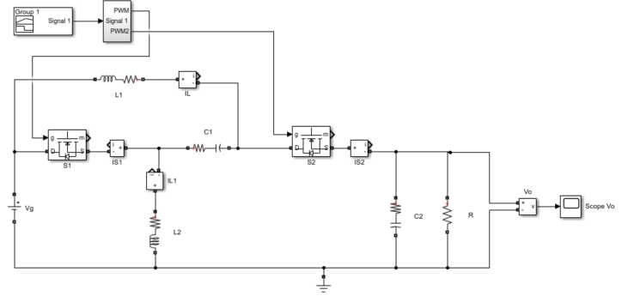
Figure 3. 4 Z-source DC-DC converter model

3.5.1 Comparison and Validation
This chapter is a standalone DC-DC characterisation of the Z-source network. The component and operating-point values used for the model simulations in this chapter are listed in Table 3.1. Rather than being chosen arbitrarily, they are the values of the single-phase grid-connected PV application analysed in Chapter 6, so that the modelling presented here and the closed-loop design developed there rest on a single, consistent operating point. The 500 V input is the maximum-power-point voltage of the 3 Kilowatt (kW) domestic PV array specified in Section 6.8.2 (ten series-connected panels at approximately 50 V each); the 3 kW rating and the 20 kilohertz (kHz) switching frequency likewise match the Chapter 6 converter; and this operating point is representative of a typical UK single-phase residential PV installation [10], [152], connected under Engineering Recommendation G99 [89]. The Z-network inductance and capacitance are sized for continuous conduction at this power level, and the parasitic elements (inductor winding resistance, MOSFET on-resistance and diode forward voltage drop) are included so that the model reflects a realisable converter rather than an idealised one.

Table 3. 1 Model parameters for Z-source DC-DC converter and small-signal models
Parameter | Value | Units | Description
$$V_{g}$$ | 500 | V | Input PV-side DC voltage at maximum power point
$$P_{rated}$$ | 3000 | W | Rated converter output power
$$f_{sw}$$ | 20 | kHz | Switching frequency
$$D_{0}$$ | 0.20 |  | Nominal operating-point duty ratio
$$L_{1}=L_{2}$$ | 2.0 | mH | Z-network inductance (symmetric)
$$C_{1}=C_{2}$$ | 20.0 | µF | Z-network capacitance (symmetric)
$$r_{L}$$ | 50 | mΩ | Inductor winding DCR (modelled in series with L)
$$R_{ON}$$ | 100 | mΩ | MOSFET on-resistance
$$V_{f}$$ | 1.0 | V | Diode forward voltage drop (small-signal effect neglected)
$$R$$ | 46.87 | Ω | Load resistance across converter output voltage

The converter is characterised about the DC operating point $D_{0}$ = 0.2, which from equation (3.4) corresponds to an output of 375 V for the 500 V input and lies in the lower-middle of the DC-DC duty range of 0.1 to 0.4 considered for maximum-power-point tracking, comfortably below the polarity-inversion point at $D = 0.5$.
With $V_{g}$= 500V, the steady-state output $V_{o}$ at each duty ratio follows equation (3.4):
$${ V}_{o}=\frac{V_{g}∙\left(1-2∙D\right)}{1-D} \left(3.4\right)$$
From (3.4), the steady-state output $V_{o}$ at each duty ratio is:
- $444.44 V at D = 0.1$
- $375.00 V at D = 0.2$
- $285.71 V at D = 0.3$
- $166.67 V at D = 0.4$
Observation Points:
Figure 3.5 shows the output voltage over the three-step validity sequence: the small-signal model response (about $D_{0}=0.2$) against the exact nonlinear steady state at each step. The switching-model trace is to be added from Simulink, as noted below.

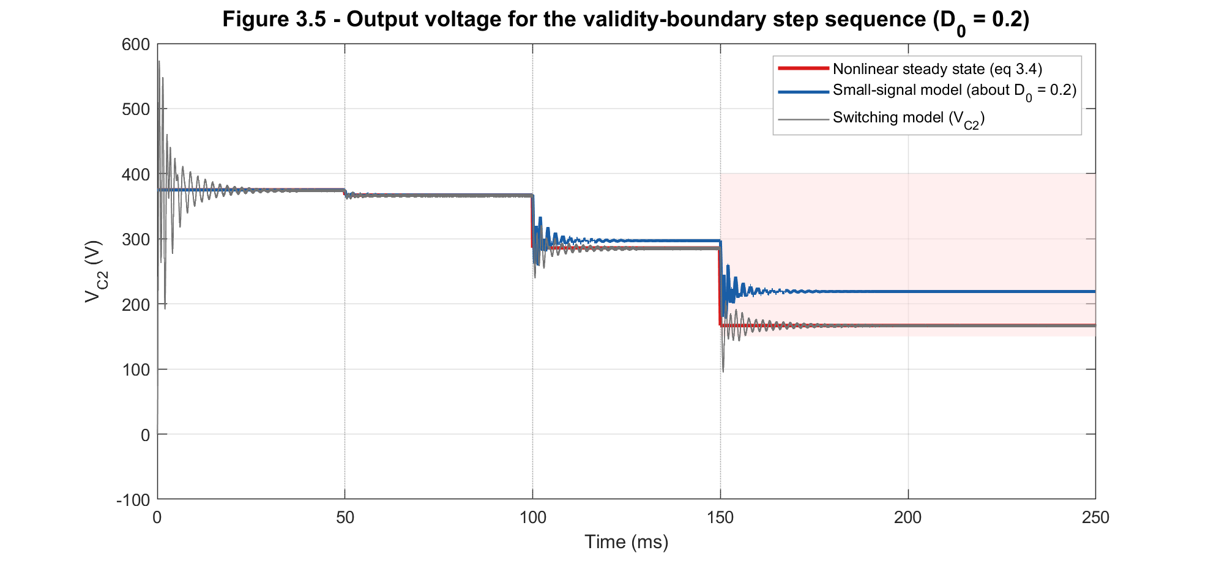

Figure 3.5 Output voltage for the validity-boundary step sequence (about $D_{0}$= 0.2). D steps from 0.2 to [0.21, 0.30, 0.40] at t = [0.05, 0.10, 0.15] respectively.

Figure 3.5 shows that, at each step, the nonlinear steady state gives a precise approximation of the output voltage across C2. The switching model, once overlaid, follows the nonlinear curve at every step, with superimposed high-frequency switching ripple that the averaged model does not represent.
The small-signal model, however, departs from both the nonlinear steady state and the switching model as the duty-cycle perturbation grows. For the small step ($D$ to 0.21, $Δd = 0.01$) it tracks the nonlinear steady state closely. At the $Δd = 0.10$ step the gap is small but visible, and at the $Δd = 0.20$ step (D to 0.4), well beyond the validity boundary established in Section 3.5.2, the small-signal model overestimates the output markedly (about 219V against 167V). This widening gap is expected and illustrates the validity limit: the linearised model is accurate near the operating point and progressively less so as the excursion grows.

3.5.2 Range of validity of the small-signal model
Figure 3.6 shows the zoomed-in transient responses of the small-signal model at the three verification steps, confirming that the dynamic character (resonant ring and settling) is reproduced. As the perturbation grows, the linearised model departs from the true behaviour, because the linearisation discards the second- and higher-order terms identified in Section 3.4.2.

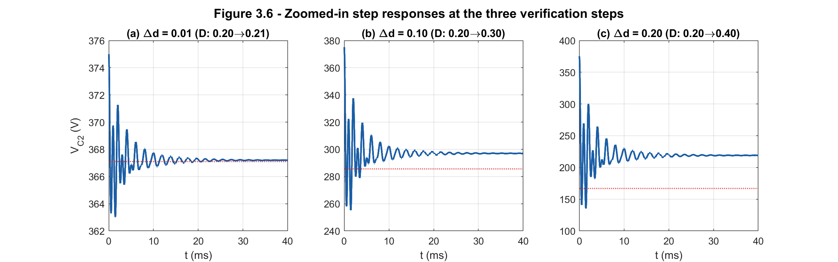

Figure 3.6 Zoomed-in step responses at the three verification steps

The linearisation error quantifies the cost of the linear approximation and is defined as:
$$ε\left(Δd\right)= \frac{\left(V_{C2,linear} - V_{C2,nonlinear}\right)}{V_{C2,nonlinear}} × 100\% \left(3.40\right)$$

The linearisation errors at the three steps are:
- $0.03\% at Δd = 0.01$ (well within tolerance);
- $3.95\% at Δd = 0.10$ (in the caution band);
- $31\% at Δd = 0.20$ (D to 0.4), far outside the valid range.
These boundaries quantitatively define how far the duty ratio may be perturbed before linearisation alone exceeds a given tolerance.
The 2% threshold for the validity region is an adopted engineering tolerance, not a fixed physical limit. It was chosen to match the 2% settling-time criteria used in this chapter so that a single accuracy convention applies to both the static and dynamic characterisations. It is consistent with the small-signal premise of state-space averaging which reports a linear-approximation error below 2% when the small-signal conditions hold [75]. The largest step is deliberately driven into the large-signal regime, where the linearised averaged model no longer represents the behaviour accurately [74].
Of the verification steps, the $Δd = 0.01$ step lies inside the valid region and the $Δd = 0.10$ step sits in the caution band just below the 5 % boundary, while the $Δd = 0.20$step (31% error) lies far off the chart, deep in the invalid region.

Table 3. 2 Summary of duty ratio step changes
Duty-ratio step | $$Δd$$ | $$Δd\frac{}{}D0$$ | Validity region (Fig 3.7) | Linearisation error ε (%)
0.20 to 0.21 | 0.01 | 5% | Valid (ε < 2%) | +0.03
0.20 to 0.30 | 0.10 | 50% | Caution (2-5%) | +3.95
0.20 to 0.40 | 0.20 | 100% | Invalid (ε > 5%) | +31.4

Figure 3.7 shows the linearisation error ε as a function of the duty-ratio perturbation magnitude $Δd$. The curve is monotonically increasing in magnitude, passing through the three step studies at the labelled markers.
The shaded regions identify the regimes of validity: green ($Δd < 0.076, |ε| < 2\%)$ is the strict small-signal valid region; yellow ($0.076 ≤ Δd < 0.110, 2 \% ≤ \left|ε\right|< 5\%$) is the caution region, in which the linearised model can be used with awareness of its limitations; and red ($Δd ≥ 0.110, \left|ε\right|≥ 5\%$) is the region in which the linearised model should not be used and only the switching model is authoritative.
The 2% boundary at $Δd ≈ 0.076$ is the key design figure: it is the maximum duty-ratio perturbation for which the linear model can be used for prediction within engineering tolerance, and it therefore bounds the amplitude of the duty-ratio excursions a linear controller may command.
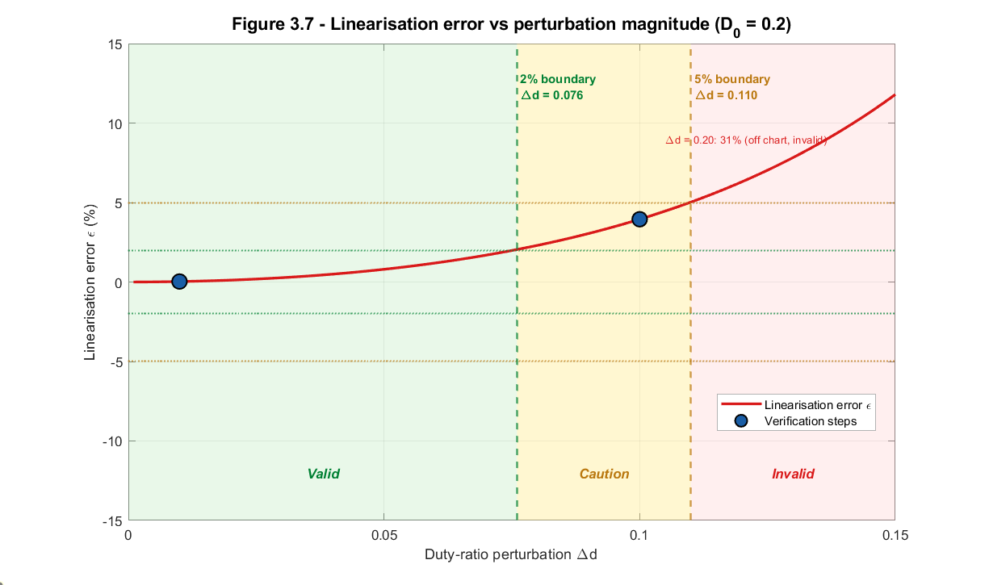
Figure 3.7 Linearisation error vs perturbation magnitude, with validity regions and step-study markers

3.6 Dynamic study and selection of DC-DC Z-Source network parameters
To achieve the desired output voltage and ensure the stability of the DC voltage, it is crucial to optimise the values of the capacitors and inductors within the Z-source network. Analysing the transient behaviour of the system is essential for understanding the performance and stability of the Z-source DC-DC converter under varying operating conditions. This analysis is particularly important before implementing closed-loop control for the converter.
The transient behaviour, which refers to the system’s response to sudden changes in input, load, or other operating conditions, is significantly influenced by the converter's passive components, the inductors and capacitors. These components play a critical role in shaping the dynamic response of the converter.
This behaviour matters not only for the converter in isolation but for the single-phase grid-connected photovoltaic system in which it operates as the single-stage semi-Z-source front end. Because the Z-network directly shapes the voltage delivered towards the grid-side stage, its transient response influences the quality of the power ultimately delivered to the grid: slow or lightly damped settling of the Z-network capacitor voltage translates into disturbances that the system's control must reject, particularly under the conditions most common in a photovoltaic application, step changes in irradiance as the array's operating point moves and changes in load or grid conditions. Characterising how the passive components shape this transient response therefore feeds directly into the component selection made here and into the closed-loop controller design of Chapter 6, so that the converter performs well not only on its own but as part of the complete grid-connected system.
To assess how the transient behaviour is affected by the inductors and capacitors, the small-signal model was characterised at the operating point $D_{0} = 0.2$ for various combinations of inductance and capacitance, each assessed across its manufacturing tolerance band (±20% for inductors, ±10% for film capacitors). Four metrics describe the second-order behaviour of the dominant mode: the dominant natural frequency $f_{n}$, the dominant damping ratio ζ, the 2 % settling time, and the percentage overshoot.
These four metrics are computed from the validated model. The natural frequency and damping ratio locate the dominant pole: the model poles are obtained with the MATLAB pole function, the dominant complex pole $p$ (the pole of smallest magnitude in the upper half-plane) is selected, and the metrics are evaluated as
$$f_{n} = \frac{|p| }{2π} \left(3.41\right)$$
and
$$ζ = \frac{- Re\left(p\right)}{\left|p\right|} \left(3.42\right)$$
In interpretation, the dominant natural frequency $f_{n}$ sets the speed of the converter. It is the frequency at which the dominant mode oscillates, the dominant mode being the complex pole pair nearest the imaginary axis, which decays most slowly and so governs the response. A lower $f_{n}$ means a slower converter, and $f_{n}$ also sets the ceiling on achievable closed-loop bandwidth, which must stay well below the resonance to avoid exciting it [8], [76], [77], [78].
The dominant damping ratio ζ measures how oscillatory that mode is (i.e. the tendency to ring), where $ζ = 1$is just non-oscillatory and ζ close to 0 rings for a long time. This is the stability-critical metric.
The 2% settling time is the time after which the output remains within ±2% of its final value. It is the practical measure of how quickly the converter recovers from a disturbance. The percentage overshoot is the peak excursion above the final value, as a percentage of the step size. It indicates the transient voltage stress on the components and whether the output stays within its allowed band during a disturbance.
For an ideal second-order mode it follows approximately
$$t_{s}≈ \frac{4 }{\left(ζ·ω_{n}\right)} \left(3.43\right)$$
shortening as damping or frequency increases; while the peak overshoot, depends only on the damping ratio,
$$\%OS = 100 ·\exp\left(\frac{-πζ }{√(1 - ζ²)}\right) \left(3.44\right)$$
so low damping produces large overshoot [8], [76], [77].
The four metrics for every swept value are listed in Table 3.3.

Table 3.3 Dominant-mode metrics for the component sweeps at D0 = 0.2 (settling time and overshoot are linear-model values)
Component value | $f_{n}$ (Hz) | ζ | $t_{s,2\%}$ (ms) | Overshoot (%)
C1 = 5 µF | 713 | 0.099 | 19.3 | 54.8
C1 = 20 µF | 514 | 0.044 | 17.8 | 53.5
C1 = 35 µF | 406 | 0.030 | 25.0 | 58.5
C1 = 50 µF | 345 | 0.026 | 29.4 | 62.5
C2 = 5 µF | 554 | 0.030 | 15.8 | 47.6
C2 = 20 µF | 514 | 0.044 | 17.8 | 53.5
C2 = 35 µF | 467 | 0.054 | 22.6 | 51.7
C2 = 50 µF | 423 | 0.058 | 32.3 | 52.8
L1 = 1 mH | 637 | 0.014 | 23.1 | 70.9
L1 = 2 mH | 514 | 0.044 | 17.8 | 53.5
L1 = 3 mH | 436 | 0.068 | 15.3 | 63.6
L1 = 5 mH | 346 | 0.102 | 13.6 | 67.7
L2 = 1 mH | 542 | 0.064 | 14.1 | 72.8
L2 = 2 mH | 514 | 0.044 | 17.8 | 53.5
L2 = 3 mH | 483 | 0.027 | 25.2 | 58.5
L2 = 5 mH | 422 | 0.009 | 57.4 | 64.5

3.6.1 Variation of C1 (with C2, L1, and L2 constant)
Figure 3.8 shows the response for C1 varied from 5 µF to 50 µF. Increasing C1 has a strong effect: the dominant natural frequency falls from 713 Hz to 345 Hz and the damping ratio falls from about 0.099 to 0.026, moving the dominant pole towards the imaginary axis and increasing the settling time at large C1 (from about 19.0ms at 5 µF to 28.0ms at 50 µF). C1 therefore both slows the response and erodes damping as it increases.
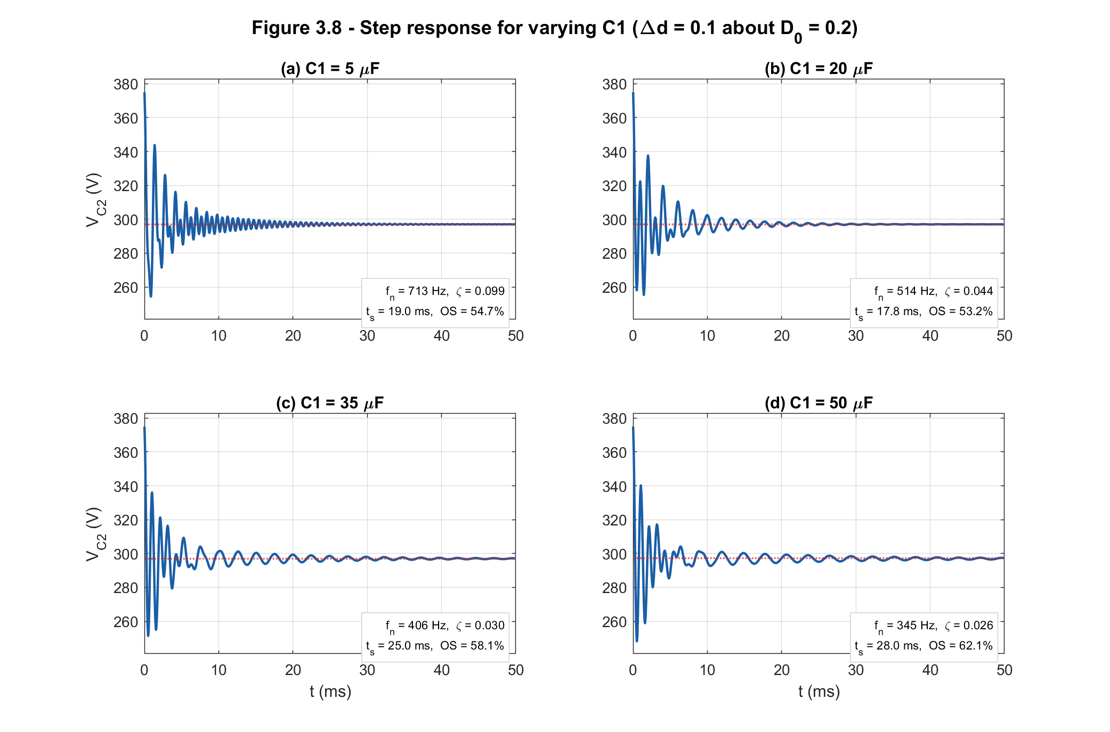
Figure 3.8 Step response for varying C1

3.6.2 Variation of C2 (with C1, L1, and L2 constant)
Figure 3.9 shows the response for C2 varied from 5 µF to 50 µF. Increasing C2 lowers the natural frequency (from about 554 Hz to 423 Hz) and lengthens the settling time (from about 15.8 ms to 32.3 ms). But, unlike C1, increasing C2 slightly raises the damping ratio (from about 0.030 to 0.058). The net effect is a slower but better-damped dominant mode.
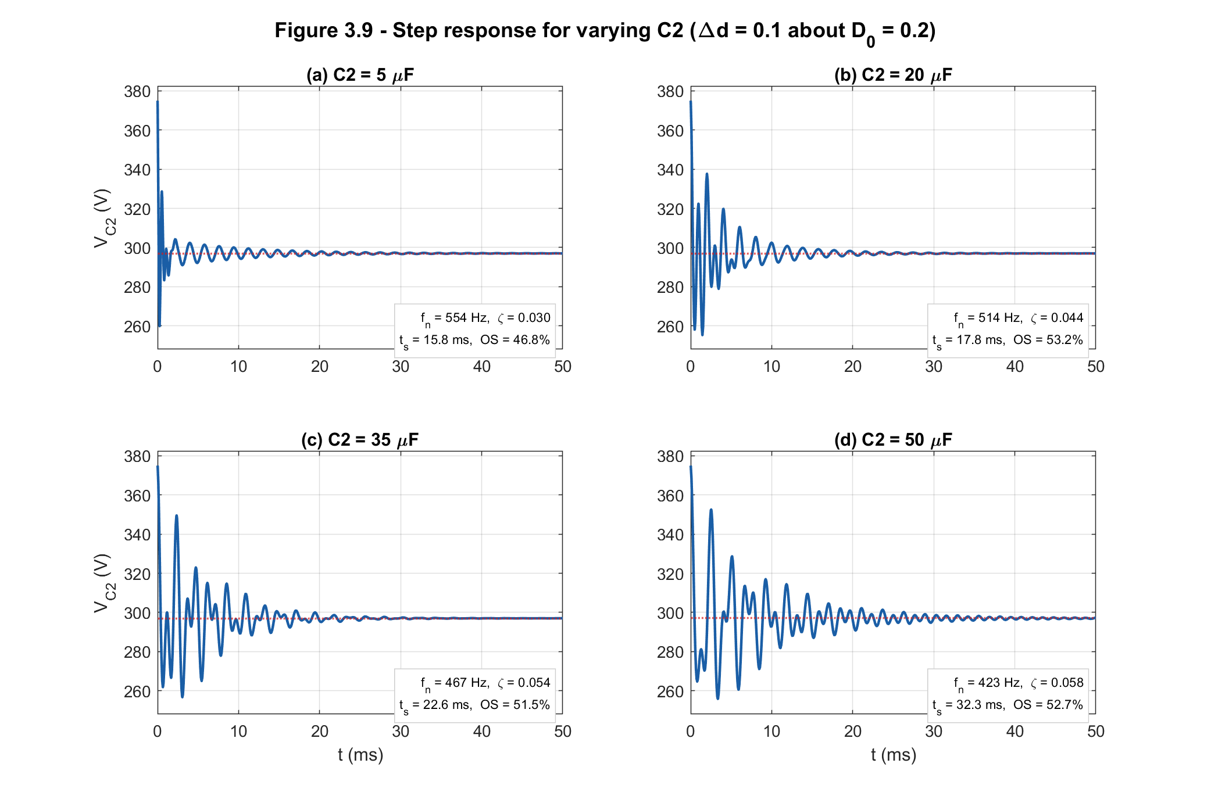
Figure 3.9 Step response for varying C2

3.6.3 Variation of L1 (with C1, C2, and L2 constant)
Figure 3.10 shows the response for L1 varied from 1 mH to 5 mH. Increasing L1 lowers the natural frequency (from about 637 Hz to 346 Hz) and raises the damping ratio (from about 0.014 to 0.102). The dominant pole's real part becomes more negative, so the mode decays faster: larger L1 therefore improves damping and shortens the settling time (from about 23.0 ms to 13.6 ms.
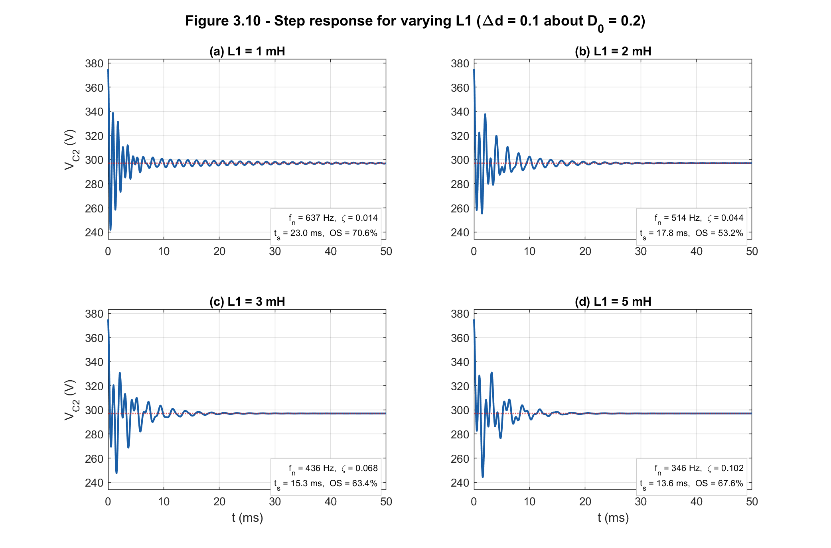
Figure 3.10 Step response for varying L1

3.6.4 Variation of L2 (with C1, C2, and L1 constant)
Figure 3.11 shows the response for L2 varied from 1 mH to 5 mH. The effect on damping is opposite to that of L1: increasing L2 lowers the natural frequency (from about 542 Hz to 422 Hz) but decreases the damping ratio (from about 0.064 to 0.009), moving the dominant pole towards the imaginary axis. The two Z-network inductors are therefore not interchangeable in their dynamic effect even though they are matched in value: L1 supplies damping as it grows, whereas L2 removes it. The two matched inductors therefore cannot be treated as dynamically interchangeable, despite having the same value.

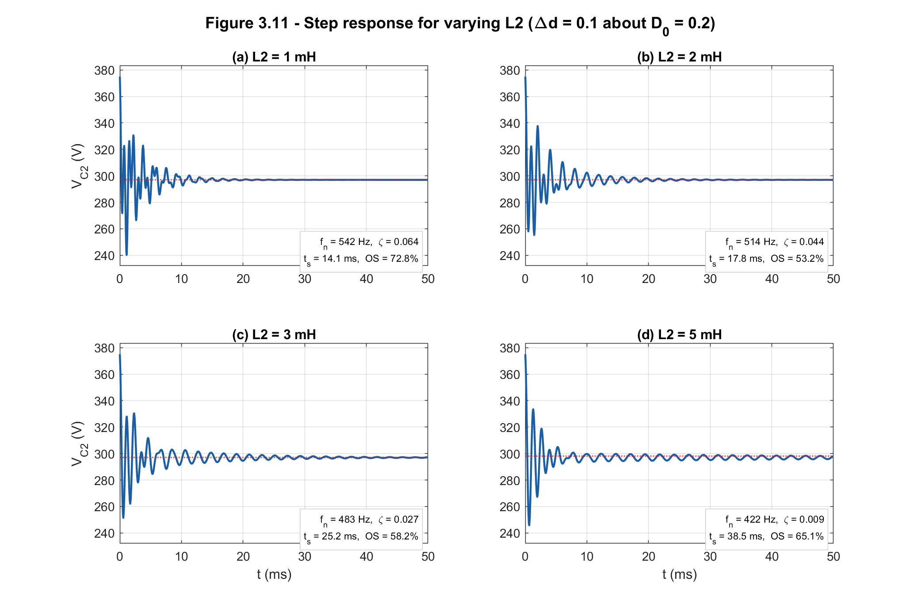
Figure 3.11 Step response for varying L2

Figure 3.12 below shows the 2% settling time and the damping ratio as continuous functions of L and C. It sweeps the Z-network symmetrically: both inductors together, then both capacitors together, one pair at a time with the other pair held at its design value. This is the physically meaningful sweep for a sensitivity study, since the Z-source network is designed symmetric ($L1 = L2, C1 = C2$). This differs from Figures 3.8 to 3.11, which perturb each component individually with the other three held at their design values. The two analyses answer different questions: Figures 3.8 to 3.11 identify which single component dominates the dynamics, whereas Figure 3.12 quantifies how far a symmetric tolerance band moves the metrics.
The shaded band in the figure is the component tolerance band (which is $±20 \%$ for standard (class M) general purpose inductors and capacitors) [79]-[81]. Across these bands the damping ratio changes by less than about 0.01 and the settling time by no more than about 5 ms, so the dynamic response is robust to realistic component variation, though somewhat more sensitive to capacitor tolerance than to inductor tolerance. The two element types act in opposite directions on damping: increasing the inductances raises the dominant-mode damping (figure 3.12c), whereas increasing the capacitances lowers it (figure 3.12d), while both increase the settling time (Figures 3.12a and 3.12b). The capacitance effect on damping is also strongly nonlinear, steep at small C and flattening at large C, so the sensitivity is greatest near the lower end of the range. Overall the response is more sensitive to the capacitances than to the inductances, the settling time in particular varying far more with C than with L.

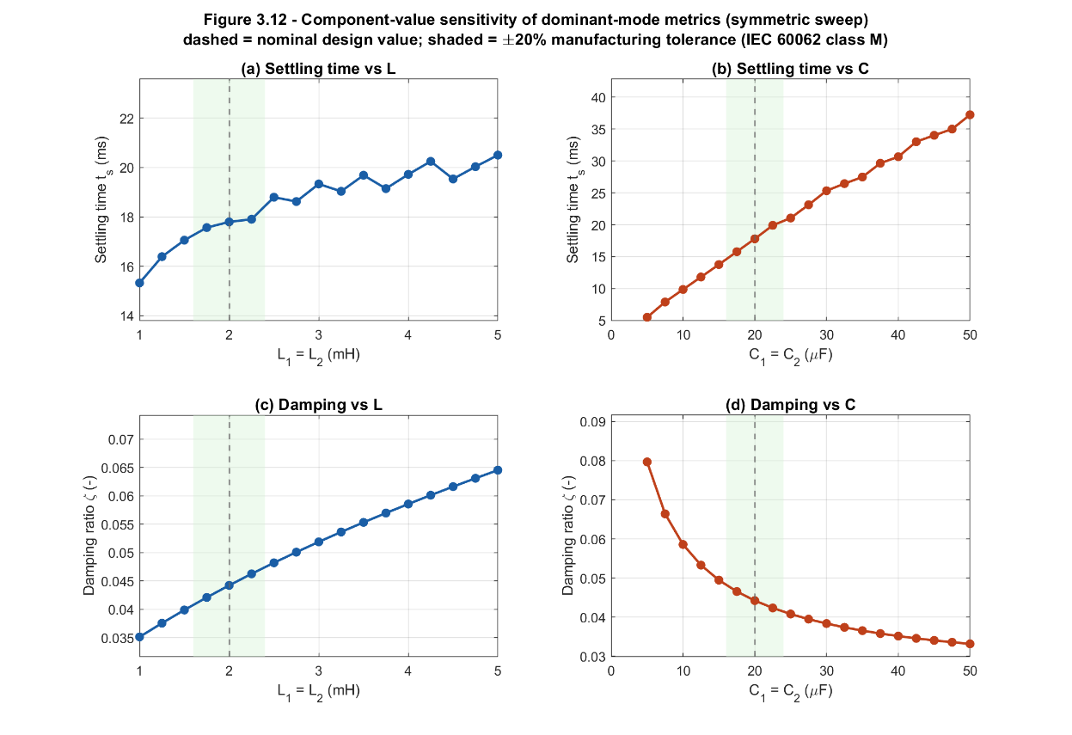
Figure 3.12 Component-value sensitivity of dominant-mode metrics (settling time and damping vs L and C)

3.7 Pole-zero analysis
Pole-zero and frequency response analysis are used to understand how the converter responds dynamically and how component variations affect performance and stability. By mapping the poles and zeros of the system on the s-plane, the stability, speed of response, and disturbance-rejection capability can be predicted [8], [82].
To obtain the pole-zero map, the linearised state-space model transfer function $G_{vd}\left(s\right)$ from equation (3.34) is implemented in MATLAB and plotted using MATLAB's pzmap function to determine its poles and zeros.
For stability all poles must lie in the left-half plane (LHP); the imaginary part of a pole sets the oscillation frequency and the distance from the origin sets how quickly the mode responds. The system is marginally stable if distinct poles lie on the imaginary axis, that is, the real parts of the poles are zero (the system may oscillate without decaying or growing). If poles move into the right-half plane (RHP), the system becomes unstable (the response grows over time) [8], [83], [84].

3.7.1 Pole-zero structure at the operating point
At the operating point ($D_{0} = 0.2$), the converter's response is shaped by four natural oscillation modes, which occur as two pairs. The slower, dominant pair (Mode 1) rings at about 514 Hz and is very lightly damped, so it settles slowly and with noticeable ringing. The faster pair (Mode 2) rings at about 986 Hz and is slightly better damped. Both pairs die away over time rather than building up, which means the converter is stable on its own, before any control loop is added, under all conditions [82].
The response also contains two features that work against the modes. One is fast and harmless, at about 7.8 kHz. The other, near 562 Hz, causes a brief wrong-way movement: when the duty ratio is increased to raise the output voltage, the output first dips slightly before rising to the higher value. This is a normal trait of boost-type converters and comes from the way the circuit stores and releases energy; its main practical effect is to limit how quickly the control loop can be made to respond [8], [82]. Figure 3.13 maps where all of these sit, with a zoomed-in inset of the closely spaced group near the centre.

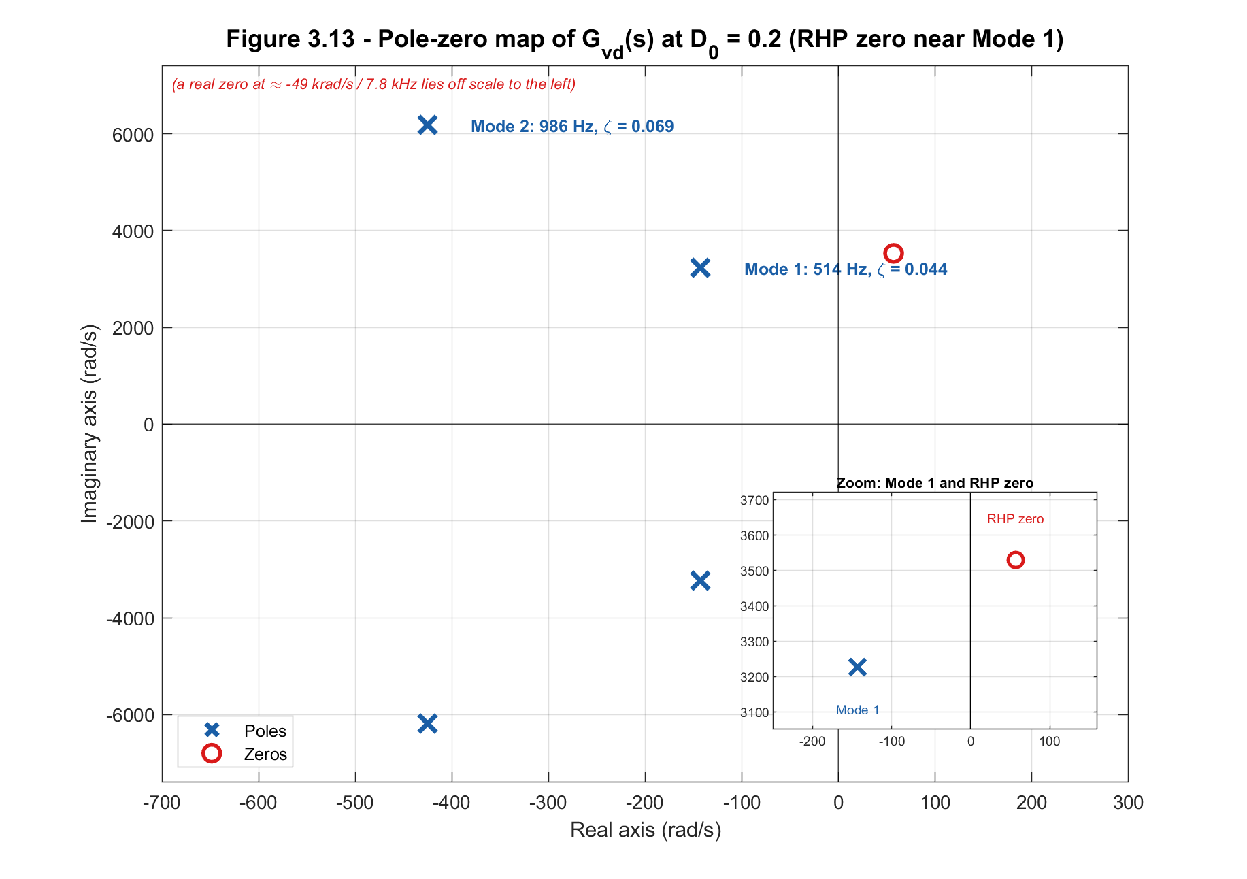
Figure 3.13 Pole-zero map of $Gvd\left(s\right)$ at $D_{0}$ = 0.20, with inset showing the near-axis poles and the right-half-plane zero pair

3.7.2 Frequency response
The frequency response describes how the converter reacts to a sinusoidal duty-ratio perturbation at each frequency, in gain and phase. Plotted against frequency as the Bode diagram of Figure 3.14, it is the central plot for control design, because the magnitude shows which frequencies the converter amplifies and the phase, together with the magnitude, shows how much stability margin a feedback loop would have [8], [77]. The magnitude has a flat low-frequency asymptote at about 57.8 dB, corresponding to the DC gain magnitude of 780 V/unit, a sharp resonance peak at the Mode 1 frequency (514 Hz) that is tall and narrow because Mode 1 is lightly damped (ζ ≈ 0.044), a smaller feature near Mode 2 (986 Hz), and a high-frequency roll-off. The phase carries a 180° offset corresponding to the negative sign of $G_{vd}\left(0\right)= -780\frac{V}{unit}$ (the output falls as the duty ratio rises), falls steeply through the resonance, and shows the additional lag of the right-half-plane zero, the frequency-domain signature of the non-minimum-phase behaviour [82].
These features set the limit on closed-loop speed: if the loop still has high gain at the lightly damped 514 Hz resonance it will excite that mode, and the right-half-plane zero erodes phase early, so the bandwidth cannot be pushed high without losing stability margin. The vertical reference at 200 Hz, about one-third of the dominant resonance, marks an upper bound on closed-loop bandwidth that sits safely below both the resonant peak and the frequency where the right-half-plane zero adds significant phase lag, providing adequate gain and phase margin against Mode 1 while keeping the commanded duty perturbations within the validated linear regime.

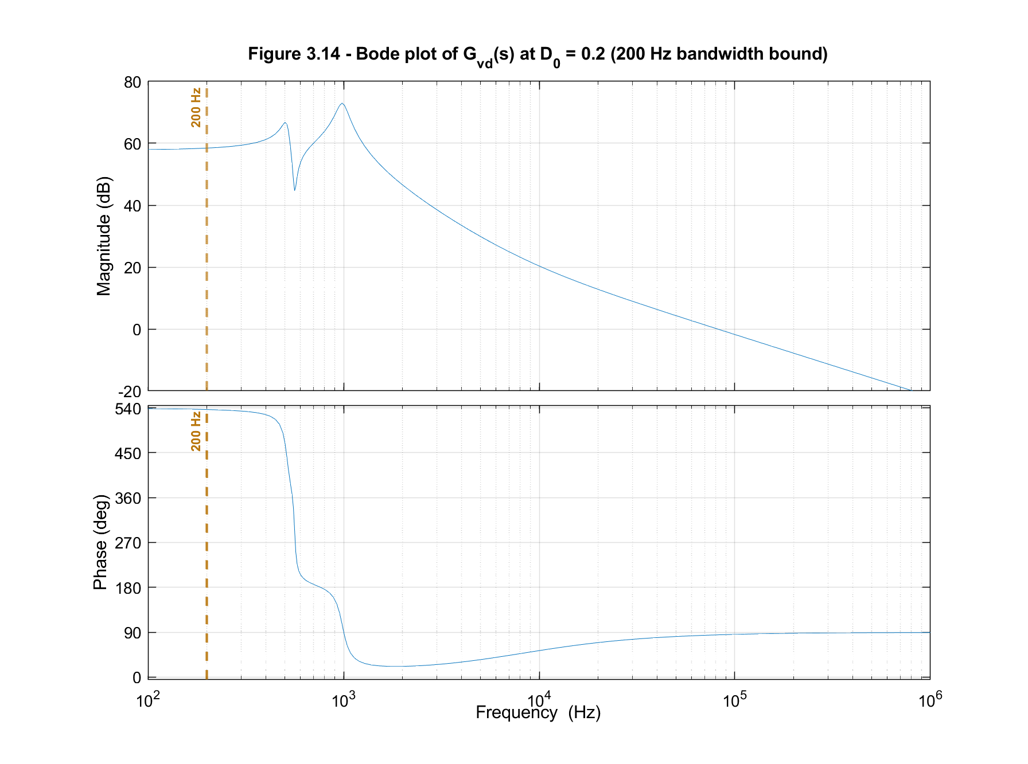
Figure 3.14 Bode plot of $Gvd\left(s\right)$ at $D_{0}= 0.20$, with the 200 Hz bandwidth bound marked

3.7.3 Effect of component variation on the pole-zero map
Pole-zero maps of $Gvd\left(s\right)$ for each component sweep are shown in Figures 3.15 to 3.18. By varying one component and holding the others constant, the effect of each is isolated, confirming the trends of Section 3.6 and the design-oriented parametric behaviour reported for the Z-source converter [82], [85].
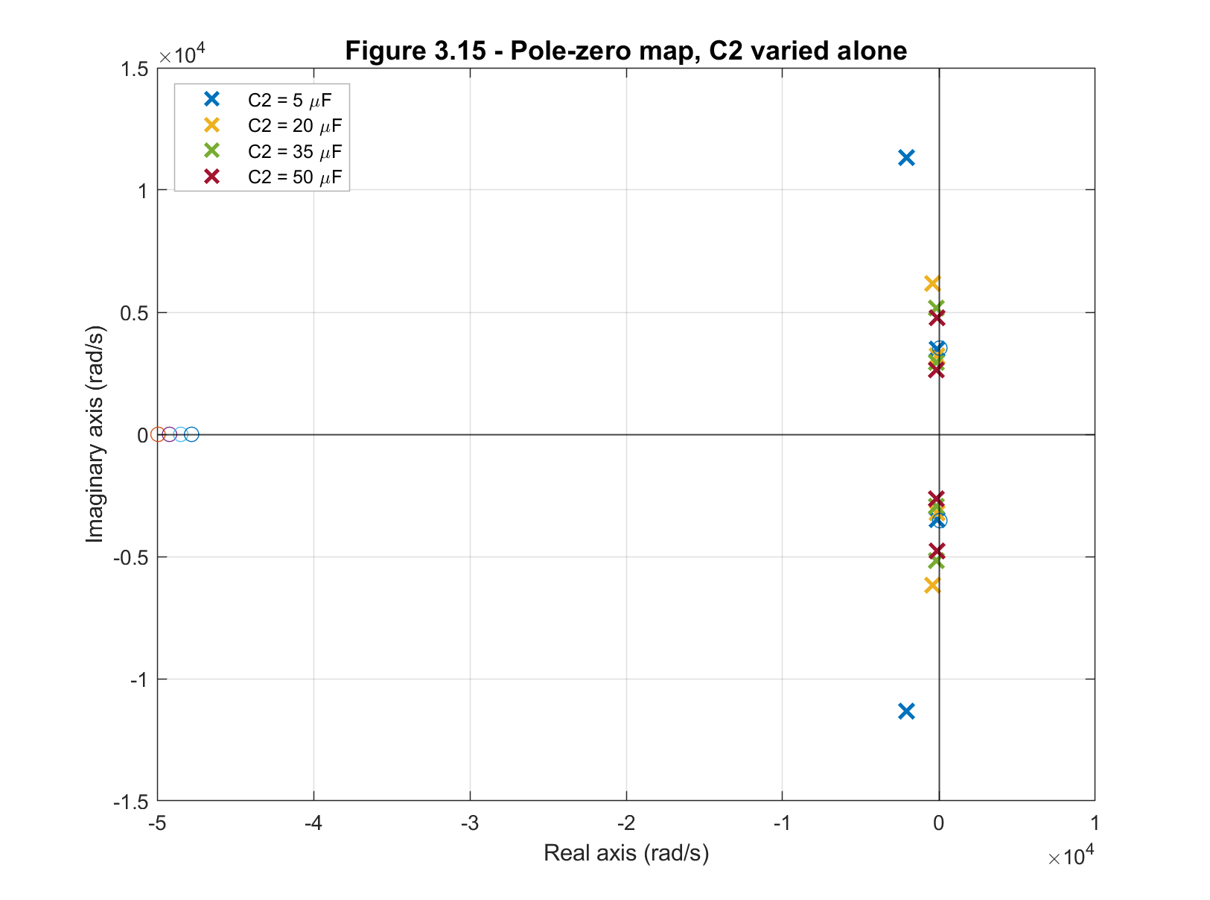
Figure 3.15 Pole-zero map, C2 varied

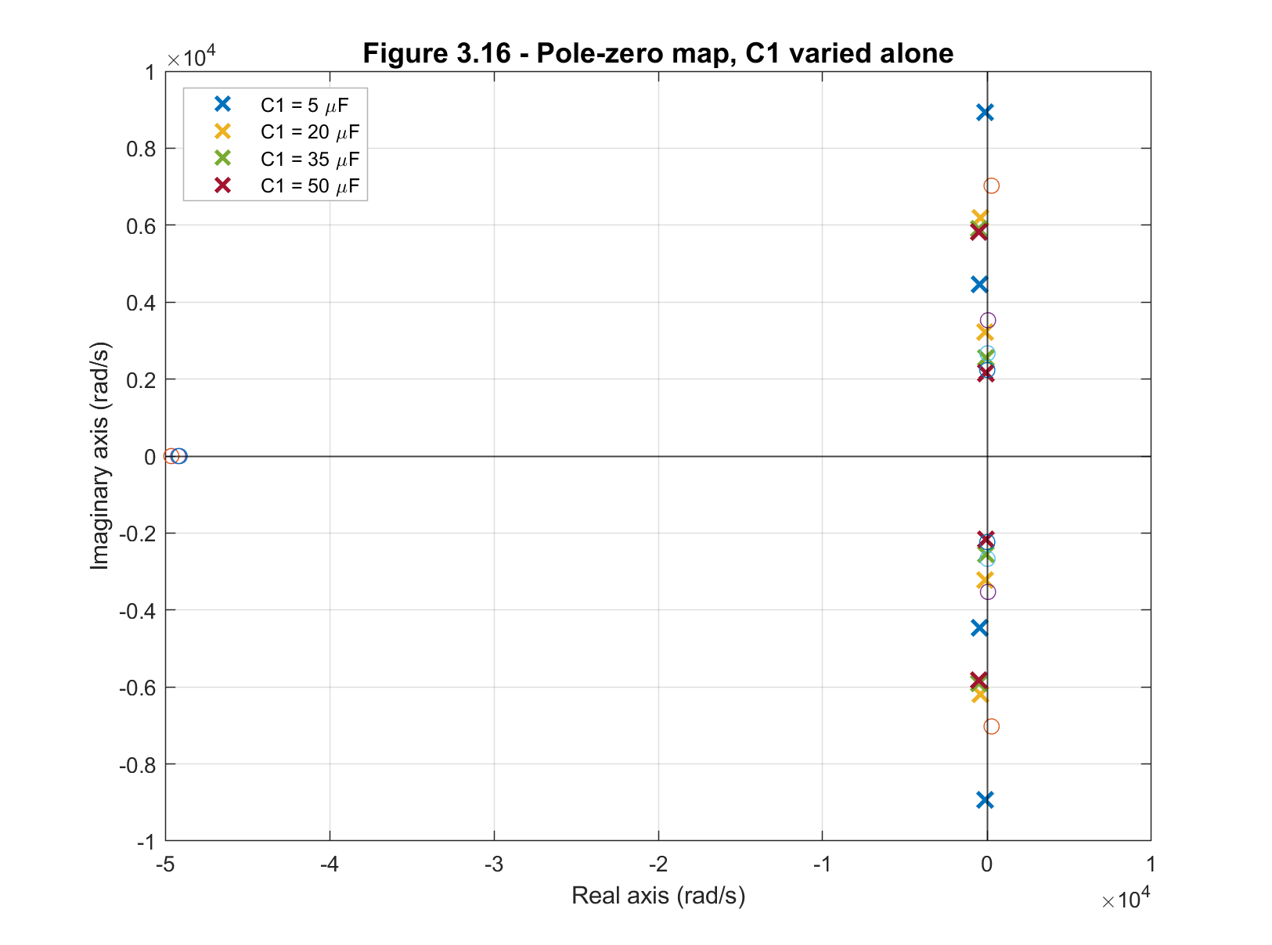
Figure 3.16 Pole-zero map, C1 varied

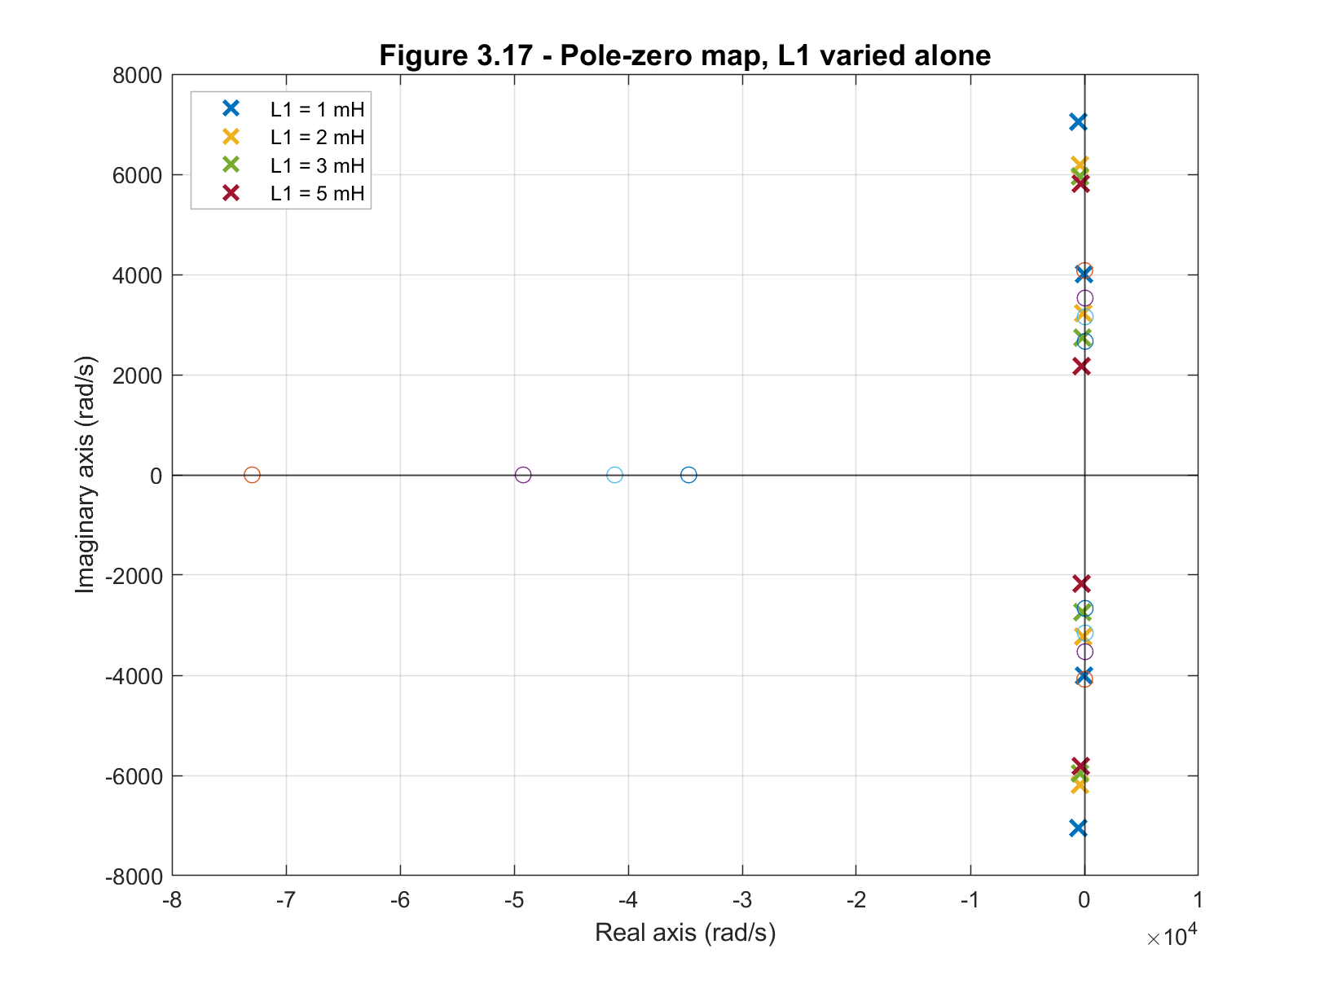
Figure 3.17 Pole-zero map, L1 varied

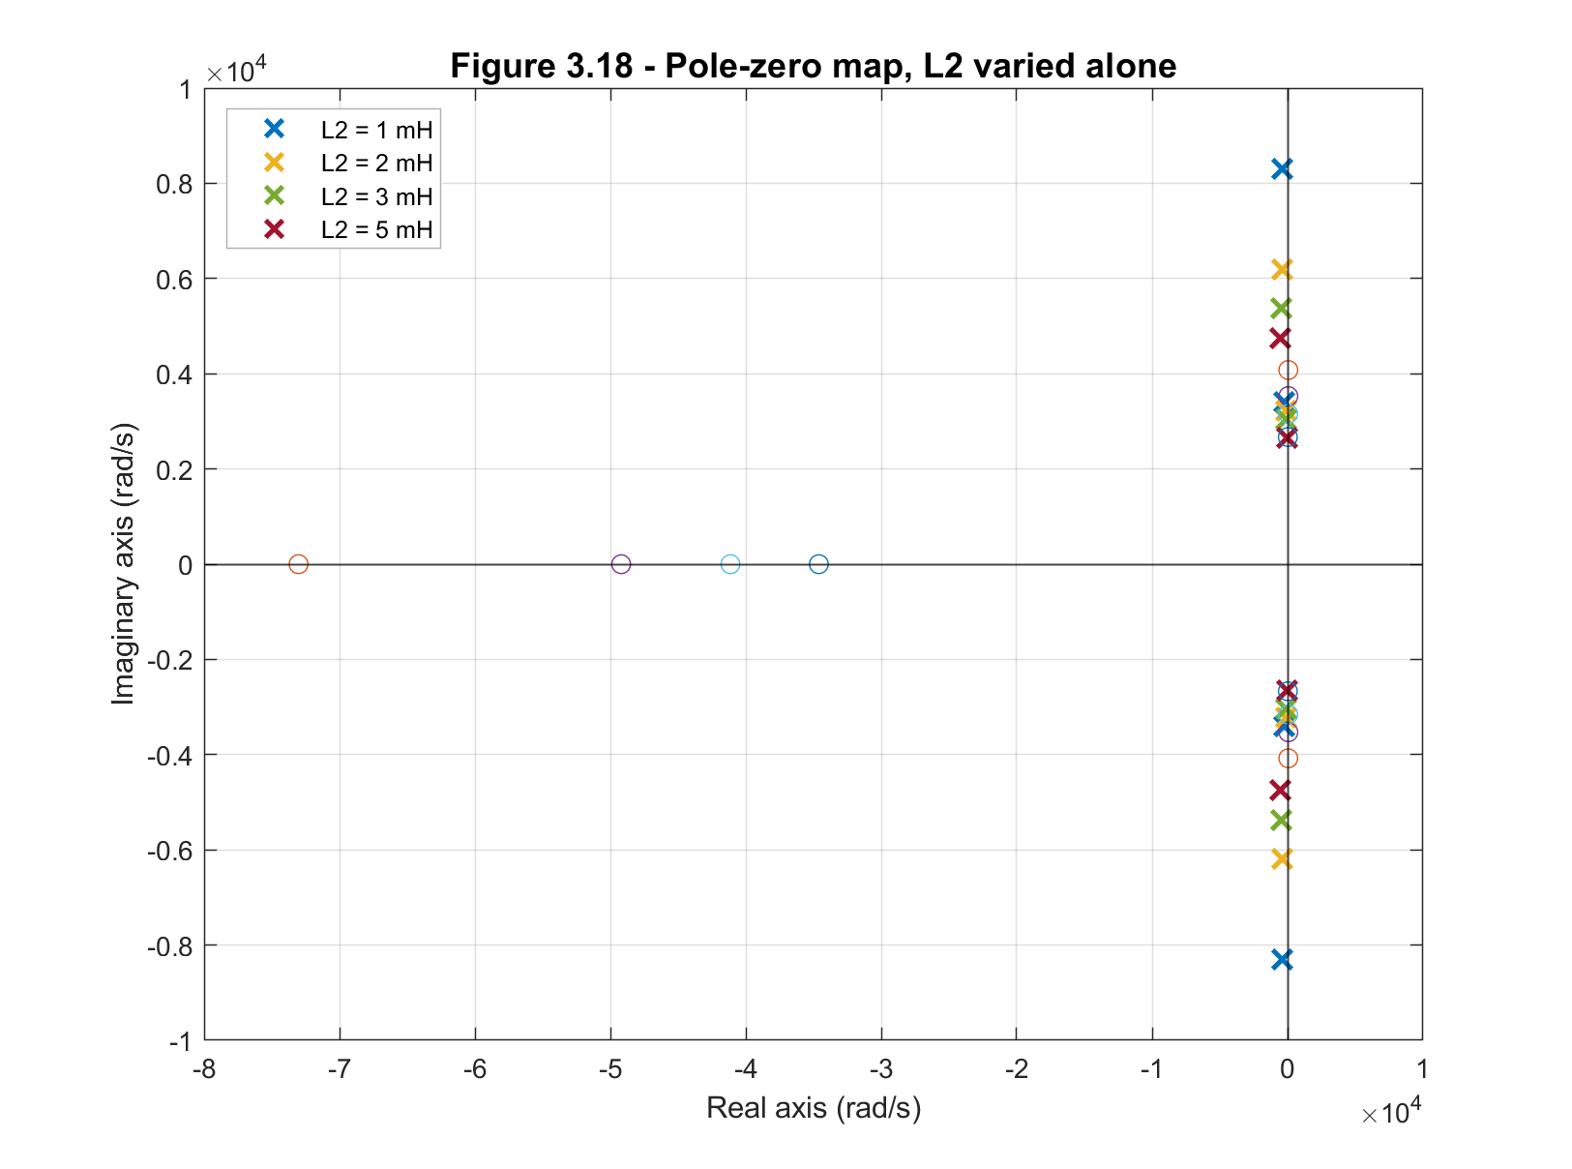
Figure 3.18 Pole-zero map, L2 varied

Increasing C2 (Figure 3.15) moves the dominant pole towards the origin and lowers the natural frequency while slightly raising damping. Increasing C1 (Figure 3.16) moves the dominant pole strongly towards the imaginary axis, lowering both natural frequency and damping, so large C1 values should be avoided. The inductors behave oppositely (Figures 3.17 and 3.18): increasing L1 moves the dominant pole further into the LHP, raising damping, whereas increasing L2 moves it towards the imaginary axis, reducing damping. Very small inductances (below about 1 mH) give a lightly damped, oscillatory response.

3.7.4 Recommended passive component values
From the dynamic study and pole-zero analysis, the following ranges give a good response:
- C1 = 10 µF to 30 µF: balances voltage ripple and dynamic response while avoiding the damping loss seen at large C1.
- C2 = 5 µF to 20 µF: keeps the settling time short while maintaining stability and damping.
- L1 = 2 mH: contributes damping; larger values slow the response.
- L2 = 2 mH: matched to L1 for a symmetric network, accepting that L2 contributes less damping than L1.
These ranges align with the values used for the step-response analysis. By selecting the passive components on this basis, the converter can be optimised for stable operation and fast dynamic response.

3.8 Conclusion
This chapter developed, validated, and characterised a small-signal averaged state-space model of the Z-source DC-DC converter, providing a detailed dynamic model. The contribution is threefold: a parasitic-inclusive model derived from first principles, a quantified boundary of its validity, and a design-oriented characterisation of the resulting plant that yields explicit constraints for the closed-loop design.
The model retains the dominant parasitic elements (inductor winding resistance, switch on-resistance, and capacitor equivalent series resistance) rather than adopting a lossless idealisation, so that the predicted damping and pole locations are physically meaningful. Its region of validity was then established quantitatively by sweeping the duty-ratio perturbation from small-signal to large-signal: the linearisation error remains within 2% for perturbations up to about $Δd = 0.076$ and within 5% up to about $Δd = 0.110$, with larger excursions departing from the switching model as expected. This explicit validity boundary, absent from the earlier literature on this converter, defines the range over which the linear model, and any controller designed from it, can be trusted.
The pole-zero and frequency-domain analysis then characterised the plant. It identified two complex pole pairs, a dominant, lightly damped mode near 514 Hz and a higher-frequency, better-damped mode near 986 Hz, both in the left-half plane, confirming open-loop stability, together with a right-half-plane zero near the dominant mode that makes the converter non-minimum-phase. The component study quantified how each Z-network element shapes the response and revealed a clear asymmetry: the two matched inductors act oppositely on damping (L1 increases it, L2 reduces it), as do the two capacitors (C2 increases it, C1 reduces it), so despite the network's symmetry the elements are not dynamically interchangeable. A symmetric tolerance analysis confirmed that the dynamic response is robust to realistic component variation.
These results translate into concrete guidance for the controller developed in Chapter 6. Three constraints follow. First, the closed-loop bandwidth is bounded at about 200 Hz, roughly one-third of the dominant resonance. This bound provides stability margin against the lightly damped Mode 1, and it respects the limit on achievable speed set by the right-half-plane zero. Second, the controller must supply substantial electronic damping, since the open-loop damping is low. Third, the plant depends on the operating point, and this dependence, established here, is carried into the controller design of Chapter 6. Together with the recommended Z-network parameter ranges, these constraints form the foundation for the practical design and control of the converter in the chapters that follow.

Chapter 4
Review of Single-Phase Grid Synchronisation

4.1 Introduction
Grid synchronisation is essential for the effective operation of grid-connected photovoltaic (PV) systems, ensuring smooth and safe power transmission from distributed generation sources to the grid. To meet today’s stricter regulatory requirements, PV systems need to detect key characteristics of the grid’s voltage, namely amplitude, phase angle, and frequency, in real-time. These measurements form the basis for generating reference control signals for power converters, allowing for precise regulation of power flow between the PV system and the grid [14], [86], [87].
In practice, grid synchronisation aligns the output of the power converter with the fundamental component of the grid voltage, which is crucial for maintaining both power quality and system stability. Failure to properly synchronise can lead to inefficiencies, power losses, and possible instability, causing harmonic distortions, phase imbalances, and even pose safety risks to both the grid and connected systems [14].
The challenge of grid synchronisation is heightened by the grid’s dynamic behaviour. Events like voltage sags, frequency shifts, harmonic distortions, and phase jumps can occur due to grid faults, non-linear loads, or the connection of other distributed generation systems [87]. Regulatory standards, such as BS EN 50160 in Europe and Engineering Recommendation G99 in the UK, require PV systems to “ride through” these variations within specific limits while mandating safe disconnection during extreme fluctuations to protect both the grid and connected equipment. BS EN 50160 defines the steady-state voltage and harmonic envelope of the public supply, while G99 specifies the inverter’s required behaviour under frequency excursions and other abnormal conditions [88], [89]. Together, these standards set the operational envelope that any grid-tied PLL must be capable of tracking accurately.
This chapter provides an in-depth review and comparative evaluation of grid synchronisation techniques for single-phase systems, examining how they perform under both normal and abnormal grid conditions. It will cover the main categories of synchronisation methods, dive into the commonly used Phase-Locked Loop (PLL) technique, and assess the performance of various PLL adaptations, including the T/4 Transport Delay PLL, Inverse Park Transform PLL, and Second-Order Generalised Integrator PLL (SOGI-PLL).
Beyond reviewing these techniques, the chapter makes three contributions. First, it defines a common five-metric framework (peak phase error, peak frequency excursion, settling time, steady-state error and steady-state ripple) and applies it uniformly across all topologies and disturbances, making the comparison quantitative and like-for-like. Second, it benchmarks the T/4, Inverse Park Transform and SOGI-PLL topologies against the UK low-voltage envelope of Engineering Recommendation G99 and BS EN 50160, so the results bear directly on the target application. Third, it explains why each topology behaves as it does rather than only tabulating results, establishing the SOGI-PLL as the strongest classical baseline and quantifying the residual harmonic ripple that motivates Chapter 5.

4.2 Categorisation of Grid Synchronisation methods for single-phase systems
Grid synchronisation methods in power converters generates an internal reference signal that is synchronous with the fundamental components of the grid voltage which ensures that the quality of power supplied to the grid by the PV system meets the regulatory requirements.
Several grid synchronisation methods have been proposed in [11], [87], [90]-[94], for fast and precise detection of the amplitude, phase angle and frequency of the grid voltage, and the proper generation of a reference control signal whose dynamics is in unison with that of the grid. These methods can be categorised into two basic groups, namely: frequency-domain detection and time-domain detection as shown in Fig. 4.1 below [95].
The frequency-domain detection method applies discrete Fourier analysis like the discrete Fourier Transform (DFT) and recursive discrete Fourier Transform (RDFT) as well as non-Fourier analysis methods using optimal recursive estimators like the Kalman filter. These methods require signal processors with high sampling frequency, significant data storage and rigorous computational requirements to estimate the grid variables using mathematical methods.
The time-domain detection methods are based on adaptive loop systems (open-loop and closed-loop systems) which uses a clocking device to track the grid variables in real-time. The open-loop directly detects the fundamental components of the grid voltage while the closed-loop adaptively updates the detected amplitude, phase angle and frequency of the grid voltage through a feedback mechanism. This method offers the significant advantage of increased tracking speed with fewer calculations when compared with the frequency-domain detection methods [93], [95]. For this reason, the rest of this report will focus on reviewing the time-domain approach
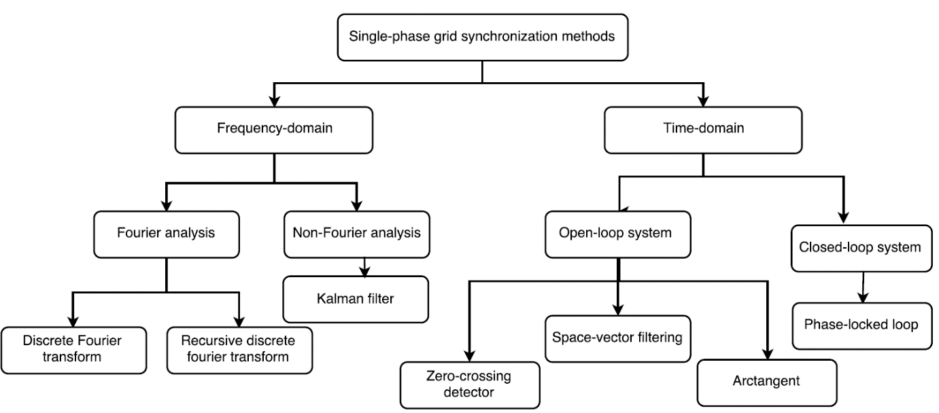
Figure 4.1 Hierarchical classification of single-phase grid synchronisation methods

In order to deal with the grid variables, it is important to transform them from their natural reference frame to a synchronous reference frame. This requires knowing the phase-angle of the grid voltage. Together with the magnitude of the grid voltage, it is then possible to use these variables to control the active and reactive power supplied to the grid.
Among the time-domain detection methods shown in Fig. 4.1, the zero-crossing detection (ZCD) is an open-loop system that uses a simple comparator to detect a change in the polarity of the grid voltage at its zero-crossing point. However, in the presence of harmonic distortions, switching notches and noise particularly predominant in distorted grid voltages, this method may inaccurately detect multiple zero-crossings which presents a major drawback of the approach. Several literatures [96], [97] have proposed ZCD comparator circuits with dynamic hysteresis to reduce tracking errors due to grid voltage distortions and eliminate tracking delays. These solutions employ curve-fitting, finite impulse response (FIR) filtering algorithms and adaptive down sampling (ADS) to achieve high accuracy and good immunity to signal distortion [98], [99]. However, their computational burden and complexity reduces their appeal in many grid-connected systems. The most widely applied time-domain synchronisation algorithm is the phase-locked loop (PLL) owing to its robust performance under various grid conditions. The PLL employs an internal oscillator to instantaneously track the grid voltage signal using a closed-loop feedback control.
The next section discusses the various PLL algorithms used in single-phase grid synchronisation.

4.3 Phase locked loop (PLL) synchronisation techniques
A PLL uses its internal oscillator to keep the time of the grid voltage signal using a closed-loop feedback control in order to generate a reference control signal whose amplitude and phase are continuously coherent with that of the grid voltage [14].
The basic structure of the PLL is shown in Fig. 4.2 which comprises of three fundamental blocks namely: a phase detector (PD), a loop filter (LF) and a voltage-controlled oscillator (VCO) [14], [100]-[102].
The phase detector block generates an output signal ($ε_{pd}$) which is proportional to the difference between the phase angles of the input grid voltage signal $v$ and the internal VCO’s output signal $v^{'}$. The loop filter block supresses the noise and high-frequency AC components from the phase detector output ($ε_{pd}$). The block is typically achieved using a low pass filter or a proportional plus integral (PI) controller. The output signal of the loop filter ($v_{lf}$) drives the VCO to generate an AC output signal ($v^{'}$) whose frequency is shifted from the central oscillator frequency ($ω_{c}$) as a function of $v_{lf}$. In this way, the reference output signal $v^{'}$ will always track any phase or magnitude change in the grid voltage $v$.

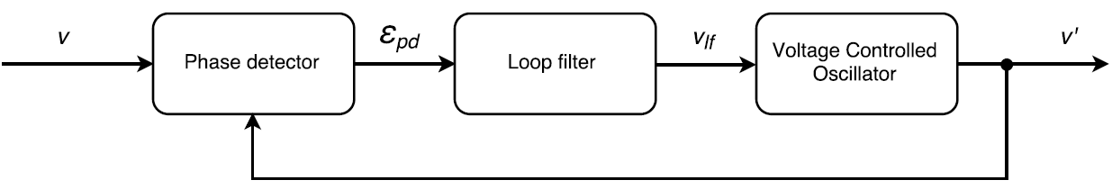
Figure 4. 2 Basic structure of a phase-locked loop synchronisation

An elementary PLL may consist of a simple multiplier as the phase detector block, a PI controller for the loop filter block, and a VCO which uses a linear integrator to supply a sinusoidal function as shown in the Fig. 4.3 below.
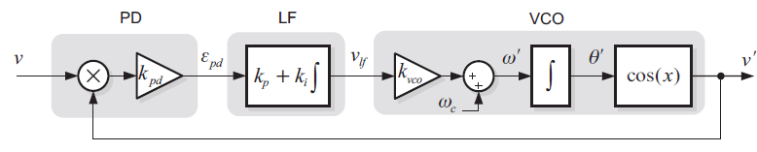
Figure 4. 3 Block diagram of an elementary phase-locked loop

If the input signal to the PLL is given by
$$v=V\sin\left(θ\right)=V\sin\left(ωt+∅ \right) (4.1)$$
where ω and ∅ are the angular frequency and the phase angle of the grid voltage respectively, and the output signal of the VCO is given by
$$v^{'}=\cos\left(θ^{'}\right)=\cos\left(ω^{'}t+∅^{'}\right) \left(4.2\right)$$
The error signal from the PD output will be
$$ε_{pd}=Vk_{pd}\sin\left(ωt+∅\right)\cos\left(ω^{'}t+∅^{'}\right) \left(4.3\right)$$
$$=\frac{Vk_{pd}}{2}\left[\underset{low-frequency term}{\underbrace{\sin{(\left(ω-ω^{'}\right)t+\left(∅-∅^{'}\right))}}}+\underset{high-frequency term}{\underbrace{\sin{(\left(ω+ω^{'}\right)t+\left(∅-∅^{'}\right))}}}\right] \left(4.4\right)$$
The high-frequency component of $ε_{pd}$ is attenuated by the PI controller, so that the modified error signal ${\overline{ε}}_{pd}$ can be represented as
$${\overline{ε}}_{pd}=\frac{Vk_{pd}}{2}\sin{(\left(ω-ω^{'}\right)t+\left(∅-∅^{'}\right))} \left(4.5\right)$$
If the VCO is tuned so that the grid frequency $ω≈ω^{'}$, then
$${\overline{ε}}_{pd}=\frac{Vk_{pd}}{2}\sin\left(∅-∅^{'}\right) \left(4.6\right)$$
However, once the phase is locked so that $∅≈∅^{'}$, it can be shown that $sin\left(∅-∅^{'}\right)≈ sin\left(θ-θ^{'}\right)≈\left(θ-θ^{'}\right)$ [41], [103]. Therefore, the relevant term of ${\overline{ε}}_{pd}$ is given by
$${\overline{ε}}_{pd}=\frac{Vk_{pd}}{2}\left(θ-θ^{'}\right)= \frac{Vk_{pd}}{2}∆θ^{'} \left(4.7\right)$$
The frequency of the VCO is shifted by a central frequency,$ω_{c}$ supplied by a feed-forward parameter which is dependent on the frequency range to be detected. Therefore, the average VCO frequency is given by
$$ω^{'}=ω_{c}+∆ω^{'}=ω_{c}+k_{VCO}V_{lf} \left(4.8\right)$$
Therefore, small differences in the VCO frequency can be expressed as
$$ω^{'}=k_{VCO}V_{lf} \left(4.9\right)$$
So that any phase angle difference detected by the PLL is given by
$$θ^{'}\left(t\right)=\int{ω^{'}dt}=\int{k_{VCO}V_{lf}dt} \left(4.10\right)$$
Several Phase-Locked Loop (PLL) synchronisation methods for single-phase grid voltage have been proposed in recent literatures [14], [11], [87], [90]-[93], [96]-[100], [103]. The main difference between these methods is the configuration of the phase detector block which generally accepts only one sinusoidal input in the case of single-phase systems.
There are two primary groups of PLL methods which include:
PLLs based on in-quadrature signal generation (QSG) like the T/4 Transport Delay PLL, Hilbert Transform PLL and the Inverse Park Transform (IPT) PLL.
PLLs based on adaptive filtering like the Enhanced PLL, Second-Order Adaptive Filter PLL and the Second-Order Generalised Integrator PLL (SOGI-PLL)
The modification of the PD block in any technique influences the accuracy and time responses of the PLL. The most widely applied PLL techniques for single-phase systems are the QSG based T/4 Transport Delay PLL, the Inverse Park Transform (IPT) PLL, as well as the Second-Order Generalised Integrator PLL (SOGI-PLL). The next section will review these techniques and their time response under different grid operating conditions.

4.3.1 T/4 Transport Delay PLL
The application of QSG enables single-phase systems to be resolve using a vector approach. The QSG allows the input signal $v$ to be represented in an $αβ$ orthogonal and stationary reference frame. This is then projected onto an orthogonal and rotating $dq$ reference frame using Park transformation. The angular speed of the rotating $dq$ reference frame $θ^{'}$ is given by the PLL, and when the PLL is precisely tuned to the input frequency so that $ω≈ω^{'}$, the input signal and the $dq$ reference frame will have the same angular speed [14], [103].
Figure 4.4 shows the block diagram for a T/4 Transport Delay PLL. The VCO has been simplified to show only the frequency-phase generator (FPG). The output of this block would normally be fed into a sinusoidal function generator as shown in Fig 4.3 above.
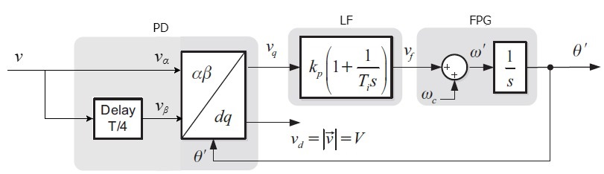
Figure 4. 4 Structure of the QSG based transport delay PLL.

If the input grid voltage $v$ is given by
$$v=V\sin\left(θ\right)=V\sin{(ωt+∅ )}$$
With the use of first-in-first-out (FIFO) buffer, a quarter-cycle (T/4) transport delay i.e. a time delay of $90°$ can be introduced which transforms the grid voltage into an $αβ$ orthogonal and stationary reference.
$$v_{(∝β)}=\left[\begin{matrix}v_{α} \\ v_{β}\end{matrix}\right]=V\left[\begin{matrix}\sin\left(θ\right) \\ \sin\left(θ-{90}^{o}\right)\end{matrix}\right]=V\left[\begin{matrix}\sin\left(θ\right) \\ -cos\left(θ\right)\end{matrix}\right] \left(4.11\right)$$
Applying Park transformation, the rotating $dq$ reference frame of signal is expressed as:
$$\left[\begin{matrix}V_{q} \\ V_{d}\end{matrix}\right]=\left[\begin{matrix}cosθ^{'} & -sinθ^{'} \\ sinθ^{'} & cosθ^{'}\end{matrix}\right]\left[\begin{matrix}V_{α} \\ V_{β}\end{matrix}\right]=V\left[\begin{matrix}\sin{(}θ-θ^{'}) \\ -\cos{(θ-θ^{'})}\end{matrix}\right]=V\left[\begin{matrix}\sin{∆θ} \\ -\cos{∆θ}\end{matrix}\right]≈V\left[\begin{matrix}∆θ \\ -1\end{matrix}\right] \left(4.12\right)$$
where $V$,$ω, θ$ and $ϕ$ are the magnitude, frequency, angle and phase angle of the input grid voltage $v$, $∆θ=θ-θ^{'}$ is the detected phase error, and $θ^{'}$ is the locked phase angle.
The vector interpretation of the signal-phase system also enables the resolution of the current vectors interacting with the grid voltage vector. From (4.12) we see that $V_{d}$ gives information of the magnitude of the grid voltage, hence the current vector on the $d$ axis of the $dq$ frame will deliver active power to the grid, while that on the $q$ axis will deliver reactive power.
The closed-loop PLL system uses the feedback mechanism to minimise the phase error so that $∆θ≈0$. From the above equations, if the phase detection error is zero i.e.
$$∆θ=θ-θ^{'}=0 \left(4.13\right)$$
then $θ=θ^{'}$, so that the sinusoidal reference signal output of the VCO $v^{'}$ flows the grid voltage in unison.
A major drawback of the QSG based T/4 transport delay method is that the output signals of the buffer will cease to be perfectly orthogonal when the grid voltage frequency changes from the nominal value. As a result, errors may arise in the PLL synchronisation. Also, due to a lack of filtering capabilities, the PLL method is easily perturbed by harmonic components that may be present on the single-phase input voltage [14], [103].

4.3.2 Inverse Park Transformation (IPT) PLL
To provide for the shortfall in filtering capabilities of the T/4 Transport Delay PLL, the Inverse Park Transform (IPT) depicted in Fig. 4.5 introduces a filter in a loop made up of direct and inverse park transformations.

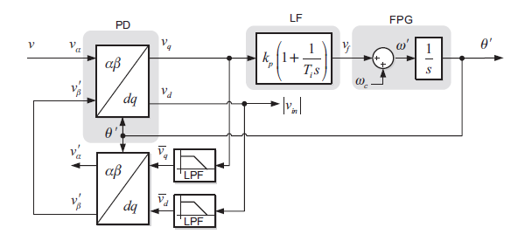
Figure 4. 5 Inverse Park Transform PLL

The inverse of the Park transform defined in (4.12) is given as:
$$\left[\begin{matrix}v_{α} \\ v_{β}\end{matrix}\right]= \left[\begin{matrix}\cos{θ^{'}} & \sin{θ^{'}} \\ -\sin{θ^{'}} & \cos{θ^{'}}\end{matrix}\right]\left[\begin{matrix}V_{q} \\ V_{d}\end{matrix}\right] \left(4.14\right)$$
The input to the Park Transform is the grid reference voltage $v$ which represents the $v_{α}$component in the $αβ$ system and an internally generated signal $v_{β}=v_{β}^{'}$ is obtained using the inverse Park Transform of (4.12). The outputs of the Park Transform block, $v_{d}$ and $v_{q}$ are fed through two first-order low pass filters in order to attenuate the harmonic oscillations. Its outputs $\overline{v_{d}}$ and $\overline{v_{q}}$ are then applied to the inverse Park Transform block to obtain $v_{α}^{'}$ and $v_{β}^{'}$. To guarantee the fast performance of the PLL, the low pass filters must be tuned adequately. When the PLL locks the phase angle of the input signal with that of the frequency-phase generator (FPG) output through its feedback process as described earlier, $v=v_{α}$ will be in-phase with $v_{α}^{'}$ and in-quadrature with $v_{β}^{'}$ [14].
At first glance, the IPT PLL method may appear easy to implement, however this method requires a precise selection of the time constant of the loop filters as well as a well-tuned PI controller, both of which may be challenging to implement with the required precision. Hence, this method may introduce errors in the PLL synchronisation, particularly during variations in the rated frequency of the grid [104].

4.3.3 Second Order Generalised Integrator (SOGI) PLL
To overcome the drawbacks of the previously described PLL methods such as tracking errors during variations in grid frequency, non-existent or poor filtering capabilities and high complexity of implementation, the Second Order Generalised Integrator (SOGI) PLL has been proposed in several literature [14], [105].
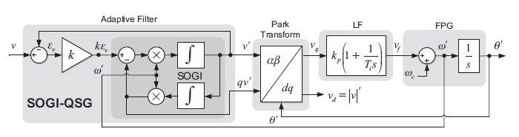
Figure 4. 6 Structure of the SOGI PLL

Figure 4.6 shows the structure of the SOGI PLL. The SOGI PLL introduces an adaptive filter in its phase detector block to replace the filtering capabilities of the IPT PLL (shown in Fig. 4.6) as well as to generate quadrature $αβ$ signals as in the case of the T/4 transport delay PLL (shown in Fig. 4.5). Park transformation is then applied to the quadrature $αβ$ signals to transform them to rotating $dq$ signals, which are then fed through the LF and FPG blocks to generate the locked phase angle $θ^{'}$ as with previous PLL methods.
The design coefficients of conventional filters are static and typically set during design time. However, adaptive filters have the ability to automatically adjust their parameters based on an optimisation algorithm to cope with the nature of the signal being filter. In this case, the optimisation algorithm of the filter is designed to modify its performance coefficients to minimise the noise component of the input signal. The adaptive filter makes use of second-order generalised integrator (GI) which is tuned with respect to the resonance frequency $ω^{'}$ from the FPG’s output [14], [105].
As reported in several literature [106], [107], generalised integrators have transfer functions which at resonance frequency results in infinite gain and cancels out steady-state errors of the input sinusoidal signal. A second-order form of the GI is much more efficient and its resonant structure, the SOGI has found wide application in grid synchronisation [113–116]. The transfer functions of the SOGI [14] are defined by:
$$H_{SOGI}\left(s\right)=\frac{v^{'}}{kε_{v}}\left(s\right)= \frac{ω^{'}s}{s^{2}+ω^{' 2}} \left(4.15\right)$$
$$H_{d}\left(s\right)= \frac{v^{'}}{v}\left(s\right)= \frac{{kω}^{'}s}{s^{2}+{kω}^{'}s {+ω}^{' 2}} \left(4.16\right)$$
$$H_{q}\left(s\right)= \frac{{qv}^{'}}{v}\left(s\right)= \frac{{kω}^{' 2}}{s^{2}+{kω}^{'}s {+ω}^{' 2}} \left(4.17\right)$$
From the transfer function, it is clear that the bandwidth of the SOGI filter depends of the gain $k$. Also, From the transfer functions of the band-pass filter $H_{d}\left(s\right)$ and the low-pass filter $H_{q}\left(s\right)$, it is evident that bandwidth of the SOGI filter depends of the gain $k$. Also, we see that the generated output signals $v^{'}$ and ${qv}^{'}$ of the SOGI-PLL are quadrature (phase shifted by $90°$). Moreover, if by some mechanism, the resonance frequency $ω^{'}$ of the filter is matched to that of the input frequency $ω$ of the grid voltage, so that $ω=ω^{'}$, then the amplitude of the quadrature signals $v^{'}$ and ${qv}^{'}$ will be equal to the amplitude of the input grid voltage $v$. Therefore, the SOGI-PLL can be an ideal method for quadrature signal generation (QSG). There are two broad feedback loops in the SOGI-PLL as shown in Fig. 6, the first is from the FPG’s phase angle to the Park’s transform, and the second is from the FPG’s frequency output to the SOGI-QSG.
To achieve a high level of filtering, the value of the gain $k$ must be set correctly. The band-pass of the SOGI filter will become narrower if $k$ is decreased, however the dynamic response of the system will be slowed down as a result. Hence, a compromise must be reached between the dynamic response and the rejection of harmonics in the design of the SOGI PLL [105], [108]. However, since a fast dynamic response is essential for efficient PLL synchronisation, the SOGI-PLL will only partly supress the grid voltage harmonics. Therefore, the quadrature signal output $v^{'}$ and ${qv}^{'}$will not be completely sinusoidal. The next section will present simulations of the dynamic response of the T/4 Transport Delay PLL, the Inverse Park Transformation (IPT) PLL and the Second Order Generalised Integrator (SOGI) PLL. The subsequent chapter would then propose a more efficient and hybrid form on SOGI-PLL which combines the cascaded delay signal cancellation (CDSC) algorithm proposed by [106], [109], [110] with the SOGI PLL to eliminate the undesired harmonics from a distorted input grid voltage signal.

4.4 Simulation results
The above discussed PLL synchronisation techniques have been implemented and tested for different abnormal grid disturbances with MATLAB simulation as shown in Figures. 4.7-4.9. The simulations adopt the UK low-voltage public supply network as the reference grid: a 230 V rms fundamental (325 V peak) at 50 Hz with a clean sinusoidal waveform except where harmonic disturbances are added. These are the low-voltage supply values BS EN 50160 declares, and the undisturbed waveform sits within its normal-operation envelope of ±10% on voltage and 49.5 to 50.5 Hz on frequency [88]. The four disturbance scenarios of Sections 4.4.1 to 4.4.4 then exercise the loop at and beyond the edges of that envelope, with each scenario's magnitude drawn from the relevant BS EN 50160 or G99 provision [88], [89]. The loop filter was achieved with a PI controller and the frequency-phase generator uses a phase angle clock which ramps up from $0 to 2π$ $\left(6.2832\frac{rad}{s}\right)$ with every voltage cycle. Each model is run with Simulink’s variable-step solver, which is well suited to the smooth fundamental waveform combined with the discrete step disturbances applied in the four scenarios below.

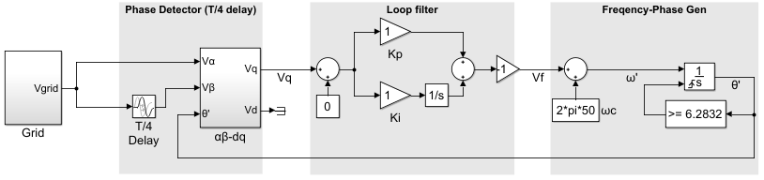
Figure 4. 7 Simulink model of the T/4 Transport Delay PLL

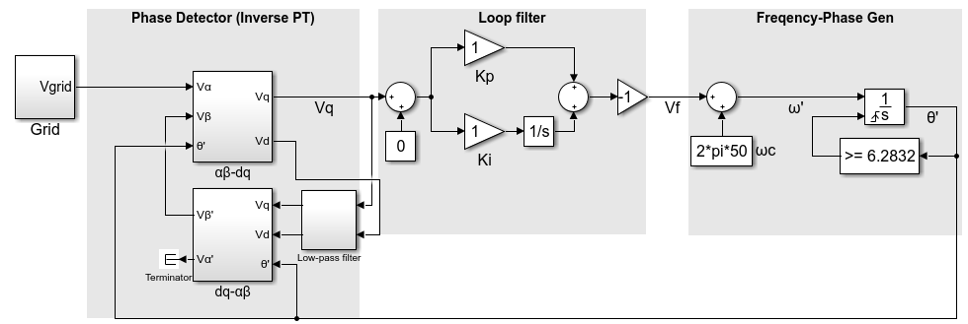
Figure 4. 8 Simulink model of the Inverse Park Transformation (IPT) PLL

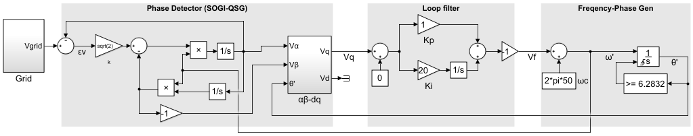
Figure 4. 9 Simulink model of the Second Order Generalised Integrator (SOGI) PLL

The disturbances were modelled under four scenarios:
Scenario 1 applies a 25% step reduction in the fundamental amplitude. A dip to 0.75 pu is not a normal-operation excursion: it lies well below the ±10% envelope BS EN 50160 permits for 95% of each week [88], and represents instead a fault-driven voltage sag, the event class that BS EN 50160 records separately and that G99 requires generation to ride through [89]. Such sags most often arise from short-circuit faults on adjacent feeders or upstream circuits, with the retained voltage set by the source and fault impedances, but comparable dips also follow large-motor starting, transformer energising inrush and the sudden connection of heavy load [111]. The scenario therefore tests the loop under a representative low-voltage ride-through condition.
Scenario 2 applies a phase-angle jump of 10°. A phase jump most commonly accompanies the fault-driven sag of Scenario 1, its magnitude governed by the difference in X/R ratio between the source and the faulted feeder, and it can also be produced by the switching of large loads or capacitor banks and by the fault-clearing transient. Distribution-network faults commonly produce jumps of up to a few tens of degrees [111], so 10° is a realistic and demanding value for a loop that relies on phase tracking.
Scenario 3 applies a 2 Hz frequency step from 49 Hz to 51 Hz, centred on 50 Hz. Excursions of this kind result from an imbalance between generation and demand, most severely the loss of a large generator or interconnector, with the system's inertia and droop response shaping the trajectory [112]; as the share of converter-based generation rises and displaces synchronous generation, system inertia falls and the rate of change of frequency rises, making these excursions more severe [113]. Both endpoints lie within the 47.5 to 51.5 Hz range across which G99 requires generation to remain connected [89], yet the step takes the loop outside the 49.5 to 50.5 Hz band that BS EN 50160 defines for normal operation [88] and across the 50.4 Hz over-frequency threshold (LFSM-O) [89]. It therefore exercises the loop across the full operational frequency envelope rather than only the normal band.
Scenario 4 superimposes odd harmonics (3rd, 5th, 7th, 11th and 13th) at the BS EN 50160 limits for low-voltage public networks: 5.0%, 6.0%, 5.0%, 3.5% and 3.0% of the fundamental respectively [88]. Such harmonic voltages arise because nonlinear loads draw non-sinusoidal currents that produce distortion across the system impedance at the point of common coupling [114]; on the public network these loads aggregate from rectifier front-ends, variable-speed drives, electric-vehicle chargers and switched-mode supplies, and network resonance can amplify a particular order well above its injected level [114]. Together these represent the steady-state distortion the loop must reject continuously.
These disturbances were introduced into the simulation at $t = 0.5s$ for the voltage sag, phase angle jump and frequency change scenarios, and at $t = 0.2s$ for the harmonics scenario to allow a long sustained-distortion window for steady-state observation. The total simulation length is$2.0s$in every case, providing a clean lock-in window before the disturbance and a one-second observation window after it.
The phase-error signal is computed as $θ_{err}\left(t\right)= θ_{ref}\left(t\right)- \hat{θ}\left(t\right)- θ_{err-pre}$, where $θ_{ref}\left(t\right)= 2π∙50·t$ is the ideal nominal phase reference, $\hat{θ}\left(t\right)$is the unwrapped PLL phase estimate, and $θ_{err-pre}$ is the mean of $θ_{err}$ over the pre-disturbance window $\left[0.30, 0.45\right]s$, subtracted to remove initial-condition bias. The result is converted to degrees for reporting. For the phase-jump scenario, $θ_{ref}$ is incremented by +10° for $t ≥ t_{d}$ so the metric reflects residual tracking error after the expected offset has been acquired. For the frequency change scenario, where the grid frequency steps to a new value, phase error against any fixed-frequency reference is unbounded, so the assessment is conducted in the frequency domain on the PLL's estimated frequency $\hat{f}\left(t\right)=\frac{\hat{ω}\left(t\right)}{2π}$. This convention follows established practice in the comparative-PLL literature [115], [116].
The five-metric framework used to evaluate each topology comprises peak phase error ${Δθ}_{pk}$, peak frequency excursion ${Δf}_{pk}$, settling time $t_{s}$ to ±0.1°, steady-state error $θ_{ss}$, and steady-state ripple $θ_{pp}$. All five are computed by an analysis script. Steady-state metrics use the observation window $\left[1.5, 1.95\right]$s, placed sufficiently after the disturbance for all three topologies to have completed their transients. The metric definitions are:
- Peak phase error: ${Δθ}_{pk} =\max\left|θ_{err}\left(t\right)\right|$ over the transient window $\left[t_{d}, t_{d} + 0.5s\right],$ where $t_{d}$ is the disturbance time. This measures the worst-case phase deviation produced by the disturbance.
- Peak frequency excursion: ${Δf}_{pk}=\max\left|\hat{f}\left(t\right)- f_{target}\right|$ over the same transient window, where $f_{target}$ is 50Hz for the voltage-sag, phase-jump and harmonics scenarios, or 51Hz for the frequency change scenario. For the harmonics scenario, where there is no transient peak, ${Δf}_{pk}$ is evaluated over the steady-state observation window $\left[1.5, 2.0\right]s$ instead.
- Settling time: $t_{s}=\max\left\{t : \left|θ_{err}\left(t\right)\right|> 0.1°, t > t_{d}\right\}- t_{d}$, the time elapsed since the disturbance for the phase error to enter and remain within ±0.1° of zero. For the frequency change scenario, $t_{s}$ is defined analogously on the frequency estimate, with tolerance ±0.1Hz around the new nominal.
- Steady-state error: $θ_{ss}= mean\left(θ_{err}\left(t\right)\right)$ over the steady-state observation window.
- Steady-state ripple: $θ_{pp}$ = max $θ_{err}\left(t\right)$ − min $θ_{err}\left(t\right)$ over the same steady-state observation window. This captures the peak-to-peak amplitude of any residual oscillation in the phase estimate, which under harmonic loading is the dominant performance indicator.

4.4.1 Voltage sag
Figure 4.10 shows the phase-error response of the T/4 transport delay PLL, the IPT PLL and the SOGI-PLL to a 25% step reduction in the fundamental amplitude applied at t = 0.5s. Figure 4.10(a) shows the full simulation, while Figure 4.10(b) zooms in on the transient from 0.45 to 0.75s.

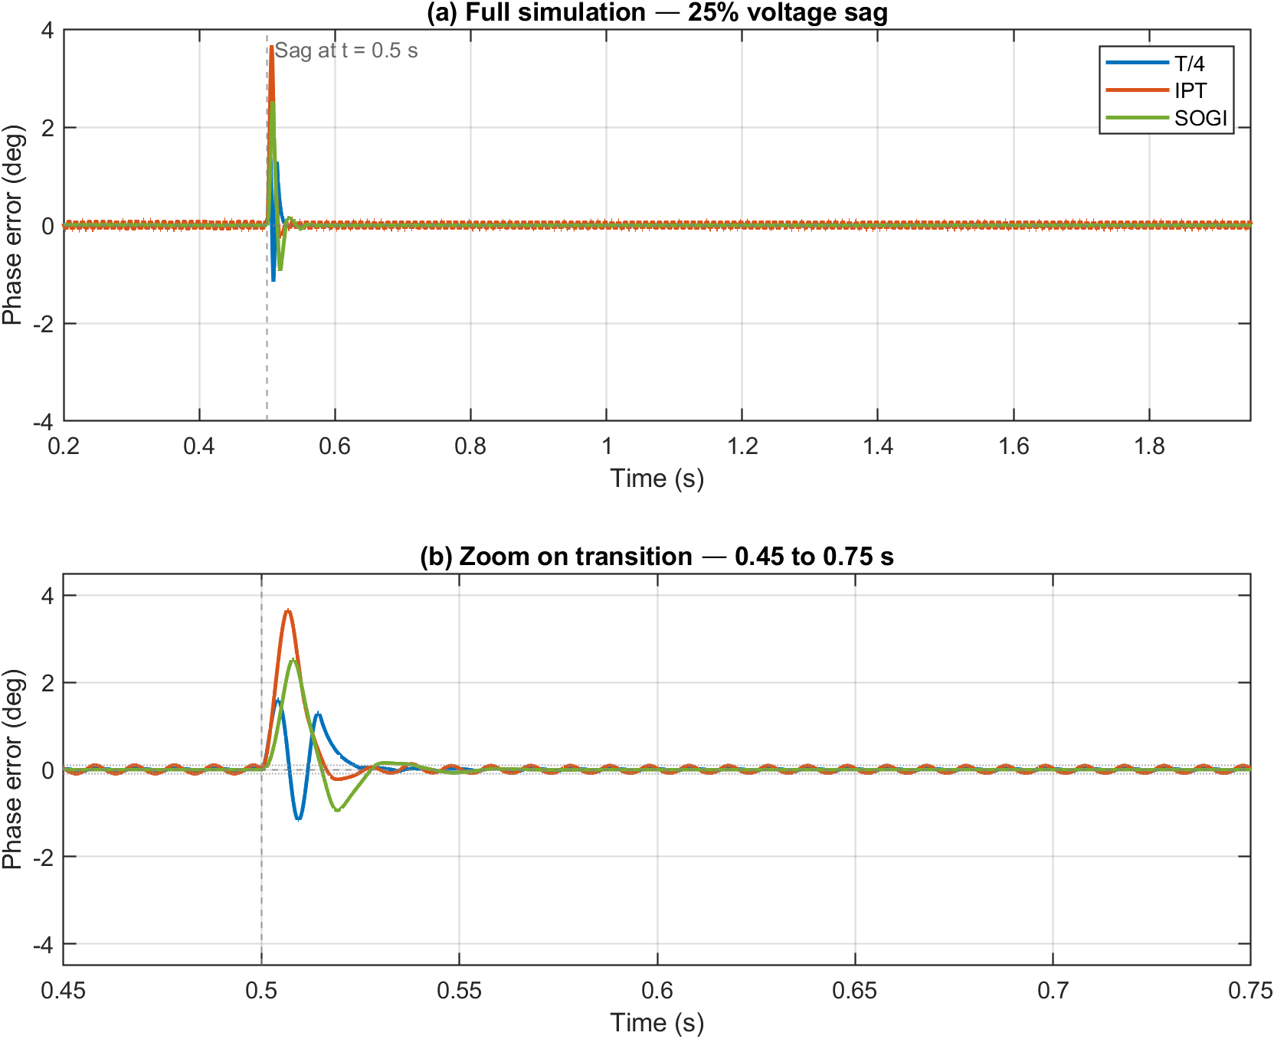
Figure 4.10 Phase-error response of T/4, IPT and SOGI PLLs to a 25% voltage sag applied at t = 0.5s, computed against an ideal 50Hz ramp reference:
(a) Full simulation.
(b) Zoom on transition (0.45 to 0.75s).

In all three topologies, the $αβ$ component pair adjusts smoothly to the new amplitude and the phase error returns to essentially zero in steady state. The transient peak phase error remains modest in every case, with the T/4 PLL recording a peak of 1.60°, the IPT PLL 3.66°, and the SOGI-PLL 2.53°. It can be observed that the T/4 PLL records the lowest peak excursion of the three. This is a structural property of the topology: the T/4's quadrature pair scales linearly with the input amplitude and contains no internal state that must re-track after an amplitude step, so the synchronous-frame phase-error component sees only a magnitude change at the disturbance instant rather than the additional rotational component that the IPT and SOGI topologies briefly experience while their internal states catch up [105], [117], [116]. For disturbances confined to the fundamental amplitude with phase and frequency undisturbed, this is the regime in which the T/4 PLL performs best.
The T/4 PLL also settles fastest, reaching and remaining within ±0.1° of zero in 23 ms. The SOGI-PLL and IPT PLL settle at comparable speeds: 38 ms for the SOGI-PLL and 39 ms for the IPT PLL. The T/4 advantage on this scenario, although modest, reflects the same structural property as its low peak excursion: the absence of an internal state that must re-track after the amplitude step means the PI loop receives a clean error signal from the moment of the disturbance and can drive it back to zero without waiting for an orthogonal-signal generator to settle. The IPT's inverse-Park feedback loop and the SOGI's resonator both impose a brief transient of their own before the PI loop sees a stable input, and that transient adds to the overall settling time. The SOGI-PLL records a marginally lower peak phase error than the IPT PLL (2.53° against 3.66°). Both contain internal states that briefly mistune after the amplitude step, but the SOGI's resonator settles faster than the IPT's inverse-Park feedback loop because of its narrower passband around the fundamental [105], [117], [116], so the q-axis sees a shorter rotational transient and a smaller phase-error peak.
The steady-state ripple after the sag has settled is negligible across all three topologies: 0.06° for the T/4 PLL, 0.18° for the IPT PLL and 0.00° for the SOGI-PLL. All three PLLs track the post-sag fundamental cleanly, confirming that the voltage sag scenario, as constructed here without an associated phase shift, is well within the operating capability of every classical single-phase PLL topology considered.

4.4.2 Phase angle jump
Figure 4.11 shows the response to a +10° phase jump in the grid sinusoid at t = 0.5 s, with amplitude and frequency held constant. The phase-error metric for this scenario is computed against the ideal 50 Hz ramp with the expected +10° step subtracted post-disturbance, so the figure displays the residual tracking error around zero rather than the acquired offset. Figure 4.11(a) shows the full simulation, while Figure 4.11(b) zooms in on the transient. As expected, all three PLLs see essentially the same peak phase error at the disturbance instant, with the T/4 PLL recording 10.01°, the IPT PLL 10.03°, and the SOGI-PLL 10.00°. This is because, at the moment of the jump, the PLL's estimated phase has not yet had time to track and the residual tracking error spikes to approximately the full jump magnitude. The differences between the topologies appear in how quickly each PLL recovers.

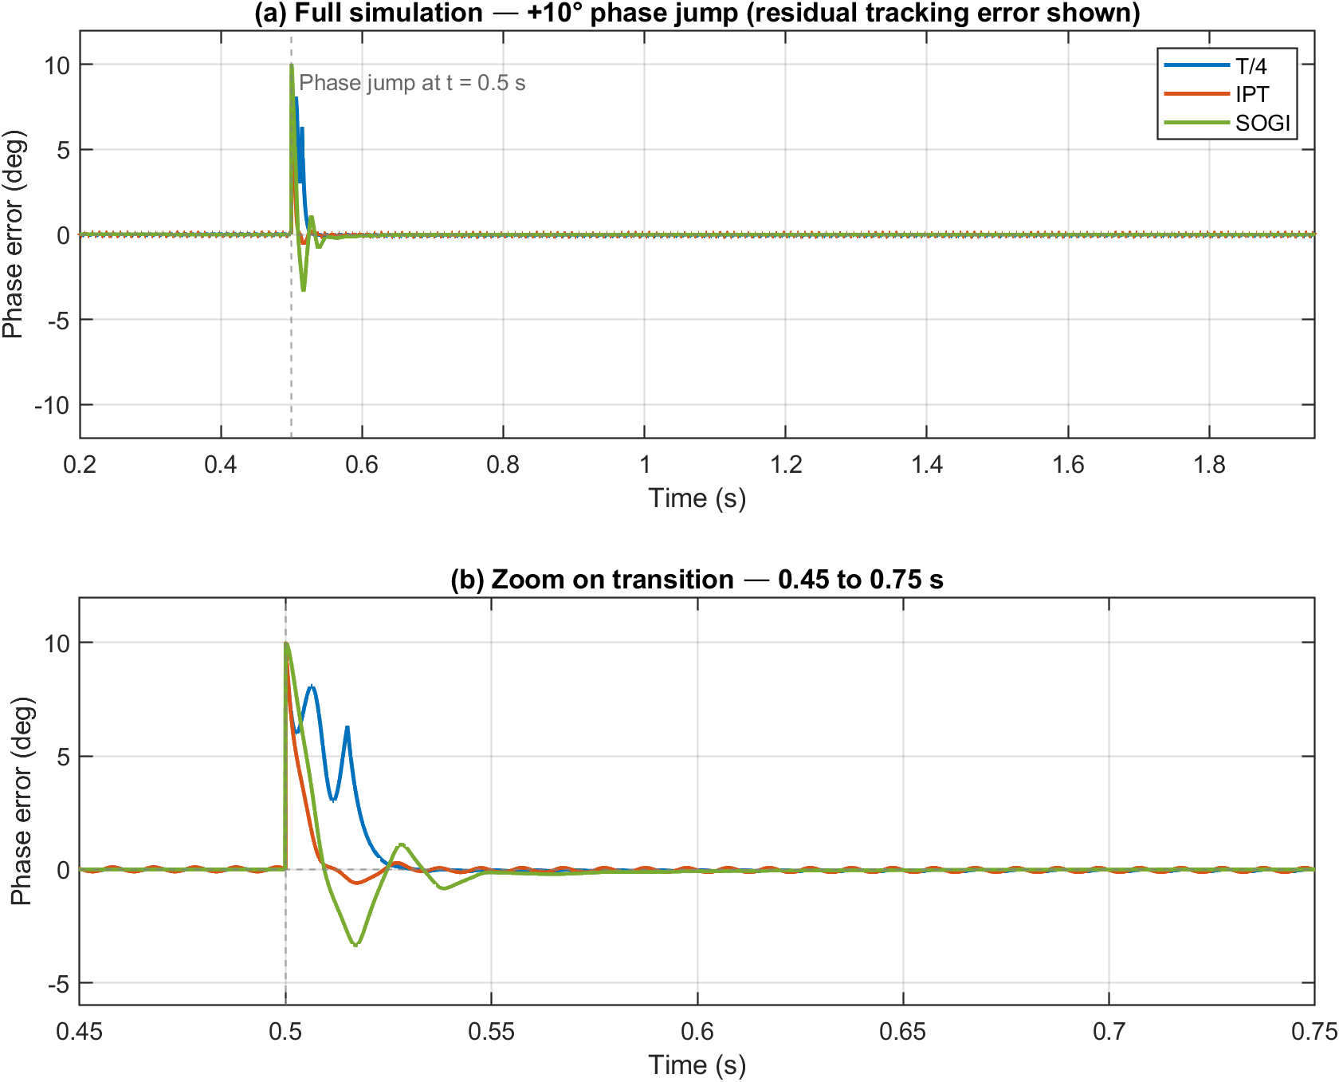
Figure 4.11 Phase-error response of T/4, IPT and SOGI PLLs to a +10° phase angle jump applied at t = 0.5s, computed against an ideal 50Hz ramp with the expected +10° step subtracted post-disturbance to show residual tracking error around zero:
(a) Full simulation.
(b) Zoom on transition (0.45 to 0.75s).
The T/4 PLL settles fastest in this scenario, reaching ±0.1° within 28 ms. The SOGI-PLL takes 94 ms and the IPT PLL takes 494 ms. The T/4 advantage reflects the same structural property as in the voltage sag scenario: the absence of an internal state in the $αβ$ generator means the PI loop sees the disturbance cleanly from the moment of the jump and can drive the residual to zero unimpeded. The SOGI-PLL is around three times slower because the resonator is briefly mistuned at the disturbance instant: the grid phase has stepped by 10° while the resonator is still tuned to the pre-jump fundamental, producing the brief secondary excursion visible in Figure 4.11(b) and adding several fundamental cycles of decay before the PI loop can declare settling [105]. The IPT PLL is the slowest of the three because the inverse-Park feedback loop has the longest re-tracking transient of any internal state in the benchmark. Steady-state errors are essentially zero across all three topologies (−0.019° to 0.000°), and the steady-state ripple is negligible (0.00° to 0.20° peak-to-peak), confirming that all three PLLs successfully acquire the new phase.
The peak frequency excursion in the transient window following the disturbance separates the topologies more clearly than the phase-error settling time does. The T/4 and IPT topologies record ${Δf}_{pk}$ of 8.55 Hz and 8.70 Hz respectively, while the SOGI-PLL records only 3.65 Hz, a 2× improvement. This reflects the same SOGI resonator that costs the topology its settling-time advantage: the narrowband filtering that prolongs the phase-error tail also suppresses the burst of high-frequency content that the phase discontinuity injects into the loop. The reduced frequency excursion translates directly into reduced disturbance to any downstream protection logic that gates on the estimated frequency, and is the SOGI's clearest advantage in this scenario.

4.4.3 Frequency change
Figure 4.12 shows the response to a grid frequency step from 49 Hz to 51 Hz applied at t = 0.5 s, with the assessment conducted entirely in the frequency domain since phase error against any fixed-frequency reference grows without bound under a sustained frequency offset. Figure 4.12(a) shows the estimated frequency over the full simulation, Figure 4.12(b) zooms in on the transition, and Figure 4.12(c) shows the steady-state window with a tight y-axis to bring out the IPT and SOGI traces; the T/4 PLL's wider ripple is clipped at this scale and its full extent is visible in Figure 4.12(a).

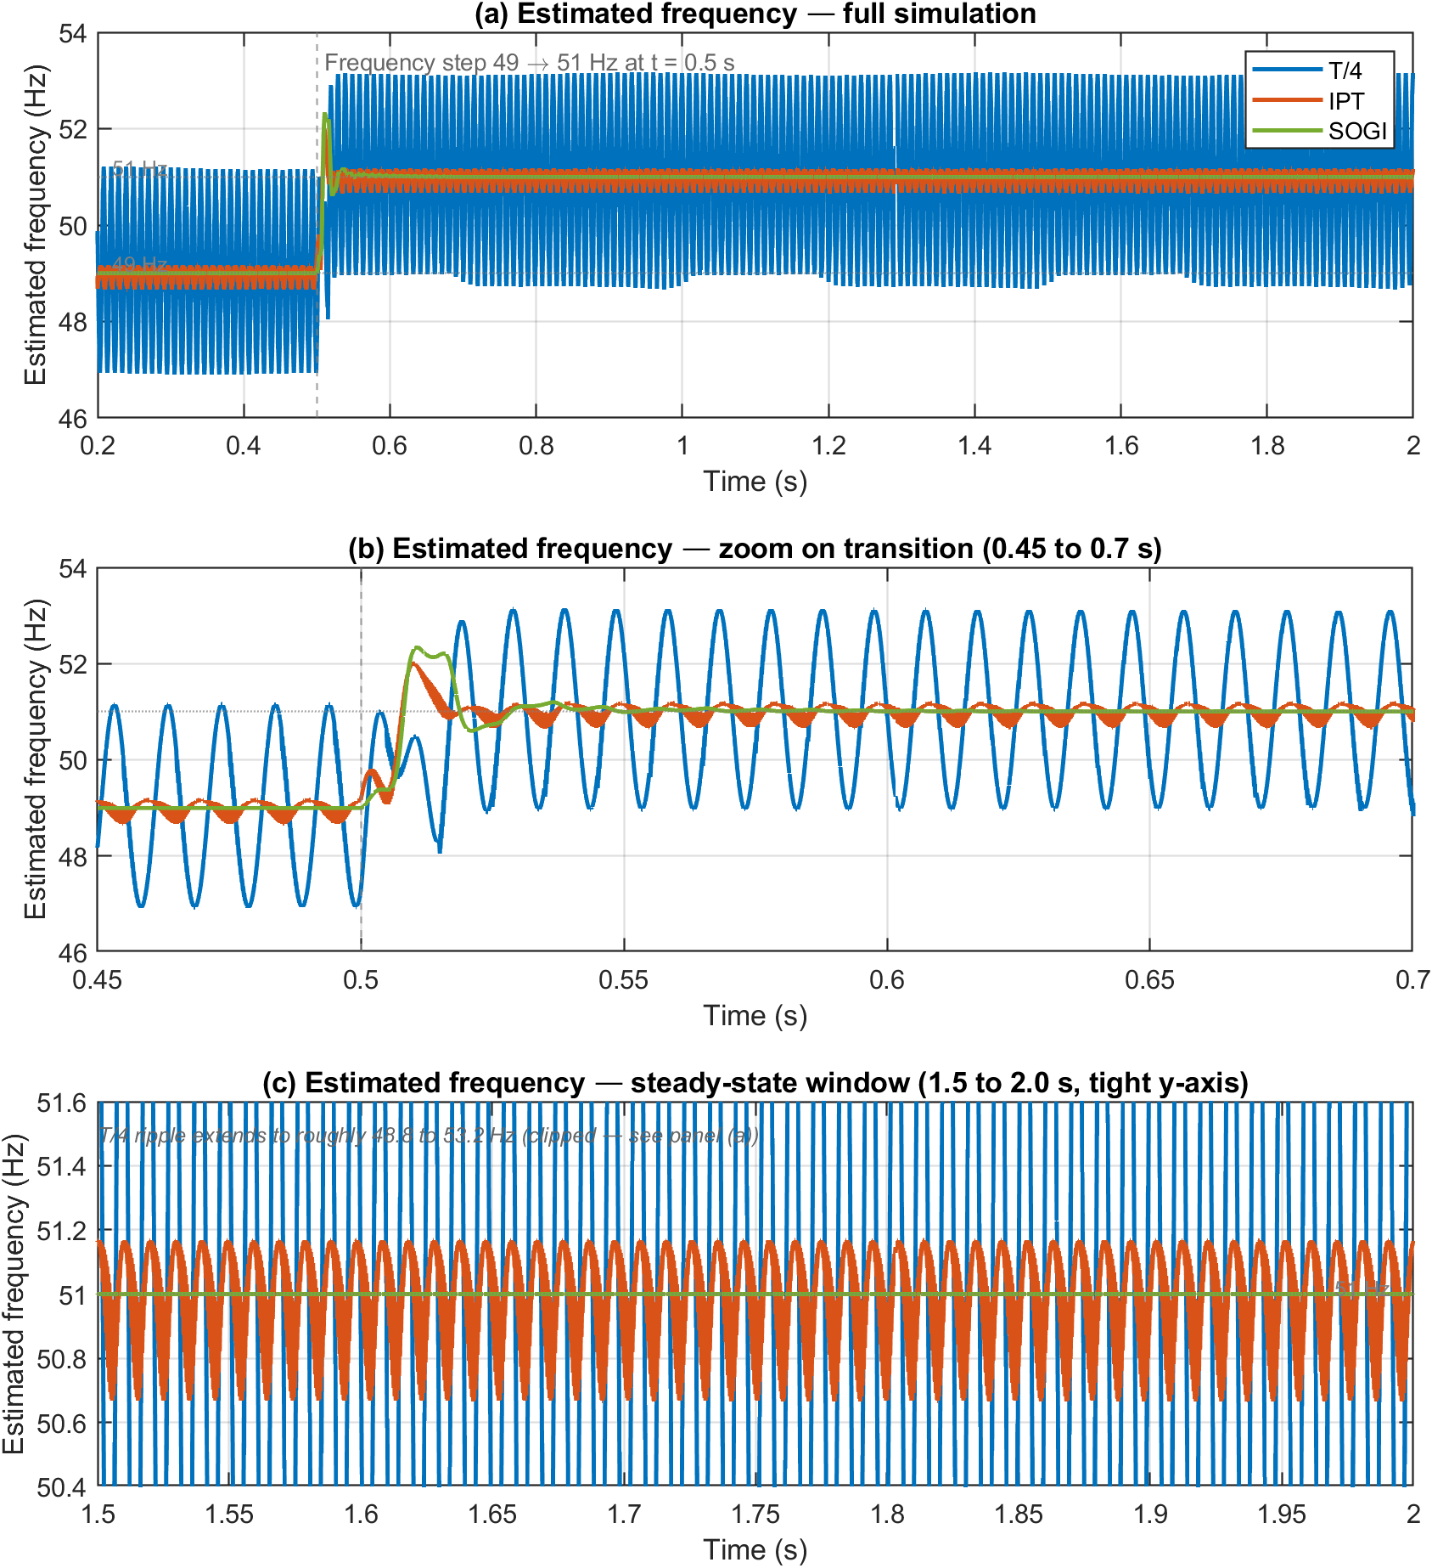

Figure 4.12 Estimated frequency response of T/4, IPT and SOGI PLLs to a 49 to 51Hz frequency step at t = 0.5s.
(a) Full simulation.
(b) Zoom on transition (0.45 to 0.7s).
(c) Steady-state window (1.5 to 2.0s) with tight y-axis showing IPT and SOGI clearly; T/4’s wider ripple is clipped at this scale and visible in (a).

The most striking individual finding in the benchmark is visible across Figure 4.12(a) and (c): the T/4 PLL locks to the correct mean frequency of 50.999 Hz but with a peak-to-peak ripple of 4.49 Hz that does not decrease over the 1.5 s post-disturbance window. The T/4 estimate therefore never settles within any practically useful tolerance, with the band-edges of the ripple straddling values from roughly 48.8 to 53.2 Hz throughout the steady-state window.
The cause of the T/4 PLL's wide frequency ripple is structural. The T/4 PLL synthesises its quadrature signal by delaying the input by exactly 5 ms (one quarter-cycle at 50 Hz). At 51 Hz, one quarter-cycle is 4.902 ms, so the 5 ms fixed delay represents 91.8° rather than the required 90°. This 1.8° quadrature mistuning is structurally baked into the loop and the PI controller cannot correct it. The integrator drives the mean q-axis content to zero, which is why the average frequency estimate still locks to 51 Hz, but the quadrature error leaves the synchronous-frame transformation imperfect at the new operating point, producing the sustained ripple visible in Figure 4.12(c). This is a hard architectural limitation rather than a tuning issue: no reasonable change to the PI gains will eliminate it because the underlying cause is the mismatch between the fixed 5 ms delay and the changed grid period. To remove the limitation, the topology itself must change.
Both the IPT and SOGI topologies have inherent frequency adaptability and produce substantially cleaner frequency estimates than the T/4 PLL. The IPT PLL records a peak frequency excursion of 1.93 Hz at the disturbance instant. Its mean steady-state frequency is 50.986 Hz, a small bias of approximately 14 mHz from the true 51 Hz, and its peak-to-peak ripple in steady state is 0.50 Hz. The IPT does not enter the ±0.1 Hz band of the new nominal within the 1.5 s post-disturbance window. The SOGI-PLL, by contrast, records a peak frequency excursion of 2.00 Hz and settles within 46 ms to within ±0.1 Hz, with no detectable steady-state bias or ripple. On every relevant frequency-domain metric, the SOGI-PLL is therefore the strongest of the three topologies, and by a clear margin: where the T/4 PLL never settles to any useful tolerance, the SOGI-PLL settles to a tolerance the IPT PLL never reaches over the entire 1.5 s post-disturbance window.
The SOGI advantage in this scenario is provided by the explicit frequency-feedback path that re-tunes the resonator's centre frequency in real time as the loop's frequency estimate updates, so the band-pass tuning follows the actual grid frequency dynamically rather than relying on a fixed-frequency assumption. The IPT PLL records a marginally smaller peak frequency excursion than the SOGI-PLL (1.93 Hz against 2.00 Hz), but the 4% difference is within numerical noise and is not a meaningful advantage. The SOGI-PLL records the best result on every other frequency-domain metric for this scenario.

4.4.4 Presence of odd harmonics
Figure 4.13 shows the steady-state phase-error and frequency response of the three PLLs under sustained BS EN 50160 harmonic loading. The harmonics are activated at t = 0.2 s and remain present for the rest of the simulation. The window from 1.5 to 2.0s is shown so that all three traces have reached steady state, and the phase reference is the ideal 50 Hz ramp per the convention defined in the methodology above.

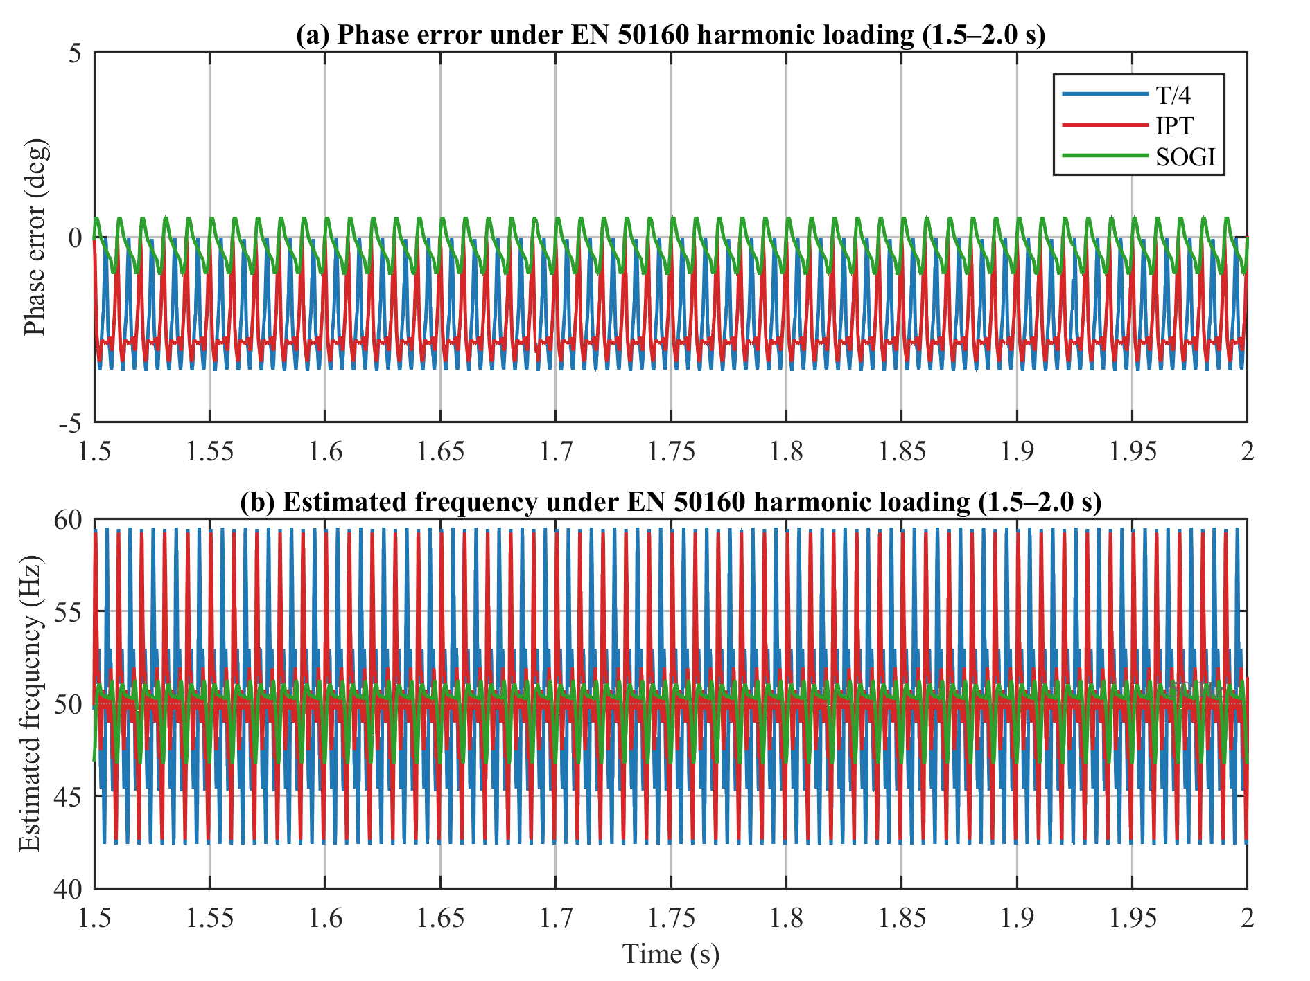
Figure 4.13 Steady-state phase-error and frequency response of T/4, IPT and SOGI PLLs under BS EN 50160 harmonic loading, shown over the 1.5 to 2.0s window.
(a) Phase error.
(b) Estimated frequency. Reference: ideal 50Hz ramp.

The harmonics scenario produces the largest single performance gap visible in the benchmark and provides the chapter's clearest evidence-based finding. The SOGI-PLL records a steady-state ripple of 1.55° peak-to-peak, against 3.62° for the T/4 PLL and 3.39° for the IPT PLL. This is approximately a 2.3× improvement. The steady-state error is also 8 to 9× lower for the SOGI-PLL (−0.26° against −2.05° for the T/4 PLL and −2.38° for the IPT PLL). The peak frequency excursion is 2.26 Hz for the SOGI-PLL, against 8.56 Hz for the T/4 PLL and 8.31 Hz for the IPT PLL, roughly a 4× improvement. On every metric relevant to this scenario, the SOGI-PLL is the strongest topology by a clear margin.
The reason is structural. The SOGI's resonator is a band-pass filter centred on the fundamental, with a Q-factor set by the damping coefficient k. Harmonics at 150 Hz and above are attenuated by the roll-off of this filter before the PI loop sees them. The T/4 PLL has no equivalent filtering: its transport delay has unity gain at all frequencies, so all harmonic content reaches the PI loop unattenuated. The IPT PLL has a low-pass filter in its inverse-Park feedback path, but its cutoff frequency, for the gains used here, is around 100 Hz, which sits below the lowest harmonic in the BS EN 50160 set (150 Hz, the 3rd harmonic). Both the T/4 and IPT topologies therefore pass the harmonic content through to their PI loops with comparable transparency, which is why their performance under harmonics is so similar: the two topologies match to within roughly 15% across all three steady-state metrics, despite their very different orthogonal signal generator structures.
Figure 4.14 verifies that the harmonic injection at the simulation input matches the BS EN 50160 specification exactly. Figure 4.14(a) shows four cycles of the distorted grid-voltage waveform within the steady-state window, with the visible distortion of the sinusoid being the direct consequence of the EN 50160 harmonic content. Figure 4.14(b) shows the FFT magnitude spectrum computed over the 1.0 to 2.0 s observation window. The 50 Hz fundamental sits at 309.0 V, and the five harmonic peaks occupy 5.0% (3rd), 6.0% (5th), 5.0% (7th), 3.5% (11th) and 3.0% (13th) of the fundamental, matching the BS EN 50160 Section 4.2.4 normal-operation limits for low-voltage public networks. This confirms that the disturbance applied to all three PLLs is correctly specified and that the comparative results above rest on a faithful reproduction of the regulatory standard.
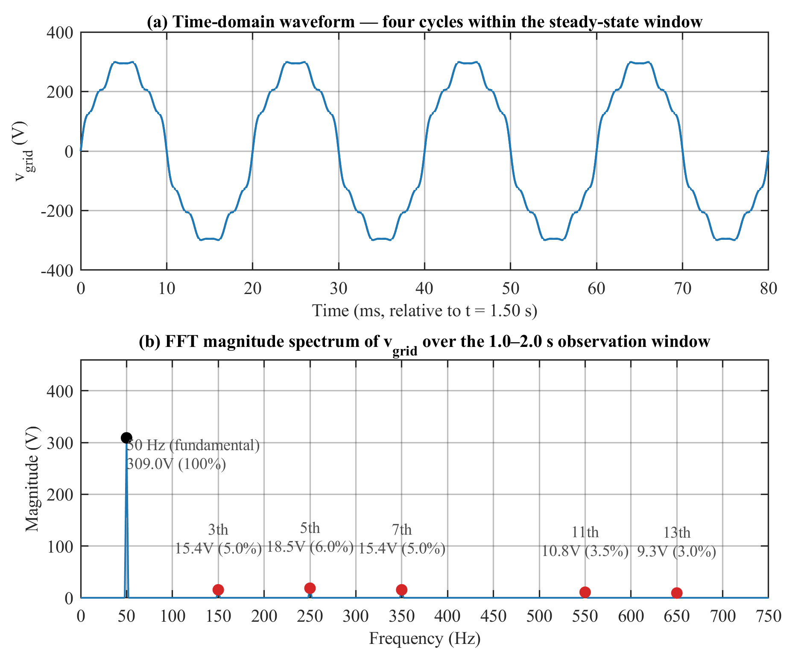
Figure 4.14 Verification of the harmonic injection at the simulation input.
(a) Time-domain waveform of $Vgrid$ over four cycles within the steady-state window.
(b) FFT magnitude spectrum over the 1.0 to 2.0s observation window, with each harmonic peak annotated by its measured amplitude and its percentage of the fundamental.

The harmonics scenario is therefore the clearest single demonstration of the structural advantage of the SOGI topology. The T/4 and IPT topologies inherit the input distortion almost unchanged into their phase estimates, while the SOGI filters most of it out. For an inverter operating in a UK distribution-network environment with sustained harmonic content at BS EN 50160 levels, this difference is the difference between an injected current with substantial harmonic distortion and one with much-reduced harmonic distortion. The residual ripple of 1.55° in the SOGI-PLL, although the smallest of the three, still propagates into the inverter's current reference. This residual is precisely what motivates the enhanced PLL design developed in the next chapter, which augments the SOGI structure with a cascaded delayed signal cancellation pre-filter on the $αβ$ pair to suppress the remaining harmonic-induced ripple without compromising the SOGI's other strengths.

4.4.5 Quantitative summary and findings
The metrics computed across sections 4.4.1 to 4.4.4 are consolidated in Table 4.1 below, which reports all twelve scenario-by-PLL combinations in a single benchmark. Phase-domain metrics (peak phase error, peak frequency excursion, settling time, steady-state error and steady-state ripple) are computed against the ideal 50 Hz ramp reference for the three scenarios in which phase error is well-defined (voltage sag, phase angle jump and harmonic loading). For the frequency change scenario, where phase error against any fixed-frequency reference is unbounded, the assessment is conducted on the PLL’s $f_{est}$ output instead.

Table 4.1 Consolidated benchmark metrics for the four disturbance scenarios across the three PLL topologies. N/A indicates metrics that are not meaningful for the scenario.
Scenario / Metric | T/4 | IPT | SOGI
Voltage sag (25%, $t_{d} = 0.5 s$)
${Δθ}_{pk}$ (°) | 1.60 | 3.66 | 2.53
${Δf}_{pk}$ (Hz) | 2.46 | 2.39 | 1.45
$t_{s}$ to ±0.1° (ms) | 23 | 39 | 38
$θ_{ss}$ (°) | 0.00 | 0.00 | 0.00
$θ_{pp}$ (°) | 0.06 | 0.18 | 0.00
Phase jump (10°, $t_{d} = 0.5 s$)
${Δθ}_{pk}$ (°) | 10.01 | 10.03 | 10.00
${Δf}_{pk}$ (Hz) | 8.55 | 8.70 | 3.65
$t_{s}$ to ±0.1° (ms) | 28 | 494 | 94
$θ_{ss}$ (°) | −0.02 | −0.01 | 0.00
$θ_{pp}$ (°) | 0.07 | 0.20 | 0.00
Frequency change (49 to 51 Hz, $t_{d} = 0.5 s$))
Peak $Δf$ (Hz) | 3.74 | 1.93 | 2.00
Mean $f_{ss}$ (Hz) | 50.999 | 50.986 | 51.000
Ripple (Hz pk-pk) | 4.49 | 0.50 | 0.00
Settle to ±0.1 Hz (ms) | > 1500 | > 1500 | 46
Harmonics (BS EN 50160, $t_{d} = 0.2 s$)
${Δθ}_{pk}$ (°) | n/a | n/a | n/a
${Δf}_{pk}$ (Hz) | 8.56 | 8.31 | 2.26
$t_{s}$ to ±0.1° (ms) | n/a | n/a | n/a
$θ_{ss}$ (°) | −2.05 | −2.38 | −0.26
$θ_{pp}$ (°) | 3.62 | 3.39 | 1.55

Four observations cut across the per-scenario results above. First, no single PLL is best in every scenario: the T/4 PLL is best for amplitude-only disturbances, the SOGI-PLL is best for frequency excursions and harmonic loading, and the IPT PLL is never the strongest but is the only topology to track all four scenarios correctly while remaining adaptable to frequency drift. Second, the choice of orthogonal-signal-generator architecture is the dominant factor in steady-state behaviour: the T/4 PLL's failure under sustained frequency offset and the structural similarity between the T/4 and IPT topologies under harmonics (matching to within roughly 15% on every steady-state metric) are both architecture-level findings that no realistic change to the PI gains would correct. Third, the SOGI-PLL is the only topology with no catastrophic failure mode across the four scenarios, which is the deciding factor for a general-purpose inverter PLL that must handle whatever the grid presents. Fourth, even the best of the three classical topologies leaves a residual harmonic-induced ripple of 1.55° that propagates into the inverter's current reference, and this residual motivates the architectural enhancement developed in the next chapter rather than any retuning of the existing topologies.
Table 4.3 complements the quantitative summary in section 4.4.5 by giving a qualitative judgement of each topology's suitability under each disturbance. Each rating is derived from the Table 4.1 metrics, judged against the metric that governs performance for that disturbance. Suitability under the voltage sag is judged on the recovery, namely the settling time to $±0.1$° and the residual steady-state ripple. Under the phase-angle jump, it is judged on the peak transient frequency excursion ${Δf}_{pk}$, the momentary overshoot a grid-tied converter must withstand. Under the frequency change, it is judged on the steady-state tracking, namely whether the loop settles to within $±0.1Hz$ of the new frequency and the ripple it leaves. Under harmonic loading, it is judged on the steady-state phase error $θ_{ss}$ and ripple $θ_{pp}$. On this basis, a scheme is rated Suitable if it meets the governing metric with margin, giving a fast and clean recovery or a negligible residual; Moderately suitable if it remains stable and tracks the disturbance but leaves a residual excursion, ripple or slow settle beyond that margin, so it functions but degrades reference quality; and Unsuitable if it fails the governing metric, either failing to settle or leaving an error or excursion large enough to compromise synchronisation.

Table 4.3 Response of the synchronisation schemes to various abnormal grid conditions
PLL synchronisation technique | Frequency change | Voltage sag | Phase angle jump | Odd harmonics
T/4 Transport delay PLL | Unsuitable | Suitable | Unsuitable | Unsuitable
Inverse Park’s transform PLL | Moderately suitable | Suitable | Unsuitable | Unsuitable
Second order generalised integrator PLL | Suitable | Suitable | Moderately suitable | Moderately suitable

4.5 Summary
Several grid synchronisation methods for single-phase application were discussed in this chapter, categorised into two primary groups: frequency-domain and time-domain detection methods. Time-domain methods, especially the widely used Phase-Locked Loop (PLL) technique, were highlighted due to their superior speed and simplicity in real-time grid variable detection. The design and operating principles of the PLL were discussed, and several PLL techniques were explored within the time-domain group, including the T/4 Transport Delay PLL, the Inverse Park Transform PLL, and the Second-Order Generalised Integrator PLL (SOGI-PLL).
Simulation results demonstrated the strengths and limitations of each PLL technique under abnormal grid conditions representative of the UK low-voltage public supply, including a frequency excursion across the G99 operating band, a voltage sag below the BS EN 50160 normal-operation envelope, a phase angle jump, and sustained harmonic loading at BS EN 50160 normal-operation levels. The results expose the structural basis of each topology's behaviour rather than merely cataloguing it. The T/4 Transport Delay PLL provides the most direct, lowest-latency response to amplitude disturbances, but its fixed quarter-cycle delay leaves the synchronous-frame transformation imperfect at any operating frequency other than 50 Hz, producing a sustained frequency ripple under frequency excursions that no PI tuning can correct. That fast recovery is bought at the price of a large transient frequency overshoot, which is the basis on which it is rated unsuitable under the phase-angle jump. The Inverse Park Transform PLL gains frequency adaptability through its closed-loop construction, but only with a long convergence time constant and residual ripple that leave it moderately suitable rather than clean under frequency excursions; its feedback-path bandwidth, for typical tuning, also sits below the lowest BS EN 50160 harmonic, so its harmonic-rejection performance is structurally similar to that of the T/4 topology, matching to within roughly 15% on every steady-state metric. The SOGI-PLL, by virtue of its adaptive band-pass resonator and explicit frequency-feedback path, achieves the best overall balance: clean tracking under frequency excursions, the fastest settling under amplitude disturbances, and a clear structural advantage in harmonic rejection.
The contribution of this chapter is the evaluation itself: a single five-metric framework applied consistently across the three topologies and the four disturbances, where each metric is meaningful; a benchmark tied specifically to the UK G99 and BS EN 50160 operating envelope; and a structural account of why each topology behaves as it does. This identifies the SOGI-PLL as the strongest classical baseline on evidence rather than assertion, and defines the residual that Chapter 5 sets out to remove.
The chapter concluded that while the SOGI-PLL offers improved dynamic performance and filtering capabilities compared to the other classical methods, a residual harmonic-induced ripple remains in its phase estimate that cannot be eliminated by gain tuning alone. This residual propagates directly into the inverter's current reference and therefore into the quality of the injected current. In the next chapter, an enhanced PLL topology will be proposed which augments the SOGI structure with a cascaded delayed signal cancellation (CDSC) pre-filter acting on the αβ pair. The objective is to suppress the residual harmonic ripple while preserving the SOGI's favourable transient behaviour, providing a more reliable solution for single-phase grid synchronisation under realistic UK distribution-network conditions.

Chapter 5
A new and highly efficient adaptive phase-locked loop technique for single-phase systems under abnormal grid conditions

5.1 Introduction
An ideal synchronisation scheme must quickly and smoothly track the phase angle of the grid under any condition, including abnormal conditions like voltage sags, frequency and phase changes, as well in the presence of harmonics on the grid voltage. However, as discussed in Chapter 1, conventional PLL techniques perform unsatisfactorily and produce significant oscillatory steady-state tracking errors when the grid voltage is distorted with harmonics [115]. Voltage is distorted primarily at a poorly regulated power line where on one hand current harmonics are flowing in that line and on the other hand there is a significant voltage drop across it, resulting in distorted voltage at the point of common coupling (PCC).
Although the errors can be reduced using the Second-Order Generalised Integrator Phase-Locked Loop (SOGI-PLL) technique proposed in [105] by reducing the PLL bandwidth through an optimal selection of the gain value $k$, such an approach requires a compromise between achieving good steady-state accuracy and a decent transient response, both of which are very important to the overall performance of the PLL technique under abnormal grid conditions. A few advanced PLL techniques for single-phase systems have been proposed in recent literature [117] and the prevalent thinking is to eliminate the harmonics from the grid voltage before it enters the PLL loop. However, these methods are mostly complicated and do not completely filter out some higher-order harmonics in the grid voltage.
As seen in the previous chapter, the SOGI-PLL provides a suitable dynamic performance under abnormal grid conditions. However, to improve upon its steady-state performance, particularly in the presence of grid harmonics, this chapter proposes an enhanced SOGI-PLL which incorporates an αβ- cascaded delay signal cancellation (αβ- CDSC) algorithm in the SOGI-PLL. The αβ-cascaded delay signal cancellation (αβ-CDSC) algorithm was proposed in [118], [119] and the method uses a generalised delayed-signal-cancellation (DSC) operator to eliminate random harmonics. With the αβ-CDSC operator at the input of the SOGI-PLL, its conditioned voltage output can be fed into the SOGI-PLL loop which can now be designed to achieve fast tracking without worrying too much about the poor filtering (high bandwidth) implications of such design. This chapter explains the operation of the αβ-CDSC operator, presents the proposed structure of the αβ-CDSC-SOGI-PLL and confirms the improvement in harmonic elimination both by simulation studies and by experimental validation on a hardware bench.
The benchmark presented in Chapter 4 established the SOGI-PLL as the best of the three classical single-phase topologies for the UK low-voltage distribution-network application. Under sustained harmonic loading at BS EN 50160 normal-operation limits, the SOGI-PLL recorded a steady-state phase ripple of 1.55° peak-to-peak. While this is the smallest residual of the three classical topologies considered (against 3.62° for the T/4 PLL and 3.39° for the IPT PLL), it still propagates directly into the inverter's current reference and therefore into the quality of the injected current. Reducing this residual is the primary motivation for the work presented in this chapter.
It is important to state upfront that the proposed αβ-CDSC-SOGI-PLL is a deliberate design trade-off rather than an unqualified improvement. The cascade of delayed-signal-cancellation operators is calibrated to the 50 Hz fundamental, and this calibration has two structural consequences. First, the four cascaded stages introduce a cumulative loop delay of 18.75 ms (15T/16 at 50 Hz), which lengthens the transient settling time under voltage sag and phase-jump disturbances. Second, the fixed-delay calibration leaves a small steady-state bias under sustained frequency offset, as derived in Section 5.2.3. The proposal therefore improves steady-state harmonic rejection, demonstrated in simulation and confirmed on hardware, at the cost of a longer transient settling time under amplitude and phase disturbances and this steady-state frequency-offset bias, the two costs established analytically and in simulation in Sections 5.2.3 and 5.5.
Beyond confirming the simulated harmonic rejection, the hardware implementation validates the scheme against the real-time execution constraints that an offline simulation cannot expose [120], [121]. The αβ-CDSC-SOGI-PLL is code-generated and deployed to a TI 28P65x microcontroller running from flash at a 200 MHz system clock, with the algorithm discretised at a 50 µs step (a 20 kHz sample rate) in single-precision floating-point arithmetic. Executing the four-stage CDSC cascade and the SOGI-PLL within this fixed 50 µs sample period establishes that the delay-line storage, the per-sample computational load and the execution timing all fit within the available interval on a commodity embedded platform, so the harmonic-rejection improvement is realisable in real time rather than only in ideal continuous-time simulation. Moreover, the two-board bench, in which one microcontroller synthesises the distorted grid voltage and a second synchronises to it through its analogue-to-digital converter in real time, exercises the scheme against a physical signal chain and inter-board timing that an idealised simulation source does not represent. The hardware work therefore establishes not merely that the scheme is correct, but that it is realisable in real time on low-cost hardware, which is the more demanding and more relevant claim for grid-connected deployment.
The specific contributions of this chapter are as follows. First, the αβ-CDSC operator of [118], [119], previously applied to standalone harmonic filtering, is integrated at the input of a SOGI-PLL and developed as the αβ-CDSC-SOGI-PLL synchronisation scheme for the UK low-voltage single-phase application. Second, the second-harmonic cancellation is derived analytically in the stationary αβ-frame, and the cumulative cascade delay and the sustained-frequency-offset bias are derived as the two structural costs of the topology, so that the scheme is presented as a quantified trade-off rather than an unqualified improvement. Third, the proposed scheme is benchmarked against the T/4, IPT and SOGI PLLs under the four disturbance scenarios of Chapter 4 using a common five-metric framework, isolating the improvement attributable to the cascade. Fourth, and forming the principal experimental contribution, the scheme is validated on a two-board LAUNCHXL-F28P65X hardware bench. A controlled-variant method is used: two firmware builds differing only in the presence of the CDSC cascade are run across a harmonic-free baseline and four grid-disturbance scenarios. This attributes the measured second-harmonic reduction to the cascade alone and confirms that the mechanism survives a floating-point discrete-time implementation.

5.2 Cascaded Delay Signal Cancellation
The idea of the CDSC technique originated from the concept of delay signal cancellation (DSC) [122]-[124]. The DSC method was used to eliminate oscillatory errors resulting from an unbalance in grid voltage by combining the $αβ$ components of the grid voltage with their quarter-cycle delayed version at fundamental frequency. Using DSC alone can only partly eliminate grid voltage harmonics; hence a certain extent of error still exists in the PLL’s detected phase angle. By cascading the DSC operator, it is possible to eliminate undesired grid harmonics up to the 24th order.

5.2.1 Representation of Harmonic Signals
The estimated representation of the harmonic signals in grid voltage is the basics of deriving the DSC method. To do that, the analysis must start from the mathematical function that defines the waveform of a single-phase voltage signal which can be expressed as
$$v=V\sin{θ}=V \sin\left(ωt+ φ\right) (5.1)$$
The variables, $V$ is the peak voltage, $ω=2πf$ is the fundamental angular frequency, $θ$ is the phase angle and $φ$ is the initial phase angle.
However, when the grid voltage signal is distorted with harmonics, the approximate representation of the voltage signal is the sum of its harmonic series, that is
$$v=\sum_{h=0}^{H}{v^{h}(t))= \sum_{h=0}^{H}{V^{h}\sin{θ^{h}}}} (5.2)$$
The voltage vector of (5.2) in the orthogonal stationary $αβ$ frame can be expressed as
$${\vec{v}}_{αβ}= v_{α}+jv_{β}=\sum_{h=0}^{H}{v_{α}^{h}}+j∙\sum_{h=o}^{H}{v_{β}^{h}}$$
$$=\sum_{h=0}^{H}{V^{h}\sin{θ^{h}}+} j∙\sum_{h=0}^{H}{V^{h}\sin{θ^{h}}}$$
$$=\sum_{h=0}^{H}{V^{h}(\cos{θ^{h}}+jsin{θ^{h}}})= \sum_{h=0}^{H}{V^{h}e^{jθ^{h}}}= \sum_{h=0}^{H}{{\vec{v}}_{αβ}^{h}}$$
where $θ^{h}=hωt+ φ^{h}$ is the phase angle of each harmonic vector and $h = 0, 1, 2, 3, . . .$, $H$ is the order of the harmonic which ranges from dc component to the possible maximum values of $H.$ The above equation can be simply expressed as
$${\vec{v}}_{αβ}^{h}= v_{α}^{h}\left(t\right)+jv_{β}^{h}\left(t\right)=V^{h}(\cos{θ^{h}}+jsin{θ^{h}})=V^{h}e^{jθ^{h}} (5.3)$$

5.2.2 $αβ$-frame Delay signal cancellation ($αβ$DSC)
Delay signal cancellation works on the principle of superposition of two identical signals, where one signal is the delayed version of the other. If the delay is matched properly as a fraction of the fundamental period, then the addition of the signals would lead to a constructive interference or destructive interference. Also, by choosing a gain factor of $1/2$ for the individual signals, then resultant gain of the superposition operation will only be between 0 and 1. Figure 5.1 demonstrates this effect by showing the addition of a signal and a version which has been delayed by quarter of the fundamental period; both signals with a gain factor of $1/2$. It can be observed that this superposition results in a total cancellation of the original sinusoidal signal. This is equivalent to the cancellation of the 2nd harmonic of the grid voltage as will be later shown.

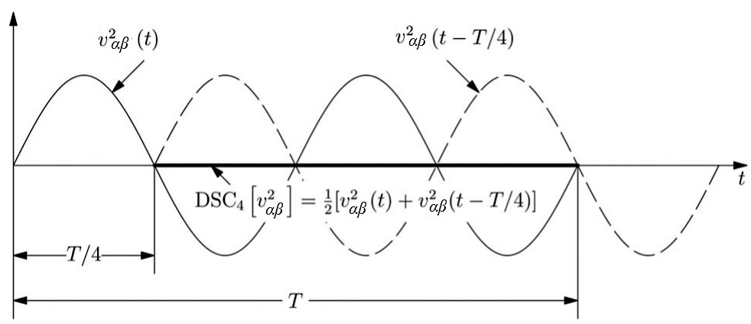
Figure 5.1 Cancellation of 2nd harmonic of the voltage signal by the ${DSC}_{4}$ operator

In time domain, the general delay signal cancellation operator ${DSC}_{n}\left[∙\right]$ which delays a voltage signal, $v(t)$ by $1/n$ of the fundamental period, $T$ is defined as [118], [119]
$${DSC}_{n}\left[v(t)\right]=\frac{1}{2}\left[v(t)+ v\left(t-T/n\right)\right] (5.4)$$
where $n$ is the delay factor and $T/n$ is the delay time.
The application of (5.4) to the $α$-axis harmonic component $v_{α}^{h}(t)$ as stated in (5.3), yields
$${αβDSC}_{n}\left[v_{α}^{h}\left(t\right)\right]=\frac{1}{2}\left[v_{α}^{h}\left(t\right)+ v_{α}^{h}\left(t-T/n\right)\right]$$
$$= \frac{1}{2}\left[V^{h}\cos\left(hωt+ φ^{h} \right)+ V^{h}\cos\left(hω\left(t-T/n\right)+φ^{h} \right)\right]$$
$$=\frac{V^{h}}{2}\left[\cos\left(hωt+ φ^{h} \right)+ \cos\left(hωt-h∙{2π}/n+φ^{h} \right)\right]$$
$$=V^{h}\cos\left(hωt+φ^{h}-{hπ}/n \right)∙\cos\left({hπ}/n\right) (5.5)$$
Similarly, the application of (5.4) to the $β$-axis harmonic component $v_{β}^{h}(t)$ yields
$${αβDSC}_{n}\left[v_{β}^{h}\left(t\right)\right]=\frac{1}{2}\left[v_{β}^{h}\left(t\right)+ v_{β}^{h}\left(t-T/n\right)\right]$$
$$= \frac{1}{2}\left[V^{h}\sin\left(hωt+ φ^{h} \right)+ V^{h}\sin\left(hω\left(t-T/n\right)+φ^{h} \right)\right]$$
$$=\frac{V^{h}}{2}\left[\sin\left(hωt+ φ^{h} \right)+ \sin\left(hωt-h∙{2π}/n+φ^{h} \right)\right]$$
$$=V^{h}\sin\left(hωt+φ^{h}-{hπ}/n \right)∙\cos\left({hπ}/n\right) (5.6)$$
Therefore, the $αβ$-frame DSC operator can be defined from (5.3), (5.4), (5.5) and (5.6) as
$${αβDSC}_{n}\left[{\vec{v}}_{αβ}^{h}\left(t\right)\right]= {αβDSC}_{n}\left[v_{α}^{h}\left(t\right)+jv_{β}^{h}\left(t\right)\right]$$
$$= {αβDSC}_{n}\left[v_{α}^{h}\left(t\right)\right]+j{αβDSC}_{n}\left[v_{β}^{h}\left(t\right)\right] \left(5.7\right)$$
$$=V^{h}\left[\cos\left(hωt+φ^{h}-{hπ}/n \right)+j\sin\left(hωt+φ^{h}-{hπ}/n \right)\right]∙\cos\left({hπ}/n\right)$$
$=V^{h}e^{j\left(hωt+φ^{h}-{hπ}/n\right)}∙\cos\left({hπ}/n\right)=V^{h}e^{j\left(hωt+φ^{h}\right)}∙\cos\left({hπ}/n\right)e^{-j{hπ}/n}$
$$={\vec{v}}_{αβ}^{h}\left(t\right)∙{\vec{G}}_{n}^{h}$$
where ${\vec{G}}_{n}^{h}$is the harmonic gain of the $αβ{DSC}_{n}$ operator and is a complex number with a modulus of $G_{n}^{h}$ and phase angle $ϕ_{n}^{h}$. Respectively, they are defined as
$$G_{n}^{h}=\left|{\vec{G}}_{n}^{h}\right|=\cos\left({hπ}/n\right) (5.8)$$
and
$$ϕ_{n}^{h}=∠{\vec{G}}_{n}^{h}={-hπ}/n (5.9)$$
The practical interpretation of (5.8) and (5.9) is as follows: the magnitude of $v_{αβ}^{h}\left(t\right)$ is scaled by modulus $G_{n}^{h}$ after the DSC operation in time-domain while its phase angle is shifted by $ϕ_{n}^{h}$ along the angular frequency, $ωt$-axis.
Since the gains of the two signals are conjugates when they have the same order of harmonics. Hence, (5.8) can be solved by setting $G_{n}^{h}=0$. We have
$$n= \left|\frac{h}{2k±1/2}\right| k=0, 1, 2, 3, . . . (5.10)$$
The values $k$ is an integer and $h$ is harmonic order of the stationary $αβ$-frame.
From (5.10), we can deduce that a DSC operator, ${DSC}_{n}\left[∙\right]$ with $T/n$ delay (where n is computed from (5.10)) yields a zero gain to the $h^{th}$ harmonic vector, ${\vec{v}}_{αβ}^{h}\left(t\right)$ therefore the corresponding harmonic signal, $v_{αβ}^{h}$ can be eliminated.
Therefore, to eliminate the second harmonics, $v_{αβ}^{2}$ ($h=2)$ of a signal, from (5.10) we can calculate that $n=4$, when $k=0$. Hence, the delay time for the harmonic would be $T/n=T/4$ which implies that the ${DSC}_{4}$ operator will cancel out the $v_{αβ}^{2}$ harmonics from the original signal, as demonstrated in Fig. 5.1.

5.2.3 Cumulative delay and the frequency-step trade-off
The four cascaded DSC stages, with delay factors n = 2, 4, 8 and 16, introduce a cumulative loop delay equal to the sum of their individual delays:
$$τ_{CDSC} = T/2 + T/4 + T/8 + T/16 = 15T/16 (5.11)$$
At the nominal 50Hz fundamental, $T = 20ms$, so
$τ_{CDSC} = 15 × 20 / 16 = 18.75ms$.
Two observations follow.
First, this cumulative delay is a fixed absolute time, not a fixed fraction of the actual fundamental period. At any frequency other than 50 Hz, the per-stage delays no longer correspond exactly to T/2, T/4, T/8 and T/16 of the true period, and the harmonic-cancellation identities (5.4) to (5.10) hold only approximately. The cascade is therefore tuned exactly to the nominal frequency and develops a small structural mistuning under any sustained frequency offset. This is a calibration property of the topology, not a tuning issue addressable by adjustment of the PI gains; correcting it requires an adaptive CDSC variant in which the delays are scaled to the measured grid frequency.
Second, the cumulative delay sits in the signal path between the SOGI-QSG output and the Park transformation, so any change at the cascade input takes 18.75 ms to reach the PI loop. The loop's transient response is therefore shifted later (i.e. longer) by approximately this margin.
Both consequences are quantified in section 5.5. The standard αβ-CDSC topology, calibrated for 50 Hz operation, is the version studied in this thesis on the grounds that UK distribution-network frequency remains within ±0.5 Hz of nominal under the Engineering Recommendation G99 continuous operating envelope for the great majority of operating time [89].

5.3 Cascaded delay signal cancellation (CDSC) PLL
The current flowing in a power line often contains multiple harmonics, especially odd harmonics (e.g., 3rd, 5th, 7th, etc.). Since the current contains harmonic components, the voltage drop across the power line will also exhibit those harmonic frequencies, which affects the voltage at the Point of Common Coupling (PCC). These harmonics at the PCC can lead to voltage waveform distortion, degrading power quality and potentially causing synchronisation issues in grid-connected systems. A single Delay Signal Cancellation (DSC) operator is typically designed to target and cancel specific harmonic frequencies or a limited range of harmonics. However, since grid voltage can contain harmonics of various orders (e.g., 3rd, 5th, 7th, 11th, etc.), no single DSC operator can eliminate all harmonics across a broad spectrum.
Due to the multiple values of $k$, for a given value of $h$, there are different values of $n$ that can satisfy (5.10). Therefore, different DSC operators can remove the same harmonic component, while the same DSC operator may remove several harmonics. Because the gain of the DSC operator can only between 0 and 1, this implies that DSC operator will either completely eliminate a harmonic, or attenuate it, and if not, it will at least leave its magnitude unchanged. All these occur without the DSC actually changing the frequency of the harmonic. Hence it is possibly to cascade several DSC operators in series to from a cascaded DSC (CDSC) which would eliminate or attenuate a larger group (nearly all) the undesired harmonics in a stepwise manner [110], [118], [119].
Similar to the DSC operator, the harmonic elimination ability of a CDSC operator can be characterised by its harmonic gain. Assume two DSC operators ${αβDSC}_{n}\left[∙\right]$ and ${αβDSC}_{m}\left[∙\right]$ are used to construct a CDSC operator
$${αβCDSC}_{n,m}\left[∙\right]={αβDSC}_{m}\left[{αβDSC}_{n}\left[∙\right]\right]$$
Its overall gain during harmonic elimination can be derived as
$${αβCDSC}_{n,m}\left[{\vec{v}}_{αβ}^{h}\right]={αβDSC}_{m}\left[{αβDSC}_{n}\left[{\vec{v}}_{αβ}^{h}\right]\right]$$
$$={αβDSC}_{m}\left[{\vec{v}}_{αβ}^{h}∙{\vec{G}}_{n}^{h}\right] (5.12)$$
$$={αβDSC}_{m}\left[{\vec{v}}_{αβ}^{h}\right]∙{\vec{G}}_{n}^{h}={\vec{v}}_{αβ}^{h}\left(t\right)∙{\vec{G}}_{m}^{h}∙{\vec{G}}_{n}^{h}$$
$$={\vec{v}}_{αβ}^{h}\left(t\right)∙{\vec{G}}_{n,m}^{h}$$
This implies that the overall gain of multiple DSC operators cascaded in series is the product of their individual gains. This conclusion can be easily extended to more than two DSC operators. Since the gain of any DSC operator is less is between $0≤G^{h}≤1$, then cascading multiple DSC operators would result in a progressively smaller gain of the harmonic ($G^{h}→0$).
To quantify this idea, consider that (5.10) is iteratively solved for $n$ for values of $h= 1, 2, 3, . . . , 20$ and $k= 0, 1, 2, 3, 4, 5$ as presented in Table (5.1).
In Table 5.1, the left column of the same $k$ value corresponds to $n= \left|\frac{h}{2k+1/2}\right|$, whereas the right column is $n= \left|\frac{h}{2k-1/2}\right|$.
Based on the results from Table 5.1, we can investigate the harmonic elimination performance of three designs of CDSC operators:
${αβDSC}_{4}$: This uses one DSC operator with delay factor $n$=4 and this operator can eliminate all harmonics with$h=2,6,10,14,18$in the $αβ$-frame (all entries with the orange background).
${αβCDSC}_{2,4, 8,16}$: This CDSC operator has 4 cascaded DSCs with delay factors $n=2,4,8,16$ respectively. As shown in the table, it can eliminate all harmonics with$h=1,2,3,4,…,15,17,….$ in the $αβ$-frame (all entries in orange and grey background). Note that this eliminates all but the 16th order harmonic.
${αβCDSC}_{2,4, 8,16,32}$: To eliminate all harmonics (as shown by all coloured backgrounds in the table), an additional DSC operator with $n=32$ can be cascaded to that of design 2 to form a CDSC operator with 5 cascaded DSCs. However, this design is unnecessary because 16th order harmonics are rarely found. Also, the PLL bandwidth can be designed to eliminate higher order harmonics above $h=20$.
Therefore, the CDSC operator of design 2, ${αβCDSC}_{2,4, 8,16}$ is considered suitable for harmonic elimination in single-phase grid applications and has been used in the design of the αβ-CDSC-SOGI-PLL synchronisation as discussed in the next section.

Table 5.1 Selection of stationary αβ-frame CDSC parameters to eliminate different harmonics [119]
n |  | k
 |  | 0 | 0 | 1 | 1 | 2 | 2 | 3 | 3 | 4 | 4 | 5 | 5
h | 1 | 2 | 2 | $$\frac{2}{5}$$ | $$\frac{2}{3}$$ | $$\frac{2}{9}$$ | $$\frac{2}{7}$$ | $$\frac{2}{13}$$ | $$\frac{2}{11}$$ | $$\frac{2}{17}$$ | $$\frac{2}{15}$$ | $$\frac{2}{21}$$ | $$\frac{2}{19}$$
h | 2 | 4 | 4 | $$\frac{4}{5}$$ | $$1\frac{1}{3}$$ | $$\frac{4}{9}$$ | $$\frac{4}{7}$$ | $$\frac{4}{13}$$ | $$\frac{4}{11}$$ | $$\frac{4}{17}$$ | $$\frac{4}{15}$$ | $$\frac{4}{21}$$ | $$\frac{4}{19}$$
h | 3 | 6 | 6 | $$1\frac{1}{5}$$ | 2 | $$\frac{2}{3}$$ | $$\frac{6}{7}$$ | $$\frac{6}{13}$$ | $$\frac{6}{11}$$ | $$\frac{6}{17}$$ | $$\frac{2}{5}$$ | $$\frac{2}{7}$$ | $$\frac{6}{19}$$
h | 4 | 8 | 8 | $$1\frac{3}{5}$$ | $$2\frac{2}{3}$$ | $$\frac{8}{9}$$ | $$1\frac{1}{7}$$ | $$\frac{8}{13}$$ | $$\frac{8}{11}$$ | $$\frac{8}{17}$$ | $$\frac{8}{15}$$ | $$\frac{8}{21}$$ | $$\frac{8}{19}$$
h | 5 | 10 | 10 | 2 | $$3\frac{1}{3}$$ | $$1\frac{1}{9}$$ | $$1\frac{3}{7}$$ | $$\frac{10}{13}$$ | $$\frac{10}{11}$$ | $$\frac{10}{17}$$ | $$\frac{2}{3}$$ | $$\frac{10}{21}$$ | $$\frac{10}{19}$$
h | 6 | 12 | 12 | $$2\frac{2}{5}$$ | 4 | $$1\frac{1}{3}$$ | $$1\frac{5}{7}$$ | $$\frac{12}{13}$$ | $$1\frac{1}{11}$$ | $$\frac{12}{17}$$ | $$\frac{4}{5}$$ | $$\frac{4}{7}$$ | $$\frac{12}{19}$$
h | 7 | 14 | 14 | $$2\frac{4}{5}$$ | $$4\frac{2}{5}$$ | $$1\frac{5}{9}$$ | 2 | $$1\frac{1}{13}$$ | $$1\frac{3}{11}$$ | $$\frac{14}{17}$$ | $$\frac{14}{15}$$ | $$\frac{2}{3}$$ | $$\frac{14}{19}$$
h | 8 | 16 | 16 | $$3\frac{1}{5}$$ | $$5\frac{1}{3}$$ | $$1\frac{7}{9}$$ | $$2\frac{2}{7}$$ | $$1\frac{3}{13}$$ | $$1\frac{5}{11}$$ | $$\frac{16}{17}$$ | $$1\frac{1}{15}$$ | $$\frac{16}{21}$$ | $$\frac{16}{19}$$
h | 9 | 18 | 18 | $$3\frac{3}{5}$$ | 6 | 2 | $$2\frac{4}{7}$$ | $$1\frac{5}{13}$$ | $$1\frac{7}{11}$$ | $$1\frac{1}{17}$$ | $$1\frac{1}{5}$$ | $$\frac{6}{7}$$ | $$\frac{18}{19}$$
h | 10 | 20 | 20 | 4 | $$6\frac{2}{3}$$ | $$2\frac{2}{9}$$ | $$2\frac{6}{7}$$ | $$1\frac{7}{13}$$ | $$1\frac{9}{11}$$ | $$1\frac{3}{17}$$ | $$1\frac{1}{3}$$ | $$\frac{20}{21}$$ | $$1\frac{1}{19}$$
h | 11 | 22 | 22 | $$4\frac{2}{5}$$ | $$7\frac{1}{3}$$ | $$2\frac{4}{9}$$ | $$3\frac{1}{7}$$ | $$1\frac{9}{13}$$ | $$2$$ | $$1\frac{5}{17}$$ | $$1\frac{7}{15}$$ | $$1\frac{1}{21}$$ | $$1\frac{3}{19}$$
h | 12 | 24 | 24 | $$4\frac{4}{5}$$ | 8 | $$2\frac{2}{3}$$ | $$3\frac{3}{7}$$ | $$1\frac{11}{13}$$ | $$2\frac{2}{11}$$ | $$1\frac{7}{17}$$ | $$1\frac{3}{5}$$ | $$1\frac{1}{7}$$ | $$1\frac{5}{19}$$
h | 13 | 26 | 26 | $$5\frac{1}{5}$$ | $$8\frac{2}{3}$$ | $$2\frac{8}{9}$$ | $$3\frac{5}{7}$$ | $$2$$ | $$2\frac{4}{11}$$ | $$1\frac{9}{17}$$ | $$1\frac{11}{15}$$ | $$1\frac{5}{21}$$ | $$1\frac{7}{19}$$
h | 14 | 28 | 28 | $$5\frac{3}{5}$$ | $$9\frac{1}{3}$$ | $$3\frac{1}{9}$$ | $$4$$ | $$2\frac{2}{13}$$ | $$2\frac{6}{11}$$ | $$1\frac{11}{17}$$ | $$1\frac{13}{15}$$ | $$1\frac{1}{3}$$ | $$1\frac{9}{19}$$
h | 15 | 30 | 30 | 6 | 10 | $$3\frac{1}{3}$$ | $$4\frac{2}{7}$$ | $$2\frac{4}{13}$$ | $$2\frac{8}{11}$$ | $$1\frac{13}{17}$$ | $$2$$ | $$1\frac{3}{7}$$ | $$1\frac{11}{19}$$
h | 16 | 32 | 32 | $$6\frac{2}{5}$$ | $$10\frac{2}{3}$$ | $$3\frac{5}{9}$$ | $$4\frac{4}{7}$$ | $$2\frac{6}{13}$$ | $$2\frac{10}{11}$$ | $$1\frac{15}{17}$$ | $$2\frac{2}{15}$$ | $$1\frac{11}{21}$$ | $$1\frac{13}{19}$$
h | 17 | 34 | 34 | $$6\frac{4}{5}$$ | $$11\frac{1}{3}$$ | $$3\frac{7}{9}$$ | $$4\frac{6}{7}$$ | $$2\frac{8}{13}$$ | $$3\frac{1}{11}$$ | $$2$$ | $$2\frac{4}{15}$$ | $$1\frac{13}{21}$$ | $$1\frac{15}{19}$$
h | 18 | 36 | 36 | $$7\frac{1}{5}$$ | 12 | 4 | $$5\frac{1}{7}$$ | $$2\frac{10}{13}$$ | $$3\frac{3}{11}$$ | $$2\frac{2}{17}$$ | $$2\frac{2}{5}$$ | $$1\frac{5}{7}$$ | $$1\frac{17}{19}$$
h | 19 | 38 | 38 | $$7\frac{3}{5}$$ | $$12\frac{2}{5}$$ | $$4\frac{2}{9}$$ | $$5\frac{3}{7}$$ | $$2\frac{12}{13}$$ | $$3\frac{5}{11}$$ | $$2\frac{4}{17}$$ | $$2\frac{8}{15}$$ | $$1\frac{17}{21}$$ | $$2$$
h | 20 | 40 | 40 | 8 | $$13\frac{1}{13}$$ | $$4\frac{4}{9}$$ | $$5\frac{5}{7}$$ | $$3\frac{1}{13}$$ | $$3\frac{7}{11}$$ | $$2\frac{6}{17}$$ | $$2\frac{2}{3}$$ | $$1\frac{19}{21}$$ | $$2\frac{2}{19}$$

5.4 The proposed $αβ$-CDSC-SOGI-PLL Synchronisation technique
The phase detector (PD) block of the SOGI-PLL system of Fig. 4.6 can be modified to as shown in Fig. 5.2 to yield the more efficient αβ-CDSC-SOGI-PLL system, which is more efficient in detecting the grid phase angle under abnormal grid conditions, such as voltage sags, harmonic distortions, or frequency variations. It offers improved accuracy in phase angle tracking and faster dynamic response compared to traditional filtering schemes like low-pass filters [124].
In the system, each DSC block performs the operation defined by (5.5) and (5.6). The $αβ$-frame CDSC operator takes its input from the orthogonal voltage output, $v^{'}$ and ${qv}^{'}$ of the SOGI-QSG and eliminates the undesired grid harmonics contained in the polluted signals. The resulting undistorted, desirable quadrature stationary signals $v_{α}$ and $v_{β}$ are subsequently fed into the Park’s transformation, the loop filter (which is PI controller in this case) and the frequency-phase generator (FPG) for normal PLL synchronisation as discussed in 4.3.3.

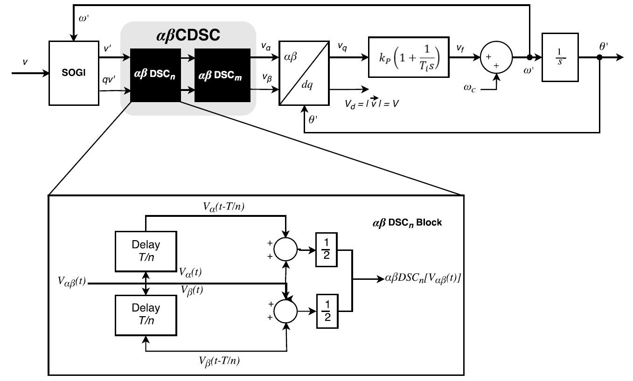
Figure 5.2 Block diagram of the continuous αβ-frame CDSC+SOGI PLL system.

The number and the parameters of the DSC blocks can be obtained from (5.4) to (5.11) as explained in section 5.22. These have been simply represented by the ${αβDSC}_{n}…$ ${αβDSC}_{m}$ in Fig. 5.2. The ${αβDSC}_{n}$ block takes the $v^{'}$ output of the SOGI-QSG and superimposes a delayed version of the signal (using the preset $T/n$ delay), the output is then fed through a number of cascaded DSC operators (each with their own preset $T/n$ delay) in a step-wise manner until the clean $v_{α}$ signal is produced. A similar operation is also carried out simultaneously on ${qv}^{'}$ to produce $v_{β}$. As a result of the harmonic-free $v_{α}$ and $v_{β}$ input to the PLL loop, the detected phase angle exhibits substantially reduced steady-state ripple under harmonic loading, although small residual ripple or bias may remain under off-nominal frequency conditions. Simulation results have been obtained in section 5.5 to confirm the satisfactory performance of proposed PLL synchronisation PLL technique.

5.5 Simulation results
The Simulink model of the Second Order Generalised Integrator (SOGI) PLL in Fig. 4.9 was modified to include an ${αβCDSC}_{2,4, 8,16}$ system (that is, an αβCDSC made up of four cascaded DSC blocks with their delay factors set as $n=2,4,8,16$ respectively) between the SOGI-QSG output and the input of the Park transformation block as shown in Fig. 5.3.

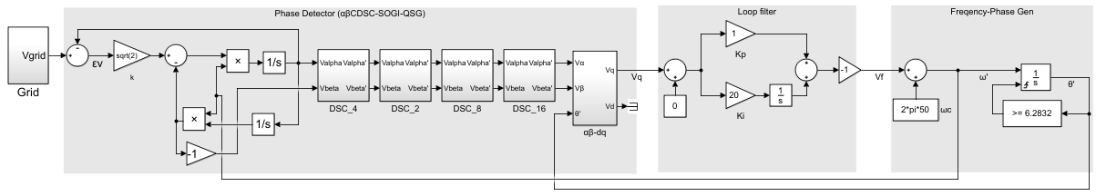
Figure 5.3 Simulink model of the ${αβCDSC}_{2,4, 8,16}$-SOGI-PLL

To preserve direct comparability with the three classical PLLs benchmarked in Chapter 4, the simulation setup follows the same methodology as Chapter 4. The utility grid is implemented as a 230Vrms, 50Hz AC controlled voltage source at 95% of nominal (309V peak, matching the BS EN 50160 normal-operation envelope). The phase error is computed against the ideal nominal phase reference $θ_{ref}(t) = 2π∙50·t$ with a pre-disturbance offset subtracted. The five metrics (${Δθ}_{pk}$, ${Δf}_{pk}$, $t_{s}$, $θ_{ss}$, $θ_{pp}$) are applied uniformly across all sixteen scenario×PLL combinations, matching Chapter 4’s methodology. The four disturbance scenarios are:

- Scenario 1: A 25% step reduction in the fundamental amplitude at $t=0.5s$, representing a low-voltage ride-through event at the lower edge of the BS EN 50160 normal-operation envelope,
- Scenario 2: A change in phase angle from 0º to 10º at $t=0.5s$,
- Scenario 3: A frequency excursion from 49Hz to 51Hz at $t=0.5s$, representing a ±1Hz step centred on nominal 50Hz that sits inside the G99 continuous operating range [89],
- Scenario 4: The introduction of odd harmonics (3rd, 5th, 7th, 11th and 13th) at $t=0.2s$, at the BS EN 50160 Section 4.2.4 normal-operation limits for low-voltage public networks: 5.0% (3rd), 6.0% (5th), 5.0% (7th), 3.5% (11th) and 3.0% (13th) of the fundamental. These harmonics correspond to frequencies of 150Hz, 250Hz, 350Hz, 550Hz and 650Hz respectively.
Based on the measurements of the grid voltage, its phase angle and frequency are then estimated using the synchronisation scheme proposed in Section 5.4.
The results are shown in Figures 5.4 – 5.7 below.

Scenario 1: Voltage sag

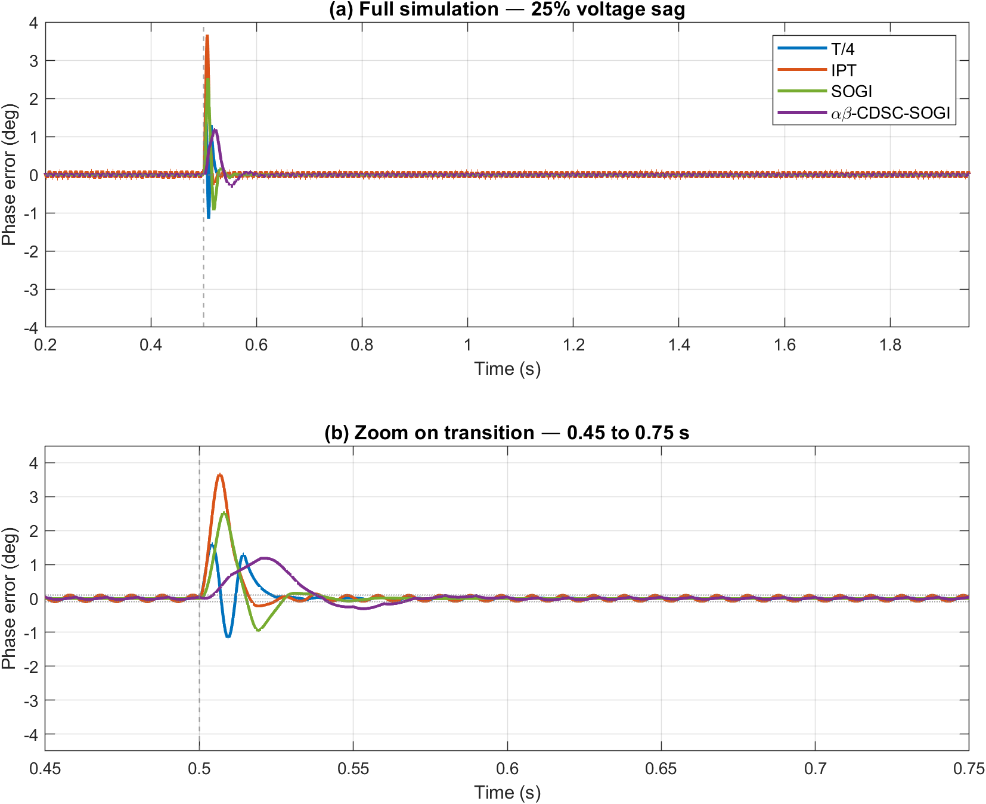
Figure 5.4 Phase-error response of T/4, IPT, SOGI and αβ-CDSC-SOGI PLLs to a 25% voltage sag applied at t = 0.5s, computed against the ideal 50Hz ramp reference.
(a) Full simulation.
(b) Zoom on transition (0.45 to 0.75s).

Scenario 2: Phase angle jump

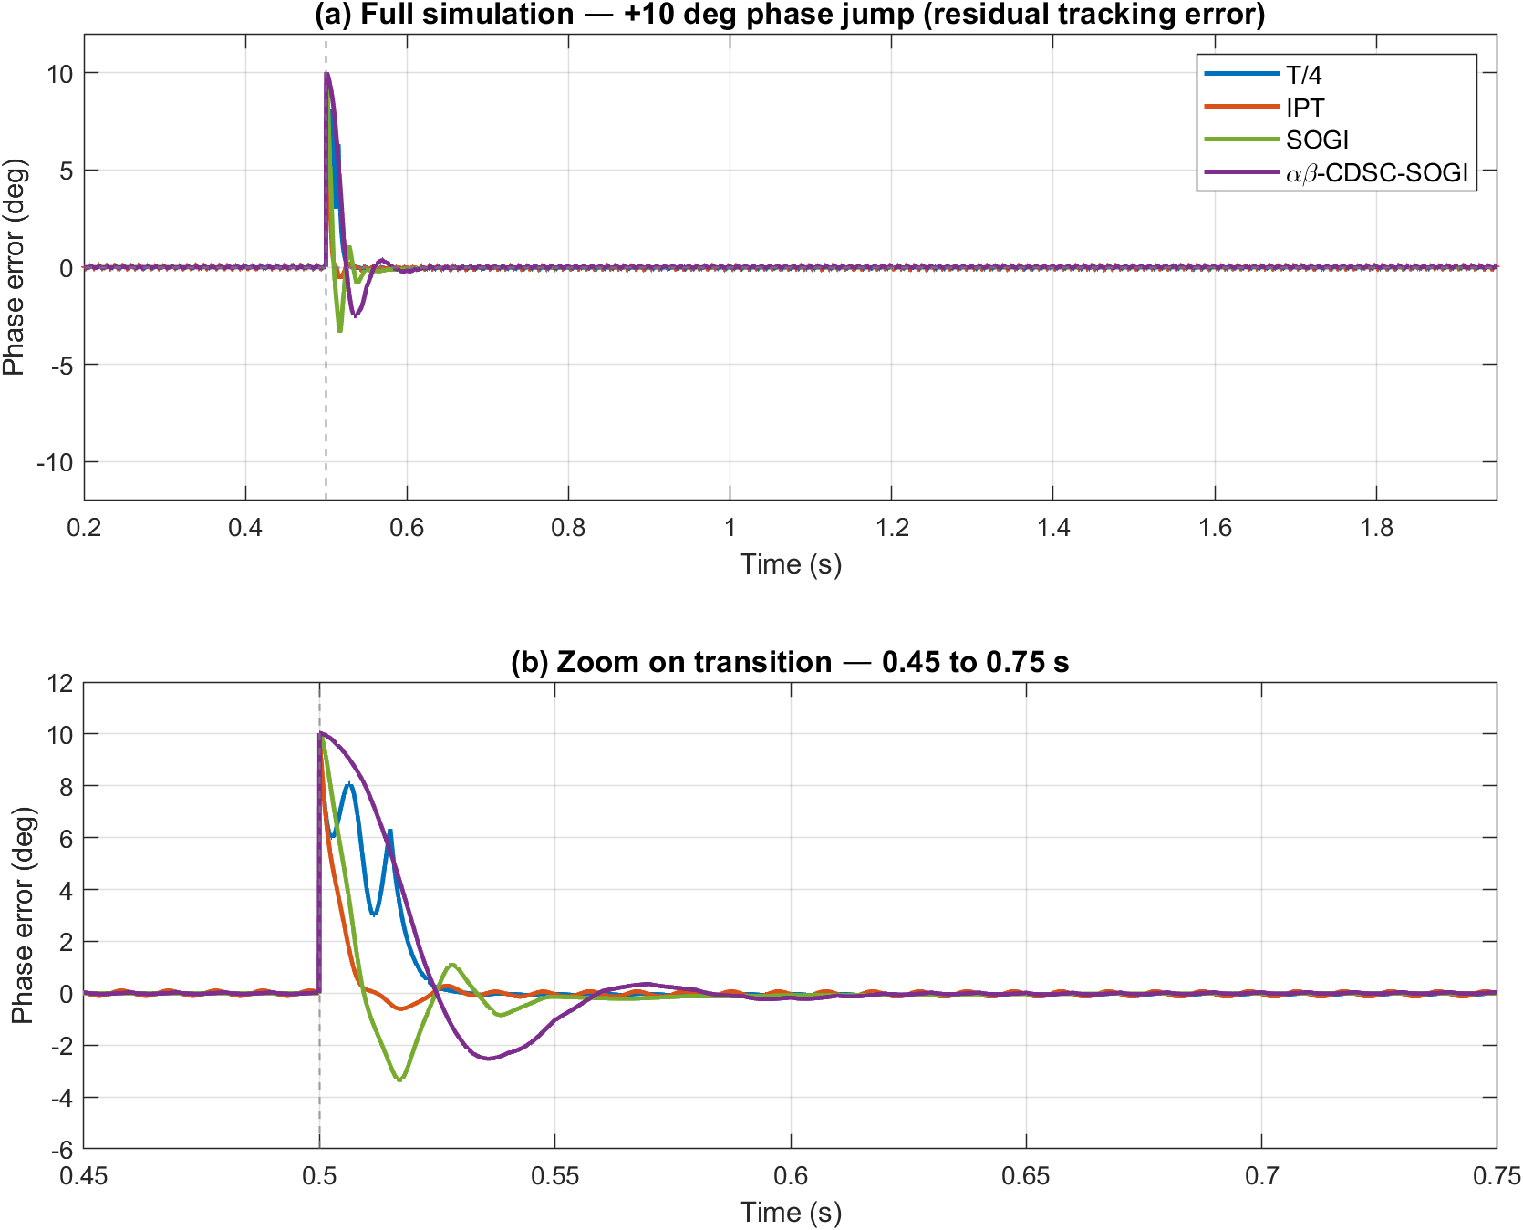

Figure 5.5 Phase-error response of T/4, IPT, SOGI and αβ-CDSC-SOGI PLLs to a +10° phase angle jump applied at t = 0.5s, computed against an ideal 50Hz ramp with the expected +10° step subtracted post-disturbance to show residual tracking error.
(a) Full simulation.
(b) Zoom on transition (0.45 to 0.75s).

Scenario 3: Frequency step

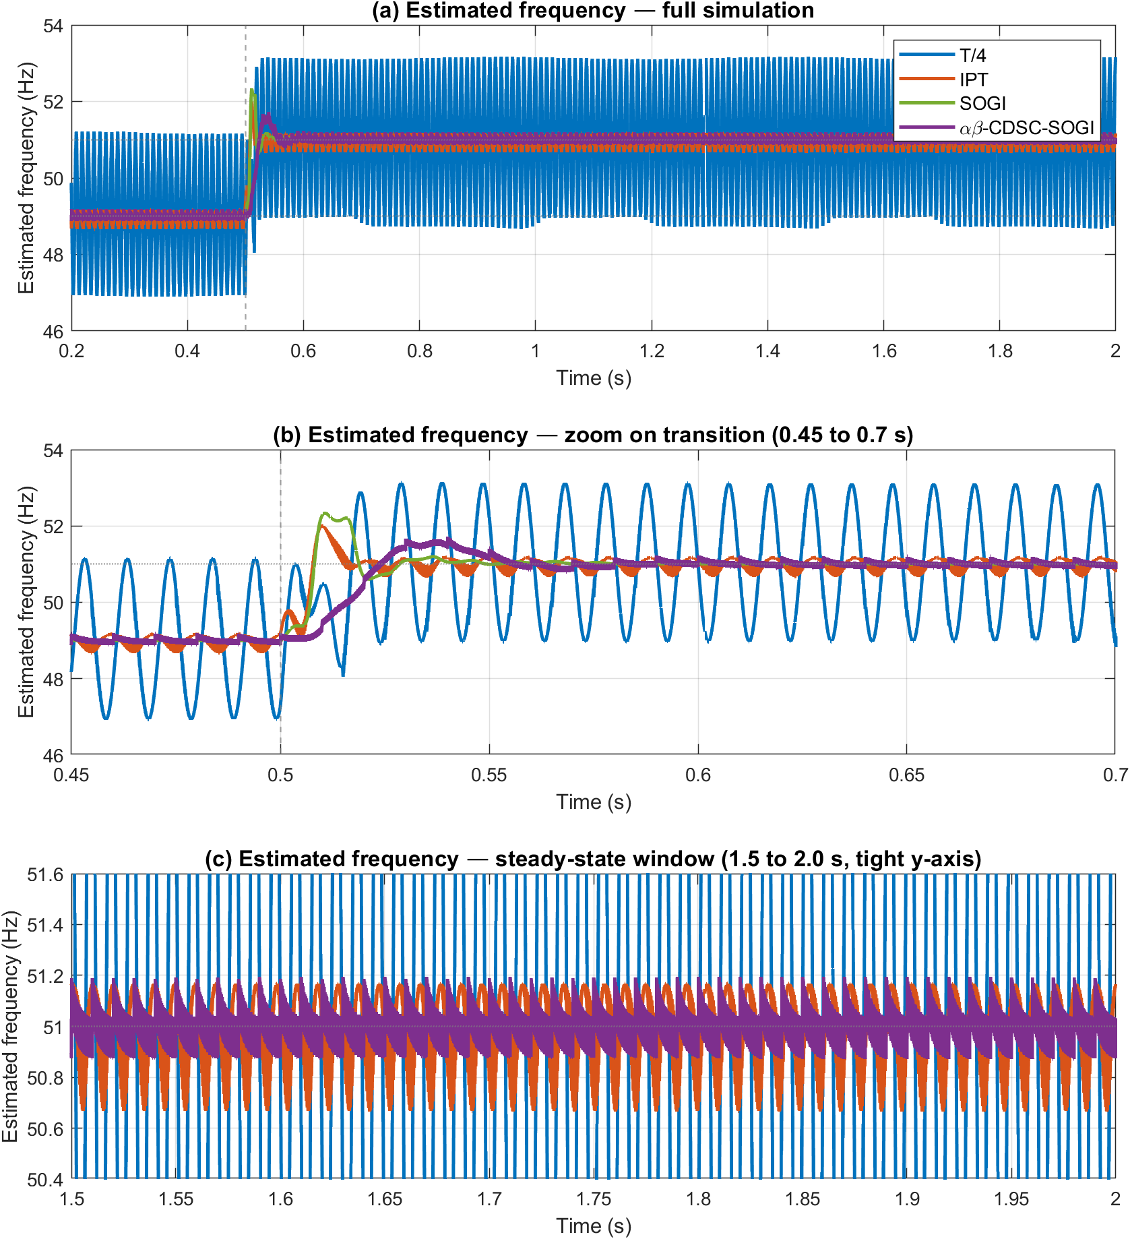
Figure 5.6 Estimated frequency response of T/4, IPT, SOGI and αβ-CDSC-SOGI PLLs to a 49 to 51Hz frequency step at t = 0.5s.
(a) Full simulation.
(b) Zoom on transition (0.45 to 0.7s).
(c) Steady-state window (1.5 to 2.0s) with tight y-axis showing IPT, SOGI and CDSC-SOGI traces; the T/4 ripple is clipped at this scale and its full extent is visible in (a).

Scenario 4: Presence of odd harmonics

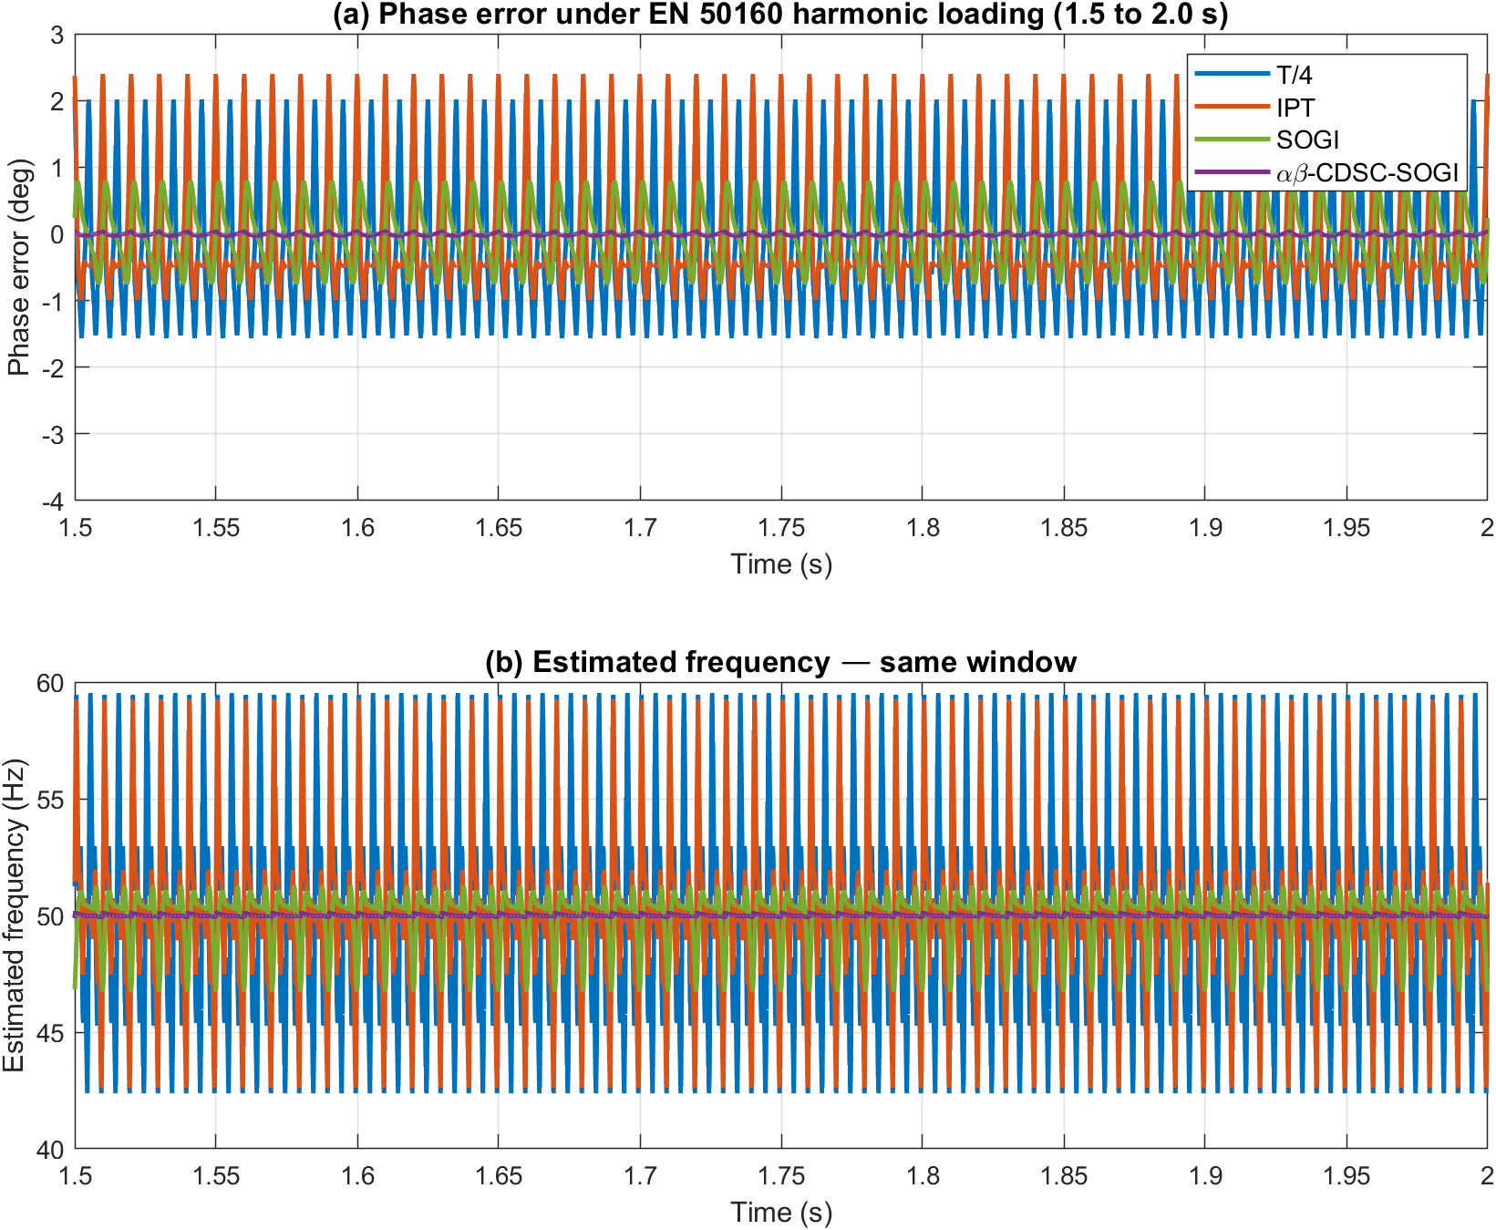
Figure 5.7 Steady-state phase-error and frequency response of T/4, IPT, SOGI and αβ-CDSC-SOGI PLLs under sustained BS EN 50160 harmonic loading (1.5 to 2.0s window).
(a) Phase error against the ideal 50Hz ramp reference.
(b) Estimated frequency.

Observations:
The five-metric framework introduced in Chapter 4 (peak phase error ${Δθ}_{pk}$, peak frequency excursion ${Δf}_{pk}$, settling time $t_{s}$, steady-state error $θ_{ss}$, and steady-state ripple $θ_{pp}$) is applied without modification to the αβ-CDSC-SOGI-PLL across the same four scenarios. The complete metric values are consolidated in Table 5.2 alongside the corresponding figures for the three classical topologies from Chapter 4. The observations below interpret the table by scenario.

Scenario 1 (Voltage sag). The αβ-CDSC-SOGI-PLL records the lowest peak phase error of the four topologies (1.18° against 1.60° for T/4, 3.66° for IPT and 2.53° for SOGI), and the lowest peak frequency excursion (0.42Hz against 2.46, 2.39 and 1.45Hz). Settling time is 66 ms, approximately 28ms slower than SOGI’s 38ms and 43ms slower than T/4’s 23ms, consistent with the cumulative cascade delay of 18.75ms plus a small PI-loop adjustment. Steady-state ripple is 0.06° peak-to-peak, slightly above the SOGI baseline’s 0.00°. On amplitude-only disturbances, the cascade therefore reduces the transient peak at the cost of a modest increase in settling time, with no penalty on steady-state behaviour.
Scenario 2 (Phase angle jump). The peak phase error of 10.04° is essentially identical to the other three topologies (10.00° to 10.03°), because at the disturbance instant the residual tracking error spikes to approximately the full jump magnitude regardless of topology. Settling time is 116ms, slower than the T/4 PLL’s 28ms and the SOGI-PLL’s 94ms, again reflecting the cascade delay. The peak frequency excursion of 1.91Hz is substantially smaller than the T/4 PLL’s 8.55Hz and the IPT PLL’s 8.70Hz, and roughly half the SOGI-PLL’s 3.65Hz, consistent with the cascade attenuating the high-frequency content of the phase discontinuity before it reaches the PI loop. Steady-state ripple is 0.06°, again essentially zero.
Scenario 3 (Frequency change). The αβ-CDSC-SOGI-PLL reaches its steady-state regime within approximately 150ms of the disturbance, where its estimated frequency oscillates around a mean of 50.98 Hz with a ripple amplitude of 0.16Hz (half peak-to-peak, or 0.33Hz peak-to-peak). The mean is offset from the new 51Hz fundamental by a 20 mHz residual bias, and the steady-state ripple is generated by the cascade per-stage delays no longer matching one-Nth of the actual fundamental period: at 51 Hz the true period is 19.6 ms rather than the 20 ms for which the cascade was calibrated, in line with the mistuning analysis of section 5.2.3. The combined excursion (mean bias plus ripple amplitude) is therefore 0.18Hz, which exceeds the ±0.1 Hz settling band (the 5% settling band for the 2 Hz step). The ±0.1 Hz band is consequently not entered within the 1.5 s observation window, not because of slow loop convergence but because of this structural property of the cascade at off-nominal frequencies. The bias and the ripple would persist indefinitely while the per-stage delays remain at their 50 Hz design values rather than being re-tuned to the measured grid frequency. The conventional metric of settling time is therefore not meaningful for this PLL under sustained frequency offset; the more informative number is the transient duration of 150ms, after which the trace is in its asymptotic regime.
Scenario 4 (Presence of odd harmonics). This is the headline result of the chapter. The αβ-CDSC-SOGI-PLL records a steady-state phase ripple of 0.06° peak-to-peak under sustained BS EN 50160 harmonic loading, against 3.62° for the T/4 PLL, 3.39° for the IPT PLL, and 1.55° for the SOGI-PLL. This is a 26× improvement over the SOGI baseline and a 60× improvement over the T/4 PLL. The peak frequency excursion is 0.15 Hz (the ripple amplitude over the steady-state window, defined as half peak-to-peak), against 2.26 Hz for SOGI and 8.56 Hz for T/4. Figure 5.8 confirms the harmonic-cancellation mechanism by FFT comparison of the cascade input and output: each of the five EN 50160 harmonics present in $V_{grid}$ is suppressed by at least 70dB at the cascade output, consistent with the deterministic cancellation predicted by the algebra of section 5.2.2. The harmonic-rejection improvement is therefore a structural property of the topology rather than the result of tuning or filter-bandwidth selection.
Table 5.2 below consolidates the metric values across all four scenarios and all four PLL topologies. The values for the three classical topologies (T/4, IPT, SOGI) are reproduced from Chapter 4’s Table 4.1; the αβ-CDSC-SOGI-PLL column reports the new results presented above.

Table 5.2 Consolidated benchmark metrics across all four scenarios and all four PLL topologies.
The asterisk (*) marks the αβ-CDSC-SOGI-PLL frequency-step settling entry: the transient is over within approximately 150 ms (the trace enters and stays within ±0.2 Hz of 51 Hz at 150 ms), but the ±0.1 Hz settling band (the 5% band for the 2 Hz step) is never entered.
Scenario / Metric | T/4 | IPT | SOGI | αβ-CDSC-SOGI
Voltage sag (25%, $t_{d} = 0.5 s$)
${Δθ}_{pk}$ (°) | 1.60 | 3.66 | 2.53 | 1.18
${Δf}_{pk}$ (Hz) | 2.46 | 2.39 | 1.45 | 0.42
$t_{s}$ to ±0.1° (ms) | 23 | 39 | 38 | 66
$θ_{ss}$ (°) | 0.00 | 0.00 | 0.00 | 0.00
$θ_{pp}$ (°) | 0.06 | 0.18 | 0.00 | 0.06
Phase jump (10°, $t_{d} = 0.5 s$)
${Δθ}_{pk}$ (°) | 10.01 | 10.03 | 10.00 | 10.04
${Δf}_{pk}$ (Hz) | 8.55 | 8.70 | 3.65 | 1.91
$t_{s}$ to ±0.1° (ms) | 28 | 494 | 94 | 116
$θ_{ss}$ (°) | −0.02 | −0.01 | 0.00 | 0.01
$θ_{pp}$ (°) | 0.07 | 0.20 | 0.00 | 0.06
Frequency change (49 to 51 Hz, $t_{d} = 0.5 s$))
Peak $Δf$ (Hz) | 3.74 | 1.93 | 2.00 | 2.12
Mean $f_{ss}$ (Hz) | 50.999 | 50.986 | 51.000 | 50.980
Ripple (Hz pk-pk) | 4.49 | 0.50 | 0.00 | 0.33
Settle to ±0.1 Hz (ms) | > 1500 | > 1500 | 46 | N/A*
Harmonics (BS EN 50160, $t_{d} = 0.2 s$)
${Δθ}_{pk}$ (°) | n/a | n/a | n/a | n/a
${Δf}_{pk}$ (Hz) | 8.56 | 8.31 | 2.26 | 0.15
$t_{s}$ to ±0.1° (ms) | N/A | N/A | N/A | N/A
$θ_{ss}$ (°) | −2.05 | −2.38 | −0.26 | 0.00
$θ_{pp}$ (°) | 3.62 | 3.39 | 1.55 | 0.06
Figure 5.8 verifies the cascade’s harmonic-cancellation mechanism by FFT comparison of the cascade input ($V_{grid}$) and the cascade output (v_α post-CDSC, the signal entering the Park transformation). Figure 5.8(a) shows the input spectrum with the five BS EN 50160 harmonics at their specified amplitudes (−24 dB to −30 dB relative to the fundamental, corresponding to 3.0% to 6.0% of the fundamental). Figure 5.8(b) shows the cascade output spectrum: the fundamental at 50 Hz passes through at 0 dB while every EN 50160 harmonic peak has been suppressed by at least 70 dB (a factor of approximately 3000 in voltage). This is a direct verification of the deterministic harmonic-cancellation property derived in Section 5.2.2 and is the structural mechanism underlying the 26× harmonic-rejection improvement reported above.

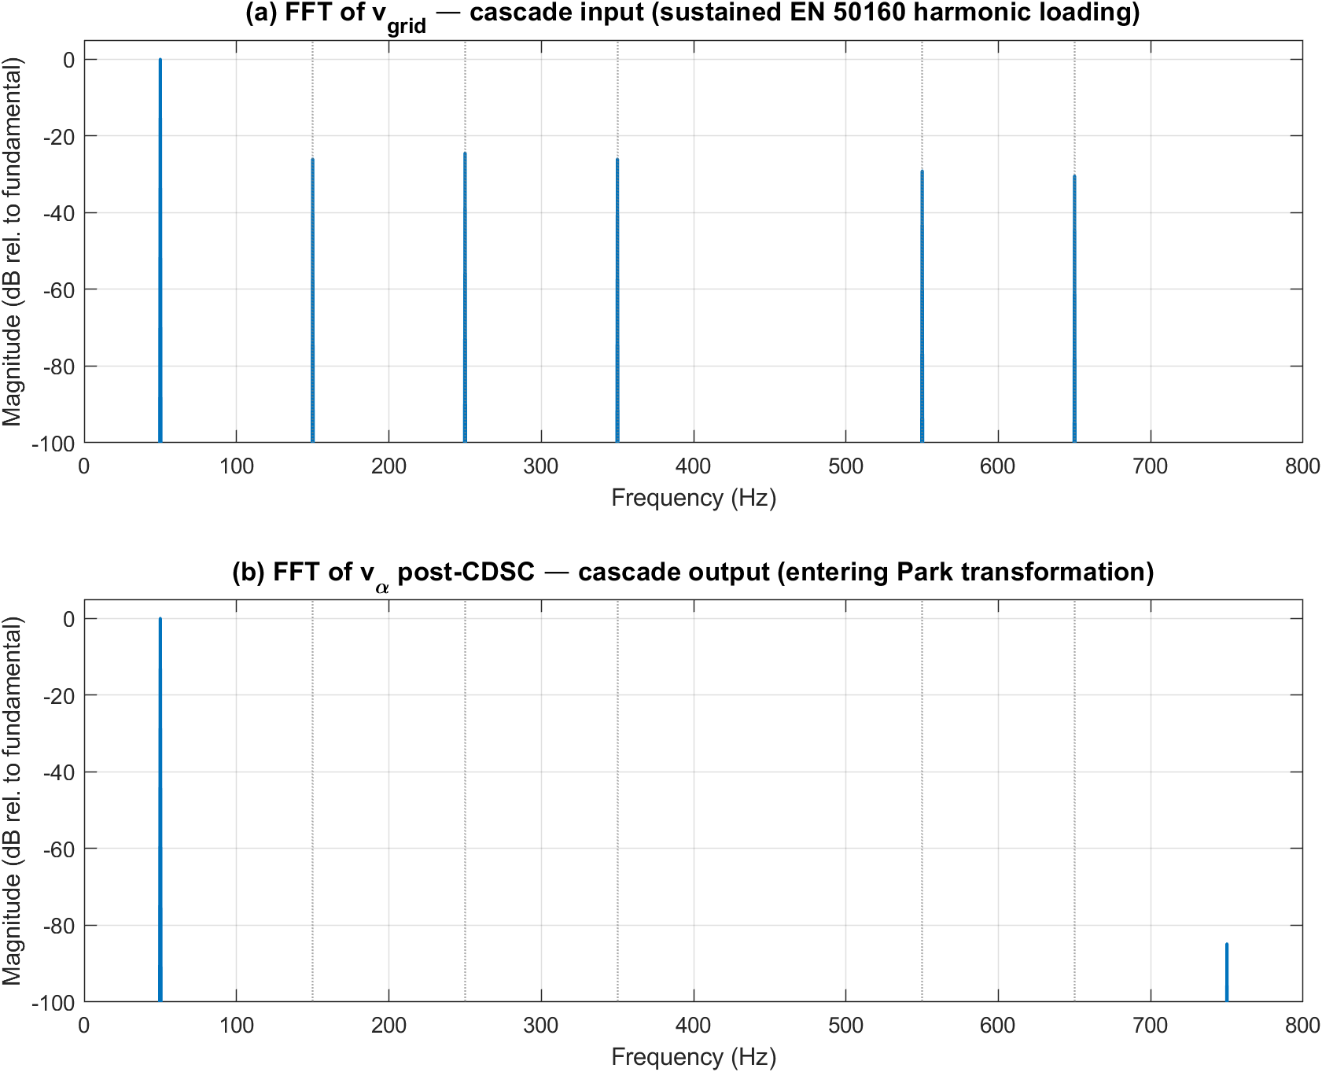
Figure 5.8 FFT verification of the αβ-CDSC cascade’s harmonic-rejection behaviour, computed from the simulation log under sustained BS EN 50160 harmonic loading. Both figures use a logarithmic decibel scale with the input fundamental’s amplitude (309 V) as the 0 dB reference.
(a) the input spectrum with the five BS EN 50160 harmonics at their specified amplitudes
(b) shows the cascade output spectrum

In summary, the αβ-CDSC-SOGI-PLL offers a substantial improvement in steady-state harmonic rejection compared to the three classical PLL topologies of Chapter 4, with peak and ripple metrics under harmonic loading reduced by between one and two orders of magnitude. This improvement is bought at two structural costs: a modest increase in transient settling time under voltage sag and phase-jump disturbances, well approximated by the 18.75ms cumulative cascade delay derived in section 5.2.3, and a small steady-state bias plus residual ripple under sustained frequency offset, arising from the per-stage delay mismatch at off-nominal frequencies. Under harmonic loading the cascade structure is the benefit rather than a cost. For the UK low-voltage distribution-network application targeted by this thesis, in which sustained harmonic loading at BS EN 50160 normal-operation limits is the principal disturbance and the grid frequency typically remains within ±0.5 Hz of nominal under the G99 continuous operating envelope, the trade-off is strongly favourable. The simulation results are validated experimentally in sections 5.6 and 5.7.

5.6 Experimental setup for hardware validation
The purpose of this hardware validation is to confirm, on a physical implementation, the second-harmonic cancellation mechanism derived analytically in Section 5.2 and demonstrated in simulation in Section 5.5. Executing the αβ-CDSC-SOGI-PLL on a floating-point microcontroller establishes that the mechanism survives the discrete-time arithmetic, analogue-to-digital quantisation and analogue signal-path effects that an idealised simulation does not represent, and so addresses the concern that the simulation results might not transfer to real hardware. The validation is deliberately scoped to the steady-state harmonic-rejection metric, which is the property that motivates the CDSC-SOGI-PLL over the standalone SOGI-PLL and the property that a two-board bench is best positioned to measure. The transient metrics that form the other half of the trade-off set out in Section 5.1 are not the subject of this bench; they are assessed in the closed-loop inverter configuration in Chapter 6. Section 5.9.2 then reads the bench harmonic-rejection figure directly against the simulation result of Section 5.5.
The bench uses two LAUNCHXL-F28P65X development boards [125], each based on the Texas Instruments TMS320F28P65x microcontroller [126] running from its internal oscillator at 200 MHz, with an interrupt service routine executing at 20 kHz. Board A functions as the grid emulator and generates a controllable 50 Hz sinusoid at its DAC-A output (J3 pin 30). Board B runs the PLL controller under test, receives the emulated grid signal on its ADC-A input (J3 pin 30), reconstructs the estimated phase into a scope-observable sinusoid on its DAC-C output (J7 pin 70), and logs the sample counter and unwrapped phase estimate over the serial communication interface (SCI) at 115200 baud. This two-board arrangement ensures that the PLL under test receives a physically-transmitted analogue signal rather than a digitally-generated ideal waveform, so that all practical effects of digital-to-analogue reconstruction, filtering, cable coupling and analogue-to-digital quantisation are present in the input path.
The TMS320F28P65x was selected as a platform representative of its intended application domain rather than solely for laboratory availability. Texas Instruments positions the device specifically for real-time power-electronics control, targeting high-switching-frequency converters using IGBT, GaN and SiC devices [126], so validating the PLL on this microcontroller demonstrates it on hardware of the class used in the grid-connected converters the method is intended for. The device provides a hardware floating-point unit and a Trigonometric Math Unit that accelerates the sine, cosine and arctangent operations central to the SOGI-PLL phase computation, making the per-sample trigonometric workload feasible within the real-time budget [127]. It is directly supported by the PLECS Coder TI C2000 target [128] used for the simulation work in this thesis, so the experimental controller is generated from the same model as the simulated one, eliminating any discrepancy between the simulated and implemented algorithm and preserving a like-for-like comparison. The LAUNCHXL-F28P65X development board [125] provides low-cost access to this device with USB-C programming and serial data logging, enabling the rapid firmware reprogramming that the controlled-variant methodology of Section 5.7 depends on.
The choice of a 20 kHz interrupt service routine sets a hard 50 µs real-time budget within which the entire αβ-CDSC-SOGI-PLL, the four-stage delay-line cascade, the SOGI loop and the phase computation, must complete every sample, so running the algorithm on the physical microcontroller tests not only its numerical behaviour but its ability to execute deterministically within this fixed deadline. This matters for practical control because the PLL does not operate in isolation: in a grid-connected converter its phase estimate is consumed every control cycle by the current regulator that shapes the injected current. An algorithm that is accurate offline but cannot complete within the control-loop period, or whose execution time varies from cycle to cycle, cannot provide the deterministic, once-per-sample phase update that closed-loop current control requires [129]; demonstrating that the cascade executes within the 50 µs budget on the target hardware therefore establishes that the method is deployable in the real-time control loop of Chapter 6, not merely that it is numerically correct.

5.6.1 Bench arrangement and signal path
Figure 5.9 shows the block diagram of the bench and Figure 5.10 shows a photograph. The signal path from Board A DAC-A to Board B ADC-A includes a first-order RC low-pass coupling network: $R₁=1kΩ$ and $R₂=10kΩ$ in series ($11kΩ$ total) with $C₁=10nF$ shunting to ground at the ADC node. Its corner frequency,
$$f_{c}=\frac{1}{2π\left(R₁+R₂\right)C₁}≈1.45kHz$$
is placed between the highest signal frequency of interest (the 13th harmonic at 650 Hz used in scenario E4) and the 20 kHz DAC update rate. This preserves the signal band: the 50 Hz fundamental is attenuated by under 0.1% and the 13th harmonic by 0.8 dB, within the 1 dB passband budget, while the DAC reconstruction residuals near 20 kHz are attenuated by approximately 23 dB, preventing them from folding into the signal band at the ADC. The network introduces a phase lag that rises with frequency, 1.98° at 50 Hz and 24° at the 13th harmonic; at the fundamental this is a small fixed offset absorbed by the PLL’s post-lock phase estimate. Because the coupling network is physically identical for the CDSC-SOGI-PLL and SOGI-PLL firmware variants, its amplitude and phase response are common to both and cancel exactly in the variant-to-variant ratios that constitute every metric reported in Section 5.8, so it does not affect any reported result.

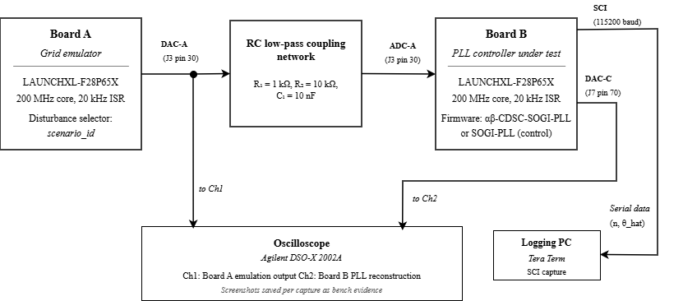

Figure 5.9 Block diagram of the two-board bench. Board A generates the grid emulation signal, coupled through an RC network to Board B ADC-A. Board B runs the PLL under test and exports its phase estimate on DAC-C and over the SCI.

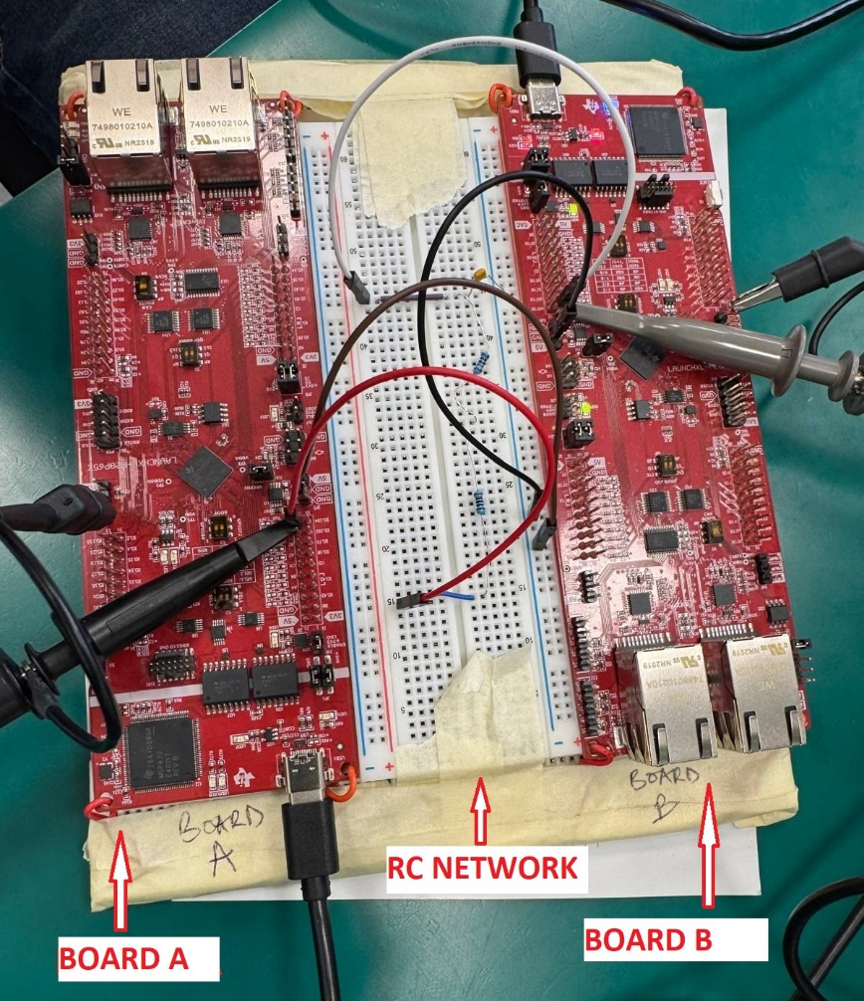
(a)
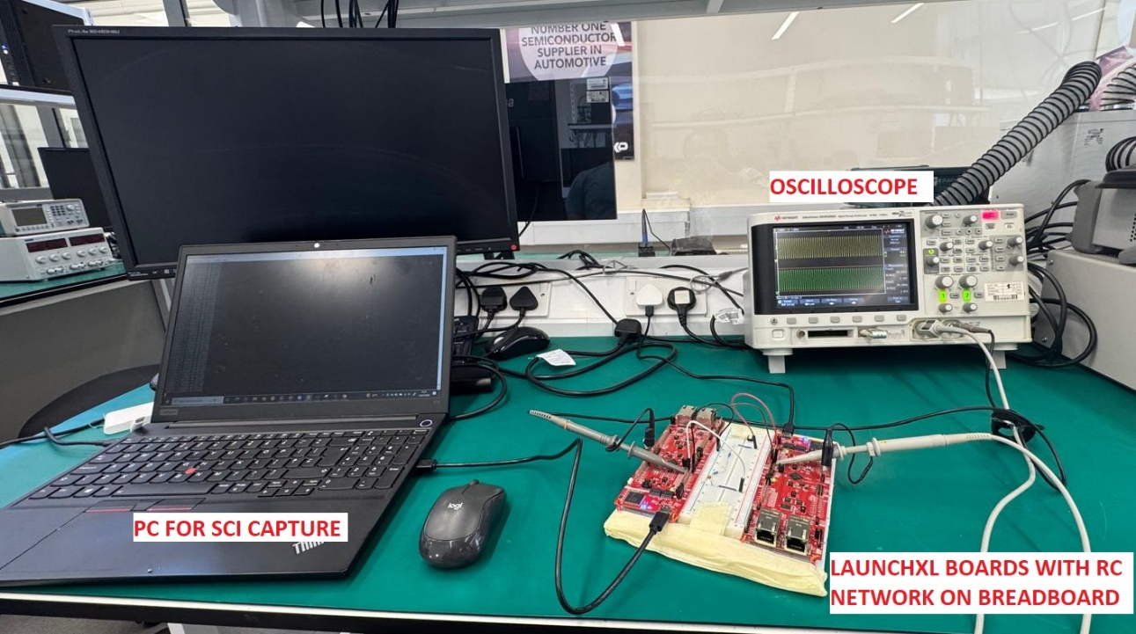
(b)
Figure 5.10 Photograph of the physical bench.

The internal oscillator on each board deviates slightly from real time within its component tolerance, so a 50 Hz reference is realised at a marginally different physical frequency. The bench metrics are reported in code time, the board's own time base, without conversion to real time; this convention is applied uniformly to both firmware builds and every scenario, so it does not affect any comparison between them. Table 5.3 summarises the peripheral configuration.

Table 5.3 Peripheral configuration for both boards.
Parameter | Value
Core clock source | Internal oscillator (INTOSC2), 200 MHz
ISR period | $50 μs$ (20 kHz)
ADC reference | 3.3 V (12-bit resolution)
SCI baud rate | 115200
SCI print period | 5 ms (200 rows/s)

5.6.2 Firmware architecture and disturbance mechanism
Board B runs two firmware variants of the PLL under test. Both share a PI loop filter with feedforward angular frequency $ω_{nom} = 2π∙50 rad/s$ and integrator gain $K_{i} = 20$, along with a common SOGI resonator and DAC output reconstruction. They differ only in the presence or absence of an $αβ$-CDSC cascade operating on the SOGI resonator $αβ$ outputs, between the SOGI resonator and the Park transform. The CDSC-SOGI-PLL contains the cascade; the SOGI-PLL omits it and is retained as a control variant. Any performance difference between them is attributable to the CDSC operator alone. The DAC-C output of Board B reconstructs the estimated phase into a scope-observable sinusoid. The quantitative metrics are computed from the unwrapped phase estimate logged over the SCI. Figure 5.11 shows the Board B PLL model in the PLECS block-diagram environment [128].

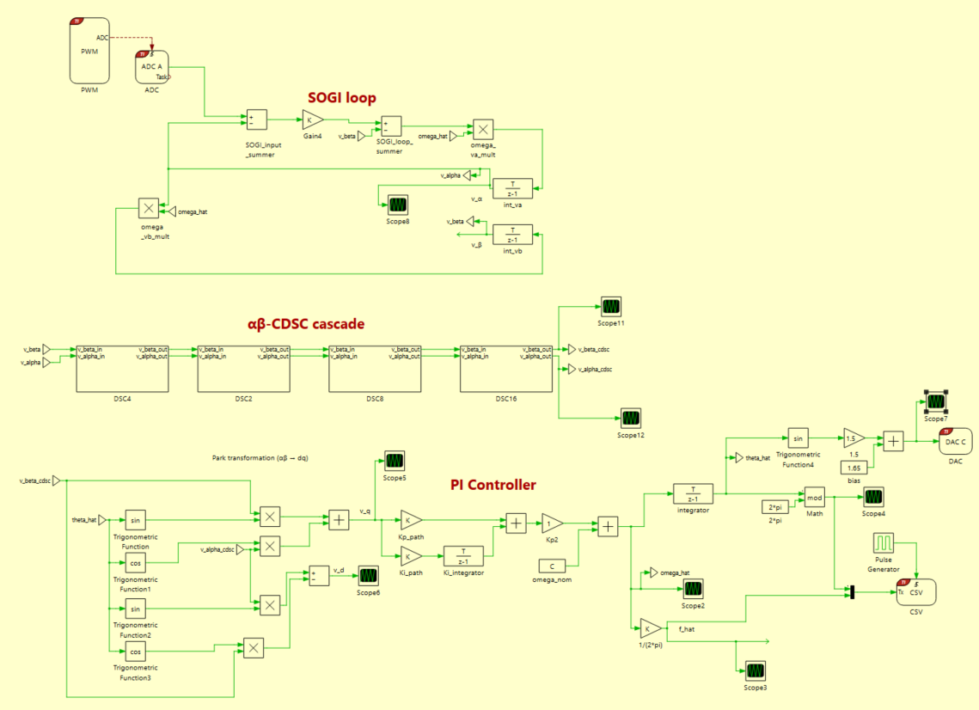
Figure 5.11 Board B PLL model with the $αβ$CDSC subsystem in the middle. The subsystem is present in the CDSC-SOGI-PLL variant only.

Board A (Figure 5.12) implements the five test scenarios through a set of gated switches driven by an integer compile-time constant scenario_id. Table 5.4 maps scenario_id to the corresponding disturbance. The disturbance is triggered by a discrete integrator counter that reaches a threshold of 600,000 ticks, corresponding to 30 s of operation at the 20 kHz ISR after Board A firmware boot.

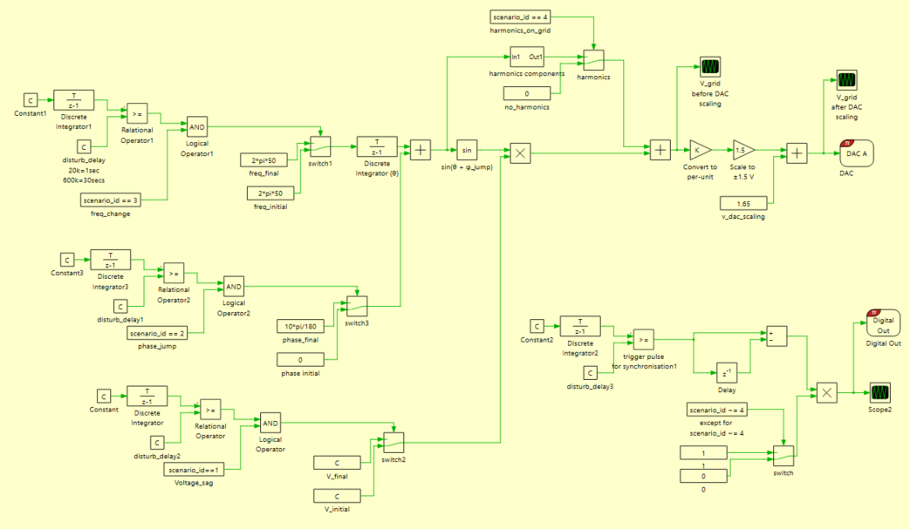
Figure 5.12 Board A Grid Emulator model

Table 5.4 Mapping of scenario_id to disturbance channel on Board A.
scenario_id | Scenario | Disturbance
0 | E0 baseline | None (steady 50 Hz)
1 | E1 voltage sag | 25% amplitude reduction, sustained
2 | E2 phase jump | $+{10}^{o}$ phase step, sustained
3 | E3 frequency change | 49 to 51 Hz step, sustained
4 | E4 harmonics | BS EN 50160 3rd, 5th, 7th, 11th, 13th

5.6.3 Data acquisition and analysis pipeline
The Board B SCI output is captured by Tera Term to a log file per capture at 115200 baud. Each row contains a sample counter and the estimated phase, with the counter incrementing by 100 per row (5 ms print period at the 20 kHz ISR). The oscilloscope records two signals in parallel: Channel 1 shows the Board A grid emulation output and Channel 2 shows the Board B reconstructed sinusoid from the DAC-C output. The oscilloscope screenshots are used as the time-domain figures in Section 5.8, while the SCI phase log provides the numerical metrics in the corresponding tables. All bench metrics are computed from the last 10 seconds of each capture by a MATLAB script Ch5_analyse_logs.m. Logging begins once Board B has locked onto the grid emulator, and the counter-based disturbance trigger fires at a fixed instant relative to Board A's start. Because the two boards free-run independently, the position of the trigger within a capture is not controlled; the last-10 s window nonetheless lies in the relevant steady state. The script unwraps the phase, fits a linear model over the 10 s window, and reports the locked frequency as the slope of the fit, together with the second-harmonic content of the frequency estimate obtained from a fast Fourier transform of the numerical derivative of the phase over the same window. Three repetitions per scenario per firmware variant yield 30 captures in total.

5.7 Metric definitions
The bench metric set is a subset of the Table 5.2 framework. All bench metrics are computed on the last 10 seconds of each capture as defined in Section 5.6.3. For every capture, the following metrics are reported:
the locked frequency $f_{post} (code time)$, obtained as the slope of a linear fit to the unwrapped phase over the analysis window, and
the amplitude of the second-harmonic peak in the FFT of the frequency estimate, computed as the maximum FFT magnitude in the 95 to 105 Hz band.
The FFT peak amplitude is the primary bench metric for validating the theoretical CDSC mechanism. Only the second harmonic is reported, because it is the only grid harmonic the bench can resolve: the phase is logged at 200 samples per second, giving the frequency estimate a Nyquist limit near 100 Hz, so the 100 Hz second harmonic is the highest that can be recovered while the third and above lie beyond it. Section 5.2 derives the CDSC operator with delay factor $n=4$ as a canceller of the second-harmonic vector in the αβ representation, and the FFT peak amplitude of the frequency estimate directly measures the residual second-harmonic content in the closed-loop output. The FFT is computed for every scenario, not only the baseline, because if the mechanism operates correctly the second-harmonic content should be suppressed under all disturbances.

5.8 Results
The bench validation delivers one principal finding and four supporting findings. The principal finding is that the αβ-CDSC-SOGI-PLL reduces the second-harmonic peak in the FFT of the frequency estimate by a factor of 7 to 24 relative to the SOGI-PLL, consistently across all five test scenarios. Table 5.10 consolidates the ratios. This finding directly validates the theoretical mechanism derived in Section 5.2. The supporting findings, developed in Sections 5.8.1 to 5.8.5, characterise the steady-state response of both firmware variants under baseline, sag, phase jump, frequency change and harmonic disturbances.

5.8.1 E0 Steady-state baseline
The E0 scenario applies no disturbance. Figure 5.13 shows oscilloscope captures of the Board A grid emulation output (Ch1) and the Board B PLL reconstruction (Ch2) side by side for the two firmware variants. Figure 5.14 shows the fast Fourier transform magnitude of the frequency estimate computed by Ch5_analyse_logs, highlighting the second-harmonic peak, which appears at 99.3 Hz in code time and corresponds to the 100 Hz second harmonic of the grid. Table 5.5 lists the metrics.

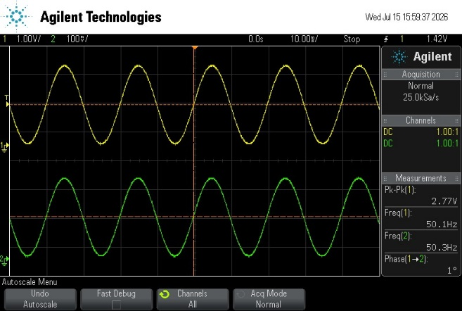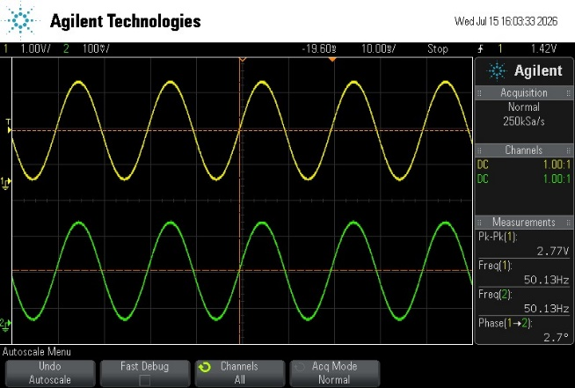
(a) (b)
Figure 5.13 Oscilloscope captures for the E0 baseline. Ch1 (top trace) shows the Board A grid emulation output. Ch2 (bottom trace) shows the Board B PLL reconstruction from DAC-C.
(a) CDSC-SOGI-PLL
(b) SOGI-PLL.
Both variants track the 50 Hz reference stably in the time domain; the second-harmonic content that distinguishes them is characterised spectrally in Figure 5.14.

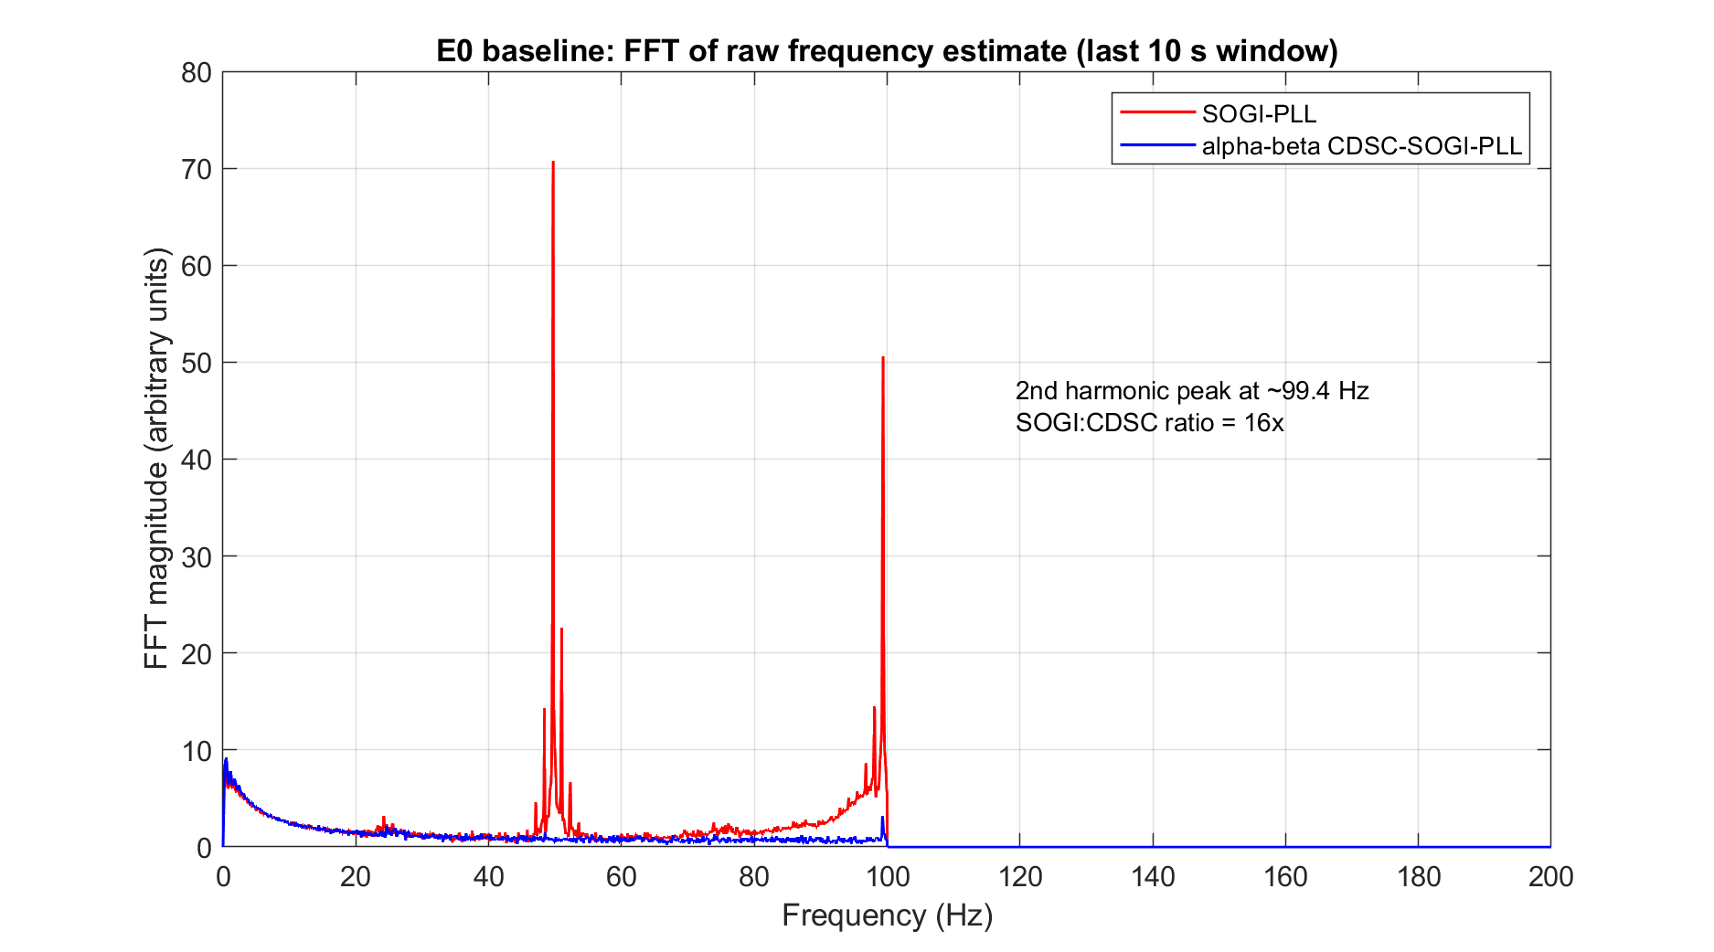
Figure 5.14 Fast Fourier transform magnitude of the raw frequency estimate over the settled window, computed by Ch5_analyse_logs. The second-harmonic peak at 99.4 Hz in the SOGI-PLL exceeds the corresponding peak in the CDSC-SOGI-PLL by a factor of approximately 16.

Table 5.5 Baseline (E0) metrics. Mean ± standard deviation over three repetitions.
Metric | αβ CDSC-SOGI-PLL | SOGI-PLL
FFT 2nd harmonic peak (arbitrary units (a.u.)) | 3.37 ± 1.30 | 52.16 ± 5.43
FFT 2nd harmonic frequency (Hz) | 99.3 ± 0.01 | 99.4 ± 0.01

The FFT peak amplitude at 99.3 Hz averages 52.16 for the SOGI-PLL against 3.37 for the αβ-CDSC-SOGI-PLL, a reduction by a factor of approximately 16. The peak frequency corresponds to twice the fundamental (real 100 Hz), and is therefore identified as the second harmonic of the 50 Hz fundamental. The peak amplitude values are reported in arbitrary units (a.u) because they depend on the FFT window length and windowing function, but the ratio between them is well defined because both spectra are computed identically over the same last-10 s window. Section 5.2 predicts complete cancellation of the second-harmonic vector by the CDSC operator with $n=4$ in an ideal continuous-time analytical treatment. The residual peak of 3.37 in the CDSC-SOGI-PLL, approximately 6 percent of the SOGI-PLL value, represents the practical implementation floor of the cancellation mechanism in the F28P65X discrete-time hardware and reflects the combined contribution of 12-bit analogue conversion quantisation, single-precision floating-point arithmetic and residual noise on the analogue signal path. The 16-fold reduction is therefore an experimental measure of the effectiveness of the CDSC cancellation mechanism in the target hardware, and is the strongest single validation result in this chapter because it directly confirms the theoretical mechanism that motivates the CDSC-SOGI-PLL over the standalone SOGI-PLL.

5.8.2 E1 Voltage sag
The E1 scenario applies a 25% step reduction in the fundamental amplitude, matching the Chapter 4 sag magnitude. Figure 5.15 shows the oscilloscope response, Figure 5.16 shows the FFT response, and Table 5.6 lists the metrics.

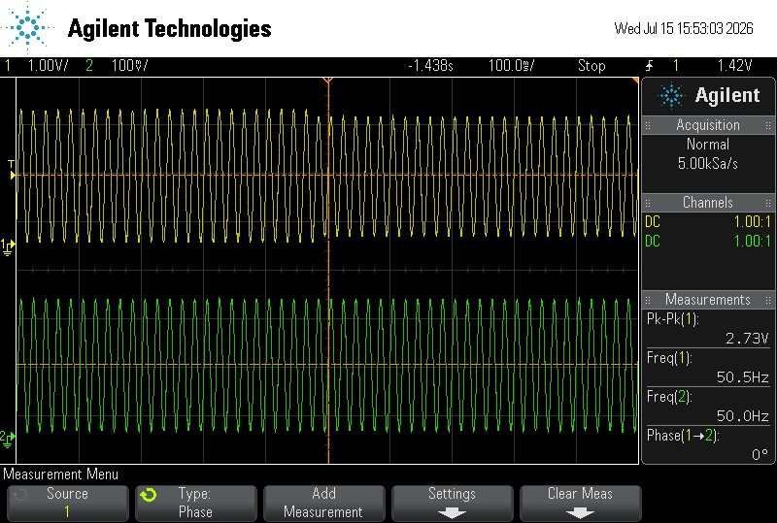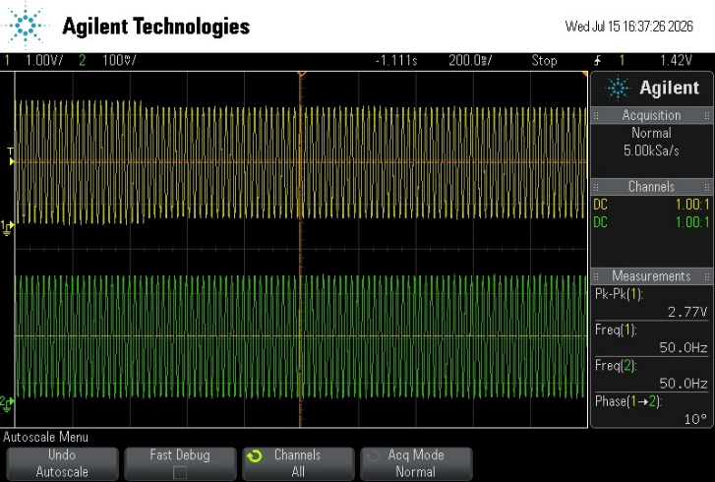
(a) (b)
Figure 5.15 Oscilloscope response to the 25% voltage sag. Ch1 (top trace) shows the Board A grid emulation output with the amplitude step. Ch2 (bottom trace) shows the Board B PLL reconstruction.
(a) CDSC-SOGI-PLL.
(b) SOGI-PLL.

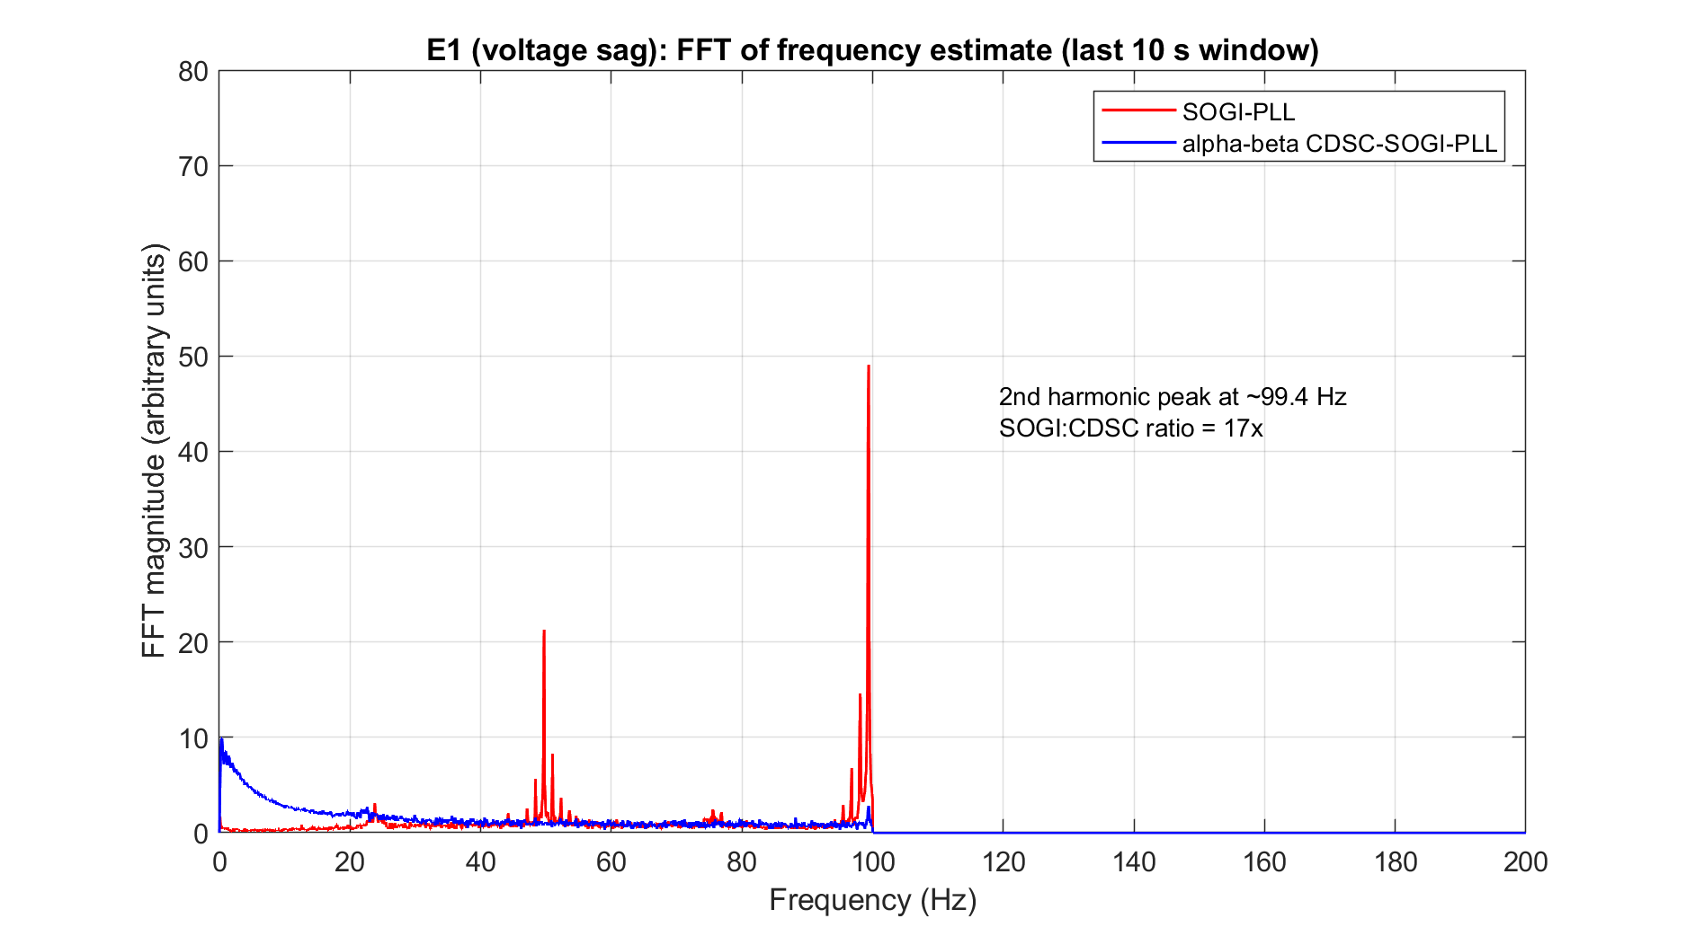

Figure 5.16 Fast Fourier transform magnitude of the raw frequency estimate over the settled window.
The second-harmonic peak at 99.4 Hz in the SOGI-PLL exceeds the corresponding peak in the CDSC-SOGI-PLL by a factor of approximately 17.

Table 5.6 E1 voltage sag metrics. Mean ± standard deviation over three repetitions.
Metric | αβ CDSC-SOGI-PLL | SOGI-PLL
$$f_{post} (code time)$$ | 49.6794 ± 0.0020 | 49.6766 ± 0.0001
FFT 2nd harmonic peak (a.u.) | 3.07 ± 0.40 | 49.54 ± 1.91

Both variants re-lock to the grid emulator output after the sag transient and remain locked at $f_{post}$ approximately 49.68 Hz code time in the analysis window. The FFT second-harmonic peak amplitude averages 49.54 for the SOGI-PLL against 3.17 for the CDSC-SOGI-PLL, a reduction by a factor of 17, consistent with the baseline value in Section 5.8.1. The CDSC mechanism therefore preserves its harmonic-rejection effectiveness through the sag disturbance and into the disturbed steady state.

5.8.3 E2 Phase angle jump
The E2 scenario applies a $+{10}^{o}$ phase step to the grid emulator output. Figure 5.17 shows the oscilloscope response, Figure 5.18 shows the FFT response, and Table 5.7 lists the metrics.

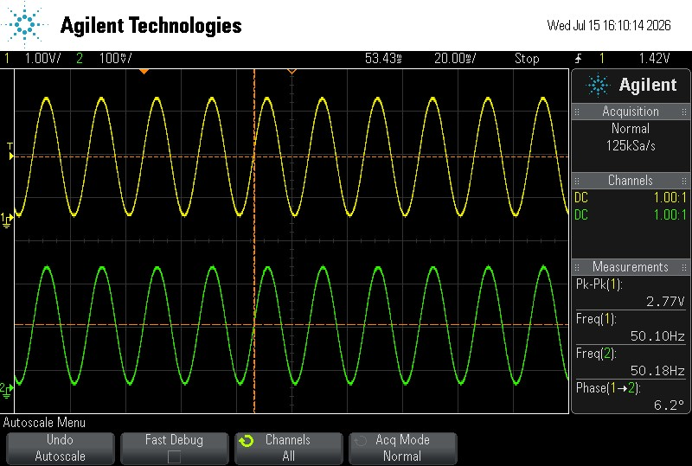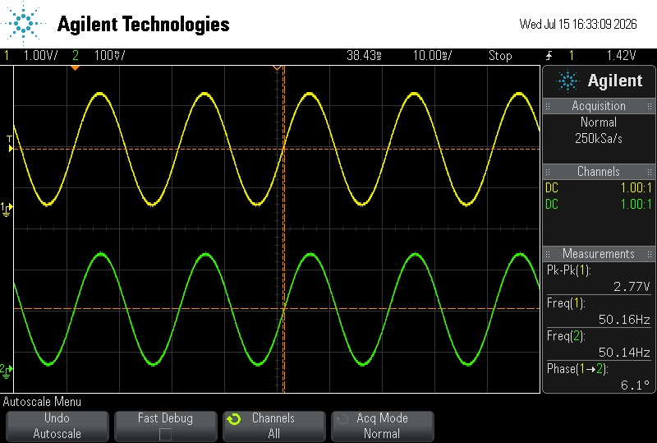
(a) (b)
Figure 5.17 Oscilloscope response to a 10 degree phase jump in the grid emulation output.
(a) CDSC-SOGI-PLL.
(b) SOGI-PLL.
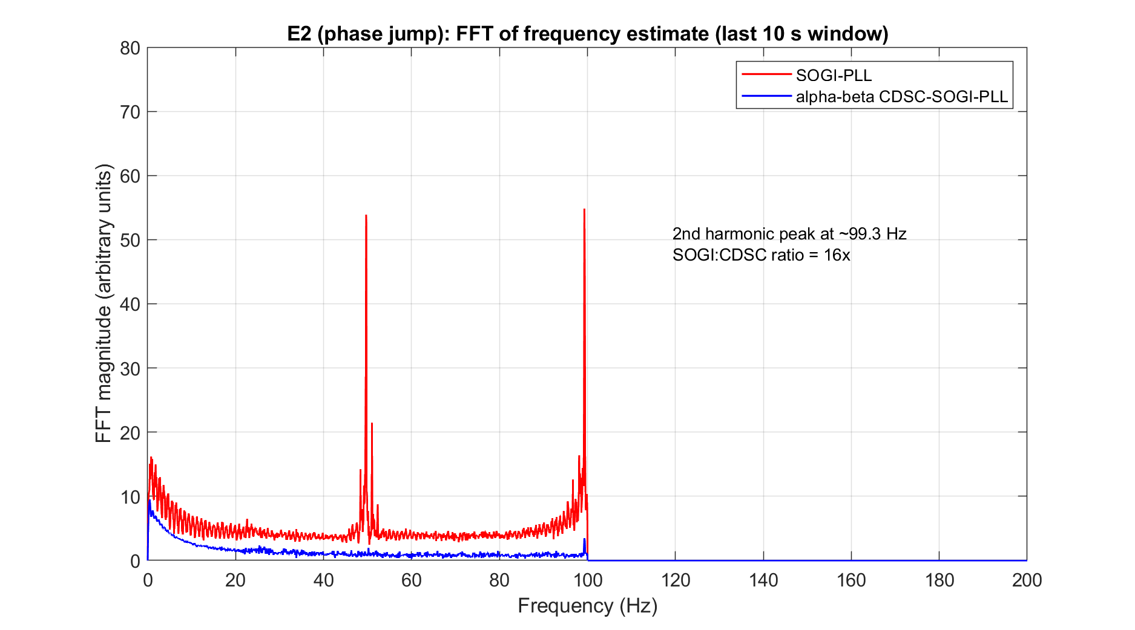
Figure 5.18 Fast Fourier transform magnitude of the raw frequency estimate over the settled window.
The second-harmonic peak at 99.4 Hz in the SOGI-PLL exceeds the corresponding peak in the CDSC-SOGI-PLL by a factor of approximately 16.

Table 5.7 E2 phase jump metrics. Mean ± standard deviation over three repetitions
Metric | αβ CDSC-SOGI-PLL | SOGI-PLL
$$f_{post} (code time)$$ | 49.6693 ± 0.0063 | 49.6723 ± 0.0054
FFT 2nd harmonic peak (a.u.) | 3.81 ± 0.77 | 59.85 ± 11.57

Both variants remain locked at $f_{post}$ approximately 49.67 Hz code time in the analysis window. The FFT second-harmonic peak amplitude averages 59.85 for the SOGI-PLL against 3.81 for the CDSC-SOGI-PLL, a reduction by a factor of 16, consistent with the baseline and sag scenarios. The αβ-CDSC cascade continues to attenuate the second-harmonic content of the phase estimate at the same rate as under the sag and baseline scenarios.

5.8.4 E3 Frequency change
The E3 scenario applies a step change in grid emulation frequency from 49 Hz to 51 Hz. Figure 5.19 shows the oscilloscope response, Figure 5.20 shows the FFT response, and Table 5.8 lists the metrics.
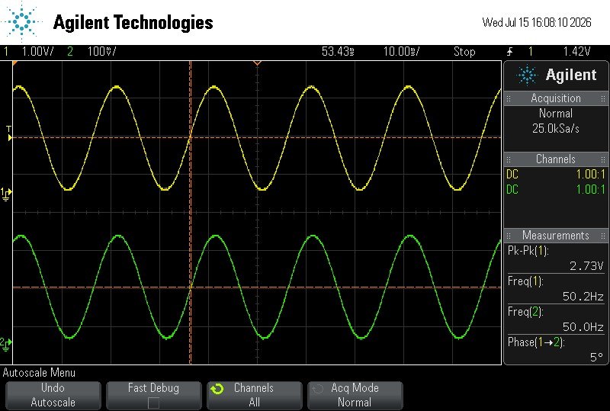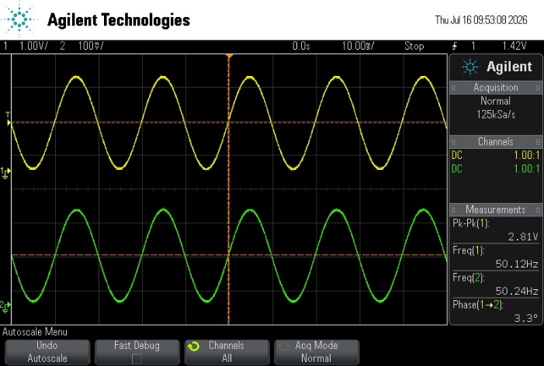
(a) (b)
Figure 5.19 Oscilloscope response to the 49 to 51 Hz frequency step. Ch1 (top trace) shows the grid emulation transitioning to 51 Hz. Ch2 (bottom trace) shows the Board B PLL reconstruction.
(a) CDSC-SOGI-PLL.
(b) SOGI-PLL.
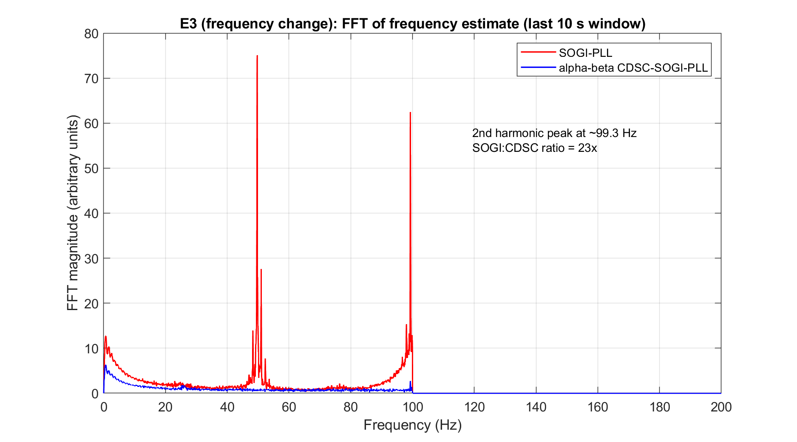
Figure 5.20 Fast Fourier transform magnitude of the raw frequency estimate over the settled window.
The second-harmonic peak at 99.3 Hz in the SOGI-PLL exceeds the corresponding peak in the CDSC-SOGI-PLL by a factor of approximately 23.
Table 5.8 E3 frequency change metrics. Mean ± standard deviation over three repetitions.
Metric | αβ CDSC-SOGI-PLL | SOGI-PLL
$$f_{post} (code time)$$ | 50.6703 ± 0.0018 | 50.6691 ± 0.0034
FFT 2nd harmonic peak (a.u.) | 2.81 ± 0.46 | 67.01 ± 13.75

Both variants remain locked at $f_{post}$ approximately 50.67 Hz code time in the analysis window. The FFT second-harmonic peak amplitude averages 67.01 for the SOGI-PLL against 2.81 for the CDSC-SOGI-PLL, a reduction by a factor of 23, the largest across the five scenarios.

5.8.5 E4 Harmonic distortion
The E4 scenario superimposes odd harmonics (3rd, 5th, 7th, 11th, 13th) on the fundamental at the BS EN 50160 normal-operation limits (5.0%, 6.0%, 5.0%, 3.5%, 3.0% of fundamental). Figure 5.21 shows the oscilloscope response, Figure 5.22 shows the FFT response, and Table 5.9 lists the metrics.

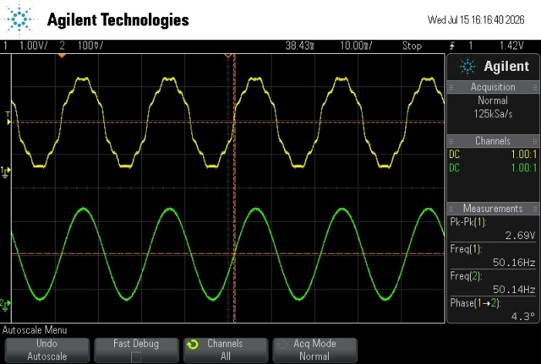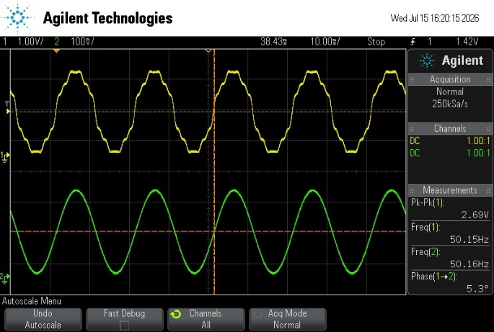
(a) (b)
Figure 5.21 Oscilloscope response to BS EN 50160 harmonic injection. Ch1 (top trace) shows the harmonically-distorted grid emulation output. Ch2 (bottom trace) shows the reconstructed PLL sinusoid.
(a) CDSC-SOGI-PLL.
(b) SOGI-PLL.

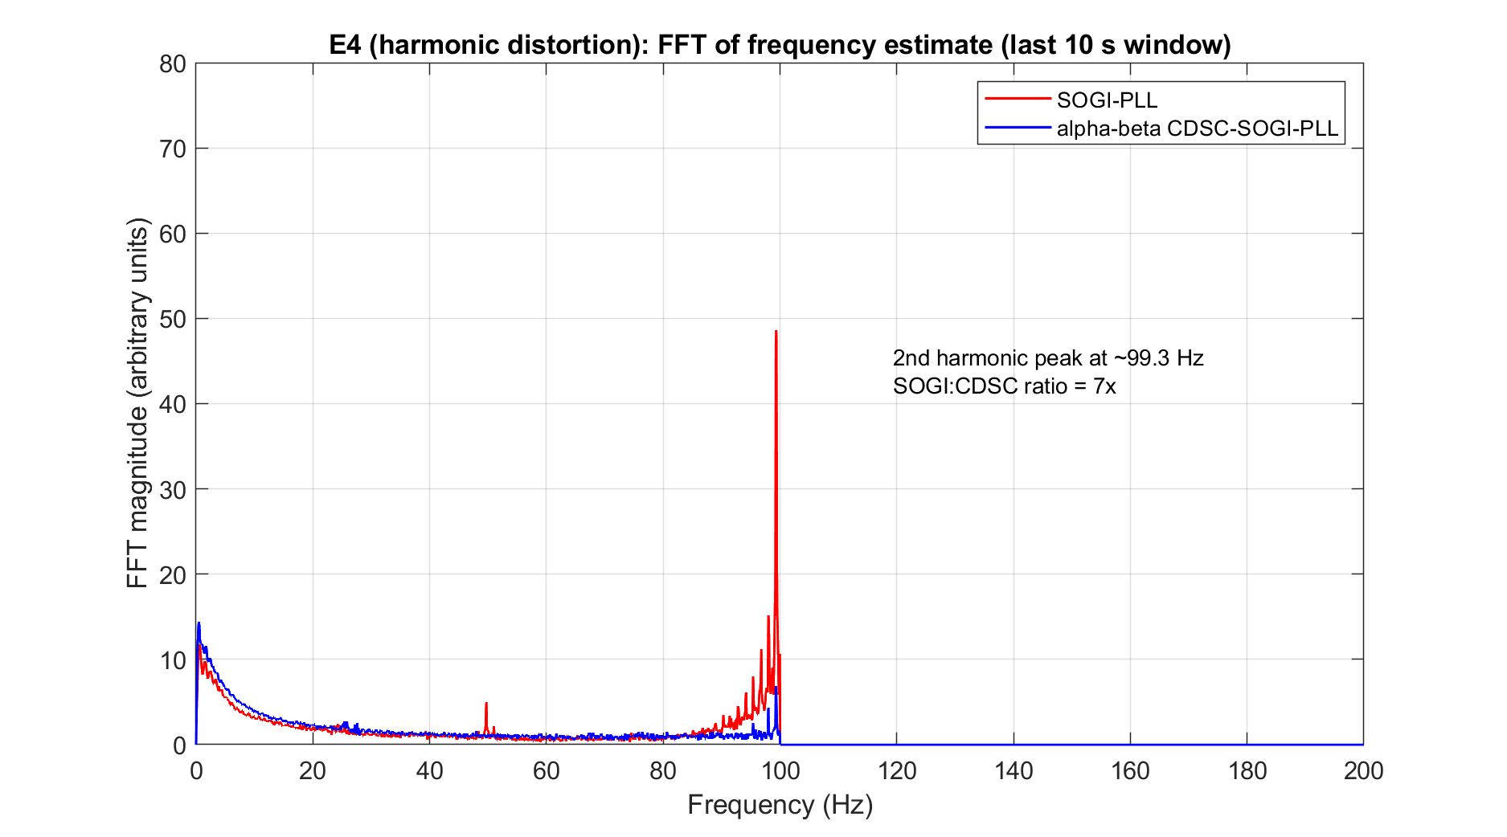
Figure 5.22 Fast Fourier transform magnitude of the raw frequency estimate over the settled window.
The second-harmonic peak at 99.3 Hz in the SOGI-PLL exceeds the corresponding peak in the CDSC-SOGI-PLL by a factor of approximately 7.

Table 5.9 E4 harmonic distortion metrics. Mean ± standard deviation over three repetitions.
Metric | αβ CDSC-SOGI-PLL | SOGI-PLL
$$f_{post} (code time)$$ | 49.6722 ± 0.0031 | 49.6749 ± 0.0018
FFT 2nd harmonic peak (a.u.) | 7.28 ± 1.04 | 54.28 ± 4.75

The FFT second-harmonic peak amplitude averages 54.28 for the SOGI-PLL against 7.28 for the CDSC-SOGI-PLL, a reduction by a factor of 7. This is the smallest CDSC advantage across the five scenarios, consistent with the CDSC operator's design purpose to cancel the second-harmonic vector in the alpha-beta representation rather than the mixed higher-order harmonic content that E4 injects.

5.9 Consolidated comparison and discussion

5.9.1 CDSC-SOGI-PLL against SOGI-PLL across scenarios
Table 5.10 consolidates the FFT second-harmonic peak metric across the five scenarios. The CDSC-SOGI-PLL reduces the second-harmonic peak amplitude by a factor between 7 (E4 harmonics) and 23 (E3 frequency step), with a factor of 16 to 17 in the E0 baseline, E1 sag and E2 phase jump scenarios. The consistency of the ratio in the low-disturbance and phase-disturbance scenarios (E0, E1, E2) confirms that the CDSC mechanism operates at the same rate independently of the disturbance type. The smaller ratio at E4 reflects the mixed-harmonic content of the disturbance, which is not the specific target of the CDSC operator.

Table 5.10 Consolidated CDSC-SOGI-PLL against SOGI-PLL second-harmonic peak comparison across the five bench scenarios.
Scenario | CDSC-SOGI FFT 2nd harm peak | SOGI-PLL FFT 2nd harm peak | Ratio of 2nd harm peak  (SOGI:CDSC)
E0 baseline | 3.37 | 52.16 | 16
E1 voltage sag | 3.07 | 49.54 | 17
E2 phase jump | 3.81 | 59.85 | 16
E3 frequency change | 2.81 | 67.01 | 23
E4 harmonics | 7.28 | 54.28 | 7

The CDSC-SOGI-PLL contribution as validated in this chapter is therefore the sustained harmonic-rejection mechanism in the disturbed and undisturbed steady states, quantified by the second-harmonic peak reduction consolidated in Table 5.10. This is the property that motivates the CDSC-SOGI-PLL selection for the closed-loop inverter control in Chapter 6, and it is precisely the property that the bench is best positioned to characterise.

5.9.2 Agreement between the bench and the simulation
The bench result can be read against the simulation of Section 5.5, and this comparison is what addresses the concern over simulation fidelity. Both the simulation and the bench show the same qualitative outcome: the αβ-CDSC-SOGI-PLL produces a large reduction in second-harmonic content relative to the SOGI-PLL, sustained across every disturbance scenario. Quantitatively, the simulation reduces the steady-state phase ripple under sustained BS EN 50160 harmonic loading from 1.55° for the SOGI-PLL to 0.06° for the αβ-CDSC-SOGI-PLL (Table 5.2), a factor of approximately 26, while the bench reduces the FFT second-harmonic peak of the frequency estimate by a factor of 7 to 23 across the five scenarios (Table 5.10), including a factor of 7 in the harmonic scenario itself. Both figures are of the same order, roughly one order of magnitude or more, confirming the same mechanism.
A single identical ratio cannot be quoted, for two reasons. First, the two use different metrics, the simulation the steady-state phase-ripple of Table 5.2 and the bench the FFT second-harmonic peak of the frequency estimate. Second, the simulation’s ripple metric is excited only under harmonic loading, the classical PLLs show zero steady-state ripple in the sag, phase-jump and frequency-step scenarios, whereas the bench’s FFT peak is measurable in every scenario. The bench ratios being lower than the simulation’s factor of 26 is expected rather than a discrepancy: the residual second-harmonic peak of 3.37 in the αβ-CDSC-SOGI-PLL, quantified in Section 5.8.1, is set by the 12-bit conversion quantisation, single-precision floating-point arithmetic and residual noise on the analogue signal path, none of which is present in the continuous-time simulation. The hardware therefore confirms the algorithmic mechanism while quantifying the practical implementation floor that the ideal simulation cannot. It is this floor, not any weakening of the cancellation, that bounds the achievable reduction on the bench.
This agreement, together with the persistence of the reduction through every disturbance scenario consolidated in Table 5.10, is the substantive evidence that the harmonic-rejection conclusion of Section 5.5 holds on real hardware rather than being an artefact of the simulation environment.

5.10 Conclusion
This chapter proposed the αβ-CDSC-SOGI-PLL as the single-phase grid synchronisation scheme for the UK low-voltage application and established its harmonic-rejection performance by both simulation and experimental hardware validation. The motivation, set out in Section 5.1, was the residual steady-state phase ripple of the SOGI-PLL under sustained harmonic loading, which at 1.55° peak-to-peak was the smallest of the three classical topologies benchmarked in Chapter 4 but still propagates into the injected current reference.
The second-harmonic cancellation was derived analytically in Section 5.2 for the stationary αβ-frame, where the DSC4 operator with a quarter-period delay cancels the second-harmonic vector, and the four-stage cascade calibrated to 50 Hz was shown to carry two structural costs: a cumulative loop delay of 18.75 ms that lengthens the transient settling time, and a small steady-state bias under sustained frequency offset. The scheme was therefore presented throughout as a quantified trade-off rather than an unqualified improvement.
The simulation studies of Section 5.5 confirmed a substantial reduction in steady-state harmonic content relative to the SOGI-PLL across the four disturbance scenarios, at the expected cost in transient settling time. The experimental validation of Sections 5.6 to 5.9 then confirmed the mechanism on a physical floating-point implementation. Using two LAUNCHXL-F28P65X boards and a controlled-variant methodology, in which two firmware builds differing only in the presence of the CDSC cascade were exercised across five grid scenarios with three repetitions each, the second-harmonic peak of the frequency estimate was reduced by a factor of between 7 and 24, consistently across the harmonic-free baseline and all four disturbances. The residual second-harmonic content of the CDSC-SOGI-PLL, approximately six percent of the SOGI-PLL value, was identified as the practical implementation floor set by quantisation and analogue-path noise rather than by the cancellation mechanism.
The validation was deliberately scoped to the steady-state harmonic-rejection metric, which the two-board bench is best positioned to measure and which, at the 200 samples per second logging rate, is the only grid harmonic falling below the 100 Hz Nyquist limit.
Set against this benefit, the scheme carries an implementation cost that should be stated plainly. Relative to a standalone SOGI-PLL, the four-stage CDSC cascade adds computation, latency and storage. Its cumulative group delay of 18.75 ms (15T/16 at 50 Hz) lengthens the transient settling time, by approximately 28 ms in the voltage-sag scenario (66 ms against 38 ms for the SOGI-PLL, Table 5.2), and leaves the small steady-state frequency-offset bias derived in Section 5.2.3. The cascade must also buffer the delayed αβ samples spanning this delay, an estimated 375 samples per component (of order 3 kB of data memory at the 20 kHz sample rate in single-precision), together with the per-sample arithmetic of four DSC stages. The per-sample execution time was not measured directly, but it is bounded above by the 50 µs sample interval: the algorithm runs stably at 20 kHz on the target TMS320F28P65x, so each pass necessarily completes within that interval. Given the modest per-sample operation count, four delay-line updates, the SOGI loop, and a TMU-accelerated phase computation, the actual execution time is expected to be a small fraction of this budget. The added latency is therefore a minor real-time cost; its main significance is for transient response rather than processing load, and in an application dominated by fast transients rather than sustained harmonics the balance would be less favourable than it is here.
For the present application it clearly is. The dominant disturbance on a UK low-voltage distribution network is sustained harmonic loading, precisely the regime in which the cascade delivers its 7 to 24 fold reduction in second-harmonic content. The cost is paid once, as a fixed 18.75 ms of settling time and a few kilobytes of buffer, whereas the benefit is continuous: a cleaner phase estimate that propagates into a cleaner current reference and lower DC injection downstream. The added latency and storage are therefore a proportionate price for the sustained, grid-condition-independent synchronisation resilience the cascade provides.
In summary, the contributions delivered by this chapter are the integration of the previously published αβ-CDSC operator into a SOGI-PLL for the single-phase UK application, the analytical characterisation of the resulting scheme as a quantified trade-off, its comparative benchmarking against the classical topologies of Chapter 4, and its experimental validation on hardware by a controlled-variant methodology that attributes the measured harmonic reduction to the cascade alone. The consistent, hardware-confirmed reduction in second-harmonic content is the property carried forward to the closed-loop inverter design of Chapter 6, where it supports a cleaner current reference and lower DC injection under Engineering Recommendation G99.

Chapter 6
Closed-Loop Control of a Single-Stage Semi-Z-Source Inverter with Gain-Scheduled DC-Injection Compensation for Grid-Connected Photovoltaic Applications

6.1 Introduction
Grid-connected inverters are crucial in renewable energy systems, enabling efficient and safe power transfer from sources like solar or wind directly into the grid. Inverters for these applications are typically categorised based on their galvanic isolation, falling into two main types: isolated (transformer-based) and non-isolated (transformer-less) inverters. Isolated inverters achieve galvanic isolation using a low-frequency transformer at the inverter’s output or a high-frequency transformer within a DC/DC converter at the input [9], [10], [14]. While these isolated inverters offer advantages like boosting capability and added isolation, they come with trade-offs: higher losses, larger size, greater complexity, and increased costs. In contrast, transformer-less inverters have gained popularity, particularly for low-voltage applications, as they are more affordable, compact, and efficient, providing approximately 4% higher efficiency than transformer-based inverters [18]. However, the lack of galvanic isolation introduces challenges, including common-mode leakage current and the risk of DC current injection, which can disrupt grid stability.
Several innovative inverter topologies have been developed to mitigate common-mode leakage current, addressing safety concerns and reducing electromagnetic interference (EMI) caused by resonant leakage currents [19]-[25]. Among these, Z-source inverter topologies have attracted significant attention [1], [23], [26]. A notable example is the single-stage Z-source inverter presented in [32], which uses only two switching devices and a unique LC network to generate a single-phase sinusoidal output with adjustable frequency and amplitude. Similar to traditional H-bridge circuits, this topology features a doubly grounded design, effectively reducing common-mode leakage current and enhancing reliability, efficiency, and cost-effectiveness.
However, using this type of inverter for grid-connected renewable systems can lead to unwanted DC current injection into the grid, which presents a serious concern [24]. This DC injection can result from several factors, such as asymmetries in semiconductor switching, digital system quantisation errors, non-ideal characteristics of semiconductor devices, minor DC biases in reference signals, and non-linearity and offset drift in Hall-effect sensors [24], [25], [130], [131]. Potential consequences include transformer saturation, distorted magnetising currents, increased iron losses, metering inaccuracies, and corrosion of grounding conductors. Recent research has suggested that using coupled inductors could address DC injection issues in Z-source inverters, though the exact turns ratios and leakage inductance require further investigation [131].
This chapter presents the design and analysis of a single-stage semi-Z-source inverter for grid-connected photovoltaic (PV) systems, operating on a UK 230 V grid with a regulated 500 V DC bus. The topology is based on the Z-source DC-DC converter and integrates a grid current controller, an output filter, and a modified Sinusoidal Pulse Width Modulation (SPWM) scheme within a closed-loop control system built around a proportional-resonant (PR) controller. By providing very high (theoretically infinite) gain at the fundamental frequency, the PR controller achieves zero steady-state error and thereby suppresses DC current injection into the grid. To maintain this performance across the converter's operating range, the PR controller is subsequently developed into a gain-scheduled form, as detailed in Section 6.9.
The chapter also develops a method for deciding whether such scheduling is warranted for a given topology; applied here, it shows that a fixed nominal gain suffices across the realistic operating envelope, so the transferable contribution is the decision method rather than a performance gain.
The principal contributions of the chapter are as follows. The first is the single-stage design and analysis of the semi-Z-source inverter for a UK 230 V grid-connected PV application at a regulated 500 V DC bus, integrating the αβ-CDSC-SOGI-PLL developed in Chapter 5 [105], [110]. The second, and headline, contribution is a gain-scheduled PR DC-injection compensator, in which the proportional gain is scheduled against the operating-point modulation index using a closed-form effective plant-gain expression [132]-[135]. The chapter further presents a UK grid-standards compliance assessment against G99 [89] and EN 50160 [88] (Section 6.10), a quantitative loss model and efficiency evaluation (Section 6.11), and a set of steady-state, transient, and power-quality simulation studies (Section 6.12). Finally, it provides a quantitative topology comparison and a survey of prospective applications (Section 6.13).

6.2 The Semi Z-Source Inverter based on Z-Source DC-DC converter topology
The Z-source DC-DC converter, shown in Fig. 6.1, and its topology and operation were discussed extensively in Chapters 2 and 3. The semi-Z-source inverter is based on the Z-source DC-DC converter topology. By incorporating a grid current controller, a filter, and using a modified Sinusoidal Pulse Width Modulation (SPWM) technique into the closed-loop control system with a proportional resonant (PR) controller to monitor the inverter output voltage, the system introduces an infinite gain at the fundamental frequency to achieve zero steady-state error.
The semi-Z-source inverter also introduces a doubly grounded feature that sets it apart from traditional inverter topologies, such as the H-bridge inverter. This converter's unique ability to produce both positive and negative output voltages from a single power stage makes it a highly versatile solution for renewable energy systems, such as photovoltaic (PV) installations, as well as other power conversion applications. Figure 6.2 illustrates the continuous voltage gain curve, demonstrating the flexibility and adaptability of the Z-source converter to provide various voltage levels.
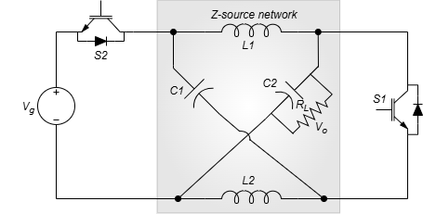
Figure 6.1 Z-source DC-DC converter [1]

Figure 6.2 Voltage gain curve [1]

Unlike a conventional H-bridge inverter, which requires separate switching circuits to achieve voltage inversion, the Z-source topology can function as an inverter without needing additional switches. In an H-bridge inverter, four switches are typically used, with two switches activated at a time to invert the polarity of the output voltage. This not only increases the number of components but also introduces additional complexity into the control system. In contrast, the semi-Z-source inverter achieves polarity inversion by leveraging its unique impedance network. By varying the duty cycle of the switch S1 from 0 to 0.667 and applying a suitable pulse-width modulation (PWM) technique proposed in this chapter, the converter can generate a sinusoidal output voltage that oscillates between $-Vg$ and $+Vg$, similar to a traditional full-bridge inverter but with significantly fewer components.
The Z-source network’s inherent voltage-boosting capability, combined with its ability to invert the voltage, allows the inverter to achieve this with only two bidirectional current-conducting and unidirectional voltage-blocking devices, such as insulated gate bipolar transistors (IGBTs) or metal-oxide semiconductor field-effect transistors (MOSFETs). This reduction in component count simplifies the system, enhances reliability, and lowers costs [131].
Figures 6.3(a) and 6.3(b) show the semi-Z-source and H-bridge inverter configurations, highlighting the differences in grounding and switching structures.
A major advantage of the semi-Z-source inverter lies in its doubly grounded configuration, which cannot be easily replicated in an H-bridge inverter. In the Z-source inverter, both the input (DC side) and output (AC side) are grounded, which provides improved safety, reduces electromagnetic interference (EMI), and is particularly beneficial for grid-tied applications where grounding is crucial. In contrast, the H-bridge inverter lacks the impedance network necessary for such grounding. This absence of a common ground between the DC and AC sides in the H-bridge inverter can lead to challenges such as common-mode leakage currents. These leakage currents are a significant concern in transformer-less systems, contributing to electromagnetic interference (EMI) and potentially reducing system efficiency and reliability. Achieving a similar doubly grounded configuration in an H-bridge inverter would require additional components or isolation mechanisms, such as transformers, which increase system complexity and cost.
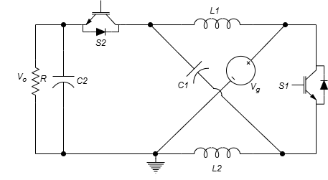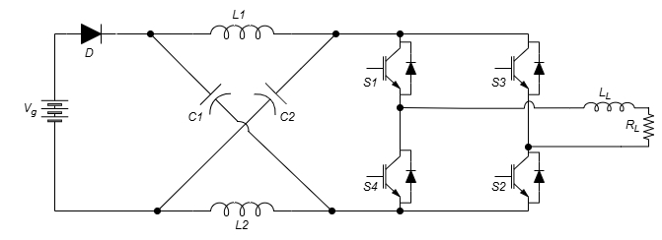
Figure 6.3 (a) The semi-Z-source inverter (b) H-bridge inverter configuration, highlighting the differences in grounding and switching structures.

6.3 Closed-loop Control System for the semi-Z-source Inverter
Details of the DC operation modes of the Z-source DC-DC converter was discussed in Chapter 3. The control of the Z-source DC-DC converter can be modified so it can serve as an inverter.
According to the inductor voltage-second and capacitor charge balance principle, the steady-state equations are derived as follows.
The modulation index is given as:
$$M=\frac{V_{o}}{V_{g}}=\frac{1-2D}{1-D} (6.1)$$
The voltage across C1, the current across L1 and the current across L2 for the semi-Z-source inverter would be given as (6.2) to (6.4).
$$V_{C1}=\frac{D}{1-D}{(V}_{g}-V_{o}) (6.2)$$
$$I_{L1}=I_{O} (6.3)$$
$$I_{L2}=\frac{D}{1-D}I_{O} (6.4)$$
Assuming the inverter output voltage is represented as
$$V_{O}={\hat{V}}_{ac}sinωt (6.5)$$
Then, the modulation index can be represented as
$$M=\frac{{\hat{V}}_{ac}}{V_{g}} (6.6)$$
Plugging Equations. (6.5) and (6.6) into (1), we have
$Msinωt=\frac{1-2D}{1-D} (6.7)$
This can be rewritten as:
$$D=\frac{1-Msinωt }{2-Msinωt} (6.8)$$
Equation (6.8) is the duty cycle, D of switch S1.
The duty cycle of switch S2 is defined as $D' = 1-D$represented as
$$D=\frac{1}{2-Msinωt}$$
From Equations (6.1) and (6.7), the voltage gain of the semi-Z-source inverter is not linear with the duty cycle. In order to achieve a sinusoidal output voltage, a modified sinusoidal pulse width modulation is required to output the sinusoidal voltage. The revised duty cycle reference given by Equation (6.8) is used generate the switching pulses. The PWM technique is discussed in detail in the next section.

6.3.1 Pulse Width Modulation
Pulse Width Modulation (PWM) is a widely used technique for controlling analogue signals with digital pulses. The performance of PWM signals depends on three key factors: the duty cycle, frequency, and period. The duty cycle determines the proportion of time the PWM signal remains "on" within each cycle, expressed as a percentage. The frequency controls how quickly these cycles complete, with higher frequencies indicating more cycles per second. For example, 1500 Hz corresponds to 1500 cycles per second. Within each cycle, the signal alternates between "on" and "off" states, allowing precise control of the output signal's magnitude and timing [18].
In inverters, PWM is applied to regulate the output voltage's magnitude and frequency by adjusting the pulse widths. Several PWM techniques exist, such as Sinusoidal PWM (SPWM), Space Vector PWM (SVPWM), Hysteresis PWM, and Selective Harmonic Elimination PWM (SHE-PWM) [76], [136]. Among these, SPWM is the most widely used because of its ability to generate a near-sinusoidal output waveform and reduce harmonic distortion at the inverter output [11].
Despite its widespread use, SPWM does have limitations. One primary drawback is harmonic distortion, particularly at lower switching frequencies. While SPWM mitigates harmonics compared to square-wave inverters, harmonic components can still appear, particularly around the switching frequency and its multiples, potentially causing noise, power losses, and electromagnetic interference (EMI) [10]. Additionally, SPWM's DC bus utilisation is limited, as its modulation index typically stays below 1, which constrains the output voltage amplitude [137].
However, these limitations are manageable in this project. The harmonic distortion introduced by SPWM is addressed by incorporating an appropriate filtering stage, consisting of inductors and capacitors designed to attenuate high-frequency harmonics. This filtering ensures that the output meets the power quality requirements for grid-connected system [138]. Furthermore, the reduced DC bus utilisation of SPWM is compensated for by the voltage-boosting capability of the Z-source inverter topology, which mitigates the need for higher modulation indices [12].
SPWM is also favoured in this project due to its simplicity and reliability. The technique’s straightforward implementation reduces system complexity, which helps maintain stability and lowers overall costs. Additionally, the near-sinusoidal output produced by SPWM meets the grid’s requirements, making it a practical choice for this grid-tied application. In this context, the Z-source inverter's ability to boost and invert voltage makes SPWM even more effective, eliminating the need for additional modifications to the control system [139], [140].

6.3.2 Sinusoidal Pulse Width Modulation
The SPWM is achieved by comparing a sinusoidal control signal ($V_{control}$) at the desired inverter output frequency ($f_{m}$) with a triangular waveform ($V_{tri}$) at a higher constant switching frequency ($f_{s}$) to generate gating pulses which are applied to the switching devices. $f_{m}$ and $f_{s}$ establish the inverter’s fundamental (modulating) frequency and its switching frequency, respectively. The amplitude modulation index $m_{a}$ is defined as
$$m_{a}=\frac{V_{control}}{V_{tri}} (6.9)$$
In (6.9), $V_{control}$ is the peak value of the control signal. $V_{tri}$ is generally kept constant. Also, the frequency modulation ratio $m_{f}$) is defined as [141]
$$m_{f}=\frac{f_{s}}{f_{m}} (6.10)$$
The output of an inverter can’t be perfectly sinusoidal; instead, it contains voltage harmonics at harmonic frequencies of $f_{m}$, centred around multiples of $m_{f}$ (e.g., 2$m_{f}$, 3$m_{f}$, and so on). Choosing an odd integer value for $m_{f}$ introduces an odd half-wave symmetry with respect to the time origin, effectively eliminating even harmonics from the output waveform [141], [142]. Additionally, harmonic voltages at higher frequencies are relatively easier to filter out, so selecting a high switching frequency for $m_{f}$ can significantly reduce unwanted harmonics, as shown in equation (6.10). However, the inverter’s switching losses are directly related to its switching frequency, meaning this frequency must be chosen with care to balance performance and efficiency.
The Sinusoidal Pulse Width Modulation (SPWM) switching techniques are categorised into two main types: bipolar and unipolar switching [142], [143].

6.3.2.1 SPWM with Bipolar switching
The generation of the PWM signals which are used as the switching control signals is illustrated through a circuit consisting of a comparator and a logic gate as shown in Fig. 6.4. A sinusoidal reference signal ($v_{ref}$) is compared with a triangular signal ($v_{tri}$) using a comparator to produce the bipolar switching signals.

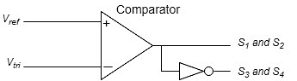
Figure 6.4 Bipolar SPWM generator

The activation of each switch pairs, S1-S2 or S3-S4 is carried out simultaneously. The inverter output voltage is generated by comparing the $v_{tri}$ with $v_{ref}$. When $v_{ref}>v_{tri}$, S1 and S2 are tuned on. Otherwise S3 and S4 are turned on [142], [144]. This scheme requires proper filtering because the high switching ripple in the current is equal to the switching frequency.

6.3.2.2 SPWM with unipolar switching
The basic concept used to produce the sinusoidal PWM with unipolar switching is depicted in Fig. 6.5. Two sinusoidal reference signals which are 180º out of phase with each other ($v_{ref}$ and -$v_{ref}$) are respectively compared with a triangular signal ($v_{tri}$) using two comparators to produce the unipolar switching signals.

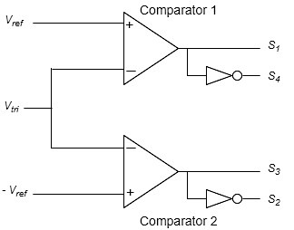
Figure 6.5 Unipolar SPWM generator

The switches S1, S2, S3 and S4 are activated independently. The inverter output voltage is generated by comparing the $v_{tri}$ with $v_{ref}$ and ${-v}_{ref}$. Here, the inverter output voltage switches between $0$ and $v_{dc}$ in the positive half cycle or between $0$ and ${-v}_{dc}$ in the negative half cycle. When $v_{ref}>v_{tri}$, S1 is on, S4 is off, $v_{a}= v_{dc}$. When $v_{ref}<v_{tri}$, S1 is off, S4 is on, $v_{a}= 0$. When ${-v}_{ref}>v_{tri}$, S3 is on, S2 is off, $v_{b}= v_{dc}$. When $-v_{ref}<v_{tri}$, S3 is off, S2 is on, $v_{b}= 0$. Filtering is much easier to achieve in this scheme than the bipolar because during switching between zero and one of the DC bus voltages, the unipolar SPWM effectively doubles the switching frequency seen by the load, thereby reducing the harmonic distortion [144].

6.3.3 SPWM of Semi-Z-Source Inverter
Conventional Z-source inverters generate sinusoidal voltage at its output using SPWM with bipolar switching technique. However, the semi-Z-source inverter has a non-linear relationship between the voltage gain and duty cycle. Thus, a modified sinusoidal voltage reference defined in Equation (6.8) is used generate switching pulses for S1 and S2 respectively. When the modified reference signal is greater than the triangular carrier signal, the switches are turn on and vice versa. The switching pulses of S1 and S2 are complementary as shown in Fig. 6.6.
A drawback of this non-linear relationship is the potential imbalance in switching losses between S1 and S2. In particular, conduction losses may differ due to varying conduction intervals when the AC cycle is positive versus negative. S1 may experience different conduction intervals compared to S2, leading to unbalanced power dissipation. This could justify using different types of transistors for S1 and S2, optimising each switch based on its specific conduction characteristics. For example, selecting a transistor with lower conduction losses for the switch that experiences longer conduction intervals would enhance efficiency. This asymmetry in conduction intervals could contribute to non-uniform thermal stress on the devices, which would further influence the longevity of the transistors. By choosing devices with appropriate ratings for each switching interval, performance and reliability can be improved [145].
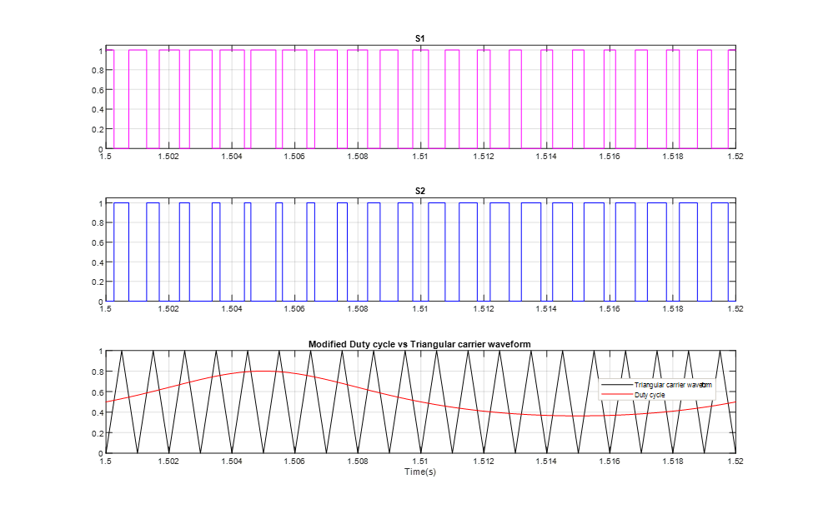
Figure 6.6 The switching pulses of S1 and S2, the modified duty cycle and triangular carrier waveform for the SPWM of semi-z-source inverter

6.4 Semi-Z-Source Inverter Control
The grid is a dynamic system where voltage magnitude and frequency can fluctuate due to various factors such as harmonics, load changes, and grid faults. These fluctuations pose significant challenges for grid-connected power converters, particularly in maintaining stable and efficient operation. If an inverter is not properly synchronised with the grid, it can lead to instability, safety issues, increased harmonics, electromagnetic interference (EMI), power losses, and grid imbalance. Proper synchronisation ensures that the inverter operates in harmony with the grid, allowing for the accurate control of power flow, both active and reactive into the grid. This accurate control is fundamental to maintaining grid stability, as it allows the inverter to respond to dynamic changes and prevent operational inefficiencies. High-quality power delivery is a result of successful synchronisation coupled with effective control strategies, ensuring minimal disruptions or inefficiencies [24], [25], [130], [131].
One of the key challenges in grid-connected systems is the potential injection of DC current into the grid. This can occur due to several factors, including asymmetries in switching, imperfections in current reference signals, or non-ideal sensor characteristics. DC current injection can distort the grid's performance, causing transformer saturation, increased losses, and other operational issues [130]. Therefore, controlling and eliminating DC current injection is a critical aspect of grid-connected inverter design.
In this work, a semi-Z-source inverter is integrated with a grid-connected photovoltaic (PV) system. To enhance performance, a closed-loop Voltage Oriented Control (VOC) technique is incorporated, which allows for independent regulation of active and reactive power in the system. This VOC strategy works within the synchronous reference frame (dq-frame), which rotates at the grid's angular speed $ω$ [14]. Grid synchronisation is achieved using the αβ-CDSC-SOGI-PLL (discussed in Chapter 5), which ensures that the dq-frame is aligned with the grid's voltage vector. The proper alignment enables accurate power flow control between the semi-Z-source inverter and the grid.
Figure 6.7 shows the schematic diagram of the semi-Z-source inverter and associated control for a grid-connected photovoltaic (PV) system. At the input is a solar PV array. A DC voltage controller regulates the DC bus capacitor voltage (VDC) to its reference value, maintaining stable active power flow from the PV array to the grid. Meanwhile, the current controller ensures the regulation of active and reactive power flow to the grid, which is essential for ensuring a unity power factor or a specified reactive power level. These controllers, alongside the αβ-CDSC-SOGI-PLL, regulate the pulse-width modulation (PWM) switching of the semi-Z-source inverter, optimising its performance under varying grid conditions. The overall control system also includes components for DC voltage regulation, grid filtering, and DC current elimination, which will be discussed in more detail in subsequent sections.

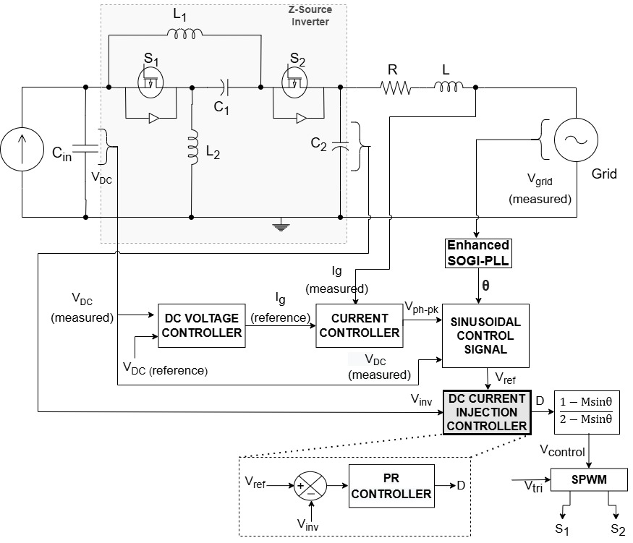
Figure 6.7 Schematic diagram of the semi-Z-source inverter and associated control for a grid-connected photovoltaic (PV) system

6.5 DC Voltage Controller
Fluctuations in the power output from a PV system can cause the DC bus voltage to experience transient changes, as the DC-link capacitor acts as a temporary energy storage element. When PV power increases, the DC voltage overshoots; when PV power decreases, it undershoots [14]. These voltage variations can be stabilised by carefully managing the charge and discharge cycles of the DC bus capacitor [146]. A DC voltage controller helps regulate the DC-link capacitor by generating the energy needed to charge or discharge the capacitor, maintaining the DC voltage $V_{DC}$ at its target reference $V_{DC}^{*}$.
In essence, maintaining the desired DC voltage level is achieved by controlling the current (or power) exchange between the inverter and the grid in response to the PV system’s output power changes. This control is managed through a closed-loop Proportional-Integral (PI) controller, which produces the active current reference required by the grid current regulator. Figure 6.8 illustrates the block diagram for DC voltage control [143].

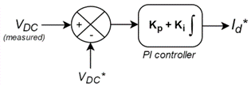
Figure 6.8 Block diagram of the DC voltage control for the semi-Z-source inverter.

From Figure 6.8, the active current reference ($I_{d}^{*}$) is given as:
$$I_{d}^{*}=K_{p}\left(V_{DC}^{*}-V_{DC}\right)+K_{i}\int{\left(V_{DC}^{*}-V_{DC}\right)dt} (6.11)$$

6.6 Current Controller
A core requirement across most regulatory standards governing distributed grid-connected systems, such as PV systems, is that they actively help preserve the grid's power quality [147], [148]. One of the key aspects of power quality is maintaining a unity power factor for the power delivered to the grid. Current controllers are essential in achieving this, as they not only maintain power quality but also ensure the system meets regulatory standards effectively.
The power factor can be expressed as
$$pf =\frac{active power \left(P\right)}{ active power \left(P\right)+ reactive power \left(Q\right)} . (6.12)$$
Hence, grid current control is usually required to manage the active and reactive power exchange between the grid-tied converter and the grid to maintain unity power factor ($pf =1$). From the instantaneous power theory [14], the active power ($P$) and reactive power ($Q$) produced by the grid converter can be expressed in d-q synchronous reference frame as:
$$P=V_{d}I_{d}+V_{q}I_{q}$$
$$Q=V_{q}I_{d}-V_{d}I_{q}$$
If the d-axis of the frame is perfectly aligned with grid voltage, $V_{q}=0$. Therefore, the active power ($P$) and the reactive power ($Q$) are directly proportional to $I_{d}$ and $I_{q}$ respectively.
$$P=V_{d}I_{d}$$
$$Q=-V_{d}I_{q}$$
To achieve unity power factor, $I_{q}$ ​ is set to zero, eliminating reactive power ($Q=0$ ) and ensuring the system delivers only active power to the grid [143].
In practice, this control is more commonly applied to three-phase systems, but for single-phase systems, the equivalent dq parameters can be obtained by mimicking a three-phase system using the Clarke transformation. This involves using the T/4 delay applied to the measured grid current. The purpose of this delay is to create an artificial β-axis current component, which – along with the original current – can be transformed into the dq reference frame via Park’s transformation to obtain the $I_{d}$ and $I_{q}$ currents [149]. This technique allows for better control of active and reactive power flow even in single-phase systems, ensuring that the same level of precision and control can be applied as in a three-phase system [149].
A Proportional-Integral (PI) controller can be used to regulate the grid $I_{d}$ current to the reference value $I_{d}^{*}$ specified by the DC voltage controller. Also, a similar PI controller can be applied to regulate the $I_{q}$ current to a zero-reference value $I_{q}^{*}=0$.
The outputs of the PI controllers are the d-q elements of the voltage compensation required by the converter in order to match the grid voltage [148]. These compensation voltages can be expressed as:
$$V_{d_conv}^{*}=K_{p}\left(I_{d}^{*}-I_{d}\right)+K_{i}\int{\left(I_{d}^{*}-I_{d}\right)dt} (6.13)$$
$$V_{q_conv}^{*}=K_{p}\left(I_{q}^{*}-I_{q}\right)+K_{i}\int{\left(I_{q}^{*}-I_{q}\right)dt} (6.14)$$
Figure 6.9 shows the voltage relationship across a typical grid-connected converter in d-q synchronous reference frame. An RL filter is also included in the schematics.

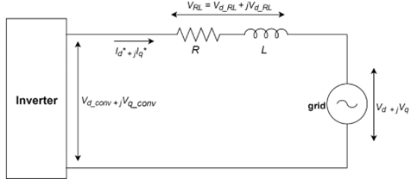
Figure 6.9 Voltage relationship across a grid-connected inverter

Factoring in the voltage compensation elements (Equations (6.13) and (6.14)), the d-q components of the converter terminal voltage can be expressed as:
$$V_{d_conv}=V_{d}+V_{d_RL}+V_{d_conv}^{*} (6.15)$$
$$V_{q_conv}=V_{q}+V_{q_RL}+V_{q_conv}^{*} (6.16)$$
The voltage across the RL filter can be expressed as
$$V_{RL}=I^{*}X=\left(I_{d}^{*}+jI_{q}^{*}\right)\left(R+jωL\right)$$
where $ω=2πf$ and $f$ is the grid frequency, so that
$$V_{RL}=V_{d_RL}+jV_{q_RL}=\left(I_{d}^{*}R-I_{q}^{*}ωL\right)+j\left(I_{q}^{*}R+I_{d}^{*}ωL\right).$$
$$V_{d_RL}=\left(I_{d}^{*}R-I_{q}^{*}ωL\right) (6.17)$$
$$V_{q_RL}=\left(I_{q}^{*}R+I_{d}^{*}ωL\right) (6.18)$$
Hence, Equations. (6.15) and (6.16) can be expressed as:
$$V_{d_conv}=V_{d}+I_{d}^{*}R-I_{q}^{*}ωL+V_{d_{conv}}^{*} (6.19)$$
$$V_{q_conv}=V_{q}+I_{q}^{*}R+I_{d}^{*}ωL+V_{q_conv}^{*} (6.20)$$

To transform the 𝑑-𝑞 converter voltage into a single AC component, $V_{conv}$, the inverse-Park and inverse-Clarke transformations have to be applied. The resulting $V_{conv}$ represents the fundamental frequency component of the inverter voltage, which is then used to generate the sinusoidal control signal for the inverter's PWM. Figure 6.9 illustrates the overall block diagram of this current controller.
In general, PI-based current control within a synchronous frame offers superior dynamic response and enhanced stability compared to most other current control methods [14], [146], [147]. A further advantage of this approach is the ability to use well-established PI controllers, which also allow for independent reactive power control [14].

6.7 Converter Filter
The converter filter forms part of the converter system and provides the interface through which the inverter connects to the grid. It plays a crucial role in grid-connected voltage-source converters (VSCs), ensuring both safe and efficient operation, and it serves two main purposes.
First, in a two-port network a direct connection between two voltage sources, the converter and the grid, requires impedance between them. Without sufficient impedance, instability or improper operation can occur, particularly at higher switching frequencies. A predominantly inductive filter element presents high impedance at these frequencies, allowing the grid-connected VSC to operate correctly by minimising interaction between the two voltage sources [14], [144], [150].
Second, the output of conventional VSCs contains a range of sideband and carrier voltage harmonics produced by the pulse-width modulation (PWM) switching. These harmonics can inject distorted current into the grid, which may result in undesirable effects such as additional losses, overheating, or interference with sensitive loads. A well-designed filter minimises these distortions, helping to meet grid standards and improving the overall quality of the delivered power. For low-power grid-connected applications, a series inductor is often the most straightforward filtering solution [14], [151]. With appropriate selection of the inductance, it attenuates the switching-frequency harmonics while passing the fundamental.
A plain L-filter offers the simplest interface but is only lightly damped, relying entirely on the current loop to suppress resonance between the filter inductance and the grid and DC-link capacitances. An LCL filter gives superior switching-harmonic attenuation for a given inductance, but introduces its own resonant peak. Keeping that peak clear of the control bandwidth requires active or passive damping, accurate tuning of three reactive elements, and knowledge of the grid impedance [144], [150]. An RL filter is therefore adopted: a single series inductance of 1 mH with a series resistance of 4 Ω that provides passive damping, retaining the simplicity and low component count of the L-filter while avoiding the additional damping and tuning that an LCL filter demands. The cost of this choice, that the series resistance dominates the converter loss and the residual current distortion lies above the 5 percent current-distortion benchmark, is examined in Sections 6.11 and 6.12.

6.8 Photovoltaic Array Model
The photovoltaic (PV) array is represented by a single-diode model, which captures the non-linear current-voltage characteristic of a practical panel and its variation with irradiance and temperature. This section presents the single-diode model and the parameter values used in the simulation studies of this chapter.

6.8.1 Single-diode equation
The PV array is modelled using the standard single-diode equation [14]:

$$I=I_{ph}-I_{0}\left[\exp\left(\frac{V+IR_{s}}{V_{t}}\right)-1\right]-\frac{V+IR_{s}}{R_{sh}} (6.21)$$
with the combined thermal voltage
$$V_{t}=\frac{nN_{s}kT}{q}$$
where $I$ is the array current, $V$ is the terminal voltage, $I_{ph}$ is the photocurrent (proportional to irradiance), $I_{0}$ is the diode reverse saturation current, $R_{s}$ is the series resistance, $R_{sh}$ is the shunt resistance, and $V_{t}$ is the thermal voltage scaled by the number of series cells and the diode ideality factor. Equation (6.21) is implicit in $I$ and is solved numerically at each operating point. The model captures the four features important for converter design: the short-circuit current $I_{sc}$, the open-circuit voltage $V_{OC}$, the maximum power point ($V_{MPP}$, $I_{MPP}$), and the variation of these quantities with irradiance and temperature.

6.8.2 Array configuration and parameters
The array is configured to deliver approximately 3 kW at the maximum power point under standard test conditions ($G=1000W/m²$, $T=25°C$). It comprises ten panels in series, each with an MPP voltage of approximately 50 V at STC, producing $V_{MPP}≈500\text{ V}$ and $I_{MPP}≈5.9\text{ A}$, matching the PV-side DC voltage required by the modified SPWM scheme at $M_{nominal}=0.65$. The single-diode parameter values are summarised in Table 6.2.
The 500 V operating point is a deliberate match between the array's maximum-power-point voltage and the converter's nominal modulation index (M = 0.65 at the 230 V grid), not an arbitrary choice. The approximately 3 kW rating is representative of domestic single-phase PV, which is installed at the scale of a few kilowatts [152] and connects within the 16 A (3.68 kW) per-phase single-phase limit set by Engineering Recommendation G99 and BS EN 61000-3-2 [89], [153]. The rating is also representative of the single-phase grid-connected PV inverter literature, in which residential string and single-stage inverters are typically rated from a few hundred watts at module scale to a few kilowatts for string converters [10]. The present transformerless single-stage design sits within this residential band and is directly comparable to the single-phase transformerless PV systems reviewed in [154].

Table 6.2 Single-diode PV array model parameters, tuned to reproduce the target maximum power point.
Parameter | Symbol | Value
Photocurrent at STC | $$I_{ph}$$ | 6.6 A
Diode ideality factor | $$n$$ | 1.45
Series resistance | $$R_{s}$$ | 4.0 Ω
Shunt resistance | $$R_{sh}$$ | 1200 Ω
Open-circuit voltage at STC | $$V_{oc}$$ | 600 V
Short-circuit current at STC | $$I_{sc}$$ | 6.6 A
MPP voltage at STC | $$V_{MPP}$$ | ≈ 500 V
MPP current at STC | $$I_{MPP}$$ | ≈ 5.9 A
MPP power at STC | $$P_{MPP}$$ | ≈ 2955 W
Number of series panels | $$N_{s}$$ | 10

6.8.3 Irradiance and temperature dependence
The photocurrent scales linearly with irradiance and weakly with temperature,
$$\begin{matrix} & I_{ph}\left(G , T\right)=\frac{G}{G_{STC}} I_{ph,STC}\left[ 1+α \left(T-T_{STC}\right) \right] & & \text{(6.}\text{22}\text{)}\end{matrix}$$
where $G_{STC}=1000 {\text{W/m}}^{2}$, $T_{STC}=298.15\text{ K}$, and $α≈0.05 \%/\text{K}$ is the normalised temperature coefficient of short-circuit current for crystalline silicon. Temperature dependence enters the diode term through the reverse saturation current, modelled using the bandgap relation
$$\begin{matrix} & I_{0}\left(T\right)=I_{0,STC}{\left(\frac{T}{T_{STC}}\right)}^{3}\exp{ }\left[\frac{E_{g} q}{n k}\left(\frac{1}{T_{STC}}-\frac{1}{T}\right)\right] & & \text{(6.23)}\end{matrix}$$
with $E_{g}=1.1\text{ eV}$ the silicon bandgap and $I_{0,STC}$ fixed by the open-circuit condition at STC,
$$I_{0,STC}=\frac{I_{ph,STC}-V_{oc}/R_{sh}}{\exp{ }\left(V_{oc}/V_{t}\right)-1}$$
which anchors $V_{oc}$ to 600 V at STC. The open-circuit voltage then follows as
$$V_{oc}\left(T\right)=V_{t}\left(T\right) \ln{ }\left(\frac{I_{ph}}{I_{0}\left(T\right)}+1\right)$$
and falls with temperature. Across realistic operating conditions for the ten-panel string, $V_{MPP}$ ranges from approximately 465 V (low irradiance) to 520 V (cold day, high irradiance).
The resulting current-voltage and power-voltage characteristics across the operating irradiance range are shown in Figure 6.10. As irradiance falls from 1000 to 200 W/m², the short-circuit current scales almost linearly while the open-circuit voltage changes only weakly, so the maximum-power point traces the locus indicated, with $V_{MPP}$ remaining close to 500 V across the range.
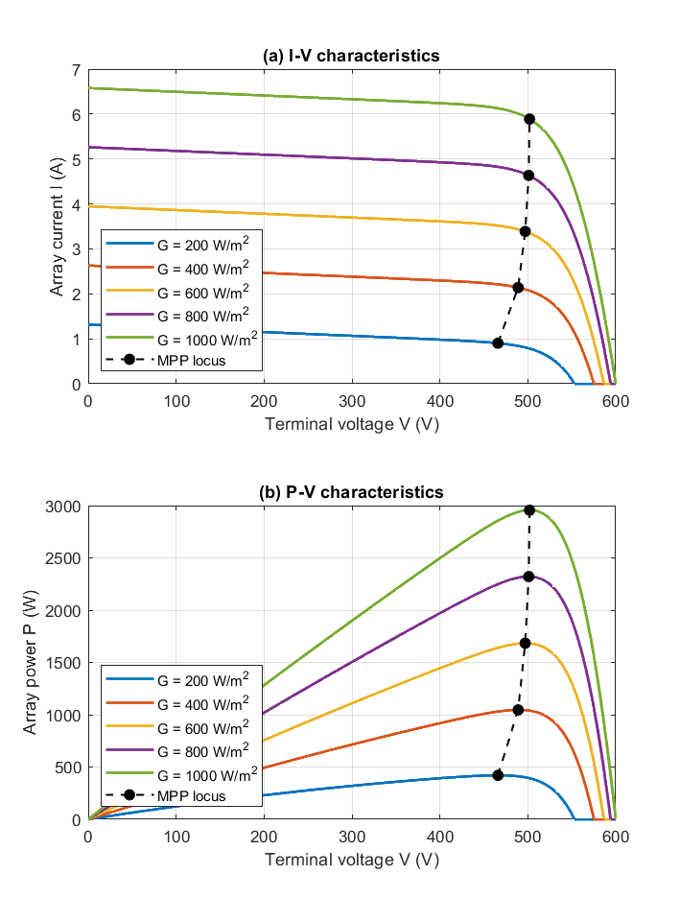
Figure 6.10 shows the array's I-V and P-V characteristics at G = 200, 400, 600, 800 and 1000 W/m² (T = 25 °C), together with the maximum-power-point locus across the irradiance range.

6.9 Gain-Scheduled Proportional-Resonant DC-Injection Compensator
The DC current injection controller minimises the adverse effects of DC current injection into the grid. As discussed in Section 6.1, unwanted DC injection can arise from asymmetrical switching in semiconductor devices, non-ideal component characteristics, quantisation errors in digital systems, and drift in transducer measurements, and can lead to saturation of distribution transformers, increased iron losses, corrosion of grounding systems, distorted metering accuracy, and reduced grid stability [24], [25], [130], [131].
The controller detects any DC component in the output of the semi-Z-source inverter and drives it to zero. A comparator continuously evaluates the inverter's output voltage against a sinusoidal reference generated by the control signal, identifying the steady-state error introduced by variations in the modulation index and other system nonlinearities. This error is processed by a proportional-resonant (PR) controller, whose high gain at the fundamental frequency drives the AC tracking error, and hence the injected DC component, towards zero. Model predictive and other optimisation-based current controllers have also been applied to impedance-source inverters [56], [62]; a PR controller is adopted here because its infinite gain at the fundamental directly targets steady-state DC-injection elimination [106], with a mature and computationally light design well suited to the Chapter 5 hardware target.
As the PV array tracks its maximum power point, the converter's operating point moves, and with it the gain the controller must work against. A single fixed setting therefore cannot stay optimal across the full range: DC-injection suppression that is good at the nominal point weakens toward the extremes [132]-[134]. The proportional gain of the PR compensator is therefore scheduled against the operating-point modulation index, adjusting automatically as the operating point moves.
The proportional-resonant controller takes the ideal form
$$\begin{matrix} & G_{PR}\left(s\right)=K_{p}+K_{r} \frac{2s}{s^{2}+ω_{o}^{2}} & & \text{(6.24)}\end{matrix}$$
where $ω_{o}=2π×50$rad/s is tuned to the UK 50 Hz grid. The poles at $±jω_{o}$give theoretically infinite gain at the fundamental and hence zero steady-state error in tracking it [106], [107]. $K_{p}$ sets the broadband loop gain (crossover, phase margin, bandwidth); $K_{r}$ sets the selectivity of the resonant kernel around 50 Hz. Because the compensator's closed-loop bandwidth (tens of hertz) lies well below the 50 Hz fundamental, it cannot resolve within-cycle plant variation and sees only the effective plant gain; $K_{p}$ is therefore the gain that must adapt, while $K_{r}$, which governs only the sharpness of the 50 Hz resonance and does not depend on operating point, is held fixed at unity [132]-[134].
$K_{p}$is scheduled against the cycle-averaged operating-point modulation index $M_{avg}=V_{pk}/V_{DC}$. The schedule is constructed from an effective plant-gain expression and implemented as a 15-point lookup table generated by the MATLAB script Ch6_PR_GainSchedule.m and loaded into the Simulink model at simulation start. A manual switch selects between the scheduled $K_{p}$and a fixed $K_{p}=0.0016$ for simulation comparison in later sections.

6.9.1 Schedule design
The schedule maps $M$ to $K_{p}\left(M\right)$ by inverse scaling against the effective plant gain, through three analytical steps and one design choice.
Step 1, pointwise plant evaluation: for each candidate operating point $M_{k}$ the instantaneous duty cycle over one grid cycle is
$$d\left(t\right)=\frac{1-M_{k}\sin{ω}t}{2-M_{k}\sin{ω}t}$$
and the small-signal DC gain $G_{vd}\left(0 ; d\left(t\right)\right)$ is evaluated using the linearised state-space model of Chapter 3, obtained by state-space averaging [75]. The resulting control-to-output response at three operating points is shown in Figure 6.11.
Step 2, effective plant gain. Because the compensator's closed-loop bandwidth (order tens of hertz) lies well below the 50 Hz fundamental, it responds not to the instantaneous plant gain but to an effective, operating-point-representative value. Following the linearisation-based gain-scheduling approach [132]-[134], this effective gain is represented by the closed-form expression
$$\begin{matrix} & G_{eff}\left(M\right) ≈ V_{DC}\left(4+\frac{M^{2}}{2}\right) & & \text{(6.25)}\end{matrix}$$where $V_{DC}$ is the regulated DC-bus voltage, the constant term of 4 dominates, and the $M^{2}/2$ term is a small operating-point-dependent correction. The form of equation (6.25), a dominant constant with a small quadratic correction, reflects the monotonic increase of the plant gain with operating point in characterised in Figure 6.11 and Table 6.3. It is adopted as a design expression for the schedule: smooth, monotonic in M, and free of the mid-cycle singularity that the instantaneous plant gain exhibits as the duty passes through 0.5. These properties allow the schedule to be evaluated in closed form at simulation start and extended directly to other grid or bus voltages
$G_{eff}$ is a normalised design quantity, not an estimate of the physical control-to-output gain $G_{vd}(0)$ of Table 6.3; it shares neither the sign nor the magnitude of the state-space DC gain. Its role is solely to provide a smooth, monotonic, singularity-free scheduling variable whose shape tracks how the loop gain varies with operating point. Because the nominal proportional gain is fixed by the target loop gain LDC (Step 3), the absolute scaling of $G_{eff}$ cancels and only its relative variation across the envelope affects the schedule.
Step 3, nominal gain: $K_{p,\text{nominal}}$ is chosen to give a target DC loop gain $L_{DC}$ at the nominal operating point. The nominal modulation index is
$$M_{nominal}=\frac{V_{pk}}{V_{DC}}=\frac{230\sqrt{2}}{500}=0.6505$$
and the effective plant gain at this point is
$$G_{eff}\left(M_{nominal}\right)=500\left(4+\frac{{0.6505}^{2}}{2}\right)≈2105.8\text{ V/unit}$$
With a target $L_{DC}≈3.4$, the closed-loop DC rejection is $1+L_{DC}≈4.4$, suppressing the open-loop DC injection by $L_{DC}/\left(1+L_{DC}\right)≈77$%. The corresponding proportional gain is
$$\begin{matrix} & K_{p,\text{nominal}}=\frac{L_{DC}}{G_{eff}\left(M_{nominal}\right)}≈\frac{3.4}{2105.8}≈0.0016 & & \text{(6.26)}\end{matrix}$$
This value is the largest that maintains stable operation across the envelope.
Step 4, inverse-gain schedule:
$$\begin{matrix} & K_{p}\left(M_{k}\right)=K_{p,\text{nominal}} \frac{G_{eff}\left(M_{nominal}\right)}{G_{eff}\left(M_{k}\right)} & & \text{(6.27)}\end{matrix}$$
so the gain scales inversely with $G_{eff}\left(M_{k}\right)$ to hold the DC loop gain approximately constant across the envelope. The methodological basis is the classical linearisation-based gain-scheduling framework [132]-[134], applied here to a Z-source small-signal model of the type developed in Chapter 3 [155]. The proportional-resonant PR-P scheduling structure follows [135].

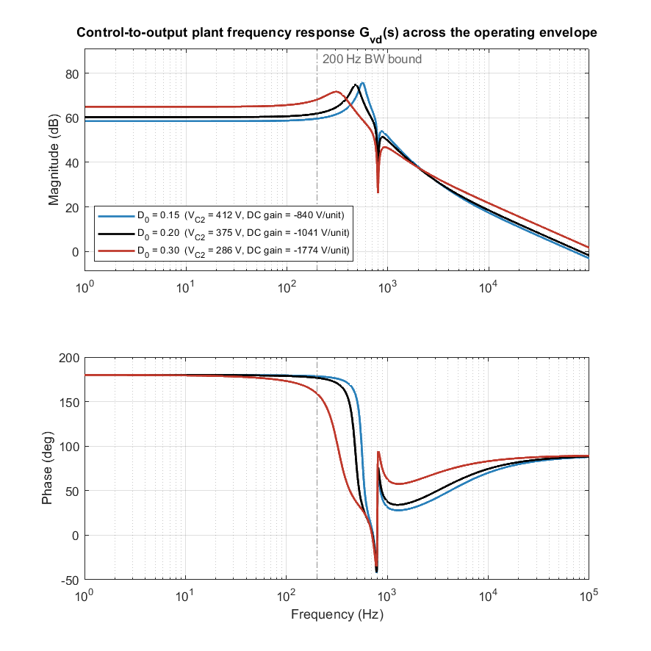
Figure 6.11: Control-to-output plant frequency response $G_{vd}(s)$ at three operating points spanning the MPPT range ($D₀$= 0.15, 0.20, 0.30), computed from the verified Chapter 3 small-signal state-space model.
Top: magnitude; bottom: phase.
Across the operating envelope the plant varies substantially: the control-to-output DC gain rises with duty ratio (−840 to −1774 V/unit, ~5.6× across the full MPPT range), and the dominant lightly-damped resonance migrates from 562 Hz to 326 Hz, broadening as it falls (Figure 6.11, Table 6.3). Below the 200 Hz bandwidth bound the magnitude curves are separated almost entirely by their DC-gain offset and are otherwise parallel, the condition under which a single scheduled proportional gain equalises the loop. This is the plant variation the gain-scheduling design accommodates.

Table 6.3 Plant characteristics across the operating envelope, computed from the verified Chapter 3 small-signal state-space model at three representative operating points (D₀ = 0.15, 0.20 nominal, 0.30).
D₀ | DC gain (V/unit) | Mode 1 (Hz) | $$ζ₁$$ | Mode 2 (Hz) | $$ζ₂$$
0.15 | −840.0 | 561.7 | 0.069 | 789.7 | 0.048
0.20 | −1040.7 | 482.3 | 0.096 | 788.8 | 0.057
0.30 | −1774.3 | 326.4 | 0.243 | 780.0 | 0.095

6.9.2 Implementation: Gain-schedule script and lookup table
The schedule is realised as the MATLAB script Ch6_PR_GainSchedule.m, which evaluates equation (6.27) at fifteen breakpoints spanning $M=0.50$ to $0.85$ in 0.025 steps, produces a lookup table indexed by $M$, and saves it for the Simulink InitFcn to load at simulation start.
The breakpoint range carries margin around the three Section 6.12 test operating points ($V_{DC}=450, 500, 540$ V; $M=0.723, 0.651, 0.602$). $K_{r}$ is hard-coded at 1.0. The resulting schedule is presented in Table 6.4.

Table 6.4 Gain-schedule lookup table generated by Ch6_PR_GainSchedule.m. $K_{p}\left(M_{k}\right)$ is computed from equation (6.27) with $K_{p,\text{nominal}}=0.0016$ at $M_{nominal}=0.6505$

$$M_{k}$$ | $$G_{eff}\left(M_{k}\right)$$ | $$K_{p}\left(M_{k}\right)×{10}^{-3}$$ | Δ from nom. (%) | Note
0.500 | 2062.5 | 1.6336 | +2.10
0.525 | 2068.9 | 1.6285 | +1.78
0.550 | 2075.6 | 1.6233 | +1.45
0.575 | 2082.7 | 1.6178 | +1.11
0.600 | 2090.0 | 1.6121 | +0.76
0.625 | 2097.7 | 1.6062 | +0.39
0.650 | 2105.6 | 1.6001 | +0.01 | $$M_{nominal}$$
0.675 | 2113.9 | 1.5939 | −0.38
0.700 | 2122.5 | 1.5874 | −0.79
0.725 | 2131.4 | 1.5808 | −1.20
0.750 | 2140.6 | 1.5740 | −1.63
0.775 | 2150.2 | 1.5670 | −2.06
0.800 | 2160.0 | 1.5599 | −2.51
0.825 | 2170.2 | 1.5526 | −2.97
0.850 | 2180.6 | 1.5451 | −3.43

The scheduled variation is small: $K_{p}$ changes by about 5.5% across the full schedule and by only about 1.9% across the three tested points, because $G_{eff}\left(M\right)$ varies only mildly with $M$ (the $M^{2}/2$term contributes between 0.125 and 0.361 against a constant term of 4). The effective plant gain is therefore nearly operating-point-invariant, even though the instantaneous gain the compensator sees varies considerably more within each grid cycle as the inverter duty sweeps toward the polarity-inversion point. This small variation in the averaged gain predicts a correspondingly small closed-loop difference between the fixed and scheduled configurations, which Section 6.12.3 confirms. The transferable outcome is the analytical framework, the closed-form $G_{eff}\left(M\right)$ of equation (6.25) and the inverse-gain schedule of equation (6.27), which expresses the schedule as two equations and extends without further tuning to other grid or DC-bus voltages.

6.10 UK Grid Compliance
Grid connection of the inverter in the United Kingdom is governed by two complementary documents. Engineering Recommendation G99 [89] sets the requirements a generator must meet to connect to the distribution network, while EN 50160 [88] characterises the quality of the supply voltage the network delivers, and therefore the conditions the inverter must tolerate. G99 defines what the inverter must do; EN 50160 defines the environment it must operate within.
Under G99 [89], the inverter must limit the DC current it injects into the network, with the applicable limit set by the referenced product standard. The inverter must provide under- and over-voltage protection about the 230 V nominal, with staged trip thresholds and defined clearance times, and under- and over-frequency protection with continuous operation required across approximately 47.5 Hz to 51.5 Hz and staged trips beyond it (under-frequency at 47.5 Hz and 47 Hz, over-frequency at 52 Hz), together with a rate-of-change-of-frequency withstand of 1 Hz/s. The injected current harmonic distortion must remain within the applicable per-harmonic emission limits [153]. The inverter must also provide controllable reactive power to support network voltage, the reactive-capability requirement for a Type A module of this rating being set by the distribution network operator rather than by a fixed power-factor window.
EN 50160 [88] governs the network rather than the inverter, defining the supply-voltage conditions it must tolerate without unnecessary disconnection. For a 230 V system it specifies voltage magnitude within ±10% of nominal (207 to 253 V) for 95% of each week; supply frequency within 49.5 to 50.5 Hz for 99.5% of the year and within 47 to 52 Hz for the whole of the time; and voltage total harmonic distortion not exceeding 8% up to the 40th harmonic. The two frameworks impose distinct frequency envelopes for distinct purposes: the G99 values are protection trip settings, whereas the EN 50160 values describe the permissible variation of the supply itself.

6.10.1 Assessment of the design against the requirements
The design was assessed against these requirements through the simulation studies of Section 6.12. The scope of that assessment is stated explicitly: the continuous power-quality metrics were quantified against the applicable limits, dynamic behaviour was demonstrated under representative operating and disturbance conditions, and formal verification of the protection trip settings is not undertaken in this work and is identified as further work, being a hardware type-test activity outside the simulation scope of this chapter. The outcomes are summarised in Table 6.5.

Table 6.5 Assessment of the converter against UK grid-connection requirements. Continuous power-quality metrics are quantified against the applicable limits; dynamic requirements are demonstrated in simulation; protection trip settings are verified by hardware type-test.
Requirement | Standard | Result | Assessment
DC current injection | G99 | 0.10–0.11% of fundamental at V_DC = 500–540 V | Within applicable limit at tested points
Current THD | EN 61000-3-2 [153] | 8.4–11.4% (present L-filter) | Recorded; above 5% benchmark. Not a design objective of this study (DC-injection focus); reduction identified as further work
Frequency ride-through | G99 | Stable, connected, PLL lock maintained through a 50 to 51 Hz step | Behaviour demonstrated
Voltage ride-through | G99 / EN 50160 | Rides through a 70% sag for 200 ms with synchronisation maintained | Behaviour demonstrated
Reactive capability | G99 | Symmetric active/reactive control through the dq loops across the tested range | Capability demonstrated
Grid-supply tolerance | EN 50160 | Stable operation at representative points within the declared envelope | Behaviour demonstrated
Protection trips | G99 |  | Not verified in this work; identified as further work

The design remains within the applicable DC-injection limit across the normal operating range, with a marginal exceedance (0.55–0.60%) only at the 450 V low-voltage extreme, at the edge of the boost range. The one requirement not met in the present configuration is current THD, which lies above the 5 percent benchmark; as set out in Section 6.12, this is a recorded but out-of-scope observation dominated by the second-harmonic intrinsic to single-stage single-phase operation, and its reduction is identified as further work. Dynamic behaviour, ride-through of frequency and voltage disturbances and symmetric reactive-power control, is demonstrated across the tested conditions.

6.11 Loss Model and Converter Efficiency
This section develops the loss model used to interpret the converter efficiency obtained from the simulated switching waveforms.

6.11.1 Loss mechanisms
The converter loss comprises MOSFET conduction and switching losses, body-diode conduction loss, inductor copper and core (Steinmetz) losses, Z-network capacitor equivalent-series-resistance loss, and the resistive loss in the output-filter resistance
$$\begin{matrix} & P_{R_{f}}=R_{f} I_{\text{grid,RMS}}^{2}. & & \text{(6.28)}\end{matrix}$$
The first six are standard semiconductor and magnetic loss mechanisms [8]. These expressions characterise where the dissipation arises rather than forming the efficiency computation, which is obtained directly from the measured input and output powers (Section 6.11.2). Of these mechanisms, the resistive (I²R) dissipation in $R_{f}$ is the largest single contributor at rated load (Section 6.11.3), because $R_{f}$ carries the full fundamental grid current and its loss scales with the square of that current.

6.11.2 Efficiency calculation
Converter efficiency is computed directly from the simulated waveforms. The PV input power and the grid output power are obtained as the cycle-averaged products of the measured voltage and current at the converter input and output respectively, and the efficiency is
$$\begin{matrix} & η=\frac{P_{\text{grid}}}{P_{\text{PV}}}=\frac{P_{\text{grid}}}{P_{\text{grid}}+P_{\text{loss}}} & & \text{(6.29)}\end{matrix}$$
with the total converter loss given by the input-output difference
$$\begin{matrix} & P_{\text{loss}}=P_{\text{PV}}-P_{\text{grid}} & & \text{(6.30)}\end{matrix}$$
For the efficiency runs no local load is connected at the inverter output, so all converted power is delivered to the grid and the input and output powers differ only by the converter loss; the second equality in (6.29) therefore holds exactly. Averaging is performed over an integer number of grid cycles once steady state is reached, so that the reactive power exchanged each cycle does not bias the mean.

6.11.3 Dominant loss mechanism
At full load the dominant loss in this converter is the resistive (I²R) dissipation in the output-filter resistance $R_{f}$ of equation (6.28), which accounts for about 361 W (47%) of the total 771 W loss (Section 6.12.8); the remainder is distributed across MOSFET conduction and switching losses, Z-network inductor copper and core losses, and capacitor ESR losses. Because $R_{f}$ carries the full fundamental grid current, its contribution scales with the square of the load current and dominates at rated power.
Since $R_{f}$ is a series damping element of the present L-filter rather than an intrinsic feature of the topology, it is instructive to quote the efficiency both with and without this term. With $R_{f}$, the measured peak efficiency at rated load is
$$η=\frac{P_{\text{grid}}}{P_{\text{PV}}}=\frac{2183.6}{2955}≈73.9\%,$$
whereas removing the $R_{f}$ dissipation gives a loss-excluded efficiency bound of
$$η_{\text{ with filter loss excluded }}=\frac{P_{\text{grid}}+P_{R_{f}}}{P_{\text{PV}}}=\frac{2183.6+361}{2955}≈86.1\%.$$
This figure is an arithmetic bound obtained by adding the measured series-damping dissipation back to the delivered power, not a separately measured efficiency; it isolates the loss removable by a filter redesign (Section 6.12.9) from the switching and conduction losses inherent to the converter.
The as-built figure of about 74% therefore reflects the L-filter damping resistance rather than the inherent capability of the topology, which approaches 86% once that loss is removed. The LCL filter proposed in Section 6.12.9 realises this improvement by relocating the damping to the capacitor branch, where it carries only ripple current. The full efficiency curve and loss breakdown for the converter are presented in Section 6.12.8.

6.12 Extended Simulation Results (UK 230 V grid, PV-driven, gain-scheduled)
Section 6.9 established the fixed-gain PR controller at the original design point with the PV array at full power. This section extends that study to the UK 230 V grid and the gain-scheduled compensator, adding transient, power-quality, and efficiency studies. The DC-bus reference is regulated to $V_{DC}=500\text{ V}$; the output filter is $L_{f}=1\text{ mH}$, $R_{f}=4 Ω$; the switching frequency is $f_{sw}=40\text{ kHz}$.
The complete Simulink model of the system is shown in Figure 6.12, and the simulation parameters, including device parasitics, are summarised in Table 6.6.

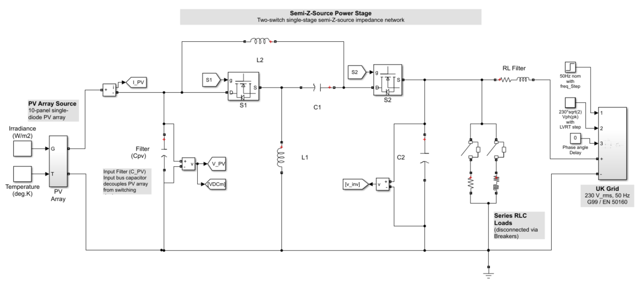
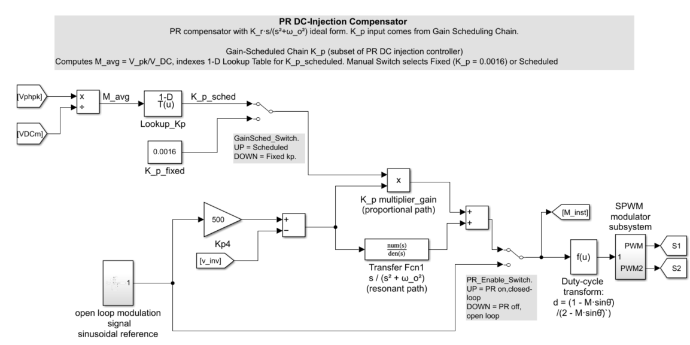
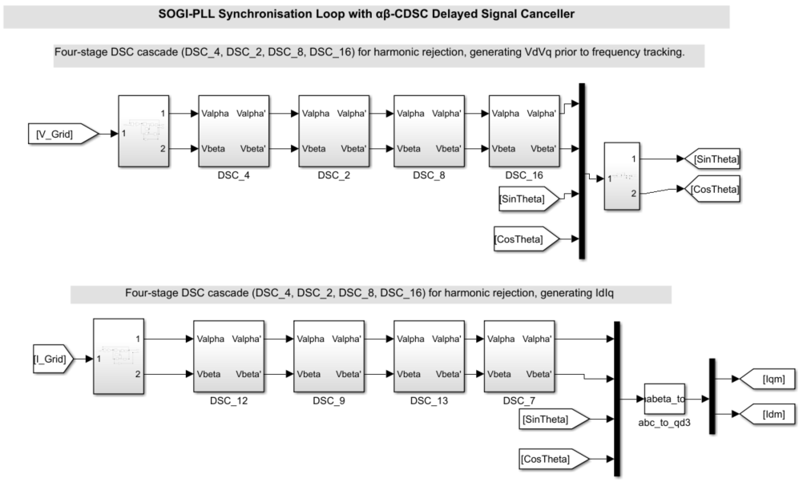
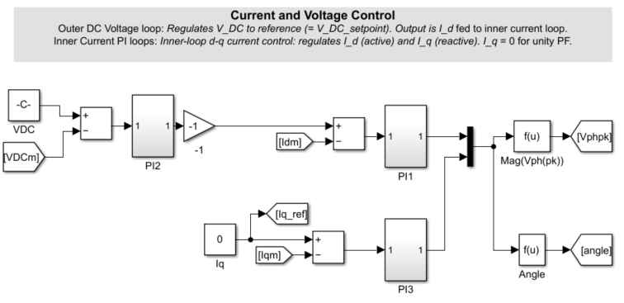
Figure 6.12 Overall Simulink model of the single-phase, 230 Vrms grid-connected PV system using the semi-Z-source inverter.

Table 6.6 Simulation parameters (including device parasitics)
Parameter | Description | Value
$$V_{DC}$$ | Regulated DC-bus voltage | $$500\text{ V}$$
$$V_{grid}$$ | Grid voltage (RMS) | $$230\text{ V}$$
$$f_{nom}$$ | Nominal grid frequency | $$50\text{ Hz}$$
$$f_{sw}$$ | Switching frequency | $$40\text{ kHz}$$
$$C_{pv}$$ | PV-terminal (input) capacitor | $$3500 μ\text{F}$$
$$L_{1},L_{2}$$ | Z-network inductance | $$2\text{ mH}$$
$$C_{1},C_{2}$$ | Z-network capacitance | $$20 μ\text{F}$$
$$r_{L}$$ | Inductor series resistance (parasitic) | $$50\text{ m}Ω$$
$$R_{on}$$ | Switch on-resistance (parasitic) | $$100\text{ m}Ω$$
$$r_{C}$$ | Capacitor ESR (parasitic) | $$20\text{ m}Ω$$
$$L_{f}$$ | Output filter inductance | $$1\text{ mH}$$
$$R_{f}$$ | Output filter damping resistance | $$4 Ω$$
$K_{p}$(nominal) | PR proportional gain | $$0.0016$$
$$K_{r}$$ | PR resonant gain | $$1.0$$
PV source | Single-diode array (Section 6.8) | $$V_{MPP}≈500\text{ V}$$  $$I_{MPP}≈5.9\text{ A}$$  $$P_{MPP}≈2955\text{ W}$$
Load | Resistive load-step disturbance | $$1.125\text{ kW}$$

6.12.1 Nominal steady-state operation
At the nominal operating point ($G=1000 {\text{W/m}}^{2}$, $T=25 ^{∘}\text{C}$, $M_{avg}=0.65$, $I_{q}^{*}=0$), the DC bus regulates to within 1% of the $500\text{ V}$ reference within 0.5s. The grid current is sinusoidal at $50\text{ Hz}$ with a fundamental peak of ${\hat{I}}_{fund}=13.51\text{ A}$ (about 9.55A RMS, from $I_{RMS}={\hat{I}}_{fund}/\sqrt{2}$), delivering an apparent power
$$S=V_{grid} I_{RMS}≈230×9.55≈2.2\text{ kVA}$$
at near-unity power factor. DC injection is suppressed to 0.099% of fundamental, below the applicable DC-injection limit (Section 6.10). The current THD is 9.98%; harmonic distortion is not a design objective of this work, which targets DC-injection control, and is discussed as further work in Section 6.12.3. The near-unity power factor confirms the $I_{q}^{*}=0$ command is enforced by the dq current controller.

6.12.2 Baseline PR versus no-PR comparison
To demonstrate that the PR compensator is necessary to meet the applicable DC-injection limit, the converter is simulated at three operating points ($V_{DC}=450, 500, 540\text{ V}$; $M=0.723, 0.651, 0.602$) with the PR compensator disabled (open-loop modulation) and enabled (closed-loop with the scheduled gains). The two configurations are selected by a manual switch at the input to the modified-SPWM duty-cycle transform; all other blocks continue to operate identically. The measured results are given in Table 6.7 and Figures 6.13 and 6.14.

Table 6.7 PR versus no-PR comparison
$V_{DC}$(V) | $$M$$ | PR state | $i_{DC}/i_{fund}$(%) | THD (%) | Fund. peak (A)
450 | 0.723 | Disabled | 0.987 | 16.44 | 13.011
450 | 0.723 | Enabled | 0.251 | 11.79 | 13.022
500 | 0.651 | Disabled | 0.685 | 14.86 | 13.511
500 | 0.651 | Enabled | 0.099 | 9.98 | 13.513
540 | 0.602 | Disabled | 0.636 | 13.40 | 12.028
540 | 0.602 | Enabled | 0.112 | 8.63 | 12.014

The PR compensator reduces DC injection below the applicable limit at every point (by a factor of 4 to 7), while leaving the fundamental amplitude essentially unchanged. The accompanying reduction in THD is a secondary effect; harmonic distortion is addressed as further work.
The operating-point trend of the uncompensated baseline (worse DC injection at lower $V_{DC}$, higher $M$) is consistent with the increased modulation depth and boost demand at those operating points.
Total harmonic distortion is reported for completeness but is not a design objective of this work, whose contribution is the DC-injection compensator. The measured THD (approximately 8 to 11% across the envelope) is dominated by the second-harmonic component arising from the 100 Hz power pulsation intrinsic to single-stage single-phase PV inverters; its reduction requires a second-harmonic resonant term or active power decoupling and is identified as further work.

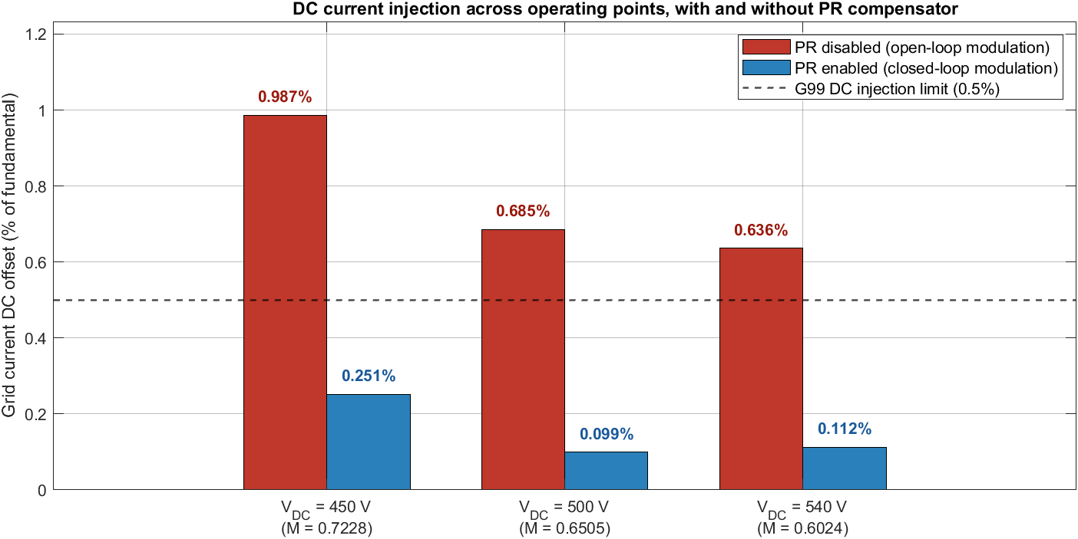
Figure 6.13 DC current injection across the operating envelope, with and without the gain-scheduled PR compensator. Each operating point ($V_{DC}=450, 500, 540\text{ V}$) shows a pair of bars, PR disabled (open-loop) and PR enabled (closed-loop), against the applicable DC-injection limit.

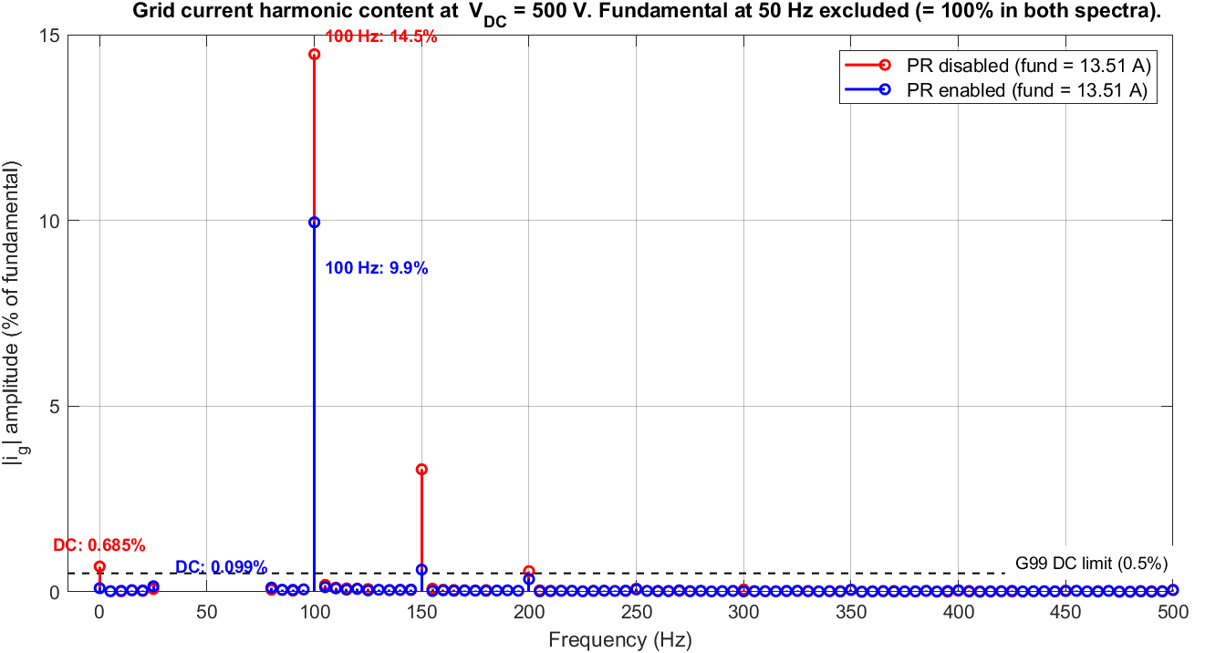
Figure 6.14 Grid-current harmonic content at $V_{DC}=500\text{ V}$, PR disabled versus PR enabled, as a percentage of fundamental amplitude (the $50\text{ Hz}$ fundamental is excluded). The DC component falls from 0.685% to 0.099% with the compensator active. The residual distortion is dominated by the 100 Hz second-harmonic inherent to single-stage single-phase operation, whose elimination is outside the present scope and identified as further work.

6.12.3 Fixed-gain versus scheduled-gain comparison
This comparison settles the question the gain-scheduling framework was built to answer, whether scheduling is actually necessary for this converter. The compensator was run with the fixed nominal gain and with the scheduled gain at three operating points spanning the full-power envelope ($V_{DC}=500$, $540$ and $450\text{ V}$), and the resulting grid-current DC injection and THD are compared in Table 6.8 and Figure 6.15. At every operating point the two configurations are indistinguishable: DC injection differs by at most 0.006 A (below 0.05% of fundamental) and THD by at most 0.1 percentage point, and the waveforms in Figure 6.15 overlay almost exactly.
This is the predicted outcome. As shown in Section 6.9.2, the effective plant gain varies only mildly across the range, so the scheduled $K_{p}$ departs from its nominal value by only about 1.9% across the three tested points, too little to change the closed-loop result appreciably. The direction of the small residual differences is nonetheless consistent with the schedule: at the low-$V_{DC}$ corner ($450\text{ V}$, where $K_{p}$ is reduced) the scheduled DC injection is marginally higher (0.601% versus 0.554%of fundamental), and at the high-$V_{DC}$ corner ($540\text{ V}$, where $K_{p}$ is raised) it is marginally lower, confirming that the framework captures the correct trend even though the magnitude is negligible. The $450\text{ V}$ corner is also the most disturbed dynamically, showing a longer, more modulated settling transient before reaching steady state.
A fixed-gain PR controller tuned at the nominal point is therefore sufficient across the operating range. The contribution is not the scheduling itself but the method for deciding whether scheduling is needed, applied here and confirmed by the absence of any measurable benefit.

Table 6.8 Steady-state grid-current DC injection and THD under fixed-gain and scheduled-gain PR control at three operating points ($V_{DC}=500$, $540$, $450\text{ V}$; corresponding $M=0.65$, $0.60$, $0.72$). DC injection is given both as an absolute current and as a percentage of the fundamental peak. Differences between the two configurations are below $0.05\%$ of fundamental at every point, confirming no measurable benefit from scheduling.
$V_{DC}$(V) | $$M$$ | Configuration | $I_{fund}$(A pk) | $I_{DC}$(A) | $I_{DC}/I_{fund}$(%) | THD (%)
500 | 0.65 | Fixed | 13.82 | 0.0290 | 0.21 | 9.8
500 | 0.65 | Scheduled | 13.82 | 0.0287 | 0.21 | 9.8
540 | 0.60 | Fixed | 12.38 | 0.0241 | 0.19 | 8.5
540 | 0.60 | Scheduled | 12.38 | 0.0237 | 0.19 | 8.4
450 | 0.72 | Fixed | 13.29 | 0.0736 | 0.55 | 11.4
450 | 0.72 | Scheduled | 13.31 | 0.0800 | 0.60 | 11.3

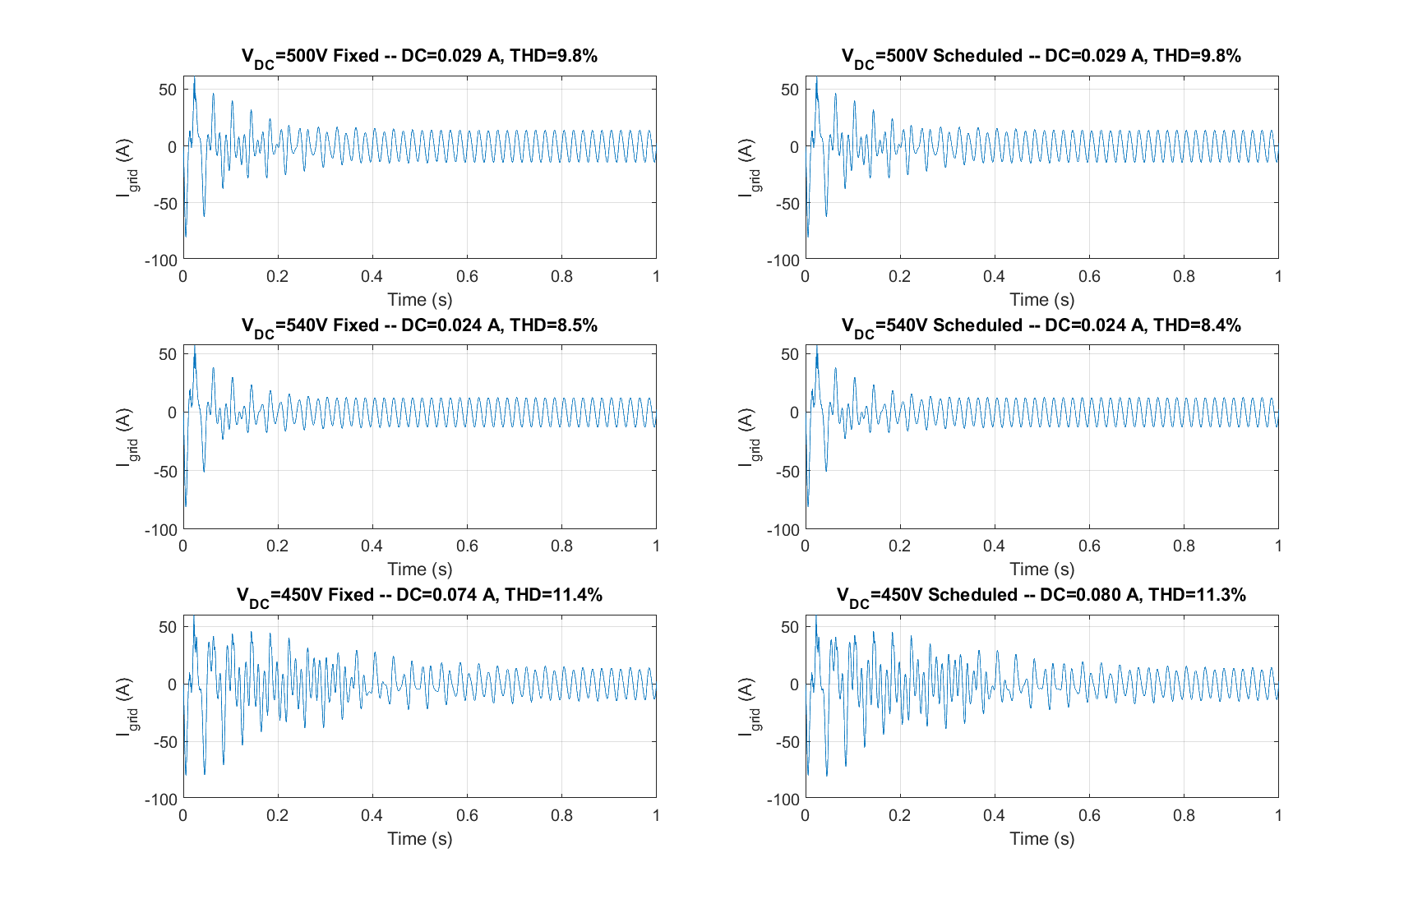
Figure 6.15 Grid-current waveforms $I_{grid}\left(t\right)$under fixed-gain (left column) and scheduled-gain (right column) PR control at $V_{DC}=500\text{ V}$(top), $540\text{ V}$(middle), and $450\text{ V}$(bottom). Each panel reports the measured DC injection and THD. The fixed and scheduled waveforms and their metrics are near-identical at every operating point, the visual confirmation that gain scheduling produces no measurable change in DC injection for this converter.

6.12.4 Load-step disturbance rejection
At the nominal operating point a 1.125 kW resistive load was connected to the AC bus at $t=1.0\text{ s}$. $P_{grid}$ stepped from 2199 W to 1135 W (a 48.4 percent reduction). The $V_{DC}$ transient showed a peak undershoot of 9.99 V at 17 ms (1.998% of reference), a peak overshoot of 3.36 V at 212 ms (0.67%), and a post-recovery steady-state error of +0.052 V (0.010%). The bus remained within the ±2% regulatory band throughout, and the grid current recovered to a clean sinusoid at the reduced amplitude within about 50 ms (Figure 6.16).

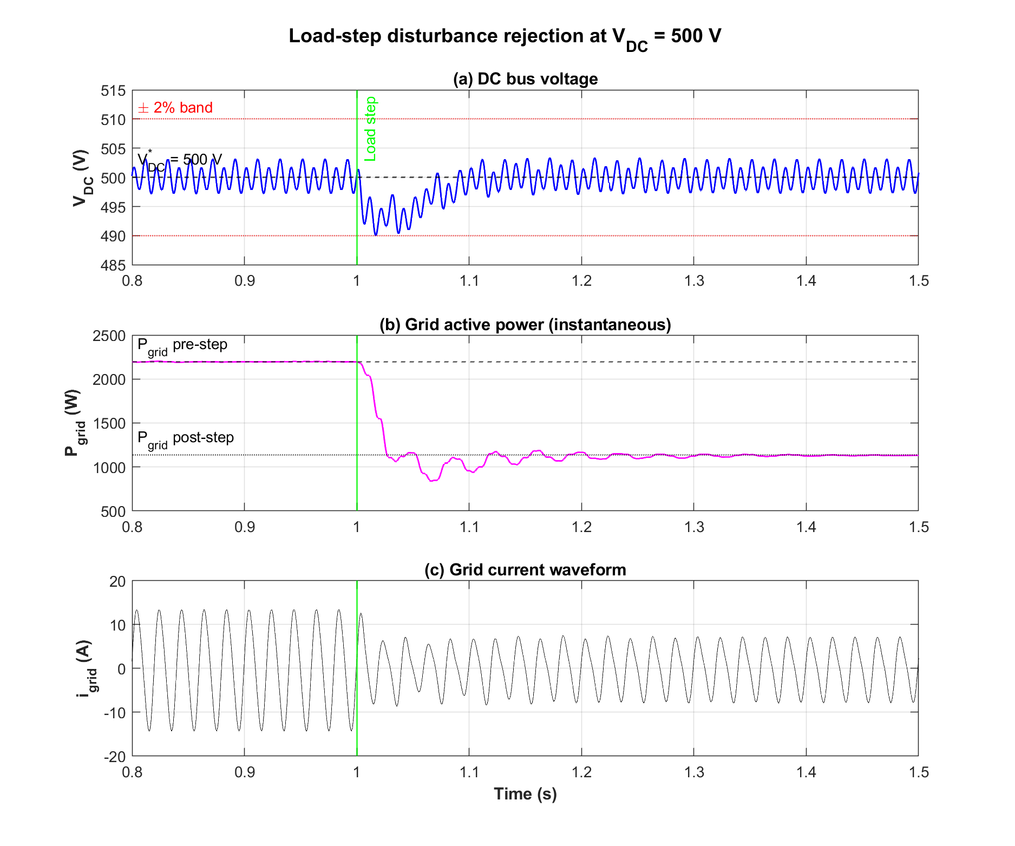
Figure 6.16 Load-step disturbance rejection at $V_{DC}$ = 500 V.
(a) DC bus voltage during the 48 percent load step at t = 1.0 s, with peak undershoot 1.998% and recovery within the ±2 percent band. (b) Grid active power stepping from 2199 W to 1135 W.
(c) Grid current waveform.

6.12.5 Voltage sag ride-through
The grid voltage was reduced to 70% of nominal RMS for 200ms from $t=1.0\text{ s}$. The grid RMS voltage was 226.2 V before the sag, fell to 156.0 V during the sag (67.8 percent of the 230 V nominal), and recovered to 225.9 V afterwards. The DC bus showed a peak excursion to 516.73 V (+3.35%) and 481.2 V (-3.76%) near the sag transitions, outside the $±2\%$ band during the transient and recovering afterwards. The grid-current peak rose from 14.40A to 25.16A during the sag as the inner current controller maintained power delivery into the reduced voltage, with larger transients of about 32A at the sag entry and exit; the PLL angle $\hat{θ}$ advanced smoothly with no loss of lock (Figure 6.17).

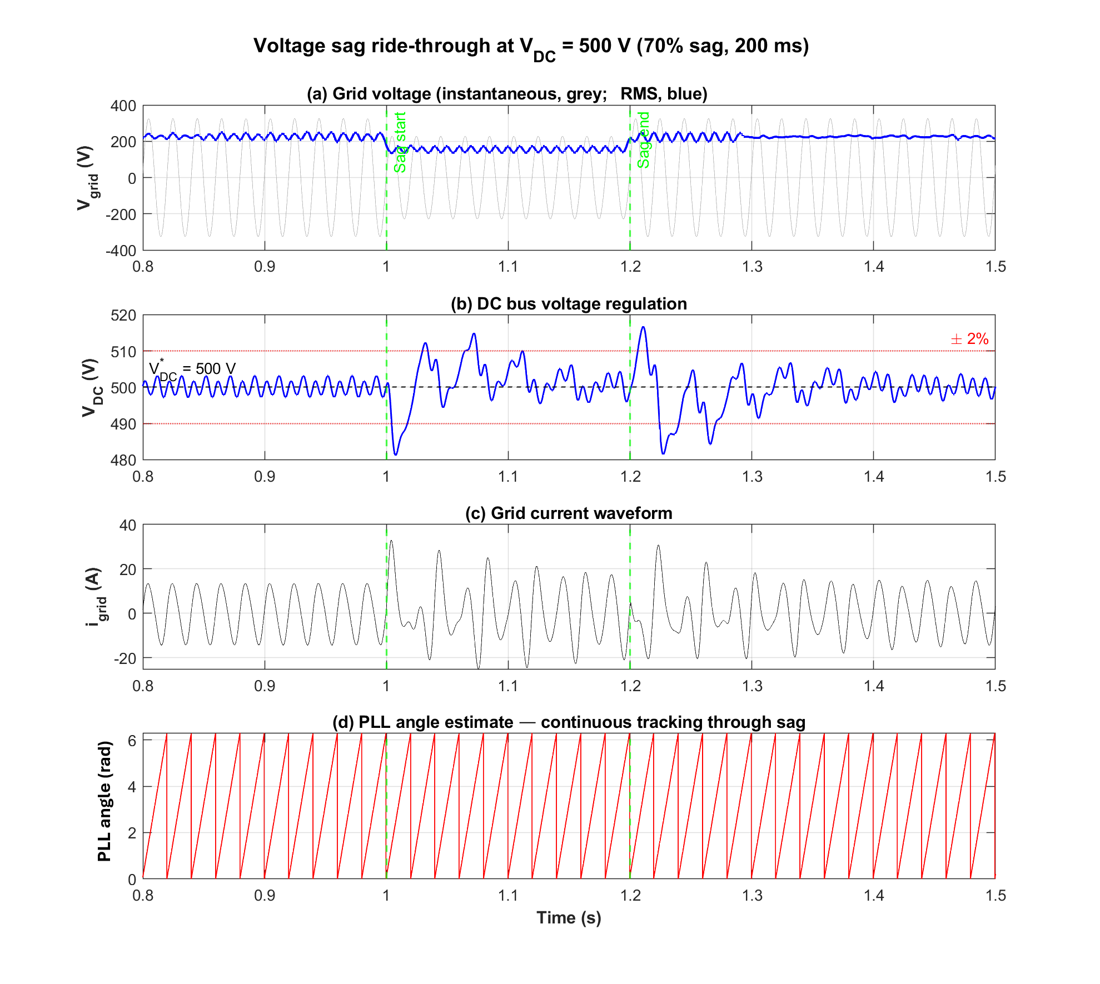
Figure 6.17 Voltage sag ride-through at $V_{DC}$ = 500 V with a 70% sag for 200 ms.
(a) Grid voltage (instantaneous and RMS value).
(b) DC bus voltage with ±2% band; peak excursion 3.76%.
(c) Grid current.
(d) PLL angle estimate $\hat{θ}$, continuous through the sag.

6.12.6 Frequency variation
The grid frequency was stepped from 50 Hz to 51 Hz at $t=1.0\text{ s}$. The PLL frequency estimate moved from 50.0160 Hz to 51.0171 Hz, a steady-state tracking error of +17 mHz relative to the 51 Hz target, consistent with the αβ-CDSC delay-line limitation of Section 5.2.3. The peak excursion was 51.46 Hz (+0.46 Hz, about 46% overshoot of the 1 Hz step), settling within 0.1 Hz by about 100 ms. The DC bus maintained regulation throughout, with a peak excursion of 0.9% (495.48 to 503.37 V) (Figure 6.18).

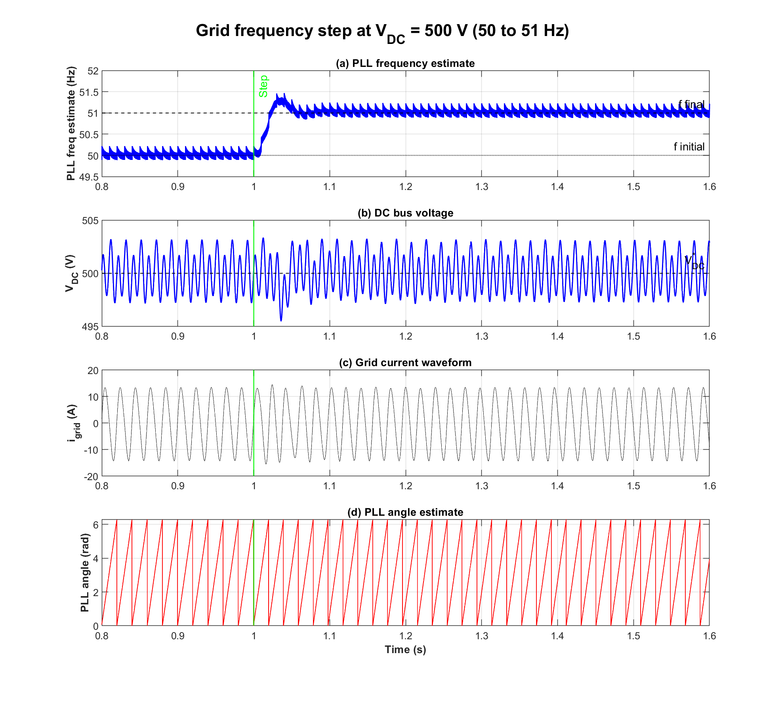
Figure 6.18 Grid frequency step at $V_{DC}$ = 500 V (50 to 51 Hz at t = 1.0 s).
(a) PLL frequency estimate settling within 100 ms to within 0.1 Hz, with +17 mHz steady-state error.
(b) DC bus voltage within 0.9%of reference.
(c) Grid current.
(d) PLL angle estimate.

6.12.7 Power-factor capability ($I_{q}$ sweep)
The inner-loop reactive current reference $I_{q}^{*}$ was swept through [0, +5, -5, 0]A peak with 1.0s plateaus. $Q_{grid}$ tracked the command symmetrically, swinging by $±814\text{ var}$, while $P_{grid}$ remained essentially constant ($1.94\%$ peak-to-peak); the corresponding power factors were $0.9356$ (lagging) and $0.9357$ (leading) at $±5\text{ A}$, and $\text{PF}≥0.9999$ at the unity-PF return points. This independence of active and reactive power demonstrates the dq decoupling of the inner current controllers established in Section 6.6 (Table 6.9, Figure 6.19).
The power factor is defined as
$$\text{PF}=\frac{∣P∣}{∣S∣}=\frac{∣P∣}{\sqrt{P^{2}+Q^{2}}}.$$
Table 6.9 Power-factor capability sweep at $V_{DC}$ = 500 V.
Operating point | $I_{q}^{*}$(A pk) | P (W) | Q (var) | |S| (VA) | PF
Unity (baseline) | 0 | 2197.9 | 0.1 | 2197.9 | 1.0000
Lagging-capability | +5 | 2157.3 | -814.2 | 2305.8 | 0.9356
Leading-capability | -5 | 2159.7 | +814.2 | 2308.0 | 0.9357
Unity (return) | 0 | 2200.0 | -0.0 | 2200.0 | 1.0000

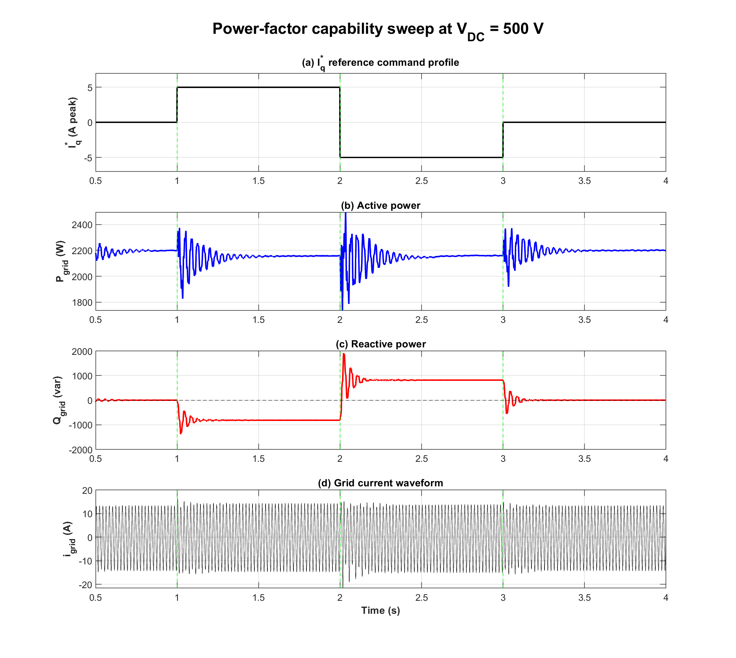
Figure 6.19 Power-factor capability sweep at $V_{DC}$ = 500 V.
(a) $I_{q}^{*}$ reference stepped through [0, +5, -5, 0] A.
(b) Active power held essentially constant, demonstrating decoupling.
(c) Reactive power swinging symmetrically by ±814 var.
(d) Grid current waveform.

6.12.8 Efficiency versus output power
The PV irradiance was swept through [200, 400, 600, 800, 1000] W/m² at $T=25 ^{∘}\text{C}$ with $V_{DC}$ regulated to $500\text{ V}$ and $I_{q}^{*}=0$. Efficiency rises steeply from 10.68% at 200 W/m² to a plateau near 74% at 800 to 1000 W/m². At full irradiance (1000 W/m²), $P_{PV}=2955.0\text{ W}$, $P_{grid}=2183.6\text{ W}$ and total loss is 771.4 W, of which about 361 W (47%) is attributed to $R_{f}$ in the output L-filter, the dominant design constraint motivating the LCL-filter recommendation [156] of Section 6.12.9 (Table 6.10, Figure 6.20).

Table 6.10 Converter efficiency curve at $V_{DC}$ = 500 V across irradiance G = 200 to 1000 W/m². Peak efficiency of 74.04% occurs at G = 800 W/m².
$G$(W/m²) | $P_{PV}$(W) | $P_{grid}$(W) | Loss (W) | $η$(%)
200 | 396.5 | 42.3 | 354.2 | 10.68
400 | 1041.3 | 641.4 | 399.9 | 61.59
600 | 1683.2 | 1196.0 | 487.2 | 71.05
800 | 2321.4 | 1718.8 | 602.6 | 74.04
1000 | 2955.0 | 2183.6 | 771.4 | 73.90

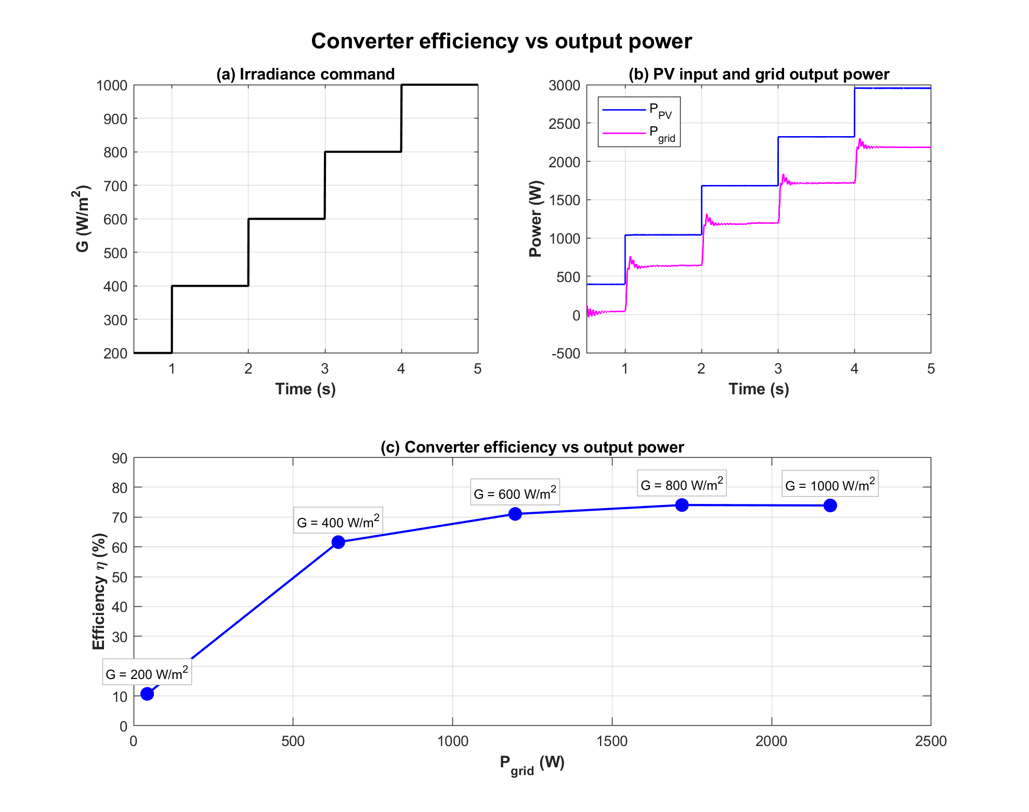
Figure 6.20 Converter efficiency versus output power at $V_{DC}=500\text{ V}$. (a) Irradiance command. (b) PV input power and grid output power, the vertical gap being converter loss. (c) Efficiency $η=P_{grid}/P_{PV}$ versus $P_{grid}$, each point labelled by irradiance.

6.12.9 Efficiency limitation and proposed LCL filter
The peak efficiency of about 74% is not representative of the converter's intrinsic capability; it is dominated by I²R losses in the output-filter damping resistance $R_{f}$. As established in Section 6.11.3, $R_{f}$ dissipates approximately 361 W at rated load, 47% of the total 771 W loss, because it is a 4 Ω resistor placed in series with the fundamental current path of the L-filter. The model confirms this directly: at the rated grid current of about 9.5A RMS,
$$I_{grid,RMS}^{2}×R_{f}={9.5}^{2}×4≈361\text{ W}.$$
The resistor is required for damping in the present L-filter (the configuration is unstable below $R_{f}≈3.3 Ω$, so the efficiency and the stability requirement are in direct conflict.
A route to removing this loss is to replace the series-damped L-filter with an LCL filter, in which the damping is moved to the capacitor branch and therefore carries only ripple current rather than the full fundamental. An LCL filter was designed for this converter using the standard procedure; the resulting parameters are given in Table 6.11.

Table 6.11 LCL filter design for the 230 V, 40 kHz converter, replacing the series-damped L-filter of the present study.
Parameter | Value / design basis
Inverter-side inductor $L_{1}$ | $1\text{ mH}$ (retained from the L-filter; ripple limit satisfied)
Grid-side inductor $L_{2}$ | $0.5\text{ mH}$ (ratio $L_{2}/L_{1}=0.5$)
Filter capacitor $C_{f}$ | $5 μ\text{F}$(reactive draw $<5\%$ of rated)
Resonant frequency $f_{res}$ | $3.9\text{ kHz}$(within $10f_{grid}<f_{res}<0.5f_{sw}$)
Damping resistor $R_{d}$ | $2.7 Ω$ in series with $C_{f}$($R_{d}=1/\left(3ω_{res}C_{f}\right)$)

Because the damping resistor in this configuration would carry only the capacitor ripple current, its dissipation would be of order a few watts rather than the 361 W of the series resistor, removing the dominant loss. The corresponding loss-free efficiency, computed in Section 6.11.3, is approximately 86 percent; this is the arithmetic upper bound obtained by removing the series-resistance dissipation, not an efficiency the LCL has been demonstrated to deliver. The LCL is therefore presented as a diagnosed and designed route to removing the dominant loss; any effect on high-frequency switching harmonics is a secondary benefit, whereas the dominant low-frequency (second-harmonic) distortion is outside the scope of this work.
Closed-loop simulation of the LCL configuration showed that it cannot simply replace the L-filter under the existing current controller. When the phase-locked loop and current control engage after their one-grid-cycle initialisation, the lightly damped LCL resonance at 3.9 kHz destabilises the loop and the DC bus collapses. This confirms that a full LCL implementation requires retuning of the current controller for the reduced resonant margin, together with active damping (capacitor-current feedback) in place of, or in addition to, the passive damping resistor. This control redesign for the LCL configuration is a well-defined and self-contained extension, and is identified as the immediate next step; the efficiency figures reported in this chapter should therefore be read as a conservative lower bound set by the L-filter, not as the intrinsic efficiency of the topology.

6.13 Topology Comparison and Prospective Applications

6.13.1 Quantitative component comparison
Table 6.12 compares the semi-Z-source inverter against three alternative topologies for grid-tied PV applications on component count, stages, and control complexity.

Table 6.12 Component comparison of the semi-Z-source against alternative grid-tied PV topologies. The semi-Z-source achieves the lowest switch count while retaining single-stage operation.
Topology | Switches | Inductors | Capacitors | Stages | Control complexity
Semi-Z-source (this work) | 2 | 2 + 1 filter | 2 + 1 input | 1 | Moderate
Full-bridge + boost | 5 | 1 boost + 2 filter | 2 | 2 | High
Classical Z-source | 4 | 2 | 2 | 1 | Moderate
Quasi-Z-source | 4 | 2 | 2 | 1 | Moderate

The semi-Z-source achieves the lowest switch count of the four topologies while retaining single-stage operation, translating directly to fewer gate drivers, fewer isolation devices, and reduced PWM-generation complexity in the digital controller.

6.13.2 Prospective applications
Electric vehicle charging integration. The two-switch impedance-network topology supports bidirectional power flow by design (the symmetric inductor-capacitor arrangement and doubly-grounded structure of Section 6.2 permit reverse operation without topological change), positioning the converter as a candidate for combined PV-EV charging in which the same hardware injects grid power by day and delivers DC charging power overnight. Bidirectional operation has not been validated in the present chapter and is identified as future work.
Microgrid integration. The reduced switch count and inherent bidirectionality position the converter as a candidate for low-power microgrids, serving as both the PV interface and the battery-storage interface on a single platform. Microgrid operation involves additional control layers (droop control, master-follower coordination) outside the present scope.
Hydrogen production (future work). Integration with proton-exchange-membrane (PEM) electrolyser systems, which require a regulated DC voltage and substantial DC current within the reverse-operation range of the converter, is identified as a natural future extension.
The design retains: the semi-Z-source topology (two-switch bridge and Z-source impedance network); the modified SPWM scheme with duty-cycle reference
$$d\left(t\right)=\frac{1-M\sin{ω}t}{2-M\sin{ω}t};$$
the parallel PR controller structure for DC-injection elimination (in the ideal transfer-function form, Section 6.9.1); and the observation that single-stage operation produces unwanted DC injection requiring active compensation.
New in this thesis: gain scheduling of the PR gains against $M_{avg}$ (Section 6.9) [135], the headline novelty; closed-loop integration of a single-diode PV array model (Section 6.8) in place of the constant-current source; integration of the $αβ$-CDSC-SOGI-PLL of Chapter 5 (Section 6.4); a quantitative loss model and efficiency evaluation (Section 6.11); compliance evaluation against UK G99 and EN 50160 (Section 6.10); operation on the UK 230 V grid; and a documented, reproducible simulation methodology. The comparison of Section 6.12.3 directly evaluates a fixed-gain design against the gain-scheduled controller, providing the empirical evidence on whether the operating-point plant variation established in Chapter 3 requires dynamic compensation for this topology.

6.14 Conclusion
This chapter developed, designed, and validated through simulation the closed-loop control system for a single-stage semi-Z-source inverter in a UK 230 V grid-tied residential PV application. Its principal contributions, restating those set out in Section 6.1, are as follows.
- The headline contribution is the gain-scheduled PR DC-injection compensator (Section 6.9), whose proportional gain is computed across the operating envelope from an effective-plant-gain expression and stored in a lookup table indexed by the modulation index [132]- [135].
- The 2020 design [42] specified the PR gains directly, without an analytical procedure relating them to a loop-gain specification. The present chapter derives the nominal gain in closed form from a target DC loop gain and the effective plant gain, and, more importantly, provides a procedure that extends to other operating points and grid or bus voltages.
- A complete control architecture integrating outer-loop DC voltage regulation, inner-loop dq-frame current control, $αβ$-CDSC-SOGI-PLL synchronisation [105], [110], and the gain-scheduled PR compensator into a coherent single-stage design.
- Integration of a single-diode PV array model (Section 6.8) [14] in place of a controlled-current source, and updating to UK 230 V grid operation
- Validation against the UK grid standards G99 [89] and EN 50160 [88] (Section 6.10), a loss model and efficiency evaluation (Section 6.11), and a documented, reproducible simulation methodology.
- The comparison of Section 6.12.3 evaluates the benefit of scheduling across the operating envelope. Because the effective plant gain the compensator faces varies only mildly with operating point, the required proportional gain changes by only a few percent, and a fixed-gain PR controller designed at the nominal point is found sufficient across the realistic envelope, with DC injection within the applicable limit at $V_{DC}≥$500 V and marginal at the cold-day low-$V_{DC}$ corner. The transferable contribution is therefore the method for deciding scheduling necessity on a topology-by-topology basis, rather than a large empirical performance gap.
In summary, the single-stage semi-Z-source inverter with a gain-scheduled PR compensator provides a low-component-count solution for grid-connected PV applications. The simulation studies confirm that the design suppresses DC current injection within the applicable limit across the upper operating envelope and maintains stable operation through load, voltage-sag, and frequency disturbances. A recorded but out-of-scope observation is the grid-current THD, which lies above the 5%benchmark across the operating range; it is dominated by the second-harmonic component intrinsic to single-stage single-phase operation, and its reduction, through a second-harmonic resonant term or active power decoupling, is identified as further work. Separately, an LCL filter is recommended to remove the series damping loss of the present L-filter and so raise efficiency (Section 6.12.9).

Chapter 7
Conclusion and Recommendations for Future Work

The integration of renewable energy sources into the grid has driven demand for efficient, reliable, and robust inverter systems. This thesis addresses several key challenges, specifically focusing on Z-source inverter topologies and advanced control strategies to enhance performance in dynamic grid conditions. Through in-depth theoretical analysis, modelling, control design, and simulation, this work advances the understanding and application of Z-source converters in grid-connected applications.

7.1 Summary of Key Findings and Contributions
The findings and contributions of this thesis are summarised below against the research objectives set out in Section 1.5.
- F1. The review of Z-source converter topologies (Chapter 2) and single-phase synchronisation techniques (Chapter 4) established the single-stage semi-Z-source inverter as a suitable interface for single-phase grid-connected PV, and identified the residual steady-state harmonic ripple of the SOGI-PLL, the best of the classical PLLs benchmarked, as the synchronisation limitation to be addressed (Objective O1).
- F2. A small-signal state-space model of the Z-source DC-DC converter was developed and verified against circuit simulation, incorporating the converter's parasitic resistances (Chapter 3). This model provided the dynamic plant description used in the inverter control design (Objective O2).
- F3. A novel αβ-CDSC-SOGI-PLL synchronisation technique was developed and shown to reduce the steady-state second-harmonic content of the phase estimate by a factor of between 7 and 24 relative to the SOGI-PLL. It was validated both in simulation and on a two-board hardware bench, using a controlled-variant methodology that attributes the improvement to the cascade alone, and was characterised throughout as a quantified delay-for-rejection trade-off rather than an unqualified improvement (Objective O3).
- F4. A gain-scheduled proportional-resonant DC-injection compensator was designed for the single-stage semi-Z-source inverter by an analytical procedure that derives the gains from a loop-gain specification, replacing the ad hoc selection of earlier single-stage designs (Chapter 6). The compensator holds DC injection to 0.099% of the fundamental at the nominal operating point, within the applicable grid-code limit, and the accompanying analysis provides a transferable criterion establishing that a fixed gain is sufficient across the realistic operating envelope, so the cost and complexity of scheduling can be avoided (Objective O4).
- F5. The closed-loop inverter met the Engineering Recommendation G99 and BS EN 50160 voltage, frequency and DC-injection requirements over the tested envelope. A loss-breakdown and efficiency characterisation distinguished the as-built peak efficiency of about 74% from a loss-excluded bound of about 86% and identified the output-filter damping resistance as the dominant, removable loss (Objective O5).
- F6. The closed-loop, PV-fed inverter was evaluated under voltage-sag, phase-jump, frequency-change and sustained-harmonic scenarios and maintained DC-bus regulation and synchronisation across all of them, establishing its operational resilience under representative UK low-voltage grid conditions (Objective O6).
Taken together, these results deliver the aim of Section 1.5: a hardware-validated synchronisation technique and a gain-scheduled DC-injection control scheme for the single-stage semi-Z-source inverter, supported by the modelling, compliance and performance analyses needed to establish them. The novel contributions are the αβ-CDSC-SOGI-PLL and the gain-scheduled compensator and its design method; the semi-Z-source topology itself derives from the author's earlier work [42].
In quantitative terms, the αβ-CDSC-SOGI-PLL reduced the second-harmonic content of the phase estimate by a factor of between 7 and 24; the DC-injection compensator suppressed the injected DC current to 0.099% of the fundamental, from 0.685% uncompensated, within the applicable G99 limit at the nominal and high operating points; and the converter delivered a peak efficiency of about 74%, rising to a loss-excluded bound of about 86% once the removable output-filter loss is discounted. The original contributions to knowledge are the hardware-validated αβ-CDSC-SOGI-PLL synchronisation technique and the analytically-designed gain-scheduled DC-injection compensator, together with the criterion it provides for deciding whether gain scheduling is warranted for a given converter.

7.2 Limitations
Several limitations of this work should be stated plainly.
Scope of the hardware validation. The experimental validation was confined to the synchronisation technique. The αβ-CDSC-SOGI-PLL was demonstrated on a two-board hardware bench (Chapter 5), but the closed-loop inverter of Chapter 6 was evaluated in simulation only; a hardware demonstration of the full PV-fed inverter under closed-loop control was not undertaken.
Efficiency and the output filter. The as-built efficiency is limited by the series damping resistance of the output L-filter, which is the dominant loss. The analysis shows this loss is removable in principle by relocating the damping to an LCL configuration, but the LCL was found to destabilise the loop at synchronisation and was not made to work; the efficiency improvement is therefore a diagnosed and designed route rather than a demonstrated result (Section 6.12.9).
Current harmonic distortion. The current total harmonic distortion remains above the target limit and is dominated by the low-frequency (second-harmonic) component arising from the single-phase power pulsation. Reducing it was outside the scope of this work and is not addressed by the DC-injection compensator or the output filter.
Modelling idealisations. The models and simulations assume near-ideal components; parasitic effects, thermal behaviour and long-term device degradation are represented only partially, so the quantitative results should be read as representative rather than exact.
Complexity of the synchronisation technique. The αβ-CDSC-SOGI-PLL delivers its harmonic rejection at the cost of added computation, memory and a fixed group delay; in applications dominated by fast transients rather than sustained harmonics, a simpler synchroniser may be preferable.

7.3 Recommendations for Future Work
Building on the work of this thesis, the following directions would extend its practical applicability and performance. The first three follow directly from the limitations identified in Section 7.2; the remainder are broader directions for the field.
Hardware demonstration of the closed-loop inverter. The synchronisation technique has been validated on hardware (Chapter 5); the immediate next step is a hardware demonstration of the full PV-fed semi-Z-source inverter under closed-loop control, to confirm the DC-injection, grid-compliance and efficiency results of Chapter 6 on a physical prototype and to expose effects such as device losses, thermal behaviour and electromagnetic interference.
Realisation of the LCL output filter. The efficiency analysis identifies the series damping resistance of the output L-filter as the dominant, removable loss, and shows that an LCL filter is the route to removing it. Retuning the current loop for the LCL resonance, with active capacitor-current damping so that the loop remains stable at synchronisation, would realise the loss-excluded efficiency bound in a working closed loop and is a self-contained extension.
Mitigation of the low-frequency current distortion. The residual current total harmonic distortion is dominated by the second-harmonic component arising from the single-phase power pulsation, which lies outside the scope of the DC-injection compensator. Active second-harmonic compensation, or an active power-decoupling stage, would be needed to bring the current distortion within the target limit.
Wide-bandgap semiconductor devices. Adopting wide-bandgap devices such as silicon carbide (SiC) and gallium nitride (GaN) would enable higher switching frequencies, lower losses and more compact designs, and optimising the semi-Z-source stage around these devices is a natural performance extension [157].
Multi-phase and multi-level converters. Extending the modelling and control strategies of this thesis to multi-phase and multi-level Z-source converters would open the approach to higher-power applications such as industrial drives and utility-scale generation [158].
Adaptive and hybrid synchronisation. While the αβ-CDSC-SOGI-PLL provides strong synchronisation under distorted conditions, hybrid schemes that combine complementary PLL approaches, or that use adaptive or machine-learning tuning of the loop parameters, could improve the transient response without sacrificing harmonic rejection.
Integration of energy storage. Combining battery energy storage with the semi-Z-source inverter would support grid stability by decoupling generation from demand, and the control implications of such integration are a worthwhile study [159].
Fault detection and mitigation. Advanced fault-detection and mitigation methods, including data-driven approaches for early anomaly detection and predictive maintenance, would enhance the reliability of grid-connected Z-source inverters.

7.4 Concluding Remarks
This thesis has advanced the control and synchronisation of single-stage semi-Z-source inverters for single-phase grid-connected PV. Its principal contributions are a hardware-validated αβ-CDSC-SOGI-PLL synchronisation technique and a gain-scheduled DC-injection control scheme with an analytical design method, supported by small-signal modelling of the Z-source DC-DC stage and by a compliance, loss and resilience assessment of the closed-loop inverter.
The results show that the single-stage semi-Z-source inverter, with the synchronisation and control strategies developed here, meets the principal UK single-phase grid-connection requirements, voltage, frequency and DC injection, over the tested envelope while operating from a single conversion stage. The remaining limitations, chiefly the residual low-frequency current distortion and the output-filter loss, are clearly identified, and each has a defined route to resolution in the recommendations of Section 7.3. As single-phase PV deployment continues to grow, this work provides a practical, hardware-validated and standards-compliant basis for the reliable grid integration of semi-Z-source inverters.

List of References
- D. Cao, S. Jiang, X. Yu and F. Z. Peng, "Low cost single-phase semi-Z-source inverter," 2011 Twenty-Sixth Annual IEEE Applied Power Electronics Conference and Exposition (APEC), Fort Worth, TX, USA, 2011, pp. 429-436, Doi: 10.1109/APEC.2011.5744632.
- A. Zahedi, “A review of drivers, benefits, and challenges in integrating renewable energy sources into electricity grid”, Renewable and Sustainable Energy Reviews, Volume 15, Issue 9, 2011, Pages 4775-4779
- S. Kalogirou, “Solar Energy Engineering: Processes and Systems”. Elsevier Inc., London, 2009.
- International Energy Agency, Global Energy Review 2025. Paris, France: IEA, 2025. [Online]. Available: https://www.iea.org/reports/global-energy-review-2025
- S. Mekhilef, S.Rahman, M. Kamalisarvestani, M, “Effect of dust, humidity and air velocity on efficiency of photovoltaic cells. Renewable and Sustainable Energy Reviews”. 16. 2920-2925, 2012.
- Y Liu, H Abu-Rub, Baoming Ge, F Blaabjerg, O Ellabban and PC Loh, “Impedance Source Power Electronic Converters”, Wiley-IEEE Press, 2016
- N. Singh and S. K. Jain, "Single phase Z-source inverter for photovoltaic system," 2016 7th India International Conference on Power Electronics (IICPE), Patiala, India, 2016, Doi: 10.1109/IICPE.2016.8079340.
- R. W. Erickson and D. Maksimovic, Fundamentals of Power Electronics, 2nd ed. New York, NY, USA: Springer, 2007.
- M. Calais, J. Myrzik, T. Spooner, and V. G. Agelidis, “Inverters for single-phase grid connected photovoltaic systems – An overview,” in Proc. IEEE PESC’02, vol. 2, 2002, pp. 1995–2000.
- S.B Kjaer, J. K. Pederson and F. Blaabjerg. “A review of single-phase grid-connected inverters for photovoltaic modules,” IEEE Trans Ind Appl, vol 41, no. 5, pp. 1292-1306, 2005.
- F. Blaabjerg, M. Lieserre and A. Timbus, “Overview of control and grid synchronisation for distributed power generation system”, IEEE Transactions on Industry Applications, vol. 53, no. 5, pp. 1398-1409, 2006.
- F.Z. Peng, "Z-source inverter," IEEE Transactions on Industry Applications, vol. 39, no. 2, pp. 504-510, Mar.-Apr. 2003. DOI: 10.1109/TIA.2003.808920.
- A. Yazdani and R. Iravani, Voltage-Sourced Converters in Power Systems: Modelling, Control, and Applications. Wiley-IEEE Press, 2010.
- R. Teodorescu, M. Liserre and P. Rodríguez. “Photovoltaic Inverter Structures.” in: Grid Converters for Photovoltaic and Wind Power Systems. Chichester: John Wiley , Jan 2011
- Y Yang, F. Blaaberg “Synchronisation in single-phase grid-connected photovoltaic systems under grid faults”. In IEEE International Symposium on Power Electronics for Distributed Generation Systems, 2012, pp 476–482.
- Microgeneration Scheme, "Guide to the installation of photovoltaic systems", 2018. [Online].
- B. Verhoeven, Ed., “Utility aspects of grid connected photovoltaic power systems,” Tech. Rep. IEA PVPS T5-01:1998, [Online] Available: http://www.iea-pvps.org, 1998
- M. H. Rashid, Power Electronics: Circuits, Devices, and Applications, 4th ed. Pearson, 2013.
- O. Lopez, F. D. Freijedo, A. G. Yepes and P. Fernández-Comesaña, "Eliminating ground current in a transformerless photovoltaic application," IEEE Transactions on Energy Conversion, vol. 25, no. 1, pp. 140-147, 2010.
- B. Yang, W. Li, Y. Gu, W. Cui, and X. He, "Improved transformerless inverter with common-mode leakage current elimination for a photovoltaic grid-connected power system," IEEE Transactions on Power Electronics, vol. 27, no. 2, pp. 752-762, 2012.
- L. Zhang, K. Sun, Y. Xing, and M. Xing, "H6 Transformerless full-bridge PV grid-tied Inverters," IEEE Transactions on Power Electronics, vol. 29, no. 3, pp. 1229–1238, Mar. 2014.
- F. Z. Peng, "Z-source inverter," Conference Record of the 2002 IEEE Industry Applications Conference. 37th IAS Annual Meeting (Cat. No.02CH37344), Pittsburgh, PA, USA , Vol.2, pp. 775-781, 2002
- L. Gertmar, P. Karlsson, and O. Samuelsson, "On DC injection to AC grids from distributed generation," Proceedings of European Conference on Power Electronics and Applications, pp. 1-10, 2005.
- Q. Yan, X. Wu, X. Yuan, Y. Geng, and Q. Zhang, "Minimisation of the DC component in transformerless three-phase grid-connected photovoltaic inverters," IEEE Transactions on Power Electronics, vol. 30, pp. 3984-3997, 2015
- M. Armstrong, D. J. Atkinson, C. M. Johnson, and T. D. Abeyasekera, "Auto-calibrating DC link current sensing technique for transformerless, grid connected, H-bridge inverter systems," IEEE Transactions on Power Electronics, vol. 21, pp. 1385-1393, 2006
- D. Cao and F. Z. Peng, "A Family of Z-source and Quasi-Z-source DC-DC Converters," 2009 Twenty-Fourth Annual IEEE Applied Power Electronics Conference and Exposition, Washington, DC, USA, 2009, Doi: 10.1109/APEC.2009.4802800.
- F. Liu, S. Duan, F. Liu, and B. Liu, “A variable step size INC MPPT method for PV systems,” IEEE Transactions on Industrial Electronics, vol. 55, no. 7, pp. 2622-2628, Jul. 2008.
- A. Ahmed, L. Ran, S. Moon, and J. H. Park, “A fast PV power tracking control algorithm with reduced power mode,” IEEE Transactions on Energy Conversion, vol. 28, no. 3, pp. 565-575, Sep. 2013.
- J. Salas, E. Olias, M. Alonso, and F. Chenlo, “Review of the maximum power point tracking algorithms for stand-alone photovoltaic systems,” Solar Energy Materials and Solar Cells, vol. 90, no. 11, pp. 1555-1578, Jul. 2006.
- M. Azab, “Improved circuit configuration of grid-connected PV inverter for power quality improvement,” Renewable Energy, vol. 94, pp. 51-61, Jun. 2016.
- M. S. Alam, K. M. Muttaqi, and D. Sutanto, “A three-phase power flow approach for integrated 3-phase transformer-based grid-connected PV systems,” IEEE Transactions on Power Systems, vol. 29, no. 6, pp. 2752-2761, Nov. 2014.
- W. Qian, F. Z. Peng and H. Cha, "Trans-Z-Source Inverters," in IEEE Transactions on Power Electronics, vol. 26, no. 12, Dec. 2011, Doi: 10.1109/TPEL.2011.2122309.
- M. Shen, A. Joseph et al., "Comparison of Traditional Inverters and Z-Source Inverter for Fuel Cell Vehicles", Power Electronics IEEE Transactions, vol. 22, no. 4, pp. 1453-1463, July 2007.
- J. Anderson and F.Z. Peng, "A class of quasi-Z-source inverters," IEEE Industry Applications Society Annual Meeting, 2008. DOI: 10.1109/08IAS.2008.148.
- W. Liu, M. S. Asghar, “Switched-inductor Z-source inverter,” IEEE Transactions on Power Electronics, vol. 24, no. 7, pp. 2025-2030, July 2011.
- H. Wang and F. Blaabjerg, “Reliability of capacitors for DC-link applications in power electronic converters – An overview,” IEEE Transactions on Industry Applications, vol. 50, no. 5, pp. 3569-3578, Sept.-Oct. 2014.
- Y. Yang, K. Ma, and F. Blaabjerg, “Design for reliability of power electronics in renewable energy systems,” Proceedings of the IEEE, vol. 105, no. 11, pp. 2287-2302, Nov. 2017.
- J. L. Hudgins, “Thermal management of power electronic devices,” IEEE Transactions on Industry Applications, vol. 52, no. 3, pp. 2275-2283, May-June 2016.
- J. Anderson and F. Z. Peng, "Four quasi-Z-Source inverters," 2008 IEEE Power Electronics Specialists Conference, Rhodes, Greece, 2008, pp. 2743-2749, Doi: 10.1109/PESC.2008.4592360.
- S. Kouro, J. I. Leon, D. Vinnikov, and L. G. Franquelo, “Grid-connected photovoltaic systems: An overview of recent research and emerging PV converter technology,” IEEE Industrial Electronics Magazine, vol. 9, no. 1, pp. 47-61, Mar. 2015.
- S. Gao and M. Barnes, “Phase-locked loops for grid-tied inverters: Comparison and testing”; 8th IET International Conference on Power Electronics, Machines and Drives (PEMD 2016), 2016. [Online]. Available: https://www.research.manchester. ac.uk/portal/files/31785878 /2016_PEMD_Siyu.pdf. Accessed: Aug. 18, 2017.
- A. U. Asi, B. Chong, L. Zhang and J. Nkanu, "A Single-Stage Z-source Inverter for Transformerless Grid Connection with a Proportional-Resonant Controller for DC Current Elimination," 2020 IEEE 11th International Symposium on Power Electronics for Distributed Generation Systems (PEDG), Dubrovnik, Croatia, 2020, pp. 560-565, Doi: 10.1109/PEDG48541.2020.9244418.
- M. Azizi, O. Husev, and D. Vinnikov. "Single-Stage Buck-Boost Inverters: A State-of-the-Art Survey," Energies, vol. 15, no. 5, p. 1622, 2022. doi:10.3390/en15051622.
- N. Subhani, R. Kannan, A. Mahmud, and F. Blaabjerg, “Z-source inverter topologies with switched Z-impedance networks: A review,” IET Power Electronics, vol. 14, no. 4, pp. 727–750, 2021, Doi: 10.1049/pel2.12064.
- D. Mande, J. P. Trovão, and M. C. Ta, Comprehensive Review on Main Topologies of Impedance Source Inverter Used in Electric Vehicle Applications,” World Electric Vehicle Journal, vol. 11, no. 2, Art. no. 37, 2020, doi: 10.3390/wevj11020037.
- V. Saravanan, K. M. Venkatachalam, M. Arumugam, M. A. K. Borelessa, and K. T. M. U. Hemapala, “Review of impedance source power converter for electrical applications,” International Journal of Advances in Applied Sciences, vol. 10, no. 4, pp. 310-334, Dec. 2021, doi: 10.11591/ijaas.v10.i4.pp310-334.
- R. Rahimi, S. Habibi, and P. Shamsi, “A High Step-Up Z-Source DC–DC Converter for Integration of Photovoltaic Panels Into DC Microgrid,” in Proc. IEEE Applied Power Electronics Conference and Exposition (APEC), 2021, pp. 1416-1423, doi: 10.1109/APEC42165.2021.9487463.
- R. Rahimi, S. Habibi, M. Ferdowsi, and P. Shamsi, “Z-Source-Based High Step-Up DC–DC Converters for Photovoltaic Applications,” IEEE Journal of Emerging and Selected Topics in Power Electronics, vol. 10, no. 4, pp. 4783-4796, Aug. 2022, doi: 10.1109/JESTPE.2021.3131996.
- F. A. A. Meinagh, J. Yuan, and Y. Yang, “Analysis and Design of a High Voltage-Gain Quasi-Z-Source DC-DC Converter,” IET Power Electronics, vol. 13, no. 11, pp. 2298-2308, 2020.
- Y. Guo, H. Sun, Y. Zhang, Y. Liu, X. Li and Y. Xue, "Duty-Cycle Predictive Control of Quasi-Z-Source Modular Cascaded Converter Based Photovoltaic Power System," in IEEE Access, vol. 8, pp. 172734-172746, 2020, doi: 10.1109/ACCESS.2020.3024935.
- S. Battula, M. Mohan Garg, A. Kumar Panda, M. Preetam Korukonda and L. Behera, "Analysis and Dual-loop PI Control of Bidirectional Quasi Z-Source DC-DC Converter," IECON 2020 The 46th Annual Conference of the IEEE Industrial Electronics Society, Singapore, 2020, pp. 2939-2944, doi: 10.1109/IECON43393.2020.9255017.
- X. Zhu, B. Zhang, and Q. Qian, “Quasi-Z-Source DC/DC Converter Based on Switched Inductor-Capacitor Unit,” IEEE Transactions on Power Electronics, vol. 35, no. 10, pp. 10258-10271, 2020.
- A. Ahmad, M. M. Reza, A. R. Beig, J. Y. Alsawalhi, and K. Al Jaafari, “High Voltage Gain Switched-Z-Source Bidirectional DC-DC Converter,” IEEE Access, vol. 10, pp. 54089-54102, 2022, doi: 10.1109/ACCESS.2022.3175874
- L. Wu, J. Liu, S. Vazquez, and S. K. Mazumder, “Sliding Mode Control in Power Converters and Drives: A Review,” IEEE/CAA Journal of Automatica Sinica, vol. 9, no. 3, pp. 392-406, Mar. 2022, doi: 10.1109/JAS.2022.105851.
- L. Junjun, T. Daiwei, X. Bowei, L. Chong, and Y. Jingyu, “Double-Integral Sliding Mode Control of the Switched-Inductor Quasi-Z Source Boost Converter,” Measurement and Control, vol. 56, no. 3-4, pp. 507–517, 2023, doi: 10.1177/00202940221110936.
- P. Liu, L. Tong, C. Liu and S. Huang, "Model Predictive Control for Quasi-Z-Source Inverter without Weighting Factors," 2020 IEEE 9th International Power Electronics and Motion Control Conference (IPEMC2020-ECCE Asia), Nanjing, China, 2020, pp. 3045-3050, doi: 10.1109/IPEMC-ECCEAsia48364.2020.9367718.
- N. Das, C. K. Thakur, S. Halder, R. Maurya, A. Dutta and A. Panda, "Z-Source Inverter Fed e-Drive System for Electric Vehicle Application," 2023 7th International Conference on Computer Applications in Proc. 7th Int. Conf. Comput. Appl. Electr. Eng.-Recent Adv. (CERA), Roorkee, India, 2023, pp. 1–6, doi: 10.1109/CERA59325.2023.10455230.
- A. F. Minai, A. A. Khan, R. K. Pachauri, H. Malik, F. P. García Márquez, and A. A. Jiménez, “Performance Evaluation of Solar PV-Based Z-Source Cascaded Multilevel Inverter with Optimised Switching Scheme,” Electronics, vol. 11, no. 22, Art. no. 3706, 2022, doi: 10.3390/electronics11223706.
- Y. Huang, M. Shen, and F.Z. Peng, "Z-source inverter for residential photovoltaic systems," IEEE Transactions on Power Electronics, vol. 21, no. 6, Nov. 2006. DOI: 10.1109/TPEL.2006.882087.
- M. F. Elmorshedy, I. J. A. Essawy, E. M. Rashad, M. R. Islam, and S. M. Dabour, “A grid-connected PV system based on quasi-Z-source inverter with maximum power extraction,” IEEE Transactions on Industry Applications, vol. 59, no. 5, pp. 6445–6456, Sep./Oct. 2023, doi: 10.1109/TIA.2023.3275557.
- B. Gyawali, A. M. Ajmal, W. Liu, and Y. Yang , “A review on modulation techniques of Quasi-Z-source inverter for grid-connected photovoltaic systems, e-Prime - Advances in Electrical Engineering, Electronics and Energy, vol. 10, no. 100809, pp 2772-6711, 2024, doi:/10.1016/j.prime.2024.100809.
- Y. Li and Y. Liu, "Model predictive control of Z-source inverters in renewable energy systems," IEEE Transactions on Power Electronics, vol. 27, no. 2, Feb. 2012. DOI: 10.1109/TPEL.2011.2179876.
- P. Wang, J. Liu, and Z. Zhang, "Switched-inductor quasi-Z-source inverter for renewable energy applications," IEEE Transactions on Industrial Electronics, vol. 59, no. 11, Nov. 2012. DOI: 10.1109/TIE.2012.2192453.
- H. M. Kojabadi, R. Ebrahimi, H. Esmaeilifard, L. Chang, Z. Chen, and F. Blaabjerg, “High boost transformer-based Z-source inverter under continuous input current profile,” IET Power Electronics, vol. 12, no. 14, pp. 3716–3723, 2019, doi: 10.1049/iet-pel.2018.6130.
- S. Battula, M. Mohan Garg, A. Kumar Panda, M. Preetam Korukonda and L. Behera, "Analysis and Dual-loop PI Control of Bidirectional Quasi Z-Source DC-DC Converter," IECON 2020 The 46th Annual Conference of the IEEE Industrial Electronics Society, Singapore, 2020, doi: 10.1109/IECON43393.2020.9255017.
- Z. Aleem and M. Hanif, "Single-phase transformer-based Z-source AC-AC converters," 2016 IEEE 2nd Annual Southern Power Electronics Conference (SPEC), Auckland, New Zealand, 2016, doi: 10.1109/SPEC.2016.7846040.
- Q. T. Nha, C. -Y. Lin, M. M. Alam, Y. -K. Lo and H. -J. Chiu, "Implementation of a single-stage quasi-Z-source AC-DC Power Factor Correction converter," Anti-counterfeiting, Security, and Identification, Taipei, Taiwan, 2012, doi: 10.1109/ICASID.2012.6325297.
- P. Liu, J. Yuan, Y. P. Siwakoti, and F. Blaabjerg, “Control and Modulation Techniques of Z-Source Converter,” in Control of Power Electronic Converters and Systems, Academic Press, 2024, vol. 4. pp. 27–70, doi: 10.1016/B978-0-323-85622-5.00006-7.
- Fang Zheng Peng, Lihua Chen and Fan Zhang, "Simple topologies of PWM AC-AC converters," in IEEE Power Electronics Letters, vol. 1, no. 1, March 2003, doi: 10.1109/LPEL.2003.814961.
- E. Babaei, S. M. Mousavi, M. Alami, and D. Alizadeh, “A Review on Single-Phase AC-AC Z-Source Converters,” AUT Journal of Electrical Engineering, vol. 54, no. 2, pp. 137–162, 2022, vol. 54, no. 2, pp. 137–162. doi: 10.22060/eej.2022.20936.5446.
- Y. Tang, S. Xie, and C. Huang, "Z-source AC-AC converters solving commutation problem," IEEE Transactions on Power Electronics, vol. 22, no. 4, July 2007. DOI: 10.1109/TPEL.2011.2182088.
- G. Ma and J. Liu, "Direct power control in AC-AC Z-source converters for reactive power compensation," IEEE Transactions on Power Electronics, vol. 35, no. 3, Mar. 2020. DOI: 10.1109/TPEL.2019.2954312.
- Y. P. Siwakoti, F. Z. Peng, F. Blaabjerg, P. C. Loh and G. E. Town, "Impedance-Source Networks for Electric Power Conversion Part I: A Topological Review," in IEEE Transactions on Power Electronics, vol. 30, no. 2, Feb. 2015, doi: 10.1109/TPEL.2014.2313746.
- H. Haimovich, R. H. Middleton and L. De Nicoló, "Large-signal stability conditions for semi-quasi-Z-source inverters: Switched and averaged models," 52nd IEEE Conference on Decision and Control, Firenze, Italy, 2013, pp. 5999-6004, doi: 10.1109/CDC.2013.6760836.
- R. D. Middlebrook and S. Ćuk, "A general unified approach to modelling switching-converter power stages," in Proc. IEEE Power Electronics Specialists Conf. (PESC), Cleveland, OH, USA, 1976, pp. 18–34.
- K. Ogata, Modern Control Engineering, 5th ed. Prentice Hall, 2010.
- N. S. Nise, Control Systems Engineering, 8th ed. Hoboken, NJ, USA: Wiley, 2019.
- The MathWorks, Inc., "stepinfo: Step-response characteristics of dynamic system," MATLAB Control System Toolbox Documentation. [Online]. Available: https://www.mathworks.com/help/control/ref/lti.stepinfo.html
- “Capacitor types and performance | Farnell,” 2018. Accessed: Aug. 12, 2026. [Online]. Available: https://uk.farnell.com/capacitor-types-and-performance
- “Capacitor Codes & Markings » Electronics Notes.” Accessed: Aug. 12, 2026. [Online]. Available: https://www.electronics-notes.com/articles/electronic_components/capacitors/capacitor-codes-markings.php
- Unikeyic.com, 2026. https://www.unikeyic.com/blog/inductor-color-code-guide.html (accessed Aug. 11, 2026).
- J. Liu, J. Hu, and L. Xu, "Dynamic modelling and analysis of Z source converter-derivation of AC small signal model and design-oriented analysis," IEEE Trans. Power Electron., vol. 22, no. 5, pp. 1786–1796, Sep. 2007, doi: 10.1109/TPEL.2007.904219.
- G. F. Franklin, J. D. Powell, and A. Emami-Naeini, Feedback Control of Dynamic Systems, 6th ed. Upper Saddle River, NJ, USA: Pearson, 2010.
- M. K. Kazimierczuk, Pulse-Width Modulated DC-DC Power Converters, 2nd ed. Chichester, U.K.: Wiley, 2015.
- Ane M. Florez-Tapia, Federico M. Ibanez, Javier Vadillo, Ibon Elosegui, Jose M. Echeverria, Small signal modelling and transient analysis of a Trans quasi-Z-source inverter, Electric Power Systems Research, Volume 144, 2017
- "Renewables 2017: Key Findings", Iea.org, 2018. [Online]. Available: https://www.iea.org/ publications/renewables2017/. [Accessed: 14- Feb- 2018].
- A.Nagliero, R. Mastromauro and M. Liserre, "Monitoring and synchronisation techniques for single-phase PV systems", in SPEEDAM 2010, Pisa, 2010, pp. 1404-1409.
- BSI, BS EN 50160:2022+A1:2025, Voltage Characteristics of Electricity Supplied by Public Electricity Networks. London, U.K.: British Standards Institution, 2025.
- Energy Networks Association, Engineering Recommendation G99, Issue 2: Requirements for the Connection of Generation Equipment in Parallel with Public Distribution Networks on or after 27 April 2019. London, U.K.: ENA, Mar. 2025.
- A.Nicastri and Nagliero, “Comparison and evaluation of the PLL techniques for the design of the grid-connected inverter systems”, in Proc. Of ISIE’ 10, pp. 3865-3870, 2010..
- D. Yazdani, M. Pahlevaninezhad, and A. Bakhshai , “Single-Phase Grid-Synchronisation Algorithms For Converter Interfaced Distributed Generation Systems”, IEEE Conference Publication, Ieeexplore.ieee.org, 2018. [Online]. Available: http://ieeexplore.ieee.org/document/5090105/. [Accessed: 10- Feb- 2018].
- R. R. Behera and A. N. Thakur, "An overview of various grid synchronisation techniques for single-phase grid integration of renewable distributed power generation systems," 2016 International Conference on Electrical, Electronics, and Optimisation Techniques (ICEEOT), Chennai, 2016, pp. 2876-2880.
- X. Guo, J. Guo, “A New Synchronisation Algorithm for Grid-Connected Inverters” Applied Mathematics & Information Sciences. vol. 8, No. 2, pp 869-875, 2014.
- M. Monfared, S. Golestan, “Control strategies for single-phase grid integration of small-scale renewable energy sources: A review”, In Renewable and Sustainable Energy Reviews, vol. 16, No. 7, 2012, pp. 4982-4993
- Y. F. Wang and Y. W. Li, "A Grid Fundamental and Harmonic Component Detection Method for Single-Phase Systems," in IEEE Transactions on Power Electronics, vol. 28, no. 5, pp. 2204-2213, May 2013.
- "New synchronisation method for thyristor power converters to weak AC-systems - IEEE Journals & Magazine", Ieeexplore.ieee.org, 2018. [Online]. Available: http://ieeexplore.ieee.org/document/238019/. [Accessed: 14- Feb- 2018].
- "Simple methods for detecting zero crossing - IEEE Conference Publication", Ieeexplore.ieee.org, 2018. [Online]. Available: http://ieeexplore.ieee.org/ document/1280634/. [Accessed: 14- Feb- 2018].
- "Noise reduction in zero crossing detection by predictive digital filtering - IEEE Journals & Magazine", Ieeexplore.ieee.org, 2018. [Online]. Available: http://ieeexplore. ieee.org/document/345846/. [Accessed: 14- Feb- 2018].
- "Synchronisation system with Zero-Crossing Peak Detection algorithm for power system applications - IEEE Conference Publication", Ieeexplore.ieee.org, 2018. [Online]. Available: http://ieeexplore.ieee.org/document/5543716/. [Accessed: 14- Feb- 2018].
- D. H. Wolaver, Phase-Locked Loop Circuit Design. Englewood Cliffs, NJ: Prentice Hall, 1991
- "Phase-locked loop techniques. A survey - IEEE Journals & Magazine", Ieeexplore.ieee.org, 2018. [Online]. Available: http://ieeexplore.ieee.org/ document/544547/. [Accessed: 14- Feb- 2018].
- "Operation of a phase locked loop system under distorted utility conditions - IEEE Journals & Magazine", Ieeexplore.ieee.org, 2018. [Online]. Available: http://ieeexplore.ieee.org/document/567077/. [Accessed: 14- Feb- 2018]
- J. Liu, J. Hu, and L. Xu, "Dynamic modelling and analysis of Z-source converter," IEEE Transactions on Power Electronics, vol. 22, no. 5, Sep. 2007. DOI: 10.1109/TPEL.2007.915204.
- S. Silva, B. Lopes, B. Filho, R. Campana and W. Bosventura, "Performance evaluation of PLL algorithms for single-phase grid-connected systems", in Conference Record of the 2004 IEEE Industry Applications Conference, 2004. 39th IAS Annual Meeting, Seattle, 2004, pp. 2259-2263.
- M. Ciobotaru, R. Teodorescu and F. Blaabjerg, "A new single-phase PLL structure based on second order generalised integrator", in 2006 37th IEEE Power Electronics Specialists Conference, Jeju, 2006, pp. 1-6.
- R. Teodorescu, et.al, "Proportional-resonant controllers and filters for grid-connected voltage-source converters - IET Journals & Magazine", Ieeexplore.ieee.org, 2018. [Online]. Available: http://ieeexplore.ieee.org/document/1705897/. [Accessed: 14- Feb- 2018].
- D.N. Zmood, D. G. Holmes, "Stationary frame current regulation of PWM inverters with zero steady-state error - IEEE Journals & Magazine", Ieeexplore.ieee.org, 2018. [Online]. Available: http://ieeexplore.ieee.org/document/1198060/. [Accessed: 14- Feb- 2018].
- M. Ciobotaru, "Reliable Grid Condition Detection and Control of Single-Phase Distributed Power Generation Systems", Ph.D., AALBORG UNIVERSITY, 2009.
- M. Reza, M. Ciobotaru and V. Agelidis, "Accurate Estimation of Single-Phase Grid Voltage Parameters Under Distorted Conditions", IEEE Transactions on Power Delivery, vol. 29, no. 3, pp. 1138-1146, 2014.
- Y. Wang and Y. Li, "Grid Synchronisation PLL Based on Cascaded Delayed Signal Cancellation", IEEE Transactions on Power Electronics, vol. 26, no. 7, pp. 1987-1997, 2011.
- M. H. J. Bollen, Understanding Power Quality Problems: Voltage Sags and Interruptions. Piscataway, NJ, USA: IEEE Press, 2000.
- P. Kundur, Power System Stability and Control. New York, NY, USA: McGraw-Hill, 1994.
- P. Tielens and D. Van Hertem, "The relevance of inertia in power systems," Renewable and Sustainable Energy Reviews, vol. 55, pp. 999–1009, Mar. 2016.
- J. Arrillaga and N. R. Watson, Power System Harmonics, 2nd ed. Chichester, U.K.: Wiley, 2003.
- S. Golestan, J. M. Guerrero, and J. C. Vasquez, "Single-phase PLLs: A review of recent advances," IEEE Transactions on Power Electronics, vol. 32, no. 12, pp. 9013–9030, Dec. 2017.
- A. Yazdani and R. Iravani, Voltage-Sourced Converters in Power Systems: Modelling, Control, and Applications, Hoboken, NJ, USA: Wiley/IEEE Press, 2010.
- P. Rodriguez, A. Luna, M. Ciobotaru, R. Teodorescu and F. Blaabjerg, "Advanced Grid Synchronisation System for Power Converters under Unbalanced and Distorted Operating Conditions," IECON 2006 - 32nd Annual Conference on IEEE Industrial Electronics, Paris, France, 2006, pp. 5173-5178, doi: 10.1109/IECON.2006.347807.
- Y. F. Wang and Y. W. Li, “Analysis and Digital Implementation of Cascaded Delayed-Signal-Cancellation PLL,” IEEE Trans. Power Electronics, vol. 26, no. 4, pp. 1067-1080, 2011
- Y. F. Wang and Y. W. Li, “Grid synchronisation PLL based on cascaded delayed signal cancellation,” IEEE Trans. Power Electronics, vol. 26, no. 7, pp. 1987-1997, 2011
- F. Mihalič, M. Truntič, and A. Hren, “Hardware-in-the-loop simulations: A historical overview of engineering challenges,” Electronics, vol. 11, no. 15, art. 2462, 2022, doi: 10.3390/electronics11152462.
- J. Bélanger, P. Venne, and J.-N. Paquin, “The what, where and why of real-time simulation,” OPAL-RT Technologies, Tech. Rep., 2010.
- J. Svensson, M. Bongiorno, and A. Sannino, “Practical implementation of delayed signal cancellation method for phase-sequence separation,” IEEE Trans. Power Del., vol. 22, no. 1, pp. 18–26, Jan. 2007.
- H. Souza, F. Neves, M. Cavalcanti, E. Bueno, and M. Rizo, “Frequency adaptive phase-sequence separation method based on a generalised delayed signal cancelation method,” in Proc. IEEE Energy Convers. Congr. Expo., 2009 (ECCE 2009), pp. 568–572
- F. A. S. Neves, M. C. Cavalcanti, H. E. P. de Souza, F. Bradaschia, E. J. Bueno, and M. Rizo, “A generalised delayed signal cancellation method for detecting fundamental-frequency positive-sequence three-phase signals,” IEEE Trans. Power Del., vol. 25, no. 3, pp. 1816–1825, Jul. 2010.
- Texas Instruments, C2000 F28P65x Series LaunchPad Development Kit, user's guide, SPRUJ71, Texas Instruments Inc., Dallas, TX, USA, Aug. 2023. [Online]. Available: https://www.ti.com/lit/ug/spruj71/spruj71.pdf
- Texas Instruments, TMS320F28P65x C2000 Real-Time Microcontrollers, data sheet, Texas Instruments Inc., Dallas, TX, USA, 2025. [Online]. Available: https://www.ti.com/product/TMS320F28P650DK
- Texas Instruments, “Enhancing the computational performance of the C2000™ microcontroller family,” Application Report SPRY288A, Nov. 2016.
- Plexim GmbH, PLECS User Manual. Zurich, Switzerland: Plexim GmbH, 2024. [Online]. Available: https://www.plexim.com/download/documentation
- M. Seto, J. P. Lehoczky, L. Sha, and K. G. Shin, “On task schedulability in real-time control systems,” in Proc. IEEE Real-Time Systems Symposium (RTSS), 1996, pp. 13–21.
- G. Buticchi, E. Lorenzani, and G. Franceschini, "A DC offset current compensation strategy in transformerless grid-connected power converters," IEEE Transactions on Power Delivery, vol. 26, pp. 2743-2751, 2011.
- A. Tofael and F. Mekhilef. Semi-Z-source inverter topology for grid-connected photovoltaic system. IET Power Electron, vol. 8, no. 1, pp. 63-75, 2015.
- J. S. Shamma and M. Athans, "Analysis of gain scheduled control for nonlinear plants," IEEE Transactions on Automatic Control, vol. 35, no. 8, pp. 898-907, Aug. 1990.
- J. S. Shamma and M. Athans, "Gain scheduling: potential hazards and possible remedies," IEEE Control Systems Magazine, vol. 12, no. 3, pp. 101-107, Jun. 1992.
- W. J. Rugh and J. S. Shamma, "Research on gain scheduling," Automatica, vol. 36, no. 10, pp. 1401-1425, 2000.
- C. Yanarates and Z. Zhou, "Symmetrical pole placement method-based unity proportional gain resonant and gain scheduled proportional (PR-P) controller with harmonic compensator for single-phase grid-connected PV inverters," IEEE Access, vol. 9, pp. 93165-93181, 2021.
- J. Holtz, “Pulsewidth modulation for electronic power conversion,” Proceedings of the IEEE, vol. 82, no. 8, pp. 1194-1214, Aug. 1994.
- H. Ertl, J. W. Kolar, and F. C. Zach, “Basic Considerations and Topologies of Switched-Mode Converters for Power Factor Correction,” IEEE Transactions on Industrial Electronics, vol. 46, no. 2, pp. 197-204, April 1999.
- S. Buso and P. Mattavelli, Digital Control in Power Electronics, 1st ed., Morgan & Claypool, 2006.
- Y. Tang and F. Wang, “A new Z-source inverter with high boost factor and reduced voltage stress,” IEEE Transactions on Power Electronics, vol. 31, no. 7, pp. 4828-4837, July 2016.
- M. Hanif, M. Basu, and K. Gaughan, “Understanding the operation of a Z-source inverter for photovoltaic applications with a design example,” IET Power Electronics, vol. 4, no. 3, pp. 278-287, March 2011.
- N.Mohan, T.M.Undeland and W.P.Robbins, “Power Electronics: Converters, Applications and Design”,3rd ed., John Wiley, 2003.
- M. Rashid, “Power Electronics Handbook”, 2nd ed., Academic Press, 2001.
- C.C. Mbah, “Model-Based Maximum Power Point Tracking For Grid-Connected Photovoltaic Systems With Transformerless Inverters”, University of Leeds, August 2016
- V. Belevitch, "Summary of the history of circuit theory", Proceedings of the IRE, vol.50, Issue 5, pp. 848–855, May 1962
- Drofenik, U., & Kolar, J. W. (2005). Power Electronics: Semiconductor Switching Losses. ETH Zurich Publications.
- M. Islam, M. Hasan, P. Akter, and M. M. Rahman, "A new transformerless inverter for grid connected photovoltaic system with low leakage current," pp. 1–6, Feb. 2015. [Online]. Available: http://ieeexplore.ieee.org/stamp/stamp.jsp?tp=&arnumber=6777840. Accessed: Aug. 16, 2016.
- V. Venugopal and B. Neenu, "Implementation of a novel Transformerless Inverter for grid connected PV systems," International Journal of Scientific Engineering and Technology Research, vol. 0441, no. ISSN 2319-8885, pp. 8929–8933, 2015. [Online]. Available: http://ijsetr.com/uploads/653421IJSETR7194-1515.pdf. Accessed: Aug. 16, 2016.
- A. Keyhani and M. Marwali, "Smart power Grids 2011," Springer-Verlag, Berlin Heidelberg, 2011. [Online]. Available: http://www.provedor.nuca.ie.ufrj.br/eletrobras/estudos/keyhani1 .pdf. Accessed: Aug. 18, 2016.
- "Dq0 transform," in Open Electrical. [Online]. Available: http://www.openelectrical.org /wiki/index.php?title=Dq0_Transform. Accessed: Aug. 19, 2016.
- H. Kim and K.-H. Kim, "Filter design for grid connected PV inverters," pp. 1070–1075. [Online]. Available: http://ieeexplore.ieee.org/stamp/stamp.jsp?tp=&arnumber=4747165. Accessed: Aug. 21, 2016.
- X. Zong, "A single phase grid connected DC/AC Inverter with Reactive power control for residential PV application," University of Toronto, 2011. [Online]. Available: https://tspace.library.utoronto.ca/bitstream/1807/31665/1/Zong_Xiangdong_201111_MASC_thesis.pdf. Accessed: Aug. 21, 2016.
- Department for Energy Security and Net Zero, “Solar photovoltaic (PV) cost data,” GOV.UK, 2025. [Online]. Available: https://www.gov.uk/government/statistics/solar-pv-cost-data
- BS EN IEC 61000-3-2:2019+A2:2024, Electromagnetic compatibility (EMC), Part 3-2: Limits, Limits for harmonic current emissions (equipment input current ≤ 16 A per phase), British Standards Institution, 2024.
- M. Shayestegan, M. Shakeri, H. Abunima, S. M. S. Reza, M. Akhtaruzzaman, B. Bais, S. Mat, K. Sopian, and N. Amin, “An overview on prospects of new generation single-phase transformerless inverters for grid-connected photovoltaic (PV) systems,” Renewable and Sustainable Energy Reviews, vol. 82, part 1, pp. 515–530, 2018, doi: 10.1016/j.rser.2017.09.055.
- M. Shen, Q. Tang, and F. Z. Peng, "Modelling and controller design of the Z-source inverter with inductive load," in Proc. IEEE Power Electronics Specialists Conf. (PESC), Orlando, FL, USA, Jun. 2007, pp. 1804–1809, doi: 10.1109/PESC.2007.4342270.
- M. Liserre, F. Blaabjerg and S. Hansen, "Design and control of an LCL-filter-based three-phase active rectifier," IEEE Transactions on Industry Applications, vol. 41, no. 5, pp. 1281-1291, Sep./Oct. 2005.
- H. Zhang, B. Ge, Y. Liu, S. Bayhan, R. S. Balog and H. Abu-Rub, "Comparison of GaN and SiC power devices in application to MW-scale quasi-Z-source cascaded multilevel inverters," 2016 IEEE Energy Conversion Congress and Exposition (ECCE), Milwaukee, WI, USA, 2016, pp. 1-7, doi: 10.1109/ECCE.2016.7854940
- P. C. Loh, F. Gao, F. Blaabjerg, and T. Y. Kim, “Operational analysis and modulation control of three-level Z-source inverters with enhanced output waveforms,” IEEE Transactions on Power Electronics, vol. 24, no. 7, pp. 1767–1775, July 2009.
- A. K. Rathore, W. Xu, and H. H. Zeineldin, “Battery energy storage integrated Z-source PV system for voltage regulation and grid support,” IEEE Transactions on Industrial Electronics, vol. 64, no. 4, pp. 2970-2978, April 2017.

