Menu

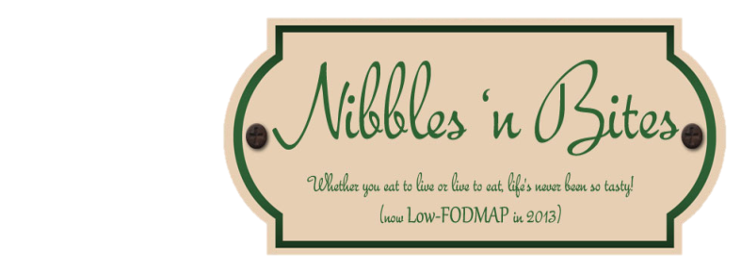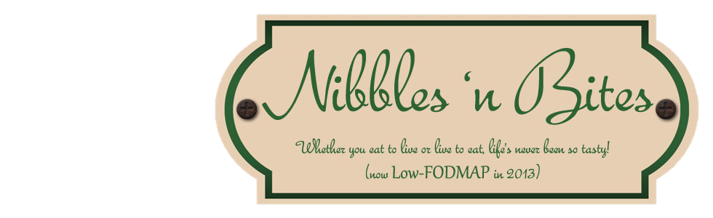

Opening Hours – Monday to Friday 07h00 to 15h00

**Tel: 078 982 5927**

**DELIVERY:** Allow 30 minutes for delivery. Charges for delivery: R10 for all orders as from 01/08/2017

**FRUIT SALAD**

**1** Plain Fruit Salad ……………………………………………………………….. R24-00

**2** Greek Yoghurt, Muesli & Honey ……………………………………….. R22-00

**3** Fruit salad, Greek Yoghurt, Muesli & Honey ………………………. R30-00

**OMELETTE**

3 Egg Omelette with any three fillings (Cheese, Bacon, Ham, Tomato,

Fried Onion, Mushroom, Green Pepper) ……………………………………… R38-00

**FRENCH TOAST**

**1** Plain ……………..………………………………………………………………… R12-00

**2** Syrup …………………..…………………………………………………………… R15-00

**3** Syrup & Cheese ………………..……………………………… ……………… R17-00

**4** Cheese ……………………………..…………………………………………….. R17-00

**5** Bacon ……………………………...…………………………………………….. R20-00

**6** Bacon & Cheese ……………………………………………………………… R25-00

**BREAKFAST BUN**

Bacon, Egg, Cheese …………………………………………………………………… R24-00

**BREAKFAST BOWL**

*(3 x scrambled eggs + white, brown or rye toast)*

**1** Bacon Cubes & Grated Cheddar Cheese …………………………….. R34-00

2 Grilled Mushrooms, Red Peppers & Grated Cheddar Cheese .. R36-00

3 Sliced Cheese Griller, Fried Onions & Grated Cheddar Cheese. R40-00

**BUILD YOUR OWN**

**(***Breakfast / Extra add on***)**

Toast ………………R 5-00 Egg ………………… R 5-00 Olives ….............. R 4-00

Bacon …………….R 8-00 Cheese ……………… R 6-00 Hashbrown ……… R12-00

Beef Patty ……….R12-00 Mushrooms .......... R 5-00 Hasbrown Cubes. R10-00

Chicken Breast …R14-00 Fried Onion .……… R 5-00 Halloumi strips … R10-00

Cheese Griller …..R 7-00 Green Pepper ……. R 4-00 Tomato …………… R 3-00

Russian …………. R12-00 Gherkins …………... R 3-00

Vienna …………… R 5-00 Mushroom sauce .. R 6-00

**HEALTHY SANDWICHES**

(white, brown, rye – not toasted)

**1** Ham, Cheese, Tomato & Lettuce …………………………………… R25-00

**2** Pastrami, Gherkin, Tomato & Lettuce, Feta …………………….. R28-00

**3** Chicken strips, Cheese, Tomato & Lettuce & Cheese ………. R28-00

**4** Andrea Special (Rye Bread, Lettuce, Tomato, Chicken, Feta

& Avocado *(when available)* ………………………………………………. R34-00

**CROISSANTS**

**1** Plain ……………………………………………………………………………. R14-00

**2** Ham & Cheese Croissant ...……………………………………………. R20-00

**3** Breakfast Croissant (Bacon, Egg & Cheese) ……………........... R26-00

**4** Chicken Croissant (Chicken Strips, Lettuce, Cheese, Tomato) R30-00

**5** Chicken fillet & Caramalised Corn …………………………………. R34-00

**TOASTED SANDWICHES**

(White/Brown/Rye)

**1** Cheese ………………………………………………………………………. R20-00

**2** Ham & Cheese …………………………………………………………… R22-00

**3** Ham, Cheese, Tomato & Sweet Chilli ………………………….. R26-00

**4** Bacon & Cheese ……………………………………………………… R26-00

**5** Bacon & Egg & Cheese ………………………………................... R30-00

**6** Chicken Mayo ……………………………………………………………. R30-00

**7** Chicken Filet, Mayo & Salad ……………………………………….. R32-00

**8** Bacon, Chicken Mayo, Salad & Cheese ……….……………….. R34-00

**9** Dagwood (Beef burger patty, egg, cheese & tomato) ……….. R36-00

**10** Mince & Cheese ………………………………………………………….. R30-00

**GOURMET FILLED PITA / TRAMEZINI’S**

**Pita Tramezini**

**1** Cheese, Lettuce & Tomato ……………………………………….. R24-00 R26-00

**2** Ham, Cheese, Tomato & Lettuce ……….…………………….. R26-00 R30-00

**3** Ham, Cheese, Tomato, Lettuce & Sweet Chilli ……………. R28-00 R32-00

**4** Bacon & Cheese ……….…………………………………………….. R28-00 R32-00

**5** Bacon, Egg & Cheese ……….……………………………………… R30-00 R34-00

**6** Chicken Mayo ………………………………………………………… R30-00 R34-00

**7** Chicken Filet, Mayo & Salad …………………………………….. R34-00 R36-00

**8** Bacon, Chicken Mayo, Salad & Cheese ………………..……. R36-00 R38-00

**9** Dagwood (Beef burger patty, egg, cheese & tomato) …….. R36-00 R38-00

**10** Mince & Cheese ……………………………………………………… R32-00 R34-00

**WRAPS**

*(Lettuce, tomato, cucumber, feta, mayo sauce)*

**1** Breakfast Wrap (Bacon, Egg, Cheese) …………………………….. R26-00

**2** Chicken Wrap (Chicken strips, Lettuce, Tomato, Cucumber,

Feta, Mayo sauce) ………………………..………………………………. R28-00

**3** Chicken & Bacon Wrap (Chicken strips, Bacon, Lettuce,

Tomato, Cucumber, Feta, Mayo sauce) ……………………………. R30-00

**4** Chicken & Hash Brown Wrap ………………………………………… R32-00

**LUNCH BOWL**

*(Lettuce, rocket, cucumber, tomato, feta, onion, french loaf)*

**1** Hashbrown & Boiled Egg, Balsamic Vinegar.……………………… R35-00

**2** Chicken Strips, Caramalized Corn, Mayo Mustard Sauce ……. R42-00

**SALADS**

*(Lettuce, tomato, cucumber, feta, mayo sauce)*

**1** Healthy Meal (Chicken Filet, Salad, Feta & Olives) ..……….. R35-00

**2** Chicken Salad ……………………………………………………………… R30-00

**3** Chicken Pasta Salad ………………………………………………………. R34-00

**4** Tuna Salad ………………………………………………………………….. R30-00

**5** Tuna Pasta Salad ………………………………………………………….. R34-00

**6** Biltong Salad ……………………………………………………………….. R35-00

**7** Pasta Salad (Sweetcorn, Peas, Ham, Cheese) …………………… R25-00

**8** Butternut Salad (Diced Grilled Butternut, Lettuce, Cucumber,

Bacon, Feta, Granola Seeds, Balsamic) ………………………. R30-00

**9** ChickenWaldorff Salad (Lettuce, Celery, Apple, Mayo Sauce,

Seeds & Chicken Strips) …………………………………………………… R35-00

**HAMBURGERS**

**1** Chicken Burger ……………………………….…………………………… R26-00

**2** Chicken Fillet Burger …………………………………………………….. R30-00

**3** Beef Burger ………………………………………………………………….. R28-00

**4** Veggie Burger ……………………………………………………………….. R30-00

**FAVOURITES**

**1** Cholesterol Injection (Chips, Bacon Pieces & Cheese) ……. R28-00

**2** Quarter Loaf (Atchar, Chips, Egg, Polony, Vienna) ………… R28-00

**CHIPS / RUSSIAN**

**H**alf Porsion Chips ……… R16-00 **H**alf Porsion Chips & Russian ... R28-00

Full Porsion Chips………. R22-00 Full Porsion Chips & Russian …. R34-00

**HOT DOG / RUSSIAN ROLL**

Hot Dog with Vienna ..... R15-00 Hot Dog with Vienna & Chips .. . R23-00

Russian Roll .................... R20-00 Russian Roll with Chips .............. R28-00

**VETKOEK**

**1** Plain …………………………………………………………………………… R 8-00

**2** Jam & Cheese ……………………………………………………………… R12-00

**3** Mince & Cheese …………………………………………………………… R20-00

**4** Chicken Mayo …………………………………………….………………. R22-00

**SAMOOSAS** **/ PIES / MUFFINS**

(*Selection Baked Daily*)

Samoosas ………………………………………………………………… R10.00

Pies …………………………………………………………………………….. R18.00

Muffins ……………………………………………………………………….. R 7.00

**DAILY SPECIALS**

(Will be announced monthly – phone / online) R45-00

**DRINKS**

**HOT**

Available from our Coffee Kiosk

**COLD**

Soft Drinks 340ml…….. R10-00 Soft Drinks 440ml .. R12-00

Liqui Fruit (340ml) … R12-00 Lipton Ice Tea .…….. R12-00

Water (Still & Sparkling) R 8-00 Sterri Stumpie ………. R12-00

Energade …………………… R12-00 Dragon .……………….. R15-00

**CIGARETTES**

(Available from the Vending Machine - cash only)

**PLATTERS / FUNCTIONS / BIRTHDAY CAKES / COMPANY TRAINING –** (On request)