Classical CNN Classification and Composite Risk Inference
Complete Technical Record - Sprint 1 to Sprint 4
Pasindu Pahasara Balasooriya Lekamlage - 104348348
COS40005 / COS40006 - Computing Technology Project A and B
Project: Q-INTERVAL-Lite+ · Workstream: classical CNN classification, composite risk inference, explainability

1. Scope
This document records every model trained, every experiment run, every literature review conducted and every result measured on the classical CNN workstream from Sprint 1 to the end of Sprint 4. Negative results and abandoned directions are recorded deliberately: several of them shaped later decisions more than the successes did, and two of them are the reason the final model differs from the one that scored highest.
Every figure quoted comes from a saved notebook output rather than from memory. Where a number could not be traced to a recorded run it is marked as such.

2. Dataset and evaluation protocol

2.1 Dataset
Mammo-Bench (Bhole, Suba and Parekh, medRxiv 2025.01.31.25321510, version posted 14 October 2025): 19,731 mammographic images from 6,500 patients across six countries, aggregating DDSM, INbreast, KAU-BCMD, CMMD, CDD-CESM and DMID. Labels are Normal / Benign / Malignant with breast density (ACR A-D), BI-RADS and abnormality type. Mammo-Bench applies its own preprocessing: format standardisation, breast segmentation, pectoral muscle removal and intelligent cropping.
A dataset audit in Sprint 4 verified 19,733 files present, matching the six-source release. No ROI masks ship with the data despite the paper stating masks were generated, and no lesion-type column has usable coverage. This ruled out lesion-localisation supervision as a future option and is recorded in Section 11.

2.2 Filtering decisions
Decision | Rationale | Effect
Suspicious Malignant → Malignant | Only 235 cases; too few to model as a fourth class | Merged into Malignant
CDD-CESM removed (1,003 images) | Contrast-enhanced spectral mammography is a different modality; the Mammo-Bench paper itself reports only about 50% accuracy on it | 18,728 images remain across 5 sources
Table 1. Dataset filtering decisions, applied consistently from v4 onward.

2.3 Split protocol
Patient-level stratified split, seed 42, stratified by patient class × source dataset, where patient class is the maximum severity across that patient’s images. Train 70% (3,873 patients, 13,093 images), validation 15% (830 patients, 2,814 images), test 15% (831 patients, 2,821 images). No patient appears in more than one split, and the split has been held constant across every experiment in this document so results are comparable.
Test class balance: Normal 706, Benign 859, Malignant 1,256 - 44.5% malignant. Train balance: Normal 3,450, Benign 4,020, Malignant 5,623. The test set contains 375 patients with malignant disease.

2.4 Metadata features
Feature | Cardinality | Encoding
Age bucket | 8 | under 30, 30s, 40s, 50s, 60s, 70s, 80+, missing
View | 3 | CC, MLO, missing
Laterality | 2 | L, R
Source dataset | 5 | cmmd, ddsm, dmid, inbreast, kau-bcmd - removed from v8 onward
Table 2. Categorical metadata encoded as learned 16-dimensional embeddings. The fourth row is the input whose removal became the central work of Sprint 4.

3. Sprint 1 - baseline establishment
EfficientNet-B0, ImageNet pretrained, all backbone layers frozen, final classifier replaced 1000 → 3. Input 224×224, batch 32, Adam at learning rate 1e-3, cross-entropy with class weights, 5 epochs, patient-level split applied.
Result: 62.19% test accuracy. Confusion analysis showed 393 malignant cases predicted as benign and 176 benign predicted as malignant. Diagnosed as underfitting rather than overfitting - training and validation loss stayed close and improvement across epochs was minimal. Cause identified as the frozen backbone: only the final classification layer was learning. Run in parallel with a ResNet-18 (60.41%) as a dual-architecture comparison.

4. Sprint 2 - pipeline rebuild
A literature review covered CNN backbones (ResNet, EfficientNet, EfficientNetV2, ConvNeXt, ConvNeXt-V2, RegNet, BiT, DenseNet), vision transformers (ViT, DeiT, Swin-T, Swin-S), hybrids (CoAtNet, MaxViT), training strategies (progressive unfreezing, discriminative learning rates, mixed precision, cosine warm restarts), calibration by temperature scaling, and explainability by Grad-CAM and Grad-CAM++.
ResNet-50 was selected and the training pipeline rebuilt with three-phase progressive unfreezing, trained locally on an RTX 4050 with mixed precision to fit the higher input resolution into 6 GB of VRAM. Approximately ten full training runs were made across the iteration cycle, adjusting augmentation strength, patience and phase-3 length.
Result: 0.70 accuracy, 0.70 macro F1, 0.74 malignant recall, 0.86 macro ROC-AUC - against the Sprint 1 baseline of 0.62 accuracy and 0.61 macro F1.
Sprint 2 also delivered the composite risk design that the product still uses: cancer, density and BI-RADS models feeding a weighted score of 0.60 × Cancer + 0.25 × BI-RADS + 0.15 × Density, with cancer risk defined as P(Malignant) × 100 + P(Benign) × 30, density weights A:25 B:50 C:75 D:100, BI-RADS weights 1:0 2:25 3:50 4:75 5:100, patient-level max-severity aggregation across the four standard views, risk tiers Low 0-33 / Medium 34-66 / High 67-100, and a malignant-bypass safety rule that returns clinical escalation instead of a numeric future-risk score when any view is malignant. BI-RADS 0 and 6 were excluded from training as incomplete assessment and biopsy-confirmed respectively. Grad-CAM++ explainability was implemented in this sprint.

5. Sprint 3 - the structural ceiling and the ensemble

5.1 Week 10 - high-accuracy architecture review
Established that published 90-99% accuracy figures in mammography arise from binary framing, small single-source datasets, image- or ROI-level splitting, and heavy preprocessing on class-balanced subsets - none of which apply to a large, multi-source, patient-level three-class task. This set realistic expectations for the rest of the project and is the reason no target above 0.80 was ever adopted.

5.2 Week 11 - SOTA review and baseline replication
The Mammo-Bench paper’s own ResNet-101 baseline is 78.8% on the three-class task; image-level splitting inflates accuracy by 5 to 30 points (Roberts et al., Scientific Data 2022); and this project would be the second known data point on the benchmark and the first under patient-level evaluation.
v3 - ResNet-101 replication, all five sources, no metadata, 384×384: 0.7027 accuracy, 0.7046 macro F1, 0.6867 malignant recall, 0.8660 AUC, ECE 0.024. The conclusion at the end of Week 11 was that single-model patient-level three-class performance appeared to have a structural ceiling around 0.72.

5.3 Week 12 - five candidate directions
v4 - CDD-CESM modality filter ablation. Hypothesis: contrast-enhanced spectral mammography is a different modality diluting the training signal, supported by the Mammo-Bench paper reporting only about 50% accuracy on it with the same backbone. Result: 0.7136 accuracy, 0.7180 macro F1, 0.7197 malignant recall, 0.8698 AUC, ECE 0.031 - accuracy +1.1 and malignant recall +3.3 over v3. The filter was adopted for every subsequent run.
v5 - ResNet-101 with clinical metadata embeddings at 512×512. Metadata embeddings concatenated with the 2048-dimensional backbone feature into a 2112 → 256 → 3 head, WeightedRandomSampler, AdamW at 1e-4, cosine annealing, 25 epochs, patience 6, temperature scaling fitted on validation via L-BFGS. Result: 0.7185 accuracy, 0.7216 macro F1, 0.7134 malignant recall, 0.8791 AUC, ECE 0.024 - the first Sprint 3 model to beat the Sprint 2 baseline of 0.7129.
Mammo-FM - foundation model, three phases. Phase 1 checkpoint inspection found the Hugging Face checkpoint was a PyTorch ZIP-format file mislabelled with a .tar extension. The first linear-probe attempt loaded zero weights, diagnosed from a key-naming mismatch: Mammo-FM uses the efficientnet-pytorch library’s underscore-prefixed convention (_conv_stem, _blocks.X._bn1) rather than torchvision’s hierarchical naming, and the run measured a random-initialised 0.5718. Rebuilt with EfficientNet.from_name('efficientnet-b5'), the linear probe reached 0.6870 accuracy, 0.6825 macro F1, 0.6775 malignant recall, 0.8600 AUC, ECE 0.026. An aggressive full fine-tune at backbone learning rate 1e-4 - ten times the conservative default, on the reasoning that Mammo-FM’s features are already mammogram-specific with no generic pretraining to preserve - reached 0.6898 accuracy, 0.6845 macro F1, 0.7150 malignant recall, 0.8747 AUC, ECE 0.051.
Structural ceiling confirmed: six independent setups spanning 0.6870 to 0.7185, a 1.6 percentage point band across fundamentally different architectures and pretraining regimes. This is the signature of a data-limited rather than architecture-limited regime, and it is why later sprints stopped searching architectures.
E1 - the Sprint 3 ensemble. The ceiling argument applies to single models only: architecturally diverse models make different errors, so averaging calibrated probabilities cancels independent noise. Members were v4 (ResNet-101, no metadata), v5 (ResNet-101 with metadata at 512px) and Mammo-FM aggressive fine-tune (EfficientNet-B5 with metadata), each run with two-view test-time augmentation, each bundle’s saved temperature applied before averaging, and weights proportional to validation accuracy with α = 4 sharpening. Result: 0.7395 accuracy, 0.7385 macro F1, 0.7611 malignant recall, 0.8914 AUC - improvements of +2.10 accuracy, +1.69 macro F1, +4.77 malignant recall and +1.23 AUC over the best single model.

5.4 Supporting models and integration delivered in Sprint 3
Density v2 - ResNet-101 with metadata, CDD-CESM filtered, four-class A/B/C/D: 0.6427 accuracy, 0.8617 AUC. BI-RADS v2 - same recipe, five-class 1-5: 0.7819 accuracy, 0.9218 AUC. Risk Inference v3 - the integrated pipeline driving the Sprint 2 formula with calibrated probabilities from the cancer ensemble, density v2 and BI-RADS v2: 99.7% patient-level malignant sensitivity, 374 of 375 cancers flagged for review, and 93.0% normal specificity, with a risk distribution of 343 High, 375 Medium and 113 Low across the 831 test patients.
Grad-CAM++ was implemented natively without an external library dependency and packaged as a method on each model object, producing three self-contained .pth bundles that deliver per-class heatmap overlays from a single call. Backend integration was delivered as risk_inference_engine.py, exposing a single analyze_patient() API that returns the Sprint 2 output schema unchanged with Sprint 3 additions - calibrated probability vectors, Grad-CAM++ overlays, per-patient confidence and most-suspicious-view index - as additive fields.

6. Sprint 4, first half - saturation, diversity repair, two negative results

6.1 Tier 1 - ensemble saturation experiment
Designed to establish whether the Sprint 3 ensemble had headroom before committing GPU time to new training. Tested exhaustively on cached calibrated probabilities: every subset combination of available members, 17 weighting schemes (accuracy, macro F1, malignant recall and macro AUC at exponents 1, 2, 4 and 8), a per-class threshold coefficient grid search, and extended four-view test-time augmentation. Selection was performed on validation only - Sprint 3 had chosen between equal-weight and validation-weighted ensembles by comparing test accuracy, which is mild test leakage, and this was corrected.
Model | 2-view TTA | 4-view TTA | Gain
v4 | 0.7136 | 0.7317 | +1.8
v5 | 0.7185 | 0.7309 | +1.2
Mammo-FM | 0.6898 | 0.7093 | +2.0
E1 ensemble | 0.7384 | 0.7384 | 0.0
Table 3. Extended TTA improves individual models but not the ensemble. Averaging across models already removes the variance TTA removes, so the gains do not compound.
A second finding was that the ensemble was carrying correlated members. v4 and v5 are both ResNet-101, with v5 being v4 plus metadata embeddings and higher resolution. Ensemble improvement tracks disagreement between members (Jeffares et al., NeurIPS 2023), and two variants of the same backbone disagree too little to contribute - which explains the modest +0.67 point ensemble gain over the best single member. A third finding was procedural: v6 had been scoped in Sprint 3 and the ensemble notebook was written to include it and configured with its bundle path, but training was not completed before the Week 12 Alpha release, so the ensemble had run with three members rather than four.

6.2 v6 - EfficientNetV2-S with CBAM and metadata
CBAM applies channel attention through a shared MLP over average and max pooling, then spatial attention through a 7×7 convolution over channel-wise average and max maps. Applied to the 1280-channel EfficientNetV2-S feature output, with metadata embeddings concatenated into a 1344 → 256 → 3 head. Input 384×384, batch 32, AdamW at 1e-4, cosine annealing, 25 epochs, patience 6; early stopped at epoch 14 with best epoch 8.
Result: 0.7185 accuracy, 0.7155 macro F1, 0.7619 malignant recall, 0.8726 AUC, ECE 0.0256 at T = 1.70. Per class F1: Normal 0.8186, Benign 0.5842, Malignant 0.7436. With four-view TTA, 0.7210 accuracy and 0.7691 malignant recall - the highest malignant recall of any single model in the project. Heavy overfitting was observed: training accuracy reached 0.9319 against validation 0.72, with validation loss rising steadily from epoch 8 onward.

6.3 E2 - ensemble rebuild
Members | Val acc | Test acc | Test macro F1 | Test mal recall | Test Benign F1
v5 + v6 | 0.7505 | 0.7441 | 0.7445 | 0.7699 | 0.6287
v4 + v5 + Mammo-FM | 0.7459 | 0.7370 | 0.7376 | 0.7524 | 0.6259
v4 + v5 + v6 + Mammo-FM | 0.7459 | 0.7434 | 0.7427 | 0.7755 | 0.6262
v5 + v6 + Mammo-FM | 0.7456 | 0.7395 | 0.7382 | 0.7651 | 0.6178
v4 + v5 + v6 | 0.7438 | 0.7451 | 0.7452 | 0.7771 | 0.6300
Table 4. Ensemble subset search, selected on validation. Two members beat every three- and four-member combination.
The weighting-scheme search selected macro-F1 to the fourth power. Class coefficients were tuned on validation under a constraint that Benign F1 must not fall below the untuned baseline, giving [1.0, 1.75, 1.70]. Final configuration: v5 + v6, macro-F1⁴ weighting, coefficients [1.0, 1.75, 1.70], four-view TTA.
Metric | Image level | Patient level
Accuracy | 0.7373 | 0.7196
Macro F1 | 0.7415 | 0.7257
Malignant recall | 0.7811 | 0.8000
Benign F1 | 0.6340 | 0.6474
Malignant-vs-rest AUC | 0.8673 | -
Specificity at 90% sensitivity | 0.6243 | -
Table 5. E2, the ensemble delivered in the first half of Sprint 4. Patient-level improvement over E1: accuracy +0.96, macro F1 +1.51, malignant recall +3.20, Benign F1 +2.10, specificity at 90% sensitivity +2.69.
A naming caution that matters when reading later comparisons. E2 is a Sprint 4 model, built in the first two weeks of this sprint. Some downstream notebooks label its row “S3 ensemble” because it was the standing baseline at the time they were written. Where this document compares against E2 it says so explicitly; E1 (0.7395) is the Sprint 3 final model.

6.4 v7 - margin-aware loss
Motivation from the literature: Benign is structurally the hardest class. It is a catch-all covering fibroadenomas, cysts, fibrocystic change and papillomas - pathologically distinct entities, several of which are documented radiological mimickers of cancer. Radiologist agreement at the benign-adjacent BI-RADS boundary is only fair (kappa 0.28-0.39), so label noise is highest exactly where the boundary is drawn. A WeightedRandomSampler changes how often the model sees each class but not where the decision boundary sits; margin-aware losses change the boundary.
Implemented from scratch: LDAM (Cao et al., NeurIPS 2019) with class-dependent margin proportional to 1/n^(1/4) subtracted from the true-class logit before softmax with logit scaling s; Focal (Lin et al., ICCV 2017) with (1−p)^γ down-weighting; LMF (Sadi et al., arXiv 2212.12741) as α·Focal + β·LDAM; and deferred re-weighting with class-balanced weights (Cui et al., CVPR 2019) activated at epoch 12. Configuration: LMF on the EfficientNetV2-S + CBAM backbone, max margin 0.5, s = 30, γ = 2.0, α = β = 1.0, no sampler (LDAM assumes the natural distribution), checkpoint selection on macro F1 rather than accuracy.
Run 1: 0.7210 accuracy, 0.7217 macro F1, Benign F1 0.6140, malignant recall 0.7508. Run 2: 0.7168 accuracy, 0.7217 macro F1, Benign F1 0.6081, malignant recall 0.7229. Benign F1 improved 2.4 to 3.0 points over v6 and macro F1 by 0.62. The run-to-run variance of about three points on malignant recall between identical configurations is recorded as a standing caution against reading single-run differences under two points as meaningful.
A calibration defect was found and fixed here. Expected calibration error went from 0.1877 to 0.2275 after temperature scaling - worse rather than better. Diagnosis: LDAM multiplies logits by s = 30 during training, so the network learns to emit logits roughly a thirtieth of their effective magnitude; at inference, softmax on raw logits is near-uniform and the model appears massively underconfident. Temperature scaling should have fitted T ≈ 1/30 ≈ 0.033, but L-BFGS initialised at 1.5 with learning rate 0.01 over 100 iterations only reached 1.37 and had not converged. The fix was to initialise temperature at 1/s and optimise log-temperature for scale stability, giving T = 0.365 and ECE 0.1891 → 0.0331. This mattered beyond v7: the ensemble averages calibrated probabilities and the risk pipeline consumes them, so an uncorrected miscalibration would have propagated silently without raising an error.

6.5 Hierarchical cascade - negative result
Motivation: the Mammo-Bench paper reports Benign F1 rising from 0.450 in flat three-class to 0.720 under a two-stage cascade on the same dataset family - the largest documented gain for the Benign class in any mammography paper reviewed, with their stage 1 at 0.891 and stage 2 at 0.736. Stage 1 was Normal versus Abnormal on EfficientNetV2-S + CBAM with a WeightedRandomSampler; stage 2 was Benign versus Malignant trained on abnormal images only (9,643 train, 2,068 validation, class balance 1.40:1), reaching 0.7196 accuracy, 0.7117 macro F1, 0.7452 malignant recall, 0.7794 AUC and ECE 0.0645 → 0.0167 at T = 1.528 - 1.64 points below the paper’s 0.736. Recombination used the chain rule with both stages temperature-calibrated before multiplication.
Metric | Flat ensemble (v5+v6) | Cascade | Change
Accuracy | 0.7451 | 0.7256 | −1.95
Macro F1 | 0.7457 | 0.7289 | −1.68
Benign F1 | 0.6312 | 0.6250 | −0.62
Malignant recall | 0.7691 | 0.7030 | −6.61
Macro AUC | 0.8918 | 0.8835 | −0.83
Table 6. The cascade lost on every metric, including the one it was built to improve.
Diagnosis: cascade Normal recall is 0.8626 against the flat ensemble’s 0.7875, while malignant recall fell from 0.7811 to 0.7030. Stage 1 over-calls Normal, and every malignant case routed there is permanently lost because stage 2 never sees it. The probable cause is the WeightedRandomSampler on stage 1: the real distribution is 3,450 Normal against 9,643 Abnormal, so balancing made Normal relatively more frequent in training than in reality and biased the model toward predicting it. This replicates a caution found in the literature review - three studies in adjacent domains (breast ultrasound, dermoscopy, chest X-ray) found flat classification matching or beating cascades, because stage-one routing errors are unrecoverable.

6.6 Dataset audit
Searched 19,733 files and the zip manifest for ROI masks, segmentation and annotation files: zero found, despite the Mammo-Bench paper stating masks were generated. No lesion-type metadata column has usable coverage. The audit also confirmed the six-source, 19,731-image release, resolving a discrepancy in which secondary sources described Mammo-Bench as seven sources including RSNA Screening at 74,436 images. Two consequences follow: RSNA is confirmed genuinely external and therefore usable for validation, and auxiliary ROI supervision - worth +0.17 to +0.23 Benign F1 in Yoshitsugu et al. 2026 - is not available on this dataset.

6.7 Source-shortcut audit and the v8 no-source retrain
The single most consequential result of the project. Every model up to this point took the source-collection identity as one of four metadata embeddings.
- Class priors differ enormously across collections: CMMD is 0% Normal and 78.7% Malignant, KAU-BCMD is 83.7% Normal and 4.3% Malignant.
- A logistic regression on source identity alone - with no image at all - reaches 0.7346 macro AUC.
- Per-source malignant recall under E2 spans 0.9514 on CMMD to 0.1429 on KAU-BCMD. On the one collection resembling a screening population the ensemble scores high accuracy while catching roughly one cancer in seven.
- Per-source recall tracks each collection’s own malignant prior almost linearly, which is the observation the shortcut slope metric was designed to quantify.
Measure | With source input | Source removed | Change
Worst-source malignant recall (KAU-BCMD) | 0.1429 | 0.4286 | +28.6
Spread across the five collections | 0.8085 | 0.3660 | −44.3
Aggregate test accuracy | 0.7373 | 0.6930 | −4.43
Table 7. v8 - ResNet-101 retrained with the source embedding removed, everything else fixed. The aggregate comparison is not like-for-like: a single ResNet-101 without TTA or threshold tuning against a two-model ensemble with both.
A parallel EfficientNetV2-S retrain settled the mechanism. Under identical conditions, removing the source field left KAU-BCMD malignant recall unchanged at 0.1429. The network recovers provenance from the pixels - the five collections differ in acquisition equipment, digitisation (DDSM is scanned film while CMMD is born-digital), exposure and vendor preprocessing - so deleting the metadata field removes a convenient copy of the signal rather than the signal itself. This result is why the second half of the sprint moved from removing inputs to removing incentives.

6.8 Screening-prevalence reframing and selective prediction
The test set is 44.5% malignant while screening prevalence is under one percent, so accuracy measured on this split describes a population that does not occur clinically. Projected to 0.7% prevalence:
Sensitivity | Specificity | Recall rate per 1,000 | Cancers found per 1,000
0.95 | 0.4677 | 535 | 6.65
0.90 | 0.6243 | 379 | 6.30
0.85 | 0.7093 | 295 | 5.95
0.80 | 0.7815 | 223 | 5.60
Table 8. E2 projected to 0.7% screening prevalence. Positive predictive value at the 90%-sensitivity point is 1.66% against a programme recall-rate norm of 30-100 per 1,000. On this evidence the model is not a standalone screening reader.
Selective prediction was implemented as a deployable response. Using top-2 margin abstention, deferring the least-confident 20% of cases lifts accuracy on the remainder from 0.7373 to 0.8005 and malignant recall from 0.7811 to 0.8333.

6.9 Patient-level bootstrap confidence intervals
Metric | Estimate | 95% confidence interval | Width
Accuracy | 0.7371 | 0.7134 - 0.7618 | 4.8
Macro F1 | 0.7411 | 0.7164 - 0.7654 | 4.9
Malignant recall | 0.7805 | 0.7482 - 0.8135 | 6.5
Benign F1 | 0.6335 | 0.5898 - 0.6745 | 8.5
Macro ROC-AUC | 0.8916 | 0.8771 - 0.9049 | 2.8
Matthews correlation | 0.5902 | 0.5512 - 0.6311 | 8.0
Table 9. Bootstrapped at the patient level. Differences under roughly two points on this test set are not distinguishable from noise - a constraint applied to every comparison made after this point.

7. Sprint 4, second half - breaking the shortcut and validating externally

7.1 The shortcut slope metric
To make the shortcut trackable across experiments rather than arguable, a single metric was defined: per-source malignant recall regressed on that source’s own malignant prior, weighted by the square root of the number of malignant cases in each source. A slope of zero means detection is independent of which collection an image came from; a slope of one means the model reproduces each collection’s prior. A companion metric, low-prevalence pooled recall, aggregates DMID, INbreast and KAU-BCMD - 50 malignant cases in total - as the closest available proxy for screening-like data.
An earlier version of this analysis used worst-source malignant recall as the headline. That was replaced because KAU-BCMD contributes only 14 malignant cases to the test set, so 0.0714 is one case, 0.1429 is two and 0.4286 is six, with almost entirely overlapping confidence intervals. The slope uses all five sources and is weighted by case count, which is why it is the figure quoted throughout.

7.2 v9 and v10 - auxiliary supervision, both negative
Hypothesis: forcing the backbone to predict breast density and abnormality type would push it toward tissue composition and lesion morphology rather than acquisition signature. Density and BI-RADS had previously been trained as separate models; here they became auxiliary heads on one shared backbone with a masked cross-entropy loss that ignores missing labels, balanced by source so that no single collection dominates a head.
Model | Auxiliary heads | Accuracy | Macro F1 | Mal recall | Slope
v8 EffNetV2 (reference) | none | 0.7097 | 0.7152 | 0.7229 | 0.650
v9 | density + abnormality | 0.7168 | 0.7124 | 0.7452 | 0.815
v10 | density only | 0.7136 | 0.7168 | 0.7046 | 1.045
Table 10. Auxiliary supervision made the shortcut worse in both configurations.
The reason is visible in the label coverage, which is almost perfectly confounded with source: abnormality type is present on 100% of CMMD, 100% of DMID and 0% of DDSM, INbreast and KAU-BCMD, while density is present on every collection except CMMD. "Does this image carry an abnormality label?" is very nearly "is this CMMD?", so the auxiliary head receives gradient almost exclusively from one collection and becomes a source detector. The masked loss then taught the backbone to represent provenance more explicitly than before.
The source-balancing mitigation was implemented in advance precisely because this risk was anticipated, and it was not sufficient. The result rules out auxiliary supervision on the labels this dataset actually carries, and establishes the general principle that any intervention correlated with source will entrench the problem rather than remove it.

7.3 v11 - Group Distributionally Robust Optimisation
The shortcut is profitable because it pays on average: predicting malignant on CMMD-like images wins on a collection that is 79.7% malignant and loses on collections that are not. Group DRO (Sagawa et al., ICLR 2020) minimises worst-group rather than average loss, maintaining a weight distribution over groups and shifting weight toward whichever group is currently performing worst. Fifteen groups were defined as source × class, with weights updated by exponentiated gradient ascent on per-group mean loss.
The group-weight step size required tuning before the run rather than after. Simulated over 435 steps per epoch across 25 epochs, η = 0.01 collapses the weight distribution onto a single group within one epoch and η = 0.001 collapses by epoch 25 - in both cases the model ends up training on a fraction of the data while appearing to run normally. At η = 0.0001 the worst group is up-weighted roughly 3.4× with 13 of 15 groups still contributing at epoch 25. The maximum group weight was logged every epoch as a guard and stayed below 0.09 for the whole run, with a warning threshold set at 0.6.
Result: shortcut slope 0.650 → 0.110 and low-prevalence pooled recall 0.38 → 0.48, at a cost of 12.1 points of malignant recall (0.7229 → 0.6019). Macro AUC fell only 0.82 points over the same interval (0.8675 → 0.8593), which indicates the ranking was largely intact and the recall loss was a threshold effect rather than lost discrimination - the observation that made v12 possible.
A checkpoint-selection defect was found and fixed during this run. The selection criterion in use saved epoch 4 at slope 1.040, while epoch 9 at slope 0.492 was never written to disk because it did not win on the criterion being tracked. The fix was to save a separate checkpoint per criterion - macro F1, low-prevalence recall, balanced, and slope-penalised - so a completed run can be re-read under a different criterion without retraining. Best epochs under the four criteria were 11, 4, 4 and 7 respectively; the slope-penalised checkpoint at epoch 7 was the one carried forward.

7.4 v12 - constrained threshold recovery and the delivered ensemble
v12 recovers the operating point v11 gave up. The search covered a 144-point grid of class coefficients across all subsets of four candidate models - v11, v8 ResNet-101, v8 EfficientNetV2 and v10 - under two hard constraints evaluated on the selection set: absolute shortcut slope at or below 0.25, and Benign F1 no lower than its untuned value. The second constraint exists because unconstrained coefficient tuning in Sprint 3 drove Benign F1 toward collapse before it was added; the first exists because the cheapest way to recover malignant recall is to re-introduce the shortcut.
Candidate model | Legal coefficient settings | Rejected on slope | Rejected on Benign
v11 Group DRO | 64 of 144 | 23 | 57
v8 ResNet-101 | 31 of 144 | 79 | 34
v8 EfficientNetV2 | 15 of 144 | 128 | 1
v10 density head | 0 of 144 | 144 | 0
Table 11. The constraints were binding rather than decorative. v10 could not be tuned inside the slope budget under any coefficient setting.
Selected configuration: v11 + v8 ResNet-101, macro-F1 weighting, class coefficients [1.0, 1.6, 2.0], four-view TTA, per-member temperatures 1.661 and 2.019. Selection-set slope was 0.182 against a test-set slope of 0.2868, so the coefficients were not fitted to selection-set noise.
Metric | E2 (Sprint 4 first half) | v12 (delivered) | Change
Accuracy (image) | 0.7373 | 0.6983 | −0.0390
Macro F1 (image) | 0.7415 | 0.7056 | −0.0359
Malignant recall (image) | 0.7811 | 0.7643 | −0.0168
Benign F1 (image) | 0.6340 | 0.6046 | −0.0294
Macro ROC-AUC | 0.8918 | 0.8810 | −0.0108
Matthews correlation | 0.5908 | 0.5276 | −0.0632
Shortcut slope | 0.8130 | 0.2868 | −0.5262 (better)
Low-prevalence pooled recall | 0.3400 | 0.4600 | +0.1200 (better)
Accuracy (patient) | 0.7196 | 0.6811 | −0.0385
Macro F1 (patient) | 0.7257 | 0.6713 | −0.0544
Malignant recall (patient) | 0.8000 | 0.9067 | +0.1067 (better)
Benign F1 (patient) | 0.6474 | 0.5466 | −0.1008
Table 12. v12 against E2 - the first like-for-like comparison the project has been able to make, since both are ensembles with four-view TTA and validation-tuned coefficients on the same test split. At patient level v12 identifies 340 of 375 cancer patients against 300.
Per-class test performance for v12: Normal precision 0.9392, recall 0.6997, F1 0.8019; Benign 0.6085 / 0.6007 / 0.6046; Malignant 0.6634 / 0.7643 / 0.7103.
Source | n images | n malignant | Prior | Recall | 95% interval
cmmd | 826 | 658 | 0.7966 | 0.8176 | 0.7860 - 0.8464
ddsm | 1,528 | 548 | 0.3586 | 0.7281 | 0.6888 - 0.7650
dmid | 76 | 21 | 0.2763 | 0.6190 | 0.3844 - 0.8189
inbreast | 61 | 15 | 0.2459 | 0.5333 | 0.2659 - 0.7873
kau-bcmd | 330 | 14 | 0.0424 | 0.1429 | 0.0178 - 0.4281
Table 13. v12 per-source malignant recall with exact Clopper-Pearson intervals. The fitted slope across these five points is 0.287. The intervals on the three small collections are wide, which is why conclusions are drawn from the fitted slope rather than any single row.

7.5 v13 - external validation on RSNA Screening Mammography
Dataset: 54,706 images from 11,913 patients across two sites and ten scanner models, at 2.117% image-level cancer prevalence (1,158 cancers). Site prevalences are 0.0225 and 0.0196. This is a screening population rather than a research collection, and is the distribution the internal test set does not represent.
Three methodological decisions. First, RSNA carries cancer / no-cancer labels while this model is three-class, so Normal and Benign both map to no-cancer and only the malignant probability is scored - which also means the external test says nothing about the Benign class. Second, a full pass was measured at roughly 12 hours of GPU time, so case-control sampling was used: all 1,158 cancers retained with negatives subsampled at 12 per case, giving 15,054 images at a sample prevalence of 0.0769, with every prevalence-dependent metric projected back to the true 2.117%. Third, a preprocessing control was run before any result was interpreted.
Measure | Internal (Mammo-Bench) | External (RSNA)
Population prevalence | 44.5% malignant | 2.117% cancer
ROC-AUC, image level | 0.8673 | 0.5855 [0.5676, 0.6034]
ROC-AUC, breast level | - | 0.6945
Sensitivity at operating point | 0.7643 | 0.8998
Specificity at operating point | - | 0.1468
Positive predictive value | - | 2.23%
Recall rate per 1,000 | - | 854
Cancers found per 1,000 | - | 19.05
Table 14. Internal against external. The internal AUC quoted is malignant-versus-rest, the closest analogue to RSNA’s binary label. Breast level covers 11,903 breasts, 492 with cancer, at sensitivity 0.9004 and specificity 0.3089.
The preprocessing control is what makes the number interpretable. v12 was re-run on the 2,821 Mammo-Bench test images through the RSNA preprocessing path rather than the native one - same images, same model, only the pipeline changed. Malignant-versus-rest AUC fell from 0.8673 to 0.7951, a loss of 7.22 points attributable to preprocessing alone. That is a lower bound rather than an estimate: the control images had already been preprocessed once by Mammo-Bench, so it measures only the additional cropping step and not the DICOM windowing an RSNA image undergoes. Of the 28.2-point total gap, 7.2 points are demonstrably pipeline and 21.0 points remain unattributed.
Target sensitivity | Specificity | PPV | Recalled / 1,000 | Found / 1,000 | Missed / 1,000
0.95 | 0.0818 | 2.19% | 919 | 20.1 | 1.1
0.90 | 0.1468 | 2.23% | 854 | 19.1 | 2.1
0.85 | 0.2070 | 2.27% | 794 | 18.0 | 3.2
0.80 | 0.2755 | 2.33% | 726 | 16.9 | 4.2
0.70 | 0.3959 | 2.45% | 606 | 14.8 | 6.3
Table 15. RSNA performance projected to the true prevalence of 21.2 cancers per 1,000 screens. National programmes operate at roughly 50-100 recalls per 1,000, so the current operating point is an order of magnitude outside deployable range and the coefficients would need re-tuning at screening prevalence.
One external result is unambiguously positive and it is the direct test of whether the sprint’s central intervention generalises. Across the ten scanner models, the correlation between a scanner’s own cancer prevalence and the model’s sensitivity on that scanner is r = −0.137, with an AUC spread of 0.157 and a sensitivity spread of 0.195. Near-zero correlation means detection is independent of which machine produced the image: the provenance dependence Group DRO was intended to remove does not reappear on data the model has never seen. Pearson r is reported rather than slope because RSNA’s prior range across scanners is 0.030 against 0.755 internally, and a 25-fold narrower range makes the two slopes numerically incomparable. Across the two sites, sensitivity spread is 0.0336 and AUC spread 0.0189.
Subgroup | n | Cancers | Sensitivity | Specificity | AUC
No implant | 14,628 | 1,145 | 0.8987 | 0.1492 | 0.5877
Implant (out of distribution) | 426 | 13 | 1.0000 | 0.0678 | 0.6618
Invasive cancers | 818 | 818 | 0.9267 | - | -
Non-invasive cancers | 340 | 340 | 0.8353 | - | -
Density A | 928 | 53 | 1.0000 | 0.0629 | 0.6678
Density B | 3,651 | 309 | 0.9579 | 0.0697 | 0.6171
Density C | 3,562 | 277 | 0.8700 | 0.1081 | 0.5428
Density D | 475 | 25 | 0.6800 | 0.2133 | 0.3254
Age under 50 | 2,953 | 95 | 0.7579 | 0.1645 | 0.4455
Age 50-60 | 5,012 | 281 | 0.8683 | 0.1858 | 0.5566
Age 60-70 | 4,897 | 418 | 0.9187 | 0.1203 | 0.5730
Age 70+ | 2,182 | 364 | 0.9396 | 0.0836 | 0.5985
Table 16. RSNA subgroup performance at the 90%-sensitivity operating point. Density D and the under-50 band score below chance.
Two subgroups scoring below 0.500 is the strongest evidence that the cause is an input problem rather than a weak model: a model that is merely weak on a subgroup scores near chance, whereas scoring below it means cancers are being ranked systematically lower than non-cancers within that group. Both subgroups are characterised by a higher proportion of bright fibroglandular tissue. The breast-cropping step is intensity-based, and pectoral muscle removal - which Mammo-Bench applies and this pipeline does not - leaves a large bright non-breast region in the MLO view, which is 51% of RSNA. That is a coherent mechanism for a below-chance result in exactly these strata and it is the first thing to test next.

7.6 Integration and handover
v12 was delivered to the application as a drop-in replacement for the Sprint 3 inference engine: same class, same method signatures and the same output field names, so no front-end change was required. A schema self-test verifies that all 14 image-level fields, 11 patient-level fields and 6 overlay keys the front end reads are still emitted, and a second self-test exercises the whole inference path on random weights so integration can be verified before any model file is downloaded. Both pass. Density and BI-RADS remain the unchanged Sprint 3 models, and the composite risk formula, its weights, thresholds and feedback strings are untouched - only the cancer term feeding it is new.
The integration closed a live defect found while reading the existing engine: it passed source_dataset into the cancer model with a default value of "ddsm", so every patient processed through the application was being described to the model as a DDSM case. v12 has no source input at all; the argument is still accepted and ignored so existing calls do not break.
One behavioural change is recorded explicitly. Patient class is now the maximum severity across views rather than the previous rule of checking whether any view exceeded a 0.40 malignant probability. The tuned class coefficients already set where the decision boundary sits, so applying the old threshold on top would apply the tuning twice, and max-severity is the rule under which the 0.9067 patient-level figure was measured. The old rule’s answer is still returned as an additive field so any difference is auditable.
Occlusion sensitivity was implemented alongside Grad-CAM++, deliberately matching the method the quantum workstream uses so the two heatmaps displayed side by side in the interface are produced the same way and are comparable. It hides a 64-pixel patch at a time over the 384-pixel input - 121 positions, batched - and measures the resulting drop in malignant probability, which makes it faithful by construction rather than inferring importance from gradients. Given the finding in Section 6.7, a method that measures what the model actually uses is the appropriate tool for checking whether it is reading the lesion.

8. Sprint 5 - investigating the unexplained external gap

8.1 Position entering the sprint
Sprint 4 delivered v12 with provenance dependence reduced from 0.813 to 0.287 and patient-level malignant recall raised from 0.800 to 0.9067, but external validation on RSNA returned an image-level ROC-AUC of 0.5855 [0.5676, 0.6034] against 0.8673 internally. The preprocessing control attributed at least 7.22 AUC points of that 28.2-point gap to the pipeline, leaving 21.0 points unexplained. Two external subgroups scored below the chance value of 0.500: breast density D at 0.3254 and women under fifty at 0.4455. The leading hypothesis was that our pipeline does not remove the pectoral muscle while the Mammo-Bench training images had it removed, and that this mismatch would hurt most in dense tissue. The Sprint 5 plan listed implementing removal and re-running the external evaluation as the first item.

8.2 Literature check before committing the sprint
The hypothesis was checked against published evidence before any implementation. The mechanism is documented: pectoral muscle resembles both tumour tissue and dense parenchyma in intensity and texture, and its presence in mediolateral oblique views is reported as raising false-positive rates in computer-aided detection. The same literature reports that the muscle boundary is hardest to separate precisely where the tissue is dense, which is consistent with the observed subgroup pattern.
What the literature does not provide is a magnitude. No located study measures the effect of a train-test preprocessing mismatch of this kind; the relevant evidence is the general domain-shift literature, where reported cross-dataset losses vary too widely to substitute for a measurement, a recent four-country benchmark reporting AUC losses between 0.165 and 0.320. Papers reporting very high accuracy after pectoral removal were disqualified on the same grounds established in the Sprint 4 ceiling review: small legacy datasets and image-level splits, with no ablation isolating the removal step.
The decision that follows is the same one taken in Sprint 4 when four hours of reading prevented a sprint spent on an unreachable target: test the hypothesis in a bounded pilot before committing three weeks to it.

8.3 Design of the bounded pilot
Two stages. A screening comparison of CC against MLO performance under the existing pipeline, then paired inference in which the same images are scored twice by the same models with the removal as the only changed factor. The screen was originally to run on the probability arrays saved in Sprint 4, but those had been written to the Kaggle working directory and did not survive the session, so both stages were folded into one run of roughly 900 images.
Three design constraints were imposed. The pilot runs inside the Sprint 4 evaluation session and reuses its load, crop, metadata and inference functions rather than reimplementing them, so that preprocessing remains the only variable. Neither ensemble member can act as a negative control, because both were trained on Mammo-Bench and therefore both saw pectoral-removed images; the substitutes are a comparison between the two architectures and application of the removal to CC images, where an operation specific to the pectoral muscle should do very little. And a guard compares the two probability arrays after scoring, because a preprocessing change that silently fails to take effect would produce a zero effect indistinguishable from a genuine null result.

8.4 Pilot 1 - paired inference
Sample: 900 RSNA images, 500 MLO and 400 CC, 450 cancers, with negatives matched to positives on density and age band. Masks were inspected before any inference.
Measure | v11 Group DRO | v8 ResNet-101
AUC change on MLO | -0.0100 [-0.0343, +0.0148] | +0.0005 [-0.0114, +0.0115]
AUC change, density B | -0.0503 [-0.0853, -0.0219] | -0.0036 [-0.0110, +0.0021]
Mean score change, cancers | +0.0176 | +0.0175
Mean score change, negatives | +0.0256 | +0.0173
Mean absolute change, CC control | 0.0018 | 0.0016
Mean absolute change, MLO | 0.0350 | 0.0224
CC AUC, original pipeline | 0.6148 [0.5595, 0.6721] | 0.5314 [0.4709, 0.5886]
MLO AUC, original pipeline | 0.5893 [0.5395, 0.6386] | 0.5015 [0.4501, 0.5514]
Table 17. Paired effect of applying pectoral removal, with patient-level bootstrap intervals. No stratum improved with an interval excluding zero; density B moved significantly worse for the Group DRO member. Cancer and negative scores both rose, which is a threshold shift rather than improved separation. The CC screen shows MLO marginally worse than CC in both members, the direction the hypothesis predicts, but with heavily overlapping intervals.
The result that made the pilot uninterpretable was not in the metrics. The removal operation applied to only 29.4% of MLO images and to 0% of density D images, the stratum the hypothesis is about, against 4.0% of CC images. Twenty-four of thirty-four rejections reported no bright component touching the expected corner. The pilot therefore did not test the hypothesis; it tested an implementation that failed to act.

8.5 Pilot 2 - diagnosing the failure
Applied rates split by site rather than by density, at 21.2% on site 1 against 65.0% on site 2, and were nearly equal by laterality at 40.0% and 46.2%, which ruled out orientation as the main cause. The intensity-based chest-side heuristic nonetheless disagreed with the recorded laterality on 27.5% of site 1 images against 0% on site 2. Measuring the distance from the detected component to the image border showed a subset of images where the component sat well inside the frame, because removal was being applied to the raw image before the breast had been cropped out of the background. Three variants were then compared.
Variant | All MLO | Density A | Density B | Density C | Density D | L / R gap
Raw image, strict edge test (original) | 43.1% | 0% | 23.5% | 17.9% | 100% | 6.2 pts
Crop first, then remove | 85.0% | 100% | 91.2% | 61.5% | 100% | 2.4 pts
Raw image, tolerant edge test | 95.6% | 100% | 97.1% | 89.7% | 100% | 1.2 pts
Table 18. The corner-search problem was real and was corrected. Application rose from 43.1% to 95.6%, including from 0% to 100% on density D.
The corrected operation passed three of the four automatic gate conditions and failed the one that matters. Applied rate on MLO reached 85.0% against a threshold of 80%, density D reached 100%, and the left-right gap fell to 2.5 points. But the same operation applied to 45.0% of CC images. CC views contain little pectoral muscle, so an operation acting on nearly half of them is not isolating the muscle. Before the correction the rule was specific but rarely acted, at 4.0% on CC against 29.4% on MLO; after it, the rule acts reliably and is not specific.

8.6 Decision on the pectoral hypothesis
The pectoral-mismatch hypothesis remains possible and is not disproved. What the two pilots establish is narrower: the intensity-based method available to this workstream cannot produce masks reliable enough to test it. Loosening the rule enough to find the muscle also causes it to find bright fibroglandular tissue, which is consistent with the documented difficulty of separating the two and offers an explanation for the significant loss observed on density B in Pilot 1. Any AUC change measured with this operation would be uninterpretable, because the operation may be removing diagnostic tissue as well as muscle.
Pectoral removal was therefore deprioritised for this sprint. Testing the hypothesis properly would require a trained segmentation model, which is sprint-sized work that no measured evidence currently justifies. Two corrections were carried into all subsequent experiments: use the recorded laterality field rather than inferring orientation from image intensity, and crop the breast before applying any other preprocessing operation.

8.7 Windowing variants - histogram screening
The remaining external-validity candidates were reordered by cost: intensity windowing first, then input resolution, then scanner-specific response. Windowing was screened against the actual training distribution before any inference.
The reference is exact rather than approximate. The Sprint 4 training notebooks read preprocessed_image_path, the Mammo-Bench images, and apply only a resize; those images are the training inputs, and 2,821 of them were available as an attached dataset. The same two filters used in training were reapplied: CDD-CESM excluded, reducing 19,731 rows to 18,728, and Suspicious Malignant folded into Malignant. The two pipelines are described as different paths rather than one path with extra steps, because the operations Mammo-Bench applied before saving remain unknown; what is known is that RSNA instead receives our own Otsu crop and our own percentile mapping.
DICOM decoding was corrected for this comparison. Header and pixel data are read separately, so a codec failure cannot suppress the metadata; rescale slope and intercept are applied before anything else; MONOCHROME1 inversion is tracked so that a VOI centre can be inverted with it; and PixelPaddingValue and PixelPaddingRangeLimit are excluded, after rescaling, before any percentile is computed. Padding exclusion before the percentile is the step that makes the comparison meaningful, since background would otherwise set the window limits and make every variant look alike. The sampled release uses transfer syntax 1.2.840.10008.1.2.4.70, JPEG 2000 lossless, decoded through dicomsdl; a representative image carried 12 bits stored, window centre 2047 and width 4096, with a valid-pixel fraction of 0.601. VOI parameters were present on 80 of 80 sampled images.
Variant | Mean Wasserstein | Worst | Mean rank | Strata won | Against baseline
DICOM VOI windowing | 0.1147 | 0.1840 | 2.0 | 5 of 10 | 7 better, 3 worse
Wider percentile, 0.1-99.9 | 0.1177 | 0.1541 | 2.0 | 2 of 10 | 7 better, 3 worse
Baseline, 1-99 percentile | 0.1719 | 0.2588 | 2.7 | 3 of 10 | -
CLAHE, clip 2.0, 8x8 tiles | 0.1964 | 0.2565 | 3.3 | 0 of 10 | 3 better, 7 worse
Table 19. Breast-pixel distance to the training distribution across ten view-by-density strata, on 400 RSNA images. Jensen-Shannon divergence produced the same ordering. CLAHE moves the distribution away from training rather than toward it, which is consistent with it being locally adaptive rather than a monotonic mapping.
Variant | Mean | Std | Max | Worst group
Wider percentile, 0.1-99.9 | 0.1188 | 0.1088 | 0.3497 | machine 216
DICOM VOI windowing | 0.1390 | 0.1714 | 0.5196 | machine 29
Baseline, 1-99 percentile | 0.1597 | 0.1259 | 0.4034 | machine 216
CLAHE, clip 2.0 | 0.1774 | 0.0559 | 0.2960 | machine 216
Table 20. Consistency within RSNA, measured as distance to the pooled training distribution across sites and scanner models. Site and scanner are not compared against Mammo-Bench, which has no counterpart to them; they test whether a variant behaves the same way across acquisition groups. DICOM VOI has the best average distance and the worst consistency, ranging from 0.0236 on one scanner to 0.5196 on another, because it inherits whatever window values each manufacturer wrote into the header.
Two limitations of the screen are recorded. The density-unknown stratum is not comparable between datasets, since for RSNA it means site 2, which records no density at all, while for Mammo-Bench it means a different set of sources with missing labels; those two strata of the ten should be excluded before the ranking is relied upon. And part of the measured distance is attributable to cropping rather than windowing, because the reference images were cropped by Mammo-Bench while ours are Otsu-cropped; this affects all variants equally, so the ranking should survive it, but the absolute distances are not purely a windowing difference.

8.8 Position at the end of week 4
CLAHE is eliminated. The wider percentile mapping leads on consistency and improves seven of ten strata; DICOM VOI leads on average distance but is not stable across scanners. The baseline and the wider percentile mapping are the candidates for paired inference, under the decision rule agreed for this work: a windowing change is adopted only if it improves discrimination consistently across both architectures, does not simply shift all scores in one direction, and does no serious harm to any subgroup. Distribution distance selects candidates; the paired model result decides.

8.9 Literature consulted in Sprint 5
Question | What the evidence supports | What it does not
Does pectoral muscle interfere with detection? | Documented mechanism: similar intensity and texture to tumour and dense parenchyma; raises false positives in CAD; boundary hardest to separate in dense tissue | No measured effect size for a train-test preprocessing mismatch
How large are cross-dataset preprocessing losses? | Domain-shift literature reports substantial and variable losses, one four-country benchmark spanning 0.165 to 0.320 AUC | Too variable to substitute for measurement on this pipeline
Do high-accuracy pectoral-removal papers apply? | Not comparable: small legacy datasets, image-level splits, no ablation isolating the removal step | They cannot be read as evidence of the gain removal would produce here
Table 21. Literature consulted before committing effort in Sprint 5, recorded with what each source does and does not establish. This follows the practice adopted in the Sprint 4 ceiling review of recording split protocol and comparability alongside every cited result.

8.10 Defects and corrections recorded in Sprint 5
- Sprint 4 saved probability arrays without image identifiers, and the arrays did not survive the session because no notebook version was committed. The sampling was deterministic enough to rebuild the row index exactly, and the saved label and site arrays were used as two independent 15,054-length checksums to verify the reconstruction rather than assume it, but the arrays themselves were unrecoverable. Every array written since carries its identifiers.
- Pectoral removal was applied before the breast crop, so on images with background padding the muscle component never reached the image border and the edge test rejected it. Ordering corrected: crop first, then any other operation.
- Orientation was inferred from column intensity rather than read from the recorded laterality field, disagreeing with the metadata on 27.5% of site 1 images. Corrected to use the metadata field.
- The paired-inference design initially risked a silent failure in which a preprocessing change does not reach the images and the measured effect is zero for the wrong reason. A guard was added that compares the two probability arrays and halts if they are identical.

9. Master results table
All figures on the same patient-level test split: 831 patients, 2,821 images.
# | Model | Acc | Macro F1 | Mal recall | Benign F1 | AUC | Slope
S1 | EfficientNet-B0, frozen backbone, 224px | 0.6219 | - | - | - | - | -
S1 | ResNet-18, frozen backbone | 0.6041 | 0.5932 | - | - | - | -
S2 | ResNet-50, progressive unfreezing | 0.7000 | 0.7000 | 0.7400 | - | 0.8600 | -
S2 | EfficientNetV2-S + CBAM, local | 0.7129 | 0.7105 | 0.7005 | - | 0.8774 | -
v3 | ResNet-101, all sources, 384px | 0.7027 | 0.7046 | 0.6867 | - | 0.8660 | -
v4 | ResNet-101, CDD-CESM removed | 0.7136 | 0.7180 | 0.7197 | 0.6234¹ | 0.8698 | -
v5 | ResNet-101 + metadata, 512px | 0.7185 | 0.7216 | 0.7134 | 0.6296¹ | 0.8791 | -
- | Mammo-FM linear probe (EffNet-B5) | 0.6870 | 0.6825 | 0.6775 | - | 0.8600 | -
- | Mammo-FM aggressive fine-tune | 0.6898 | 0.6845 | 0.7150 | 0.5752¹ | 0.8747 | -
E1 | Ensemble v4+v5+Mammo-FM - Sprint 3 final | 0.7395 | 0.7385 | 0.7611 | 0.6285 | 0.8914 | -
v6 | EfficientNetV2-S + CBAM + metadata | 0.7185 | 0.7155 | 0.7619 | 0.5870¹ | 0.8726 | -
v7 | EfficientNetV2 + CBAM, LMF margin loss | 0.7168 | 0.7217 | 0.7229 | 0.6081 | 0.8671 | -
- | Hierarchical cascade, recombined | 0.7256 | 0.7289 | 0.7030 | 0.6250 | 0.8835 | -
E2 | Ensemble v5+v6 tuned - Sprint 4 first half | 0.7373 | 0.7415 | 0.7811 | 0.6340 | 0.8918 | 0.813
v8 | ResNet-101, source removed | 0.6930 | 0.7033 | 0.6728 | 0.5942 | 0.8696 | 0.440
v8 | EfficientNetV2, source removed | 0.7097 | 0.7152 | 0.7229 | 0.5851 | 0.8675 | 0.650
v9 | Multi-task: density + abnormality | 0.7168 | 0.7124 | 0.7452 | 0.5754 | 0.8760 | 0.815
v10 | Multi-task: density only | 0.7136 | 0.7168 | 0.7046 | 0.6059 | 0.8801 | 1.045
v11 | Group DRO, source × class | 0.6760 | 0.6902 | 0.6019 | 0.6024 | 0.8593 | 0.110
v12 | Ensemble v11 + v8 ResNet - DELIVERED | 0.6983 | 0.7056 | 0.7643 | 0.6046 | 0.8810 | 0.287
Table 22. Every model trained on this workstream. ¹ measured under four-view TTA in the Sprint 4 Tier 1 experiment. Shortcut slope was only defined from the Sprint 4 audit onward, so earlier rows are blank rather than zero.
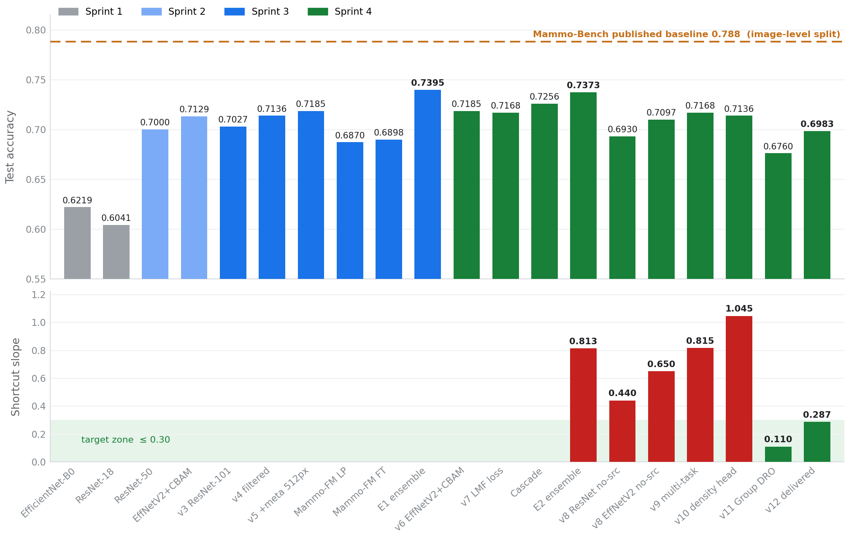
Figure 1. Twenty models across four sprints. Upper panel: test accuracy, with the published Mammo-Bench baseline marked. Lower panel: shortcut slope where measured, with the target zone shaded. The two panels together are the argument of Sprint 4 - accuracy fell slightly while the provenance dependence fell by two thirds.
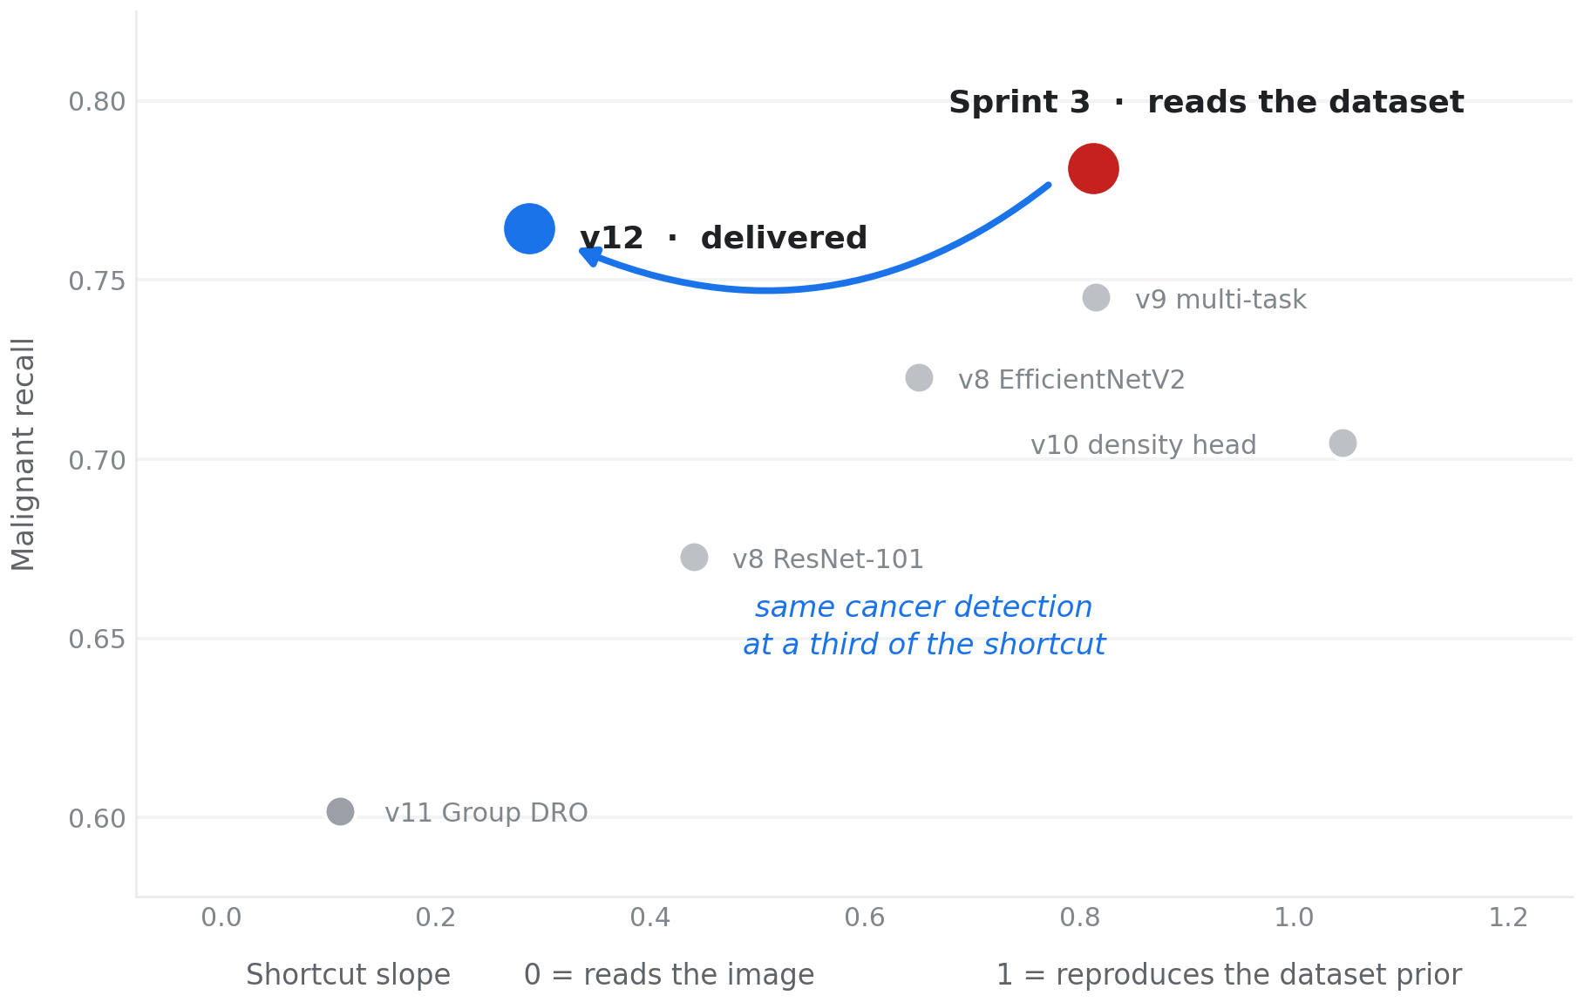
Figure 2. The same information plotted against itself for the Sprint 4 models. E2 sits top right at high detection and high provenance dependence; v12 sits well to the left at almost the same height.
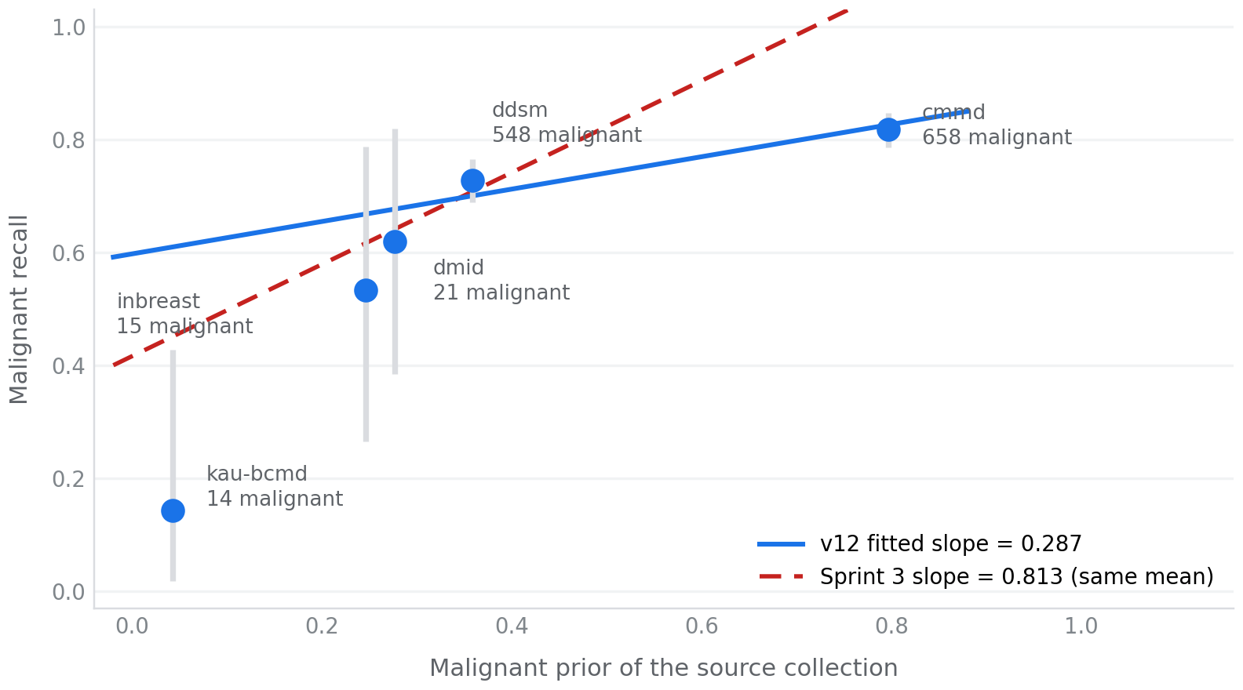
Figure 3. v12 per-source malignant recall against source prior, with exact 95% Clopper-Pearson intervals. The solid line is the fitted slope of 0.287; the dashed line is E2’s slope of 0.813 anchored at the same mean, for scale.
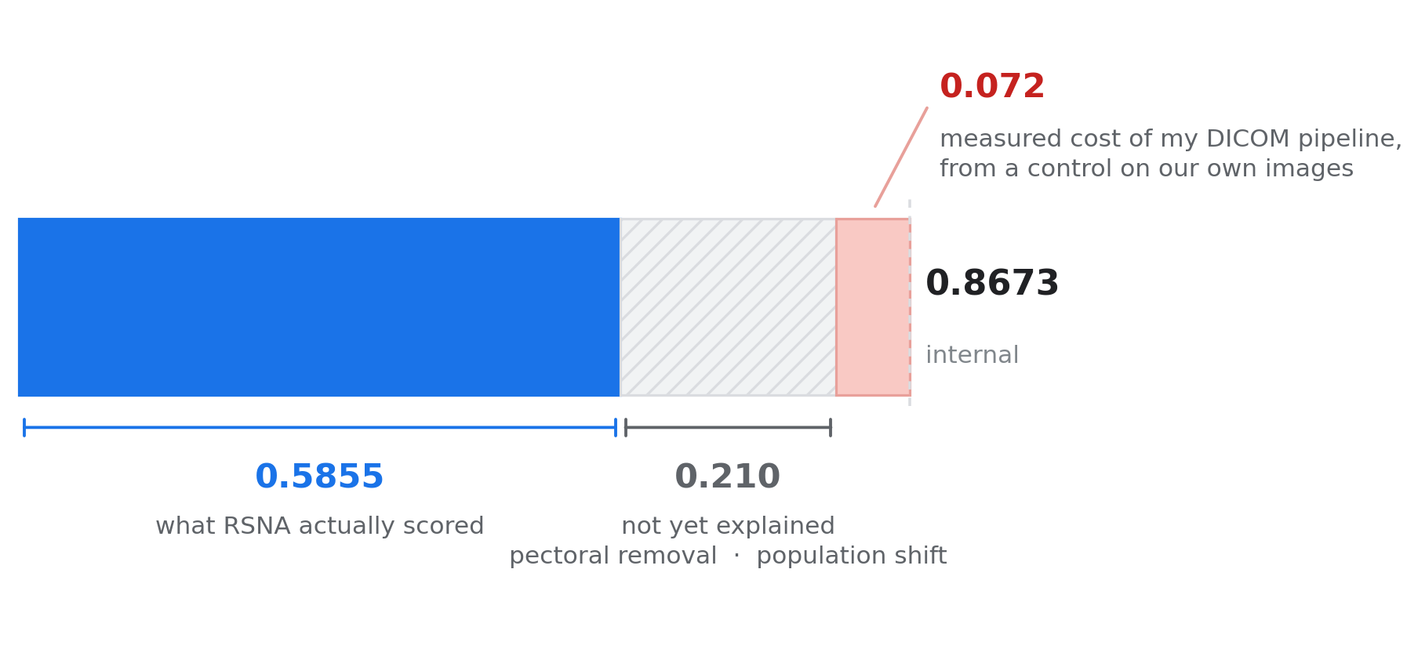
Figure 4. Decomposition of the internal-to-external gap in image-level ROC-AUC. The red segment is measured by the preprocessing control; the grey segment is not yet attributed.
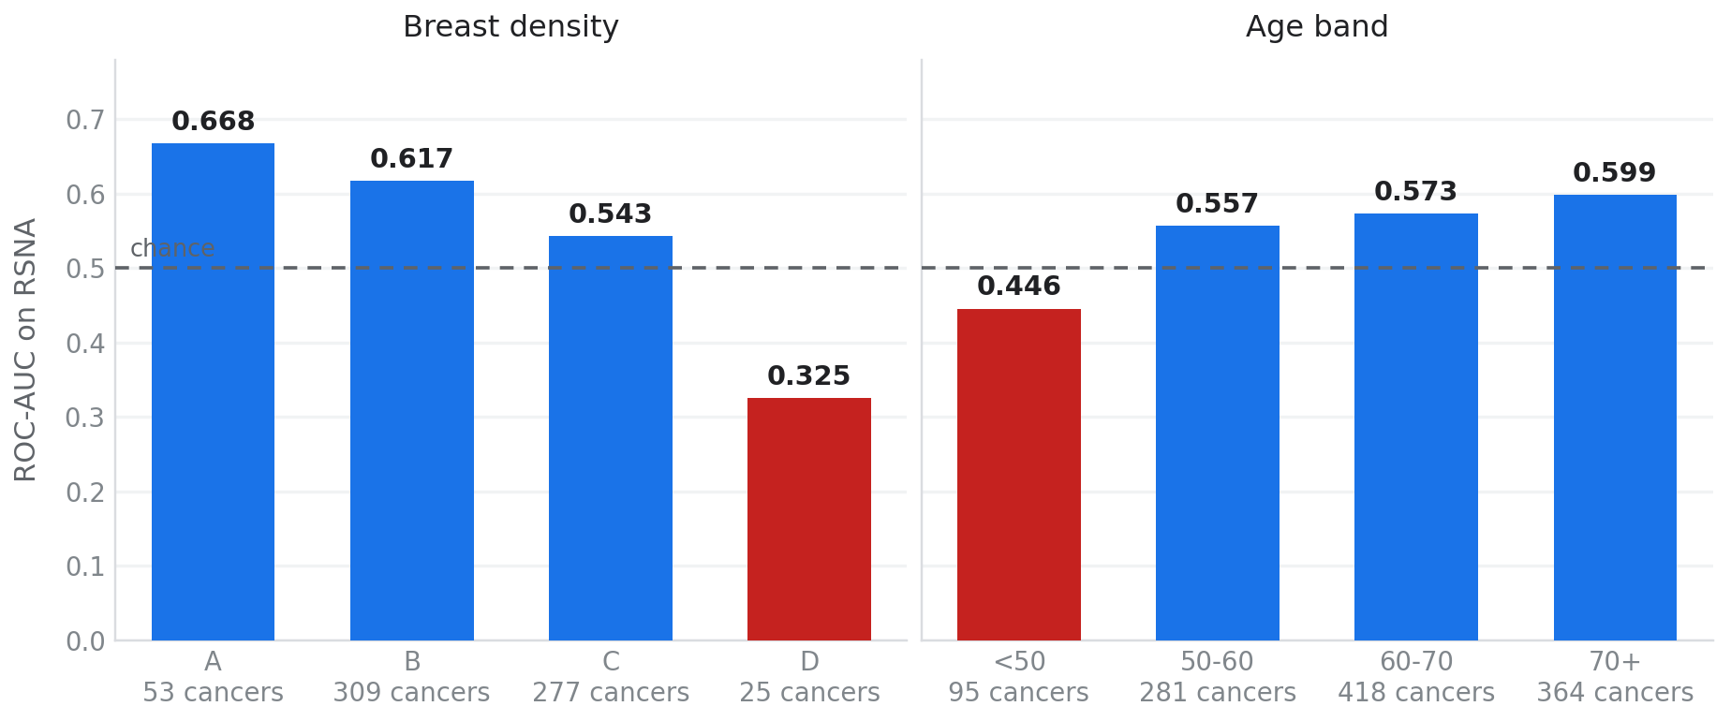
Figure 5. External ROC-AUC by breast density and age band. Two subgroups fall below chance, which points at the input rather than the model.

10. Architectures and methods implemented
ResNet-101 with metadata (v3, v4, v5, v8, Density v2, BI-RADS v2). Backbone fc replaced with Identity; four 16-dimensional embeddings concatenated with the 2048-dimensional pooled feature; head Dropout(0.3) → Linear(2112, 256) → ReLU → Dropout(0.3) → Linear(256, n_classes).
EfficientNetV2-S with CBAM and metadata (v6, v7, cascade stages, v9-v11). Features retained at 1280 channels; CBAM applies channel attention from a shared MLP over average and max pooling at reduction 16, then spatial attention from a 7×7 convolution over channel-wise average and max maps; global average pool, concatenate metadata, head Dropout(0.3) → Linear(1344, 256) → ReLU → Dropout(0.3) → Linear(256, n_classes).
Mammo-FM (EfficientNet-B5) with metadata. Constructed via EfficientNet.from_name('efficientnet-b5') from the efficientnet-pytorch library, which was required to match Mammo-FM’s underscore-prefixed state-dict naming; extract_features then adaptive average pool to 2048, concatenate metadata, same head shape.
Loss functions implemented from scratch: LDAM with configurable max margin and logit scale; Focal with configurable γ; LMF as a weighted combination; deferred re-weighting with class-balanced weights; and masked auxiliary cross-entropy with per-source balancing for the multi-task heads.
Group DRO implemented as a loss wrapper maintaining a weight vector over 15 source × class groups, updated by exponentiated gradient ascent on per-group mean loss with index_add accumulation, handling groups absent from a batch, and logging maximum group weight each epoch as a collapse guard.
Grad-CAM++ implemented natively against the final convolutional block with no external library, packaged as a method on the model object so bundles are self-contained. Occlusion sensitivity implemented as a batched 121-position sweep at 64-pixel patch and 32-pixel stride over the 384-pixel input, with Gaussian smoothing of the resulting grid.
Evaluation methods implemented: temperature scaling by L-BFGS on validation with log-temperature parameterisation; expected calibration error; four-view test-time augmentation in a single decode pass; per-class threshold coefficients with renormalisation; patient-level max-severity aggregation; top-2 margin abstention with coverage calibration; exact Clopper-Pearson intervals; patient-level bootstrap confidence intervals; the shortcut slope regression; and prevalence projection of sensitivity, specificity and PPV.

11. Literature reviews conducted
Review | Sprint | Scope
CNN backbones and training strategies | 2 | ResNet, EfficientNet, EfficientNetV2, ConvNeXt, ConvNeXt-V2, RegNet, BiT, DenseNet, ViT, DeiT, Swin, CoAtNet, MaxViT; progressive unfreezing, discriminative learning rates, mixed precision, cosine warm restarts; temperature scaling; Grad-CAM and Grad-CAM++
High-accuracy architectures | 3 (Wk 10) | Why published 90-99% figures are not comparable: binary framing, single-source data, image or ROI-level splitting, heavy preprocessing on balanced subsets
SOTA mammography 2024-2026 | 3 (Wk 11) | Mammo-Bench baselines, patient-level comparable results, MV-Swin-T, MSMV-Swin, ConvNeXt-S, lightweight ViTs, foundation models
Performance-ceiling deep dive | 4 | Realistic ceiling for patient-level multi-source three-class; cascade replication evidence; Benign-class mechanisms; multi-view fusion gains; resolution effects; ensemble saturation theory
Data-regime deep dive | 4 | Scaling curves, dataset pooling risks, shortcut learning, foundation-model underperformance, multi-task gains, screening-prevalence metrics, commercial operating points
Shortcut learning and robustness | 4 | Zech et al. on hospital-system confounding; DeGrave et al. on COVID-19 radiography shortcuts; Sagawa et al. on Group DRO; commercial system operating points for benchmarking
Pectoral removal and external transfer | 5 | Whether pectoral-muscle mismatch is a defensible explanation for the external gap before committing the sprint to it; segmentation versus intensity methods; what the literature does and does not support. Recorded in full at Section 8.2
DICOM windowing and cross-scanner transfer | 5 | Percentile windowing, CLAHE, and DICOM VOI LUT as competing greyscale mappings; distribution-distance screening as a candidate filter rather than a decision procedure. Recorded in full at Section 8.9
Table 23. Reviews conducted across the project. The Sprint 4 and Sprint 5 reviews changed the direction of the work rather than confirming it.
Written artifacts for these reviews are held in the repository under literature_reviews/, indexed newest first in INDEX.md: mammography-classification-ceiling-analysis.md (Sprint 4), Literature_Review_SOTA_Mammography_2025_2026.md and Literature_Review_HighAccuracy_Architectures.md and Model_Architectures_Reference.md (Sprint 3), Sprint2_Research_Synthesis.md (Sprint 2), and four supporting PDF reviews covering calibration of probabilistic risk scores, explainability method comparison, multi-view CC/MLO fusion, and a survey of deep learning in mammography 2022-2026. The Sprint 5 reviews are recorded inline at Sections 8.2 and 8.9 rather than as separate files.
Key sources. Bhole et al. 2025 (Mammo-Bench) · Roberts et al., Scientific Data 2022 (data leakage) · Guo et al., ICML 2017 (temperature scaling) · Cao et al., NeurIPS 2019 (LDAM) · Cui et al., CVPR 2019 (class-balanced loss) · Sadi et al., arXiv 2212.12741 (LMF) · Jeffares et al., NeurIPS 2023 (ensemble effectiveness) · Ghosh et al., MICCAI 2024 (Mammo-CLIP) · Ghosh et al., arXiv 2025 (Mammo-FM) · Sarker et al., ISBI 2024 (MV-Swin-T) · Chen and Martel, arXiv 2504.19900 (MVPT-NET) · Calas et al., Clinics 2012 (BI-RADS inter-reader agreement) · Ameen, Diagnostics 2025 (EfficientNetV2 + CBAM) · Thian et al., Journal of Digital Imaging 2022 (fixed-architecture scaling) · Zech et al., PLOS Medicine 2018 (hospital-system confounding) · DeGrave et al., Nature Machine Intelligence 2021 (shortcuts over signal) · Sagawa et al., ICLR 2020 (Group DRO) · Rodriguez-Ruiz et al., JNCI 2019 (Transpara) · Kim et al., Lancet Digital Health 2020 (Lunit) · McKinney et al., Nature 2020 (DeepMind).

12. Defects found and fixed
Recorded because each one would have produced a wrong number silently rather than an error, and because two of them changed a result that had already been reported.
Defect | How it presented | Fix
Mammo-FM checkpoint loaded zero weights | Linear probe scored 0.5718 - a random-initialised result reported as a real one | Rebuilt with efficientnet-pytorch naming; strict loading enforced thereafter
Temperature scaling made calibration worse | ECE 0.1877 → 0.2275 after scaling on v7 | LDAM logit scale s = 30 not accounted for; initialise T at 1/s and optimise log-temperature. ECE 0.1891 → 0.0331
Test leakage in ensemble selection | Sprint 3 chose between weighting schemes by comparing test accuracy | All selection moved to validation only from Sprint 4 Tier 1 onward
Worst-source recall used as headline metric | 14 malignant cases in that source, so one case moves the figure by 7 points | Replaced with a case-weighted slope across all five sources plus a pooled low-prevalence figure
Checkpoint criterion discarded the better model | Saved epoch 4 at slope 1.040; epoch 9 at slope 0.492 never written to disk | Save one checkpoint per criterion so a run can be re-read without retraining
Coefficient scaling broke AUC computation | roc_auc_score raised a ValueError on multiclass scores that no longer summed to 1 | Renormalise after scaling; verified the argmax is unchanged so earlier results stand
Shortcut test structurally unable to detect anything | Negative sampling forces every site to identical prevalence, so a slope against sample prior reads zero regardless of the model | Use true priors from the full release rather than the evaluation sample
Slope not comparable across datasets | Internal prior range 0.755 against RSNA 0.030 - the same slope means different things | Report Pearson r and raw sensitivity spread externally
Preprocessing timing estimate wrong by ~25× | Full-resolution percentile and crop operations dominated CPU cost at ~1030 ms per image | Downscale before windowing: 253 ms → 27 ms; run became feasible
12-hour session cap lost a completed run | Results written only after all models finished, so a model completed hours earlier was lost at 73% | Per-model checkpointing with resume; incremental saving now default above one hour
Table 24. Defects found and fixed across the project.

13. Statistical verifications performed
- Prevalence projection formula validated against a four-million-row simulation: analytic PPV 7.1686% against simulated 7.1456%.
- Case-control subsampling verified unbiased over 400 replicates at five sampling rates - AUC mean 0.8137-0.8138 against a true 0.8137. Sensitivity uncertainty (±0.017) is roughly five times the subsampling-induced AUC uncertainty (±0.003), so the sampling is not the limiting source of error.
- Single-pass four-view TTA verified numerically identical to per-view averaging, maximum difference 3.4 × 10⁻⁸.
- Group DRO step size swept by simulation over 435 steps per epoch across 25 epochs before the run, establishing that the published default collapses the weight distribution within one epoch.
- Exact Clopper-Pearson intervals used for all per-source recalls, and patient-level bootstrap intervals for the aggregate metrics, establishing a two-point noise floor on this test set.
- v10 epoch-level results replayed through v11 selection logic to confirm the checkpoint defect and quantify what it had cost.

14. Key findings, including negative results
Confirmed. CDD-CESM removal improves standard-mammography classification (+1.1 accuracy, +3.3 malignant recall). Clinical metadata embeddings and higher resolution improve over the plain backbone. Architecturally diverse ensembling breaks the single-model ceiling. Temperature scaling reliably brings ECE below 0.05 once the logit scale is accounted for. Margin-aware loss improves the Benign class by 2.4-3.0 points. Extended TTA improves individual models by 1.2-2.0 points. Two diverse ensemble members outperform three or four correlated ones. Group DRO reduces provenance dependence substantially and the reduction holds on unseen data.
Negative results. Mammo-FM, pretrained on 821,000 mammograms, underperformed a task-trained ResNet-101 by 2.9 points. The hierarchical cascade lost 1.95 accuracy and 6.61 malignant recall despite the strongest published evidence of any intervention tried. Ensemble subset selection, weighting schemes and threshold tuning produced no gain on the saturated Sprint 3 ensemble, and extended TTA gains do not compound into an ensemble. Removing the source input was insufficient on its own and architecture-dependent. Auxiliary supervision on density and abnormality made the shortcut worse in both configurations tried. External validation did not transfer.
The most important finding. Part of the measured performance was dataset recognition rather than pathology recognition. Source identity alone reaches 0.7346 macro AUC with no image; per-source malignant recall under E2 spans 0.1429 to 0.9514; the fitted slope is 0.813. Aggregate accuracy on this benchmark is therefore not the metric the project should optimise, and the delivered model is deliberately 3.9 accuracy points below the highest internal score because most of that difference was not measuring what it appeared to measure.
Structural observations. Six architectures landed within a 1.6-point band, the signature of a data-limited rather than architecture-limited regime. Benign has remained the weakest class across every architecture, loss function and ensemble configuration - consistent with it being a pathologically heterogeneous catch-all whose labels carry only fair inter-reader agreement. And the two interventions that worked (ensembling, Group DRO) both changed the objective rather than the architecture.

15. Open questions and known risks
- External generalisation is unresolved. 0.5855 is confounded by a preprocessing difference of at least 7.2 AUC points and should not be quoted as generalisation performance; equally, the internal figures should not be quoted as validated.
- Pectoral muscle removal is not implemented. It is the leading candidate for the unattributed 21 points and is untested.
- Source image resolution is unverified. Mammo-CLIP trains at 1520×912 and Mammo-FM at high resolution while this work trains at 384-512, so the Mammo-FM result may reflect a resolution mismatch rather than a model limitation.
- Label semantics across the six constituent datasets are not documented as harmonised. "Benign" may carry different meanings across sources, which would place a ceiling on Benign F1 independent of modelling.
- Validation-set reuse. Subsets, weights, class coefficients and checkpoints have all been selected on the same 830-patient validation set across four sprints. Accumulated selection pressure is acknowledged and would inflate every internal figure.
- Low-prevalence pooled recall rests on 50 malignant cases; differences under roughly six points on it are not distinguishable from noise.
- The operating point was tuned at 44.5% prevalence and recalls 854 women per 1,000 at screening prevalence, against a programme norm of 50-100. Re-tuning is required before any deployment claim.
- Mammo-Bench ships no ROI masks, which rules out lesion-localisation supervision on this dataset.

16. Deliverables
Sprint | Delivered
1 | EfficientNet-B0 baseline; patient-level split protocol; underfitting diagnosis
2 | ResNet-50 with three-phase progressive unfreezing; composite risk formula and safety rules; Grad-CAM++ implementation
3 | v3, v4, v5, three Mammo-FM variants; E1 ensemble; Density v2 and BI-RADS v2; Risk Inference v3; three explainable bundles; risk_inference_engine.py backend integration
4 | v6, v7, cascade, v8 ×2, v9, v10, v11, v12; the shortcut slope metric; E2 ensemble; screening-prevalence reframing; selective prediction; bootstrap intervals; RSNA external validation with preprocessing control; qinterval_classifier.py and the rewritten risk_inference_engine.py with two self-tests; occlusion-sensitivity explainability; handover documentation
Table 25. Deliverables by sprint. Notebooks, model bundles and inference modules are maintained in the project repository.
Sprint 5 additions to the deliverables above: Sprint5_PectoralPilot.ipynb, the bounded paired-inference pilot with mask validation and a preprocessing-swap guard; Sprint5_PectoralDiagnostic.ipynb, the failure diagnosis and gated retry; Sprint5_WindowingHistogramScreen.ipynb, the corrected DICOM decode and the windowing comparison against the training distribution; pilot_paired_scores.csv, every per-image score under both conditions; and Sprint5_Pectoral_Finding.docx, the written decision.
Two open questions from Sprint 4 have changed status. The pectoral-mismatch hypothesis is no longer the leading untested explanation but an untestable one with the tools available: it is neither confirmed nor disproved, and revisiting it requires a trained segmentation model. The 21.0 unexplained AUC points remain unexplained; the candidates now stand in the order intensity windowing, input resolution, scanner-specific response, with windowing screened and awaiting its paired-inference decision. The subgroups scoring below chance have not moved, and the statement of status is unchanged: the model performs as measured on research data and is not yet shown to work on a screening population.
Compiled from saved notebook outputs. Sprint 1 through Sprint 5, week 4.

