BANKING SYSTEM DATABASE

Authored By:

Marlon Mavinier 000372201

Nico Hammer 000377237

Course: CPRO 1301A Database Design and SQL

# Table of Contents

## Introduction

## Requirement Analysis

## Entity-Relationship Diagram

## Data Dictionary

## SQL Implementation

### Data Definition Language (DDL)

### Data Manipulation Language (DML)

### Single-Table Queries

### Multi-Table Queries

### Advanced Queries

## Testing

## Conclusion

## References

# Introduction

## Project overview

## For our database design project, we have chosen to use the domain of a banking system.

## Objectives

## The main objectives of this project are to:

1. have multiple types of users (customer, teller, administrator) with different abilities in interacting with the database.
2. Provide a useable and functional mock banking system with multiple types of users and accounts as well as transaction records.

## Tools Used

To create our database, we will be using the following tools:

* MySQL as the query language used to interact with the database
* MySQL Workbench and DBeaver as the development environments used to create the database
* Draw.io to create the E-R diagram of the database

# Requirement Analysis

## Business Requirements

Customers may create either one or both of the following: a chequing account, a savings account. Each customer is assigned a unique customer id and must provide their first and last name as well as one or both of their email or phone number upon account creation.

Each account must have a unique account id as well as the corresponding customer id, the account balance, and the account type. A record of every account’s transactions must be recorded and contain the transaction amount, transaction date, transaction type, and the sender and receiver IDs; accounts may have more than one transaction but a transaction can only be associated with one account.

Tellers must be able to view and update account balances as well as account emails/phone numbers, view the account and transaction information and ID’s, and create additional accounts for new or existing customers.

Administrators must be able to view and update all information available within the database.

## Data Requirements

The database will have at least the following entities: customers, accounts, transactions. Customers will be a strong entity, and the accounts and transactions will be weak entities as they are reliant on the customer existing. The relationship between them will be such that: each customer may have one or two accounts, each account can only have one customer_id associated with it, each account may have 0 or more transactions, and each transaction may only have one account_id associated with it. Each entities attributes are listed below.

Customers: customer_id, first_name, last_name, email_address, phone_number

Accounts: account_id, customer_id, account_type, account_balance

Transactions: transaction_id, account_id, transaction_date, transaction_amount, sender_id, receiver_id

## User Roles

The database will have at least the following user roles:

* Customers who can create one of two account types, view their account balance and email/phone number, as well as being able to view their transactions.
* Tellers who can view and update account balances and id’s, view the id’s associated with both accounts and transactions, create additional accounts
* Administrators who will be able to view and modify all information in the database

# Entity Relationship Diagram



## Entities

The entities currently in the E-R diagram are the following: Customers, Accounts, Transactions.

* Customers are the strong entity and have the attributes: customer_id,first_name,last_name, email,phone_number
* Accounts is a weak entity and has the attributes: account_id,customer_id,account_type,account_balance
* Transactions is a weak entity and has the attributes: transaction_id,account_id,transaction_date, transaction_amount,sender_id,receiver_id

## Relationships

The entities in the database will have at least the following relationships:

1. Customers will have a 1:1 total relationship with Accounts as a customer can have up to two account types but they must have at least one account, customer_id will be the primary key for the Customers table
2. Accounts will have a 1:1 total relationship with Customers as each account can only be associated with one customer using the customer_id as the foreign key and account_id as its primary key
3. Accounts will have a 0:M partial relationship with transactions as an account doesn’t necessarily need to have any transactions
4. Transactions will have a M:1 total relationship with Accounts as each account can have multiple transactions using the account_id as the foreign key and transaction_id as its primary key

# Data Dictionary

## Normalization

Each table in the database is normalized to at least the third normal form (3NF). This is proved by the fact that:

* Each column/cell in the tables have only one value (1NF)
* Each column/cell in the tables have a single primary key (2NF)
* There are no transitive dependencies between the tables or columns

**Table: customer**

| **Column Name** | **Data Type** | **Size** | **Constraints** | **Description** |
| --- | --- | --- | --- | --- |
| **customer_id** | INT | - | PRIMARY KEY, NOT NULL, AUTO_INCREMENT, UNIQUE | Unique identifier for each customer. |
| **first_name** | VARCHAR | 50 | NOT NULL | First name of the customer. |
| **last_name** | VARCHAR | 100 | NOT NULL | Last name of the customer. |
| **email** | VARCHAR | 255 | - | customers email address. |
| **phone** | VARCHAR | 9 | NOT NULL, UNIQUE | Contact number of the customer. |

**Table: accounts**

| **Column Name** | **Data Type** | **Size** | **Constraints** | **Description** |
| --- | --- | --- | --- | --- |
| **account_id** | INT | - | PRIMARY KEY, NOT NULL, AUTO_INCREMENT, UNIQUE | Unique identifier for each account. |
| **customer_id** | INT | - | NOT NULL | Foreign key reference to the customer in the customers table |
| **account_type** | VARCHAR | 3 | NOT NULL | Type of the customer account (SAV or CHK) |
| **account_balance** | DECIMAL(10,2) | - | DEFAULT 0.00 | Balance of the account, defaults to 0.00 if no balance is used to create the entry |

**Table: transactions**

| **Column Name** | **Data Type** | **Size** | **Constraints** | **Description** |
| --- | --- | --- | --- | --- |
| **transaction_id** | VARCHAR | 36 | PRIMARY KEY, NOT NULL, UNIQUE | Unique identifier for each transaction. |
| **account_id** | INT | - | NOT NULL | Foreign key reference to the account in the accounts table |
| **transaction_date** | DATE | - | NOT NULL | Date of which the transaction was carried out |
| **transaction_amount** | DECIMAL(10,2) | - | NOT NULL | The amount of the transaction |
| **sender_id** | INT | - | NOT NULL | The ID of the account that sent the transaction |
| **reciever_id** | INT | - | NOT NULL | The ID of the account that recieved the transaction |

# DDL

# 

# 

# 

# DML

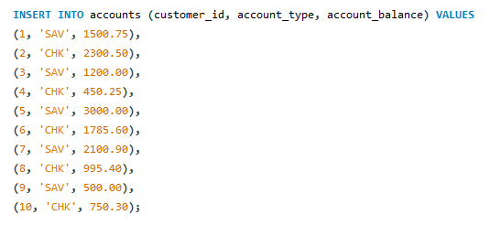

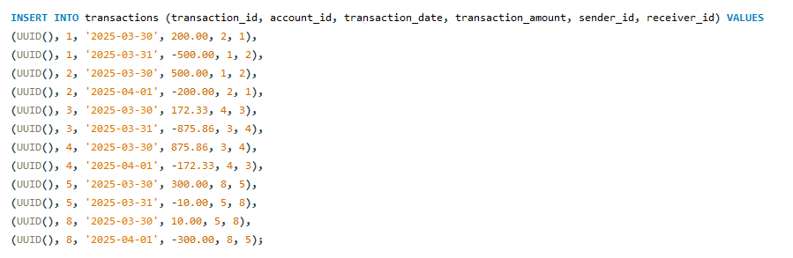

# Single-Table Queries

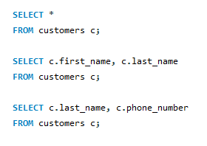

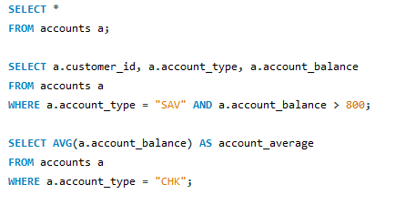

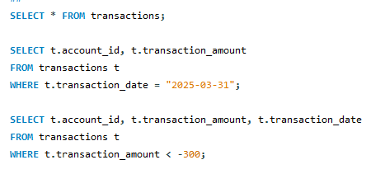

# Multi-Table Queries

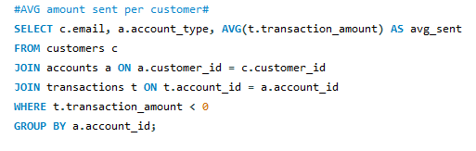

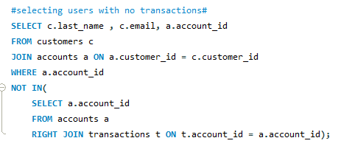

# Advanced Queries

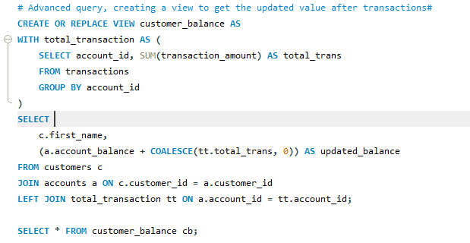

# Testing And Validation

# Single-Table Queries

SELECT * FROM customers;

This query returns every customer in the customers table.

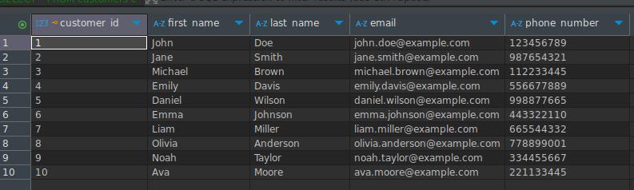

SELECT c.first_name, c.last_name FROM customers c;

This query returns the first and last name from the customers in the customers table.

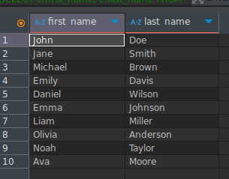

SELECT c.last_name, c.phone_number FROM customers c;

Query that returns the customers last name and phone number.

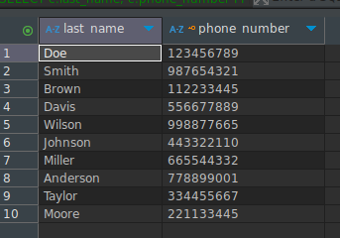

SELECT * FROM accounts;

Query that returns every account in the accounts table.

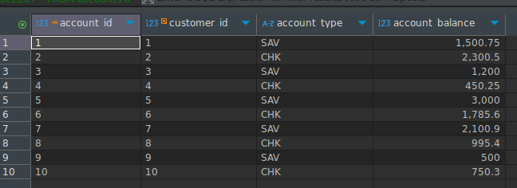

SELECT a.customer_id, a.account_type, a.account_balance

FROM accounts a

WHERE a.account_type = "SAV" AND a.account_balance > 800;

Query that returns all accounts where the account type is saving and has a balance greater than 800;

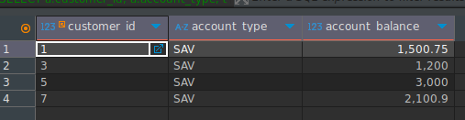

This is the return of the same query when we inform an account_type that does not exist, for example “Leasing”;

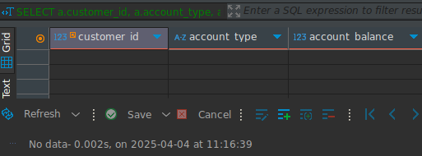

SELECT AVG(a.account_balance) AS account_average

FROM accounts a

WHERE a.account_type = "CHK";

This query returns the average balance for all checking accounts;

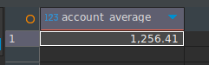

The following result happens when the wrong column is provided to calculate the average of the account balance, in this case the column used was account_id;  
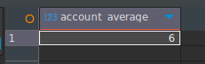

SELECT * FROM transactions;

Returns everything in the transactions table.

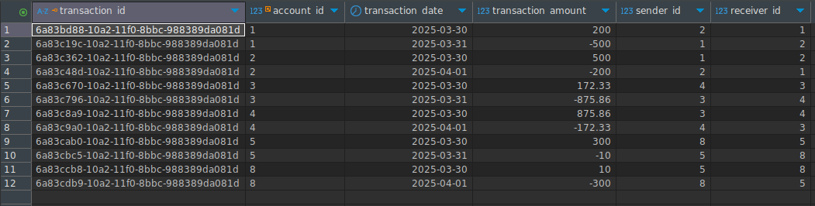

SELECT t.account_id, t.transaction_amount

FROM transactions t

WHERE t.transaction_date = "2025-03-31";

This query returns all transactions made in 2025-03-31.

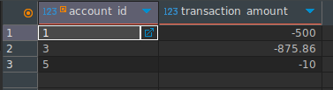

The return when an invalid date is passed for column transaction_date.

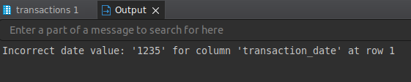

SELECT t.account_id, t.transaction_amount, t.transaction_date

FROM transactions t

WHERE t.transaction_amount < -300;

This query returns all transactions where more than 300 were debited from the sender’s account.

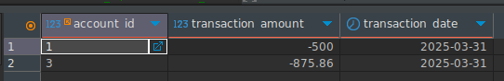

The return when an invalid data is passed to compare.

SELECT c.email, a.account_type, AVG(t.transaction_amount) AS avg_sent

FROM customers c

JOIN accounts a ON a.customer_id = c.customer_id

JOIN transactions t ON t.account_id = a.account_id

WHERE t.transaction_amount < 0

GROUP BY a.account_id;

This query retrieves the email, account_rype and the average sent by each customer who has at least one debit transaction, grouping by account_id.

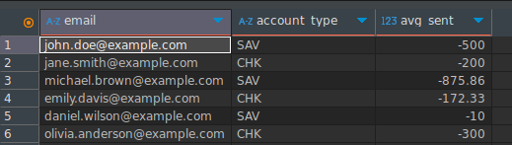

When the correct column is not specified to calculate the average, the following error will happen.

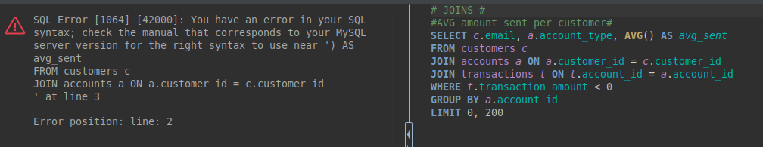

SELECT c.last_name , c.email, a.account_id

FROM customers c

JOIN accounts a ON a.customer_id = c.customer_id

WHERE a.account_id

NOT IN(

SELECT a.account_id

FROM accounts a

RIGHT JOIN transactions t ON t.account_id = a.account_id);

This query returns the customer lastname, email and account id for those customers who do not have a transaction.

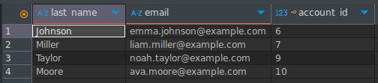

The following is the result when the right join is made with a different column, in this case account_type.

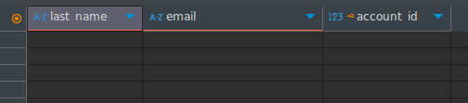

CREATE OR REPLACE VIEW customer_balance AS

WITH total_transaction AS (

SELECT account_id, SUM(transaction_amount) AS total_trans

FROM transactions

GROUP BY account_id

)

SELECT

c.first_name,

(a.account_balance + COALESCE(tt.total_trans, 0)) AS updated_balance

FROM customers c

JOIN accounts a ON c.customer_id = a.customer_id

LEFT JOIN total_transaction tt ON a.account_id = tt.account_id;

This query creates a view to get the updated account_balance after the customers make transactions.  
  
When we run : SELECT * FROM customer_balance;   
We get the current up to date information on the account_balance for all the customers.  
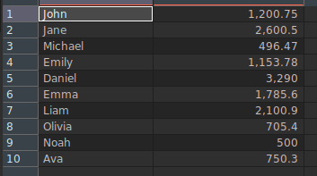

CREATE INDEX idx_tranactionDate on transactions(transaction_date);

This query creates indexes in the column transaction_date in the transactions table.

The following query returns the indexes for the transactions table.

SHOW INDEX FROM transactions;

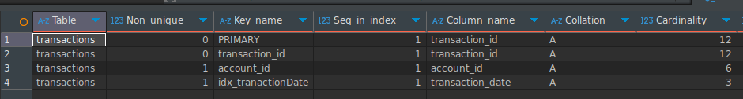

# Conclusion

Using MYSQL, we were able to create a simple and functional banking database that handles customers, accounts, and transactions.

Some potential improvements that could be made for the database would be to implement multi-user permissions, or to have more tables such as branches, etc. to create a more scalable and robust database.