Assignment Submission Report
Name:Nico Natividad
Course / Cohort: 68
Assignment: Assignment 1 - JavaScript Fundamentals
GitHub Repository Link:
Nico-Natividad/Assignment-1---JavaScript-Fundamentals
Evidence of Functionality
Frontend/UI
Attach 3 screenshots only:
- Main screen
- One interaction working
- One validation / error state

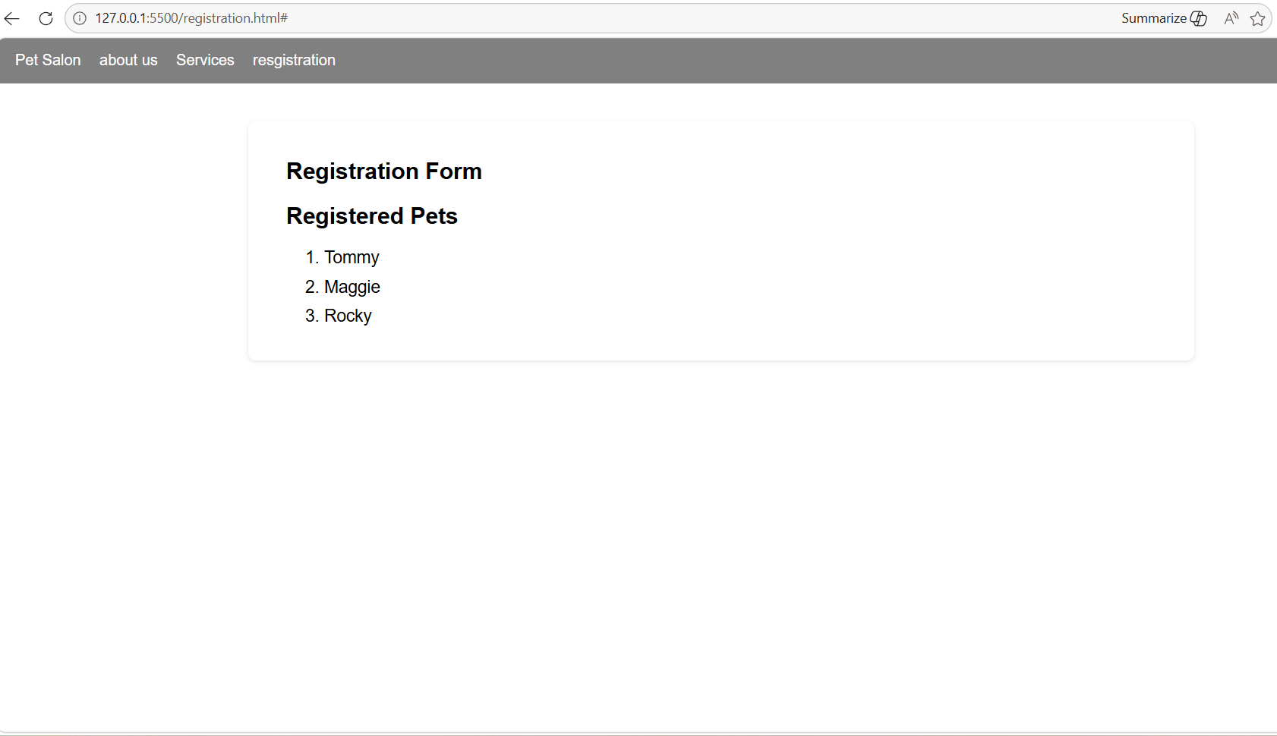

Backend/Logic
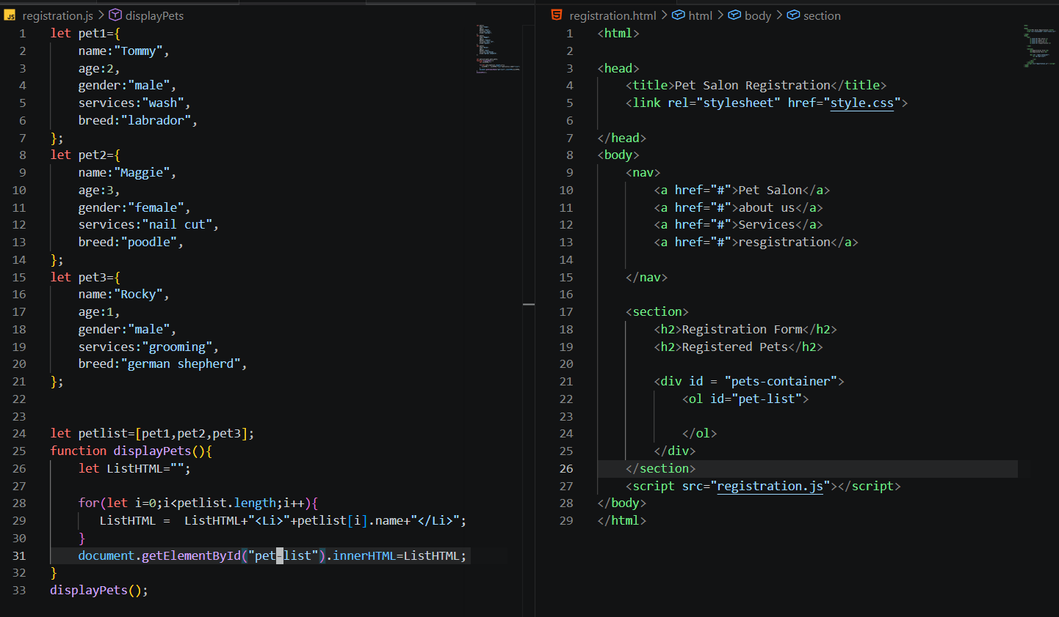
AI Disclosure (Required) – Highlight the one that applies
- I did not use AI
- I used AI for help
- AI generated parts of my code

