Assignment Submission Report

Name:Nico Natividad
Course: introduction to web api
Cohort:68
Assignment: RESTful API

GitHub Repository Link: Nico-Natividad/110-flask

Evidence of Functionality - Frontend/UI
Attach 3 screenshots only (examples):
- Main screen
- One interaction working
- One validation / error state

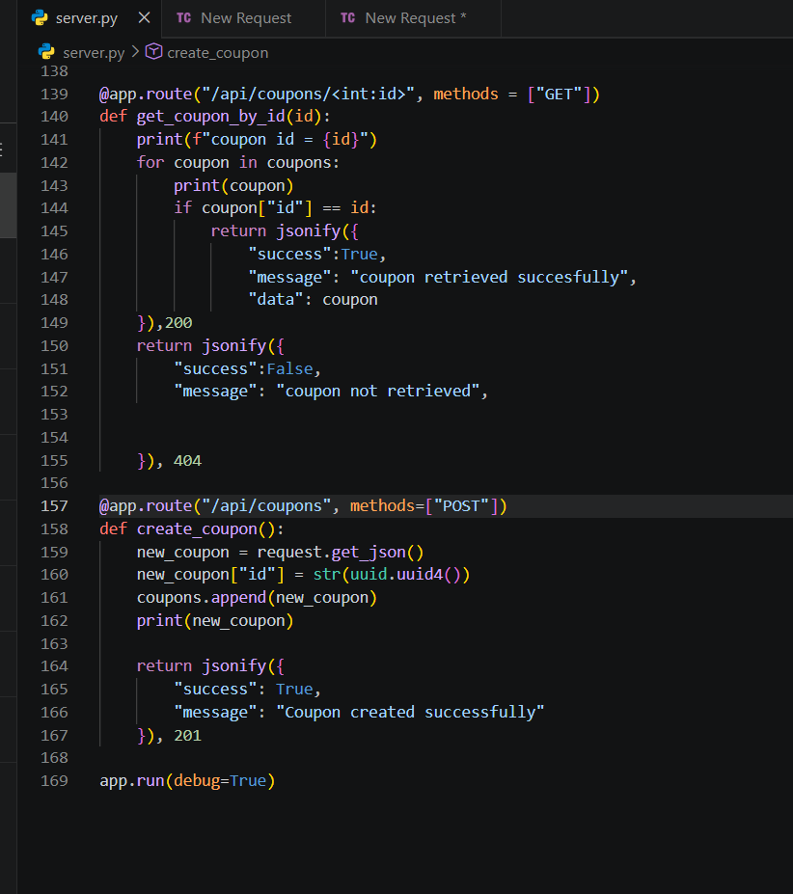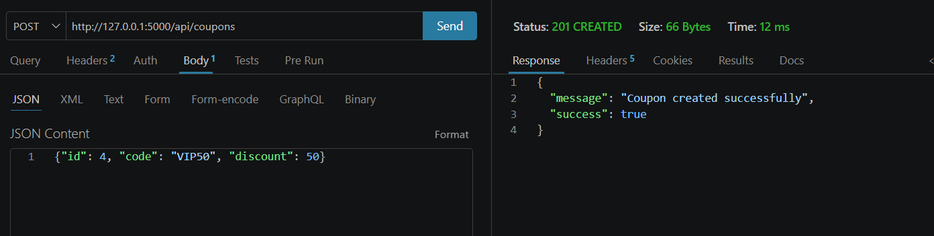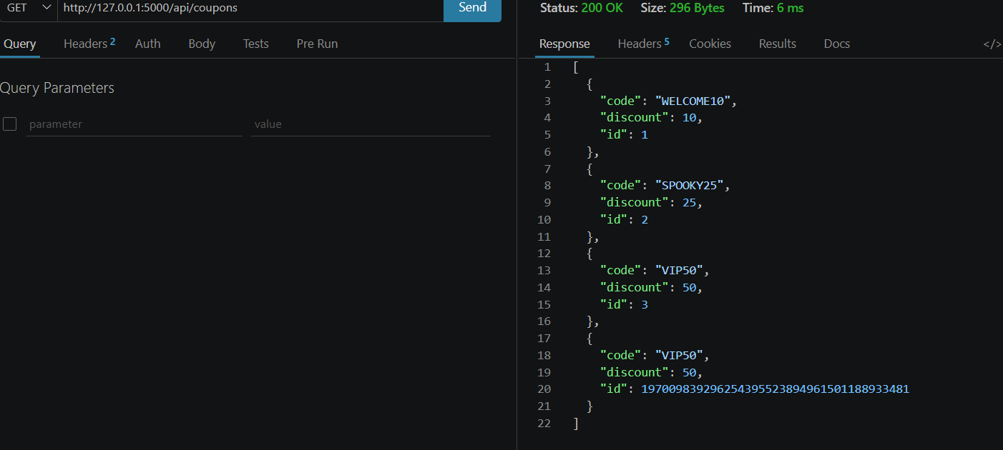

AI Disclosure (Required) – Highlight the one that applies
- I did not use AI
- I used AI for help
- AI generated parts of my code

