THE TECHNICAL UNIVERSITY OF KENYA
Department of information technology

IBL 2305: SOFTWARE DESIGN AND DEVELOPMENT
Project Documentation Package

ONLINE EXAM REGISTRATION SYSTEM
Software requirement specification, Structured Analysis (DFD/ERD) and UML Design

Cohort: BTIT Y2S2-B.Tech Computer Network and information Technology
Name: Nicole Wanjiku Kinyanjui
Reg No: SCCJ/03157/2024
Lecturer: Mr.Chrispinus Ambani
Document covers: module 1 (SRS)-Module 2 (DFD/ERD)-Module 3 (UML-Modeling)

PROJECT OVERVIEW: ONLINE EXAM REGISTRATION SYSTEM
Chapter1: Introduction
Purpose: To produce a web based platform where students can register exams after creating an account, view exams they qualify to take register and pay for the exams, reduce manual paperwork, prevent scheduling conflicts, generate reports and provide real time status updates to the administrator and students all from a single, auditable system.
Scope
The system will cover: student self-registration and login; browsing of eligible exams; exam registration and fee payment (or payment verification); automatic eligibility and capacity checks; admission slip generation; and administrator functions for exam scheduling, approval, student records, and reporting. The system will not cover the actual delivery/proctoring of exams (i.e. it is a registration system, not an exam-sitting platform), and it will not process payroll or academic transcript generation.
Problem Statement
Manual registration is still away students register for exams in many institutions: it is time consuming as many students have to queue at examinations office to fill forms and check fee balances. It also error prone as they are done manually. It also lacks real time verification of student eligibility and difficult to audit or keep up with the student growing numbers.
The Online Exam Registration System tackles the problem by digitizing the workflow. Students will be able to create an account, view exam eligibility, register and pay for the exams-while administrators manage the schedules, audit and generate reports.
Objectives
- To eliminate manual, paper-based exam registration and replace it with a secure web-based workflow.
- To automatically verify student eligibility (e.g. fee status) before allowing exam registration.
- To provide students with instant, printable admission slips upon successful registration.
- To give the examinations office a real-time view of registration numbers, capacity, and revenue collected.
- To maintain an auditable record of every registration, payment, and administrative decision.
Version Control Repository
This project uses Git and GitHub for version control. GitHub is used to store the project source code, track changes, and maintain project versions throughout development.
Item | Details
Repository Name | Student-Registration-System
Version Control | Git
Repository Platform | GitHub
Repository URL | https://github.com/yourusername/Student-Registration-System

Key actors:
- Student: Register for exams, view results and schedules receive confirmations.
- Administrator: Manages exam schedules, monitor registrations and generate reports.
Chapter 2: SOFTWARE REQUIREMENT SPECIFICATION (SRS)

- Functional requirements
- User Authentication: Students and admins must log in securely
- Student registration: System to allow new students to create an account using their registration number.
- Eligibility Validation: System must check if student meet the requirement
- Exam Registration: System to allow students to select an exam and submit registration request
- Amin dashboard: Admins can create, update or delete exam schedules, generate reports, manages student records, approve or reject registration,
- Notifications: Automated confirmation emails or SMS sent upon successful registration
- Admission Slip Generation: The system shall generate a printable pdf once registration is confirmed
- Non-functional Requirements
- Security: Data must be encrypted using HTTPS/TLS; passwords to be stored using a salted hash.
- Usability: A responsive mobile friendly interface for students
- Performance: System should response to registration request within 3 seconds
- Availability: System should be available 99% of the time during registration window
- Reliability: System should be data persistence
- Scalability: Should support increase of registered students
- Maintainability: Code should be easy to maintain

Chapter 3: system Analysis and Design
Level 0 DFD-Context Diagram
The context diagram shows the system as a single process with two external entities-student and admin-and data flows between them and the system
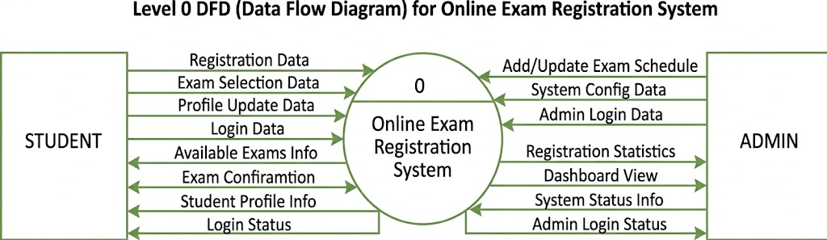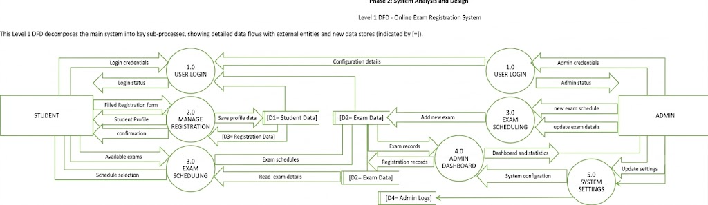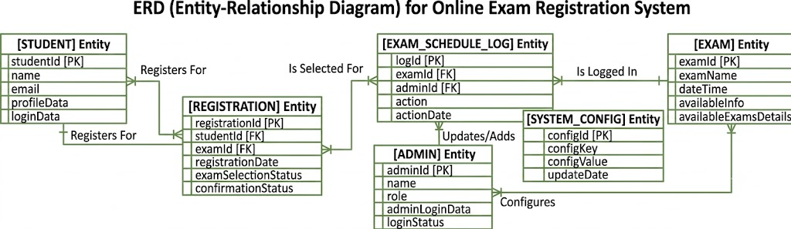
UML Modeling
- Use Case Diagram
