Bitcoin Power Law Notes – Nicolas, January 2025

Section 1: What is a Power Law?
The power law states that a relative change in one quantity results in a proportional relative change in another.

A power law distribution has the form of Y = k X ^alpha, where:
- X and Y are variables of interest
- Alpha is the law’s exponent
- k is a constant

If you plot two quantities against each other with logarithmic axes and they show a linear relationship, this indicates that the two quantities have a power law distribution.

Y = k X ^ alpha
Log(Y) = log(k) + Alpha log(X)

Key properties
- Scale invariance: if X and Y follow a power law, so do aX and bY for any a, b.
- The value of alpha determines the nature of the growth or decay
- Small changes in x can result in large changes in y when a is large
- Power law functions appear in a wide variety of phenomena, such as physics (gravity), biology (metabolic rates), economics (wealth distribution)…

A variable Y follows a power law if its rate of growth is proportional to the variable itself raised to a power. This is exactly what happens in processes showing feedback effects.

Section 2: Why do social networks exhibit power laws?
For a detailed explanation see: https://ieeexplore.ieee.org/document/8280512

Key points:
- In the paper above, the authors develop a simple but general model to predict how the number of nodes and number of links (edges) in a social network evolves through time. This model is called NETTIDE.
- The authors fitted this model to data from WeChat, arXiv, Enron and Weibo. The model predicts network growth up to 730 days ahead with only a 3% error margin.
- They observe that both nodes and links in these networks grow following a power law pattern, not sigmoid or exponential curves (as were intuitively expected).
- Why not exponential (INTUITION): because the growth rate is not exactly proportional to network size, but as time increases the growth rate decreases because people are less likely to recommend the platform to others (everything staying the same).
- Why not sigmoidal (INTUITION): sigmoidal curves are useful when the number of users is bounded, but in this situation, there are so many potential users that we can assume the number of potential users is much larger than the number of current users.
- Power law has a behaviour qualitatively in between sigmoidal and exponential curves.

More detail:
The paper introduces the NETTIDE model to capture node growth and link growth in social network. This is a simple and general model. Depending on the parameters node growth can exhibit Exponential, S curve, Power Law or Weibull growth.

The authors used the following equation to model the number of nodes in a network through time:
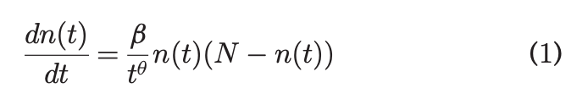

- N – n(t) term shows that the growth is constrained by the total number of potential nodes in the network (where N is the max number of nodes)
- Beta / t^theta is the fizzling/infection/excitement rate since the inception of the network. People have decaying excitement to infect their friends to join a social network.
- The scaling component theta leads to various growth dynamics, including power law growth as a special case for theta = 1. We refer to theta as temporal fizzling exponent.
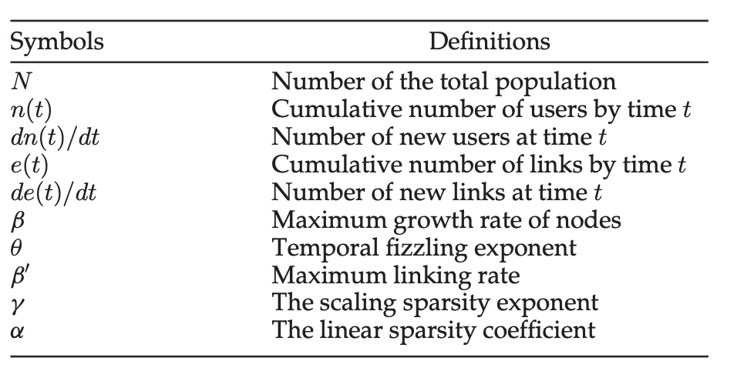

The is a more complicated equation for the number of links (edges) in the network as a function of time:

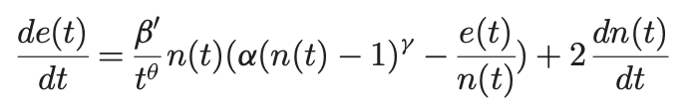
It is justified as follows:
- External Links: 2dndt captures the process where a newly arriving node bring two new links because we treat al ink as a bidirectional link
- Internal links: for each existing node, he tries to link the existing neighbors which have not yet been linked. Because of the organisational structure, less than full existing nodes can be accessed and alpha(n-1)^gamma captures the average accessible existing neigbors. The term e/n is the average number of existing neigbors to be excluded. Gamma is decided empirically.

The authors fitted this model to data from WeChat, arXiv, Enron and Weibo. They observe that both nodes and links in these networks grow following a power law pattern, not sigmoid or exponential curves.

The model predicts network growth up to 730 days ahead with only a 3% error margin.

Intuition:
Why not exponential: Growth rate proportional to network size / time since inception. As time progresses growth slows down in proportion to the elapsed time. Hence theta must be nonzero. Hence exponential is not a correct description.
Why not sigmoidal: sigmoidal curves are useful when the number of users is bounded, but in this situation, there are so many potential users that we can assume the number of potential users is much larger than the number of current users, so N – n(t) ~ N

Section 3: Why Bitcoin is a power law. Fitting the models, what parameters are used.
For more detail see: (https://medium.com/quantonomy/modeling-bitcoin-growth-with-network-theory-c476b91fdd20)

Bitcoin operates on a decentralized network, where each address represents a node, and transactions between addresses represent links. The growth of this network, in terms of the number of active addresses and the transaction volume, can be modelled using Differential Equations (DEs) as in the paper linked above.

In the article above the Giovanni fits the NETTIDE model to bitcoin dynamics. The model has very few parameters which are intuitive, and fits the data well.
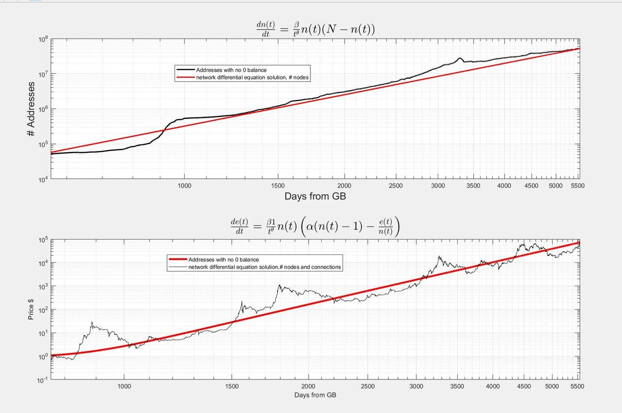

Densification: refers to how the number of connections (links/edges) within a network increases to the number of nodes (addresses). As the network grows, it can either spread out, adding new nodes with relatively few connections or it can densify, where existing nodes form more connections.
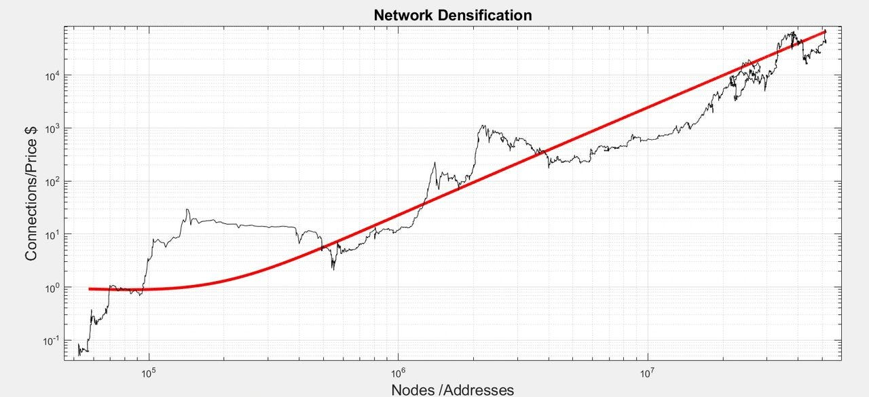
WHY DOES HE EQUATE THE PRICE TO THE NUMBER OF CONNECTIONS??
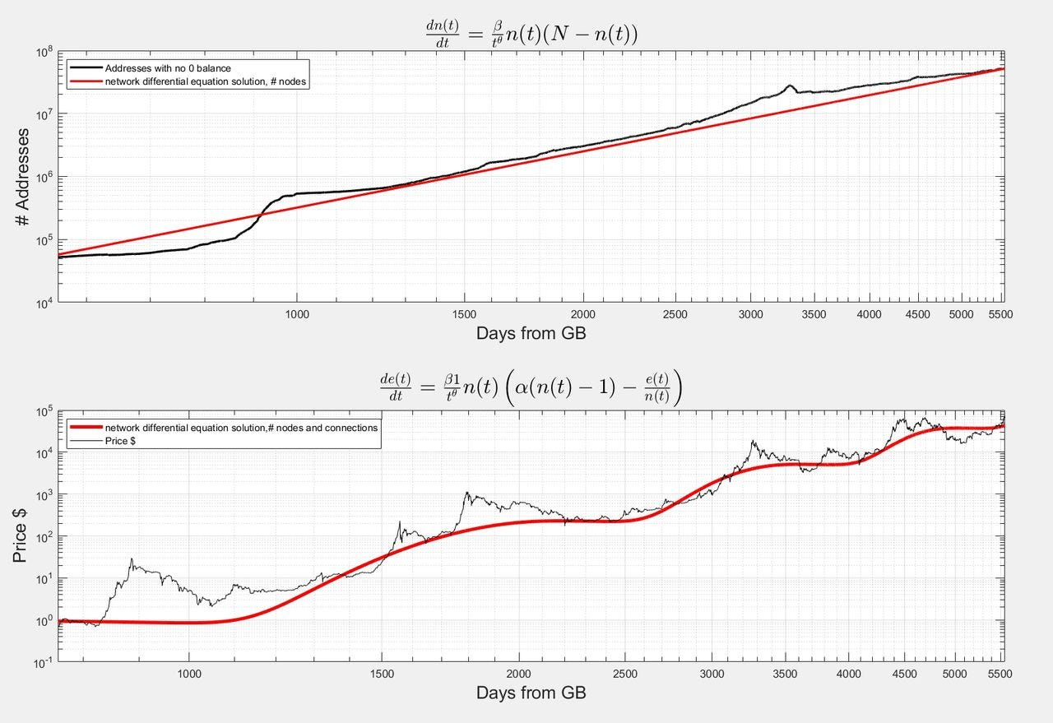
Section 4: Addressing questions about the theory

Literature Review

The Bitcoin Power Law Theory (Santostasi, 2024)
- Price, hash rate, and addresses are all power laws of each other and of time.
- Power laws are ubiquitous in nature, they are common because it can be shown mathematically that they emerge any time you have some kind of process where the output becomes the new input in an iterative process.
- This is exactly what happens with bitcoin where for example the hash rate now affects the hash rate later in an infinite loop
- Scale invariance is a property of objects or laws that remain unchanged when scales of length, energy or other variables are multiplied by a common factor.

