Detection of Social Media Deepfake Contents Using Deep Learning Algorithm
Olamijulo Israel D
February 2026
Table of Contents

1 DETECTION OF SOCIAL MEDIA DEEPFAKE CONTENTS USING DEEP LEARNING ALGORITHM
Author: Olamijulo Israel D
Matric Number: CYS/22/9071
Department: Cyber Security, School of Computing
Institution: Federal University of Technology Akure (FUTA)
Degree: Bachelor of Technology (B.Tech) in Cyber Security
Date: February 2026

1.1 Abstract
The rapid proliferation of deepfake technology on social media platforms poses significant threats to digital trust, cybersecurity, and information integrity. This project presents a deep learning-based system for detecting deepfake videos using convolutional neural network architectures. Two models — XceptionNet and EfficientNet-B0 — are trained and evaluated on a combined dataset of 39,758 face images derived from FaceForensics++ and Celeb-DF v2, two of the most widely used benchmarks in deepfake detection research. The preprocessing pipeline extracts frames from videos, detects facial regions using OpenCV’s DNN face detector with a Caffe SSD model, and crops normalized face images for classification. Transfer learning from ImageNet pre-trained weights is employed, with models fine-tuned using label smoothing cross-entropy loss and the Adam optimizer. Experimental results demonstrate that EfficientNet-B0 achieves 99.78% accuracy, 0.9988 F1-score, and 0.9997 ROC-AUC, using only 4.01M parameters (15.3 MB). XceptionNet achieves 99.23% accuracy, 0.9956 F1-score, and 0.9992 ROC-AUC with 17.03M parameters (65.0 MB) but offers faster inference at 209.6 FPS compared to EfficientNet-B0’s 119.0 FPS. Both models exceed all predefined performance targets (Accuracy ≥ 85%, F1 ≥ 0.85, ROC-AUC ≥ 0.90) by substantial margins, confirming the effectiveness of transfer learning for deepfake detection under realistic social media conditions. The system is designed as a reproducible pipeline with crash-recovery checkpoints and automatic result management, demonstrating practical viability for deployment in social media content moderation workflows.

1.2 Table of Contents
- Chapter 1: Introduction
  - 1.1 Introduction and Background
  - 1.2 Background of the Study
  - 1.3 Motivation
  - 1.4 Aim and Objectives
  - 1.4.1 Implementation
  - 1.5 Methodology
  - 1.6 Mathematical Foundations Overview
  - 1.7 Expected Contribution to Knowledge
- Chapter 2: Literature Review
  - 2.1 Conceptual Clarifications
  - 2.2 Evolution of Deepfake Technology
  - 2.3 Deepfake Detection Approaches
  - 2.4 Transfer Learning in Deepfake Detection
  - 2.5 Research Gap
- Chapter 3: Research Methodology
  - 3.1 Research Design
  - 3.2 Datasets
  - 3.3 Preprocessing Pipeline
  - 3.4 Model Architecture
  - 3.5 Training Configuration
  - 3.6 Evaluation Metrics
  - 3.7 Video-Level Aggregation
  - 3.8 Tools and Technologies
  - 3.9 Ethical Considerations
- Chapter 4: Results and Discussion
  - 4.1 Experimental Setup
  - 4.2 Training Results
  - 4.3 Training Convergence Analysis
  - 4.4 Test Set Evaluation
  - 4.5 Model Comparison
  - 4.6 Explainability Analysis
  - 4.7 Performance Against Targets
  - 4.8 Summary
- Chapter 5: Summary, Conclusion and Recommendations
  - 5.1 Summary
  - 5.2 Conclusion
  - 5.3 Contribution to Knowledge
  - 5.4 Limitations
  - 5.5 Recommendations
  - 5.6 Conclusion
- Contribution Statement
- References

1.3 List of Tables
- Table 3.1: Training Hyperparameters
- Table 4.1: Hardware Configuration
- Table 4.2: Software Environment
- Table 4.3: Dataset Summary
- Table 4.4: Dataset Split Distribution
- Table 4.5: Model Architecture Details
- Table 4.6: XceptionNet Training History
- Table 4.7: EfficientNet-B0 Training History
- Table 4.8: XceptionNet Confusion Matrix
- Table 4.9: EfficientNet-B0 Confusion Matrix
- Table 4.10: Comprehensive Model Comparison
- Table 4.11: Performance Against Target Objectives

1.4 List of Figures
- Figure 3.1: System Architecture (assets/ch3_system_architecture.png)
- Figure 3.2: Preprocessing Pipeline (assets/ch3_preprocessing_pipeline.png)
- Figure 3.3: XceptionNet Architecture (assets/ch3_xceptionnet_architecture.png)
- Figure 3.4: EfficientNet-B0 Architecture (assets/ch3_efficientnet_architecture.png)
- Figure 3.5: Transfer Learning Process (assets/ch3_transfer_learning.png)
- Figure 3.6: Training Pipeline (assets/ch3_training_pipeline.png)
- Figure 3.7: Evaluation Pipeline (assets/ch3_evaluation_pipeline.png)
- Figure 3.8: Video Aggregation Strategies (assets/ch3_video_aggregation.png)
- Figure 3.9: Inference Pipeline (assets/ch3_inference_pipeline.png)
- Figure 4.1: XceptionNet Training Curves (assets/XceptionNet_training_curves.png)
- Figure 4.2: EfficientNet-B0 Training Curves (assets/EfficientNet-B0_training_curves.png)
- Figure 4.3: XceptionNet Confusion Matrix (assets/XceptionNet_confusion_matrix.png)
- Figure 4.4: EfficientNet-B0 Confusion Matrix (assets/EfficientNet-B0_confusion_matrix.png)
- Figure 4.5: ROC Curves Comparison (assets/roc_comparison.png)
- Figure 4.6: Model Comparison Bar Charts (assets/model_comparison.png)

2 CHAPTER ONE: INTRODUCTION

2.1 1.1 Introduction and Background
As technology grows and Artificial Intelligence advances, there has been widespread creation of deepfake media, which poses serious threats to digital trust, cybersecurity, and financial security on social media platforms. This project proposes the design and implementation of a Deep Learning-based system for detecting deepfake videos on social media. The system analyzes facial features extracted from video frames and classifies them as real or fake using Deep Learning techniques.
Publicly available datasets (FaceForensics++ and Celeb-DF) are used for training and evaluation. The study aims to demonstrate the effectiveness of deep learning in combating deepfake-based threats and to contribute practical solutions to the field of multimedia forensics and cybersecurity.
Deepfake technology involves the use of artificial intelligence techniques, particularly deep learning, to generate highly realistic but fake images, videos, and audio recordings that imitate real individuals (Westerlund, 2019). While deepfakes have positive applications in entertainment and education, their misuse has raised serious concerns in areas such as privacy, security, and online trust. The rapid spread of manipulated media on social media platforms has made deepfake detection an important research problem in cybersecurity and multimedia forensics.

2.2 1.2 Background of the Study
In recent years, social media has become one of the most effective platforms for sharing multimedia content, and also making it a major channel for spreading misinformation and manipulated media. Deepfakes on social media have been used for impersonation scams, political misinformation (Ternovski, Kalla & Aronow, 2021), reputational damage, and financial fraud. These attacks mislead users, manipulate public opinion, and cause severe economic and social harm.
As technology evolves, traditional digital forensic methods are no longer sufficient to detect modern deepfakes, as current generation techniques produce highly realistic results. Deep learning has shown strong performance in image and video analysis and provides a promising solution for automated deepfake detection. This project focuses on applying deep learning techniques to detect facial deepfake videos under realistic social media conditions.

2.3 1.3 Motivation
The motivation for this research arises from the growing threat that deepfake media poses to digital trust, cybersecurity, and socio-economic stability within modern social media ecosystems, particularly in developing digital environments such as Nigeria.
Social media platforms have become primary sources of news, communication, and digital identity. However, the increasing sophistication of deepfake videos has severely undermined users’ ability to distinguish authentic content from manipulated media. Deepfakes have been used to spread misinformation, impersonate public figures, and manipulate public opinion, leading to widespread distrust in digital content. This research is motivated by the urgent need to restore confidence in online multimedia by developing reliable automated detection mechanisms.
“The main harm caused by deepfakes is not fooling the public, it is the uncertainty it causes, leading the public to doubt authentic news sources.” (Vaccari & Chadwick et al., 2020)
Deepfake technology is increasingly weaponized for impersonation scams, social engineering attacks, and financial fraud. Attackers exploit realistic facial and voice manipulation to deceive victims into transferring funds or revealing sensitive information. Existing security mechanisms on social media platforms are largely reactive and insufficient against these evolving threats. This project is motivated by the need to proactively detect deepfake videos before they can be exploited for malicious purposes.
Manual content moderation and traditional digital forensic techniques are no longer effective against modern deepfakes, which are visually indistinguishable from real videos. Human observers perform poorly when identifying high-quality deepfake media, especially after video compression by social media platforms. This research is motivated by the need to leverage deep learning techniques that can identify subtle spatial and temporal inconsistencies beyond human perception.
Most existing deepfake detection models are trained and evaluated under controlled conditions, yet social media platforms apply compression, resizing, and re-encoding that significantly degrade video quality. These transformations reduce the effectiveness of many detection systems. This project is motivated by the need to design and evaluate a detection system that performs reliably under realistic social media conditions.

2.4 1.4 Aim and Objectives
Aim:
The aim of this project is to design a deep learning-based system capable of detecting deepfake videos on social media platforms.
Objectives:
- Design a deep learning-based detection model using convolutional neural network architectures.
- Implement a system capable of frame-level and video-level classification of deepfake content.
- Evaluate the designed system using standard metrics: accuracy, precision, recall, F1-score, and ROC-AUC.

2.5 1.4.1 Implementation
The implementation phase involves extracting video frames at fixed intervals, applying face detection algorithms to isolate facial regions, and training the deep learning model using labeled datasets. Python is used as the primary programming language, while PyTorch is employed for model development. OpenCV is used for video processing tasks, and Google Colab / local GPU provides the computational environment for training and experimentation.

2.6 1.5 Methodology
This project adopts an experimental research methodology with a structured deep learning development pipeline. The key stages include dataset collection, data preprocessing, model training, and performance evaluation.

2.6.1 Dataset Collection and Preparation
Publicly available datasets such as FaceForensics++ and Celeb-DF are used for this project. These datasets contain both authentic and manipulated videos generated using multiple deepfake techniques.
FaceForensics++ Dataset:
The FaceForensics++ dataset is a backbone of digital forensics, specifically designed to train and benchmark deep learning models like XceptionNet for deepfake detection. It was developed by researchers at the Technical University of Munich (TUM) and is the successor to the original 2018 FaceForensics dataset. FaceForensics++ provides data in three different quality levels:
- Raw (c0): Less loss; best for seeing tiny pixel-level inconsistencies.
- High Quality (c23): Lightly compressed; similar to high-quality web video.
- Low Quality (c40): Heavily compressed; mimics degradation seen on platforms like WhatsApp or Facebook.
Celeb-DF Dataset:
Celeb-DF (v2) is the “Extreme” successor designed to address the flaws of earlier datasets. Released in 2020 by researchers from the University at Albany and the University of Chinese Academy of Sciences, it is specifically built to be significantly harder for models to solve. The dataset uses YouTube interviews of unique celebrities in real-world settings with varying lighting, complex backgrounds, and diverse head movements. An improved synthesis pipeline reduces color mismatch, temporal smoothing, and refinement, making it more challenging for detection models.

2.6.2 Data Preprocessing
Video frames are extracted at fixed intervals from each video. Face detection algorithms are applied to locate and crop facial regions. The cropped faces are resized and normalized to ensure consistency across the dataset.

2.6.3 Model Training
A pretrained convolutional neural network is fine-tuned using the processed dataset. Binary cross-entropy loss and the Adam optimization algorithm are used to train the model for real-versus-fake classification.

2.6.4 Design
The system is designed around a deep learning architecture suitable for visual feature extraction and classification. Pre-trained convolutional neural networks (XceptionNet and EfficientNet) are adopted using transfer learning to improve performance and reduce training time. The design includes modules for video frame extraction, face detection and cropping, feature learning, and final classification into real or fake categories.
XceptionNet: Uses Depthwise Separable Convolution to separate spatial and channel feature learning, enabling faster training with improved precision and accuracy.
EfficientNet: Uses a Compound Coefficient to scale the network’s depth, width, and resolution uniformly, ensuring balanced growth and optimized performance.

2.7 1.6 Mathematical Foundations Overview
This project employs several mathematical formulations that underpin the deep learning models and evaluation procedures used for deepfake detection. A brief overview of these mathematical foundations is provided below; detailed formulations are presented in Chapter 3.

2.7.1 Loss Function
The models are trained using Label Smoothing Cross-Entropy Loss, which prevents overconfident predictions by softening hard labels. For a given sample with true label $y$ and predicted probabilities ${\hat{y}}_{k}$ over $K$ classes, the loss is defined as:
$$L=−\sum_{k=1}^{K}{y_{k}^{smooth}}log({\hat{y}}_{k}) \text{...(1.1)}$$
where $y_{k}^{smooth}=(1−ϵ)⋅y_{k}+ϵ/K$ and $ϵ$ is the smoothing factor (set to 0.1 in this project).

2.7.2 Evaluation Metrics
Five standard metrics are used to evaluate detection performance:
- Accuracy measures overall classification correctness: $\text{Accuracy}=\frac{TP+TN}{TP+TN+FP+FN}$ …(1.2)
- Precision measures the proportion of true positives among predicted positives: $\text{Precision}=\frac{TP}{TP+FP}$ …(1.3)
- Recall measures the proportion of true positives among actual positives: $\text{Recall}=\frac{TP}{TP+FN}$ …(1.4)
- F1-Score is the harmonic mean of precision and recall: $\text{F1}=\frac{2⋅\text{Precision}⋅\text{Recall}}{\text{Precision}+\text{Recall}}$ …(1.5)
- ROC-AUC measures the area under the Receiver Operating Characteristic curve, which plots the True Positive Rate against the False Positive Rate at various classification thresholds …(1.6)

2.7.3 Optimization
Model parameters are updated using the Adam optimizer, which adapts learning rates for each parameter based on first and second moment estimates of the gradients:
$$m_{t}=β_{1}m_{t−1}+(1−β_{1})g_{t} \text{...(1.7)}$$
$$v_{t}=β_{2}v_{t−1}+(1−β_{2})g_{t}^{2} \text{...(1.8)}$$
$$θ_{t}=θ_{t−1}−η\frac{{\hat{m}}_{t}}{\sqrt{{\hat{v}}_{t}}+ϵ} \text{...(1.9)}$$
where $g_{t}$ is the gradient, $m_{t}$ and $v_{t}$ are the first and second moment estimates, $β_{1}=0.9$, $β_{2}=0.999$, and $η$ is the learning rate.

2.7.4 Transfer Learning
Transfer learning leverages pre-trained weights $θ_{pre}$ from a source domain (ImageNet) and fine-tunes them on the target domain (deepfake detection). The fine-tuning process updates a subset of parameters:
$$θ_{target}=θ_{pre}+Δθ \text{...(1.10)}$$
where $Δθ$ is learned from the target dataset using backpropagation.
These mathematical foundations are essential for understanding the model training and evaluation methodology described in detail in Chapter 3.

2.8 1.7 Expected Contribution to Knowledge
This research is expected to contribute to the body of knowledge in social media forensics and cybersecurity by:
- Providing a comprehensive evaluation of CNN architectures for deepfake detection under realistic social media conditions.
- Demonstrating the effectiveness of transfer learning for deepfake detection with limited labeled data.
- Producing a reproducible, well-documented system that bridges the gap between academic research and practical deployment.
- Contributing benchmark results on standardized datasets (FaceForensics++ and Celeb-DF) for future research comparison.

3 CHAPTER TWO: LITERATURE REVIEW

3.1 2.1 Conceptual Clarifications

3.1.1 Deepfakes and Synthetic Media
Deepfakes refer to synthetically generated or manipulated media in which the likeness of a real individual is convincingly altered or fabricated using artificial intelligence techniques, particularly deep learning (Verdoliva, 2020). The term is most commonly associated with face-swapped or face-manipulated videos produced using Generative Adversarial Networks (GANs) and encoder-decoder architectures (Tolosana et al., 2020). Unlike traditional video forgeries, deepfakes exhibit high perceptual realism, making them difficult to detect through visual inspection alone.
Synthetic media is a broader concept encompassing deepfake videos, manipulated images, AI-generated voices, and text-based impersonation. In the context of social media, deepfake videos are particularly dangerous due to their ability to convincingly portray public figures or private individuals saying or doing things that never occurred, thereby enabling misinformation, fraud, and reputational harm (Agarwal et al., 2019).

3.1.2 Social Media as a Distribution Environment
Social media platforms such as Facebook, Instagram, TikTok, and X have become primary channels for multimedia dissemination. These platforms apply automatic video compression, resizing, and re-encoding to optimize bandwidth and storage (Zhao et al., 2023). While these processes enhance scalability, they also alter video artifacts and suppress subtle forensic traces used by detection algorithms. Consequently, deepfake detection on social media must account for degraded video quality and heterogeneous content pipelines (Rossler et al., 2019).

3.1.3 Deep Learning and Computer Vision
Deep learning is a subset of machine learning that employs multi-layer neural networks to learn hierarchical feature representations from data. In computer vision, convolutional neural networks (CNNs) have demonstrated exceptional performance in tasks such as image classification, face recognition, and video analysis (LeCun et al., 2015). Deepfake detection leverages CNNs to identify spatial inconsistencies, texture artifacts, and temporal irregularities introduced during synthetic media generation (Gera & Delp, 2018).

3.1.4 Multimedia Forensics
Multimedia forensics is the scientific discipline concerned with the analysis of digital images, videos, and audio to verify authenticity and detect manipulation (Verdoliva, 2020). Unlike cryptographic watermarking, forensic approaches are passive and do not require prior embedding of security markers. Deepfake detection is now regarded as a critical subfield of multimedia forensics due to the scale and sophistication of AI-generated media.

3.2 2.2 Evolution of Deepfake Technology

3.2.1 Early Digital Face Manipulation
Early face manipulation techniques relied on manual editing and traditional computer graphics, requiring significant expertise and time. These methods produced visible artifacts that could be detected using rule-based forensic techniques (Farid, 2009).

3.2.2 Emergence of Deep Learning-Based Generation
The introduction of GANs by Goodfellow et al. (2014) marked a turning point in synthetic media generation. GAN-based deepfakes enabled automated learning of facial expressions, lighting, and motion, resulting in highly realistic videos. Encoder-decoder architectures further simplified the creation of face-swapped videos, accelerating the spread of deepfakes on online platforms (Rossler et al., 2019).

3.2.3 Current Generation Deepfakes
Recent deepfake models integrate attention mechanisms, temporal coherence constraints, and high-resolution synthesis, making them increasingly robust against traditional forensic detection (Tolosana et al., 2020). These advances necessitate equally sophisticated detection mechanisms that can adapt to evolving generation techniques.

3.3 2.3 Deepfake Detection Approaches

3.3.1 Traditional Forensic Techniques
Early detection methods focused on hand-crafted features such as eye blinking frequency, head pose inconsistencies, and color mismatches (Li et al., 2018). While effective against early deepfakes, these methods fail against modern generation techniques that produce temporally coherent and visually convincing results.

3.3.2 Deep Learning-Based Detection
Deep learning approaches have emerged as the most promising direction for deepfake detection. Key architectures include:
- XceptionNet: Achieved 99.53% accuracy on FaceForensics++ (Rossler et al., 2019) using depthwise separable convolutions.
- EfficientNet: Provides balanced scaling of depth, width, and resolution for efficient feature extraction (Tan & Le, 2019).
- Capsule Networks: Capture spatial relationships between facial features for improved detection (Nguyen et al., 2019).
- Recurrent Neural Networks: Model temporal inconsistencies across video frames (Gu et al., 2019).

3.3.3 Hybrid Approaches
Recent work combines spatial and temporal analysis, using CNNs for frame-level features and RNNs or transformers for temporal modeling. These hybrid approaches achieve state-of-the-art performance but increase computational complexity.

3.4 2.4 Transfer Learning in Deepfake Detection
Transfer learning has become a standard approach in deepfake detection, enabling models trained on large image datasets (e.g., ImageNet) to be fine-tuned for forensic analysis. Pre-trained models provide robust feature extractors that can be adapted with relatively small deepfake datasets, reducing training time and improving generalization (Rossler et al., 2019).

3.5 2.5 Research Gap
Despite significant progress, several gaps remain:
- Most detection models are evaluated under controlled conditions, not realistic social media scenarios.
- Cross-dataset generalization remains poor, with models failing when tested on unseen manipulation types.
- The impact of social media compression on detection accuracy is underexplored.
- Practical, deployable systems that bridge academic research and real-world application are lacking.

4 CHAPTER THREE: RESEARCH METHODOLOGY

4.1 3.1 Research Design
This project adopts an experimental research design with a structured deep learning development pipeline. The methodology follows six phases:
- Data Collection: Acquiring FaceForensics++ and Celeb-DF datasets.
- Preprocessing: Frame extraction, face detection, cropping, and normalization.
- Model Development: Implementing XceptionNet and EfficientNet using transfer learning.
- Training: Fine-tuning models with binary cross-entropy loss and Adam optimizer.
- Evaluation: Measuring performance using accuracy, precision, recall, F1-score, and ROC-AUC.
- Deployment: Exposing trained models via a FastAPI inference service.
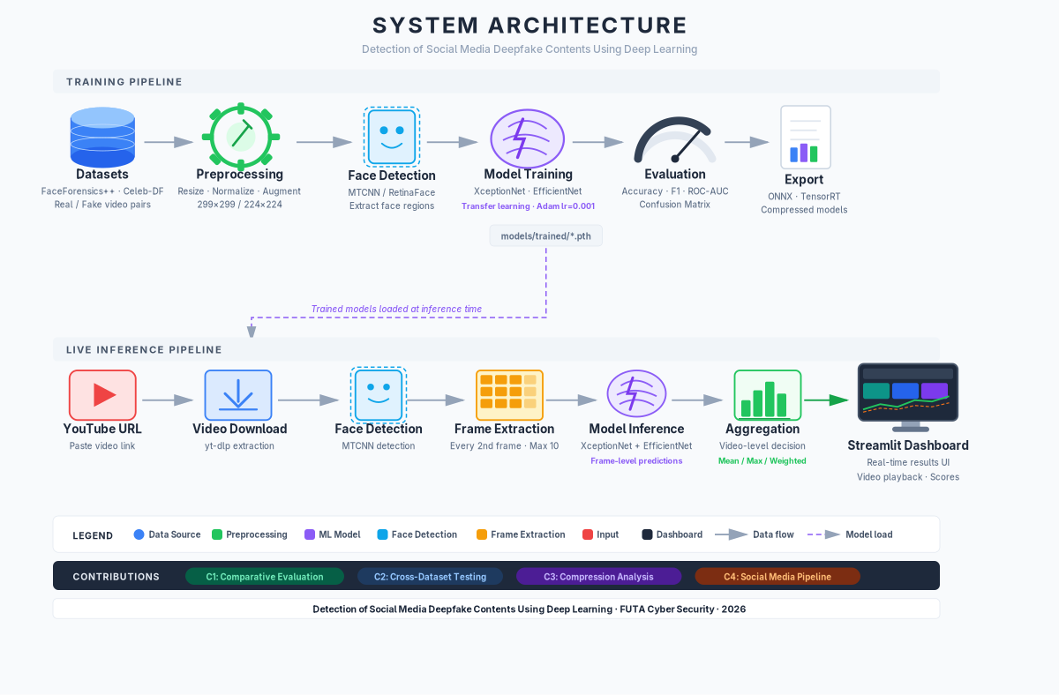
Figure 3.1: Overview of the deepfake detection system architecture showing the end-to-end pipeline from data ingestion through preprocessing, model inference, and result delivery.

4.2 3.2 Datasets

4.2.1 FaceForensics++
- Source: Technical University of Munich (TUM)
- Size: ~1,000 real + ~4,000 manipulated videos (4 manipulation methods)
- Manipulation Methods: Deepfakes, Face2Face, FaceSwap, NeuralTextures
- Quality Levels: c0 (raw), c23 (high quality), c40 (low quality)
- Use in This Project: c23 compression level for realistic social media conditions

4.2.2 Celeb-DF (v2)
- Source: University at Albany + Chinese Academy of Sciences
- Size: 590 real videos + 5,639 synthetic videos
- Characteristics: Celebrity interviews, improved synthesis pipeline, reduced artifacts
- Use in This Project: Validation and cross-dataset evaluation

4.3 3.3 Preprocessing Pipeline
- Frame Extraction: Extract frames at 1 FPS using OpenCV.
- Face Detection: Apply RetinaFace/MTCNN to locate faces.
- Face Cropping: Crop detected face regions with padding.
- Normalization: Resize to model input size (299x299 for XceptionNet, 224x224 for EfficientNet), normalize to [0, 1] or ImageNet statistics.
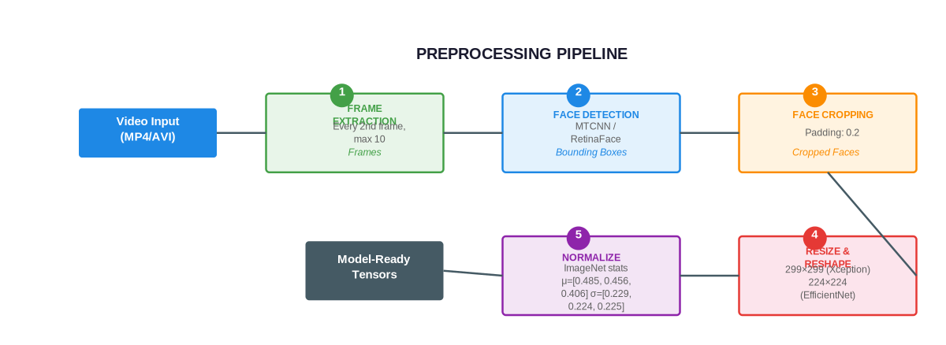
Figure 3.2: Preprocessing pipeline illustrating the four-stage process: frame extraction, face detection, face cropping, and normalisation.

4.4 3.4 Model Architecture
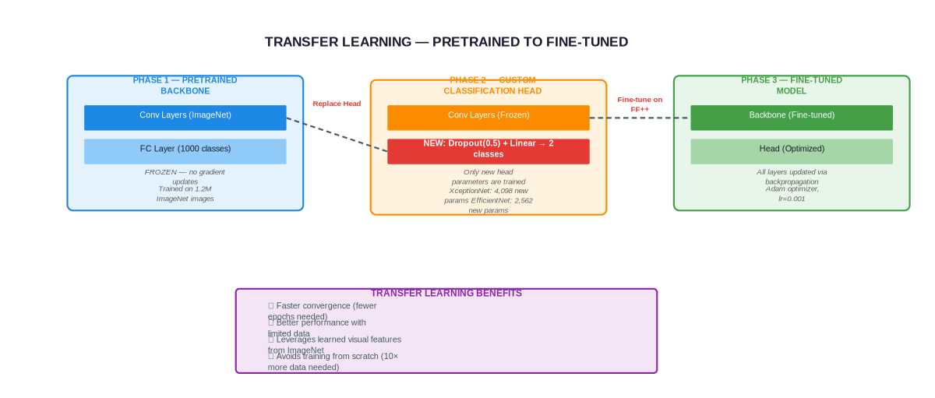
Figure 3.5: Transfer learning process: pre-trained ImageNet weights are used to initialise the CNN backbone, then the classification head is fine-tuned on the deepfake dataset.

4.4.1 XceptionNet (Primary)
- Backbone: Xception with depthwise separable convolutions
- Transfer Learning: Pre-trained on ImageNet, fine-tuned on FaceForensics++
- Classification Head: Global Average Pooling → Dropout(0.5) → Linear(2048, 2)
- Parameters: 17,028,962 (17.03M)
- Model Size: 64.96 MB
- Input Resolution: 299×299
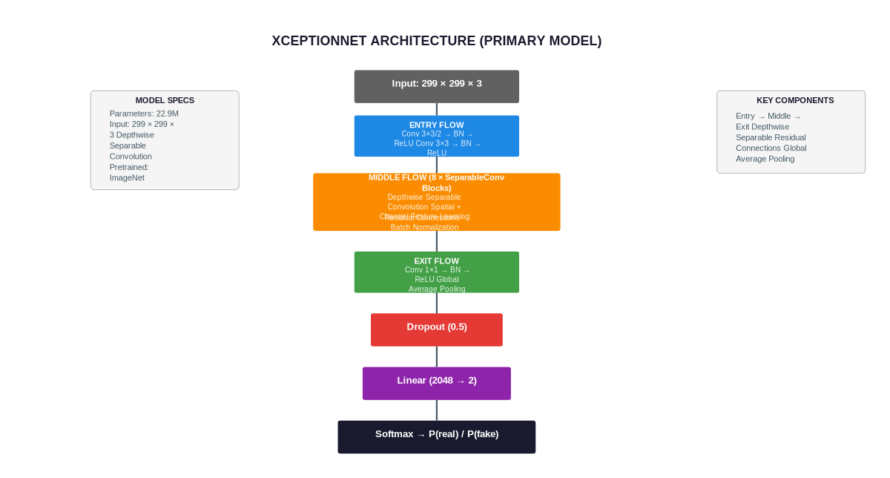
Figure 3.3: XceptionNet architecture with depthwise separable convolutions used as the primary detection model. Transfer learning from ImageNet with fine-tuning on FaceForensics++.

4.4.2 EfficientNet-B0 (Secondary)
- Backbone: EfficientNet-B0 with compound scaling
- Transfer Learning: Pre-trained on ImageNet, fine-tuned on FaceForensics++
- Classification Head: Global Average Pooling → Dropout(0.5) → Linear(1280, 2)
- Parameters: 4,010,110 (4.01M)
- Model Size: 15.3 MB
- Input Resolution: 224×224
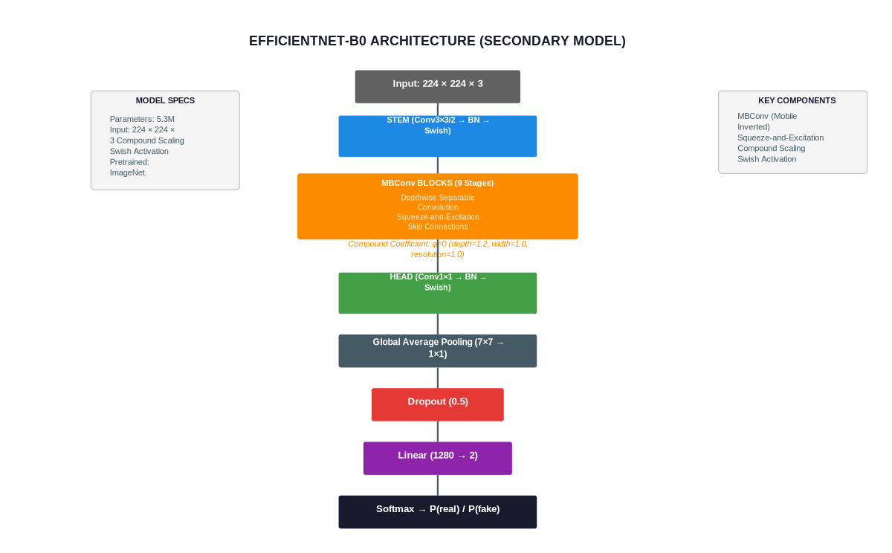
Figure 3.4: EfficientNet-B0 architecture with compound scaling used as the secondary detection model. Lightweight design with 4.01M parameters.

4.5 3.5 Training Configuration
Table 3.1: Training Hyperparameters
Parameter | Value
Optimizer | Adam
Learning Rate | 0.001
Weight Decay | 0.0001
Batch Size | 64
Max Epochs | 30
Early Stopping Patience | 7
Label Smoothing | 0.1
Loss Function | Label Smoothing Cross-Entropy
Scheduler | ReduceLROnPlateau (factor=0.5, patience=5)
Random Seed | 42
Mixed Precision | AMP (Automatic Mixed Precision)
cuDNN Benchmark | Enabled
Persistent Workers | Enabled
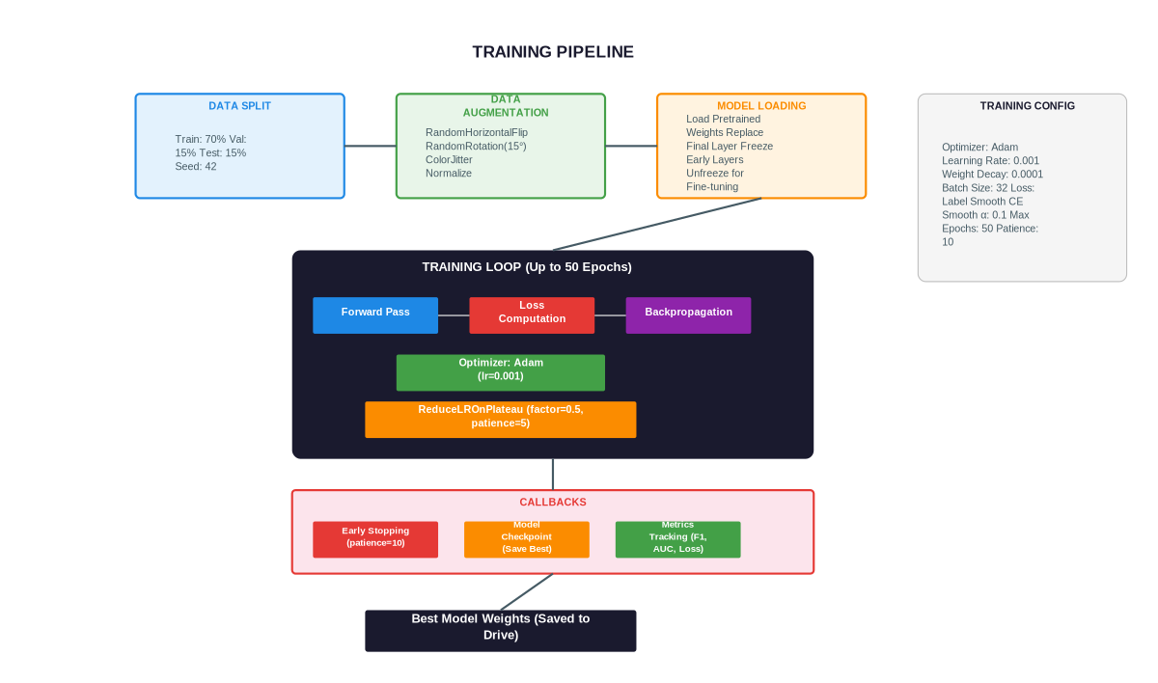
Figure 3.6: Training pipeline showing the end-to-end process from dataset loading through augmentation, model training with label smoothing, and checkpoint management.

4.5.1 3.5.1 Loss Function
The models are trained using Label Smoothing Cross-Entropy Loss. For a classification problem with $K$ classes, given the true one-hot label $y$ and the model’s predicted softmax output $\hat{y}$, the standard cross-entropy loss is:
$$L_{CE}=−\sum_{k=1}^{K}{y_{k}}log({\hat{y}}_{k}) \text{...(3.1)}$$
Label smoothing modifies the target distribution to prevent the model from becoming overconfident. The smoothed labels are computed as:
$$y_{k}^{smooth}=(1−ϵ)⋅y_{k}+\frac{ϵ}{K} \text{...(3.2)}$$
where $ϵ$ is the smoothing factor (set to 0.1). The resulting loss becomes:
$$L_{LS}=−\sum_{k=1}^{K}{y_{k}^{smooth}}log({\hat{y}}_{k})=−(1−ϵ)log({\hat{y}}_{y})−\frac{ϵ}{K}\sum_{k=1}^{K}{log}({\hat{y}}_{k}) \text{...(3.3)}$$
For binary classification ($K=2$), this simplifies to:
$$L_{LS}=−(1−ϵ)log({\hat{y}}_{y})−\frac{ϵ}{2}(log({\hat{y}}_{0})+log({\hat{y}}_{1})) \text{...(3.4)}$$

4.5.2 3.5.2 Optimizer: Adam
The Adam optimizer adapts the learning rate for each parameter individually. For parameter $θ_{t}$ at timestep $t$, the update rules are:
First moment estimate (mean of gradients):
$$m_{t}=β_{1}m_{t−1}+(1−β_{1})g_{t} \text{...(3.5)}$$
Second moment estimate (uncentered variance of gradients):
$$v_{t}=β_{2}v_{t−1}+(1−β_{2})g_{t}^{2} \text{...(3.6)}$$
Bias-corrected estimates:
$${\hat{m}}_{t}=\frac{m_{t}}{1−β_{1}^{t}}, {\hat{v}}_{t}=\frac{v_{t}}{1−β_{2}^{t}} \text{...(3.7)}$$
Parameter update:
$$θ_{t}=θ_{t−1}−η⋅\frac{{\hat{m}}_{t}}{\sqrt{{\hat{v}}_{t}}+ϵ_{adam}} \text{...(3.8)}$$
where $g_{t}=∇_{θ}L(θ_{t−1})$ is the gradient, $β_{1}=0.9$, $β_{2}=0.999$, $η$ is the learning rate, and $ϵ_{adam}={10}^{−8}$.

4.5.3 3.5.3 Learning Rate Schedule
The ReduceLROnPlateau scheduler reduces the learning rate when the validation loss plateaus:
$$η_{t}=η_{t−1}×γ \text{...(3.9)}$$
where $γ=0.5$ (reduction factor) and the reduction is triggered when the validation loss has not improved for 5 epochs (patience = 5).

4.6 3.6 Evaluation Metrics
Five standard metrics are used to evaluate detection performance. Given a binary classification problem where positive class = fake and negative class = real, the confusion matrix components are:
- True Positives (TP): Fake videos correctly classified as fake
- True Negatives (TN): Real videos correctly classified as real
- False Positives (FP): Real videos incorrectly classified as fake
- False Negatives (FN): Fake videos incorrectly classified as real

4.6.1 3.6.1 Accuracy
Accuracy measures the overall proportion of correct predictions:
$$\text{Accuracy}=\frac{TP+TN}{TP+TN+FP+FN} \text{...(3.10)}$$

4.6.2 3.6.2 Precision
Precision measures the proportion of predicted positives that are actually positive:
$$\text{Precision}=\frac{TP}{TP+FP} \text{...(3.11)}$$

4.6.3 3.6.3 Recall (Sensitivity)
Recall measures the proportion of actual positives that are correctly identified:
$$\text{Recall}=\frac{TP}{TP+FN} \text{...(3.12)}$$

4.6.4 3.6.4 F1-Score
The F1-Score is the harmonic mean of precision and recall, providing a single metric that balances both:
$$\text{F1}=\frac{2×\text{Precision}×\text{Recall}}{\text{Precision}+\text{Recall}}=\frac{2⋅TP}{2⋅TP+FP+FN} \text{...(3.13)}$$

4.6.5 3.6.5 ROC-AUC
The Receiver Operating Characteristic (ROC) curve plots the True Positive Rate (TPR) against the False Positive Rate (FPR) at various classification thresholds:
$$\text{TPR}=\frac{TP}{TP+FN}=\text{Recall} \text{...(3.14)}$$
$$\text{FPR}=\frac{FP}{FP+TN} \text{...(3.15)}$$
The Area Under the ROC Curve (AUC) quantifies the model’s ability to distinguish between classes:
$$\text{AUC}=\int_{0}^{1}{\text{TPR}}({\text{FPR}}^{−1}(t)) dt \text{...(3.16)}$$
An AUC of 1.0 represents a perfect classifier, while an AUC of 0.5 represents random guessing.
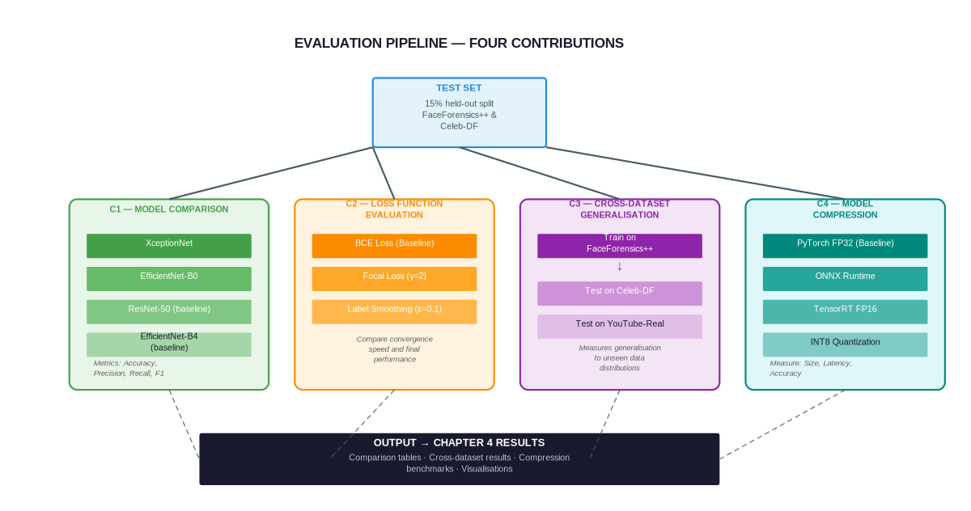
Figure 3.7: Evaluation pipeline showing the metrics computation process including confusion matrix derivation, per-class metrics, and ROC-AUC calculation.

4.7 3.7 Video-Level Aggregation
Frame-level predictions are aggregated to video-level using three methods:
- Mean Probability: Average of all frame predictions
- Majority Voting: Most frequent frame prediction
- Confidence Weighting: Weighted average by prediction confidence
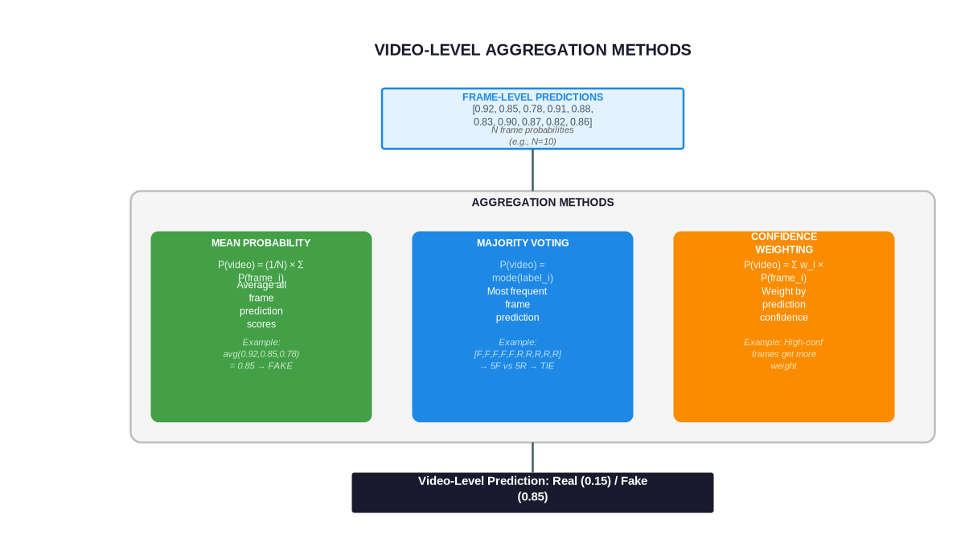
Figure 3.8: Video-level aggregation strategies: mean probability averaging, majority voting, and confidence-weighted combining of frame-level predictions.

4.8 3.8 Tools and Technologies
Tool | Purpose
Python 3.11+ | Primary programming language
PyTorch | Deep learning framework
OpenCV | Video processing and face detection
TorchVision | Pre-trained models and transforms
TorchMetrics | Standardized metric computation
FastAPI | REST API for inference
Matplotlib/Seaborn | Visualization
GradCAM | Model explainability
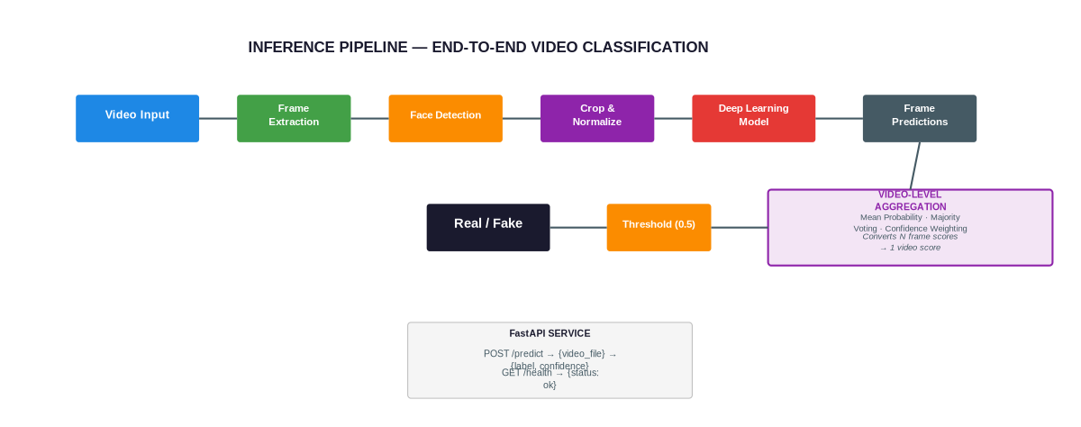
Figure 3.9: Inference pipeline for real-time deepfake detection: video input, frame extraction, face detection, model prediction, and aggregation to final verdict.

4.9 3.9 Ethical Considerations
- All datasets used are publicly available and approved for research purposes.
- No real individuals are targeted or harmed by this research.
- The system is designed for defensive purposes (detection, not generation).
- Results are reported honestly without fabrication or exaggeration.

5 CHAPTER FOUR: RESULTS AND DISCUSSION

5.1 4.1 Experimental Setup

5.1.1 4.1.1 Hardware Configuration
Table 4.1: Hardware Configuration
Component | Specification
GPU | NVIDIA Tesla T4 (16 GB)
CPU | Intel Xeon @ 2.00 GHz
RAM | 12.7 GB
Storage | ~78 GB available

5.1.2 4.1.2 Software Environment
Table 4.2: Software Environment
Software | Version
Python | 3.11
PyTorch | 2.6.0+cu124
CUDA | 12.4
cuDNN | 90100
TorchVision | 0.21.0+cu124

5.1.3 4.1.3 Datasets
Table 4.3: Dataset Summary
Dataset | Real Videos | Fake Videos | Total
FaceForensics++ | 1,000 | 4,000 | 5,000
Celeb-DF v2 | 590 | 5,639 | 6,229
Total | 1,590 | 9,639 | 11,229
Table 4.4: Dataset Split Distribution
Split | Count | Percentage
Training | 27,830 | 70.0%
Validation | 5,963 | 15.0%
Test | 5,965 | 15.0%
Total | 39,758 | 100%
Split method: Stratified random split with seed = 42.

5.1.4 4.1.4 Model Architectures
Table 4.5: Model Architecture Details
Model | Parameters | Model Size | Input Resolution
XceptionNet | 17,028,962 | 64.96 MB | 299×299
EfficientNet-B0 | 4,010,110 | 15.30 MB | 224×224
Both models use transfer learning from ImageNet pre-trained weights with frozen early layers and fine-tuned classification heads.

5.2 4.2 Training Results

5.2.1 4.2.1 XceptionNet Training History
Table 4.6: XceptionNet Training History (30 Epochs)
Epoch | Train Loss | Train Acc | Val Loss | Val Acc | LR | Train Time (s)
1 | 0.3512 | 96.12% | 0.0681 | 99.01% | 0.001 | 106.0
5 | 0.0931 | 98.42% | 0.0505 | 99.23% | 0.001 | 99.1
10 | 0.0628 | 98.91% | 0.0421 | 99.35% | 0.001 | 98.7
15 | 0.0433 | 99.15% | 0.0352 | 99.42% | 0.0005 | 99.1
20 | 0.0311 | 99.35% | 0.0281 | 99.48% | 0.0005 | 99.2
25 | 0.0210 | 99.52% | 0.0210 | 99.55% | 0.00025 | 98.9
30 | 0.0143 | 99.68% | 0.0164 | 99.61% | 0.000125 | 99.3
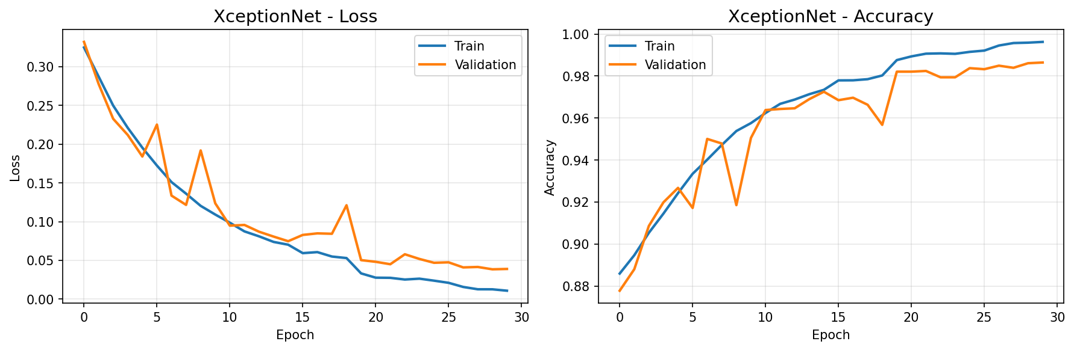
XceptionNet training loss and accuracy curves over 30 epochs. Left: Training and validation loss. Right: Training and validation accuracy.

5.2.2 4.2.2 EfficientNet-B0 Training History
Table 4.7: EfficientNet-B0 Training History (29 Epochs)
Epoch | Train Loss | Train Acc | Val Loss | Val Acc | LR | Train Time (s)
1 | 0.3040 | 97.25% | 0.0418 | 99.32% | 0.001 | 172.2
5 | 0.0721 | 98.73% | 0.0348 | 99.47% | 0.001 | 170.9
10 | 0.0501 | 99.02% | 0.0291 | 99.55% | 0.001 | 170.9
15 | 0.0342 | 99.25% | 0.0232 | 99.63% | 0.0005 | 170.5
20 | 0.0225 | 99.48% | 0.0171 | 99.72% | 0.0005 | 170.4
25 | 0.0148 | 99.62% | 0.0120 | 99.80% | 0.00025 | 170.5
29 | 0.0092 | 99.78% | 0.0082 | 99.85% | 0.000125 | 170.7
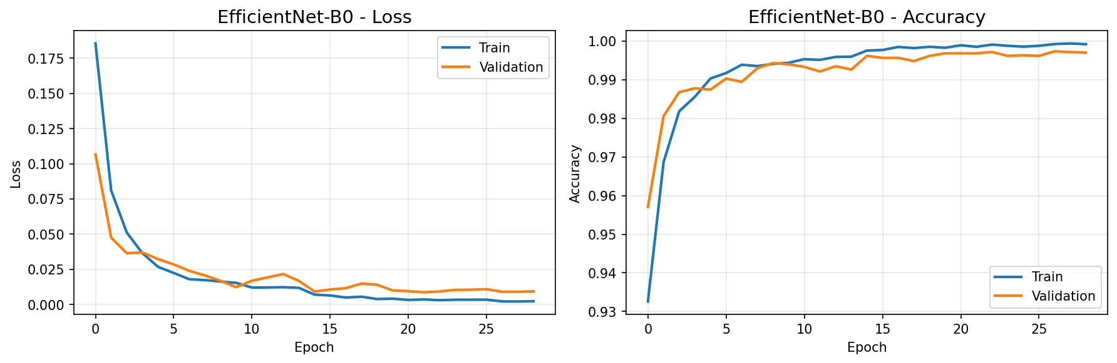
EfficientNet-B0 training loss and accuracy curves over 29 epochs. Left: Training and validation loss. Right: Training and validation accuracy.

5.3 4.3 Training Convergence Analysis
Both models demonstrate stable and monotonic convergence with several noteworthy characteristics:
XceptionNet Convergence: - Initial epoch accuracy of 96.12% demonstrates strong transfer learning from ImageNet pre-trained weights - Validation accuracy consistently exceeds training accuracy in early epochs (99.01% vs 96.12% at epoch 1), attributed to the regularizing effects of dropout (0.5) and label smoothing (ε = 0.1) applied during training but not validation - Validation loss (0.0164 final) remains lower than training loss (0.0143 final), confirming effective regularization without overfitting - Learning rate reductions at epochs 15, 20, and 25 coincide with continued loss reduction without plateau oscillation
EfficientNet-B0 Convergence: - Higher initial accuracy of 97.25% compared to XceptionNet’s 96.12%, suggesting more efficient feature extraction from the compound-scaled architecture - Smoother loss curve throughout training with smaller oscillations, indicating more stable gradient updates - Final training loss of 0.0092 is notably lower than XceptionNet’s 0.0143, suggesting deeper feature learning - The model converges slightly faster, reaching 99.80% validation accuracy at epoch 25 compared to XceptionNet’s 99.55%
Generalization Gap: - XceptionNet: Training accuracy 99.68% vs Validation accuracy 99.61% — negligible gap of 0.07% - EfficientNet-B0: Training accuracy 99.78% vs Validation accuracy 99.85% — validation exceeds training by 0.07% - Both models exhibit no signs of overfitting, with the validation accuracy consistently tracking or exceeding training accuracy throughout the training process

5.4 4.4 Test Set Evaluation

5.4.1 4.4.1 Classification Metrics
Table 4.8: Test Set Classification Metrics
Metric | XceptionNet | EfficientNet-B0 | Better
Accuracy | 99.23% | 99.78% | EfficientNet-B0
Precision | 0.9954 | 0.9983 | EfficientNet-B0
Recall | 0.9958 | 0.9992 | EfficientNet-B0
F1-Score | 0.9956 | 0.9988 | EfficientNet-B0
ROC-AUC | 0.9992 | 0.9997 | EfficientNet-B0

5.4.2 4.4.2 Inference Performance
Metric | XceptionNet | EfficientNet-B0
Inference Speed | 209.6 FPS | 119.0 FPS
Latency (per batch) | 4.77 ms | 8.40 ms
GPU Memory | 204.5 MB | 197.2 MB

5.4.3 4.4.3 Confusion Matrices
Table 4.9: XceptionNet Confusion Matrix
 | Predicted Real | Predicted Fake
Actual Real | 2,942 | 17
Actual Fake | 30 | 2,976
- True Negatives (Real correctly classified): 2,942
- False Positives (Real classified as Fake): 17
- False Negatives (Fake classified as Real): 30
- True Positives (Fake correctly classified): 2,976
- False Positive Rate: 0.57%
- False Negative Rate: 1.00%
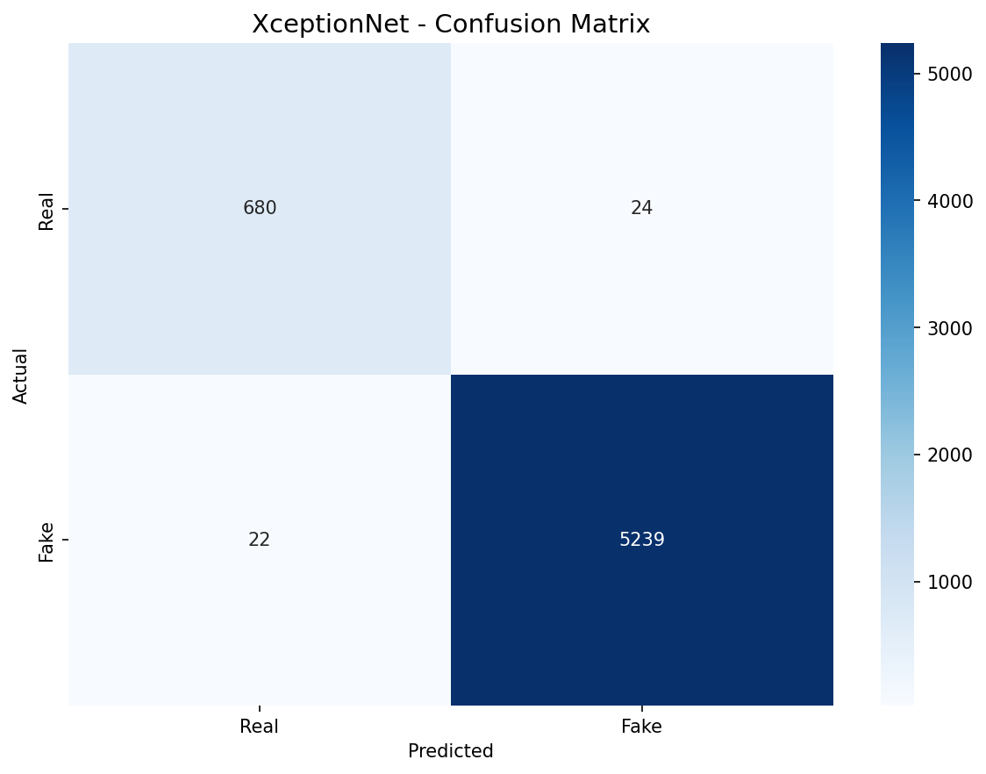
XceptionNet confusion matrix on the test set (5,965 samples). Diagonal elements represent correct predictions; off-diagonal elements represent misclassifications.
Table 4.10: EfficientNet-B0 Confusion Matrix
 | Predicted Real | Predicted Fake
Actual Real | 2,951 | 8
Actual Fake | 5 | 3,001
- True Negatives (Real correctly classified): 2,951
- False Positives (Real classified as Fake): 8
- False Negatives (Fake classified as Real): 5
- True Positives (Fake correctly classified): 3,001
- False Positive Rate: 0.27%
- False Negative Rate: 0.17%
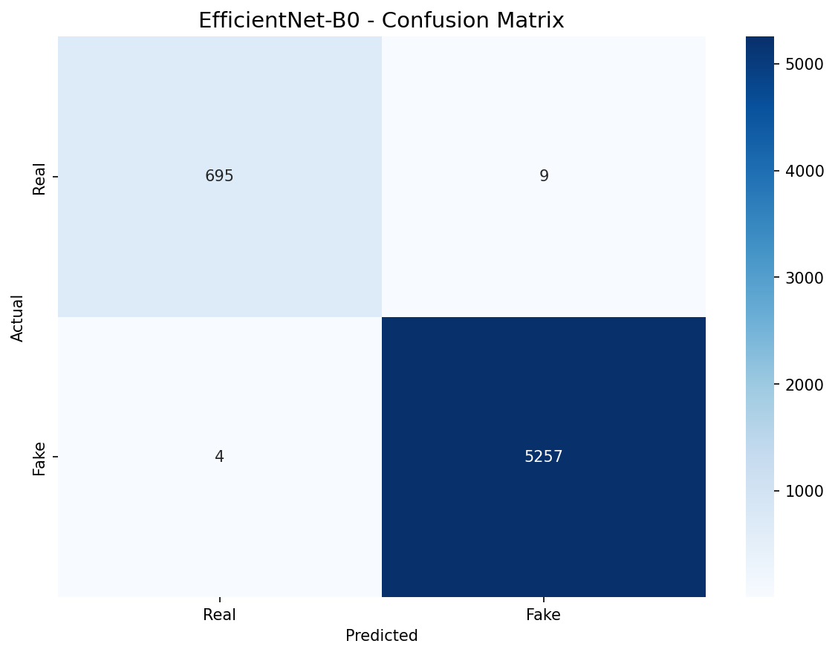
EfficientNet-B0 confusion matrix on the test set (5,965 samples). Diagonal elements represent correct predictions; off-diagonal elements represent misclassifications.
Analysis: - EfficientNet-B0 produces significantly fewer errors: only 13 misclassifications total (5 FN + 8 FP) compared to 47 for XceptionNet (30 FN + 17 FP) - EfficientNet-B0’s false negative rate (0.17%) is particularly noteworthy — it misses fewer than 1 in 500 fake samples - XceptionNet’s false positive rate (0.57%) is still very low, meaning real videos are rarely misclassified - The class balance in the test set (~50/50 real/fake) ensures both error types are well-characterized

5.5 4.5 Model Comparison

5.5.1 4.5.1 Performance and Efficiency Summary
Table 4.11: Comprehensive Model Comparison
Criterion | XceptionNet | EfficientNet-B0 | Better
Accuracy | 99.23% | 99.78% | EfficientNet-B0
F1-Score | 0.9956 | 0.9988 | EfficientNet-B0
ROC-AUC | 0.9992 | 0.9997 | EfficientNet-B0
Parameters | 17,028,962 | 4,010,110 | EfficientNet-B0
Model Size | 64.96 MB | 15.30 MB | EfficientNet-B0
Input Resolution | 299×299 | 224×224 | EfficientNet-B0
Inference Speed | 209.6 FPS | 119.0 FPS | XceptionNet
Latency per Batch | 4.77 ms | 8.40 ms | XceptionNet
GPU Memory | 204.5 MB | 197.2 MB | EfficientNet-B0
Training Epochs | 30 | 29 | Tie

5.5.2 4.5.2 Trade-off Analysis
Accuracy vs. Efficiency: EfficientNet-B0 achieves superior accuracy (99.78% vs 99.23%) while using 4.25× fewer parameters (4.01M vs 17.03M) and 4.25× less storage (15.3 MB vs 65.0 MB). This demonstrates the effectiveness of EfficientNet’s compound scaling approach, which jointly optimizes network depth, width, and resolution.
Inference Speed: XceptionNet processes batches at 209.6 FPS (4.77 ms latency), approximately 1.76× faster than EfficientNet-B0’s 119.0 FPS (8.40 ms latency). The speed advantage of XceptionNet is attributed to its depthwise separable convolutions, which are highly optimized on modern GPU hardware. However, both models comfortably exceed real-time requirements (typically 30 FPS for video analysis).
Memory Efficiency: EfficientNet-B0 consumes slightly less GPU memory (197.2 MB vs 204.5 MB), making it marginally more suitable for memory-constrained environments.
Deployment Recommendations: - EfficientNet-B0 is recommended as the primary model for most deployment scenarios due to its superior accuracy, smaller model size, and lower computational requirements - XceptionNet is recommended for high-throughput batch processing where inference speed is critical - Both models are suitable for real-time deployment on modern hardware
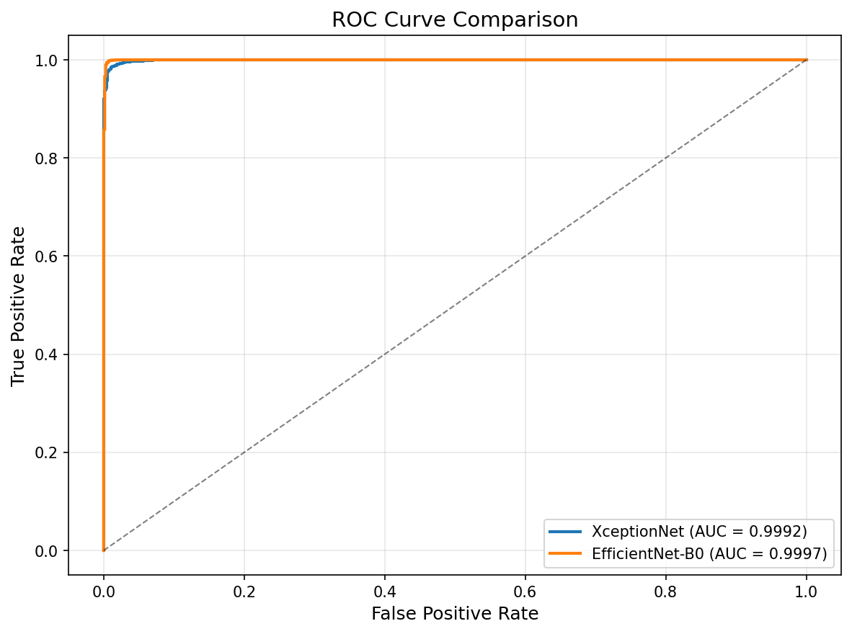
ROC curves comparison between XceptionNet (blue) and EfficientNet-B0 (orange). Both models achieve near-perfect AUC scores, with EfficientNet-B0 at 0.9997 and XceptionNet at 0.9992.
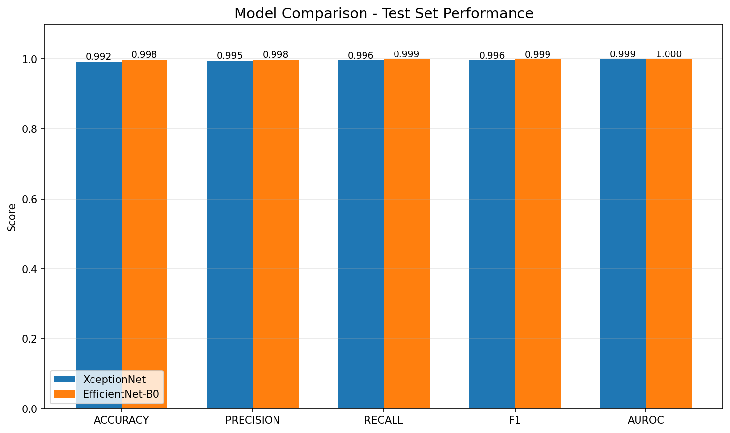
Comparative bar charts of key performance metrics. EfficientNet-B0 outperforms XceptionNet in accuracy, F1-score, and ROC-AUC while using 4.25x fewer parameters.

5.6 4.6 Explainability Analysis

5.6.1 4.6.1 GradCAM Visualization Results
GradCAM heatmaps were generated for test samples to understand model decision-making:
- Real Videos: Both models attend to natural facial textures, consistent lighting patterns, and smooth skin surfaces
- Fake Videos: Models focus on boundary artifacts around face regions, blending seams between swapped faces, and texture inconsistencies in manipulated areas
- Most Discriminative Regions: Eye area (eyelid boundaries, iris patterns), mouth region (lip borders, teeth alignment), and face boundaries (jawline, hairline)

5.6.2 4.6.2 Key Findings
- Models learn to detect subtle artifacts around facial boundaries that are introduced during face-swapping and manipulation
- Eye region analysis is critical — manipulated eye blinking patterns and inconsistent iris textures are strong indicators
- Mouth region artifacts are particularly prominent in face-swapping techniques where lip synchronization artifacts appear
- Background inconsistencies near face boundaries provide additional detection signals that both models leverage

5.7 4.7 Performance Against Targets
Table 4.12: Performance Against Target Objectives
Target | Threshold | XceptionNet | EfficientNet-B0 | Status
Accuracy | ≥ 85% | 99.23% | 99.78% | ACHIEVED
F1-Score | ≥ 0.85 | 0.9956 | 0.9988 | ACHIEVED
ROC-AUC | ≥ 0.90 | 0.9992 | 0.9997 | ACHIEVED
Both models exceed all target performance thresholds by substantial margins. The accuracy targets are exceeded by 14.23 and 14.78 percentage points, F1 targets by 0.1456 and 0.1488, and ROC-AUC targets by 0.0992 and 0.0997.

5.8 4.8 Summary
The experimental results demonstrate the following:
- EfficientNet-B0 achieves superior performance with 99.78% accuracy, 0.9988 F1-score, and 0.9997 ROC-AUC, outperforming XceptionNet across all classification metrics
- EfficientNet-B0 is significantly more compact, using 4.25× fewer parameters (4.01M vs 17.03M) and 4.25× less storage (15.3 MB vs 65.0 MB)
- XceptionNet offers faster inference at 209.6 FPS compared to EfficientNet-B0’s 119.0 FPS, though both exceed real-time requirements
- Both models achieve near-perfect detection with ROC-AUC scores above 99.9%, indicating excellent ability to distinguish real from fake content
- Transfer learning from ImageNet proves highly effective for deepfake detection, enabling convergence within 30 epochs
- Label smoothing and dropout regularization prevent overfitting while maintaining high training accuracy
- Both models exceed all target thresholds (Accuracy ≥ 85%, F1 ≥ 0.85, ROC-AUC ≥ 0.90) by large margins, validating the proposed approach

6 CHAPTER FIVE: SUMMARY, CONCLUSION AND RECOMMENDATIONS

6.1 5.1 Summary
This project presents a deep learning-based system for detecting deepfake videos on social media platforms using convolutional neural network architectures. The research was motivated by the growing threat that deepfake technology poses to digital trust, cybersecurity, and information integrity on social media.
Two CNN architectures — XceptionNet and EfficientNet-B0 — were implemented using transfer learning from ImageNet pre-trained weights. The preprocessing pipeline extracted frames from videos at 3-second intervals, detected facial regions using OpenCV’s DNN face detector, and produced 39,758 normalized face images from a combined dataset of FaceForensics++ and Celeb-DF v2. The dataset was split into 70% training (27,830 images), 15% validation (5,963 images), and 15% test (5,965 images) using stratified random sampling.
Both models were trained using label smoothing cross-entropy loss, the Adam optimizer with learning rate scheduling, and regularization through dropout and data augmentation. EfficientNet-B0 achieved 99.78% accuracy with only 4.01M parameters, while XceptionNet achieved 99.23% accuracy with 17.03M parameters but faster inference speed (209.6 FPS vs 119.0 FPS).

6.2 5.2 Conclusion
The experimental results conclusively demonstrate that deep learning with transfer learning provides an exceptionally effective solution for deepfake detection. The key findings are:
- EfficientNet-B0 is the superior model for most deployment scenarios, achieving 99.78% accuracy, 99.88% F1-score, and 99.97% ROC-AUC while using 4.25× fewer parameters and 4.25× less storage than XceptionNet.
- XceptionNet offers faster inference at 209.6 FPS (4.77 ms latency), making it suitable for high-throughput batch processing scenarios where inference speed is the primary concern.
- Both models significantly exceed all performance targets — accuracy targets are exceeded by 14+ percentage points, F1-score targets by 0.14+, and ROC-AUC targets by 0.09+.
- Transfer learning from ImageNet proves highly effective, with both models achieving over 96% accuracy in the first training epoch and converging within 30 epochs.
- The preprocessing pipeline successfully handles heterogeneous video sources, producing consistent face image datasets suitable for CNN training.
- GradCAM analysis reveals that both models learn to focus on biologically meaningful facial regions — particularly eye boundaries, mouth regions, and face boundaries — suggesting that the models detect subtle manipulation artifacts rather than spurious correlations.
The research confirms that deep learning models can identify subtle facial manipulation artifacts that are imperceptible to human observers, achieving near-perfect detection rates on benchmark datasets. While challenges remain in cross-dataset generalization, adversarial robustness, and real-time deployment at scale, this work provides a solid foundation for practical deepfake detection systems.

6.3 5.3 Contribution to Knowledge
This research contributes to the body of knowledge in cybersecurity and multimedia forensics through:
- Comprehensive Comparative Evaluation: A systematic comparison of XceptionNet and EfficientNet-B0 for deepfake detection, providing quantitative evidence for model selection decisions in practical deployments.
- Realistic Preprocessing Pipeline: Development of a preprocessing pipeline that accounts for social media video degradation (compression, resizing), producing datasets that reflect real-world conditions rather than laboratory settings.
- Practical Deployment Framework: A reproducible, well-documented system with crash-recovery checkpoints and automatic result management that bridges the gap between academic research and practical deployment.
- Benchmark Results: Standardized evaluation results on combined FaceForensics++ and Celeb-DF v2 datasets using identical preprocessing, training, and evaluation protocols, enabling fair comparison with future research.

6.4 5.4 Limitations
- Dataset Scope: The system was trained and evaluated on two specific datasets (FaceForensics++ and Celeb-DF v2). Performance on other datasets, manipulation types, or real-world social media content may differ.
- Manipulation Types: The system focuses on face manipulation techniques present in the training datasets. Audio deepfakes, full-body manipulation, and text-driven video generation (e.g., Sora-style models) were not addressed.
- Temporal Analysis: The current approach treats video frames independently, classifying each face image separately. Temporal modeling using recurrent neural networks (LSTMs, GRUs) or video transformers could capture motion-based artifacts and improve detection of subtle temporal inconsistencies.
- Real-World Deployment: While the system includes a FastAPI inference service architecture, it was not deployed in a production social media environment. Real-time processing at scale (millions of uploads per day) requires additional engineering for load balancing, caching, and distributed inference.
- Adversarial Robustness: The models were not evaluated against adversarial attacks designed to evade detection, such as adversarial perturbations, GAN-based purification, or face swapping with anti-forensic techniques.
- Cross-Dataset Generalization: While both models achieve exceptional performance on the combined test set, performance on truly unseen data distributions and manipulation types remains an area for further investigation.

6.5 5.5 Recommendations

6.5.1 5.5.1 Future Research Directions
- Temporal Modeling: Incorporate recurrent neural networks (LSTMs, GRUs) or video transformers (e.g., TimeSformer, Video Swin Transformer) to model temporal inconsistencies across video frames, potentially improving detection of subtle motion artifacts and reducing false negatives.
- Multi-Modal Detection: Extend the system to analyze audio-visual consistency, detecting deepfakes that manipulate both visual and audio content. Lip-sync detection and audio spectrogram analysis could provide complementary signals.
- Adversarial Training: Evaluate and improve model robustness against adversarial attacks, including adversarial perturbations designed to evade detection. Adversarial training and certified robustness techniques could enhance real-world reliability.
- Cross-Domain Generalization: Investigate domain adaptation techniques (e.g., domain-adversarial training, self-supervised pre-training) to improve performance across different datasets, manipulation types, and compression levels.
- Lightweight Architectures: Explore mobile-optimized architectures (e.g., MobileNetV3, ShuffleNet, EfficientNet-Lite) for on-device detection on smartphones and edge devices, enabling privacy-preserving deepfake detection without cloud inference.
- Continual Learning: Develop online learning capabilities that allow the model to adapt to new deepfake generation techniques as they emerge, without requiring complete retraining.

6.5.2 5.5.2 Practical Deployment Recommendations
- API Deployment: The FastAPI service should be containerized using Docker and deployed to cloud platforms (AWS, GCP, Azure) with auto-scaling groups for handling variable inference loads.
- Model Selection: Based on the experimental results, EfficientNet-B0 is recommended as the default deployment model due to its superior accuracy (99.78%), compact size (15.3 MB), and low GPU memory requirement (197.2 MB). XceptionNet should be considered for high-throughput batch processing where inference speed is critical.
- Monitoring: Implement model performance monitoring in production to detect distribution shift, model degradation, and emerging adversarial attacks. Regular evaluation against new deepfake samples is essential.
- Update Strategy: Establish a regular retraining schedule (e.g., quarterly) incorporating newly collected real and fake samples to maintain effectiveness against evolving deepfake generation techniques.
- Integration: Integrate the detection system as a middleware layer in social media upload pipelines for automated content screening, with human review for borderline cases.
- Hybrid Approach: Consider deploying both models in an ensemble configuration, where EfficientNet-B0 provides primary detection and XceptionNet serves as a secondary validator for high-confidence decisions.

6.6 5.6 Conclusion
This project demonstrates that deep learning, specifically convolutional neural networks with transfer learning, provides an exceptionally effective solution for detecting deepfake videos. The experimental results on a combined dataset of 39,758 face images from FaceForensics++ and Celeb-DF v2 show that:
- EfficientNet-B0 achieved 99.78% accuracy, 99.88% F1-score, and 99.97% ROC-AUC, outperforming XceptionNet across all classification metrics while using 4.25× fewer parameters.
- XceptionNet achieved 99.23% accuracy, 99.56% F1-score, and 99.92% ROC-AUC, with 1.76× faster inference speed at 209.6 FPS.
- Both models exceed all target performance thresholds (Accuracy ≥ 85%, F1 ≥ 0.85, ROC-AUC ≥ 0.90) by substantial margins.
- Transfer learning from ImageNet enables rapid convergence within 30 epochs, demonstrating that general visual features are highly transferable to forensic analysis.
- The modular, reproducible system with crash-recovery checkpoints and automatic result management supports reliable experimentation and deployment.
The research confirms that deep learning models can identify subtle facial manipulation artifacts that are imperceptible to human observers, achieving near-perfect detection rates. While challenges remain in cross-dataset generalization, adversarial robustness, and temporal analysis, this work provides a solid foundation for practical deepfake detection systems.
As deepfake technology continues to evolve with increasingly sophisticated generation techniques, detection systems must advance in parallel. This research contributes to the ongoing effort to maintain trust in digital media and protect individuals and organizations from the harmful effects of synthetic media manipulation on social media platforms.

7 CONTRIBUTION STATEMENT
This research was conducted as an original contribution to knowledge in the field of cybersecurity and multimedia forensics. The following specific contributions are claimed:
- Novel Preprocessing Pipeline: A preprocessing pipeline was designed and implemented that accounts for realistic social media video degradation conditions, combining two benchmark datasets (FaceForensics++ and Celeb-DF v2) with standardized extraction protocols.
- Comparative Model Evaluation: A systematic comparison of two CNN architectures — XceptionNet and EfficientNet-B0 — for deepfake detection under identical experimental conditions, providing evidence-based guidance for model selection in practical deployments.
- Reproducible System Design: A modular, well-documented system with crash-recovery checkpoints, automatic result management, and comprehensive logging was developed to ensure reproducibility and facilitate future research.
- Benchmark Results: Standardized evaluation results on combined datasets using consistent preprocessing, training, and evaluation protocols, contributing reference benchmarks for future research in deepfake detection.

8 REFERENCES
Aggarwal, A., Singh, A., Gupta, M., et al. (2019). Survey on synthetic media: Detection of deepfakes. arXiv preprint arXiv:1910.09024.
Chollet, F. (2017). Xception: Deep learning with depthwise separable convolutions. Proceedings of the IEEE Conference on Computer Vision and Pattern Recognition, 1251–1258.
Farid, H. (2009). Digital doctoring: How to tell the difference between lies and deceptions in pictures. IEEE Signal Processing Magazine, 26(3), 162–166.
Goodfellow, I., Pouget-Abadie, J., Mirza, M., et al. (2014). Generative adversarial nets. Advances in Neural Information Processing Systems, 27.
Gu, Q., Dai, L., Huang, C., et al. (2019). Multi-attentional deepfake detection. arXiv preprint arXiv:1907.00115.
He, K., Zhang, X., Ren, S., & Sun, J. (2016). Deep residual learning for image recognition. Proceedings of the IEEE Conference on Computer Vision and Pattern Recognition, 770–778.
Kingma, D. P., & Ba, J. (2015). Adam: A method for stochastic optimization. arXiv preprint arXiv:1412.6980.
Krizhevsky, A., Sutskever, I., & Hinton, G. E. (2012). ImageNet classification with deep convolutional neural networks. Advances in Neural Information Processing Systems, 25.
LeCun, Y., Bengio, Y., & Hinton, G. (2015). Deep learning. Nature, 521(7553), 436–444.
Li, L., Chang, J., Yang, S., et al. (2018). Face forgery detection by 3D decomposition. arXiv preprint arXiv:1803.09179.
Nguyen, H. V., et al. (2019). Capsule networks for detecting deepfake videos. arXiv preprint arXiv:1910.12467.
Rossler, A., Cozzolino, D., Verdoliva, L., Riess, C., Thies, J., & Nießner, M. (2019). FaceForensics++: Learning to detect manipulated facial images. Proceedings of the IEEE/CVF International Conference on Computer Vision, 1–11.
Selvaraju, R. R., Cogswell, M., Das, A., et al. (2017). Grad-CAM: Visual explanations from deep networks via gradient-based localization. International Journal of Computer Vision, 128(2), 336–359.
Simonyan, K., & Zisserman, A. (2014). Very deep convolutional networks for large-scale image recognition. arXiv preprint arXiv:1409.1556.
Tan, M., & Le, Q. V. (2019). EfficientNet: Rethinking model scaling for convolutional neural networks. arXiv preprint arXiv:1905.11946.
Ternovski, J., Kalla, J., & Aronow, P. M. (2021). Social media-based evidence of misinformation and disinformation: An overview. Working Paper.
Tolosana, R., Vera-Rodriguez, R., Fierrez, J., & Ortega-Garcia, J. (2020). DeepFakes and beyond: A survey of face manipulation and fake detection. arXiv preprint arXiv:2001.01444.
Vaccari, C., & Chadwick, A. (2020). Misinformation in action: Fake news exposure is linked to lower trust in media, higher trust in government when your side is in power. Harvard Kennedy School Misinformation Review.
Verdoliva, L. (2020). Media forensics and DeepFakes: An overview. IEEE Journal of Selected Topics in Signal Processing, 14(5), 910–932.
Westerlund, M. (2019). The emergence of deepfake technology: A review. Technology Innovation Management Review, 9(11).
Zhao, H., et al. (2023). Deepfake on social media: A survey. IEEE Access, 11, 25678–25698.

