Lab 06

I created a traffic light emulator which is ran by binary numbers. There are three lights that run for a certain amount of seconds at a time in a 15 second time period. The red light turns on from 0-5 seconds, the green light runs for 6-10 seconds, and the yellow light is turned on from 11-15 seconds. I have converted each second to a binary number, which enables to whichever light to turn on from that number. I decided to do this specific project because I wanted to explore something so ordinary and attempt to produce a replica using logic gates. In order for the lights to turn on, I decided to use a t- flip flop that temporarily holds the state of each light bulb and attach that to the digit display. The outputs are lightbulbs that would turn if one were to plug them in, but I chose to use them for binary digits. The inputs are the toggle switch, or "t", a clock, a reset button, and a toggle switch that controls the 'pre.' Basically, I used "AND" gates to combine the binary digits, and I used the "OR" gates which have 5-6 inputs to tell the lightbulb to turn on with either one of the digits that I combined with an "AND" gate. Since I used binary numbers, each '1' in place in the binary number, I plugged directly in to the "AND" gate. For each '0' in the binary code, I decided to use a "NOT" gate.

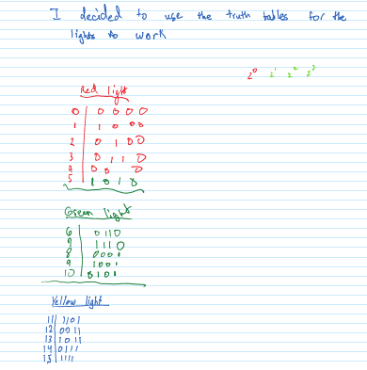Truth Table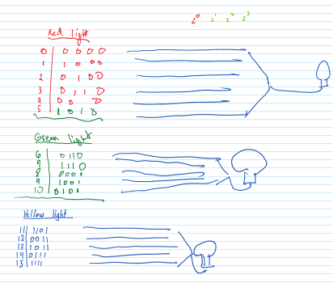Diagram

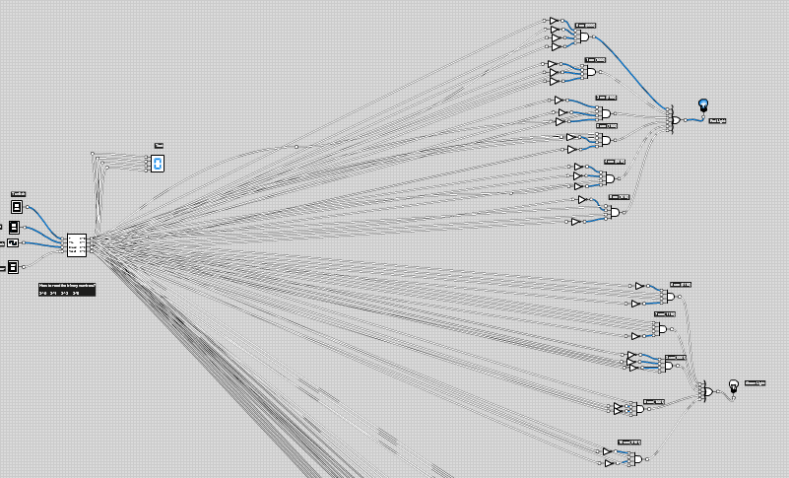Screenshot of logicly program