Nicolas Achury

Assessment for Senior Energy Modeller

Aurora Energy Research

**Assessment**

The optimization problem can be written as follows:

**Objective function:**

Battery operational revenue:

Battery operational cost:

Battery fixed operational costs:

Battery CAPEX:

Maximise the battery revenue:

**Subject to:**

* **Dynamic charge equations**

are decision variables describing whether the battery charges on markets 1, 2, 3 or curtailment (this latter is assumed to be a different market with prices equal to 0). are auxiliary variables describing the State of Energy and the net charge.

* **Dynamic discharge equations**

are decision variables describing whether the battery discharges on markets 1, 2, 3 or curtailment. This latter with a price equal to the max price of market 1 and market 2, which is intended to reflect intraday trading for curtailed electricity. is auxiliary variable describing the net discharge.

* **Operational constraint (can’t charge and discharge at the same time):**

are binary variables describing the operation condition of the battery.

* **Dynamic State of Energy:**
* **Curtailment constraints**

There are some curtailment periods on the system (total generation > total demand). The battery can’t charge more energy than the one being curtailed.

* **Dynamic market 3 trading:**

and are binary variables describing whether the battery is trading in market 3.

For 48 half hour periods, the discharge () and charge () decision variables must respect the State of Energy of the battery at the beginning of the period.

For 48 half hour periods, the market 3 binary trading variables must equal 48 (trading the whole day)

**Python code:**

The code follows the structure:

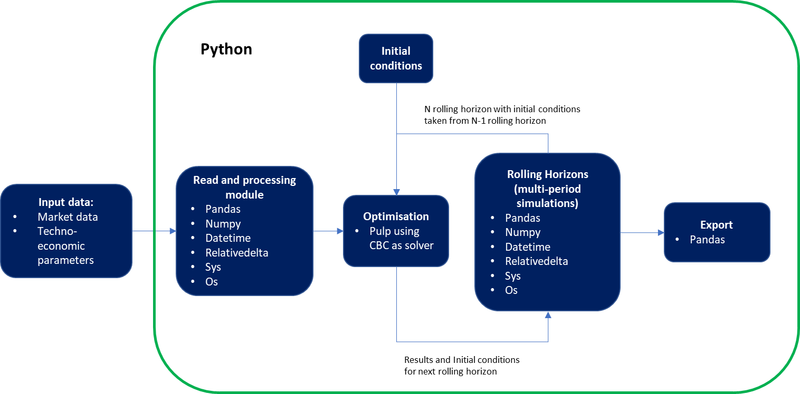

**Further work**

* Include cycle and degradation conditions.
* The optimisation model in Python is defined to maximise operational revenue. Total revenue (operation revenue – fixed operation costs – capex) are calculated outside of the model.
* Optimise the code structure. It currently solves 2018, but doesn’t seem to solve 2019/2020 (or is taking a significant amount of time).
* Constrains and code review. 2018 results don’t show any market 3 trading (except for the first 48 hours as the initial conditions were defined as 1 to allow trading).