Part 6

**sl=0, sr=0, δ=0** is a no slip and no skip condition. As expected, the

kinematic model yields positions that precisely follow the shape of a 5m square.

**sl=0.1, sr=0.2, δ=0** is a slip no skid condition. Normally in a straight path the vehicle angular velocity is 0. However with the presence of uneven slip

in both wheels, the vehicle turns due to non-equal left and right wheel angular velocities resulting in a changing theta value.

**sl=0, sr=0, δ=5** is a no skip skid condition. The vehicle path is at

an angle with the desired path due to the presence of lateral velocity Vy. With both slips zero theta is zero and the vehicle angular velocity is also 0 (and the robot travels the correct longitudinal distance).

**sl=0.1, sr=0.2, δ=5** is a slip and skid condition. The robot experiences both a changing theta during the straight-line path and a lateral velocity Vy.

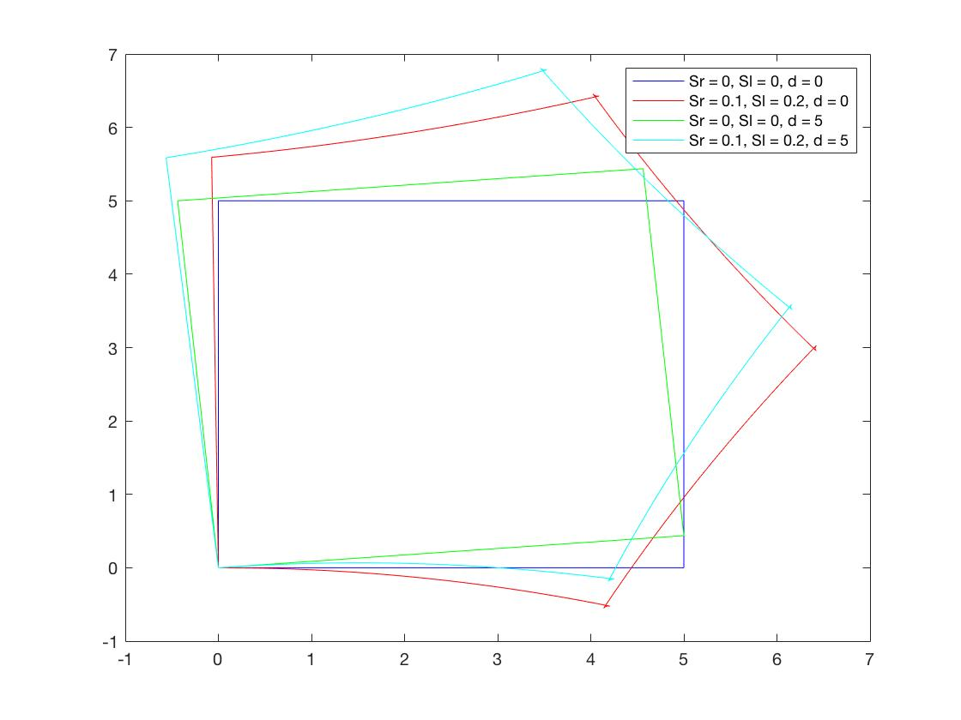

Figure - Plot of the robot path for each skid and slip condition

Part 7

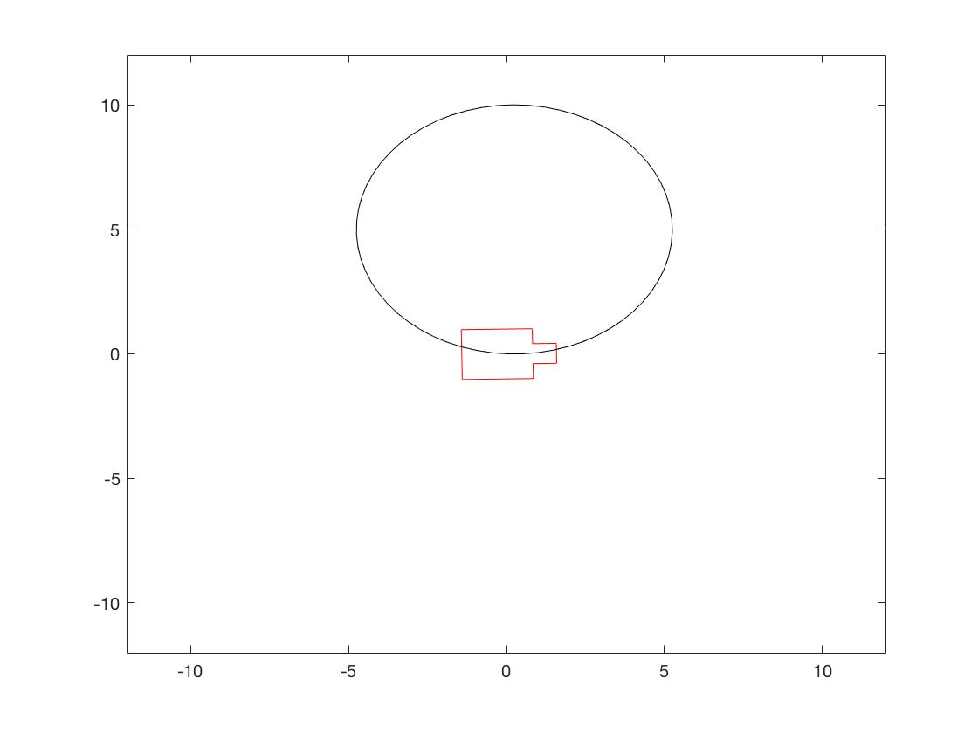With an increased integration step, the kinematic model creates longer linear movements between points. The robot also is plotted roughly ten times as fast. The effect is most noticeable in the circular path, shown in Figure 2.

Figure - Circular path with dT = 0.5 s