Nicolas Buxbaum

EBS 289K

Wednesday, May 8, 2019

Assignment 2

Part 1

With the robot and controller parameters outlined in the assignment (Wheelbase = 2.5 m, |γmax| ≤ 45,|vmax|≤5 m/s, dt=DT=0.01) , a simple semi-circle turn of radius 2 m is shown below (Fig 1).

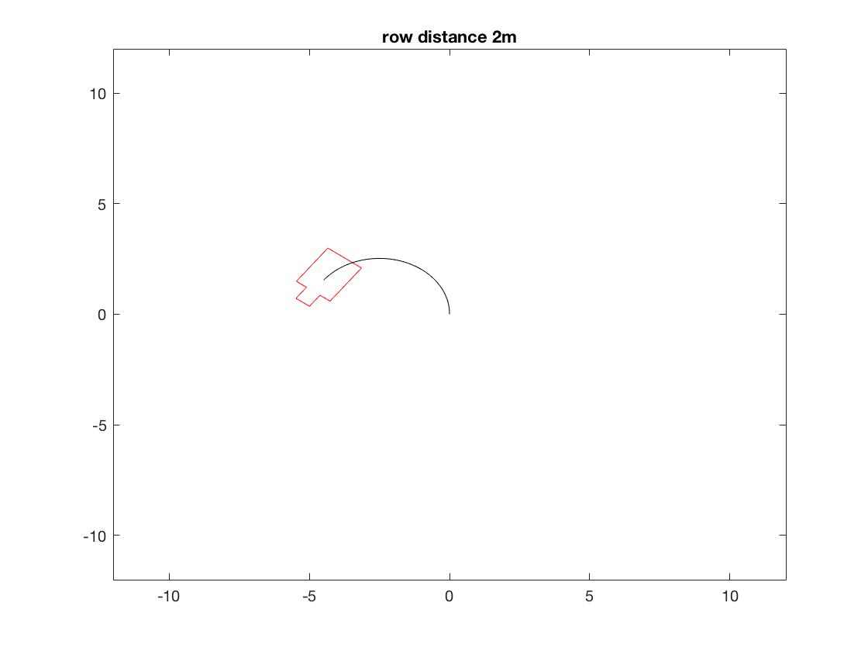

Figure 1 - Row distance is 2m

A similar turn with radius 3m is shown in Figure 2. The first turn is not accomplished because the desired radius is smaller than the minimum robot turning radius. In other words, the desired gamma is larger than the maximum gamma of the robot.

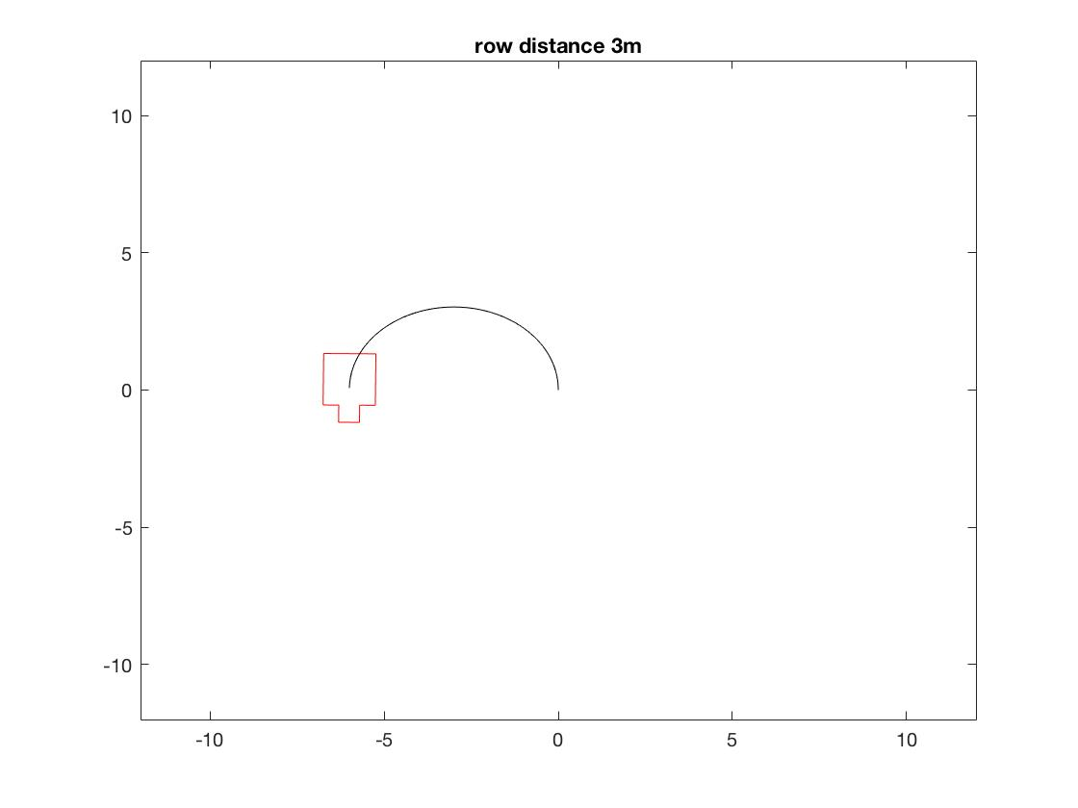

Figure 2 - row distance is 3m

Part 2

With small slip angles of 4 degrees added, the robot trajectory is modified to include a horizontal velocity vector oriented inwards (around the center of the radius of the turn). As the time of travel is the same as in Part 1, the robot’s final position is towards the positive X-axis and negative Y-axis compared with the robot in Figure 2.

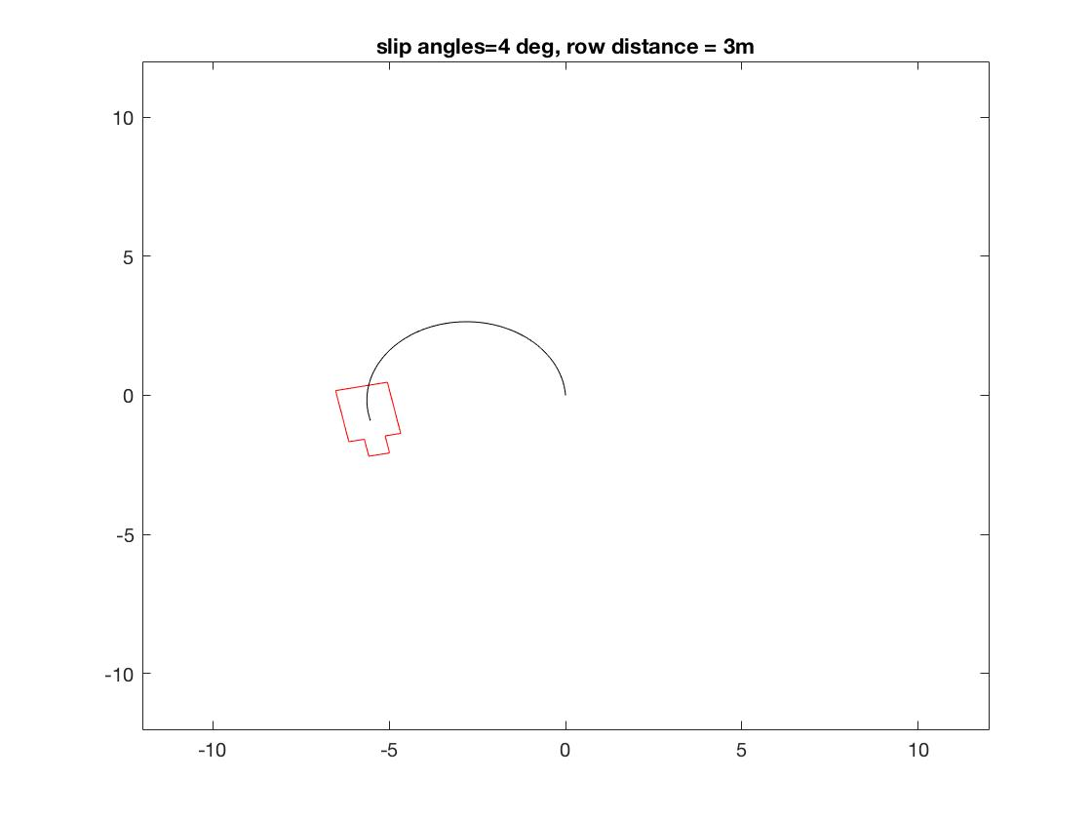

Figure 3 - Small slip angles

The effect of increasing the slip angle (while still maintaining a skid of 0) is shown in figure 4. As the slip angle increases, the turning angle of the robot increases.

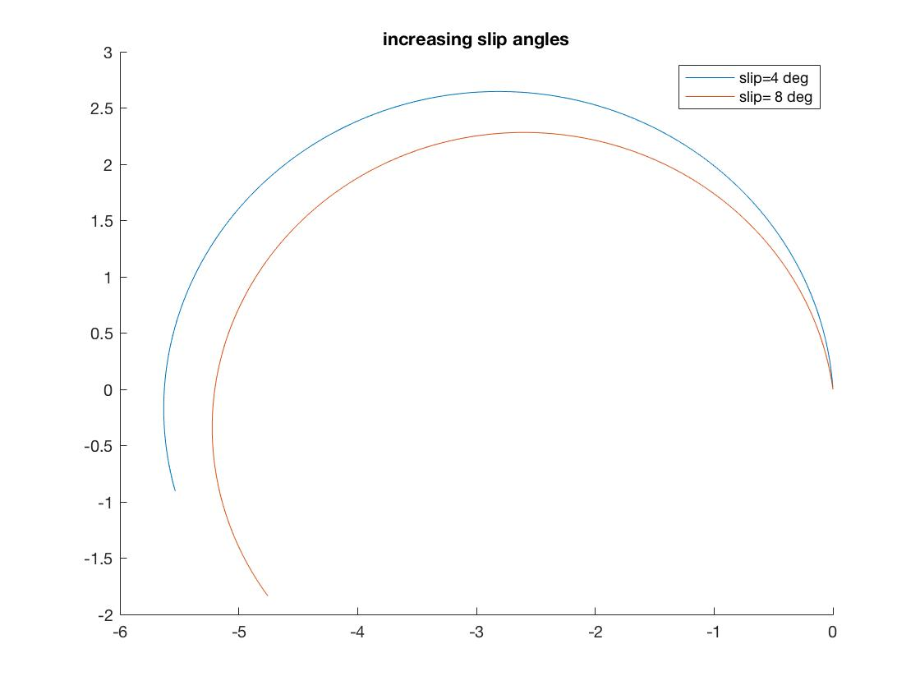

Figure 4 - Increasing the slip angle

The robot path with no slip angle and a skid percentage of 10% is shown in figure 5. This results in smaller linear distance travelled since the wheel is skidding (linear velocity is reduced).

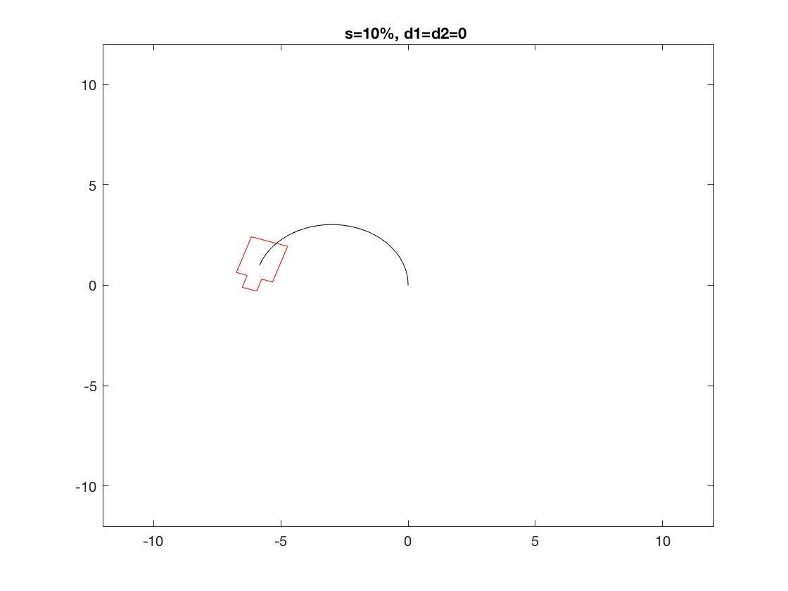

Figure 5 - no slip, skid condition

Part 3

For this part we introduce τγ = {0,.5,1,1.5,2} with τv = 0 and τv = 1. These conditions are shown in figure 6 and figure 7. In both figures we can see that as τγ increases the robot is less able to make the turn required. The delay in steering response causes the robot to reach the desired gamma later than is required to make the turn. The robot starts its path with an initial velocity of 0. The desired velocity is our maximum allowable velocity which is reached after the Euler integration. With a τv of 0, this happens instantaneously, and the robot reaches its target point. With a τγ of 1 however, this acceleration takes time and the path is shortened due to our chosen travel time, which was based upon the assumption that the robot would accelerate instantaneously.

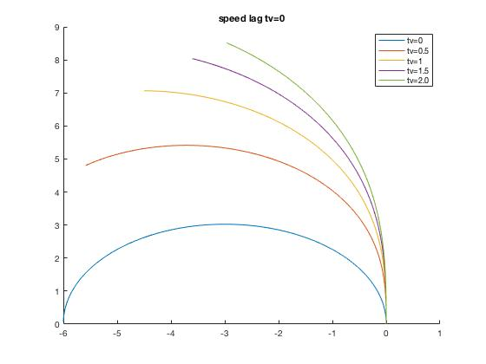

Figure 6 - τv = 0

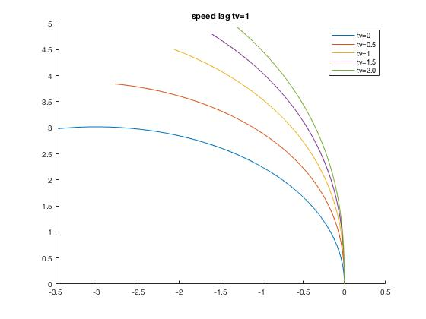

Figure 7 - τv = 1