Nicolas Buxbaum

EBS 289K

Thursday, May 9, 2019

Assignment 3

Part 2

The robot is initialized at a position that is not on the path, and therefore the initial tracking error is high but falls quickly. The average tracking error is roughly 0.25m. The error will never be zero, despite the fact that the path appears to look accurate. This is due to the effects of look ahead distance, as well as Euler and controller integration. One could improve the error calculation by having a more well defined path (increasing the number of points) since the calculated nearest point to the robot is not necessarily the nearest point on the path if the path was a continuous function.

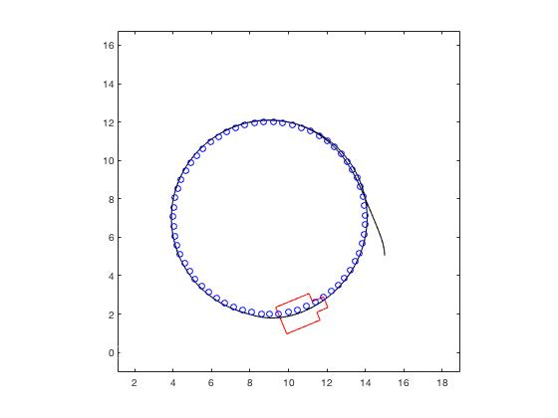

Figure 1 - Circular path

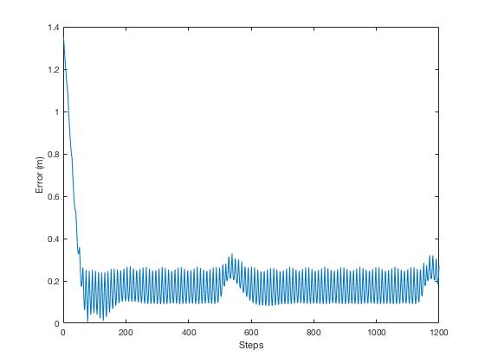

Figure 2 - Error of circular path

Part 3

The maximum error is (LD = 5 m) 2.625 m. The 95th percentile error (LD = 5 m) is 1.503 m. The RMSE of error (LD = 5 m) is 0.733 m. At a fixed speed, one can see the effect of increasing lookahead distance in Figures 3 and 6. Smoothness appears to increase with increasing lookahead distance, while stability decreases with decreasing lookahead distance. One can see the instability (overshoot) right after the second corner in Figure 6. At extremely small lookahead values strong instability in the form of oscillations occur. Corner cutting is greater with greater lookahead distance as expected. When the speed was doubled, no noticeable change occurred to the path or to the tracking error.

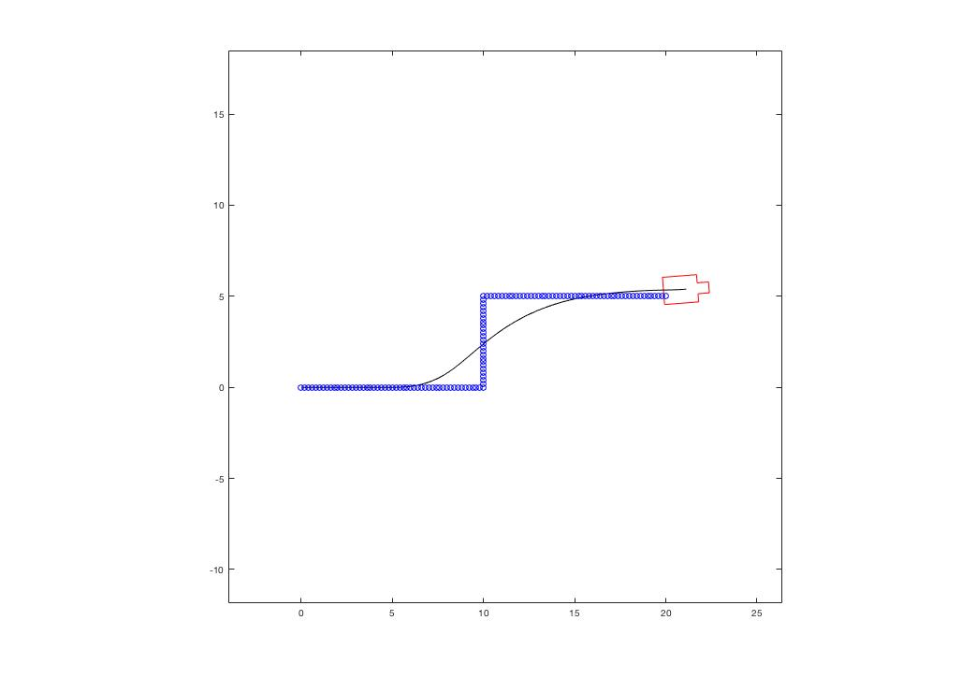

Figure 3 - Lane change path with Ld = 5m

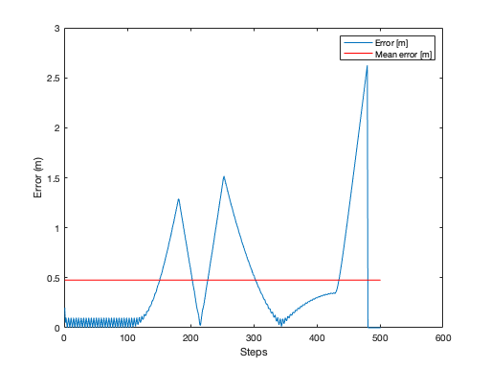 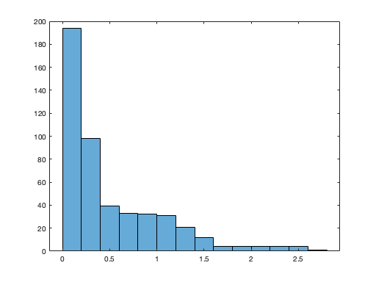

Figure 4 - Path error with Ld = 5 m Figure 5 - Error histogram with Ld = 5m

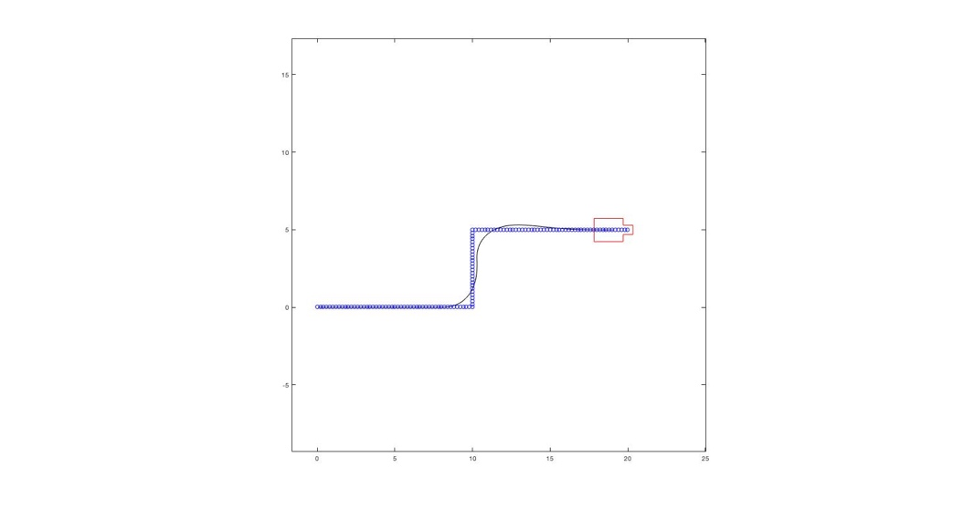 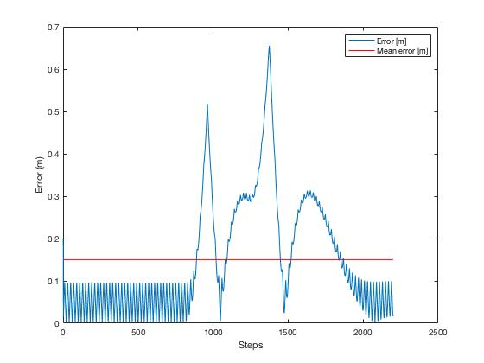

Figure 6 - Robot path with Ld = 2 m Figure 7 – Error for path with Ld = 2 m

Part 4

After introducing steering and velocity delays (Figures 8 and 9) and comparing similar conditions under instantaneous dynamics (Figures 6 and 7), we can notice several phenomena. First, at the first turn the error is reduced by approximately 0.1 m under the delay condition. However, during the exit of the turn and subsequent path travel, the error is in general larger under the delay condition. This trend continues for the rest of the path, with the delay condition error generally larger than the instantaneous dynamics condition. As the robot is less responsive to changes in desired steering angle, the delay in the initial turn actually causes the robot to better track the path. This advantage is quickly terminated as the robot struggles to correct its path, resulting in reduced stability and poorer tracking. Doubling the steering delay furthers the mentioned trend, with the initial turn error reduced and subsequent path error increased as shown in Figure 10 and 11.

With a smaller maximum steering angle (Figure 12 and 13), the robot’s minimum turning radius increases. This increases corner cutting as well as path smoothness. One can see this reflected in the error plot, as the error tends to change more slowly compared with Figure 7. The overall error however, is generally larger at each point of the path.

The effect of a slip factor of 15% can be seen in Figures 14 and 15. There is essentially no effect of a slip only condition other than the robot not reaching its final endpoint. A skid condition (d1=d2=5 deg) is shown in Figures 16 and 17. Under this condition the robot has a tangential velocity component vy (in the positive Y direction). This is shown in Figure 17 as the error is increasing over the straight line portion of the path. Additionally, the error is larger at the first turn as the robot is making an even larger turn due to vy. However, this same effect actually decreases the error during the second, right hand, turn. After the second turn the error is again greater when compared to normal dynamics.

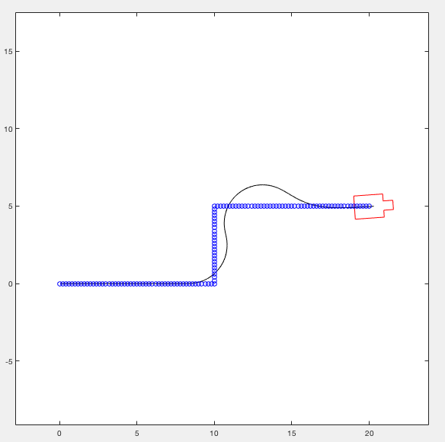 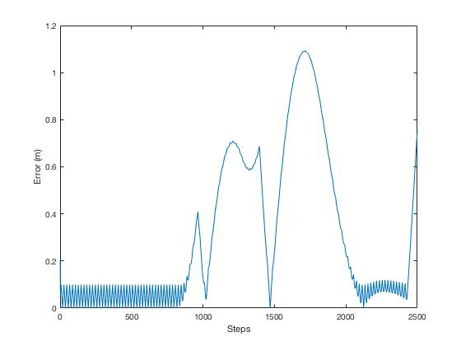

Figure 8 - τγ = 0.15 s, τv = 0.5 Figure 9 – Error with τγ = 0.15 s, τv = 0.5

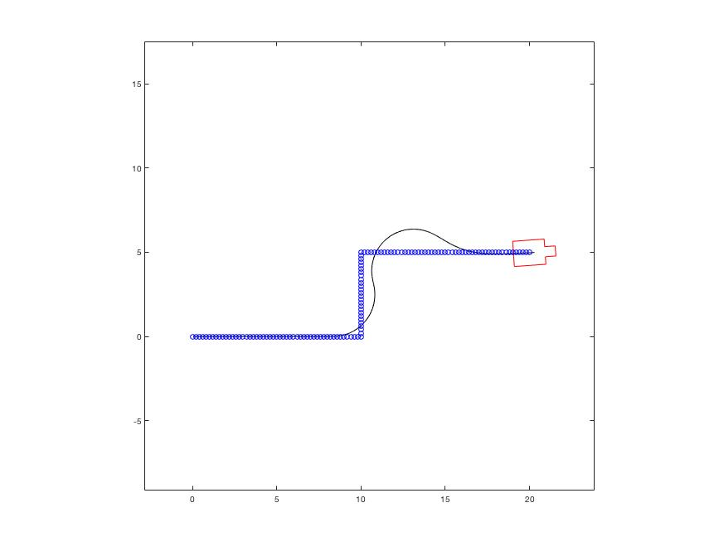 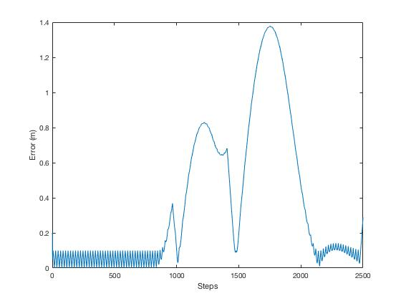

Figure 10 - τγ = 0.3 s, τv = 0.5 Figure 11 – Error with τγ = 0.3 s, τv = 0.5

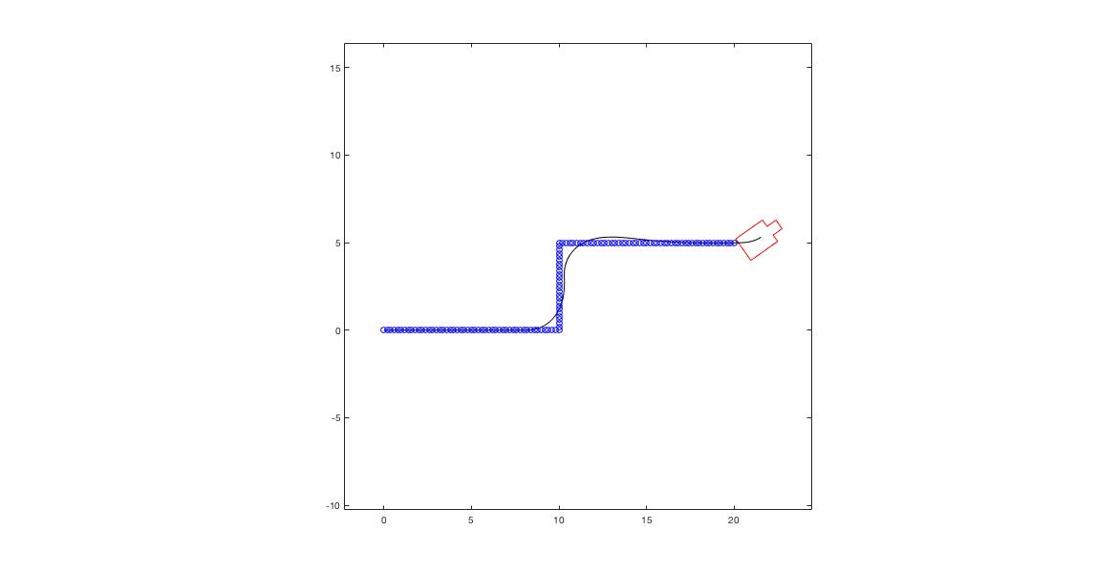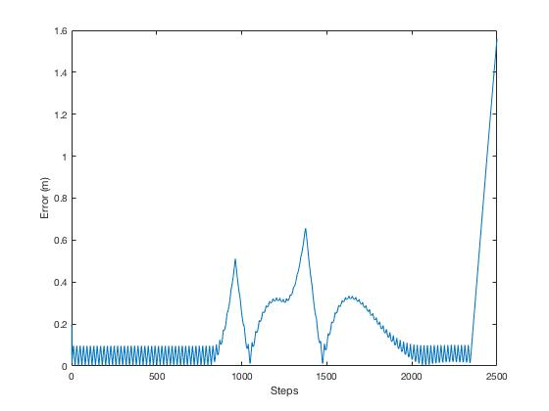

Figure 12 - τγ = 0 s, τv = 0, Ld = 2 m, γmax = 35o Figure 13 – Error for τγ = 0 s, τv = 0, Ld = 2 m, γmax = 35o

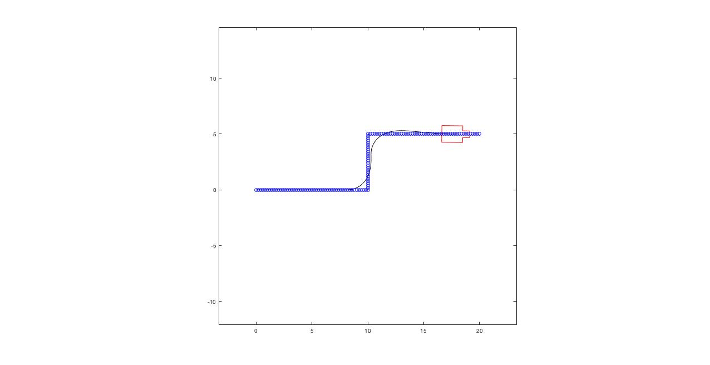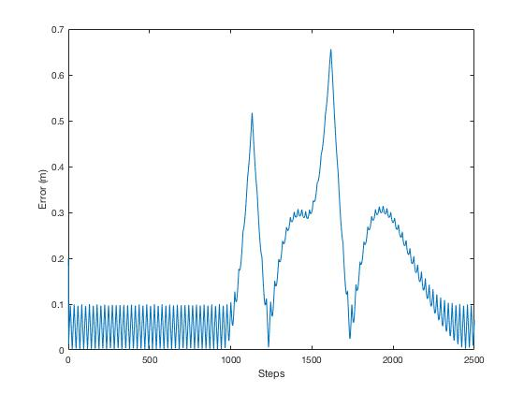

Figure 14 – slip = 15% Figure 15 – error for slip = 15%

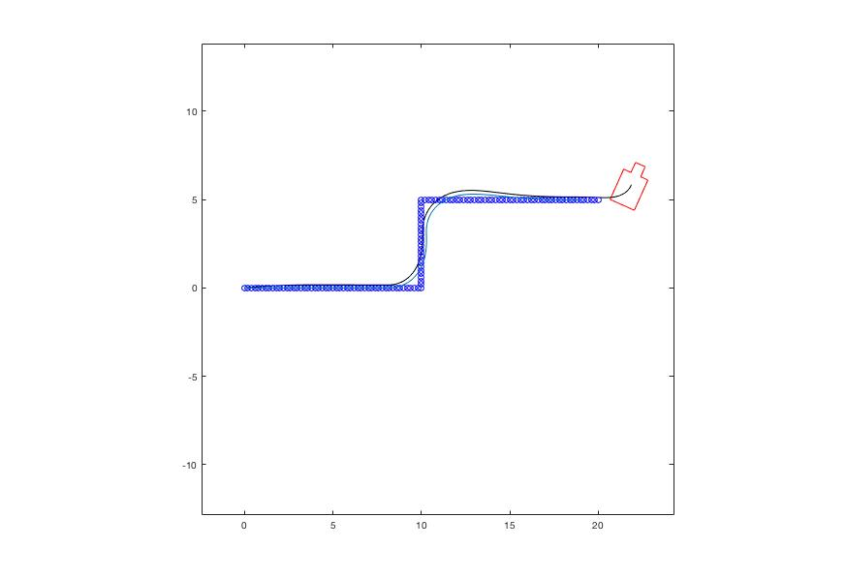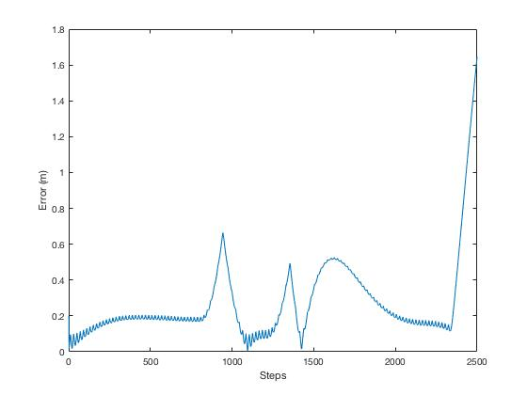

Figure 16 – Skid condition. d1 = d2 = 5 %. Normal dynamics shown in blue Figure 17 – Error for skid condition. d1 = d2 = 5 %