Summary of the lessons – Advanced Programming 2022/2023

-Lesson [1] :
- Introduction, difference between a compiled and an interpreted language:
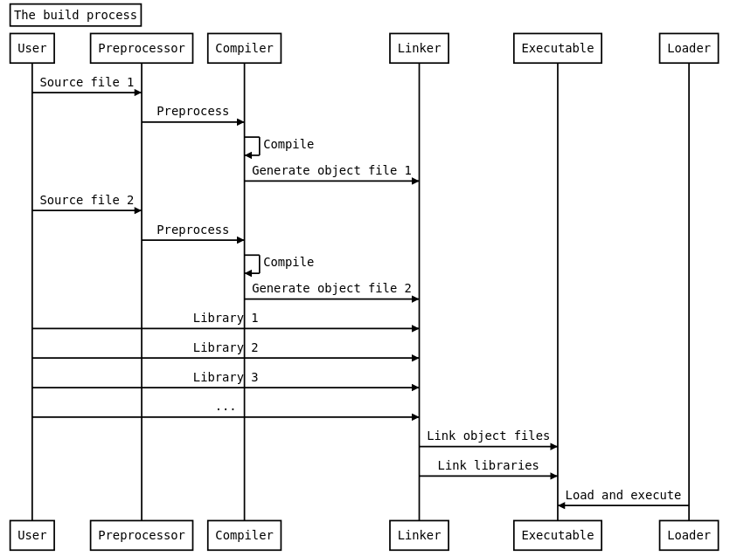
The linker is responsible to link together the libraries and other object files already compiled:
e.g. : g++ main.o helper.o -o my_program

The Loader, instead, has the main role to allocate memory, set up the environment and start the execution of the Executables.

- Introduction to Unix environment: What is a shell, bash scripting (base):

Some variables can affect the way running processes will behave on a computer, these are called environmental variables, for example: export PATH="/usr/sbin:$PATH".

Login vs Non-login shell: The non-login shell does not require to log

Initialization files: In a shell are scripts or configuration files that are executed or sourced when the shell starts. These files are used to set up the shell environment, customize its behavior, and define various settings that affect how the shell operates.

Run scripts: the first line of the script tells the shell which interpreter to use while executing the file
Interestingly, there are many commands that allow flexibility.
The output of a command could be interpreted : e.g. :

list=’ls -l’ ; list=$(ls -l)

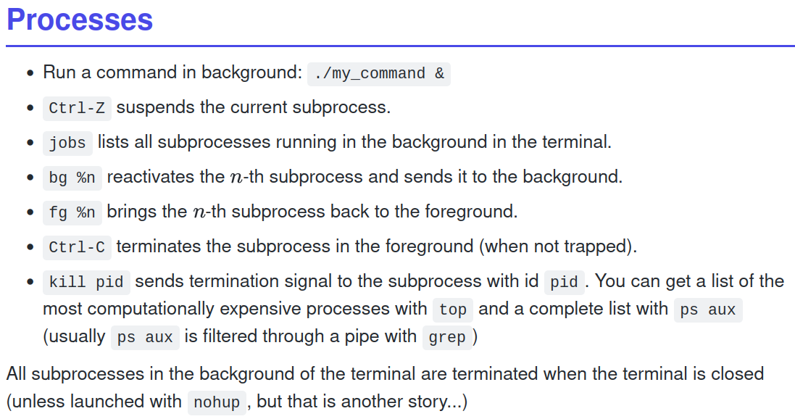

-Lesson[2]: C++ Basis

Hello_world_program: “return 0” is seen as a thing that say “ok”, everything is ok by the OS.
It is common to have “0” as the normal value to say that everything is ok.
Use the g++ as compiler: g++ helloworld.cpp -O MyProgram to generate the executable

Basic data-types: Why the declaration? Why the definition? “<<” is the cat operator.
- All integers are converted to a bool. #0 is false.
- The “auto” operator: It is important that it will be safely used!

Initialization:
-Int a = 10; # copy init
-Int a(10); # Direct init
-Int a{10};# Uniform init → Recommended for the compilation

Stack vs Heap:
Stack: Everything has a fixed memory, used for variables that live shortly.
Heap: The variables need to be allocated/deallocated → Heap is handled by pointers!
Used for dynamic data with extended lifetime
→ Int* heap_ptr = new int(45);
→delete heap_ptr;

Basic data structures: struct, enum, POD(Plain Old Data):classes without constructor, union.

Declarations and Definitions:
- declarations don’t allocate memory but RESERVE memory: int x;
Give flexibility to the code.
- definitions allocate memory: int x =5;

Initialization:
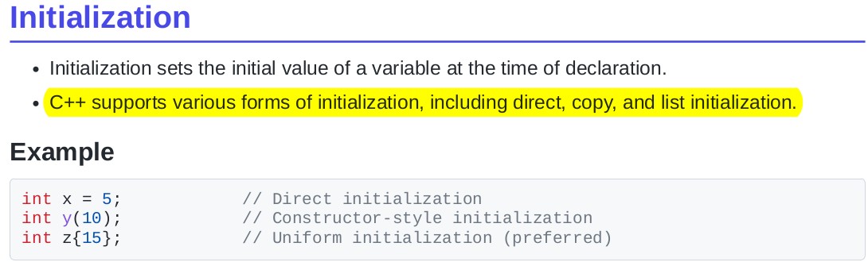
Switch construct: Used to handle multiple if.

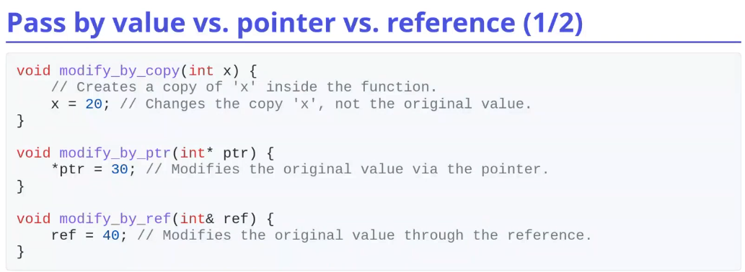
Pointer Vs Reference:

Use the std copy with
variables that are small.

Use the reference with
classes.

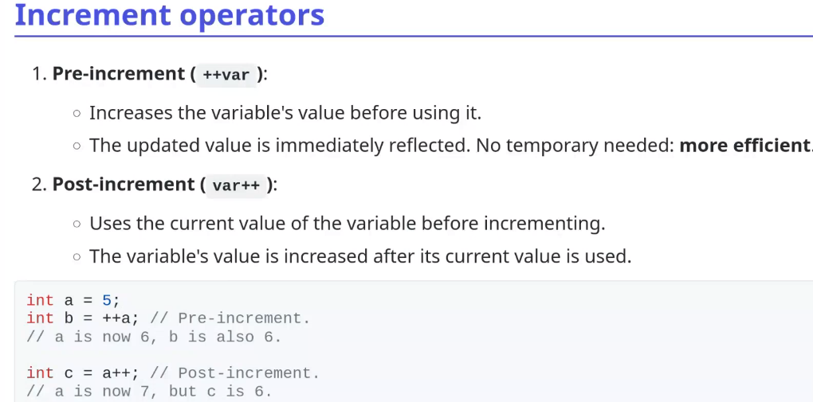
Increment operator:

Enumeration, Union, struct:

