Autonomous quadcopter for rapid underground mine mapping and exploration

Nico Epler1[1], and Callen Fisher2

1Department of Electrical and Electronic Engineering, University of Stellenbosch, South Africa, 23910712@sun.ac.za

2Department of Electrical and Electronic Engineering, University of Stellenbosch, South Africa, cfisher@sun.ac.za

Abstract. Mine surveying and mapping is a time-consuming and hazardous task that is critical to most underground mining operations. Recently, the introduction of robotics for underground mine mapping has reduced these safety risks for humans. This project aims to develop an autonomous quadcopter equipped with dedicated sensors capable of performing 3D SLAM (Simultaneous Localization and Mapping) in GNSS (Global Navigation Satellite System)-denied environments, such as underground mine sites. Various localization and mapping algorithms were compared and tested, and the SpectacularAI package proved to be a computationally efficient SLAM method that can run on the quadcopter’s onboard computer, generating dense and detailed point cloud maps. Additionally, autonomous exploration and path planning methods for three dimensional spaces were analysed, and appropriate algorithms were implemented to ensure the platform’s autonomy in communication-limited subterranean environments.

1. Introduction

Given the significant human safety and health hazards in underground mines—including fires, rock falls, gas leaks, and floods [1]—robots have recently been deployed to assist with underground mine surveying, environmental monitoring, and exploration. Such robotic platforms include autonomous rovers for underground 3D mapping using rotating lidar sensors [2] and composite systems like the Rhino, which utilize lidar and RGB-D fusion for underground localization and mapping [3].

More recent approaches extend these capabilities through multi-robot exploration, mapping, and terrain perception by networking platforms such as quadrupeds, rovers, and UAVs (Unmanned Aerial Vehicles) [4]. UAVs, in particular, serve as rapid exploration tools that provide fast data collection and extensive coverage, with most of these platforms relying on lidars to perform SLAM algorithms [5]. They can also navigate challenging terrain conditions—such as extreme slopes, water pools, tight spaces, and vertical shafts—where quadrupeds and rovers often struggle [5]. Moreover, subterranean environments present a significant need for autonomy due to limited communication capabilities and intricate layouts that demand low-latency, real-time decision making [4].

The aim of this project is to design and develop a small-scale, agile quadcopter that performs onboard SLAM and autonomous exploration in underground mines, delivering a comprehensive 3D representation of the environment.

1. Methodology and Results

The developed platform, called Void Raven, consists of a custom-built 5-inch quadcopter with components specifically chosen for performance and efficiency to maximize the UAV’s permittable payload and exploration time. Additionally, the quadcopter is equipped with a Pixhawk 6C Mini Flight Controller running PX4, which handles low-level flight control and facilitates processes such as position estimate calculations.

Additional components integrated into the platform include a Khadas Vim4 running Ubuntu 22.04 and ROS2 for onboard computing, a Here Flow optical flow sensor to aid with position control in the absence of GNSS in underground environments, and an OAK-D Pro W RGB-D camera that provides depth information and generates a point cloud for onboard SLAM and autonomous exploration. A RGB-D camera was chosen over the commonly used lidar because it is significantly lower in cost, lighter, smaller in size, provides more visual information, including surface texture and colour, and has lower power consumption. A detailed image of the platform is shown in Fig 1.

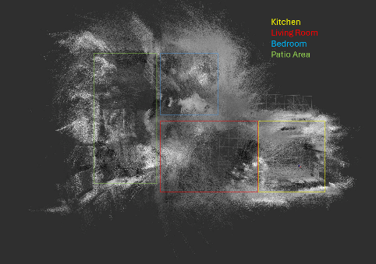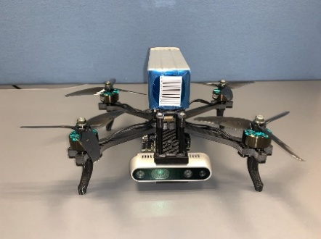Careful considerations were required when selecting SLAM algorithms due to the Vim4's limited computational power and arm64 architecture, while most SLAM solutions are developed for powerful AMD64 platforms. After thorough evaluation and testing, it was decided to employ the SpectacularAI package to perform SLAM. This package was modified such that its native HybVIO module, which fuses visual odometry with IMU (Inertial Measurement Unit) data to track the camera's position [6], is incorporated into the Flight Controllers EKF (extended Kalman filter) to obtain a more robust global position estimate. In addition, the package’s inherent OpenVSLAM module, a re-implementation of ORB-SLAM2, is used for loop closure optimization [7]. Fig 2 shows a point cloud map created by the system after down sampling and outlier removal has been performed onboard. For this test, the UAV was teleoperated through an apartment, where clear outlines between individual rooms can be seen.

Fig. 2. Point Cloud Map created using the developed platform

Fig. 1. Detailed Picture of the Platform

The resultant local map point clouds were further used to create a probabilistic volumetric occupancy grid using OctoMap[8] which is beneficial for the autonomous navigation suite due to its reduced complexity. Finally, various autonomous exploration algorithms, including local and global planners, were deployed and tested on the platform. The RRT algorithm proved to be computational efficient enough to run on the Khadas Vim4 while providing quick exploration capabilities, though it sometimes results in slightly suboptimal paths.

Conclusion

A quadcopter capable of autonomously exploring and mapping GNSS-denied environments, such as underground mines, was successfully developed using cost-effective and energy-efficient components. The deployed software suite was tested and proved to generate a point cloud map of its environment, containing detailed features. Additionally, the RRT path planning algorithm was used to enable the platform to rapidly explore environments, although it occasionally chose slightly suboptimal paths. Finally, future improvements could include integrating precision landing and data deployment features to connect with other platforms, enabling multi-agent exploration.

References

1. Q. Han, Y. Bao, S. Pasricha, Improving Safety in Cyber Enabled Underground Mines, In Proceedings of the 8th International Conference on Networking, Systems and Security, NySysS, 21-23 December 2021, New York, USA(2021)
2. T. Neumann, A. Ferrein, S. Kallweit, I. Scholl, Towards a Mobile Mapping Robot for Underground Mines, in Proceedings of the 2014 Pattern Recognition Association of South Africs, Robotics and Mechatronics and African Language Technology International Joint Symposium, PRASA, RobMech and AfLat, 27-28 November 2014, Cape Town, South Africa (2014)
3. C. Tatsch, J. A. Bredu, D. Covell, I. B. Tulu, Y. Gu, Rhino: An Autonomous Robot for Mapping Underground Mine Environments,In Proceedings of the 26th IEEE International Conference on Advanced Intelligent Mechatronics, AIM, 28-30 June, Seattle, USA (2023)
4. M. Tranzatto, T. Miki, M. Dharmadhikari, L. Bernreiter, M. Kulkarni, F. Mascarich, O. Andersson, S. Khattak, M. Hutter, R. Siegwart, K. Alexis, Science Robotics 7, 66 (2022)
5. P. De Petris, H. Nguyen, M. Dharmadhikari, M. Kulkarni, N. Khedekar, F. Mascarich, K. Alexis, Rmf-owl: A collision-tolerant flying robot for autonomous subterranean exploration, In Proceedings of the International Conference on Unmanned Aircraft Systems, ICUAS, 21-24 June 2022, Dubrovnik, Croatia (2022)
6. O. Seiskari, P. Rantalankila, J. Kannala, J. Ylilammi, E. Rahtu, A. Solin, HybVIO: Pushing the limits of real-time visual-inertial odometry, In Proceedings of the IEEE Winter Conference on Applications of Computer Vision, CVF, 18-24 June 2022, New Orleans, USA (2022)
7. S. Sumikura, M. Shibuya, K. Sakurada, OpenVSLAM: A versatile visual SLAM framework, In Proceedings of the 27th ACM international conference on multimedia, ACM Multimedia, 21-25 October 2019, Nice, France (2019)
8. A Hornung, K. M.Wurm, M. Bennewitz, C. Stachniss, W. Burgard, Autonomous Robots 34, 3 (2013)

1. Corresponding author: [23910712@sun.ac.za](mailto:author@email.org)