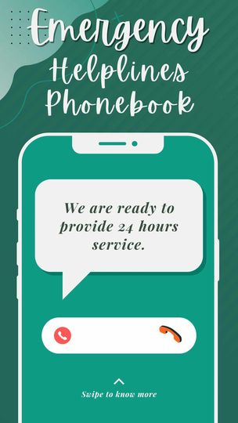

**Table of Contents**

* [📚Introduction](https://github.com/CarlBradford/KuryenTell/tree/main#introduction)
* [✨Features](https://github.com/CarlBradford/KuryenTell/tree/main#features)
* [💻System Preview](https://github.com/CarlBradford/KuryenTell/tree/main#system-preview)
* [🌏Sustainable Development Goals (SDGs)](https://github.com/CarlBradford/KuryenTell/tree/main#sustainable-development-goals-sdgs)
* [🎥 Video Presentation](https://github.com/CarlBradford/KuryenTell/tree/main#video-presentation)
* [🤵Meet the Team](https://github.com/CarlBradford/KuryenTell/tree/main#meet-the-team)

**📚Introduction**

Our program is act like a phonebook but rather than only having contacts that is saved by the user, it contains information and contacts for emergency services.

**✨Features**

* Emergency Services Contacts: Include numbers for police, fire, medical emergency services.
* Mental Health Crisis Line: Offer a helpline for individuals in mental health crises, connecting them with professional support.
* Suicide Prevention Hotline: Include a helpline dedicated to preventing suicides, offering support and intervention.
* Natural Disaster Hotline: Have a number for reporting natural disasters or emergencies, connecting users to relevant authorities.

**✒Getting Started**

* 24/7 Availability: Ensure that all listed contacts are available 24/7 and can respond promptly to emergency situations.
* Publicize the Phonebook: Make the emergency phonebook readily available to the public.
* Categorize Contacts: Organize the contacts into categories such as medical, law enforcement, mental health, etc., to facilitate quick access during emergencies.
* Regular Updates: Regularly update the phonebook to reflect any changes in contact information authorities.

**⚙Installation**

**1.From there open settings and look for Project:File_Name.**

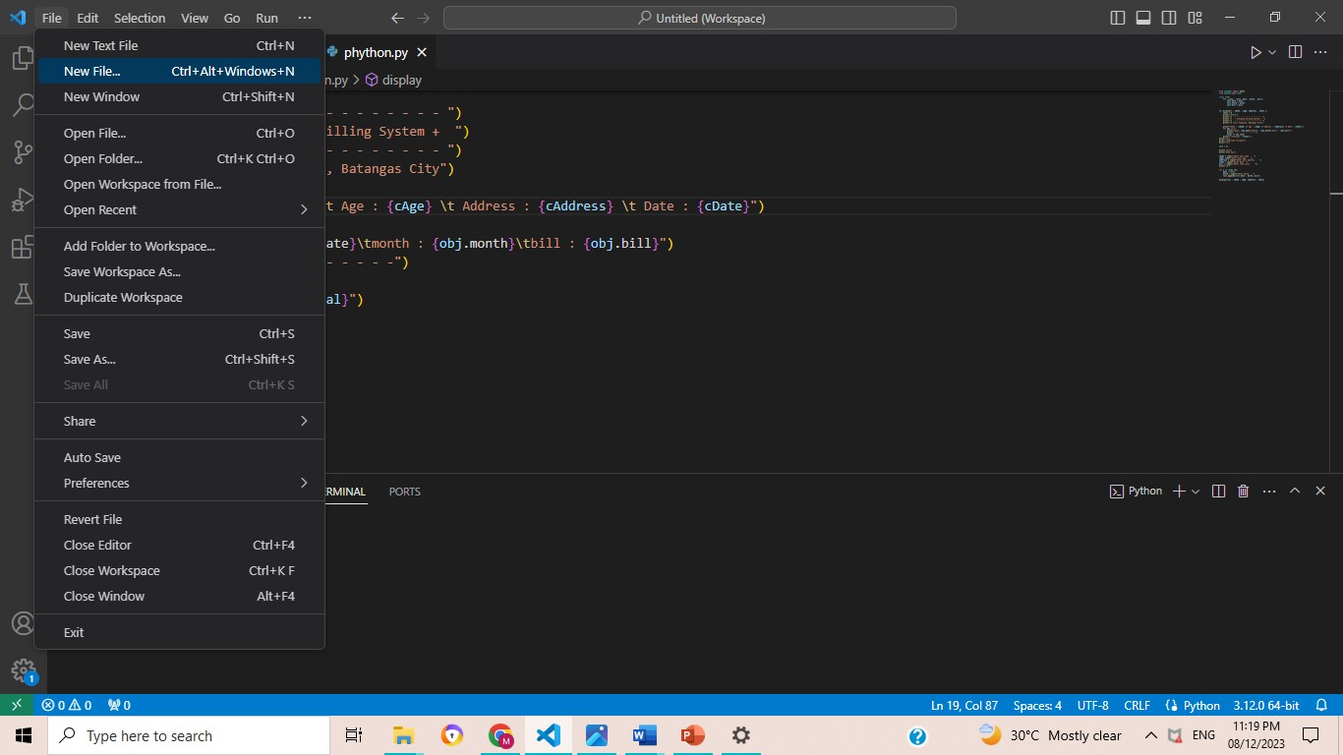

**2. If you are using Visual Studio code, open a terminal.**

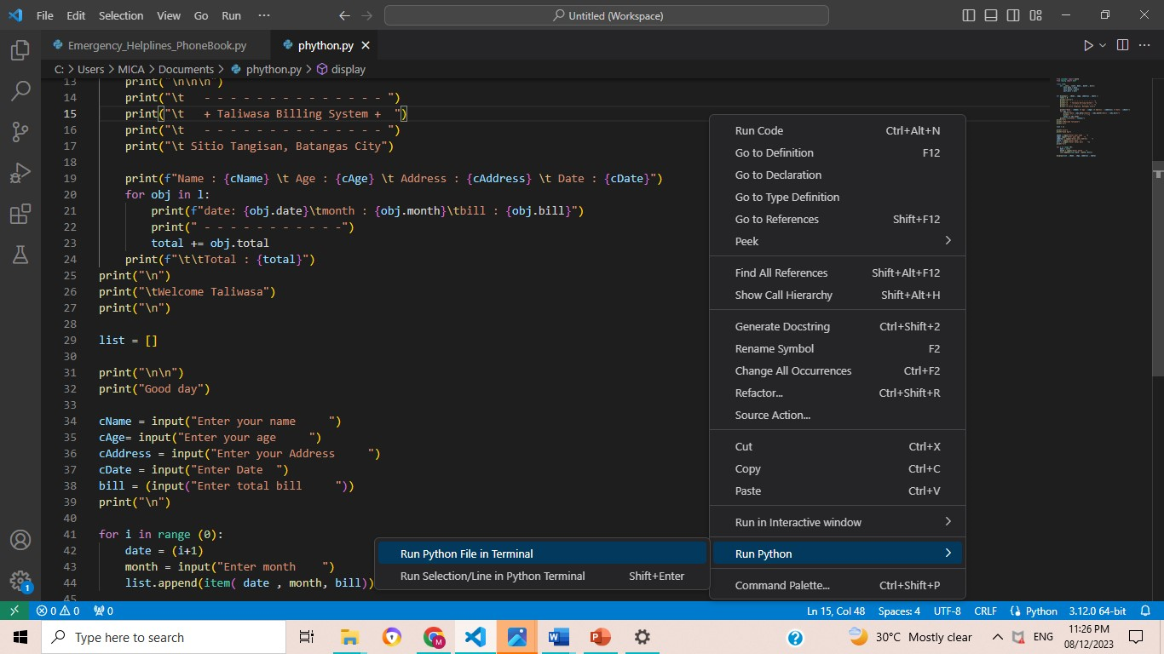

**💻System Preview**

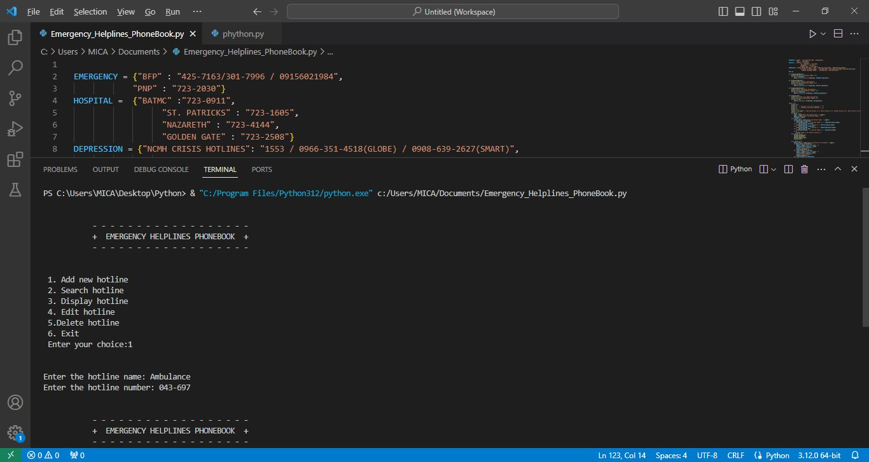

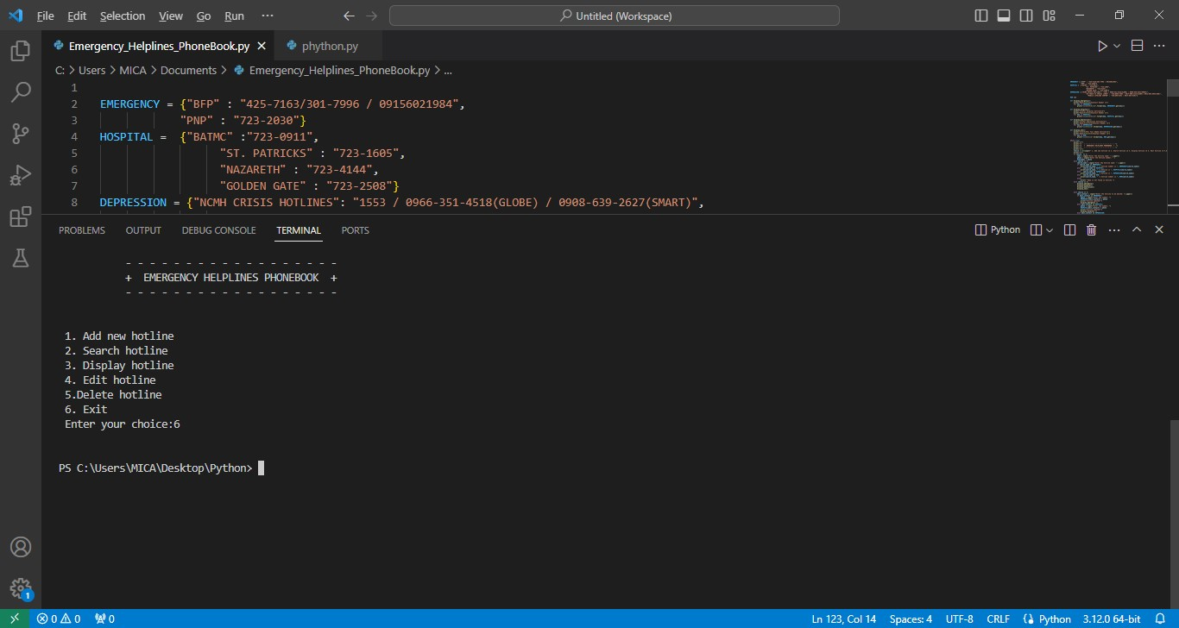

******🌏 Sustainable Development Goals (SDGs)**

Emergency Helplines Phonebook aligns with several United Nations Sustainable Development Goals (SDGs), including:

**SDG 3: Good Health and well-being**

* "Ensure healthy lives and promote well-being for all at all ages”.

**SDG 13: Partnerships for the Goal**

“Strengthen the means of implementation and revitalize the Global Partnership for Sustainable Development”.

**🎥Video Presentation**

The user must first choose from the actions they want to do on their phonebook by entering the corresponding number from 1-5 as can be seen on the choices.

Choice number 1 is to add new contact. If the user enters number 1, then the program will ask the name of the hotline they one to input then next is the number and it will they be saved.

Choice number 2 is to search for a hotline It will ask the user to input the name of the hotline. If the name exists in the program, then it will be displayed, if not, then a message will be displayed, saying "The name is not present in the collection."

Choice number 3 will just display all the contacts that exist in the collection. Choice number 4 is to edit the number of an existing hotline. The program will ask the user for the name of the hotline they want to edit. The proceed to ask the number that will be saved as a new contact for that hotline. If the name is not present in the existing contact collection, then it will display a message.

Choice number 5 is to delete a contact in the collection. It will ask the user for the name of the contact to be deleted. It will also confirm if they want to delete that contact by asking yes or no. It will also show the remaining contacts after it has been deleted. Choice number 6 will just exit the program and stop repeating it.

<https://l.messenger.com/l.php?u=https%3A%2F%2Fdrive.google.com%2Ffile%2Fd%2F1-AXXBFKwlNEp05wz2hU6xkui2QHM2rCE%2Fview%3Fusp%3Ddrivesdk&h=AT1zo6PhgIQgjaA8mBnPgKHL99B9yhJTIzl2ntMDNB59sc-tGIAETysLHAML5c37eGBOKZnoOKzWFgxqCOi3dH_xRl-7CkWaOjHK_EuEXExu-CgSSSasToxqDix8n86foPxpaQ>