CiliaTracks

Biological Workflow Protocol

Table of Contents
1 Overview……………………………………………………………………………………………………………1
2 Materials……………………………………………………………………………………………………………1
3 Microsphere Application……………………………………………………………………………………1
4 Capturing particle Movement……………………………………..…………………………………….2

1. Overview

CiliaTracks is a comprehensive Python package and dedicated website that enables clinicians and researchers to analyze cilia-driven particle motility and accurately predict PCD from high-speed video microscopy (HSVM) data.

To carry out analysis with CiliaTracks, HSVM data must first be collected through a standardized biological protocol. This workflow involves applying fluorescent microspheres to cultured airway liquid interface (ALI) cells and capturing their movement.

2. Materials

- 1% Solids 1.9 μm diameter green, fluorescent polymer microspheres (Thermo Fisher Scientific, CAT. NO. G0200)
- 2% Nu-Serum (Corning, Product Number 355100) media
- ALI differentiated cultured airway epithelial cells in Transwells (6.5 mm or 12 mm diameter, Product Numbers 3472 & 3462)
- Widefield inverted fluorescence microscope capable of capturing videos at 100 fps

3. Microsphere Application

- Dilute 1% solids, 1.9 μm diameter green, fluorescent polymer microspheres 1:1000 in warm 2% Nu-Serum
  - Incubate at 37ºC for a minimum of 10 minutes
- Acquire cultured cells of interest (differentiated on Transwell plates)
  - Gently wash the apical chamber with warm 2% Nu-Serum, lightly rotating for 1 minute
  - Aspirate media
- Mix diluted fluorescent microspheres solution and apply beads to surface of inserts slowly, aiming for the center
  - Add 20 μL for 6.5 mm diameter Transwells, 60 μL for 12 mm
- Incubate cells for 10 minutes at 37 ºC
4. Capturing Particle Movement

- Turn on microscope, and its environmental chamber, setting it to 37ºC
- Acquire cells from incubator and place in microscope
- Initialize following microscope settings:
  - Set to Fusion EPI viewing mode
  - Set to GFP fluorescence channel
  - 10x magnification

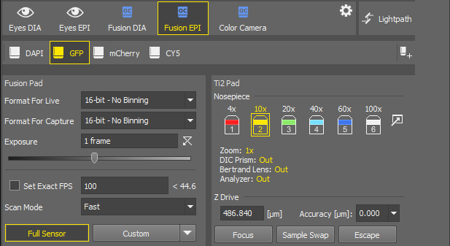

- Visualize and identify regions on insert with maximum bead movement
  - Best regions for capture are typically away from the center of insert

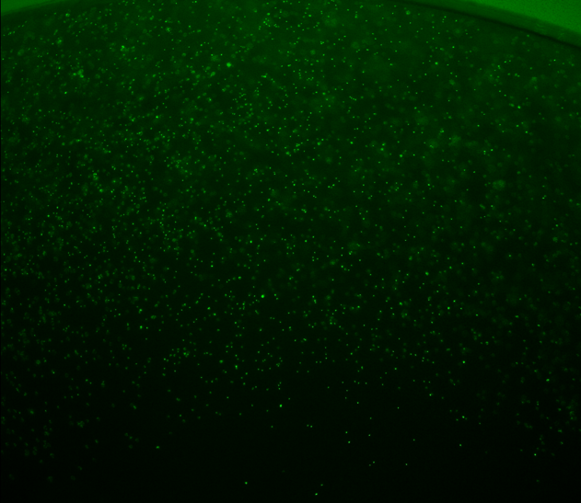
Capture region
4x magnification

- Once a suitable region is identified, ensure focus and contrast are well adjusted. Capture a 4.45 second video at 100 fps and 10x magnification.
- Note down the μm/pixel ratio for the specified resolution

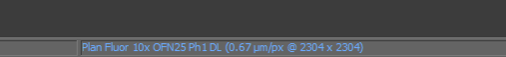
- Save video as .avi file with MJPEG compression if possible
- Capture a minimum of 3 videos per insert

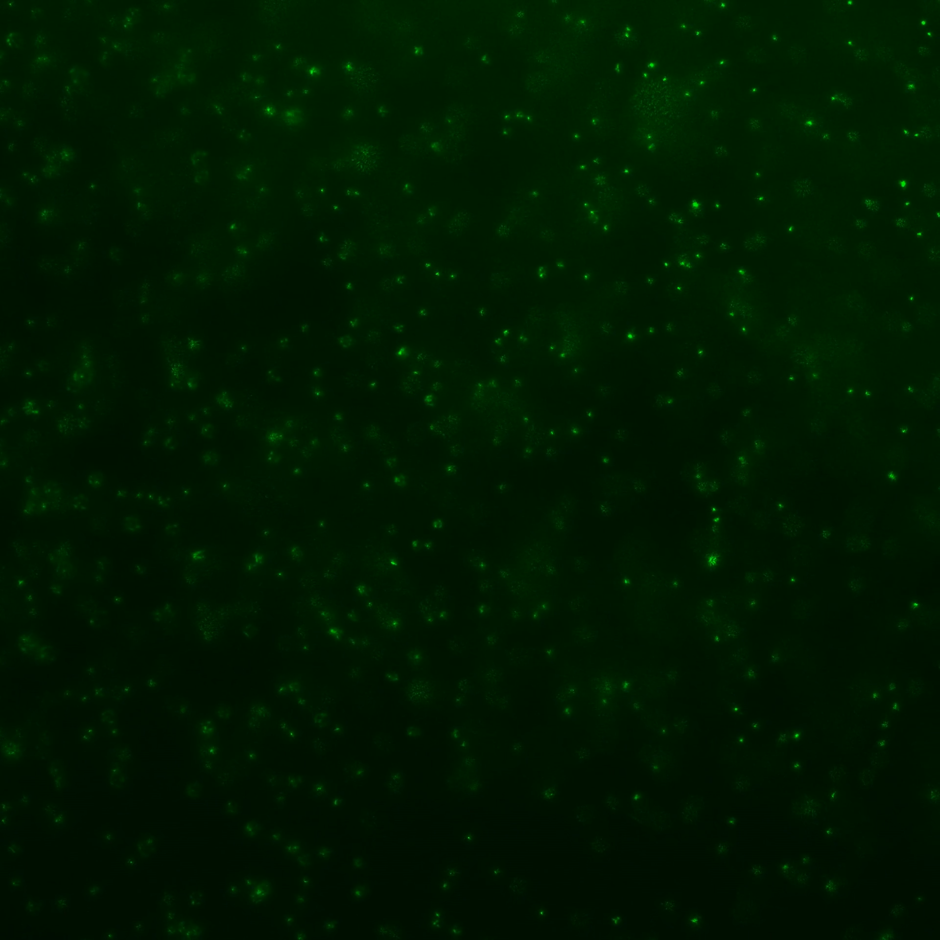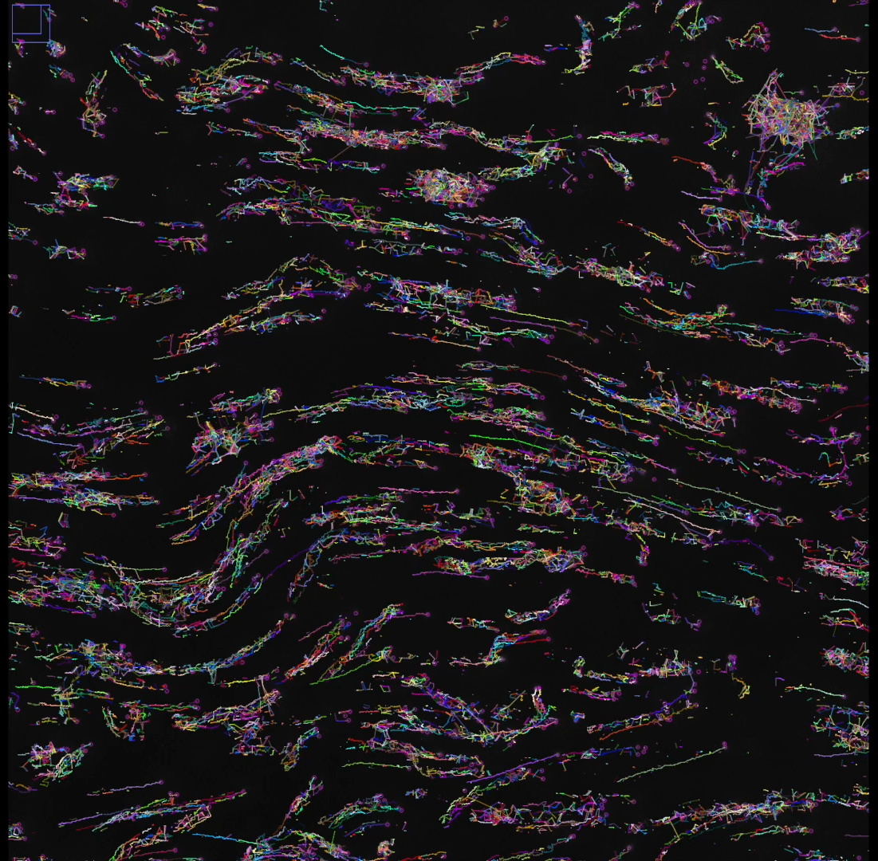
Particle movement
Raw capture
Healthy Cells

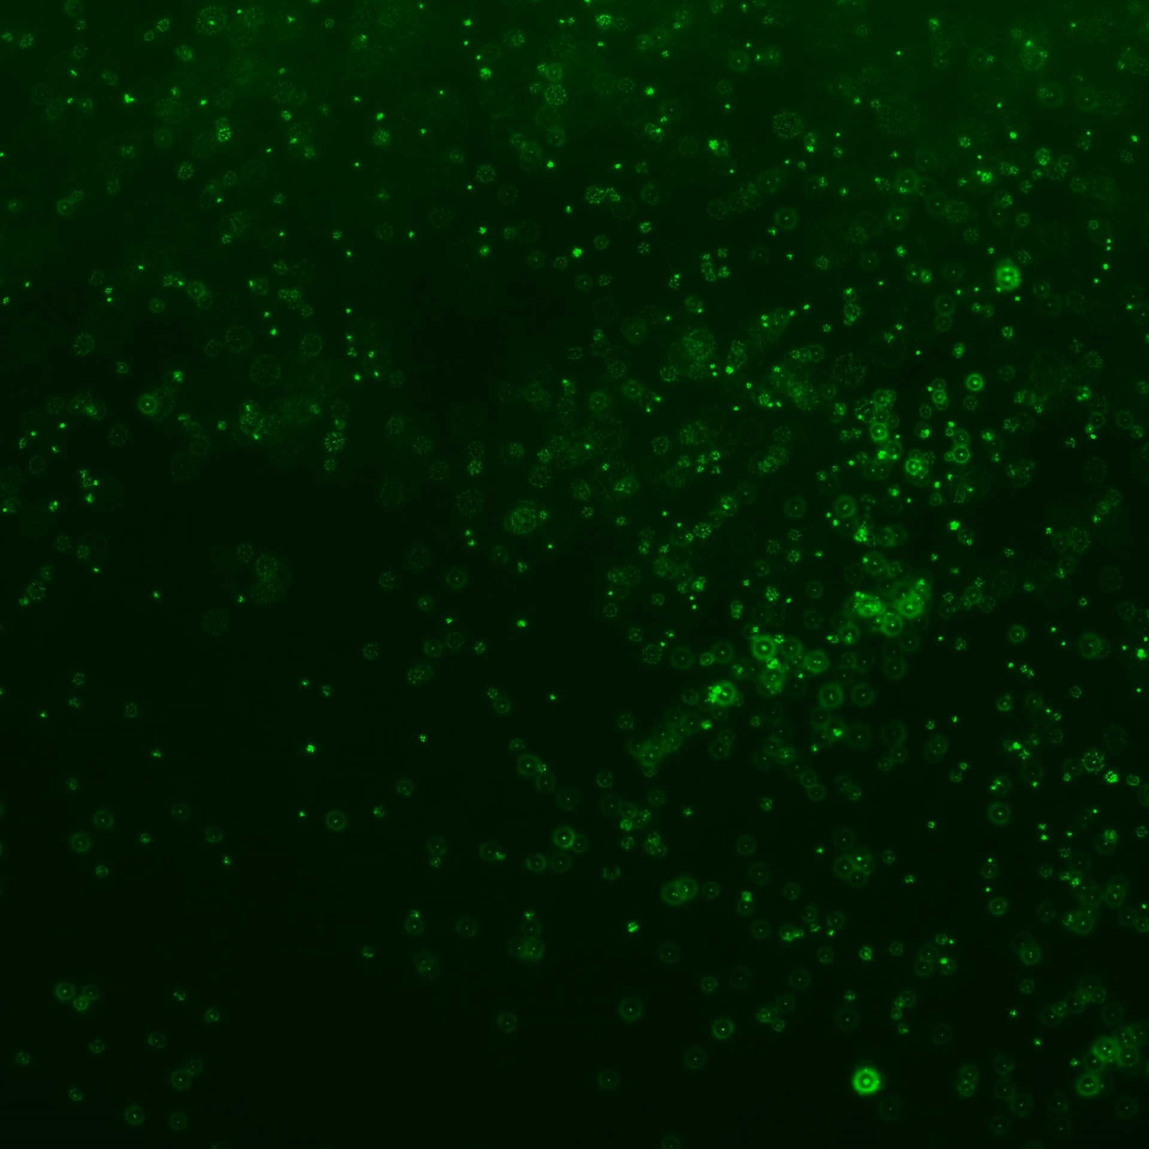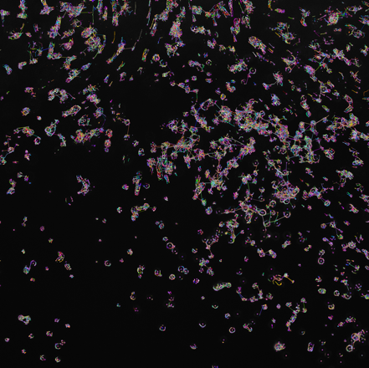
Particle movement
Raw capture
PCD Cells

- Once finished capturing process, rinse inserts with 2% Nu-Serum three times
- Use CIliaTracks for subsequent analysis

