

IT342-[Section]
System Integration and Architecture

System Design Document (SDD)

Project Title: BookBud
Prepared By: Colo, Nico John Gadia

Version:0.4
Date: February 28, 2026
Status: Final

REVISION HISTORY TABLE
Version | Date | Author | Changes Made | Status
0.1 | 2/21/2026 | Colo, Nico John G. | Initial draft | Draft
0.2 | 2/28/2026 | Colo, Nico John G | Finalized SSD | Final
0.3 | 3/07/2026 | Colo, Nico John G. | Added external API integrations — Google OAuth 2.0, SMTP email notifications, PayMongo webhook correction | Review
0.4 | 05/20/2026 | Colo, Nico John G. | Changed paymongo to Stripe Payment Gateway | Review
0.5 | [Date] | [Your Name] | Incorporated feedback | Revised
0.6 | [Date] | [Your Name] | Final review and corrections | Final
1 | [Date] | [Your Name] | Baseline version for development | Approved

TABLE OF CONTENTS
Contents
EXECUTIVE SUMMARY 4
1.0 INTRODUCTION 5
2.0 FUNCTIONAL REQUIREMENTS SPECIFICATION 5
3.0 NON-FUNCTIONAL REQUIREMENTS 8
4.0 SYSTEM ARCHITECTURE 9
5.0 API CONTRACT & COMMUNICATION 10
Authentication Endpoints 11
User Registration 11
User Login 11
6.0 DATABASE DESIGN 13
7.0 UI/UX DESIGN 14
8.0 PLAN 17

EXECUTIVE SUMMARY
1.1 Project Overview
BookBud is a peer-to-peer book rental and resale marketplace designed to give students, avid readers, and book collectors affordable access to physical books. The platform enables users to list their personal books for rent or sale, discover titles from other users filtered by genre, author, or condition, and complete transactions within a secure, end-to-end managed flow. The tagline "Read more for less." encapsulates the core value proposition - maximizing reading access while minimizing cost.
Architecturally, BookBud follows a classic three-tier design: a Spring Boot RESTful backend (Java), a ReactJS web frontend, and an Android mobile application (Kotlin). All three tiers communicate through a versioned, JWT-secured REST API and share a common PostgreSQL relational database managed via Hibernate/JPA. The system is deployed to cloud platforms (Render / Railway / Vercel / Google Cloud) and version-controlled via Git and GitHub.
1.2 Objectives
- Build a fully functional peer-to-peer book marketplace MVP supporting both rental and resale transaction types.
- Implement a three-tier architecture using Spring Boot (backend), React (web), and Android (mobile).
- Design and expose a versioned RESTful API that enables seamless, authenticated communication across all client platforms.
- Design a responsive user interface that works consistently across web and mobile platforms
- Deploy all system components to production-ready environments
- Deliver a consistent, accessible, and visually branded user experience aligned with the BookBud design language (primary color: #FF6F20)
- Deploy all system components to production-ready cloud environments with CI/CD pipelines.
- Enforce system security through JWT authentication, bcrypt password hashing (12 salt rounds), HTTPS, and role-based access control (RBAC).
- Document the full system design - from requirements through database schema and API contracts - as an authoritative implementation reference.
1.3 Scope
Included Features:
- User registration, login, and profile management with JWT authentication
- Book listing: title, author, genre, condition grading, price (rent/sale), and transaction type
- Book discovery with search and multi-filter support (genre, condition, type, price range)
- Wishlist management - save books for future consideration
- Rental and sales transaction lifecycle management (Pending → Active → Completed / Cancelled)
- Payment recording: method, amount, date, and payment status tracking
- In-app notification system triggered by transaction state changes
- User rating system (stored in USER table as aggregate decimal)
- Admin panel for book, user, and transaction governance
- Responsive ReactJS web interface (mobile-first, Tailwind CSS)
- Native Android application (Jetpack Compose, Retrofit, Room cache)
- PostgreSQL relational database with full schema and migration scripts
- Google OAuth 2.0 login — users can sign in with Google, account is saved/linked in the database, and a BookBud JWT is generated after OAuth login
- Email notifications via SMTP — welcome email on registration, transaction confirmation email when a transaction is created
- External API integration via Google Books API — used to auto-fill book details (title, author, genre, cover image) when creating a new listi
- Real-time payment gateway (Stripe, PayPal, GCash API) Phase
Excluded Features:
- In-app peer-to-peer chat / messaging system
- Book review and star-rating system (separate from user trust rating)
- Email or SMS notification delivery
- Automated inventory or stock management
- Multi-currency or international shipping support
- Push notifications (Firebase FCM) Phase 2
- Advanced analytics dashboard with charts/KPIs
- Multi-language / internationalisation (i18n) support

1.0 INTRODUCTION
1.1 Purpose
This Software Design Document (SDD) is the authoritative design specification for the BookBud system. It captures all requirements, architectural decisions, API contracts, database schema, UI/UX references, and the implementation roadmap needed to guide the entire development lifecycle. The document ensures that the Spring Boot backend, ReactJS web application, and Android mobile application are built to a consistent, agreed-upon specification and can be integrated seamlessly.
This SDD will be updated iteratively as the project progresses through design, development, and testing phases. All implementation decisions must reference and remain consistent with this document.

2.0 FUNCTIONAL REQUIREMENTS SPECIFICATION
2.1 Project Overview
Project Name: BookBud
Domain: Peer-to-Peer Book Rental & Resale Marketplace
Primary Users:
- User
- Administrator
Problem Statement: Students and avid readers frequently purchase books they read only once, creating both a financial burden and a growing pile of idle books. Existing second-hand platforms lack a dedicated environment for peer-to-peer rentals — most force users into outright purchases even when temporary access would be enough. There is no streamlined system that lets a person both monetize their idle books and affordably access books from others within one platform.
Solution: BookBud is a dual-purpose marketplace where a single user account can list books for rent or sale, and at the same time discover and transact on books listed by other users. The platform manages the full transaction lifecycle — from discovery and wishlist through payment recording and completion. Physical exchange of books is self-arranged between both parties using contact details visible on each other's profile once a transaction is initiated

2.2 Core User Journeys
Journey 1: Listing a Book (Owner / Seller / Lender)
- User logs in and navigates to My Listings → clicks Add Book.
- Fills in the listing form: title, author, genre, condition, transaction type (Rent / Sale / Both), and the corresponding price_rent and/or price_sale.
- Submits — book record is created with status "Available" and assigned to the current user as owner.
- The listing is immediately visible on the public catalog.
- When another user initiates a transaction, the owner receives an in-app notification.
- Both parties view each other's contact info on the Transaction Detail screen to coordinate the physical meetup.
- Once the book is handed over, the owner marks the transaction as Active.
- After the rental period ends or sale is completed, the owner marks the transaction as Completed. Book status resets to "Available" for rentals or updates to "Sold" for sales.
Journey 2: Renting a Book (Renter)
- User logs in and lands on the Book Catalog.
- Browses by genre, condition, or uses the search bar.
- Opens a Book Detail page to review title, author, genre, condition, rental price, and owner info.
- Clicks Add to Wishlist to save for later, or clicks Rent Now to proceed.
- Selects rental start date and end date.
- Confirms the rental — transaction record is created with status Pending, book status updates to Rented.
- Both the renter and the owner receive in-app notifications.
- Both parties view each other's contact info on the Transaction Detail screen to arrange the meetup.
- Renter records the payment by selecting payment method (Cash / GCash / Bank Transfer).
- Owner marks the transaction Active once the book is handed over.
- At the end of the rental period, the renter returns the book and the owner marks the transaction Completed. Book status resets to Available.
Journey 3: Buying a Book (Buyer)
- User logs in and browses the catalog filtered by transaction type Sale or Both.
- Opens Book Detail to review sale price and owner info.
- Clicks Buy Now — transaction record is created with status Pending.
- Both buyer and owner receive in-app notifications.
- Both parties view each other's contact info on the Transaction Detail screen to arrange the meetup.
- Buyer records the payment upon meetup.
- Owner marks the transaction as Completed — book status updates to Sold.
Journey 4: Managing Your Activity
- User visits My Transactions to see all transactions — both as owner and as renter/buyer — in one unified view.
- User visits My Listings to view, edit, or delete books they have listed.
- User visits Wishlist to review saved books and act on any item.
- User removes books from wishlist that are no longer of interest.
- User checks the notification bell for transaction updates and marks notifications as read.
- User visits their Profile to update their username, social media handle, mobile number, and other contact details so transaction partners can reach them.
Journey 5: Administrator — Platform Governance
- Admin logs in with a role = ADMIN account.
- Admin navigates to the Admin Panel to review flagged or reported listings and can approve, edit, or remove them. Removed listings are set to Unavailable and the owner is notified.
- Admin views all transactions across the platform and can update status or cancel disputed transactions.
- Admin manages user accounts — views the full user list, and can suspend or ban accounts for policy violations.
- Admin monitors notification logs for system events.
2.3 Feature List (MoSCoW)
MUST HAVE
- User Registration & Authentication — Email and password sign-up with input validation. JWT access and refresh tokens issued on login. Passwords hashed with bcrypt (12 salt rounds). Every user registers under one unified account type. Screens: Registration, Login, Forgot Password.
- User Profile with Contact Info — Users store and update their username, facebook_url, messenger handle, and mobile_number on their profile. Contact info is essential for coordinating physical book meetups. It is only visible to confirmed transaction partners — never exposed on the public catalog.
- Book Listing & Management — Full CRUD for book records. Fields: title, author, genre, condition, transaction type, price_rent, price_sale, status, and owner. Only the owner or an admin may edit or delete a listing. Screens: Add Book, Edit Book, My Listings, Book Detail.
- Book Discovery & Search — Full public catalog browsing with keyword search (title/author) and multi-filter support: genre, condition, transaction type, and price range. No login required to browse. Screens: Catalog / Home, Search Results.
- Wishlist — Users save books to a personal wishlist for later consideration. A user cannot wishlist their own book. Saved books can be removed at any time. Screen: Wishlist Page.
- Transaction Management — Full rental and sale lifecycle: Pending → Active → Completed, with Cancelled available at any stage before Completed. The owner controls the Active and Completed status transitions. Both parties can view each other's contact info on the Transaction Detail screen once a transaction exists. A user can be the owner in one transaction and the renter/buyer in another simultaneously. Screens: Initiate Transaction, Transaction Detail (with Contact Info panel), My Transactions.
- Payment Recording — After a transaction is created, the buyer/renter records the payment: amount, payment method (Cash / GCash / Bank Transfer), payment date, and payment status (Pending / Paid). One payment record per transaction. Screens: Payment Screen, Payment Confirmation, Transaction Detail payment tab.
- In-App Notification System — Notifications are triggered by: transaction created (notifies owner), transaction status changed to Active / Completed / Cancelled (notifies both parties), payment recorded (notifies owner), and listing removed by admin (notifies owner). Users can mark individual notifications or all notifications as read. Screens: Notification Bell with unread badge, Notifications List Page.
- Admin Panel — Dedicated interface for platform governance. Includes: Book Management (view all listings, set any to Unavailable, edit or delete), User Management (view all users, suspend or ban accounts), Transaction Management (view all transactions, cancel disputed ones), and Notification Logs (monitor system events). Admin accounts are role-protected — regular users receive HTTP 403 when attempting to access admin endpoints.
- Google OAuth Login — Users can sign in using their Google account. On first login, a new BookBud user account is created and linked to the Google identity. On subsequent logins, the existing account is retrieved. A BookBud JWT access and refresh token are generated and returned after successful OAuth authentication. Screens: Login Page (Google Sign-In button).
- Payment gateway integration via Stripe payment (sandbox/test mode) — processes rental and purchase payments, records results in the database, and handles success and failure callbacks
- Email Notifications (SMTP) — A welcome email is sent to the user immediately after successful registration. A transaction confirmation email is sent to both the owner and the renter/buyer when a new transaction is created, including the book title, transaction type, dates, and a link to the Transaction Detail screen.
- External API Integration (Google Books API) — When a user creates a new book listing, they can search by title to retrieve matching results from the Google Books API. Selecting a result auto-fills the title, author, genre, and cover image fields on the Add Book form. The user can still edit any field before submitting.

SHOULD HAVE
- User Rating System — After a transaction is marked Completed, both parties can submit a trust rating (0.00–5.00) for each other. The aggregate rating is stored on the user record and displayed on listings and transaction details to help build credibility between strangers arranging meetups.
- Transaction History — My Transactions page shows all past and active transactions in a single unified view, with the user's role clearly labeled (Buyer / Renter / Seller / Lender) and filter tabs by status (All / Pending / Active / Completed / Cancelled).
COULD HAVE
- Saved Search / New Listing Alerts — Notify users when a new book matching their saved filters is listed. Nice UX enhancement, not critical for MVP.
- Book Condition Photo Upload — Attach photos to a listing to support trust.
WON'T HAVE (Phase 1)
- In-App Chat / Messaging — Real-time peer messaging requires WebSocket infrastructure — significant complexity beyond MVP scope. Users coordinate meetups via their own contact details instead.
2.4 Detailed Feature Specifications
User Authentication & Profile Management
- Screens: Registration · Login · Forgot Password · Profile View/Edit
- Fields: user_id · username · email · password_hash · rating · facebook_url · messenger · mobile_number · created_at
- Validation: Email must be valid format and unique. Username must be unique and between 3–30 characters. Password must be at least 8 characters with at least one uppercase letter and one digit. Confirm password must match. Mobile number is optional but if provided must be a valid format.
- Security: Contact fields (facebook_url, messenger, mobile_number) are only returned by the API when the requesting user has an active transaction with the profile owner.
Book Listing & Management
- Screens: Add Book · Edit Book · My Listings · Book Detail · Catalog/Home
- Fields: book_id · title · author · genre · condition (New / Like New / Good / Fair / Poor) · price_rent · price_sale · transaction_type (Rent / Sale / Both) · status (Available / Rented / Sold / Unavailable) · owner_id
- Validation: Title, author, condition, and transaction type are required. At least one of price_rent or price_sale must be set depending on transaction type. Price must be greater than 0. Title must be 200 characters or fewer. Book status is locked from editing while a transaction is active on it.
Transaction Management
- Screens: Initiate Transaction · My Transactions · Transaction Detail · Contact Info Panel
- Fields: transaction_id · book_id · user_id (renter/buyer) · owner_id (book owner) · start_date · end_date (null for sales) · status (Pending / Active / Completed / Cancelled)
- Validation: start_date must be on or before end_date. Book must have status Available at the time of transaction creation. A user cannot initiate a transaction on their own listing. end_date is required for Rent-type transactions only.
- Contact Info: Both parties can view each other's facebook_url, messenger, and mobile_number on the Transaction Detail screen once a transaction record exists.
Payment Recording
- Screens: Payment Screen · Payment Confirmation · Transaction Detail (payment tab)
- Fields: payment_id · transaction_id · amount · payment_method (Cash / GCash / Bank Transfer) · payment_date · payment_status (Pending / Paid)
- Validation: Amount must be greater than 0. Payment method must be one of the valid enum values. Only one payment record is allowed per transaction.
In-App Notification System
- Screens: Notification Bell with unread count badge · Notifications List Page
- Fields: notification_id · user_id · message · is_read (default false) · created_at
- Triggers: Transaction created → owner notified. Status changed to Active, Completed, or Cancelled → both parties notified. Payment recorded → owner notified. Admin removes a listing → owner notified.
Admin Panel
- Screens: Admin Dashboard · Book Management · User Management · Transaction Management · Notification Logs
- Book Management: View all listings with status filters. Set any listing to Unavailable. Edit or hard-delete listings. Owner is notified on admin removal.
- User Management: View full user list with account status. Suspend or permanently ban accounts. Banned users cannot log in.
- Transaction Management: View all transactions across the platform. Cancel any disputed transaction and trigger notifications to both parties.
- Notification Logs: View a system-wide log of all notifications for monitoring and debugging.
- Security: All admin routes require role = ADMIN. Regular user accounts receive HTTP 403 Forbidden on any admin endpoint attempt.
2.5 Acceptance Criteria
AC-01: Successful User Registration
- Given I am a new user
- When I enter a valid email and strong password
- And confirm password matches
- And click "Create Account"
- Then my account should be created
- And I should be automatically logged in
- And redirected to the Book Catalog
AC-02: Rental Transaction Flow
- Given I am logged in as a user
- When I find an available book I do not own
- And I select a valid rental start and end date
- And confirm the transaction
- Then a transaction record should be created with status Pending
- And the book status should update to Rented
- And both me and the owner receive an in-app notification
- And I can see the owner's contact details on the Transaction Detail screen to arrange meetup
AC-03: Book Listing Published
- Given I am logged in as a user
- When I fill in the Add Book form with all required valid fields
- And submit the listing
- Then the book should appear on the public catalog
- And be available for rent or purchase by other users
AC-04: Payment Recorded Successfully
- Given I have a Pending transaction
- When I submit a valid payment amount and payment method
- Then a payment record should be created
- And the transaction becomes eligible for the owner to mark as Active
AC-05: Wishlist Add and Remove
- Given I am logged in as a user
- When I click Add to Wishlist on a book I do not own
- Then the book should appear on my Wishlist page
- When I click Remove on that book
- Then it should no longer appear on my Wishlist
AC-06: Notification Triggered on Status Change
- Given a transaction exists between two users
- When the transaction status changes
- Then both parties should receive an in-app notification
- And the notification bell should show an updated unread count
AC-07: Admin Book Removal
- Given I am logged in as an administrator
- When I delete a reported book listing
- Then the listing status should be set to Unavailable
- And it should no longer appear on the public catalog
- And the original owner should receive an in-app notification
AC-08: Role-Based Access Enforcement
- Given I am logged in as a regular user
- When I attempt to access an admin-only screen or endpoint
- Then the system should return HTTP 403 Forbidden
- And the action should not be performed
AC-09: Same User Acts as Both Owner and Renter
- Given I am a registered user with an active book listing
- When I also initiate a rental on another user's book
- Then both transactions should be recorded correctly
- And my My Transactions page should show both transactions in a unified view
- And each transaction should display my correct role (Owner or Renter/Buyer)
AC-10: Contact Info Visible Only to Transaction Parties
- Given two users have an existing transaction
- When either party opens the Transaction Detail screen
- Then they should see each other's contact details (facebook_url, messenger, mobile_number)
- And those contact details should NOT be visible to any other user on the public catalog or profile pages
AC-11: Rating Submitted After Completed Transaction
- Given a transaction with status Completed
- When either party submits a rating between 0.00 and 5.00
- Then the rated user’s aggregate rating must automatically update on their profile
- And the Submit Rating button must no longer be visible for the party who already submitted a rating
- And any attempt to submit a second rating from the same user for the same transaction must return an error

3.0 NON-FUNCTIONAL REQUIREMENTS
3.1 Performance Requirements
- API response time: ≤ 2 seconds for 95% of all requests under normal load
- Web page initial load time: ≤ 3 seconds on a standard broadband connection
- Book catalog and search results must load and render within 2 seconds of query submission
- Mobile app cold start time: ≤ 3 seconds on Android API Level 24 and above
- System must support a minimum of 100 concurrent users without performance degradation
- Database queries must complete within 500ms including all joins and filter operations
- Transaction status updates must be reflected in the UI within 5 seconds of submission
3.2 Security Requirements
- All client-server communication must use HTTPS with TLS 1.2 or higher
- All secured endpoints must require a valid JWT Bearer token in the Authorization header
- JWT access tokens expire after 1 hour; refresh tokens expire after 7 days
- User passwords must be hashed using bcrypt with a minimum of 12 salt rounds before storage
- Password hashes must never be returned in any API response under any circumstance
- All database interactions must use parameterized queries or ORM-managed queries to prevent SQL injection
- All user-generated input rendered in the UI must be sanitized to prevent XSS attacks
- Login endpoint must be rate-limited to a maximum of 100 requests per minute per IP address
- Contact info fields (facebook_url, messenger, mobile_number) must only be returned by the API when the requesting user has a confirmed transaction with that profile owner
- Admin-only endpoints must verify role = ADMIN on every request and return HTTP 403 Forbidden to any non-admin caller
- Banned or suspended user accounts must be rejected at authentication with a clear error message
3.3 Compatibility Requirements
- Web application must be fully functional on the two most recent versions of Chrome, Firefox, Safari, and Edge
- Android application must target API Level 34 (Android 14)
- Web UI must be responsive and fully usable across three breakpoints: Mobile (360px and above), Tablet (768px and above), and Desktop (1024px and above)
- Backend must be deployable on standard cloud platforms including Railway, Render, and Heroku
- Web frontend must be deployable on Vercel or Netlify without configuration changes
- Operating system support for development and deployment: Windows 10 and above, macOS 10.15 Catalina and above, Ubuntu Linux 20.04 LTS and above
3.4 Usability Requirements
- A new user should be able to complete their first rental or purchase transaction within 5 minutes of registering
- Web application must comply with WCAG 2.1 Level AA accessibility standards
- Navigation structure must be consistent across all pages so users always know where they are and how to get to any section
- All form validation errors must display a clear, specific message alongside the affected field and indicate how to correct the input
- All interactive touch targets on mobile must be a minimum of 44x44 pixels to ensure reliable tap accuracy
- The web application must support full keyboard navigation for all core user flows including registration, browsing, listing a book, and completing a transaction
- Empty states (no listings, no transactions, empty wishlist) must display a helpful message and a clear call-to-action guiding the user on what to do next
- The application must display a loading indicator for any operation that takes longer than 500ms to complete

4.0 SYSTEM ARCHITECTURE
4.1 Component Diagram
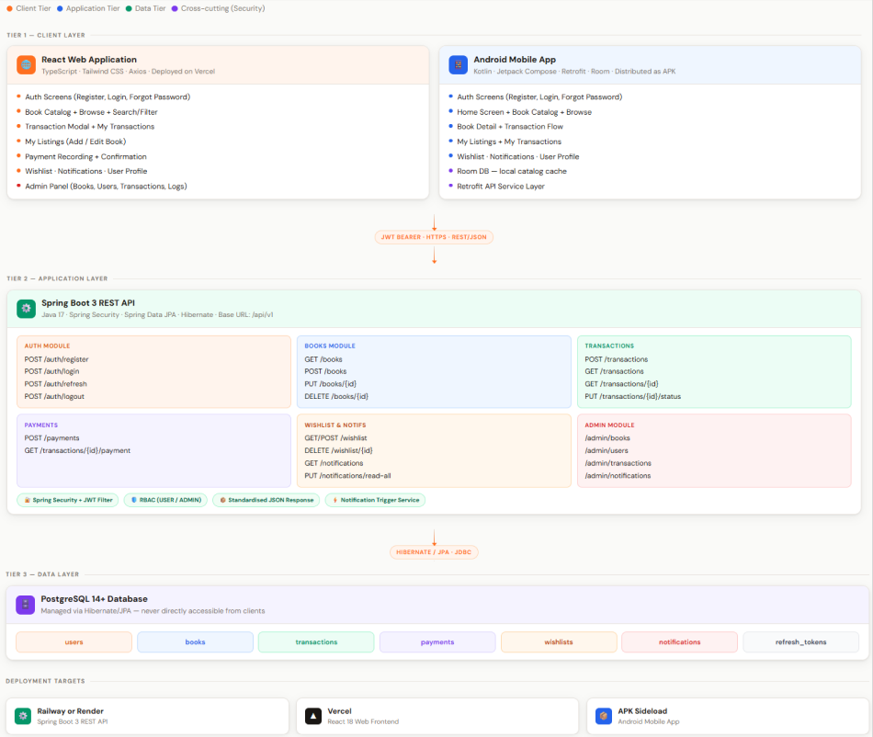
Overview
BookBud follows a three-tier client-server architecture. All three tiers — the Spring Boot backend, the ReactJS web frontend, and the Android mobile application — communicate exclusively through a versioned, JWT-secured RESTful API. No tier communicates directly with the database except the backend.
Tier 1 — Client Layer
ReactJS Web Application (TypeScript, Tailwind CSS) deployed on Vercel. Responsible for all user-facing web screens including authentication, book browsing, listing management, transaction flows, wishlist, notifications, user profile, and the admin panel.
Android Mobile Application (Kotlin, Jetpack Compose) distributed as a signed APK. Uses Retrofit for API calls and Room for local caching of catalog data. to: Android Mobile Application (Kotlin, XML-based UI layouts, Android API Level 34) distributed as a signed APK. Uses Retrofit for API calls and connects to the same Spring Boot backend as the web application.
Tier 2 — Application Layer
Spring Boot 3 REST API (Java 17+) deployed on Railway or Render. Handles all business logic, authentication, authorization, transaction lifecycle management, notification triggering, and data validation. Exposes a versioned API at base URL /api/v1. All endpoints return a standardized JSON response envelope.
Tier 3 — Data Layer
PostgreSQL 14+ relational database managed via Hibernate/JPA. Stores all persisted data including users, books, transactions, payments, wishlists, notifications, and refresh tokens. The database is never directly accessible from either client tier.
Technology Stack
Backend: Java 17+, Spring Security OAuth2 Client, Spring Boot 3.x, Spring Security, Spring Data JPA, Hibernate, Google Books API (external)

Database: PostgreSQL 14+ Web Frontend: React 18, TypeScript, Tailwind CSS, Axios Mobile: Kotlin, Jetpack Compose, Retrofit, Room to: Mobile: Kotlin, XML-based UI layouts, Retrofit, Android API Level 34 Deployment: Railway or Render (Backend), Vercel (Web), APK sideload (Android) Version Control: Git, GitHub

Communication Flow
Both the web and mobile clients authenticate using POST /auth/login to receive a JWT access token and a refresh token. Every subsequent secured request includes the access token in the Authorization header as a Bearer token. When the access token expires after 1 hour, the client silently refreshes it using POST /auth/refresh with the refresh token. The backend validates all incoming tokens using Spring Security before processing any request. Admin routes additionally verify that the decoded token carries role = ADMIN and return HTTP 403 Forbidden if it does not.

5.0 API CONTRACT & COMMUNICATION
5.1 API Standards
Base URL | https://[server_hostname]:[port]/api/v1
Format | JSON for all requests/responses
Authentication | Bearer token (JWT) in Authorization header
Response Structure | {  "success": boolean,  "data": object|null,  "error": {  "code": string,  "message": string,  "details": object|null  },  "timestamp": string  }

5.2 Endpoint Specifications

Authentication Endpoints

User Registration
Description | Register a new user account. Returns JWT access and refresh tokens on success.
API URL | /api/v1/auth/register
HTTP Method | POST
Format | JSON for all requests/responses
Authentication | None
Request Payload | {"username": string, "email": string, "password": string, "confirm_password": string }
Response Structure | {"success": true, "data": { "user": { "user_id": string, "username": string, "email": string, "role": "USER", "created_at": string }, "accessToken": string, "refreshToken": string },"error": null, "timestamp": string }
Validation Rules | Email must be valid format and unique. Username must be unique and between 3-30 characters. Password must be at least 8 characters with at least one uppercase letter and one digit. confirm_password must match password.
Error Codes | VALID-001 (validation failed), DB-002 (email or username already exists)

User Login
Description | Authenticate an existing user. Returns JWT access and refresh tokens.
API URL | /api/v1/auth/login
HTTP Method | POST
Format | JSON for all requests/responses
Authentication | None
Request Payload | { "email": string, "password": string }
Response Structure | { "success": true, "data": { "user": { "user_id": string, "username": string, "email": string, "role": "USER" | "ADMIN", "rating": number | null }, "accessToken": string, "refreshToken": string }, "error": null, "timestamp": string }
Error Codes | AUTH-001 (invalid credentials), AUTH-004 (account suspended or banned)

Forgot Password
Description | Submit a password reset request. Logs the request server-side. Always returns success to prevent user enumeration. Email delivery is out of scope for Phase 1.
API URL | /api/v1/auth/forgot-password
HTTP Method | POST
Format | None
Authentication | None
Request Payload | { "email": string }
Response Structure | { "success": true, "data": null, "error": null, "timestamp": string }

Refresh Token
Description | Exchange a valid refresh token for a new access token.
API URL | /api/v1/auth/refresh
HTTP Method | POST
Format | JSON for all requests/responses
Authentication | None
Request Payload | { "refreshToken": string }
Response Structure | { "success": true, "data": { "accessToken": string, "refreshToken": string }, "error": null, "timestamp": string }
Error Codes | AUTH-002 (token expired), AUTH-005 (invalid refresh token)

Logout
Description | Invalidate the current refresh token server-side.
API URL | /api/v1/auth/logout
HTTP Method | POST
Format | JSON for all requests/responses
Authentication | Bearer token required
Request Payload | { "refreshToken": string }
Response Structure | { "success": true, "data": null, "error": null, "timestamp": string }

Get Current Authenticated User
Description | Returns the profile of the currently authenticated user based on their JWT token.
API URL | /api/v1/auth/me
HTTP Method | GET
Authentication | Bearer token required
Request Payload | None
Response Structure | { "success": true, "data": { "user_id": string, "username": string, "email": string, "role": "USER" | "ADMIN", "rating": number | null, "created_at": string }, "error": null, "timestamp": string }
Response Structure | AUTH-002 (token expired or invalid)

Search Books via Google Books API
Description | Searches the Google Books API by title keyword and returns matching book suggestions for auto-filling the Add Book form.
API URL | /api/v1/books/search-external
HTTP Method | GET
Authentication | Bearer token required
Query Parameters: | q (keyword — title)
Response Structure | { "success": true, "data": [ { "title": string, "author": string, "genre": string, "cover_image_url": string } ], "error": null, "timestamp": string }
Response Structure | SYSTEM-001 (external API unavailable)

Description: Searches the Google Books API by title keyword and returns matching book suggestions for auto-filling the Add Book form. API URL: /api/v1/books/search-external HTTP Method: GETAuthentication: Bearer token required Query Parameters: q (keyword — title) Response Structure: { "success": true, "data": [ { "title": string, "author": string, "genre": string, "cover_image_url": string } ], "error": null, "timestamp": string } Error Codes: SYSTEM-001 (external API unavailable)

USER PROFILE ENDPOINTS

Get User Profile
Description | Retrieve a user's profile. Contact fields are only returned if the requesting user has an active transaction with this user.
API URL | /api/v1/users/{user_id}
HTTP Method | GET
Format | JSON for all requests/responses
Authentication | Bearer token required
Request Payload | None
Response | { "success": true, "data": { "user_id": string, "username": string, "rating": number,
Structure | "created_at": string, "facebook_url": string | null, "messenger": string | null,"mobile_number": string | null }, "error": null, "timestamp": string}
Security Note | facebook_url, messenger, and mobile_number are only included when the requesting user shares a confirmed transaction with the profile owner.
Error Codes | AUTH-002 (not authenticated), DB-001 (user not found)

Update User Profile

Description | Update the authenticated user's editable profile fields.
API URL | /api/v1/users/{user_id}
HTTP Method | PUT
Format | JSON for all requests/responses
Authentication | Bearer token required (own profile or ADMIN)
Request Payload | { "username": string, "facebook_url": string | null, "messenger": string | null, "mobile_number": string | null }
Response Structure | { "success": true, "data": { updated user object }, "error": null, "timestamp": string }
Error Codes | AUTH-003 (insufficient permissions), VALID-001 (validation failed)

BOOK ENDPOINTS

Get All Books - Catalog

Description | Retrieve the public book catalog with optional keyword search and multi-filter support. No authentication required.
API URL | /api/v1/books
HTTP Method | GET
Format | JSON for all requests/responses
Authentication | None
Query Parameters | q (keyword — title or author), genre, condition, type (Rent / Sale / Both), min_price, max_price, status (default: Available), page (default: 0), size (default: 20)
Response Structure | { "success": true, "data": { "content": [ array of book objects ], "page": number, "size": number, "totalElements": number }, "error": null, "timestamp": string }

Create Book Listing
Description | Create a new book listing owned by the authenticated user. Book is created with status "Available" and owner_id set to the requesting user.
API URL | /api/v1/books
HTTP Method | POST
Format | JSON for all requests/responses
Authentication | Bearer token required
Request Payload | { "title": string, "author": string, "genre": string, "condition": "New" | "Like New" | "Good" | "Fair" | "Poor", "transaction_type": "Rent" | "Sale" | "Both", "price_rent": number | null, "price_sale": number | null }
Response Structure | { "success": true, "data": { created book object with owner_id and status "Available" }, "error": null, "timestamp": string }
Error Codes | VALID-001 (missing required fields or invalid price), AUTH-002 (not authenticated)

Update Book Listing

Description | Update an existing book listing. Only the owner or an ADMIN may update. Cannot update a book locked by an active transaction.
API URL | /api/v1/books/{book_id}
HTTP Method | PUT
Format | JSON for all requests/responses
Authentication | Bearer token required (owner or ADMIN)
Request Payload | { "title": string, "author": string, "genre": string, "condition": "New" | "Like New" | "Good" | "Fair" | "Poor", "transaction_type": "Rent" | "Sale" | "Both", "price_rent": number | null, "price_sale": number | null }
Response Structure | { "success": true, "data": { updated book object }, "error": null, "timestamp": string }
Error Codes | AUTH-003 (not owner or admin), DB-001 (book not found), BUSINESS-001 (book locked by active transaction)

Delete Book Listing

Description | Delete a book listing. Owner deletion permanently removes the record and cascade deletes associated wishlist entries. Admin deletion sets status to Unavailable and triggers an in-app notification to the owner.
API URL | /api/v1/books/{book_id}
HTTP Method | DELETE
Format | JSON for all requests/responses
Authentication | Bearer token required (owner or ADMIN)
Request Payload | None
Response Structure | { "success": true, "data": null, "error": null, "timestamp": string }
Error Codes | AUTH-003 (insufficient permissions), DB-001 (book not found), BUSINESS-001 (book locked by active transaction)

Submit Rating
Description | Submit a trust rating for the counterpart after a transaction is Completed. The backend recalculates the recipient's aggregate rating and updates users.rating.
API URL | /api/v1/transactions/{transaction_id}/rating
HTTP Method | POST
Authentication | Authentication: Bearer token required (must be a party to the transaction — owner or renter/buyer)
Request Payload | { "rating": number (0.00–5.00) }
Response Structure | { "success": true, "data": { "transaction_id": string, "rated_user_id": string, "rating": number, "new_aggregate_rating": number }, "error": null, "timestamp": string }
Error Codes | BUSINESS-007 (transaction not Completed), BUSINESS-008 (rating already submitted), AUTH-003 (not a party to this transaction), DB-001 (transaction not found)

TRANSACTION ENDPOINTS

Create Transaction
Description | Initiate a rental or purchase transaction on an available book. Creates transaction with status Pending and updates book status. Both parties receive an in-app notification.
API URL | /api/v1/transactions
HTTP Method | POST
Format | JSON for all requests/responses
Authentication | Bearer token required
Request Payload | { "book_id": string, "start_date": string (YYYY-MM-DD), "end_date": string | null (required for Rent, null for Sale) }
Response Structure | { "success": true, "data": { "transaction_id": string, "book_id": string, "user_id": string, "owner_id": string, "start_date": string, "end_date": string | null, "status": "Pending", "created_at": string }, "error": null, "timestamp": string }
Error Codes | VALID-001 (invalid dates), BUSINESS-002 (book not available), BUSINESS-003 (cannot transact own listing)

Google OAuth Login — Initiate
Description | Redirects the user to Google's login page.
API URL | /api/v1/auth/oauth/google
HTTP Method | GET
Authentication | None
Request Payload | None
Response | HTTP 302 Redirect
Error Codes | N/A

1. Google OAuth: Initiate Login
- Description: This is the starting point for users who want to log in via Google. It redirects them away from your app to Google's secure consent screen.
- API URL: /api/v1/auth/oauth/google
- Method: GET
- Authentication: None
- Response: HTTP 302 (Redirect to Google)

2. Google OAuth: Login Callback
- Description: Once the user logs into Google, Google sends them back here with a "code." This endpoint handles account creation (for new users) or retrieval (for returning users).
- API URL: /api/v1/auth/oauth/google/callback
- Method: GET
- Response: A JSON object containing the User Profile and JWT Tokens (accessToken and refreshToken).
- Error Codes: AUTH-006 (Google failure) or AUTH-004 (Account suspended).

3. Welcome Email (SMTP)
- Description: A friendly automated email sent to greet new members of the community.
- Trigger: Successful registration via standard sign-up or the Google OAuth callback.
- Recipient: The newly registered user.
- Content: A warm greeting, a quick intro to BookBud, and a link to start browsing books.
- Note: This runs in the background; if the email fails, the user is still registered.

4. Transaction Confirmation Email (SMTP)
- Description: An automated notification that confirms a book deal has been made.
- Trigger: A successful POST request to /api/v1/transactions.
- Recipients: Two separate emails are sent—one to the book owner and one to the renter/buyer.
- Content: Includes the book title, the type of transaction (Rent/Buy), dates, the other person's username, and a link to the transaction details.

Get My Transactions

Description | Retrieve all transactions where the authenticated user appears as either the owner or the renter/buyer in a single unified view.
API URL | /api/v1/transactions
HTTP Method | GET
Format | JSON for all requests/responses
Authentication | Bearer token required
Query Parameters | status (optional filter: Pending / Active / Completed / Cancelled), page, size
Response Structure | { "success": true, "data": { "content": [ array of transaction objects each including the user's role ], "page": number,  "size": number, "totalElements": number }, "error": null, "timestamp": string }

Get Single Transaction

Description | Retrieve full details of a transaction. Both parties contact info is included in the response.
API URL | /api/v1/transactions/{transaction_id}
HTTP Method | GET
Format | JSON for all requests/responses
Authentication | Bearer token required (must be a party to the transaction or ADMIN)
Request Payload | None
Response Structure | { "success": true, "data": { full transaction object including both parties' facebook_url, messenger, and mobile_number }, "error": null, "timestamp": string }
Error Codes | AUTH-003 (not a party to this transaction), DB-001 (transaction not found)

Initiate Payment

Description | Creates a PayMongo payment session for a transaction and returns a checkout URL.
API URL | /api/v1/payments/initiate
HTTP Method | POST
Format | None
Authentication | Bearer token required
Request Payload: | { "transaction_id": string, "payment_method": "card" | "gcash" | "grab_pay" }
Response Structure: | { "success": true, "data": { "payment_id": string, "checkout_url": string, "payment_status": "Pending" }, "error": null, "timestamp": string }
Error Codes: | { "success": true, "data": { "content": [ array of transaction objects each including the user's role ], "page": number, "size": number, "totalElements": number }, "error": null, "timestamp": string }

Payment Webhook (Stripe Payment)

Description | Creates a Stripe payment session for a transaction and returns a checkout URL.
API URL | /api/v1/payments/webhook
HTTP Method | POST
Format | None
Authentication | Stripe webhook signature header
Request Payload: | Stripe event payload (handled internally)
Response Structure: | { "success": true, "data": { "payment_id": string, "checkout_url": string, "payment_status": "Pending" }, "error": null, "timestamp": string }
Error Codes: | None

Update Transaction Status

Description | Update the status of a transaction. Valid transitions: Pending to Active (owner only), Active to Completed (owner only), Pending or Active to Cancelled (either party or ADMIN). Both parties are notified on every status change.
API URL | /api/v1/transactions/{transaction_id}/status
HTTP Method | PUT
Format | JSON for all requests/responses
Authentication | Bearer token required
Request Payload | { "status": "Active" | "Completed" | "Cancelled" }
Response Structure | { "success": true, "data": { updated transaction object }, "error": null, "timestamp": string }
Error Codes | AUTH-003 (not authorized for this transition), BUSINESS-004 (invalid status transition)

PAYMENT ENDPOINTS

Record Payment

Description | Record a payment for a transaction. Only one payment record is allowed per transaction. Owner receives an in-app notification on submission.
API URL | /api/v1/payments
HTTP Method | POST
Format | JSON for all requests/responses
Authentication | Bearer token required
Request Payload | { "transaction_id": string, "amount": number, "payment_method": "Cash" | "GCash" | "Bank Transfer", "payment_date": string (YYYY-MM-DD) }
Response Structure | { "success": true, "data": { "payment_id": string, "transaction_id": string, "amount": number, "payment_method": string, "payment_date": string, "payment_status": "Pending" }, "error": null, "timestamp": string }
Error Codes | VALID-001 (invalid amount or method), BUSINESS-005 (payment already recorded for this transaction)

Get Payment by Transaction

Description | Retrieve the payment record associated with a specific transaction.
API URL | /api/v1/transactions/{transaction_id}/payment
HTTP Method | GET
Format | JSON for all requests/responses
Authentication | Bearer token required (must be a party to the transaction or ADMIN)
Request Payload | None
Response Structure | { "success": true, "data": { "payment_id": string, "transaction_id": string, "amount": number, "payment_method": string, "payment_date": string, "payment_status": string }, "error": null, "timestamp": string }
Error Codes | DB-001 (payment not found), AUTH-003 (not a party to this transaction)

WISHLIST ENDPOINTS
Get My Wishlist

Description | Retrieve all wishlist entries for the authenticated user, each including the full book object.
API URL | /api/v1/wishlist
HTTP Method | GET
Format | JSON for all requests/responses
Authentication | Bearer token required
Request Payload | None
Response Structure | { "success": true, "data": [ array of wishlist entries with full book objects ], "error": null, "timestamp": string }

Add to Wishlist
Description | Save a book to the authenticated user's wishlist. A user cannot wishlist their own book.
API URL | /api/v1/wishlist
HTTP Method | POST
Format | JSON for all requests/responses
Authentication | Bearer token required
Request Payload | { "book_id": string }
Response Structure | { "success": true, "data": { "wishlist_id": string, "user_id": string, "book_id": string, "date_added": string }, "error": null, "timestamp": string }
Error Codes | BUSINESS-006 (cannot wishlist own book), DB-002 (book already in wishlist)

Remove from Wishlist
Description | Remove a specific entry from the authenticated user's wishlist.
API URL | /api/v1/wishlist/{wishlist_id}
HTTP Method | DELETE
Format | JSON for all requests/responses
Authentication | Bearer token required (own wishlist entry only)
Request Payload | None
Response Structure | { "success": true, "data": null, "error": null, "timestamp": string }
Error Codes | AUTH-003 (not own entry), DB-001 (entry not found)

NOTIFICATION ENDPOINTS
Get My Notifications
Description | Retrieve all notifications for the authenticated user ordered by most recent first.
API URL | /api/v1/notifications
HTTP Method | GET
Format | JSON for all requests/responses
Authentication | Bearer token required
Request Payload | None
Response Structure | { "success": true, "data": [ array of notification objects with is_read status ], "error": null, "timestamp": string }

Mark Notification as Read
Description | Mark a single notification as read.
API URL | /api/v1/notifications/{notification_id}/read
HTTP Method | PUT
Format | JSON for all requests/responses
Authentication | Bearer token required (own notification only)
Request Payload | None
Response Structure | { "success": true, "data": { updated notification object }, "error": null, "timestamp": string }
Error Codes | AUTH-003 (not own notification), DB-001 (notification not found)

Mark All Notifications as Read
Description | Mark all of the authenticated user's notifications as read in a single operation.
API URL | /api/v1/notifications/read-all
HTTP Method | PUT
Format | JSON for all requests/responses
Authentication | Bearer token required
Request Payload | None
Response Structure | { "success": true, "data": null, "error": null, "timestamp": string }

Delete Notification
Description | Permanently delete a single notification.
API URL | /api/v1/notifications/{notification_id}
HTTP Method | DELETE
Format | JSON for all requests/responses
Authentication | Bearer token required (own notification only)
Request Payload | None
Response Structure | { "success": true, "data": null, "error": null, "timestamp": string }
Error Codes | AUTH-003 (not own notification), DB-001 (notification not found)

ADMIN ENDPOINTS
All admin endpoints require a JWT token with role = ADMIN. Any request from a non-admin account returns HTTP 403 Forbidden.
Get All Books (Admin)
Description | Retrieve all book listings across the platform regardless of status.
API URL | /api/v1/admin/books
HTTP Method | GET
Format | JSON for all requests/responses
Authentication | Bearer token required (ADMIN only)
Request Payload | None
Response Structure | { "success": true, "data": { paginated list of all book objects }, "error": null, "timestamp": string }

Update Book Status (Admin)
Description | Update the status of any book listing. Setting to Unavailable triggers an in-app notification to the book owner.
API URL | /api/v1/admin/books/{book_id}/status
HTTP Method | PUT
Format | JSON for all requests/responses
Authentication | Bearer token required (ADMIN only)
Request Payload | { "status": "Available" | "Unavailable" | "Rented" | "Sold" }
Response Structure | { "success": true, "data": { updated book object }, "error": null, "timestamp": string }
Error Codes | AUTH-003 (not ADMIN), DB-001 (book not found)

Get All Users (Admin)
Description | Retrieve all registered user accounts with full account status information.
API URL | /api/v1/admin/users
HTTP Method | GET
Format | JSON for all requests/responses
Authentication | Bearer token required (ADMIN only)
Request Payload | None
Response Structure | { "success": true, "data": { paginated list of all user objects }, "error": null, "timestamp": string }

Update User Status (Admin)
Description | Suspend or ban a user account. Banned users are rejected at authentication with a clear error message.
API URL | /api/v1/admin/users/{user_id}/status
HTTP Method | PUT
Format | JSON for all requests/responses
Authentication | Bearer token required (ADMIN only)
Request Payload | { "status": "Active" | "Suspended" | "Banned" }
Response Structure | { "success": true, "data": { updated user object }, "error": null, "timestamp": string }
Error Codes | AUTH-003 (not ADMIN), DB-001 (user not found)

Get All Transactions (Admin)
Description | Retrieve all transactions across the platform for oversight and dispute resolution.
API URL | /api/v1/admin/transactions
HTTP Method | GET
Format | JSON for all requests/responses
Authentication | Bearer token required (ADMIN only)
Request Payload | None
Response Structure | { "success": true, "data": { paginated list of all transaction objects }, "error": null, "timestamp": string }

Cancel Transaction (Admin)
Description | Force-cancel any active or pending transaction. Triggers in-app notifications to both parties.
API URL | /api/v1/admin/transactions/{transaction_id}/cancel
HTTP Method | PUT
Format | JSON for all requests/responses
Authentication | Bearer token required (ADMIN only)
Request Payload | None
Response Structure | { "success": true, "data": { updated transaction object with status "Cancelled" }, "error": null, "timestamp": string }
Error Codes | AUTH-003 (not ADMIN), DB-001 (transaction not found), BUSINESS-004 (transaction already completed)

Get Notification Logs (Admin)
Description | Retrieve a system-wide log of all notifications sent to all users for monitoring and debugging.
API URL | /api/v1/admin/notifications
HTTP Method | GET
Format | JSON for all requests/responses
Authentication | Bearer token required (ADMIN only)
Request Payload | None
Response Structure | { "success": true, "data": { paginated list of all notification objects with recipient usernames and trigger events }, "error": null, "timestamp": string }

]
5.3 Error Handling
HTTP Status Codes
- 200 OK — Successful request
- 201 Created — Resource successfully created
- 400 Bad Request — Invalid input or failed validation
- 401 Unauthorized — Authentication required or token invalid
- 403 Forbidden — Authenticated but insufficient permissions
- 404 Not Found — Requested resource does not exist
- 409 Conflict — Duplicate resource (email already registered, book already wishlisted)
- 500 Internal Server Error — Unexpected server-side failure
- BUSINESS-007: Rating cannot be submitted — transaction is not yet Completed
- BUSINESS-008: Rating already submitted by this user for this transaction
Common Error Codes
AUTH-001: Invalid email or password credentials AUTH-002: JWT access token has expired AUTH-003: Insufficient permissions for this action AUTH-004: Account is suspended or banned AUTH-005: Refresh token is invalid or expired
VALID-001: Request body failed validation — details object lists each failing field and reason
DB-001: Requested resource was not found DB-002: Duplicate entry — resource already exists
BUSINESS-001: Book status is locked by an active transaction and cannot be edited BUSINESS-002: Book is not Available — transaction cannot be created BUSINESS-003: A user cannot initiate a transaction on their own listing BUSINESS-004: Invalid transaction status transition BUSINESS-005: A payment record already exists for this transaction BUSINESS-006: A user cannot add their own listing to their wishlist
SYSTEM-001: Unexpected internal server error
AUTH-006: Google OAuth failed — invalid code or Google API error
SYSTEM-002: SMTP unavailable — email not sent, operation continues normally

Error Response Example:
{
"success": false,
"data": null,
"error": {
"code": "VALID-001",
"message": "Validation failed",
"details": {
"email": "Email is required and must be a valid format",
"password": "Password must be at least 8 characters with 1 uppercase letter and 1 digit"
}
},
"timestamp": "2026-02-28T10:30:00Z"
}

6.0 DATABASE DESIGN
6.1 Entity Relationship Diagram
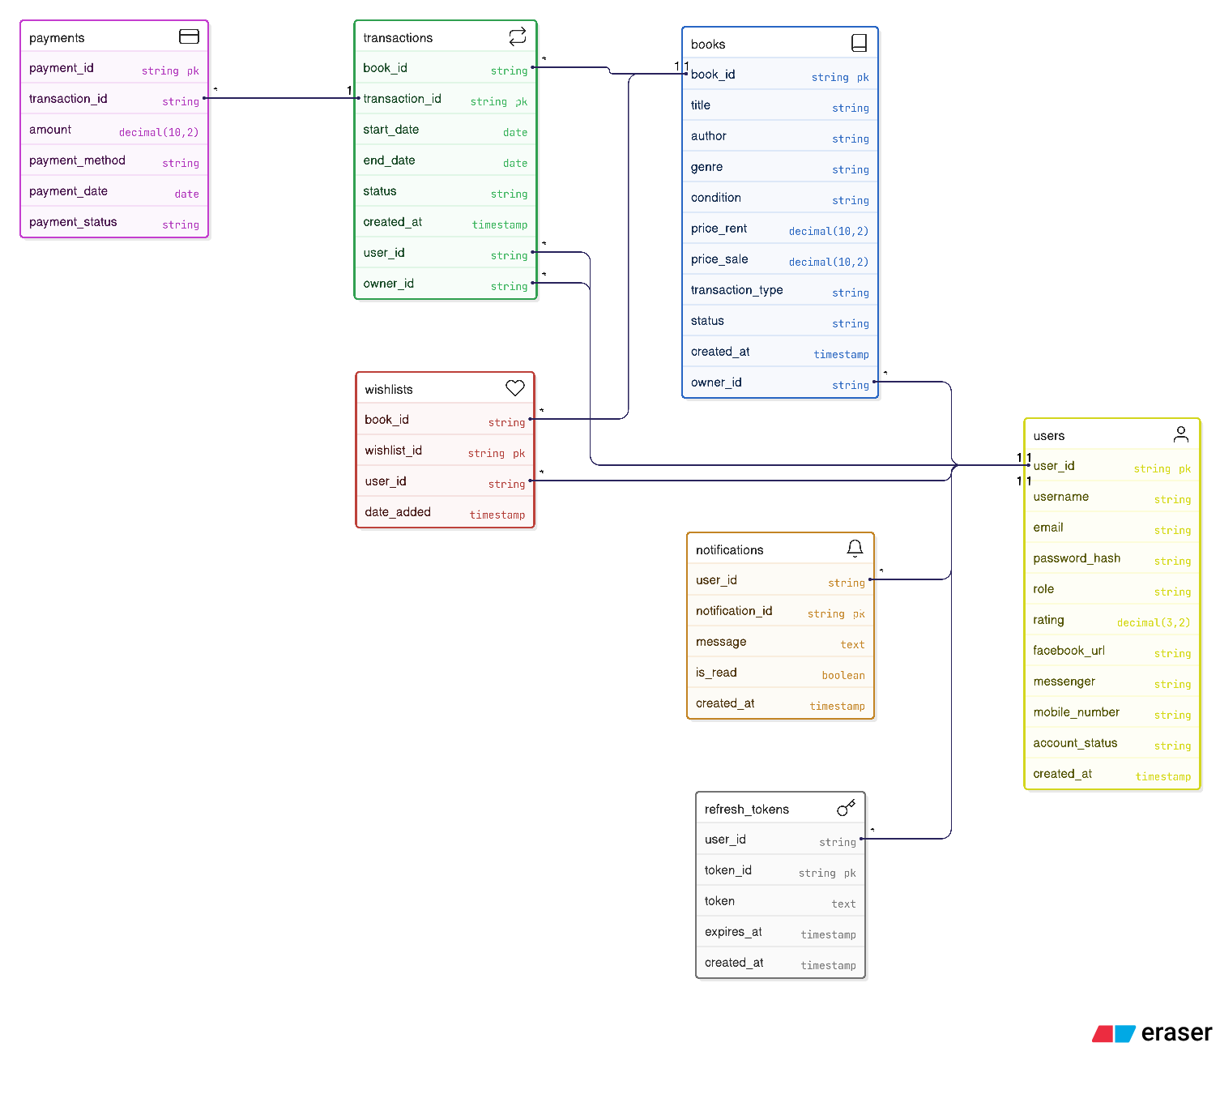

Detailed Relationships:
- One-to-Many: USER → BOOK (one user can own multiple book listings)
- One-to-Many: USER → TRANSACTION as owner_id (one user can be the owner in multiple transactions)
- One-to-Many: USER → TRANSACTION as user_id (one user can be the renter/buyer in multiple transactions)
- One-to-Many: TRANSACTION → PAYMENT (one transaction has one payment record)
- Many-to-One: BOOK → USER (each book belongs to one owner)
- Many-to-One: WISHLIST → USER (each wishlist entry belongs to one user)
- Many-to-One: WISHLIST → BOOK (each wishlist entry references one book)
- Many-to-One: NOTIFICATION → USER (each notification belongs to one user)
- One-to-Many: USER → NOTIFICATION (one user can have multiple notifications)
Key Tables:
- users — user accounts, authentication, contact info, and trust rating
- books — book listings with pricing, condition, transaction type, and status
- transactions — rental and sale lifecycle records linking buyer/renter and owner
- payments — payment records per transaction
- wishlists — saved books per user
- notifications — in-app event notifications per user
- refresh_tokens — JWT refresh token storage per user
Table Structure:
- users: user_id (PK), username, email, password_hash, role (USER / ADMIN), rating (DECIMAL 3,2), facebook_url, messenger, mobile_number, account_status , created_at
- books: book_id (PK), title, author, genre, condition (New / Like New / Good / Fair / Poor), price_rent (DECIMAL 10,2 nullable), price_sale (DECIMAL 10,2 nullable), transaction_type (Rent / Sale / Both), status (Available / Rented / Sold / Unavailable), owner_id (FK → users), created_at
- transactions: transaction_id (PK), book_id (FK → books), user_id (FK → users — the renter or buyer), owner_id (FK → users — the book owner), start_date, end_date (nullable for sales), status (Pending / Active / Completed / Cancelled), owner_rated (BOOLEAN default false), renter_rated (BOOLEAN default false), created_at
- payments: payment_id (PK), transaction_id (FK → transactions), amount (DECIMAL 10,2), payment_method (Cash / GCash / Bank Transfer), payment_date, payment_status (Pending / Paid/failed)
- wishlists: wishlist_id (PK), user_id (FK → users), book_id (FK → books), date_added
- notifications: notification_id (PK), user_id (FK → users), message (TEXT), is_read (BOOLEAN default false), created_at
- refresh_tokens: token_id (PK), user_id (FK → users), token (TEXT), expires_at, created_at

7.0 UI/UX DESIGN
7.1 Web Application Wireframes
Landing Page - A cozy, digital sanctuary designed for effortless exploration. It features a clean navigation menu (Home, About, Genres, Books, Gallery) that leads users through a warm, bookshelf-inspired experience, showcasing a vibrant community and curated literary collections to turn guests into members.
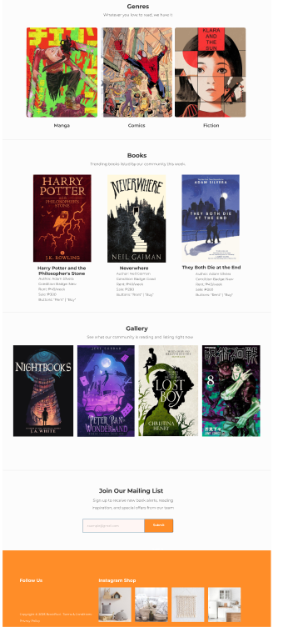Registration Page — Input fields for username, email, password, and confirm password, Create Account button, link to Login page
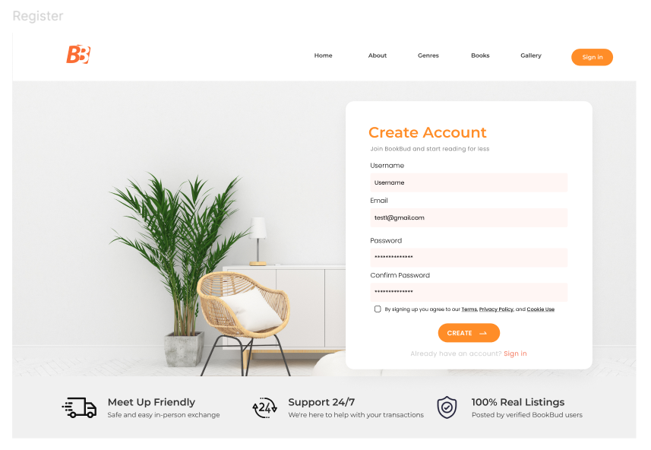
Login Page — Email and password inputs, Login button, links to Register and Forgot Password
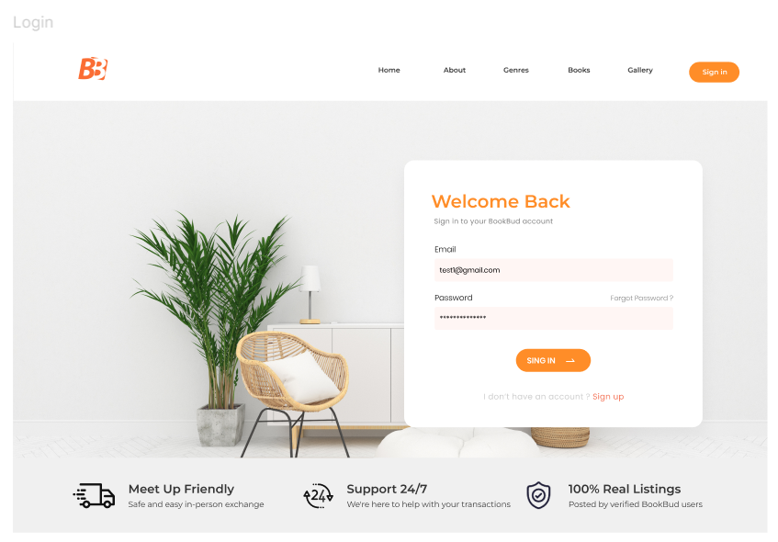
Forgot Password Page — Email input, Send Reset Link button, back to Login link
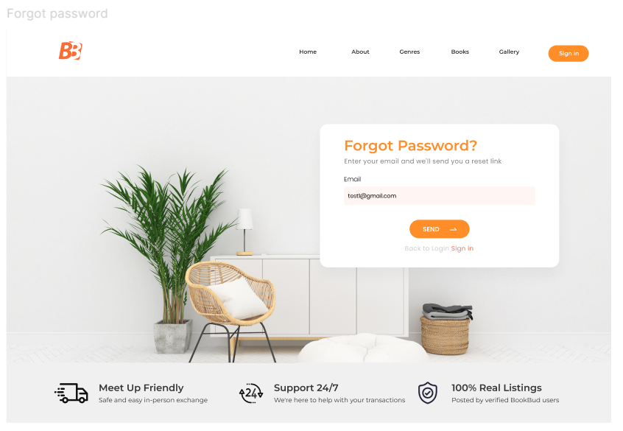
Dashboard — Greeting header with date, search bar, List a Book shortcut button. Four stat cards: My Listings, Active Rentals, Books Sold, Total Earned. Featured Most Wanted banner with book cover previews. Recently Listed Near You grid of mini book cards. My Recent Activity feed showing the last three transactions with status.
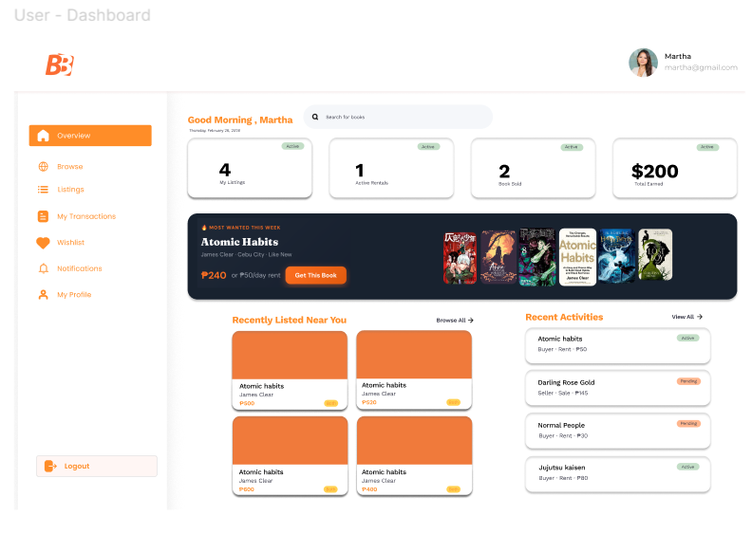
Browse & Rent/Buy — Page header with result count, keyword search bar, sort dropdown. Filter bar with three groups: Type (All / Rent / Buy), Genre, and Condition. Responsive book card grid. Each card shows: cover image, badge (Hot / New / Top Seller), wishlist heart toggle, transaction type pill, title, author, buy price, rental price per day, condition, genre, seller location, seller rating, and a primary action button (Rent Now / Buy Now / Rent or Buy). Empty state with message and call-to-action when no results match.

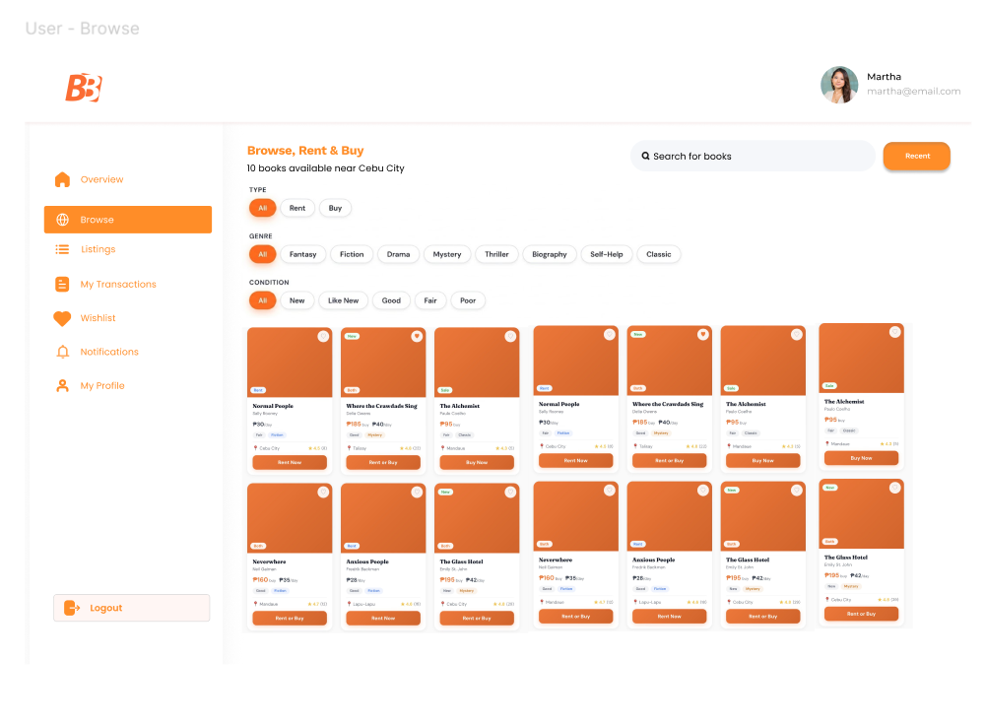
Transaction Modal — Triggered from any book card. Shows book cover, title, author, condition, genre pills. Seller section with name, star rating, and location. Rent/Buy toggle for Both-type listings. Price display. Date pickers for start and end date when Rent is selected. Payment method selector: Cash, GCash, Bank Transfer. Cancel and confirm buttons. Success screen on confirmation referencing seller name and directing user to My Transactions.
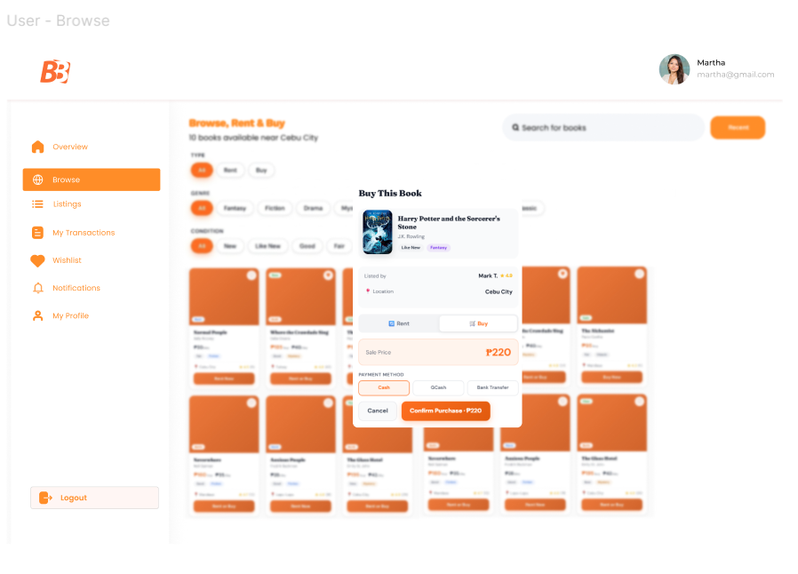
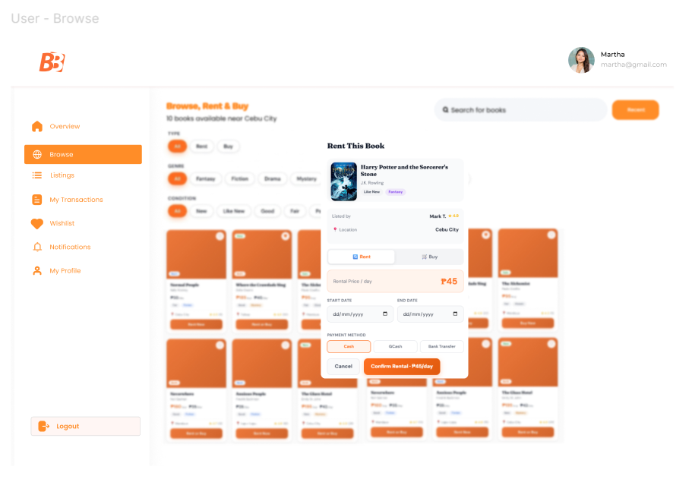
My Listings — Page header with listing count and Add New Book button. Filter tabs: All, Available, On Hold, Rented, Sold with counts. Book card grid. Each card shows cover, transaction type badge, status badge, title, author, condition, genre, prices, Edit button, and Manage button. Dashed add-new card at the end of the grid.
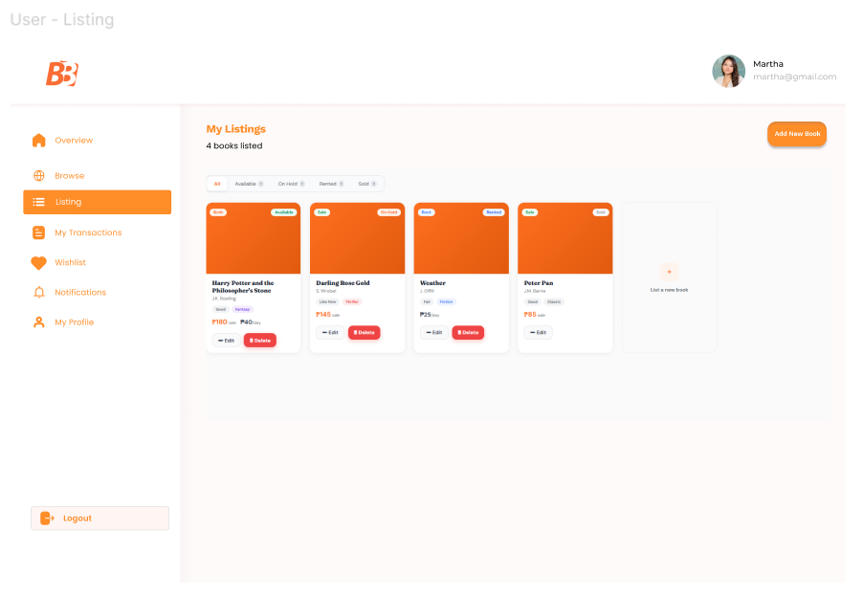
Add / Edit Book Modal — Fields: Title, Author, Genre dropdown, Condition dropdown, Transaction Type toggle (Rent / Sale / Both), conditional Rental Price and Sale Price inputs based on selected type. Cancel and Publish / Save buttons. Success confirmation screen.
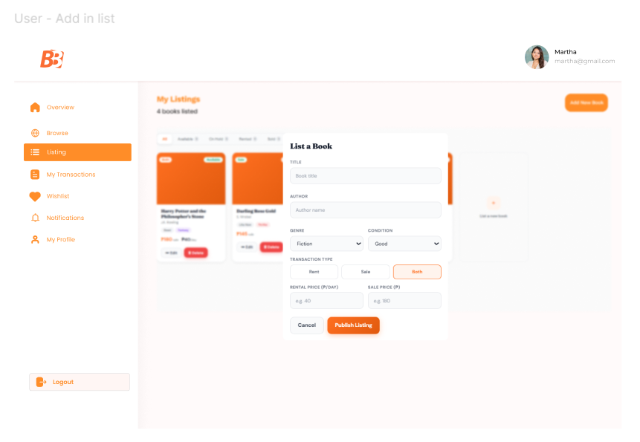
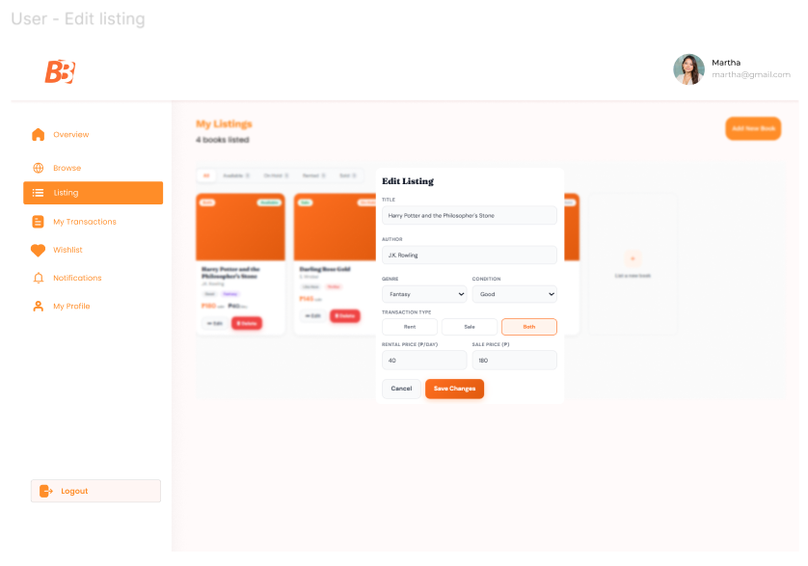

My Transactions — Page header. Filter tabs: All, Pending, Active, Completed, Cancelled. Each transaction row shows: book cover, title, transaction ID, type pill, role pill (As Buyer / As Seller / As Renter / As Lender), status pill, counterpart name, dates, amount, and payment method. View Contact button on Pending and Active transactions that opens a Contact Info panel showing the counterpart's facebook_url, messenger, and mobile_number. Mark as Active and Mark as Completed action buttons shown to the owner on eligible transactions. Cancel button shown on Pending transactions.
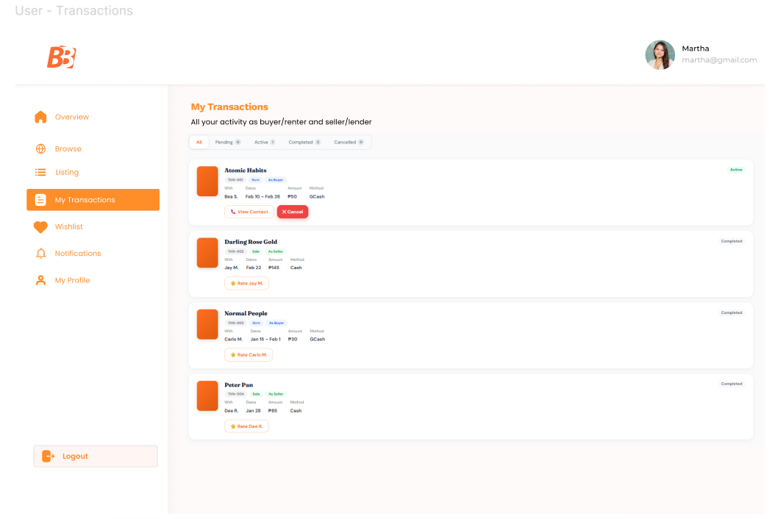
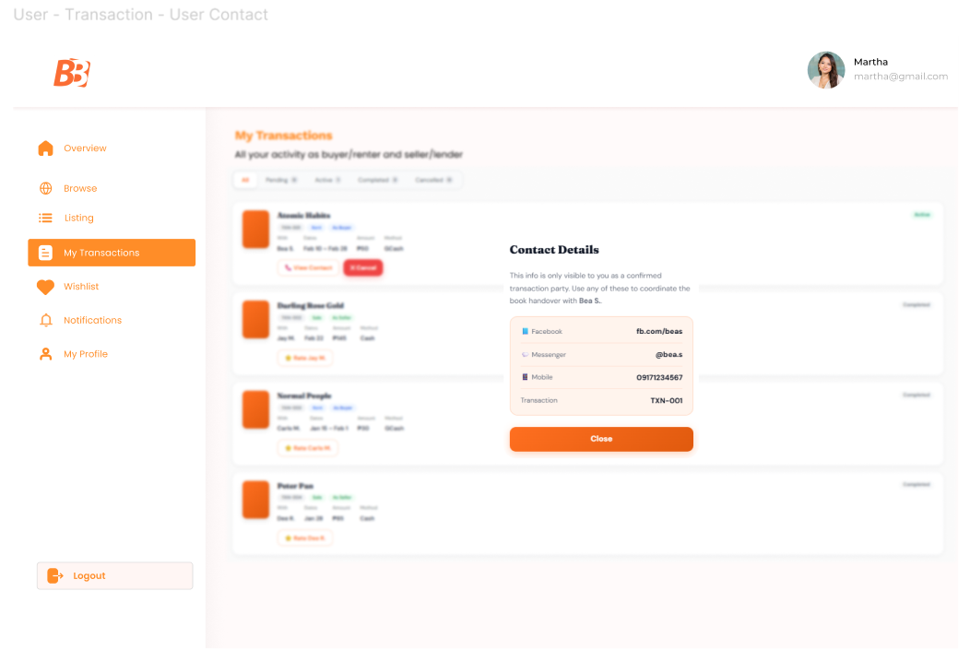
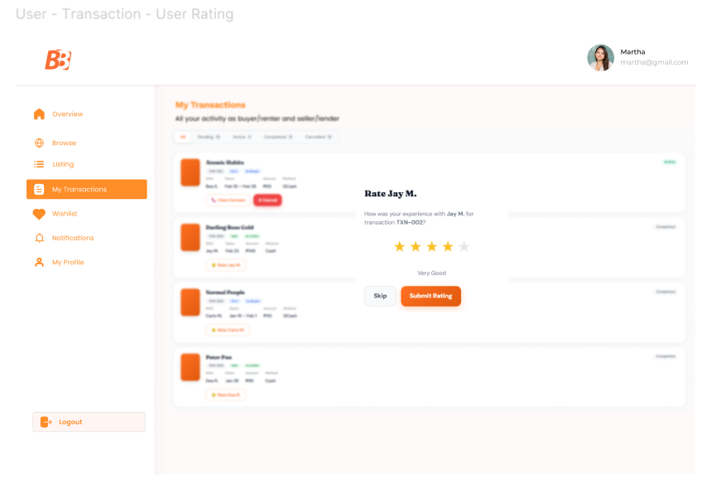
Payment Screen — Triggered after transaction is created. Fields: Amount (pre-filled from book price), Payment Method selector, Payment Date. Submit Payment button. Payment Confirmation screen showing all recorded details.
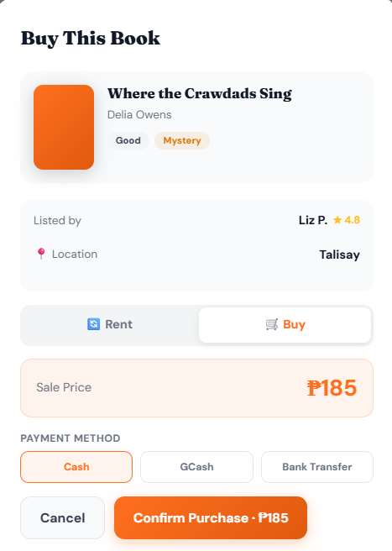
Wishlist — Page header with saved count. Book card grid. Each card shows cover, remove button, title, author, prices, and Rent Now / Buy Now / Rent or Buy action button. Empty state when wishlist is empty.
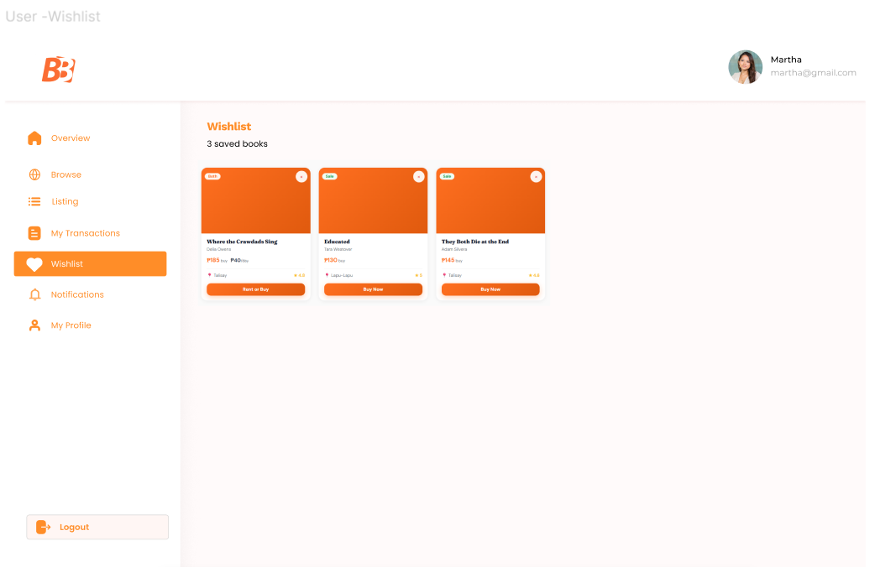
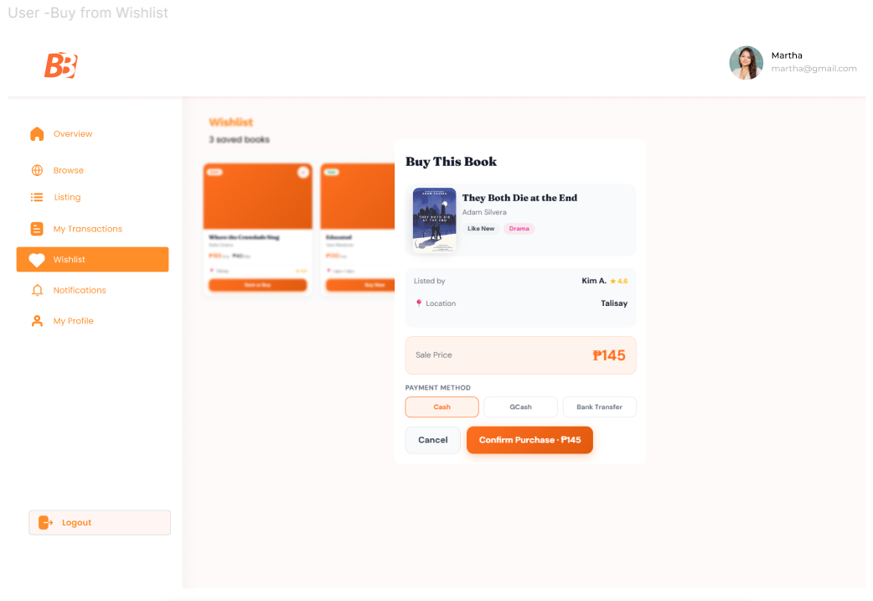
Notifications — Page header with Mark All Read button. Notification list. Each item shows an unread dot indicator (orange when unread, grey when read), highlighted background for unread items, message text, and timestamp. Click on any item marks it as read.
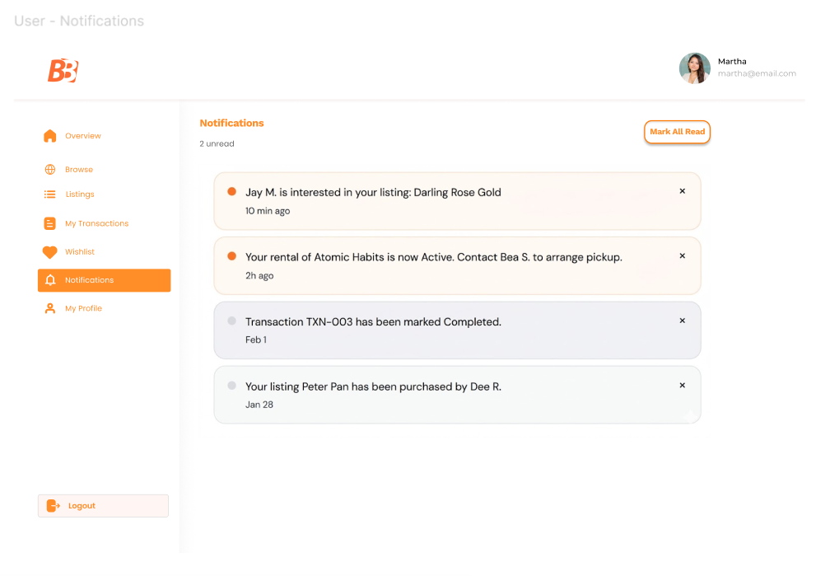
User Profile — Displays username and email (read-only). Editable fields: facebook_url, messenger handle, mobile_number. Edit Profile button that enables inline editing. Save Changes button. Trust rating display (star rating with numeric value). Note explaining that contact info is only shared with confirmed transaction partners.
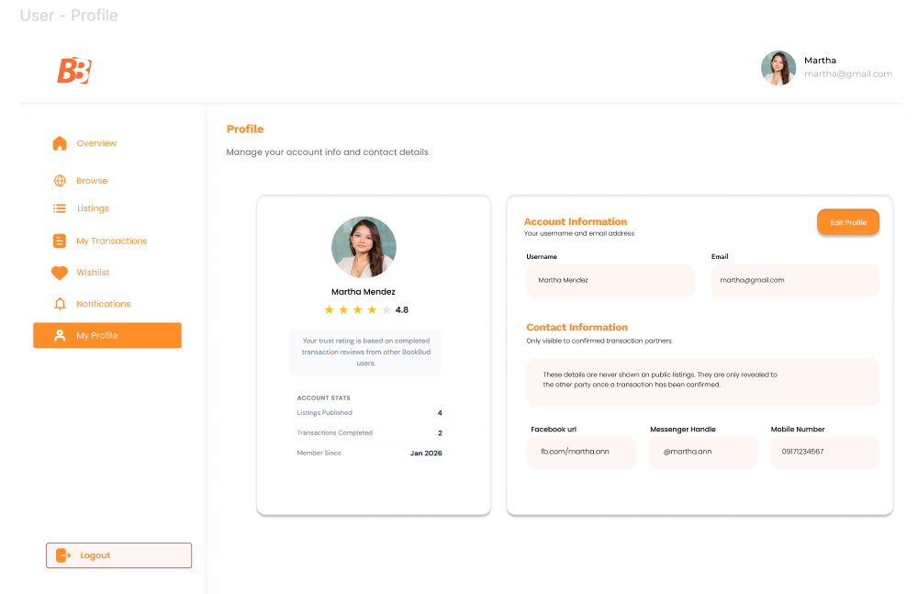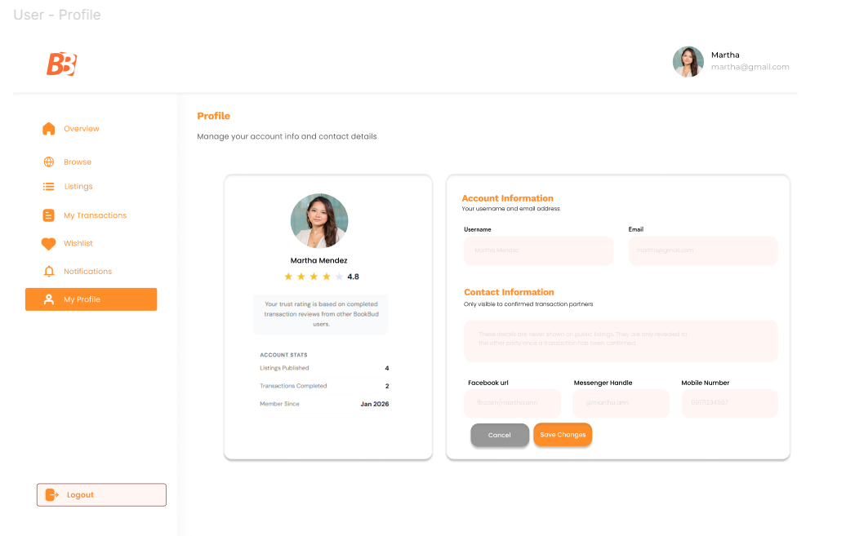

Admin Screens
Admin Dashboard — Summary stats: Total Users, Total Listings, Active Transactions, Flagged Listings. Quick navigation cards to each admin section.
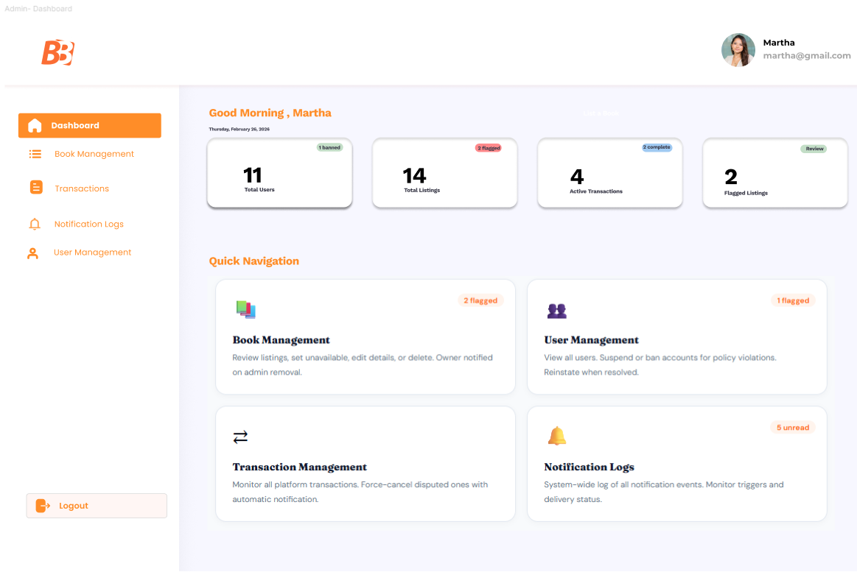
Admin Book Management — Full table of all book listings with columns: book ID, title, author, owner username, condition, transaction type, status, listed date. Actions per row: View, Edit, Set to Unavailable, Delete. Owner is notified on admin removal.
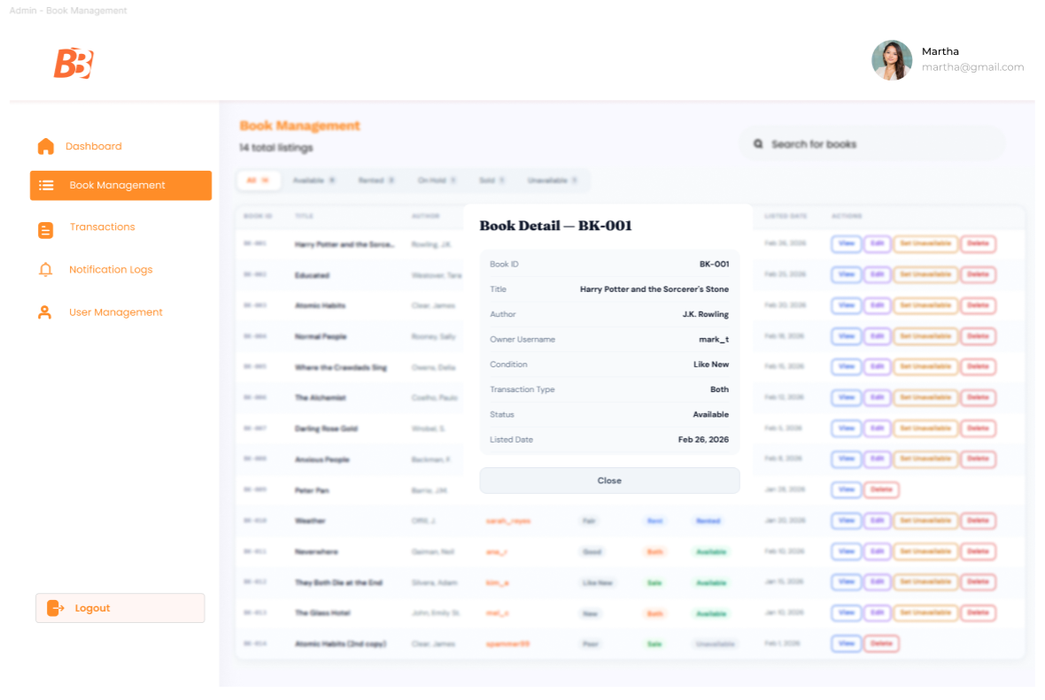
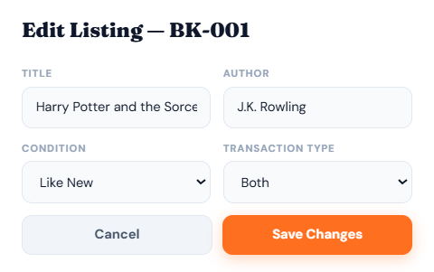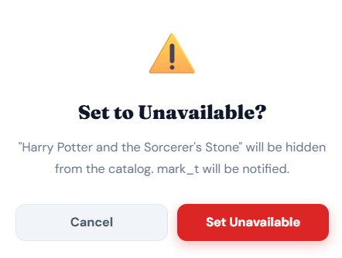
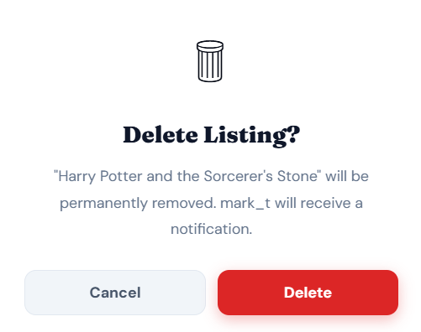
Admin User Management — Full table of all users with columns: user ID, username, email, role, rating, account status (Active / Suspended / Banned), registered date. Actions per row: View Profile, Suspend, Ban. Banned users are blocked from login.
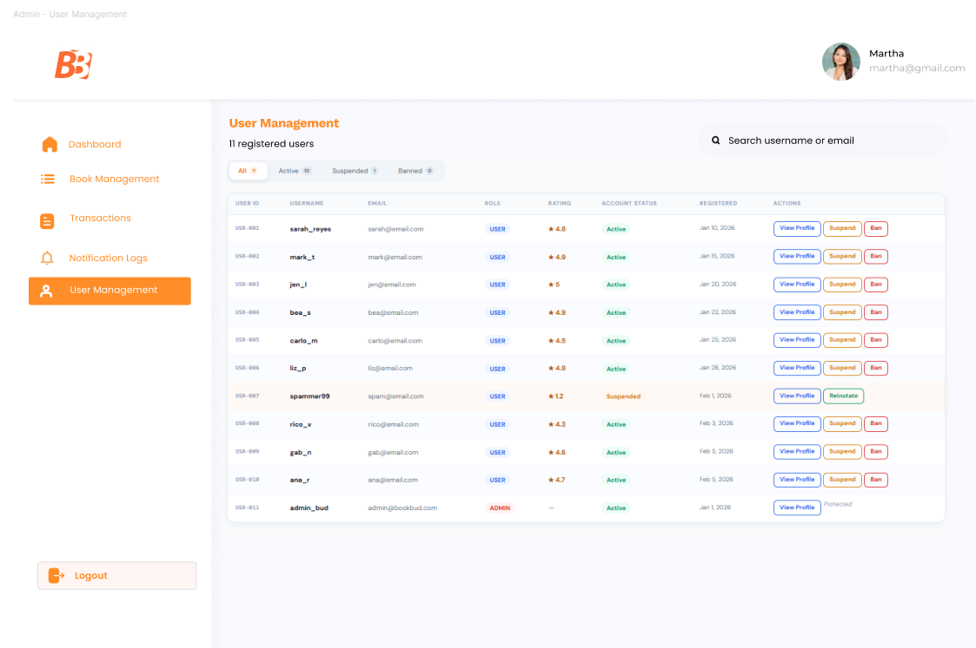
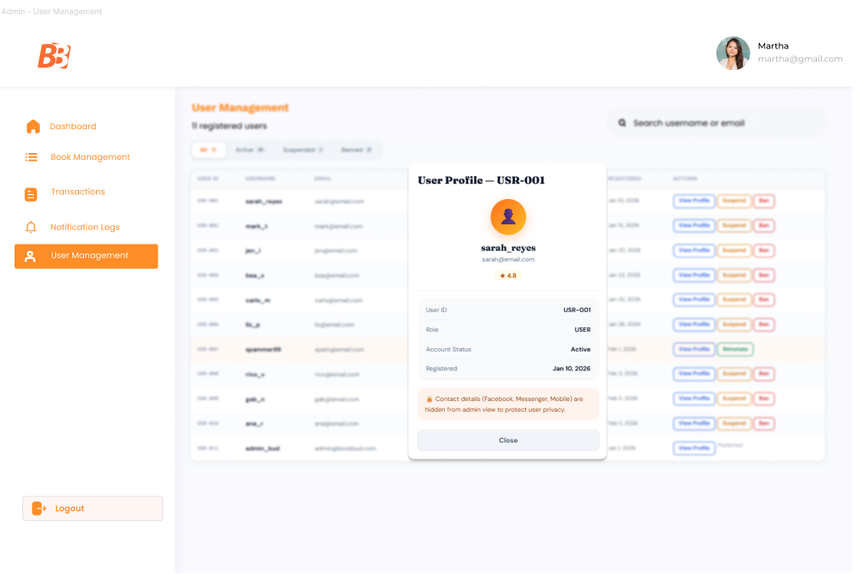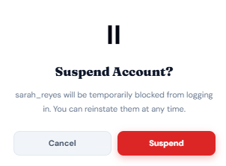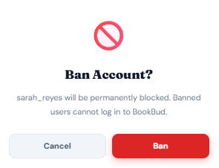

Admin Transaction Management — Full table of all transactions with columns: transaction ID, book title, owner username, renter/buyer username, type, status, dates, amount. Actions per row: View Detail, Cancel Transaction. Cancellation triggers notifications to both parties.
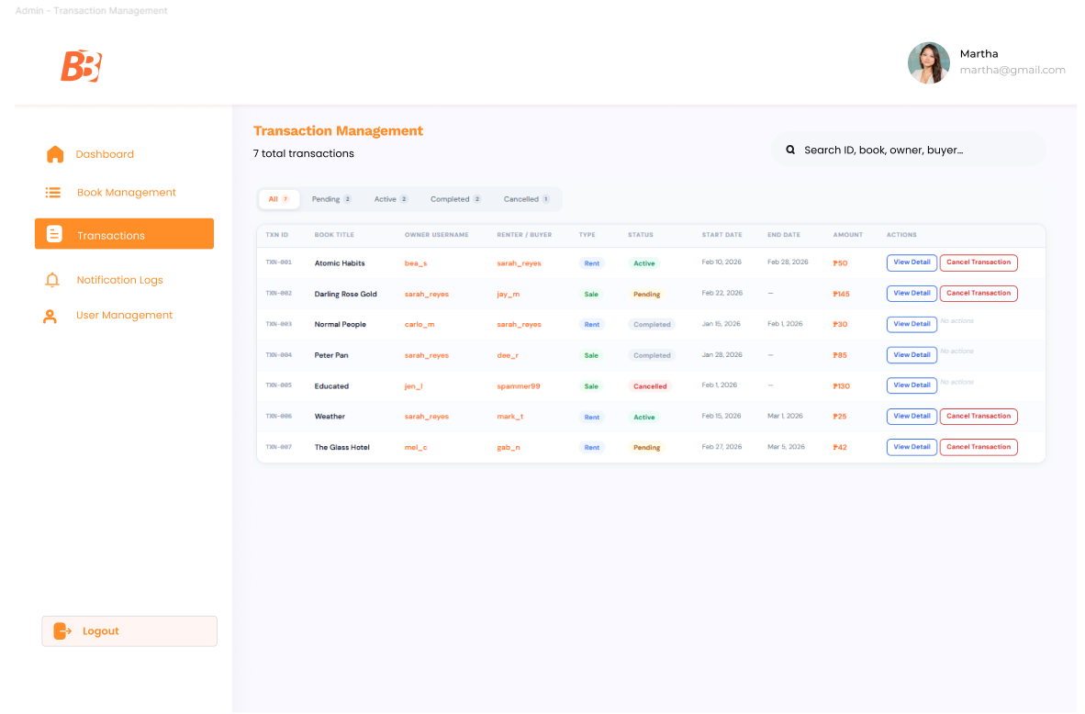
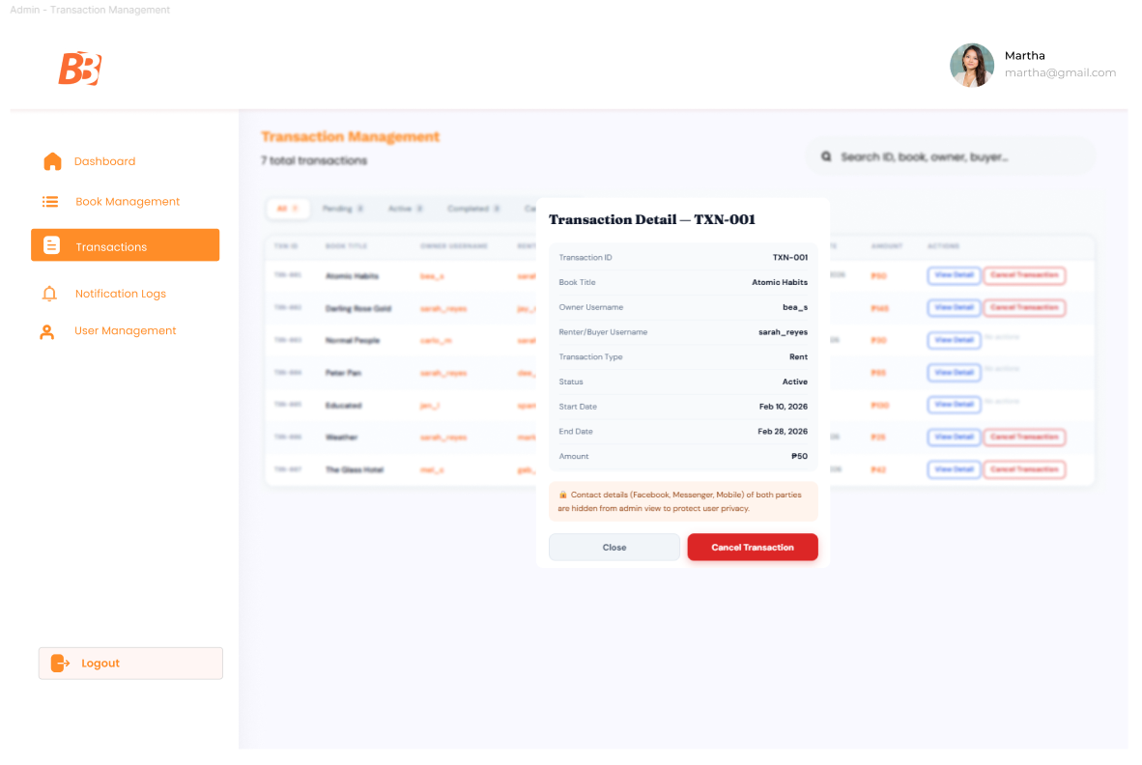
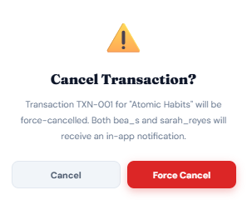
Admin Notification Logs — System-wide log of all notifications with columns: notification ID, recipient username, message, trigger event, read status, created timestamp.
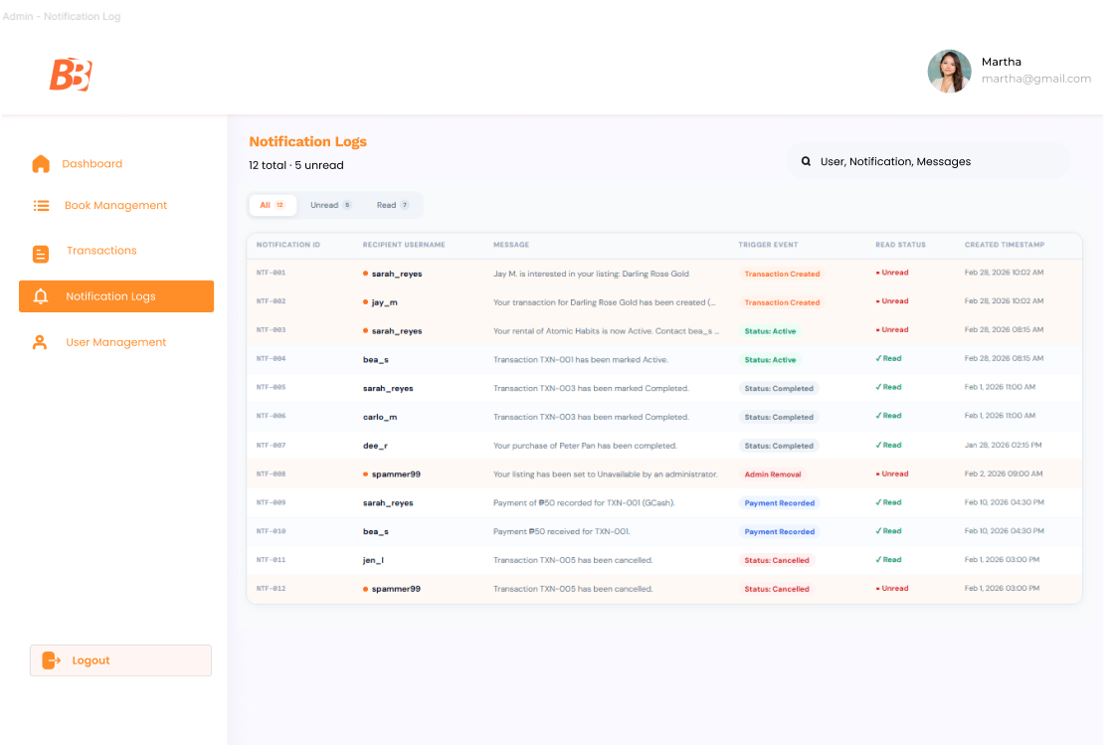

7.2 Mobile Application Wireframes
Design System
Colors: Primary (#FF6F20), Primary Dark (#E05A0E), Primary Light (#FFF4ED), Success (#059669), Warning (#B45309), Error (#DC2626). Typography: Fraunces (serif), worksans, Poppins, Montserrat for headings and display text, DM Sans (sans-serif) for body, labels, buttons, and inputs. Spacing follows an 8px grid system all padding, margin, and gap values are multiples of 4 or 8. Components use consistent orange gradient buttons with drop shadow, light gray inputs with orange focus border, white cards with subtle border and orange hover shadow, and modals with a 22px border radius and backdrop blur overlay.

Bottom Navigation
[⊞ Home] [🔍 Browse] [📋 Listings] [⇄ Transactions] [👤 Profile]
The bottom navigation bar is persistent across all main screens. Active tab is indicated by an orange top border and bold orange label. Minimum touch target size is 44×44px per item.
Splash Screen

Login Screen - Email and password inputs, Login button, links to Register and Forgot Password
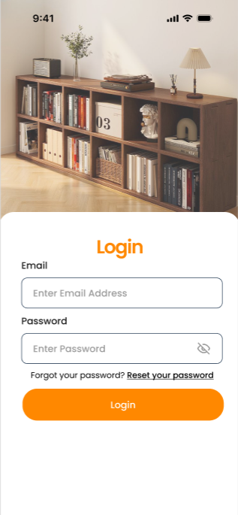
Registration Page — Input fields for username, email, password, and confirm password, Create Account button, link to Login page
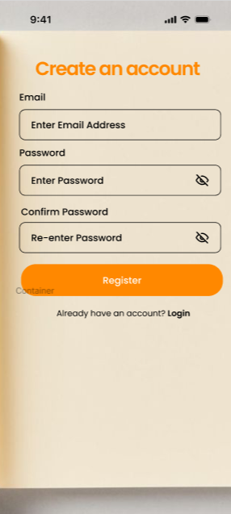
Forgot Password Page — Email input, Send Reset Link button, back to Login link
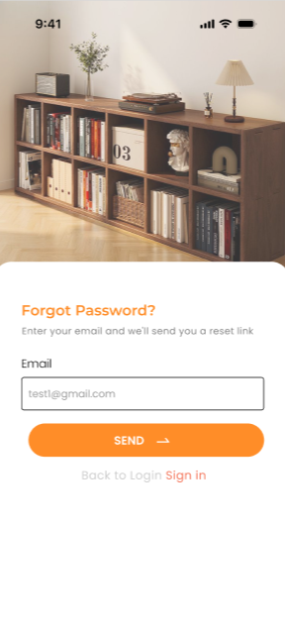
Home Screen - Personalized greeting with the user's first name and a morning/afternoon/evening label. Four tappable summary chips arranged in a horizontal scroll row showing: Active Transactions, Pending Transactions, My Listings, and Wishlist count — each with a color-coded icon and badge. Featured Books section below as a horizontal scroll of book cards, each showing cover image, title, author, price, and badge label where applicable (Hot, New, Top Seller). Recently Listed section as a vertical list of condensed book rows with cover, title, author, transaction type pill, condition pill, price, and location. Pull to refresh on the full scroll view.
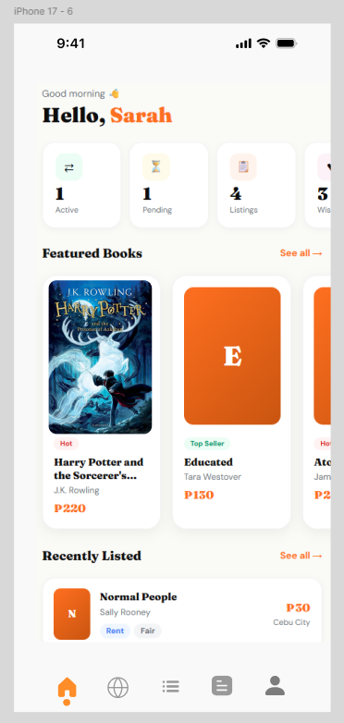

Browse & Catalog Screen - Persistent search bar at the top with live filtering by title and author and a clear button. Two-row filter section: first row is a transaction type toggle (All Types / For Rent / For Sale), second row is a horizontal scrollable genre chip row (All, Fantasy, Fiction, Self-Help, Mystery, Biography, Drama, Classic, Thriller). Result count label below the filters. Full-width book cards in a vertical list, each showing cover image, title, author, genre pill, condition pill, transaction type pill, price (rental daily rate and/or sale price), seller rating, and location. Wishlist heart icon per card — filled orange when saved, outline when not — toggled on tap. Empty state illustration and message when no results are found.

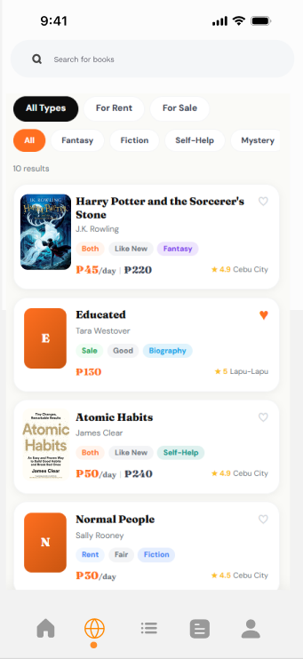

Book Detail Screen - Back arrow in the top left. Wishlist heart toggle in the top right. Dark gradient hero section containing the book cover with drop shadow and a badge pill where applicable. Below the hero: book title in Fraunces serif, author in DM Sans, and genre, condition, and transaction type pills. Seller card showing seller avatar, username, trust star rating, location, and listing date. Pricing section — for Both-type listings a Rent / Sale segmented toggle is displayed, with the price updating accordingly. For Rent-type the daily rate is shown with a /day label. For Sale-type the fixed sale price is shown. Fixed bottom CTA button — "Rent This Book" or "Buy This Book" depending on the selected transaction type.

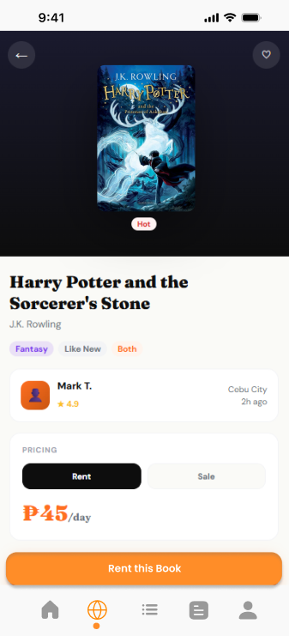

Transaction Flow Screen - Displayed after tapping the CTA on the Book Detail screen. Header shows the transaction type and book title. Book summary card at the top with cover, title, author, and type pill. Rental period section (Rent only) with start date and end date selectors and calculated duration in days. Payment method selector with three options: GCash, Cash, Bank Transfer — displayed as a segmented toggle. Order summary card showing the unit price, duration, and total amount in orange. Privacy notice stating that contact details of both parties will be shared only after the transaction is confirmed. Full-width orange Confirm Transaction button. On confirmation, the transaction is created, a notification is sent to both parties, and the user is returned to My Transactions.
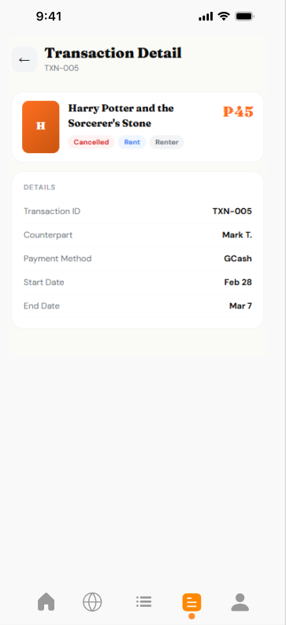
My Listings Screen - Screen header with listing count and a floating orange + button to add a new listing. Tab bar below the header with filter tabs: All, Available, On Hold, Rented, Sold — each showing a count badge. Book listing cards in a vertical list showing cover, title, author, status pill, transaction type pill, and price. Edit and Delete action buttons beneath each card for non-Sold listings. Tapping Edit opens the edit form. Tapping Delete removes the listing immediately. Empty state with a prompt to add the first listing when the list is empty.
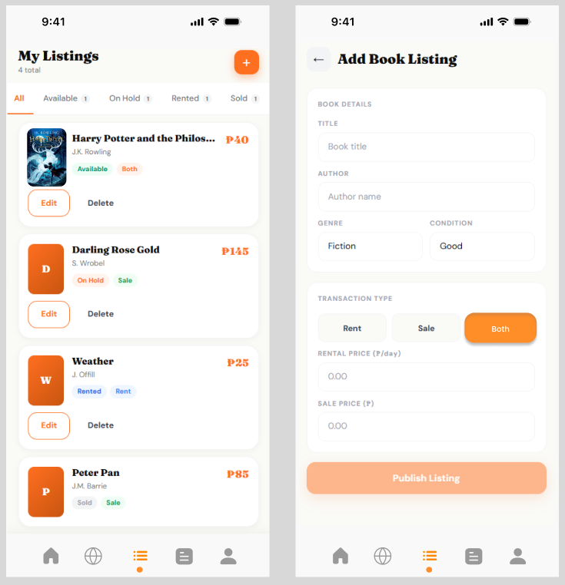

Add / Edit Book Screen - Screen header with back arrow. Form fields: Title (text), Author (text), Genre (dropdown), Condition (dropdown: New, Like New, Good, Fair, Poor), Transaction Type (segmented toggle: Rent / Sale / Both). Rental Price field (shown when type is Rent or Both). Sale Price field (shown when type is Sale or Both). All fields validated before enabling the Publish Listing button. Orange gradient Publish Listing button spanning full width. Inline field-level error messages for empty required fields.
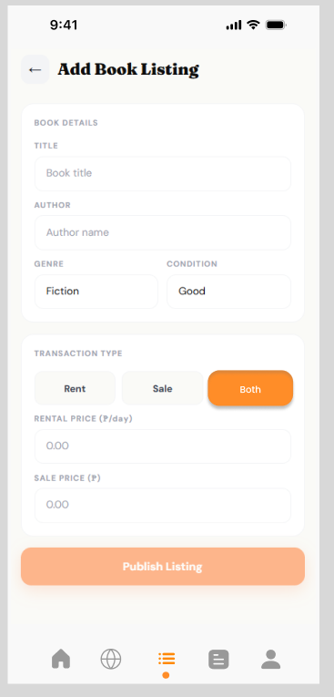

My Transactions Screen - Screen header showing total transaction count. Tab bar with filter tabs: All, Pending, Active, Completed, Cancelled — each with a count badge. Transaction cards in a vertical list showing book cover, title, counterpart name with role label (Owner or Renter), status pill, transaction type pill, amount, and payment method. For Pending and Active transactions: date range label and a View Contact button displayed at the bottom of the card. For Owner role on Active transactions: a Mark as Completed button is also shown. Tapping a card opens the Transaction Detail screen.
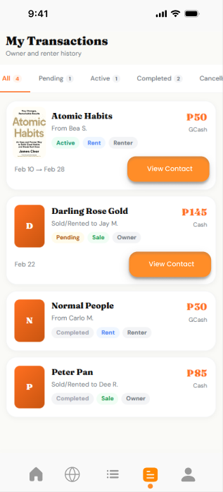
Transaction Detail Screen - Back arrow header with the transaction ID as subtitle. Book summary card at the top. Details section with transaction ID, counterpart name, payment method, start date, and end date. Contact card — displayed only for Pending and Active transactions — showing a dark background with the counterpart's Facebook URL, Messenger handle, and mobile number. Privacy note below the contact card. Action buttons at the bottom: Mark as Completed (Owner + Active only) and Cancel Transaction (Pending or Active). Completed and Cancelled transactions show no action buttons.

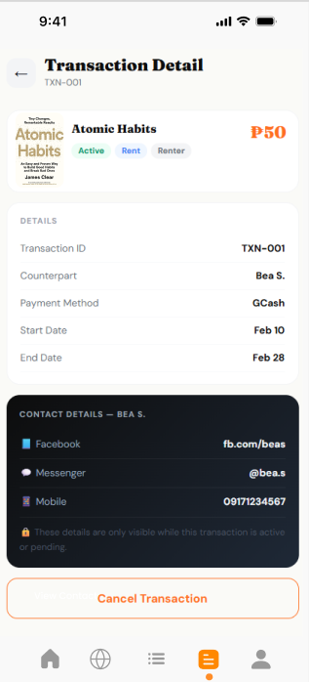
Notifications (Profile Screen Drawer) - Accessible via the bell icon on the Profile screen. Slides up as a bottom sheet drawer. Header with "Notifications" title and a Mark All Read link when unread notifications exist. Notification rows each showing an icon, message text, timestamp, and an orange dot indicator for unread items. Tapping a row marks it as read. Empty state shown when all notifications have been read.
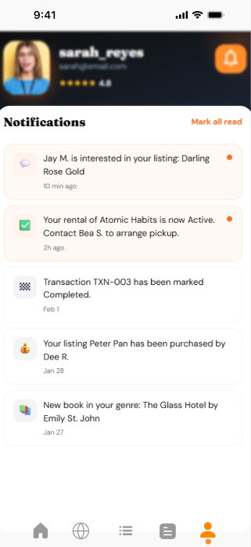
Profile Screen - Dark gradient hero section containing user avatar, username, email, trust star rating, and a stats row showing listing count, completed transactions, and member since date. Bell icon in the top right with an unread badge that opens the notifications drawer. Account Information card below with editable username and email fields. Contact Information card with editable Facebook URL, Messenger handle, and mobile number fields — with a privacy notice that these are only shared with confirmed transaction partners. Edit and Save Changes buttons to toggle the form between view and edit modes. Save confirmation toast shown on successful save. Sign Out button at the bottom.
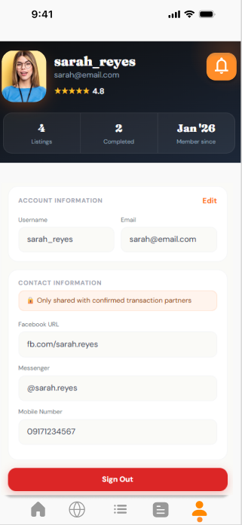

Admin Panel - Mobile
Dashboard — 4 KPI cards (users, listings, active txns), recent transactions table, flagged listings panel, suspended users alert
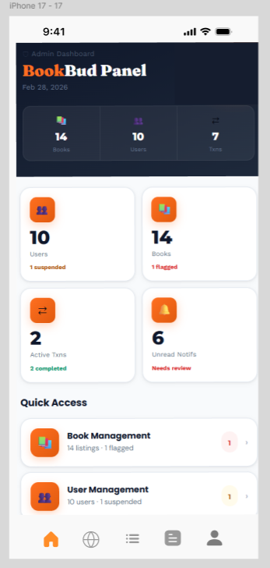
Users — searchable/filterable table with suspend/restore actions, view modal with full user detail
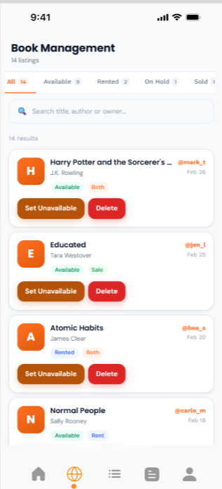
Books & Listings — full catalog table with remove/restore per listing, filter by type and status
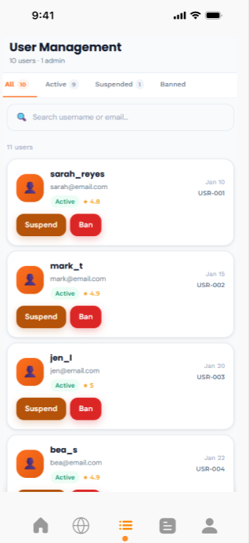
Transactions — full txn log with cancel/activate actions and detail modal
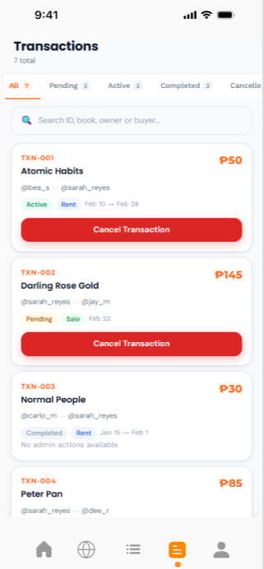
Notifications Log — event-type filter chips, unread dots, mark-read actions
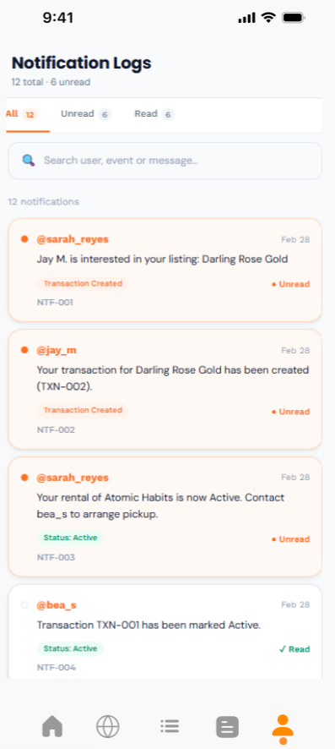

8.0 PLAN
8.1 Project Timeline
Phase 1: Planning & Design (Week 1-2) Week 1: Requirements & Architecture
- Day 1-2: Project setup, repo init, SDD skeleton
- Day 3-4: Functional & non-functional requirements
- Day 5-7: System architecture + component diagram
Week 2: Detailed Design
- Day 1-2: API contracts (auth, books, transactions, payments, wishlist, notifications)
- Day 3-4: Database schema + ERD
- Day 5-6: Figma wireframes for all screens
- Day 7: Implementation plan review
Phase 2: Backend Development (Week 3-4) Week 3: Foundation
- Day 1: Spring Boot 3 setup (Maven, Security, JPA, PostgreSQL)
- Day 2: DB entities + Hibernate schema
- Day 3: JWT auth — register, login, refresh, logout
- Day 4: User profile endpoints (GET/PUT)
- Day 5: Book CRUD endpoints with owner validation
Week 4: Core Features
- Day 1: Book discovery — search + filters (genre, condition, type, price)
- Day 2: Transaction endpoints — create, get, update with lifecycle validation
- Day 3: Payment recording + wishlist endpoints
- Day 4: Notification system — trigger, mark read, mark all read
- Day 5: Admin endpoints — moderation, user mgmt, role enforcement
Phase 3: Web Application (Week 5-6) Week 5: Frontend Foundation
- Day 1: React 18 + TypeScript + Tailwind + Axios setup
- Day 2: Auth screens — Register, Login, Forgot Password
- Day 3: Book Catalog + Browse with search/filters
- Day 4: Transaction modal — Rent/Buy, date pickers, payment method
- Day 5: My Listings — Add/Edit book modals
Week 6: Complete Web Features
- Day 1: My Transactions — unified view, status controls, Contact Info
- Day 2: Payment Recording + Confirmation screens
- Day 3: Wishlist, Notifications, User Profile pages
- Day 4: Admin Panel — Books, Users, Transactions, Notification Logs
- Day 5: Full API integration, error handling, responsive polish
Phase 4: Mobile Application (Week 7-8) Week 7: Android Foundation
- Day 1: Android Studio setup (Kotlin, XML layouts, Retrofit, API Level 34)
- Day 2: Auth screens — Register, Login, Forgot Password
- Day 3: Book Catalog — search, filters, book cards
- Day 4: Transaction flow — date pickers, payment selection
- Day 5: Retrofit service layer wired to all endpoints
Week 8: Complete Mobile App
- Day 1: My Listings — Add/Edit flows
- Day 2: My Transactions — status controls, Contact Info
- Day 3: Wishlist, Notifications, User Profile screens
- Day 4: UI polish, loading states, device testing
- Day 5: APK generation, signing, documentation
Phase 5: Integration & Deployment (Week 9-10) Week 9: Integration Testing
- Day 1: End-to-end testing across web + Android
- Day 2: Bug fixes + edge cases
- Day 3: Security review — JWT, roles, contact visibility
- Day 4: Performance testing vs. NFR benchmarks
- Day 5: Final SDD documentation updates
Week 10: Deployment
- Day 1: Backend → Railway or Render
- Day 2: Frontend → Vercel
- Day 3: APK distribution + install testing
- Day 4: Smoke testing across all environments
- Day 5: Submit
Milestones:
- M1 (End Week 2): Design docs, ERD, and wireframes complete
- M2 (End Week 4): Full backend API tested via Postman
- M3 (End Week 6): Web app complete with full API integration
- M4 (End Week 8): Android APK complete
- M5 (End Week 10): Full system deployed and submitted
Critical Path:
- JWT auth → all other backend work
- Book CRUD/discovery → frontend catalog
- Transaction + payment endpoints → transaction UI
- Admin endpoints secured → admin panel exposed
- Integration testing → deployment
Risk Mitigation:
- Ship the simplest working version first, polish later
- Test API contracts early on each platform
- Keep main always deployable; use feature branches
- MUST HAVEs first — defer SHOULD HAVEs if needed
- Update the SDD as decisions change

