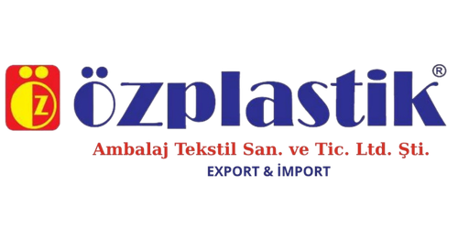

DECLARATION OF CONFORMITY
Manufacturer / Issuer:
ÖZPLASTİK TEKSTİL GİDA DERİ İNŞAAT PET. TUR. MOB. BEYAZ EŞYA SAN. TİC. LTD. ŞTİ. EXPORT & İMPORT
VAT Number:7040072586
Address: Doğu Sanayi Sitesi 14. Blok No: 13, Yenibosna, Merkez Mah, Istanbul, Turkey
Phone: 0212 654 98 54; 0212 654 98 55
Email: info@ozplastiktekstil.com
Web: www.ozplastiktekstil.com
We hereby declare under our sole responsibility that the product specified below:
Polyethylene bags (LDPE / HDPE)
Intended use: General purpose packaging / Industrial use
is in conformity with the essential requirements of the following European regulations and directives:
Directive 94/62/EC on packaging and packaging waste (and subsequent amendments), including the imposed limits for the concentration of heavy metals (lead, cadmium, mercury, and hexavalent chromium).
Regulation (EC) No 1907/2006 (REACH) - the product does not contain Substances of Very High Concern (SVHC) in concentrations exceeding 0.1% by weight.
The materials used in the manufacturing process are safe and do not alter the organoleptic characteristics (odor, taste, appearance) of the packaged goods. The product is 100% recyclable.
This declaration is issued based on internal technical documentation and the certificates provided by the raw material manufacturers. The technical documentation is retained by the company and made available to the competent authorities upon request.
Date and place of issue: September 15, 2026, Istanbul, TURKEY
Name of the legal representative: Memet Yakar
Position: Managing Director
Company signature and stamp:

