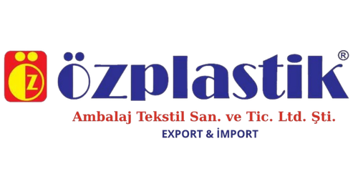
DECLARATION OF CONFORMITY AND DELIVERY
Supplier:

ÖZPLASTİK TEKSTİL GIDA DERİ İNŞAAT PET. TUR. MOB. BEYAZ EŞYA SAN. TİC. LTD. ŞTİ. EXPORT & İMPORT
VAT Number: 7040072586
Address: Doğu Sanayi Sitesi 14. Blok No: 13, Yenibosna, Merkez Mah, Istanbul, Turkey
Tel: 0212 654 98 54; 0212 654 98 55
Email: info@ozplastiktekstil.com
Web: www.ozplastiktekstil.com

Beneficiary:

DEKORAMA IMPORT S.R.L.
Registered Office: 88 Agricultorilor Street, Buftea, Ilfov County, Bucharest, Romania
Tax ID (CUI): 38393721

The undersigned, ÖZPLASTİK TEKSTİL GİDA DERİ İNŞAAT PET. TUR. MOB. BEYAZ EŞYA SAN. TİC. LTD. ŞTİ. EXPORT & İMPORT, legally represented by MEMET YAKAR, in his capacity as Administrator, declare under my sole responsibility, being aware of the legal provisions regarding false statements and the regulations concerning product quality, the following:
We hereby confirm that, during the years 2024, 2025, and 2026, our company has manufactured and delivered to DEKORAMA IMPORT S.R.L. polyethylene bags (LDPE/HDPE) with a thickness of 50 microns.
We guarantee that all products in the aforementioned category, delivered to the above-mentioned beneficiary during the reference period, have been manufactured and distributed in strict compliance with the applicable norms and standards of the European Union (EU) in force. These products comply with the applicable requirements regarding the quality of plastic materials and packaging safety.
This declaration has been issued to serve the beneficiary, DEKORAMA IMPORT S.R.L., in proving the traceability and conformity of the products.

Date of issue: September 15, 2026
MEMET YAKAR

