Ejercicio 7

|  |
| --- |
| Pila Auxiliar |
| 1 |
| 3 4 7 |

a)

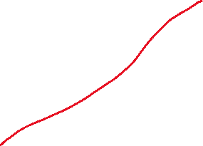

|  |  |  |
| --- | --- | --- |
| Posicion | Nombre | Atributos |
| 1 | x | Int |
| 2 | calculo | Func(int) |
| 3 | v | Int |
| 4 | w | Int |
| 5 | z | Int |
| 3 | main | … |
| 4 | a | Int |
| 5 | b | Int |
| 6 | y | Int |
| 7 | c | Int |
|  |  |  |
|  |  |  |
|  |  |  |

b) y d)

c)



|  |  |  |
| --- | --- | --- |
| Segmentos de códigos de las funciones- Almacenamiento Estático   |  | | --- | | 0 1 2 |  |  | | --- | | 0 2 5 | |
| |  | | --- | | 2 0 3 0 8 |  |  | | --- | | 3 1 5 1 7 |  |  | | --- | | 0 3 4 9 10 |  |  | | --- | | 6 0 15 0 | |
| |  | | --- | | 3 1 5 1 |   Parametros formales   |  | | --- | | 2 0 3 0 | |
| Variables locales |
| Almacenamiento temporal  2==3 F |
| Resultado   |  | | --- | | 0 1 2 | |
| Direccion de retorno al main |
|  |
| Monticulo |

|  |
| --- |
| Salida:  …..6  …..0  …..15  .....0  ….2  ….5....10 |