MachineLearning-2025W Exercise 0 – Dataset Description

1. Explanation of choice for data sets
The task was to identify data sets that are not closely related, so we focused on finding able to find one whose characteristics are mainly nominal whilst the other is based only on continuous features. Though what both have in common is that the target variables consist of more than just two. This similarity as well as the difference in characteristics make it interesting to see and compare the different ways in which we might have to implement our models in the upcoming exercises.

2. Dataset 1: Soybean
The large soybean dataset which was donated to UCI by R.S. Michalski and R.L. Chilausky in 1988. This particular version merges the training and test data into a single dataset. The domain of the data is biology, with the focus being on classifying soybean diseases based on the characteristics and environment of the plants.

2.1 Data Structure
The dataset includes 683 records and 36 nominal attributes, 16 of which are binary, which describe the environment (e.g. temperature, weather) and characteristics of the soybean plants (e.g. leaf, seed and stem characteristics). For a more detailed data structure analysis, see the code base.

2.2 Target Variable
The target variable is “class” and it includes 19 diseases of soybeans. The names and distribution of these classes can be seen in the plot below. In previous studies, only the top 15 classes were considered, since the last 4 have less than 20 instances in the dataset.
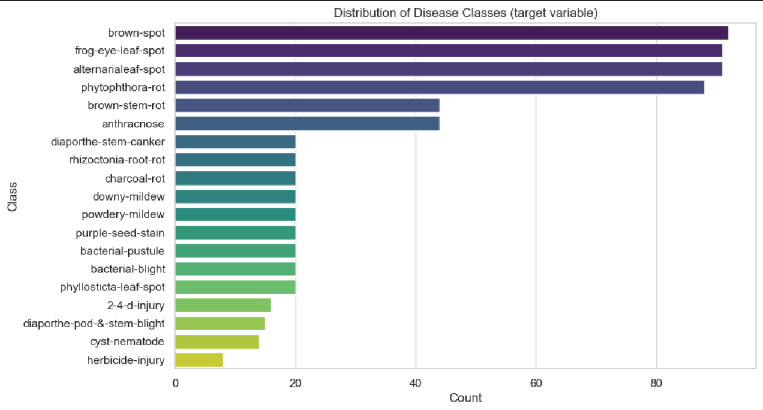

2.3 Data Quality and Preprocessing Notes
The dataset contains 2337 missing values, which is 9.5% of the data. Only 3 attributes are missing ≤10 values. As mentioned before, 4 of the target classes are deemed to have insufficient data, so we will also need to consider removing them. Further feature analysis would be important, to find out which are the most crucial features, but as a first look we assume the “Damaged Area” and “Plant Growth Status” will be important in finding the correct target class.
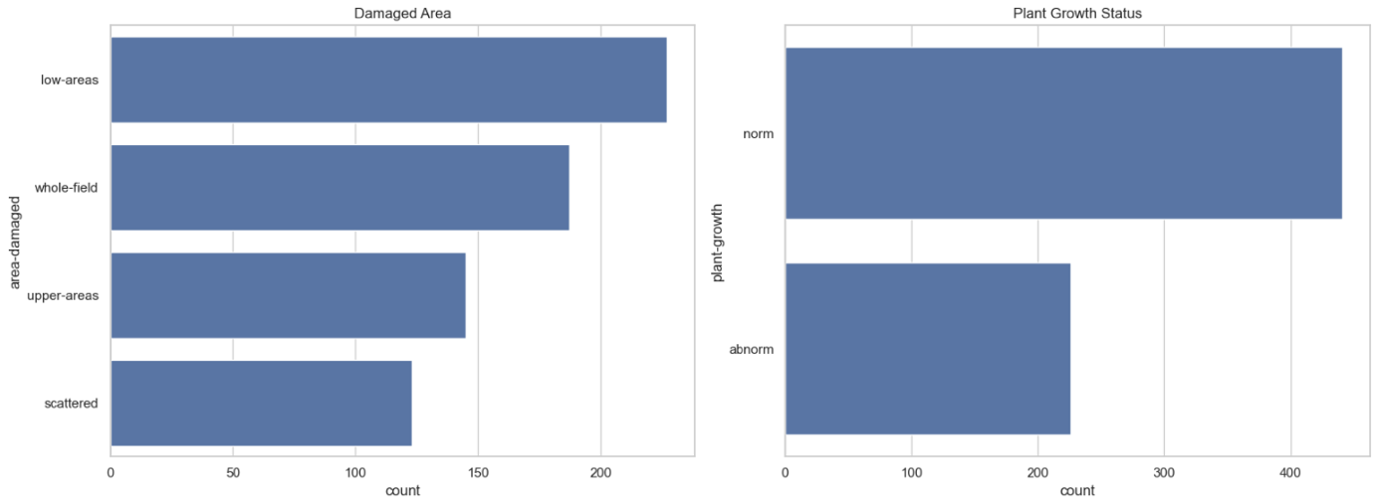

3. Dataset 2: Wine Quality
We have chosen two datasets by [Cortez et al., 2009] - one is of a red and one of a white wine variant of a Portuguese wine called “Vinho Verde”. The idea is to use the provided continuous variables to model the (already provided) wine quality while probably having to select relevant features. The authors mentioned that some input variables might be irrelevant, which might be an interesting point to investigate as well as that there could be correlations between some.

3.1 Data Structure
Number of Records | Features
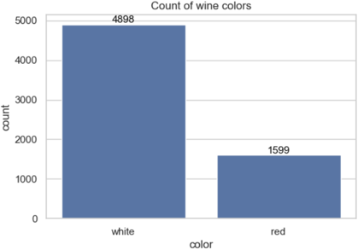4898 (white), 1599 (red) | Name Range Name Range  fixed_acidity 3.8 - 15.9 total_sulfur_dioxide 6.0 - 440.0  volatile_acidity 0.08 - 1.58 density 0.98711 - 1.03898  citric_acid 0.0 - 1.66 pH 2.72 - 4.01  residual_sugar 0.6 - 65.8 sulphates 0.22 - 2.0  chlorides 0.009 - 0.611 alcohol 8.0 - 14.9  free_sulfur_dioxide 1.0 - 289.0 color red or white

3.2 Target Variable
The target variable is called “quality” and ranges from 3 – 9 (for white: 3-9, for red: 3-8). According to the data set description the possible values would be between 0 (“very” bad) and 10 (“very excellent”).

3.3 Data Quality and Preprocessing Notes
The dataset contains no missing values, but further preprocessing is still needed. We first have to combine the two datasets, then normalize them since feature ranges vary significantly. Without normalization, features like total_sulfur_dioxide could dominate model results, leading to bias. Additionally, some features display skewed distributions (see plot on the right below), which may indicate outliers or even important characteristics of wine quality classification.
