CMSC203 Assignment 0

Class: CMSC203
Program: Assignment 0
Instructor:
Summary of Description: Setup GitHub, Install and setup JDK, install and setup Eclipse and JavaFX
Due Date: 6/11/2026
Integrity Pledge: I pledge that I have completed the programming assignment independently.
I have not copied the code from a student or any source.

Complete the following five parts of Assignment 0:

Part 1: Setup GitHub

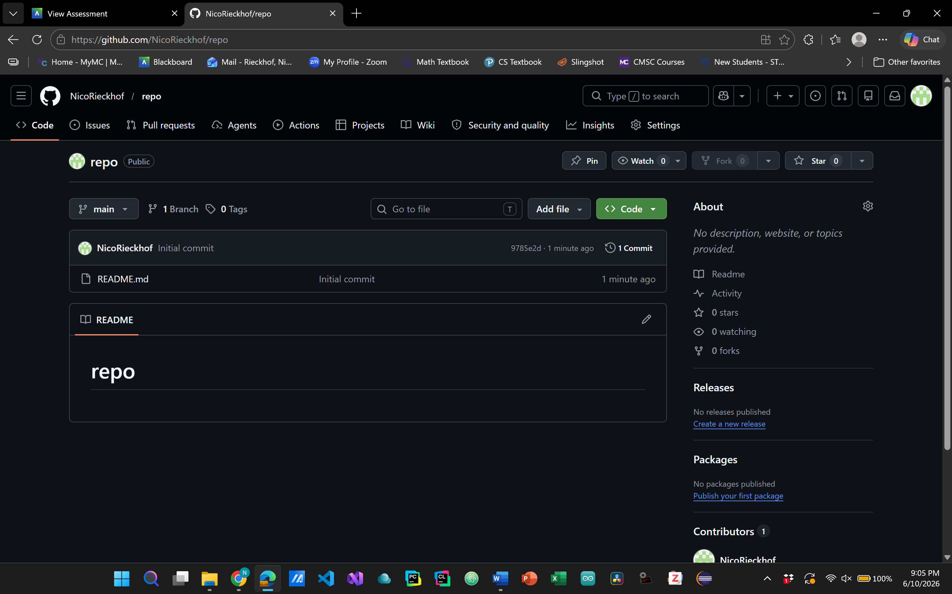
Part 2 -Install JDK, Test java Application from Command Line
Provide the screen shots from Step 1 and 2 here:
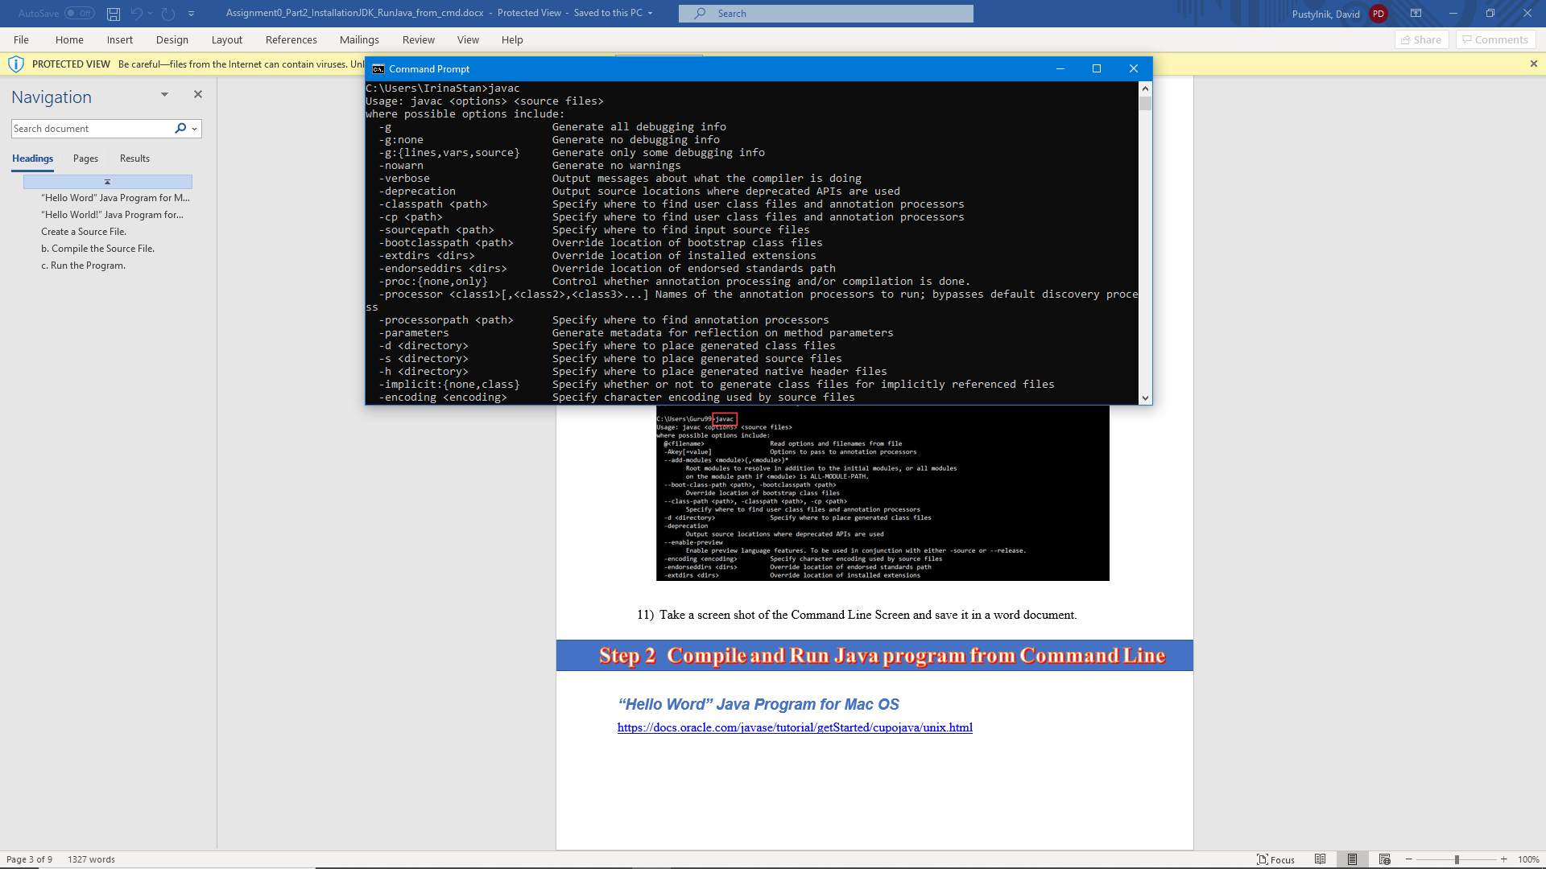
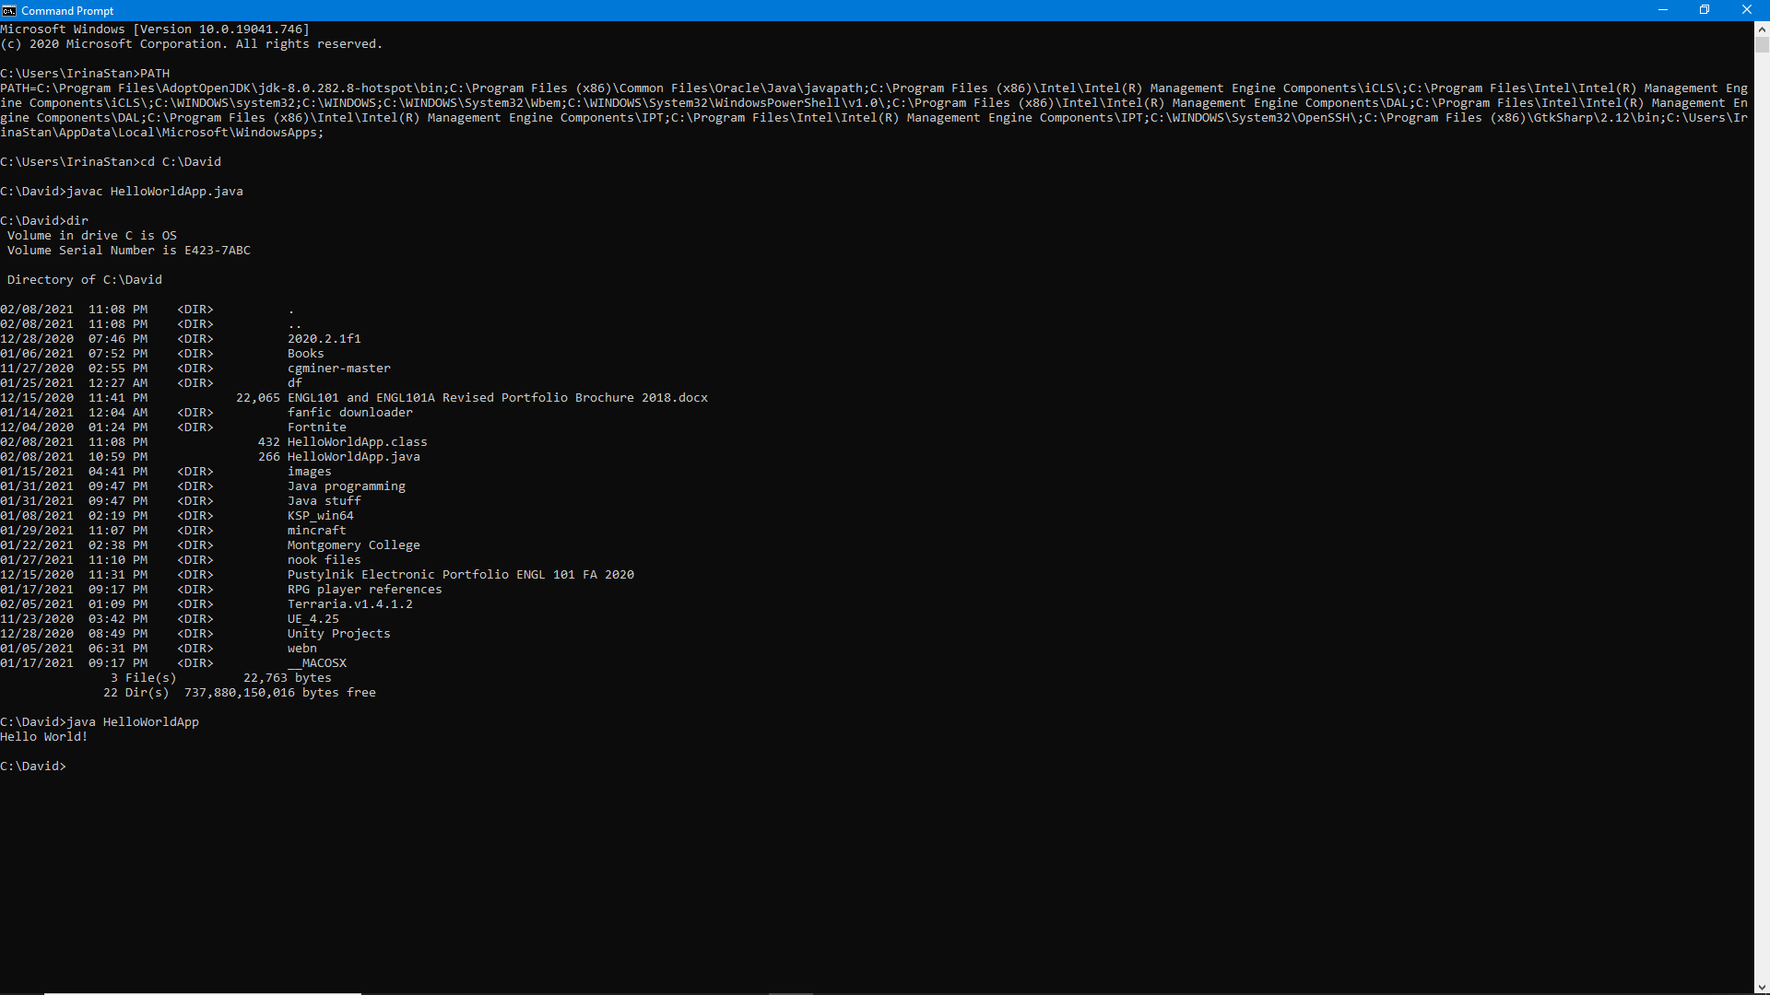

Part 3 - Install Eclipse, Test Eclipse Java Application
Provide the screen shots from Step 1 and 2 here:

I ALREAY HAD ECLIPSE INSTALLED FROM OTHER CLASSES

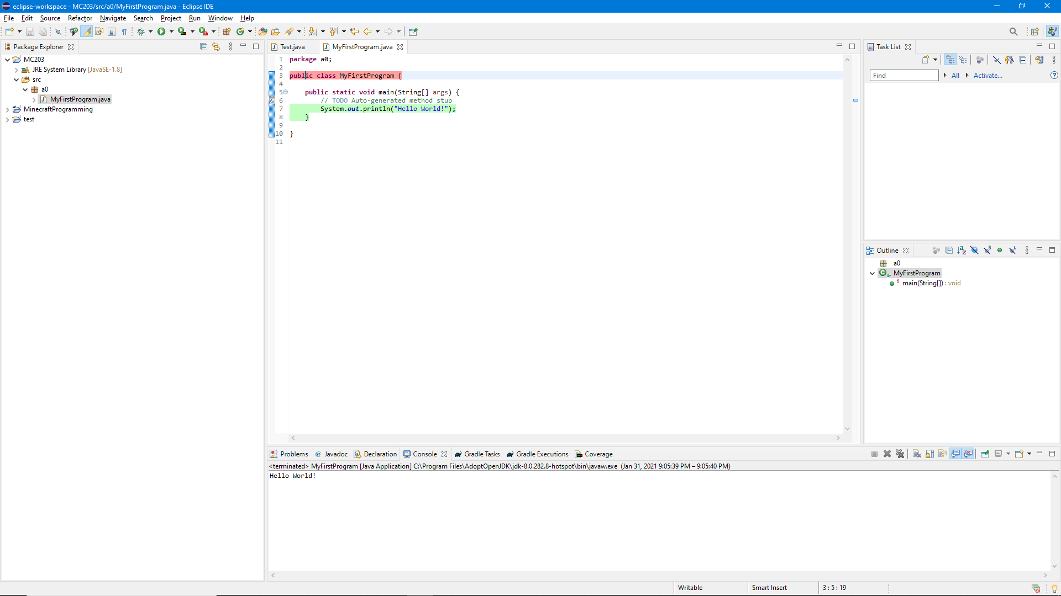

Part 4 - Install, Setup, Test Junit Program.

Provide the screen shots showing:
  - Eclipse with working JUnit Test example
  - Project screenshot
  - Running example screenshot
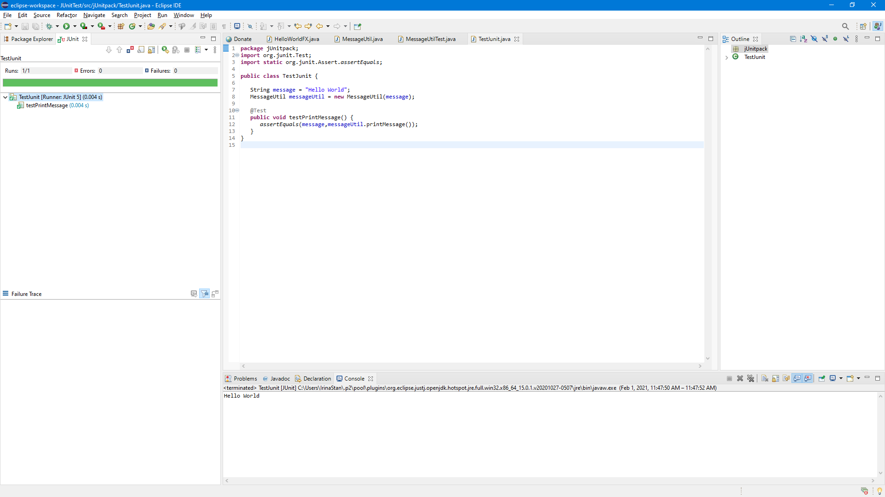

Part 5 - Install, Setup, and Test JavaFX Application.
Provide the screen shots showing:
- JavaFX Project screenshot
- Running example screenshot
- Java Source Code File
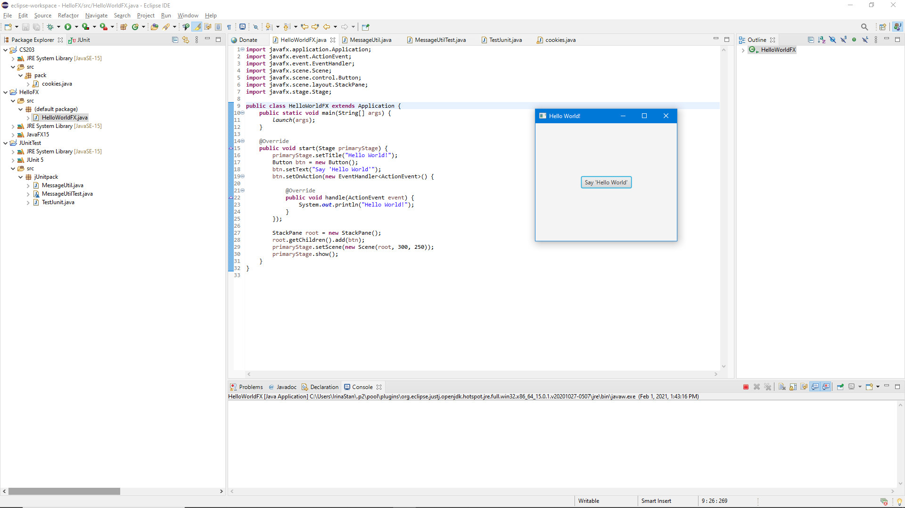

Lessons Learned <Provide answers to the questions listed below>:

Write about your Learning Experience, highlighting your lessons learned and learning experience from working on this assignment.

What have you learned?
I have learned that my internet is slow. I also learned that installing files is a pain.
What did you struggle with?
Importing the user libraries.
What parts of this assignment were you successful with, and what parts (if any) were you not successful with?
I was not successful in using the VM input line and had to use the one from the website.
Provide any additional resources/links/videos you used to while working on this assignment.

Check List: <Provide answers to the column Y/N or N/A >:

# |  | Y/N | Comments
 | Assignment files:
 | - FirstInitialLastName_Assignment0.docx/pdf | Yes
 | - Source java files
 | Program compiles | YEs
 | Program runs with desired outputs related to a Test Plan | Yes
 | Documentation file: Screenshots of
 | - Part1: Setup GitHub | Yes
 | - Part 2 -Install JDK, Test java Application from Command Line | YEs
 | - Part 3 - Install Eclipse, Test Eclipse Java Application | Yes
 | - Part 4 - Install, Setup, Test Junit Program | Yes
 | - Part 5 - Install, Setup, and Test JavaFX Application. | Yes
 | - Lessons Learned | Yes
 | - Checklist is completed and included in the Documentation | Yes

