NWEN_243 Project 1

**Name:** Nico Wartmann

**Student ID:** 300671406

**Date:** 08.08.2024

3. Testing Server and Client locally



7. Testing of Server and client on AWS Instances

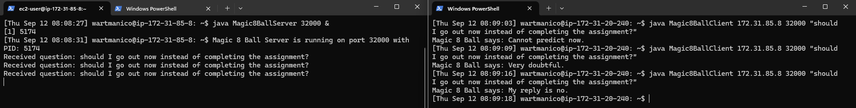

8.2 Crontab setup

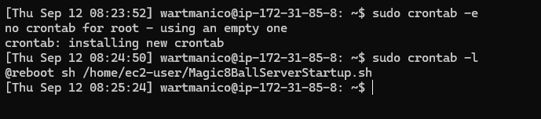

Test after reboot:

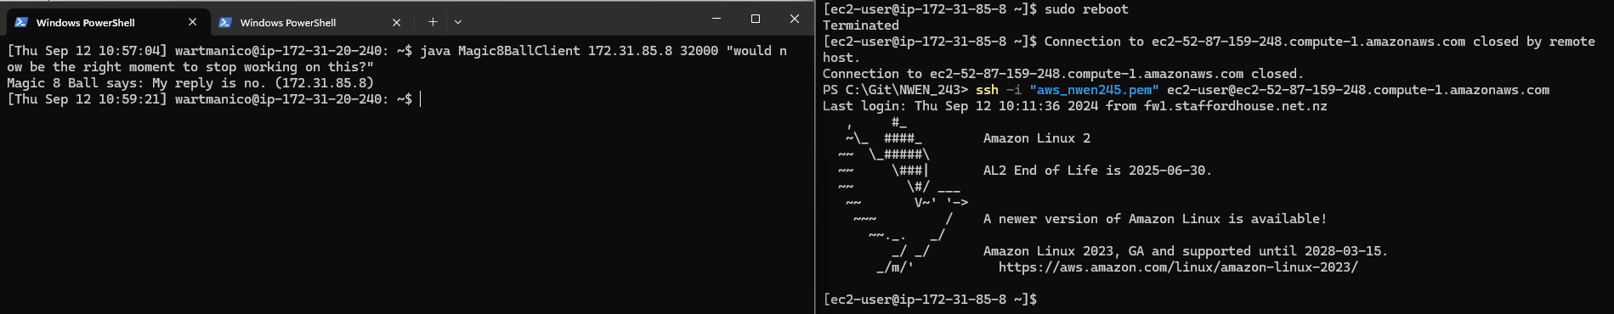

8.3 Creating and running the Image

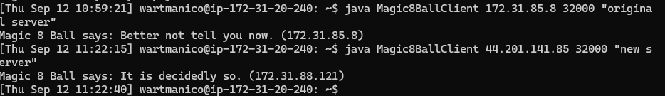

Part II

Launch Templates

