NWEN_243 Project 1

**Name:** Nico Wartmann

**Student ID:** 300671406

**Date:** 08.08.2024

## Making a Docker Image

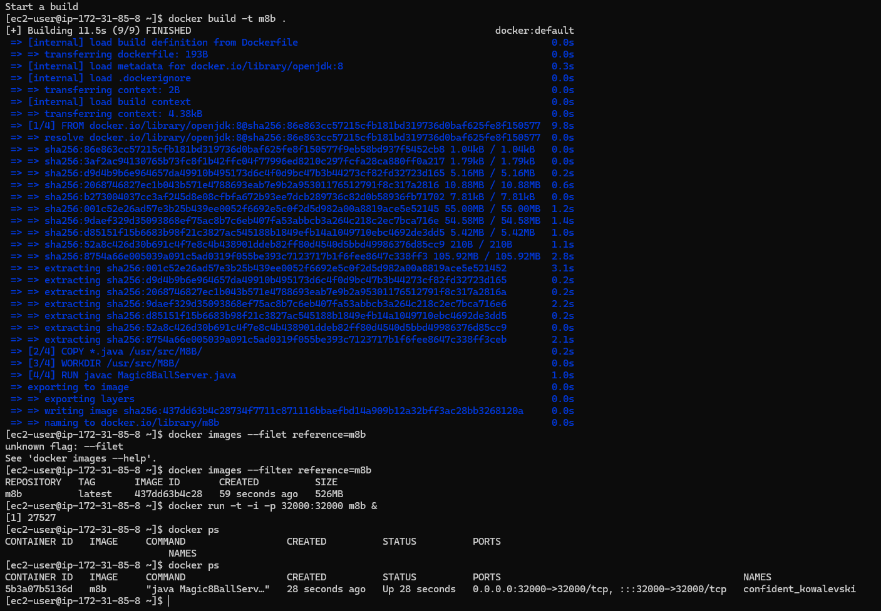

Figure : docker ps

## Running and Testing Docker on EC2 instance

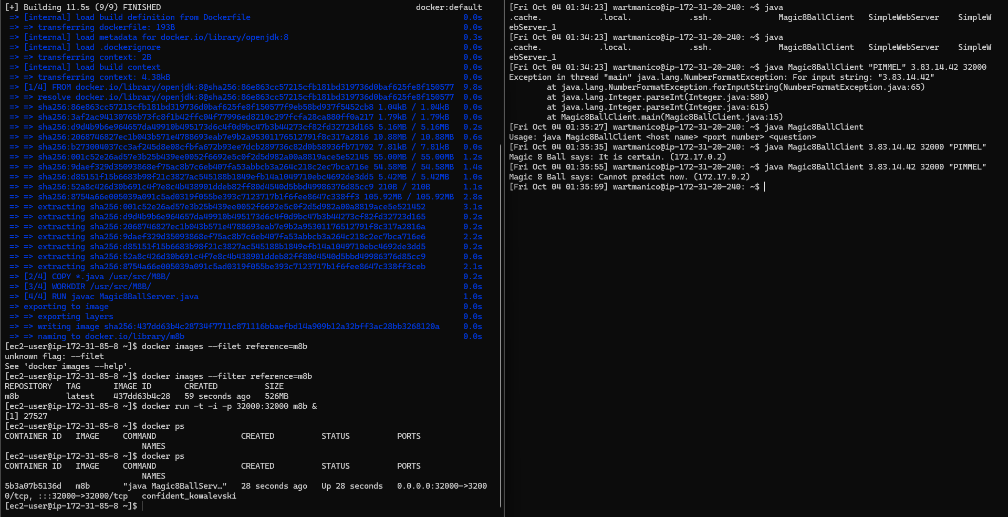

Figure : test from client

As can be seen in the Image above, the test to connect to the server running in the docker container was successful.

## Pushing Docker image to a container registry

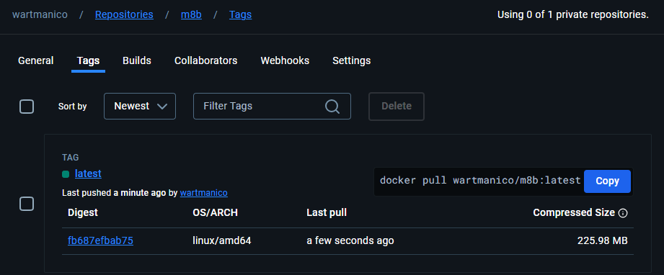

Figure : Docker Tag

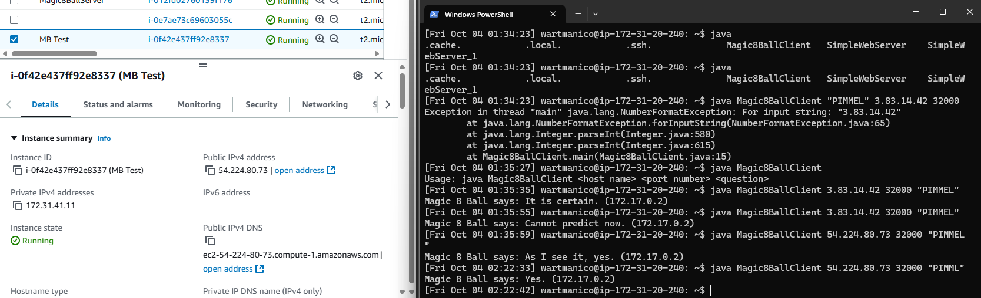

Figure : Testing docker image on second Instance

As can be seen above, I could successfully run the docker image on another EC2 instance.

## Distributing the container – AWS ECS and Fargate

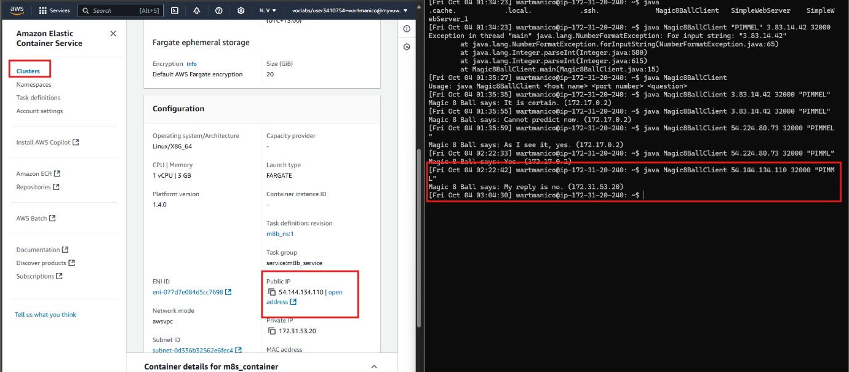

Figure : Test serverless setup from client

The screenshot above proves that the task is running and working. Therefore I succeeded creating the service in a serverless setup.

## Questions

65.

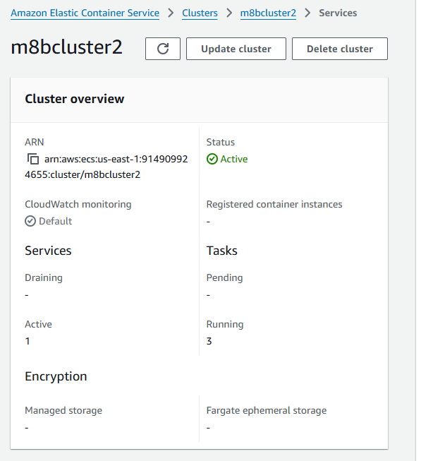

Figure : new cluster with 3 Tasks

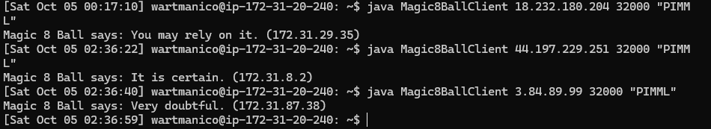

Figure : tests from client to all Tasks

66. The Public IP of each task is different

67. A Load Balancer