NWEN_243 Project 1

**Name:** Nico Wartmann

**Student ID:** 300671406

**Date:** 05.10.2024

It didn’t feel necessary for me to document the steps before as they are already documented in detail in the assignment itself. Documenting copying code and executing shell commands exactly as instructed does not feel reasonable.



Figure : Testing Setup from Client

## Part 5: Question

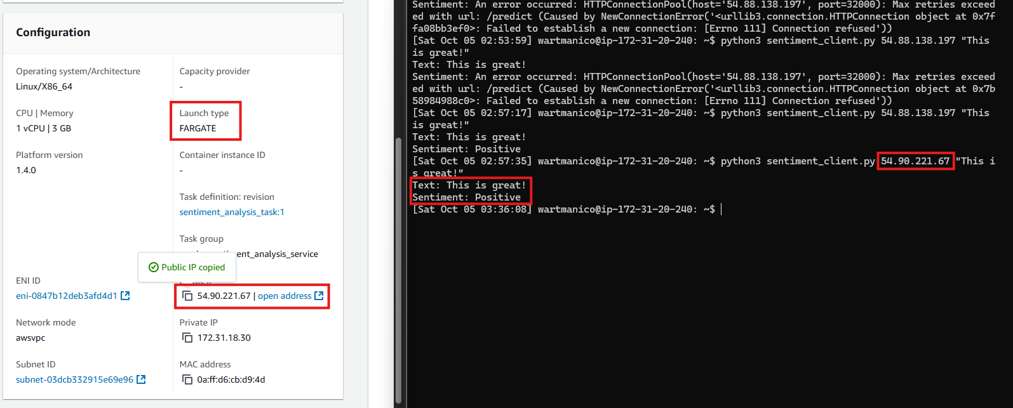

Figure : Task in cluster

To get one example of a scalable solution I executed the following steps:

* I created a Tag of the Docker Image on the EC2 instance and pushed it to a Repository on my Docker
* I created a Task with this tag in the ECS console
* I created a new cluster in ECS console
* I deployed the task onto the new cluster

With this solution the app can run serverless and can easily be replicated. All we need to do to get more is increase the number of desired tasks on the cluster.

This is by no means a complete setup. A load balancer would make this much more reasonable, so the app availability can be scaled up and down automatically by demand. Also without the load balancer we would have to promote multiple public Ips which frankly doesn’t seem like a reasonable thing to do.

Another solution would be to host this application in a EC2 instance and create and terminate instances of it with a Load Balancer and Auto Scaler. This has a larger overhead though and since the docker image already exists, the first solution explained seems more reasonable.

