THE DESCRIPTIVE GEOMETRY OF NOSE CONES
© 1996 Gary A. Crowell Sr.

In my work on the VCP program, it was necessary to collect the equations describing the various nose cone shapes. This collection also brought together some nomenclature and nose cone information that I have never seen gathered in a single source, so I’ve tried to tidy it up and present it here for your amusement.

GENERAL DIMENSIONS

In all of the following nosecone shape equations, L is the overall length of the nosecone, and R is the radius of the base of the nosecone. y is the radius at any point x, as x varies from 0, at the tip of the nosecone, to L. The equations define the 2-dimensional profile of the nose shape. The full body of revolution of the nosecone is formed by rotating the profile around the centerline (^{C}/_{L}). Note that the equations describe the ‘perfect’ shape; practical nosecones are often blunted or truncated for manufacturing or aerodynamic reasons (see the following section on ‘Bluffness Ratio’).

Dimensions used in the equations
L
R
x = 0
x = L
x
y
^{C}/_{L}
y = R
y = 0

While a practical nose cone used in modeling usually includes a shoulder for mounting to a tube, that aspect will be ignored here, as it has no aerodynamic effects, and its mass and inertial contributions are easily handled separately.

NOSE CONE SHAPE EQUATIONS

CONICAL
A very common nose cone shape is a simple cone. This shape is often chosen for its ease of manufacture, and is also often (mis)chosen for its drag characteristics. The sides of a conical profile are straight lines, so the diameter equation is simply,

φ
L
R
^{C}/_{L}
Conical nosecone
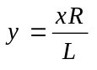
Cones are sometimes defined by their ‘half angle’, φ :
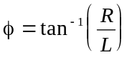 ,and, 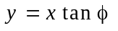
Cones are also special cases of the Power and Parabolic series, as shown in the following sections.

BI-CONIC

φ₂
L₂
R₂
^{C}/_{L}

Bi-Conic nosecone
φ₁
R₁
L₁
L
A Bi-Conic nosecone shape is simply a cone stacked on top of a frustrum of a cone (commonly known to modelers as a ‘conical transition section’ shape), where the base of the upper cone is equal in diameter to the smaller diameter of the frustrum.

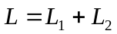

for 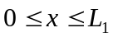, for 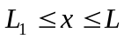,

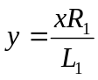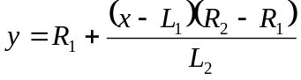
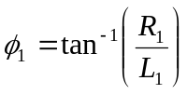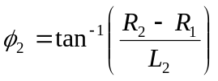

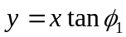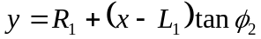

POWER SERIES

L
R
Power Series Dwg TBD
^{C}/_{L}
The Power Series includes the shape commonly known to modelers as a ‘parabolic’ nose cone. (Oddly enough, the shape correctly known as a parabolic nose cone is a member of the Parabolic Series, and is something completely different.) The Power Series shape is characterized by its (usually) blunt tip, and by the fact that its base is not tangent to the body tube. There is always a discontinuity at the nosecone-body joint that looks distinctly non-aerodynamic; however the shape is sometimes modified at the base to smooth out this discontinuity. Often people speak of a parabola shape, when what they are actually looking for is an elliptical shape, which is tangent at its base. It is also interesting to note that both a flat-faced cylinder and a cone are shapes that are members of the Power Series

The Power series nose shape is generated by rotating a parabola about its axis. The base of the nosecone is parallel to the lattus rectum of the parabola, and the factor ‘n’ controls the ‘bluntness’ of the shape. As n decreases towards zero, the Power Series nose shape becomes increasingly blunt; at values of n above about .7, the tip becomes sharp.

For 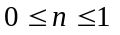, 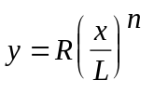

Where: n = 1 for a CONE
n = .75 for a ¾ POWER
n = .5 for a ½ POWER (PARABOLA)
n = 0 for a CYLINDER

TANGENT OGIVE
Next to a simple cone, the Tangent Ogive shape is the most familiar in hobby rocketry. The profile of this shape is formed by a segment of a circle such that the rocket body is tangent to the curve of the nosecone at its base; and the base is on the radius of the circle. The popularity of this shape is largely due to the ease of constructing its profile, since that profile is just a segment of a circle that can be simply drawn with a compass.

L
R
Ogive Radius
ρ
^{C}/_{L}
Tangent Ogive

The radius of the circle that forms the ogive is called the Ogive Radius, ρ, and it is related to the length and base radius of the nose cone:

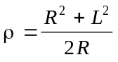

The radius y at any point x, as x varies from 0 to L is:

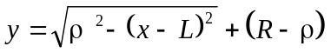

The nosecone length, L, must be equal to, or less than the Ogive Radius. If they are equal, then the shape is a hemisphere.

SECANT OGIVE
The profile of this shape is also formed by a segment of a circle, but the base of the shape is not on the radius of the circle defined by the ogive radius. The rocket body will not be tangent to the curve of the nose at its base. The Ogive Radius, ρ, is not determined by R and L (as it is for a tangent ogive), but rather is one of the factors to be chosen to define the nose shape. If the chosen Ogive Radius of a Secant Ogive is greater than the Ogive Radius of a Tangent Ogive with the same R and L, then the resulting Secant Ogive appears as a Tangent Ogive with a portion of the base truncated; figure n

R
L
ρ
^{C}/_{L}
Secant Ogive

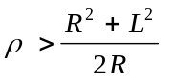 ,and, 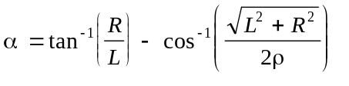

Then the radius y at any point x, as x varies from 0 to L is:

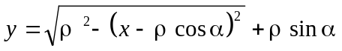

If the chosen ρ is less than the Tangent Ogive ρ, then the result will be a Secant Ogive that bulges out to a maximum diameter that is greater than the base diameter; figure n+1. The classic example of this shape is the nose cone of the Honest John. Also, the chosen ogive radius must be greater than twice the length of the nose cone.

R
L
ρ
^{C}/_{L}
Secant Ogive
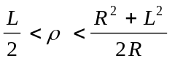

Programming note: The inverse cosine function, required in the equations above, is not directly supported by most programming languages. The derived function for the inverse cosine, in BASIC syntax, is as follows:
,where atn(1) is pi/4 radians.
Arcsin(z) = atn(z/sqr(-z*z+1))

ELLIPTICAL
The profile of this shape is one-half of an ellipse, with the major axis being the centerline and the minor axis being the base of the nosecone. A rotation of a full ellipse about its major axis is called a prolate spheroid, so an elliptical nose shape would properly be known as a prolate hemispheroid. This shape is popular in model rocketry due to the blunt nose and tangent base, which are attractive features for subsonic flight. Note however, that this is not a shape normally found in professional rocketry. Note also, that if R equals L, this shape is a hemisphere.

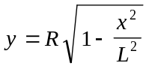

L
R
Elliptical nosecone
^{C}/_{L}

PARABOLIC SERIES
The Parabolic Series nose shape is not the blunt shape that is envisioned when people commonly refer to a ‘parabolic’ nose cone. The Parabolic Series nose shape is generated by rotating a segment of a parabola around a line parallel to its Latus Rectum. (Shutup Beavis.) This construction is similar to that of the Tangent Ogive, except that a parabola is the defining shape rather than a circle. Just as it does on an Ogive, this construction produces a nose shape with a sharp tip. For the blunt shape typically associated with a ‘parabolic’ nose, see the Power Series. (And, of course, the ‘parabolic’ shape is also often confused with the elliptical shape.)

R
L
^{C}/_{L}
Full Parabola K’=1
Lattus Rectum

For 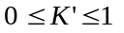, 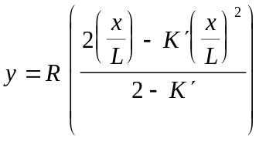

K’ can vary anywhere between 0 and 1, but the most common values used for nose cone shapes are:

K’ = 0 for a CONE
K’ = .5 for a 1/2 PARABOLA
K’ = .75 for a 3/4 PARABOLA
K’ = 1 for a PARABOLA

For the case of the full Parabola (K’=1) the shape is tangent to the body at its base, and the base is on the axis of the parabola. Values of K’ less than one result in a ‘slimmer’ shape, whose appearance is similar to that of the secant ogive. The shape is no longer tangent at the base, and the base is parallel to, but offset from, the axis of the parabola.

HAACK SERIES
Unlike all of the previous nose cone shapes the Haack Series shapes are not constructed from geometric figures. Their shape is instead mathematically derived for the purpose of minimizing drag. While the series is a continuous set of shapes determined by the value of C in the equations below, two values of C have particular significance. When C=0, the notation ‘LD’ signifies minimum drag for the given length and diameter, and when C=1/3, ‘LV’ indicates minimum drag for a given length and volume. Note that the Haack series nose cones are not perfectly tangent to the body at their base, however the discontinuity is usually so slight as to be imperceptible. Likewise, the Haack nose tips do not come to a sharp point, but are slightly rounded.

L
R
HAACK drawing TBD
^{C}/_{L}

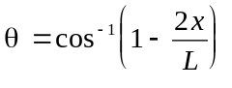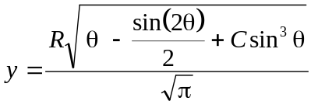

Where: C = 1/3 for LV-HAACK
C = 0 for LD-HAACK (This shape is also known as the Von Karman, or, the Von Karman Ogive)

NOSECONE CENTER-OF-PRESSURE CALCULATIONS
Standard Barrowman values, TIR-33
Normal force on the nose, regardless of shape: (Exception: a ‘bulgy’ secant ogive?)

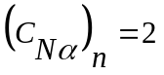

Center of Pressure (CP) location of the nose, measured from the base of the nose is:

For a conical nosecone, 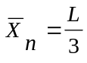
For an ogive nosecone, 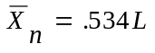 (estimate for L>6R)
For a parabolic nosecone, 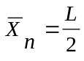 (Power Series, Parabola)

(Note that these formulas have been altered to place the reference point for any longitudinal measurements to be the aft end of the nose cone [excluding any shoulder]. Although it is the most common reference point in most aeronautical texts, the tip of the nose cone becomes a remarkably inconvenient reference point in practical use.)

These equations for the CP location are all determined from the formula:
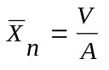
where L is the length, V is the volume, and A is the base area of the nose cone. The base area is simply πR ² , and equations are readily available for the volume of a cone and parabola. Likewise we can get an equation for the volume of an ellipse (prolate hemispheroid), and determine a CP location for that shape:
For an elliptical nosecone, 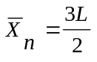
It is interesting to note that the common value used for the CP position on a Tangent Ogive is actually not simply proportional to length The value of .534L that is commonly used is only an approximation that holds well when L ≥ 6R. This is normal for most ogive nosecones, but there are many exceptions. The exact volume of a Tangent Ogive is:

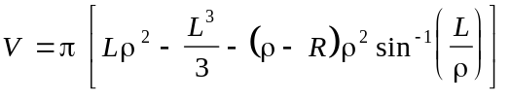 where,
and the equation 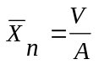

can be used to determine the CP location. We must remember that when Jim Barrowman simplified aerodynamic analysis methods for model rocketry use, it was an era when slide rules were the, ah, rule. When currently programming applications, it is a simple matter to use the more rigorous forms.

For some of the other shapes, I do not have convenient expressions for their volumes. However it is a simple matter to perform a numerical integration on those shapes to determine their volume. In the case of the LV-HAACK and Von Karman shapes, numerical integration on a variety of examples shows that the CP location is not dependent upon the diameter, but is simply proportional to the length:
For an LV_HAACK nosecone, 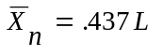
For a Von Karman nosecone, 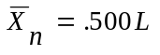
The secant ogive, and the Power and Parabolic series that aren’t covered by the Conical and Parabolic CP equations, do not have simple proportional relationships. We must resort to numerical integration to determine the CP location for each individual instance of these shapes.

Examples

L
R
Estimation of an Elliptical nosecone
^{C}/_{L}

h
R₂
^{C}/_{L}
frustrum of a cone
R₁

Note that some nose cones occasionally include a cylindrical section extending aft of the actual nose cone shape, usually to expand the payload section of the nose. A cylindrical body section has no effect on the CP location within the Barrowman Equations. It is only necessary to adjust the reference point of the nose shape to account for the cylindrical section.

NOSE CONE DRAG CHARACTERISTICS

Below Mach .8, the nose pressure drag is essentially zero for all shapes. The major significant factor is friction drag, which is largely dependent upon the wetted area, the surface smoothness of that area, and the presence of any discontinuities in the shape. In strictly subsonic model rockets, a short, blunt, smooth elliptical shape is usually best. In the transonic region and beyond, where the pressure drag increases dramatically, the effect of nose shape on drag becomes highly significant. The factors influencing the pressure drag are the general shape of the nosecone, its fineness ratio, and its bluffness ratio.

Wetted Area - The wetted area is the total surface area of the nosecone shape that is exposed to the airflow. This does not include the base area of the nosecone. Friction drag on the rocket will depend upon the total wetted area. Equations for determining wetted area are provided in the appendix, but for a quick comparison, the following table compares the wetted areas for nosecone shapes of a similar 4:1 fineness ratio:

{table TBD}

General Shape - Many of the references contain empirical data comparing the drag characteristics of various nose shapes in different flight regimes. The chart below, from reference 4, seems to be the most comprehensive and useful compilation of data for the flight regime of greatest interest. This chart generally agrees with more detailed, but less comprehensive data found in other references (most notably the USAF Datcom).

0.8
1.0
1.2
1.4
1.6
1.8
2.0
MACH NUMBER
Ogive
Cone
LV-HAACK
Von Karman
Parabola
3/4 Parabola
1/2 Parabola
x^{3/4} Power
x^{1/2} Power
Comparison of drag characteristics of various nose shapes in the transonic-to-
low Mach regions. Rankings are: superior (1), good (2), fair (3), inferior (4).
1
1
1
1
1
1
1
1
1
2
2
2
2
2
2
2
2
2
2
3
3
3
3
3
3
3
4
4
Many high-power and amateur rockets are striving to accomplish the goal of “Mach-busting”. Therefore their greatest concern is flight performance in the transonic region from 0.8 to 1.2 Mach, and nosecone shapes should be chosen with that in mind. Although data is not available for many shapes in the transonic region, the table clearly suggests that either the Von Karman shape, or Power Series shape with n = ½, would be preferable to the popular Conical or Ogive shapes, for this purpose.

This observation goes against the often-repeated conventional wisdom that a conical nose is optimum for a Mach-breaking rocket. I suspect that this belief derives from observations of sounding rockets that often utilize conical nose shapes, such as the Black Brant III, for example. Such sounding rockets spend little of their flight time in the transonic region, accelerating quickly to multiple Mach numbers. When it decelerates after burnout, the sounding rocket remains at multiple Mach for most of its remaining flight due to the decreased air density at altitude. At the higher Mach numbers where it spends most of its flight, a cone then becomes the optimum low-drag shape. Fighter aircraft are probably good examples of nose shapes optimized for the transonic region, although their nose shapes are often distorted by other considerations of avionics and inlets. An F-16 nose appears to be a very close match to a Von Karman shape. (What we really need is a nosecone whose shape can be transmorgified in flight to match the regime - see the Disney movie ‘The Flight of the Navigator’ for a good example of this concept.)

Note that at present, commercially available Von Karman nosecones are very rare. If you desire to fabricate your own nosecones, the VCP program will print any size profile of the Von Karman, or any of the other shapes, to a Windows printer. (Royalties will gladly be accepted, in care of the author.)

Due to the close visual similarity of the Von Karman shape with a Tangent Ogive, I suspect that some full size rockets that are reported in documentation to have “Ogive” nosecones, may actually have “Von Karman Ogive” nose shapes. Without exact measurements, it would be difficult to distinguish between the two shapes in photographs.

Fineness Ratio - The ratio of the length of a nosecone compared to its the base diameter is known as the ‘Fineness Ratio’; e.g., a nosecone that is 10 inches long and 2 inches in diameter would have a fineness ratio of 5:1. Note that this is sometimes also called the ‘Aspect Ratio’, though that term is usually applied to wings and fins. Note also that the term ‘fineness ratio’ is often applied to the entire vehicle, considering the overall length and diameter. The length/diameter relation is also often called the ‘Caliber’ of a nosecone; the previous example would have a caliber of ‘5’. At supersonic speeds, the fineness ratio has a very significant affect on nose cone wave drag, particularly at low ratios; but there is very little additional gain for ratios increasing beyond 5:1. Remember that as the fineness ratio increases, the wetted area, and thus the skin friction component of drag, is also going to increase. Therefore the minimum drag fineness ratio is ultimately going to be a tradeoff between the decreasing wave drag and increasing friction drag.

Nose Fineness Ratio f_{n} ,
dimensionless
0.0
0.1
0.2
0.3
0.4
1
2
3
4
5
Wave
Drag Coefficient
C_{D} ,
Conical
Shape at
M = 1.4

Bluffness Ratio - While most of the nosecone shapes ideally come to a sharp tip, they are often blunted to some degree as a practical matter for ease of manufacturing, resistance to handling and flight damage, and safety. This blunting is most often specified as a hemispherical ‘tip diameter’ of the nosecone. The term ‘Bluffness Ratio’ is often used to describe a blunted tip, and is equal to the tip diameter divided by the base diameter. Fortunately, there is little or no drag increase for slight blunting of a sharp nose shape. In fact, for constant overall lengths, there is a decrease in drag for bluffness ratios of up to 0.2, with an optimum at about 0.15. A flat truncation of a nose tip is known as a Me’plat diameter, and the drag reduction effect of a Me’plat truncation is shown in the diagram below. The diagram data are for noses that have been blunted to different diameters while maintaining a constant overall length (i.e., the ogive radius or cone angle is adjusted). It is interesting to note that many types of rifle bullets and artillery shells feature Me’plat truncated tips.

24
Me’plat Diameter d_{m}, cal
(Flat unless otherwise indicated).
-8
-4
0
4
8
12
16
20
0
0.1
0.2
0.3
0.4
Percent Change in Drag Coefficient ΔC_{D}, %
Mach
0.765
1.3
1.8
2.4
Inscribed
Spherical
Tip
Added
Spherical
Tip
4:1 Von Karman Ogive with Percent Change in Drag Coefficient vs Me’plat Diameter
0.15 caliber Me’plat truncation.

Note that this does not mean that you should immediately chop all of the sharp tips off of your nose cones! Removing a tip decreases the fineness ratio, which results in increased pressure drag. However, if you are limited by materials or tools to a 15” finished nosecone length, for example, then your maximum fineness ratio is fixed by that length and the base diameter. With such a limit, then using a 16” sharp-tip shape, and blunting the tip to fit the 15” limit will produce a lower drag shape than a 15” sharp tipped nosecone. Whether by design or coincidence, most commercially-made tangent ogive hobby nosecones are blunted to a bluffness ratio of about .1.

TRANSONIC EFFECTS ON NOSE CONE CENTER OF PRESSURE AND NORMAL FORCE

The Barrowman equations are very specific in their assumption that the flight regime is below .5 Mach. In this range it is a good assumption that the nose cone center of pressure and the normal force are constant. Above this point, however, there are significant changes that should be considered.

TBD

OTHER MEASURATION FORMULAE

Reference Area - CP and drag calculations are always based upon a particular reference area of a rocket. That reference area is nearly always chosen to be the area of the base of the nose cone, which is: 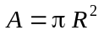 (Exception - a ‘bulgy’ secant ogive?)

Fineness Ratio - For any shape, the fineness ratio of a nose cone is its length divided by its diameter. For example, one might speak of a 5-to-1 (also written as 5:1) ogive nosecone shape, meaning that its length is five times its diameter. This ratio is sometimes also called the ‘Aspect Ratio’.
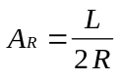

Volume - When computing volume for purposes of CP calculations, exclude any nosecone shoulder. When computing volume for mass or density calculations, the shoulder would be included.

For a cylinder: 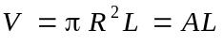

For a Tangent Ogive:

where,

For a Cone: 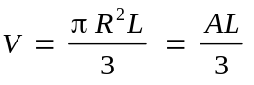

For a Parabola: 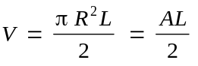 (Power Series, n = .5)

For an Ellipse: 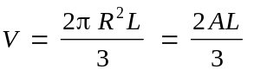 (prolate hemispheroid)

For all others, numerically integrate the volume of a conical frustrum over the length of the shape:
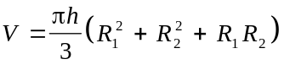
where: R₁ and R₂ are the forward and aft radii, and h is the height, of the frustrum.

Wetted Area - The wetted area is the total surface area of the nosecone shape that is exposed to the airflow. This does not include the base area or the area of any shoulder section. The wetted area value is used in drag calculations.

For a cylinder: 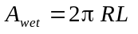 (Does not include face.)

For a Tangent Ogive: 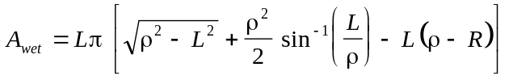 gives neg?

where,

For a Cone: 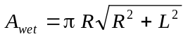 2pi? Nope, this looks ok.

For an Ellipse: 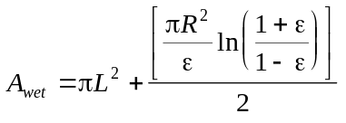 where: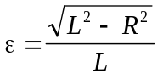 half of this?

For all others, numerically integrate the surface area of a conical frustrum over the length of the shape:
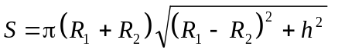
where: R₁ and R₂ are the forward and aft radii, and h is the height, of the frustrum.

Mass For any homogenous solid shape, the mass is simply the volume times the density of the material. But it gets interesting when the shape is hollow, as most hobby nose cones are.
Numerically integrate the volume of an annular conical frustrum:

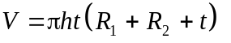
where: R₁ and R₂ are the forward and aft radii, h is the height, and t is the wall thickness of the hollow frustrum. (Assuming that the thickness remains constant over the height of the frustrum.) When either radius is less than the wall thickness (as would be the case near the tip of the nose cone), the equation for volume of a solid frustrum would be used.

Note that the mass of any nose cone shoulder should be similarly calculated and included. For this, the equation for volume of a hollow cylinder might be useful:
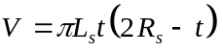
where: R_{s} is radius, t is the wall thickness, and L_{s} is the length of the shoulder.

Lateral Area - This value can be used for CP estimates using the center-of-lateral area method, in cases where the Barrowman CP does not apply. A_{lat} is the lateral area, and X_{lat} is the distance from the base of the figure to the center of lateral area of that figure.

For a Cylinder: 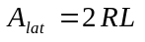 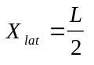

For a Cone: 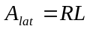 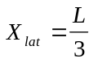

For an Ellipse: 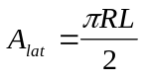 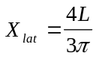

For all others, numerically integrate the lateral area of a conical frustrum over the length of the shape:
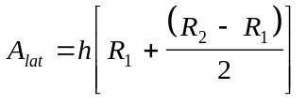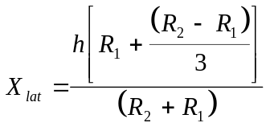

where: R₁ and R₂ are the forward and aft radii, and h is the height, of the frustrum.

Center-of-Gravity Solid/Hollow/Shoulder? Material Density - show how by numerical integration
Inertial Moments Solid/Hollow/Shoulder? Material Density - show how by numerical integration. Rotational and Longitudinal.

REFERENCES

- Hymer, T.C.; Moore, F.G.; “User’s Guide for an Interactive Personal Computer Interface for the Aeroprediction Code” NSWCDD/TR-94/107, June 1994, Dahlgren, VA.
- MIL-HDBK-762(MI); ”Design of Aerodynamically Stabilized Free Rockets”; U.S. Army Missile Command; July 1990.
- Crowell, G.A., Sr.; “VCP Stability Analysis Program”, Version 1.64; Copyright 1996.
- Chinn, S.S.; Missile Configuration Design, McGraw-Hill Book Co., Inc., New York, Copyright 1961.
- Barrowman, J.S.; “Technical Information Report - 33, Calculating the Center of Pressure of a Model Rocket”; Centuri Engineering Co.; Copyright 1970.
- Barrowman, J.S.; “The Practical Calculation of the Aerodynamic Characteristics of Slender Finned Vehicles”, M.S. Dissertation, The Catholic University of America, March 1967.
- Donatelli, G., Lt.; “In Pursuit of Mach 1”; Model Rocketeer, October 1983.
- Hoak, D.E.; Carlson, M.W.; Finck, R.D.; “USAF Stability and Control Datcom”, USAF Stability and Control Methods, McDonnell Douglas Corp., Douglas Aircraft Division for Flight Control Division, US Air Force Flight Dynamics Laboratory, Wright-Patterson AFB, Ohio, 1960.
- Beyer, W.H.; “Standard Mathematical Tables”, 24th ed., The Chemical Rubber Co., 1974.
- Perkins, E.W.; “Investigation of the Drag of Various Axially Symmetric Nose Shapes of Fineness Ratio 3 for Mach Numbers from 1.24 to 7.4”, NACA Report 1386, 1952.
- Stoney, Jr, W.E.; “Transonic Drag Measurements of Eight Body-Nose Shapes”, NACA Research Memorandum L53K17, 1954.
- Perkins, E.W.; “Investigation of the Drag of Various Axially Symmetric Nose Shapes of Fineness Ratio 3 for Mach Numbers from 1.24 to 3.67”, NACA Research Memorandum A52H28, 1952.

L
Ogive Radius
ρ
^{C}/_{L}
Secant Ogive
R
L
ρ
^{C}/_{L}
Tangent Ogive
R

