
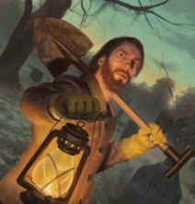

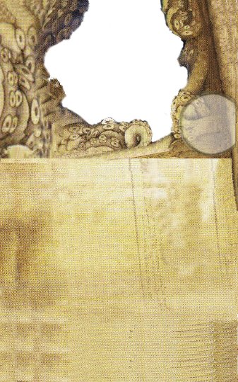



Slugger

Action: Discard this card to test (,2).
If you pass, deal Weapon damage of a Heavy Weapon plus two additional damage.

Sales Talk

During your turn, if you are in the same space as a Person token, you may discard this card to take an additional action.
Deadshot

Action: Discard this card to test (,2).
If you pass, deal Weapon damage of a Firearm Weapon plus the number of .





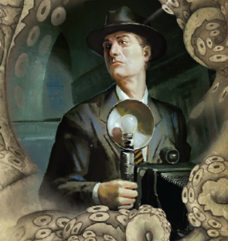




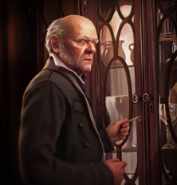

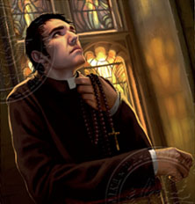






Flash, Bang!

Discard this card to place a Fire token in your space and you may place a Restraint token on a monster in the same space.
Look Out!

If you are in a space with a window, you may spend 1 Clue to place this card in your space. The space becomes an Outdoor space.




Push On

During your turn, you may discard this card to take a free Push action with a boost of three on Strength.
Old Blunderbuss

Action: Discard this card to test (,2).
If you pass, deal 2 Damage plus the number of .








Hidden Depths

If you go Insane, improve .

During your turn, you may discard this card to take a free action.



Commanding Voice

During your turn, you may discard this card to Interact with a Person token within range.

Frayed Nerves

Improve .

Immediately, you suffer Horror, discard this card. If you discard this card, discard all Improvement tokens.
Occult Expert

If you possess a Tome or Spell, you may discard this card for an investigator in range to gain 1 .

Driven to Collect

During your turn, you may discard this card to move to an Item in range on the game board and take a free Trade action.

Master of Magic

If you resolve a Spell test, you may discard this card instead of flipping the Spell card.

Inspiring Prayer

You may discard this card, for another investigator within range who is taking a test to gain 1 .
Ready to Serve

During your turn, you may discard this card to take an additional action.
On the Case

You may discard this card to move 1 space after performing a Search action.

