**Databases Laboratory Work №1:**

**“Instalarea si configurarea MS SQL Server 2017”**

**Prerequisites:**

1. Chapter one: Instalarea si configurarea MS SQL Server;

**Objectives:**

1. Learn what is SQL, SQL Server, SQL Server Management Studio;
2. Learn how to install database tools (SQL Server & SSMS);
3. Learn how to manage connection with a server (register, exclude, modify);

**Tasks:**

1. Install SQL Server;
2. Install SSMS;

**Implementation:**

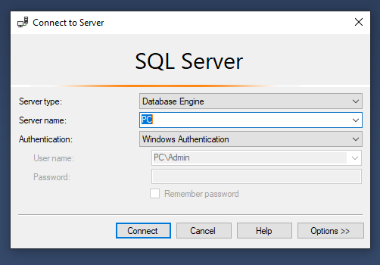

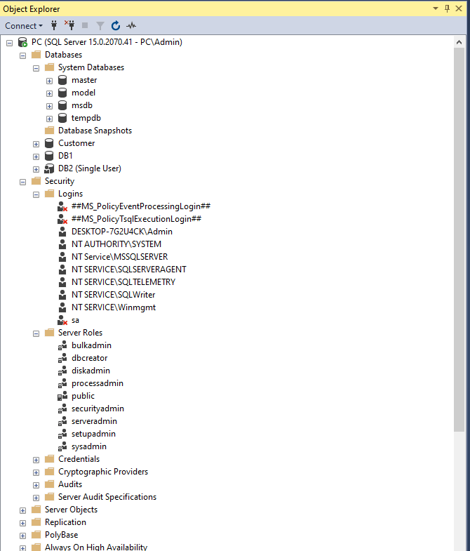

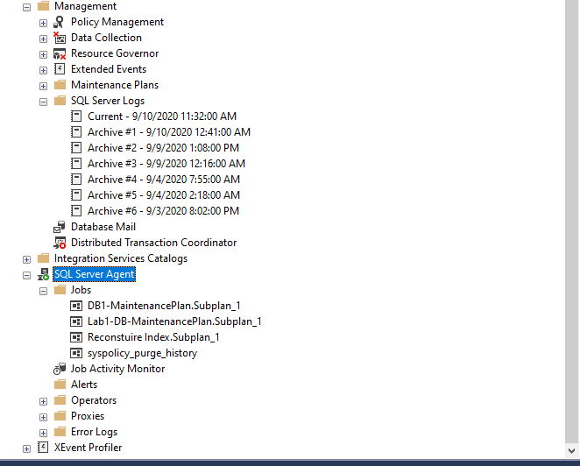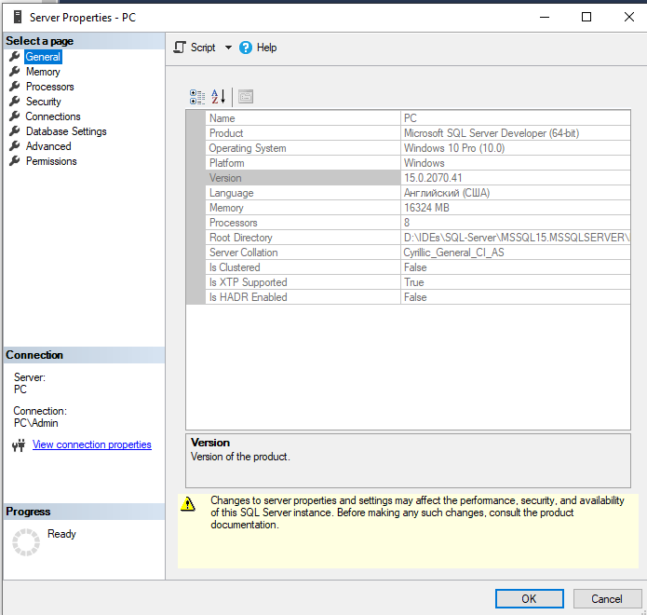

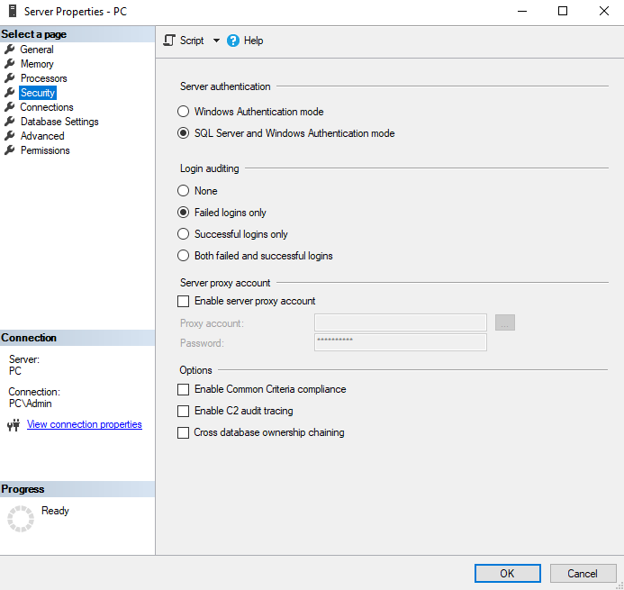

**Conclusion:**

In this laboratory work I managed to:

1. Install & learn about SQL Server (relational database management studio);
2. Install & learn about SQL Server Management Studio (integrated environment for managing any SQL infrastructure);
3. Learn about how to register a new local server;