**1. Crearea si intretinerea Bazei de Date**

**Intrebari de control:**

**1. Tipuri de fisiere utilizate de Microsoft SQL Server 2017**

**Primary** - Contains startup information for the database and points to the other files in the database. Every database has one primary data file. The recommended file name extension for primary data files is .mdf **Secondary** - Optional user-defined data files. Data can be spread across multiple disks by putting each file on a different disk drive. The recommended file name extension for secondary data files is .ndf **Transaction Log** - The log holds information used to recover the database. There must be at least one log file for each database. The recommended file name extension for transaction logs is .ldf

**2. Structura paginilor de pastrare a datelor.**

Database pages are the internal basic structure to organize the data in the database files; The default page size in MySQL Server is 8 Kb.

**3. Baze de date de sistem, importanta si rolul lor.**

**Master Database** - contains information about SQL server configuration. Without Master database, server can’t be started. This will store the metadata information about all other objects(Databases,Stored Procedure,Tables,Views,etc.) which is Created in the SQL Server . **Model Database** - sets a template for every database that was newly created . It serves as a template for the SQL server in order to create a new database. When we create a new database, the data present in model database are moved to new database to create its default objects which include tables, stored procedures, etc. **msdb** - is used mainly by the SQL server Management Studio, SQL Server Agent to store system activities like sql server jobs, mail, service broker, maintenance plans, user and system database backup history, Replication information, log shipping .We need to take a backup of this database for the proper function of SQL Server Agent Service. **TempDB** - is a temporary location for storing temporary tables(Global and Local) and temporary stored procedure that hold intermediate results during the sorting or query processing and cursors. **Resource** - is a read-only database that contains all the system objects that are included with SQL Server. SQL Server system objects, such as sys.objects, are physically persisted in the Resource database, but they logically appear in the sys schema of every database. The Resource database does not contain user data or user metadata.

**4. Principiile de creare a bazei de date in mediul SQL Server Management Studio**

* Launch **MS SQL Server Management Studio**
* In the tree right-click on **Databases** and select **New Database..**
* Follow the instructions in the window

**5. Ce este un plan de intretinere a bazei de date si care sunt tehnicile de creare a planului de intretinere?**

A maintenance plan executes necessary tasks for our database, such as managing backups or verifying the DB integrity. There are 2 ways of creating a backup plan:

* Using the **Maintenance plan wizard**
* Manually creating a **New Maintenance plan..**

**Sarcini practice:**

* 1. **Creati o baza de date plasata fizic in mapa MyDocuments\Data, fixand o crestere a fsierului primar a bazei de 16MB cu limita de crestere de 128 MB si a log-ului de 64 MB cu limita de crestere de 1024 MB. Pentru fisierele secundare sa se defineasca un Filegroup nou implicit, setand cresterea fisierelor secundare de 64 MB cu limita de 1024 MB.**

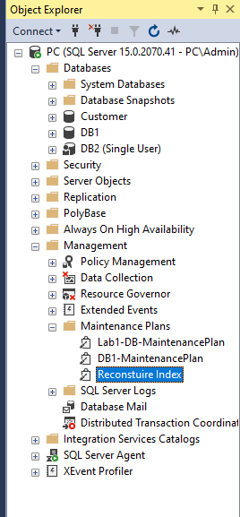

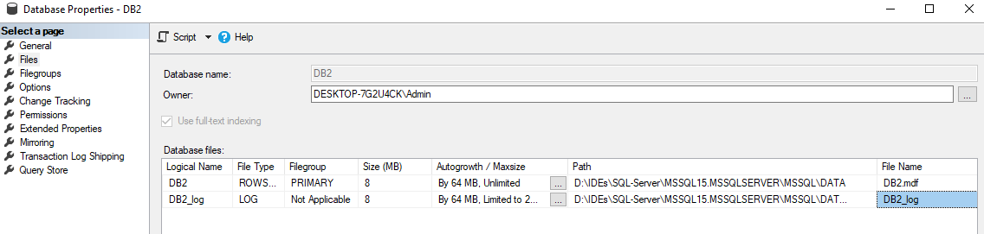

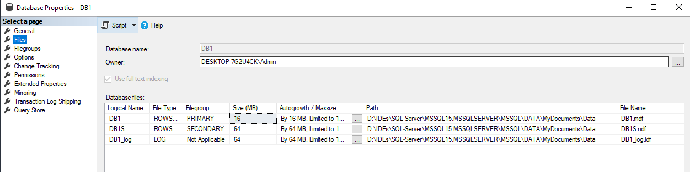

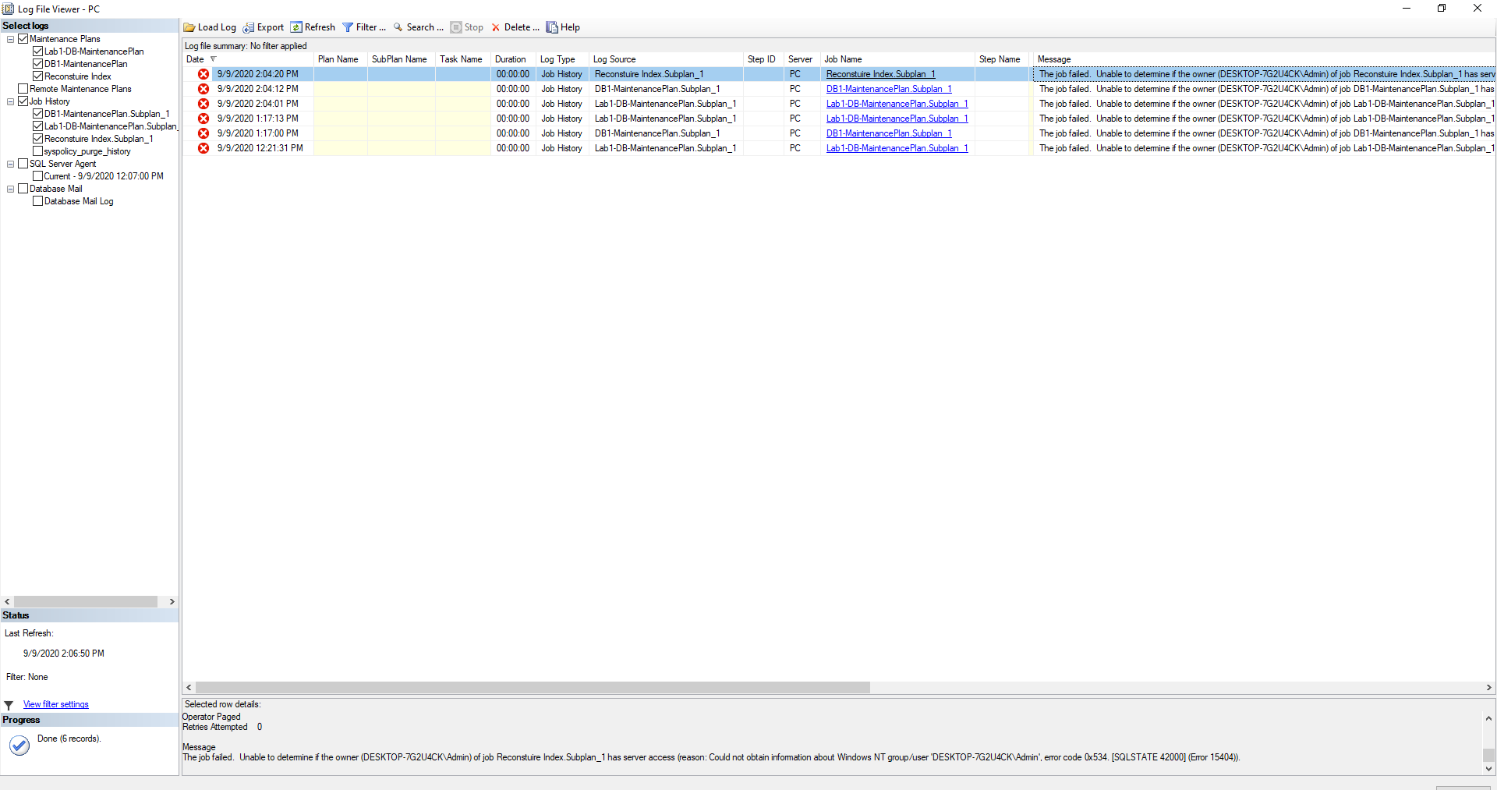

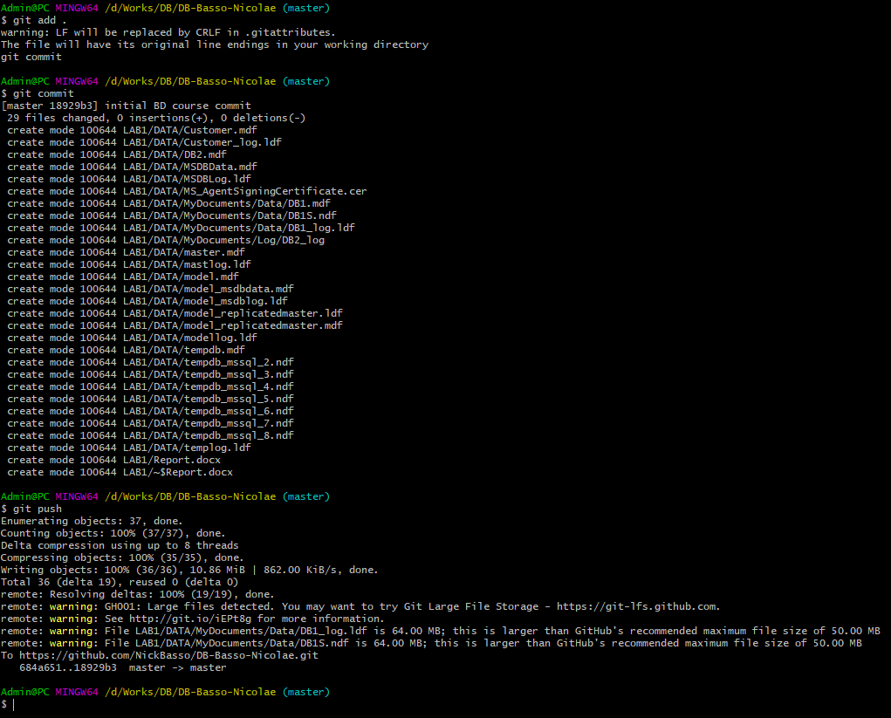

Reduced the file size to fix errors:

