**Databases Laboratory Work №3:**

**“****Crearea si modificarea tabelelor in SQL Server Management Studio”**

**Prerequisites:**

1. Chapter one: Instalarea si configurarea MS SQL Server;
2. Chapter two: “Crearea si intretinerea bazei de date”;
3. Chapter three: “Crearea si modificarea tabelelor in SQL Server Management Studio”;

**Objectives:**

1. Learn SQL data types;
2. Learn how to create data tables;
3. Learn how to manage data table properties;
4. Learn how to modify table structure;

**Tasks (p.72 book):**

1. Answer control questions;
2. Solve the practical tasks listed below;

**Intrebari de control:**

***1. Ce proprietati obligatorii trebuie sa posede o coloana?***

* + ***Name***
  + ***Data type***
  + ***Allows null?***
  + ***Default value***
  + ***Length***
  + ***Precision***
  + ***Scale***

***2. Care sunt tipurile de date utilizate de sistemul SQL Server?***

* + ***Exact numeric***
  + ***Approximate numeric***
  + ***Character sequence***
  + ***Binary***
  + ***Date/time***
  + ***Special***

***3. Ce constrangeri de integritate utilizeaza SQL Server pentru mentinerea consistentei bazei de date?***

* + ***NOT NULL***
  + ***UNIQUE***
  + ***PRIMARY KEY***
  + ***FORGEIN KEY***
  + ***CHECK***

***4. Ce dificultati si urmari pot aparea in procesul de stergere a campurilor din tabelele, deja, existente?***

***There will be no difficulties when deleting columns which are not related elsewhere except for the current table; In other cases though, when columns are PRIMAY KEY, FOREIGN KEY or UNIQUE, and are indexed in other tables, it will be required to delete all the relations between the tables, othetwise the database is going to become non-working, and hence, unsupported.s***

***5. Ce dificultati si urmari pot aparea in procesul de modificare a campurilor din tabelele, deja, existente? Care campuri nu pot fi modificate?***

***There are cases when column properties may not be changed:***

* + ***It is of type TIMESTAMP or UNIQUEIDENTIFIER***
  + ***It is a computed column***
  + ***It is used in an index***
  + ***Column is used for CREATE STATISTICS instruction***
  + ***It is PRIMARY KEY or is in FOREIGN KEY REFERENCES constraint***
  + ***Column is begin used in CHECK or UNIQUE***
  + ***Column is associated with the DEFAULT clause***
  + ***Column type may not be switched if the table it is contained in, is divided***

**Sarcini practice & implementation:**

1. *Care din numerele prezentate mai jos pot fi introduse intr-un camp de tipul DECIMAL(4, 1)?*

**

*a)16,2; b)116,2*

*DECIMAL(4,1) – no more than 4 digits in total & 1 for the decimal part;*

1. *Fie [Col1] din tabelul de mai jos este de tip INT, si [Col2] este de tip DECIMAL (2.1)*

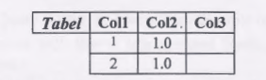

*Ce tip de date trebuie sa fie [Col3] pentru a pastra rezultatul urmatoarei expresii Col1*Col2?*

*DECIMAL(2,1) is the smallest type that fits both (INT)1*(DECIMAL(2,1))1.0 and (INT)2*(DECIMAL(2,1))1.0: here we proceed according to the type-cast precedence rules (DECIMAL has a higher priority than INT)*

1. *Creati o baza de date numita universitatea cu proprietati implicite. in cadrul acestei baze de date, creati 2 tabele (grupe, discipline), scheme le carora sunt definite in sectiunea 3 .3 a capitolului*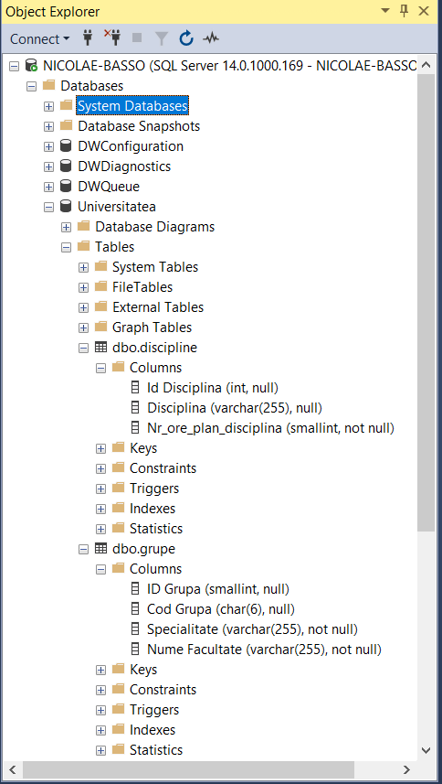

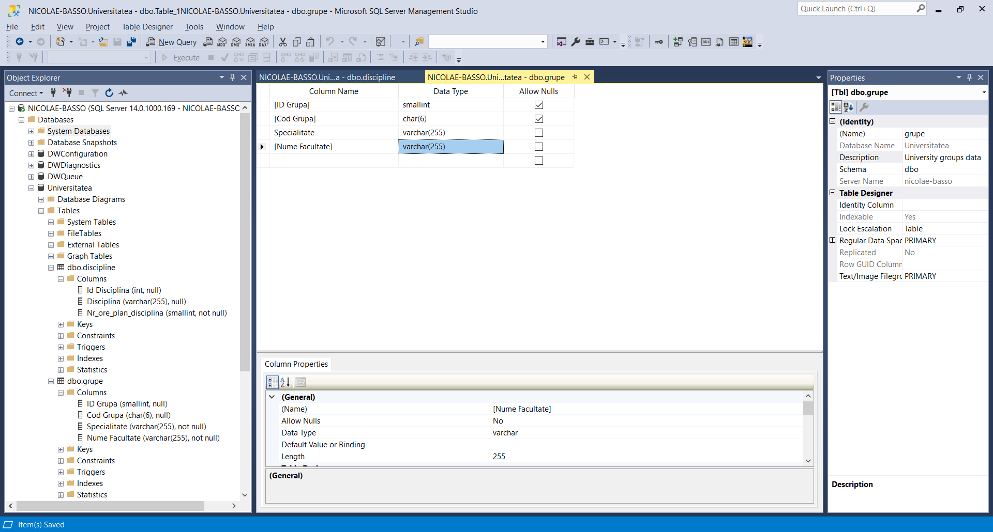

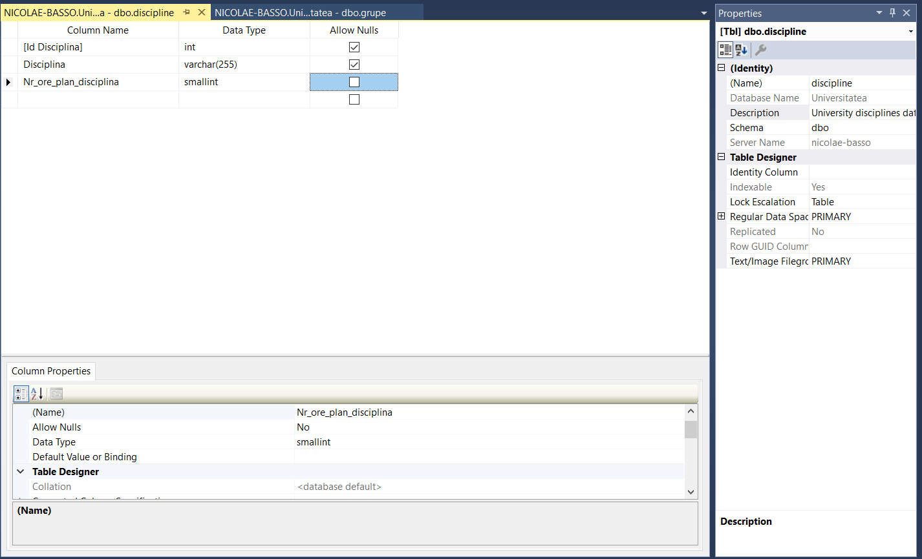

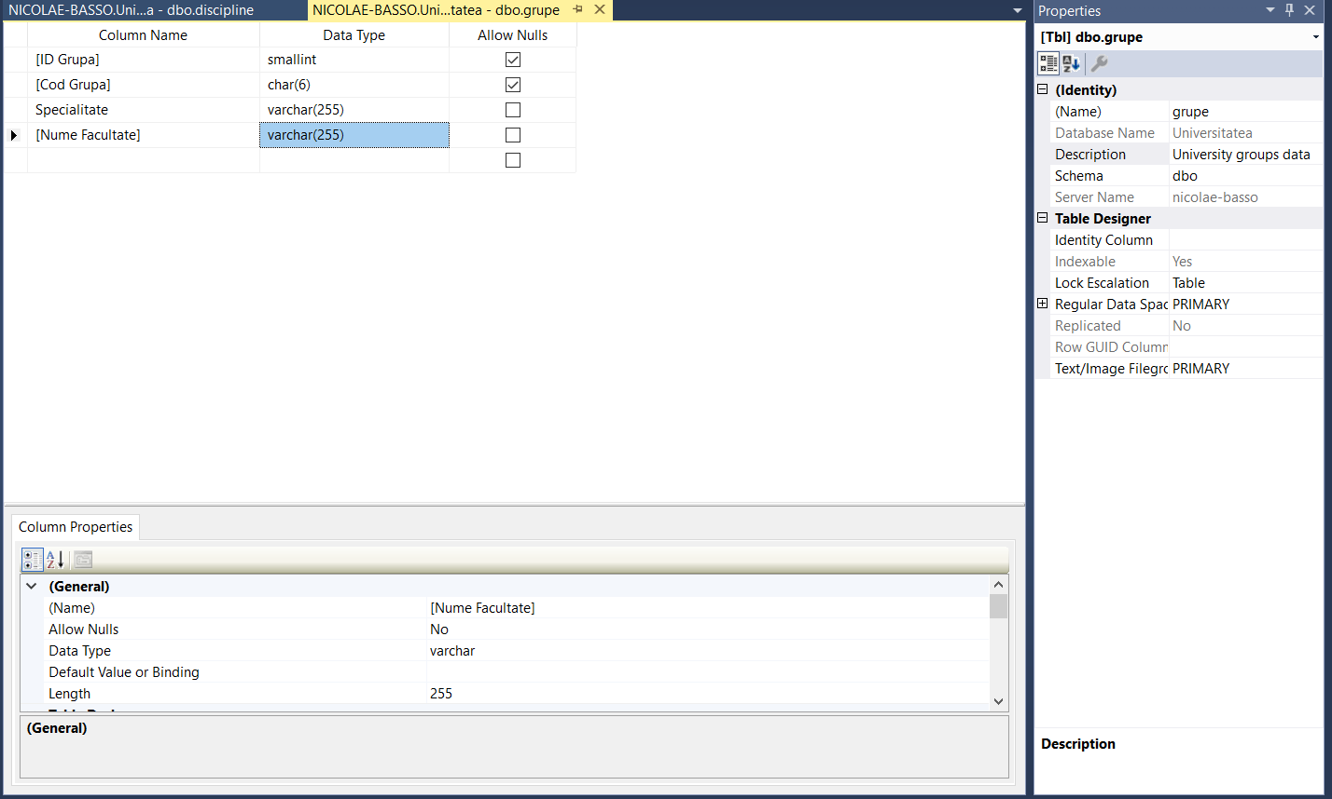

1. *Inserati in tabelele respective ale bazei de date universitatea urmatoarele inregistrari*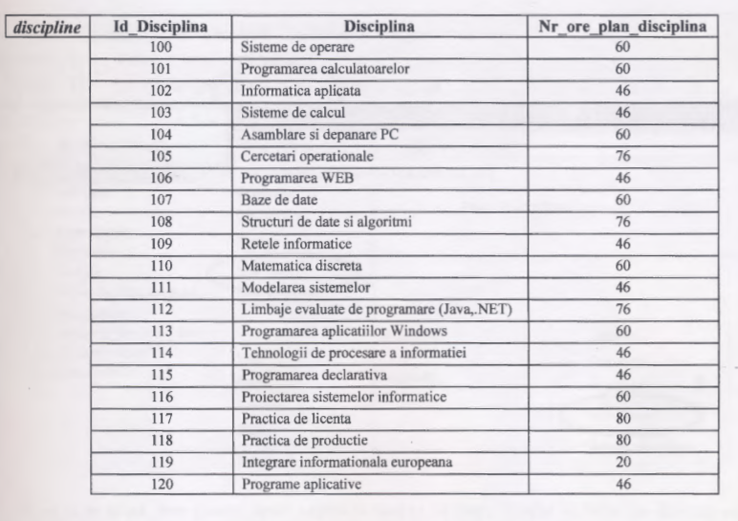

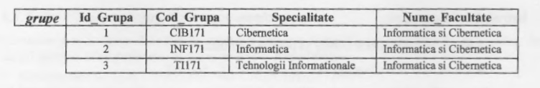

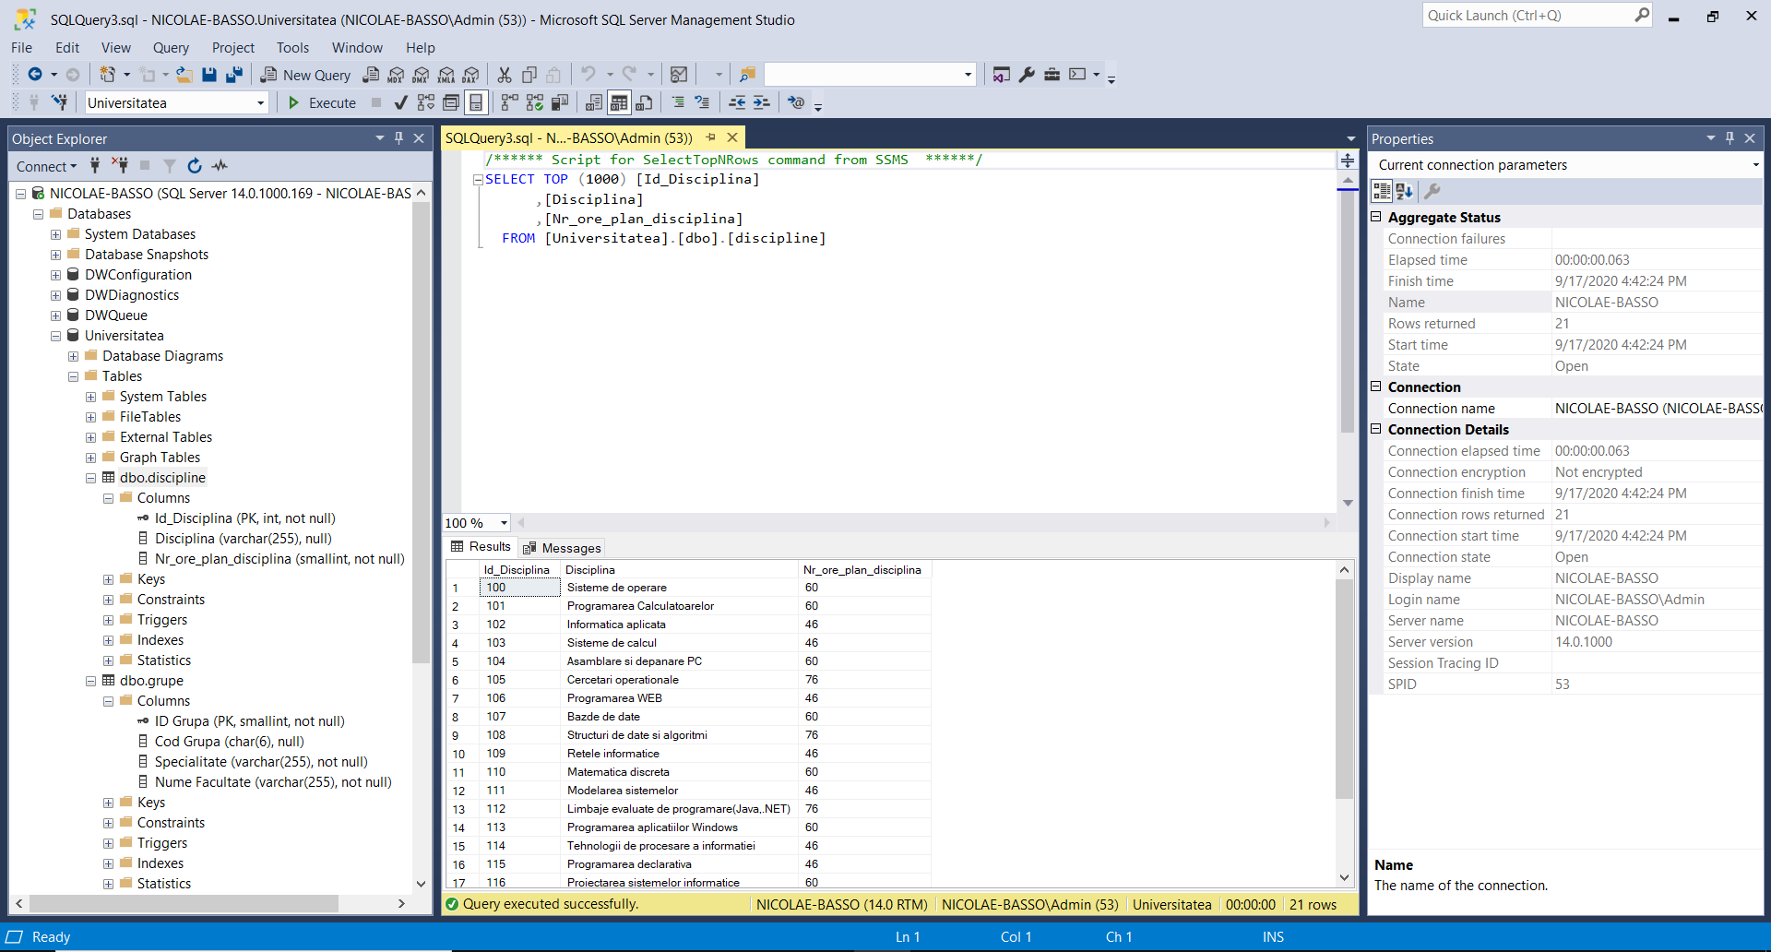

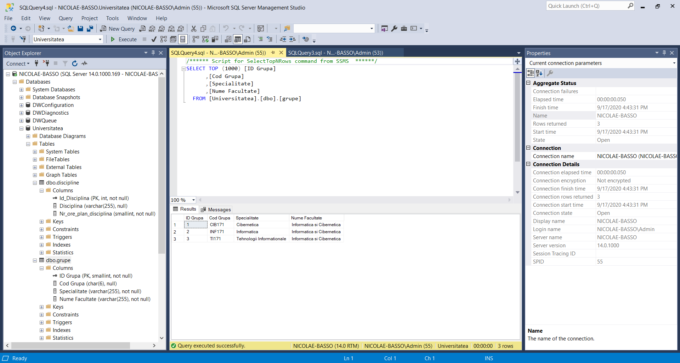

**Conclusion:**

In this laboratory work I learned about MS SQL Server data types, how to create tables, create columns, configure their properties & set its values properly, how to keep database integrity.