**Databases Laboratory Work №4:**

**“SELECT Transact-SQL”**

**Prerequisites:**

1. Chapter one: Instalarea si configurarea MS SQL Server;
2. Chapter two: “Crearea si intretinerea bazei de date”;
3. Chapter three: “Crearea si modificarea tabelelor in SQL Server Management Studio”;
4. Chaper four: “SELECT Transact-SQL”

**Objectives:**

1. Learn basic SQL queries

**Tasks (p.96 book):**

1. Answer control questions;
2. Solve the practical tasks listed below;

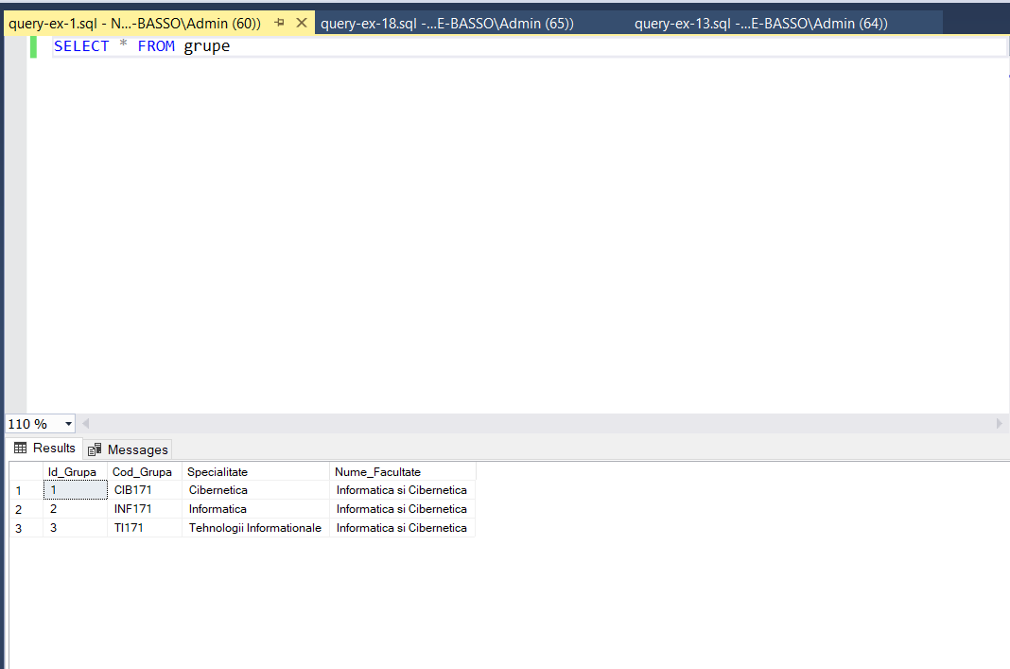

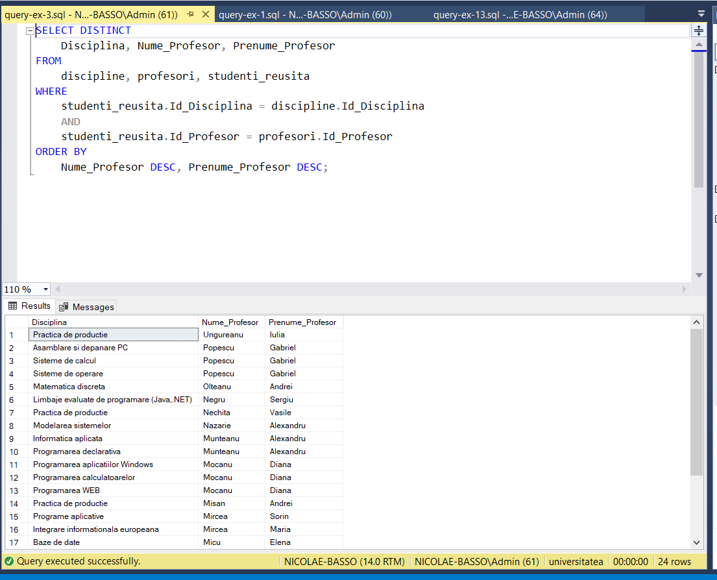

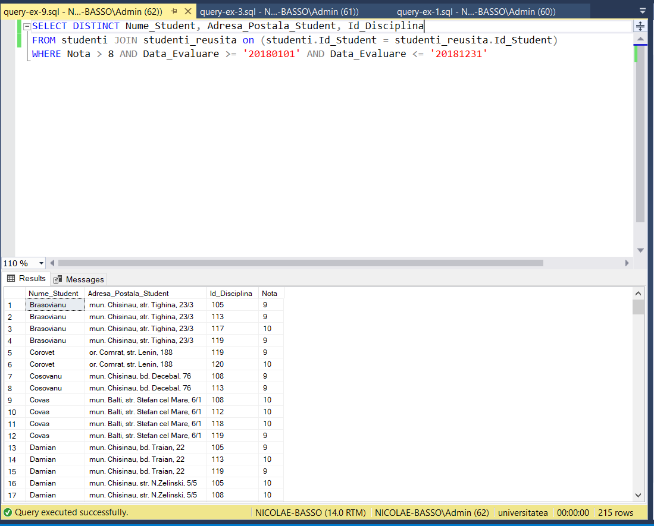

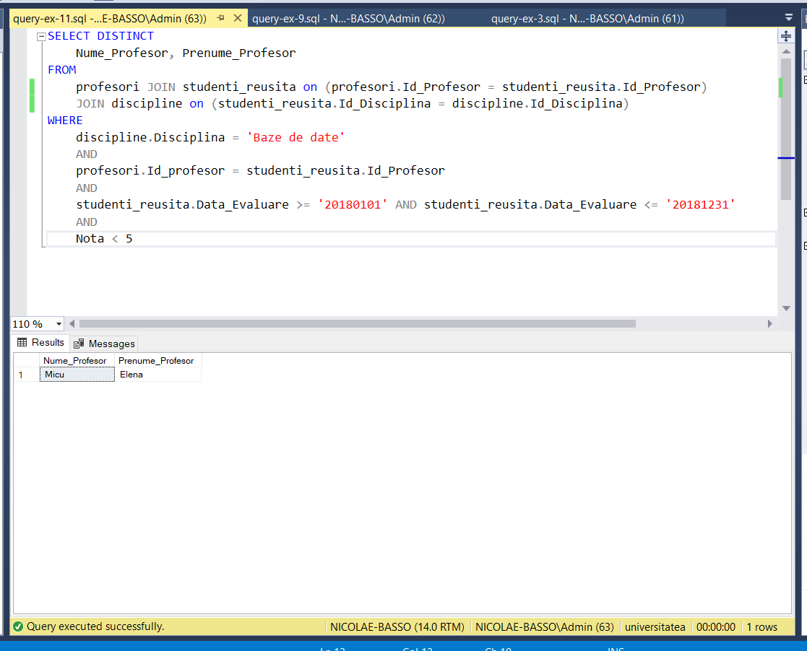

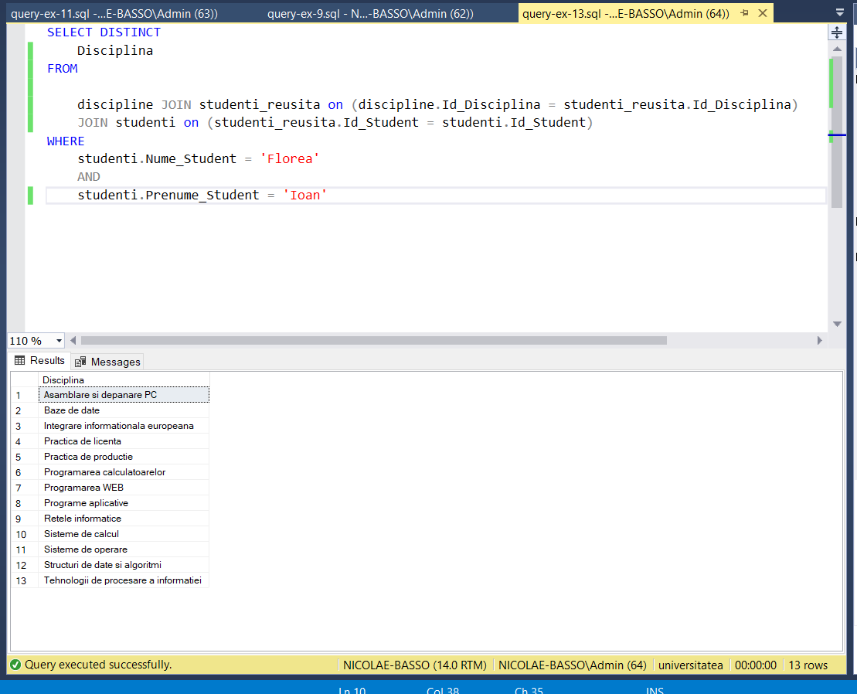

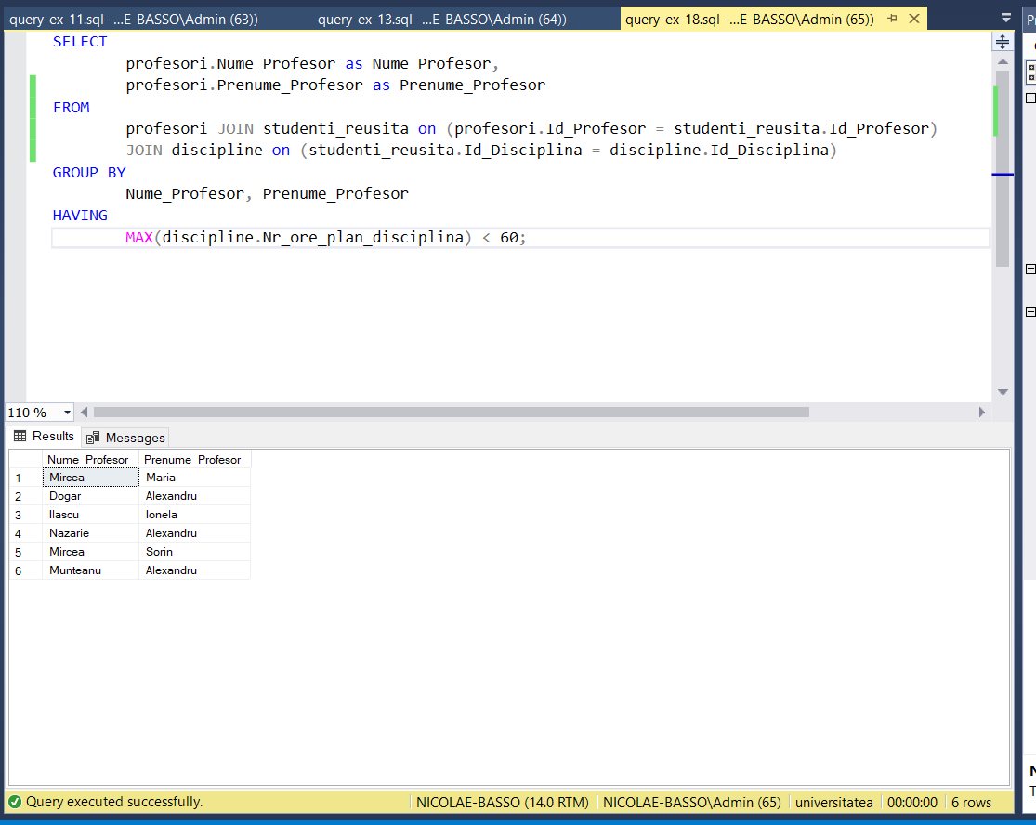

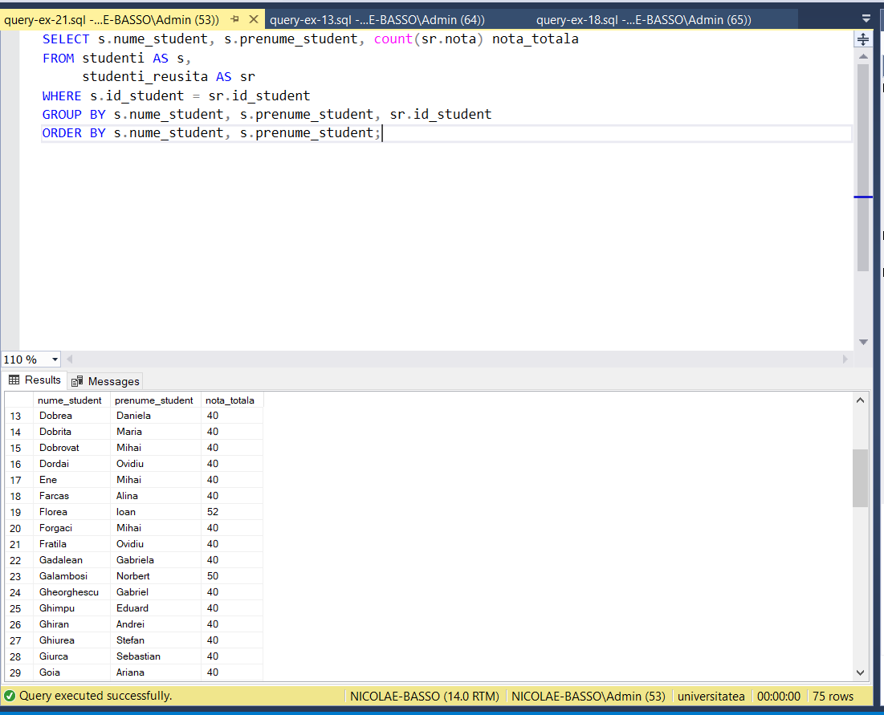

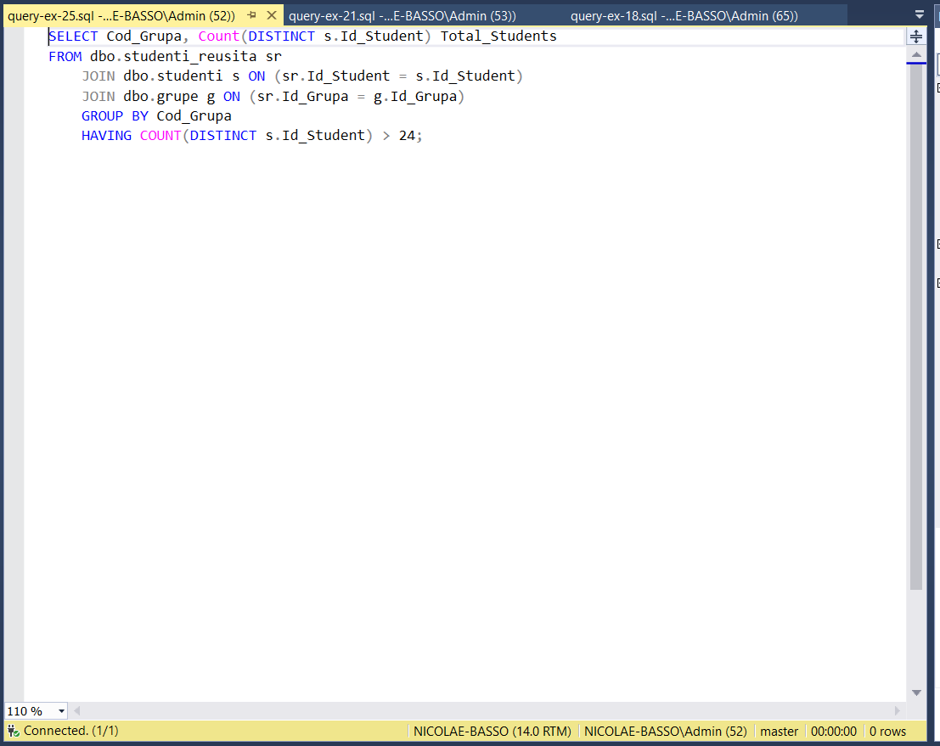

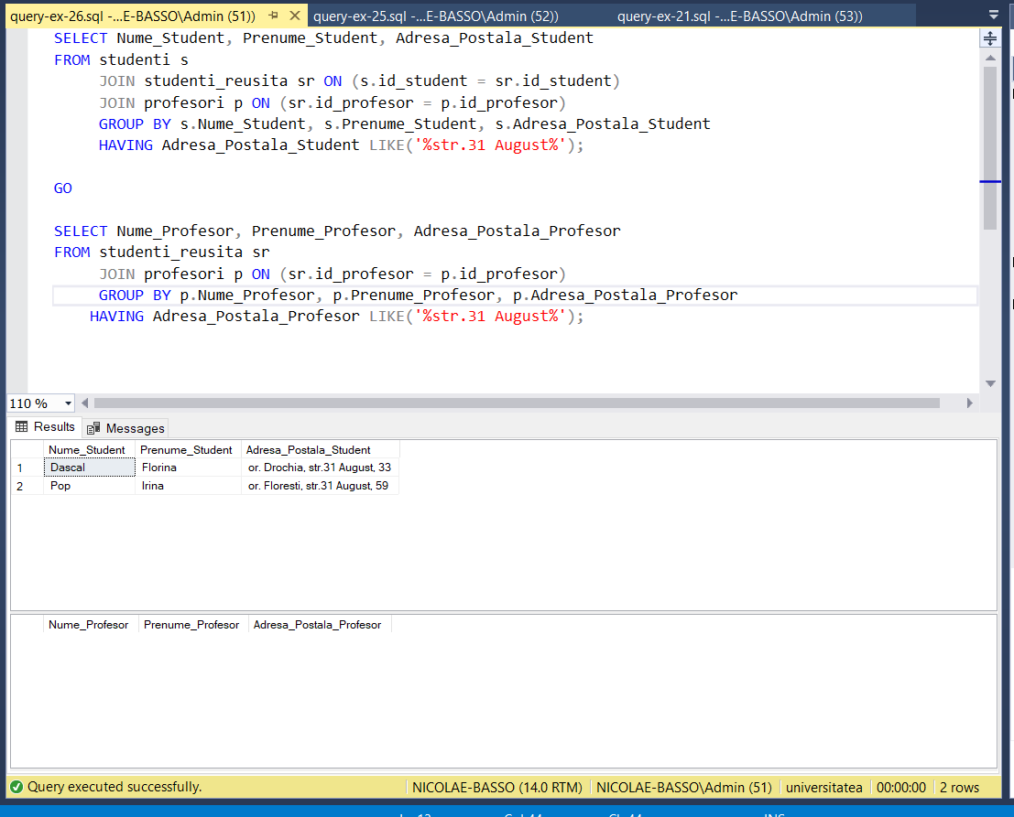

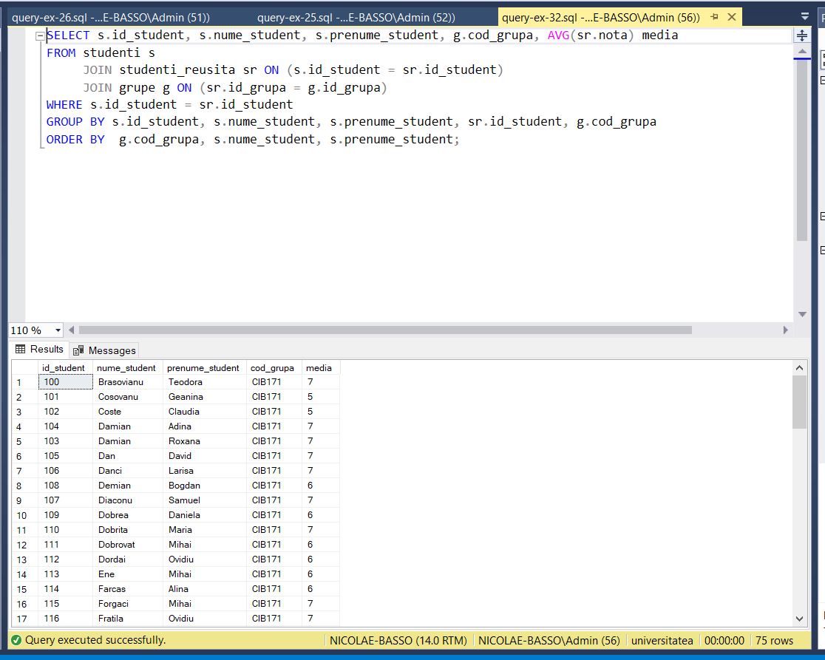

**Conclusion:**

In this laboratory work I learned how to make basic SQL queries using SELECT, FROM, WHERE, GROUP BY, ORDER BY, HAVING, agregate functions, arithmetic & logic operations.