**TECHNICAL UNIVERSITY OF MOLDOVA**

**FACULTY OF COMPUTERS, INFORMATICS AND MICROELECTRONICS**

**DEPARTMENT OF SOFTWARE ENGINEERING AND AUTOMATICS**

**Report of laboratory work №3**

**Theme: Sensors**

**Fulfilled: st.gr. FAF-191 Boico Alexandr**

**Controlled: univ. lecturer Moraru Dumitru**

**Chișinău 2022**

**The task of the laboratory work:**

To develop an application basing on MCU which will receive signal from at least 3 which will display their output signal in terminal:

1. Implement converting of signals to physical parameters.

2. Add supplementary sensors (DHT or Ultrasonic).

**Progress of work**

**1. Description of the main functions used to perform the tasks**

The following code is used to control Temperature sensor, to convert its output signal to physical value and display it in terminal:

**Appendix 1**

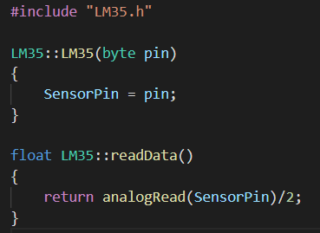

Fig 1. LM35.cpp

Next is the LDR sensor also known as photoresistor, the electrical resistance of which changes under the influence of light rays falling on a photosensitive surface and does not depend on the applied voltage, as in a conventional resistor.

**Appendix 2**

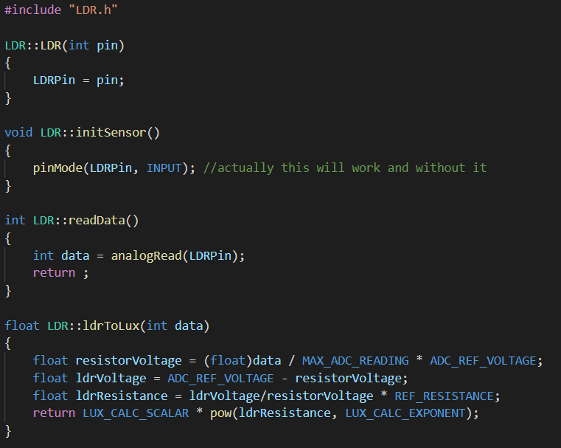

Fig 2. LDR.cpp

The following code is used to control Ultrasonic sensor, to convert its output signal to physical value and display it in terminal:

Also

**Appendix 3**

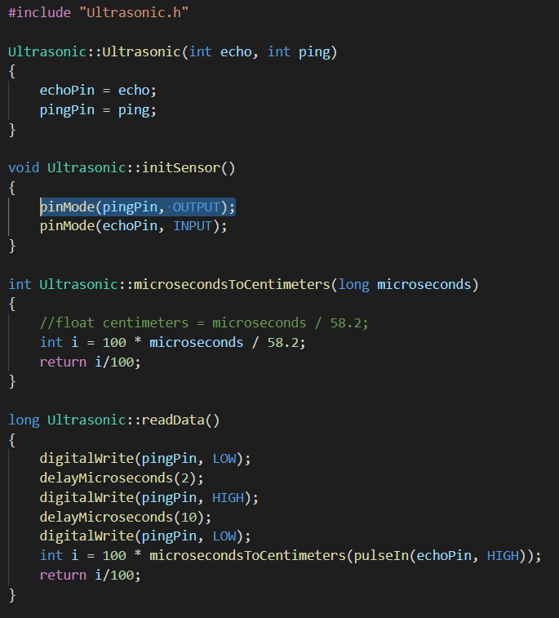

Fig 3. Ultrasonic.cpp

Our task also proposed to implement 2 types of filters. I have chosen Weighted Moving Average and

**Conclusion**

In this laboratory work I have developed one program, which implements the interaction with 3 sensors – 2 analog and 1 digital, and outputs the data gathered from sensor data to the terminal. I have learned basic skills of working with standard sensors, with supplementary sensors as DHT and Ultrasonic, building simulated electrical schematic, and running the simulation program. I have also learned basic skills of working with Arduino IDE and Proteus programs.

**Appendix**

**Electrical schema in proteus**

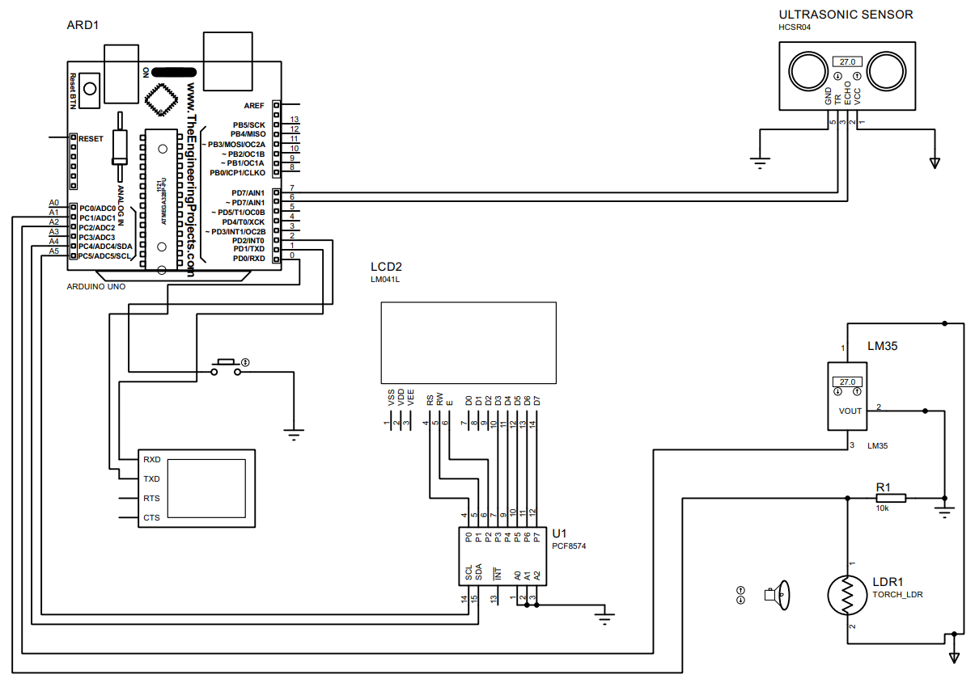

**Code**