Network Distributed Computing

Assignment 1

Name: Nicolae Casian

Student ID: B00144312

1. The Client and Server Python Code

Server Python Code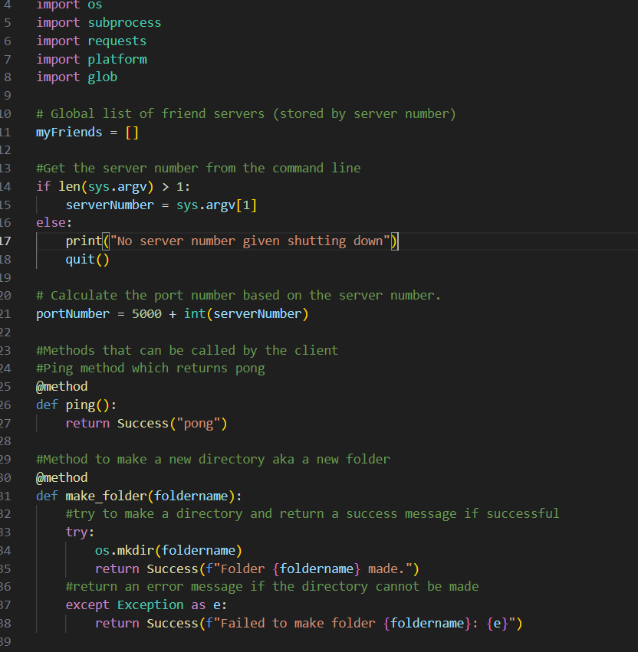

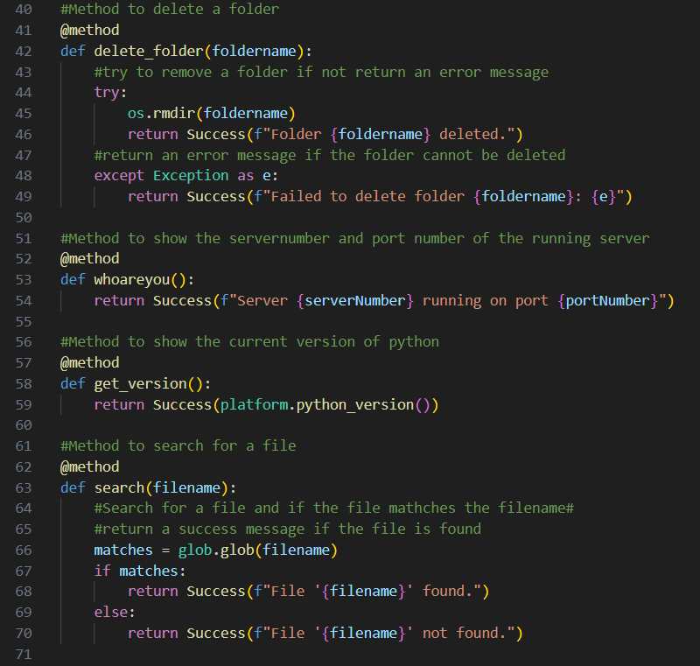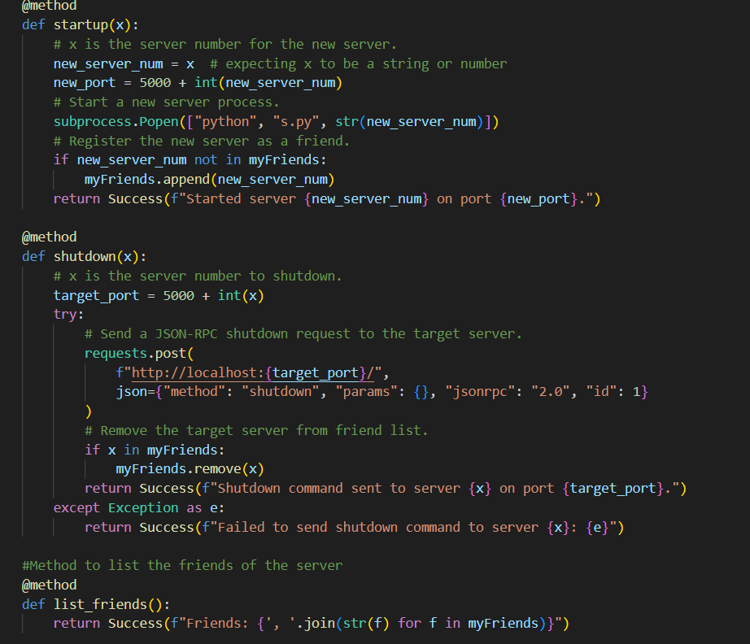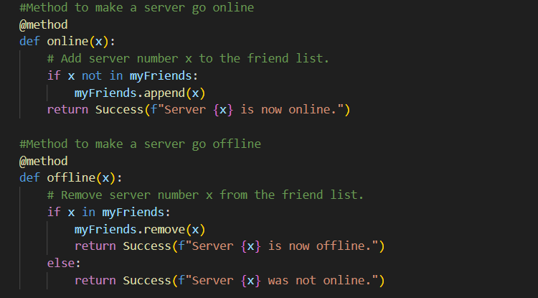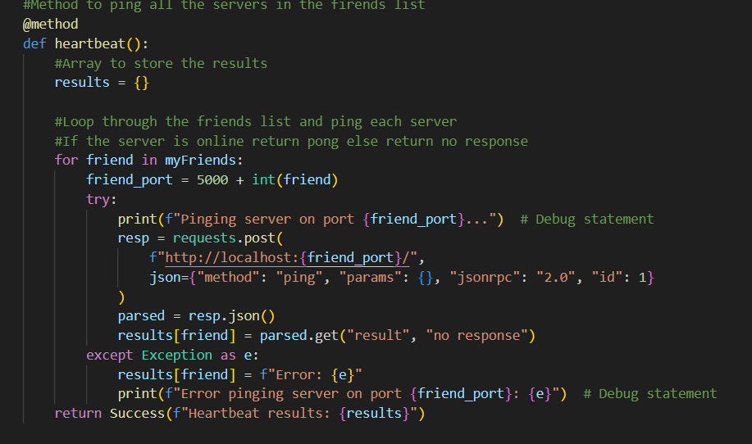

Client Python Code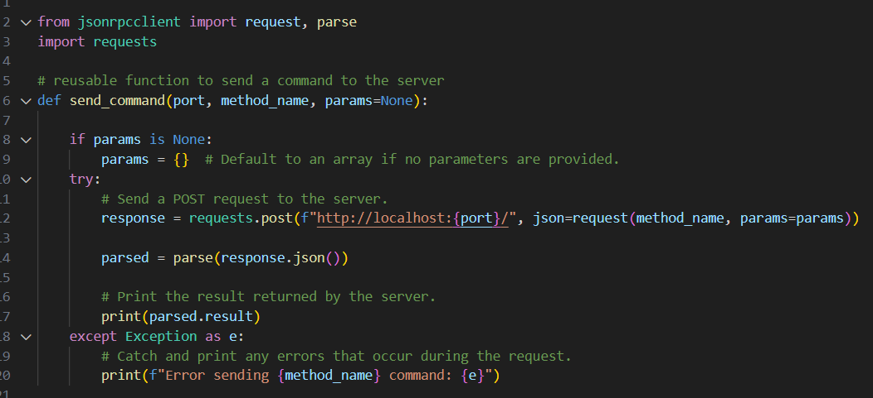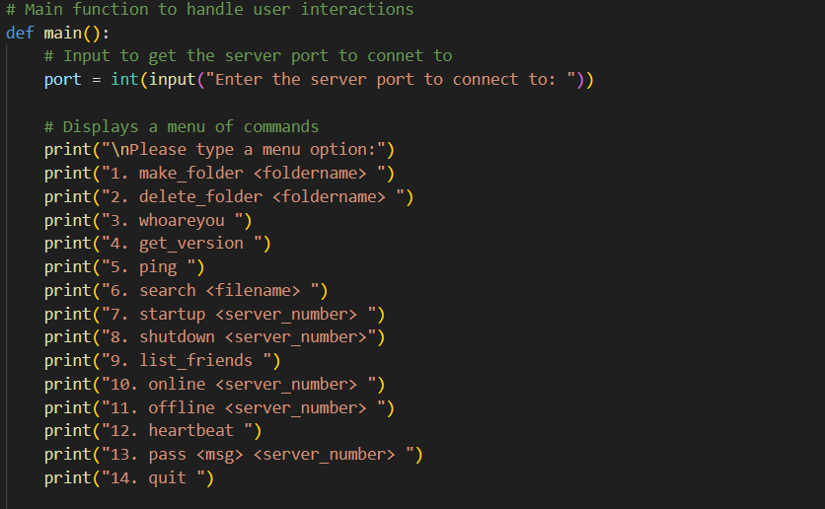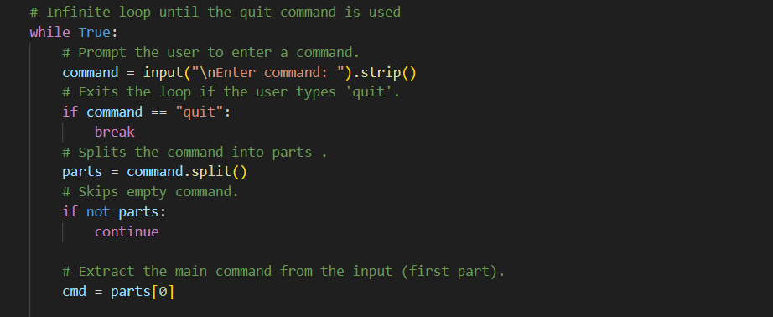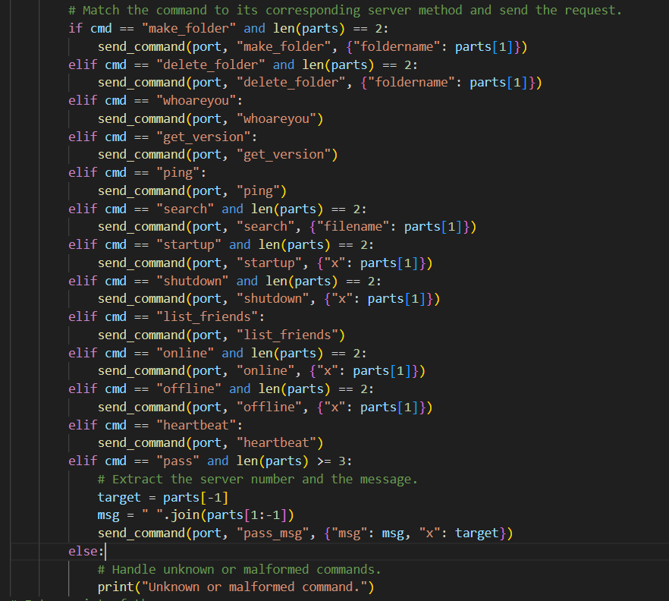

1. Scripts Used to Run the Code

Running the server and client code

1. Running the server side

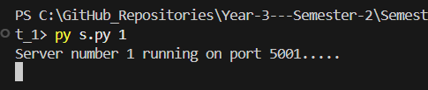

2. Running the client side

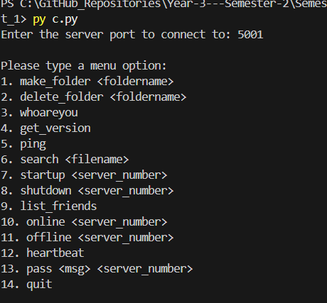

3. Running make_folder script

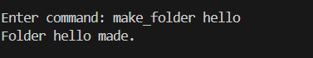

4. Running delete_folder script

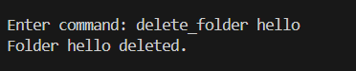

5. Runing whoareyou script

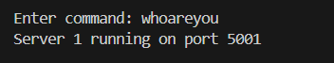

6. Running get_version script

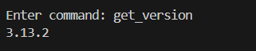

7. Running ping script

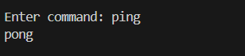

8. Running search file script

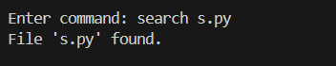

9. Running startup server script

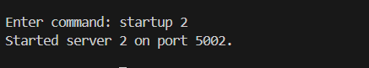

10. Running shutdown server script

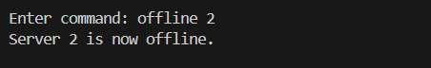

11. Running list_friends script

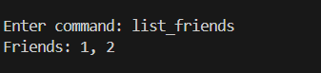

12. Running online and offline script

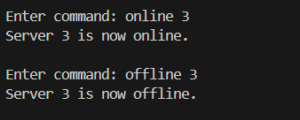

13. Running heartbeat script

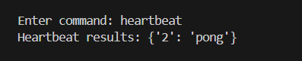

14. Running pass msg to a server script



3. Python Unit Tests

Testing Ping , make_folder and delete_folder functions

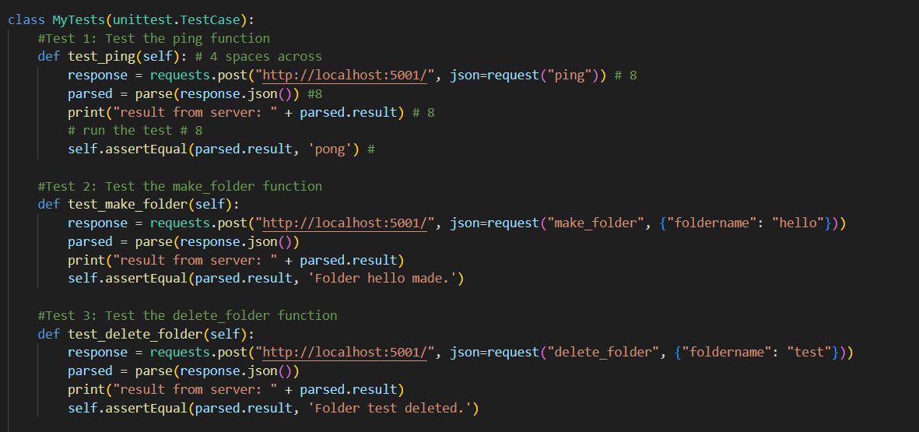

Testing whoareyou, get_version and search functions

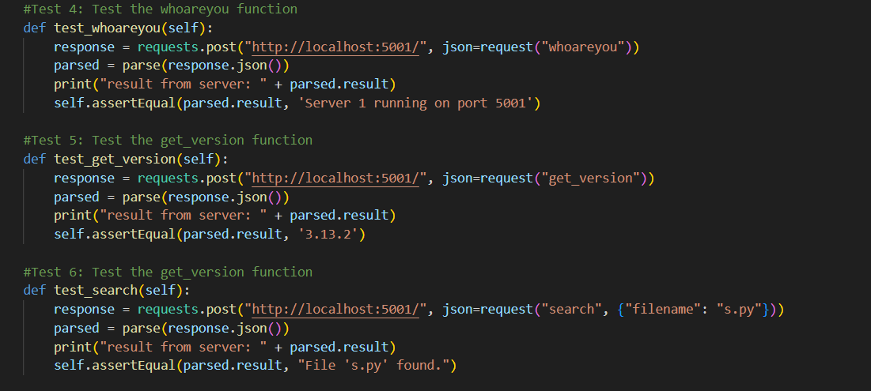

Testing startup, shutdown and list_friends functions

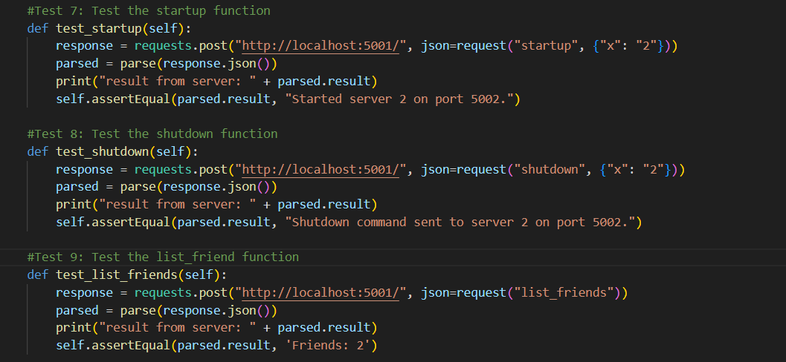

Testing the online, offline, heartbeat and pass_msg functions

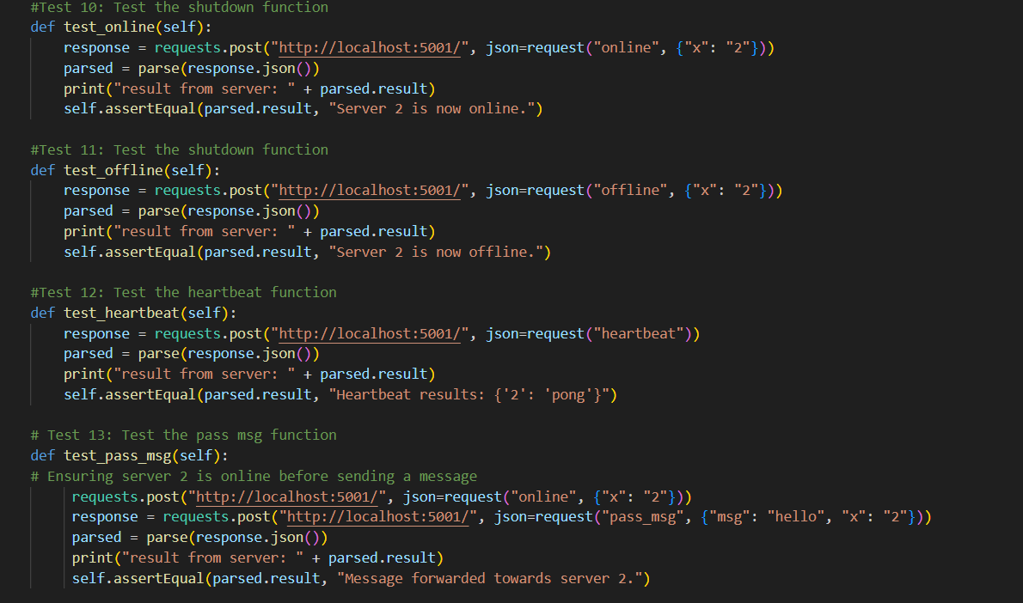

4. Results of my Unit Tests

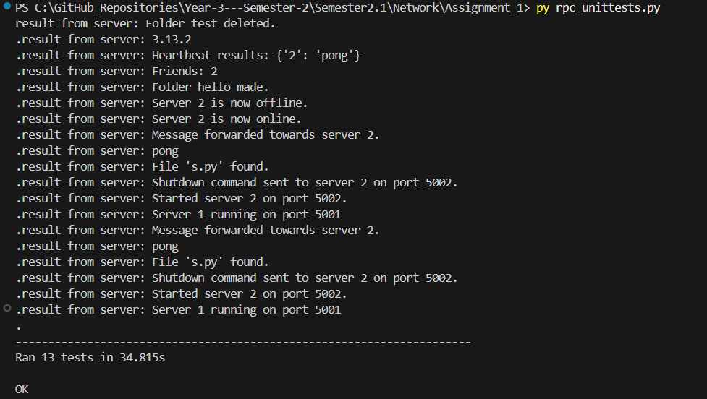

5. Diagrams of each function

1. Ping Diagram

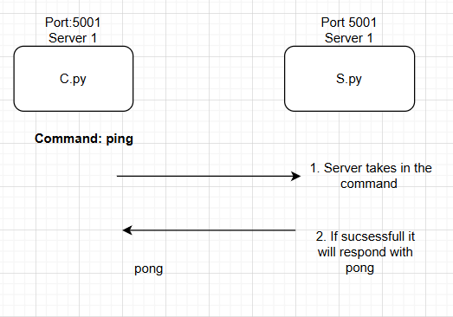

1. Make_folder diagram

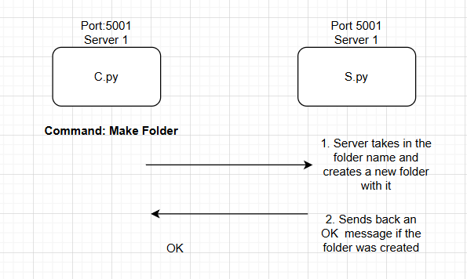

1. Delete_Folder Diagram

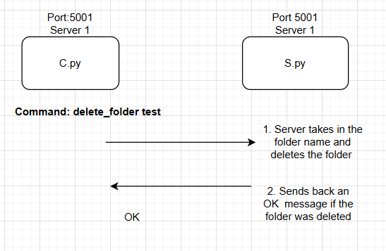

1. Whoareyou Diagram

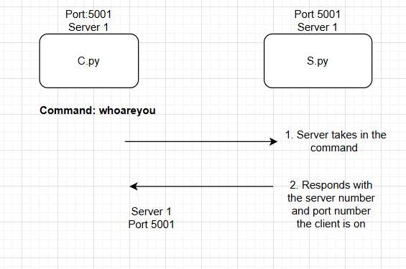

1. Get_version Diagram

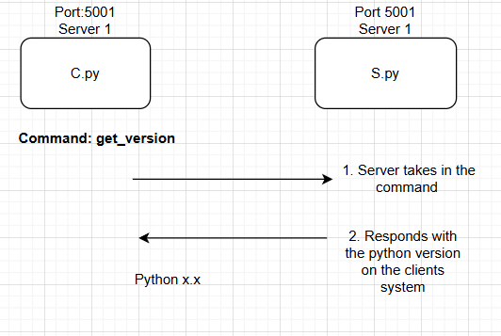

6.Search Diagram

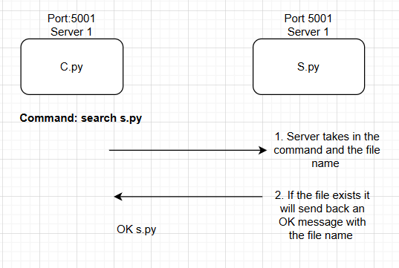

7.Startup Diagram

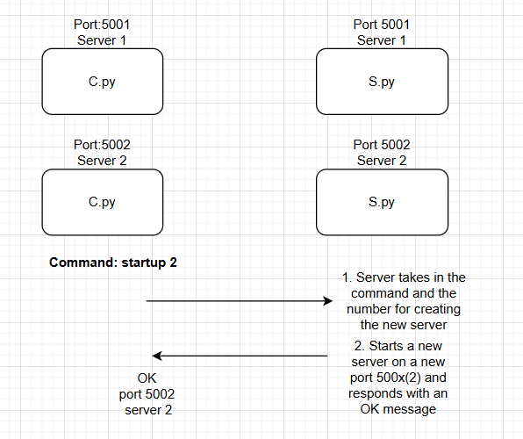

8. Shutdown Diagram

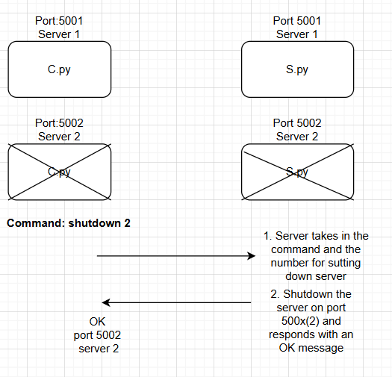

9. List_Friends Diagram

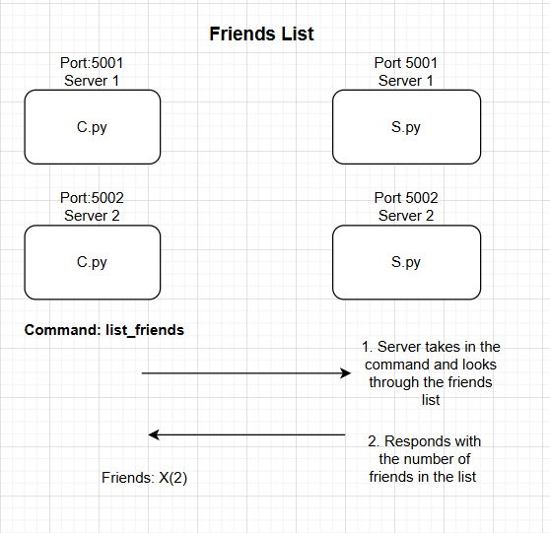

10. Online Diagram

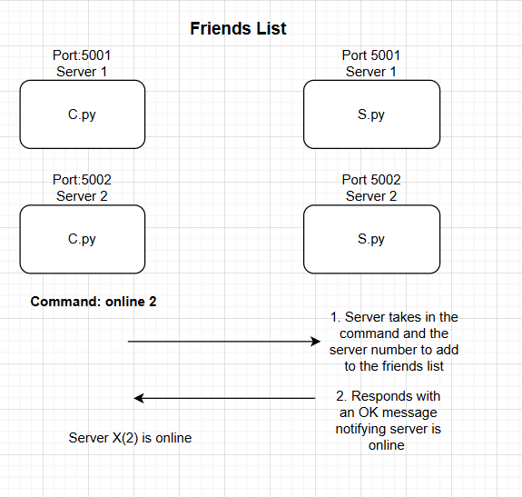

11. Offline Diagram

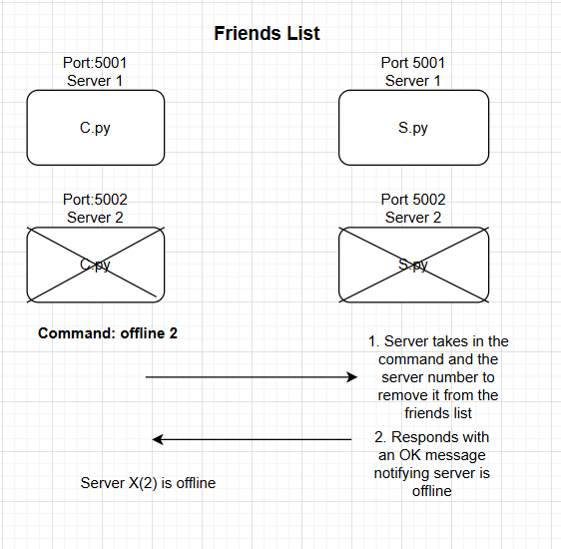

12. Heartbeat Diagram

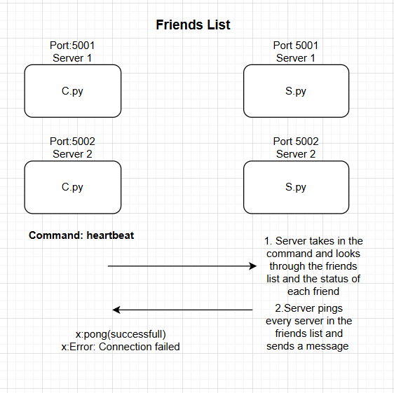

13. Pass msg Diagram

